Module 03 – Solutions

Modern Navigation Systems – EN.525.645.81

Submitted: 9/24/2018

**Kyle Mercer**

* 1. Show, using the equations from Mod 2a, slide 9, that x2 + y2 + z2 = r2.

A point **A** represented with *lat*/*long* (ie. [θ,ϕ]) coordinates on a sphere of radius re may be represented in Cartesian coordinates as:

$$x=r_{e}\cos\left(θ\right)\cos\left(ϕ\right)$$

$$y=r_{e}\cos\left(θ\right)\sin\left(ϕ\right)$$

$$z=r_{e}sin\left(θ\right)$$

By plugging in and simplifying using trigonometric identities we see that:

$$x^{2}+y^{2}+z^{2}=r_{e}^{2}\cos^{2}{θ\cos^{2}{ϕ+}}r_{e}^{2}\cos^{2}{θ\sin^{2}{ϕ+}}r_{e}^{2}\sin^{2}{θ}$$

$$\underset{⇔}{}x^{2}+y^{2}+z^{2}=r_{e}^{2}\cos^{2}{θ(1-\cos^{2}{ϕ+1-\sin^{2}{ϕ)+r_{e}^{2}\sin^{2}{θ}}}}$$

$$\underset{⇔}{}x^{2}+y^{2}+z^{2}=r_{e}^{2}\cos^{2}{θ}(\sin^{2}{ϕ+\cos^{2}{ϕ)}}{+r}_{e}^{2}\sin^{2}{θ}$$

$$\underset{⇔}{}x^{2}+y^{2}+z^{2}=r_{e}^{2}\cos^{2}{θ}+r_{e}^{2}\sin^{2}{θ}$$

$$\underset{⇔}{}x^{2}+y^{2}+z^{2}=r_{e}^{2}\left(\cos^{2}{θ}+\sin^{2}{θ}\right)$$

$$\underset{⇔}{}x^{2}+y^{2}+z^{2}=r_{e}^{2}$$

1.2. Derive, for the circle x2 + y2 = 1000 the tangent line that approximates the circle at the angle of 30 degrees from the origin.

For the polar coordinate point represented by R = √(1000) and θ = 30°, the Cartesian coordinates [x,y] are computed as:

$$x=\sqrt{1000}×\cos{30°}=27.386$$

$$y=\sqrt{1000}×\sin{30°}=15.811$$

This radius segment and point [x,y] defines a line that runs through the origin of the form y = mx+b where m equals the ratio of y divided by x and b = 0

$$f\left(x\right)=\frac{15.811}{27.386}x$$

The slope of the line perpendicular to this function, *fT(x)*, at the point [x,y] on the circle represents the line tangent to the circle at that point (ie. where R = √(1000) and θ = 30° in polar form). The slope of that line is the negative inverse of the ratio m for f(x).

$$f_{T}\left(x\right)=\frac{-27.386}{15.811}x+b$$

Solve for b by plugging in point [x.y]:

$$15.811=\frac{-27.386}{15.811}×27.386+b$$

$$\underset{⇔}{}b=63.245$$

Thus for the circle x2 + y2 = 1000 the tangent line that approximates the circle at the angle of 30 degrees from the origin is:

$$f_{T}\left(x\right)=-1.732x+63.245$$

1.3. Plot the line segment and the circle segment on the same graph using scales that demonstrate the quality of the approximation.

From MATLAB, we plot the function *FT(x)* against x2 + y2 = 1000 as follows:

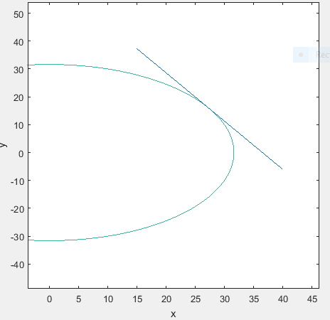

Zooming into the tangent point we see the quality of the approximation:

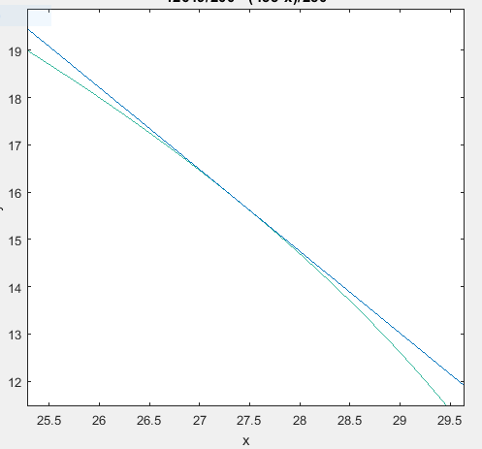

2.1. Use Napier’s rules to compute 89 55 51.

The arcs provided from Mason and Dixon’s journal for the circular triangle EAP are:

AE = 5’

AP = 50° 16’ 42.6”

First convert the arc lengths to radians (with radius 1 unit)

AE = 5’ = 1/12° = 1/12° × π/180° = π/2160 rad ≈ 0.001454 rad

AP = 50° 16’ 42.6” = 50° + 4/15° + 0.1183° = 50.2785π/180 rad ≈ 0.877525 rad

Using one of the rules for spherical right triangles we can compute the arc EP as:

$$\cos{AP}=\cos{EP}\cos{AE}$$

$$EP=\cos^{-1}{\frac{\cos{AP}}{\cos{AE}}}=0.8775241 rad$$

We calculate angle PAE using:

$$\tan{b}=\cos{A}\tan{c}$$

$$\tan{AE}=\cos{PAE}\tan{AP}$$

$$PAE=\cos^{1}{\frac{\tan{AE}}{\tan{AP}}=1.569588 rad}$$

$$1.569588 rad=89.930768°=89° {55}^{'} 50.76"$$

2.2. Derive 17.14 feet for AE = 5’ of arc.

(Attempted) For the triangle AEB, the angle EAB is calculated as:

$$EAB=90°-89° {55}^{'}50.76"=0.0692°=0.0012072 rad$$

Using Napier’s Rules we can solve for the curve EB:

$$\sin{a}=\sin{A}\sin{c}$$

$$\sin{EB}=\sin{EAB}\sin{AE}$$

$$EB=\sin^{-1}\left(\sin{EAB}\sin{AE}\right)$$

$$AE=5^{'}=0.0833°=0.0015 rad$$

So:

$$EB=\sin^{-1}\left(\sin{0.0012072}×\sin{0.0015}\right)=1.75578e-6 rad$$

Since the meridian which passes through B, E, and P is a great circle we can use the radius of the Earth to find the arc length for EB as:

$$r_{e}×1.75578e-6=0.006951 mi=36.70128 feet$$

3.1. Solve problem 2.4 from the text.

(Attempt) Start with the cosine of the range angle equation and as the book suggests, expand the sins to the third order and the cosines to the second order.

$$\cos{\frac{D}{R_{G}}}=\sin{ϕ}\sin{ϕ_{t}}+\cos{ϕ}\cos{ϕ_{t}}\cos\left(λ-λ_{t}\right)$$

$$=\sin{ϕ}\sin\left(ϕ+Δϕ\right)+\cos{ϕ}\cos\left(ϕ+Δϕ\right)\cos\left(Δλ\right)$$

$$=\sin{ϕ}\left(\sin{ϕ}\cos{Δϕ}+\cos{ϕ}\sin{Δϕ}\right)+\cos{ϕ}\left(\cos{ϕ}\cos{Δϕ}-\sin{ϕ}\sin{Δϕ}\right)\cos{Δλ}$$

$$=\sin^{2}{ϕ}\cos{Δϕ}+\sin{ϕ}\cos{ϕ}\sin{Δϕ+\cos^{2}{ϕ}\cos{Δϕ}\cos{Δλ}-\sin{ϕ}\sin{Δϕ}\cos{ϕ}\cos{Δλ}}$$

The sine of a small number is the same small number and the cosine of a small number can be approximated as 1-x^2/2:

$$=\sin^{2}{ϕ}\left(1-\frac{Δϕ^{2}}{2}\right)+\sin{ϕ}\cos{ϕ}\left(Δϕ\right)+\cos^{2}{ϕ}\left(1-\frac{Δϕ^{2}}{2}\right)\left(1-\frac{Δλ^{2}}{2}\right)-\sin{ϕ}\cos{ϕ}\left(Δϕ\right)\left(1-\frac{Δλ^{2}}{2}\right)$$

$$=\sin^{2}{ϕ}-\sin^{2}{ϕ}\left(\frac{Δϕ^{2}}{2}\right)+\sin{ϕ}\cos{ϕ}\left(Δϕ\right)-\sin{ϕ}\cos{ϕ}\left(Δϕ\right)+\sin{ϕ}\cos{ϕ}\left(Δϕ\right)\left(\frac{Δλ^{2}}{2}\right)+$$

$$\cos^{2}{ϕ}-\cos^{2}{ϕ}\left(\frac{Δϕ^{2}}{2}\right)-\cos^{2}{ϕ\left(\frac{Δλ^{2}}{2}\right)+\cos^{2}{ϕ}\left(\frac{Δλ^{2}}{2}+\frac{Δϕ^{2}}{2}\right)}$$

$${=sin}^{2}{ϕ}+\cos^{2}{ϕ}-\sin^{2}{ϕ}\left(\frac{Δϕ^{2}}{2}\right)-\cos^{2}{ϕ}\left(\frac{Δϕ^{2}}{2}\right)+\sin{ϕ}\cos{ϕ}\left(Δϕ\right)\left(\frac{Δλ^{2}}{2}\right)$$

$$-\cos^{2}{ϕ\left(\frac{Δλ^{2}}{2}\right)+\cos^{2}{ϕ}\left(\frac{Δλ^{2}}{2}\right)\left(\frac{Δϕ^{2}}{2}\right)}$$

$$=1-\frac{Δϕ^{2}}{2}\left(\sin^{2}{ϕ}+\cos^{2}{ϕ}\right)+\sin{ϕ}\cos{ϕ}\left(Δϕ\right)\left(\frac{Δλ^{2}}{2}\right)-\cos^{2}{ϕ}\left(\frac{Δλ^{2}}{2}\right)+\cos^{2}{ϕ}\left(\frac{Δλ^{2}}{2}\right)\left(\frac{Δϕ^{2}}{2}\right)$$

Note: The last term in the previous expression is significantly small and may be treated as negligible.

$$\cos{\frac{D}{R_{G}}}=1-\frac{Δϕ^{2}}{2}+\sin{ϕ}\cos{ϕ}\left(Δϕ\right)\left(\frac{Δλ^{2}}{2}\right)-\cos^{2}{ϕ}\left(\frac{Δλ^{2}}{2}\right)$$

Recall, D/RG = ϕ. If we substitute D for D0 + ΔD then:

$$=1-\frac{{\left(D+ΔD\right)}^{2}}{2R^{2}}+\sin{ϕ}\cos{ϕ}\left(Δϕ\right)\left(\frac{Δλ^{2}}{2}\right)-\cos^{2}{ϕ}\left(\frac{Δλ^{2}}{2}\right)$$

$$=1-\frac{D^{2}-2ΔD\left(D\right)}{2}-\frac{ΔD^{2}}{4}$$

*From here, the remainder of the solution to derive equation 2.21 in the text eludes me…will have to resubmit.