Module 05 - Assignment

Modern Navigation Systems – EN.525.645.81

Submitted: 10/8/2018

**Kyle Mercer**

1. Derive the period of a pendulum by solving the differential equation F = ma = -mg sinθ where a = l d2θ/dt2 and l is the length of the pendulum. Assume sinθ ~ θ. Draw a sketch the shows the angle θ and assume that l is the radius of the earth = 6358 km and that g = 9.8 m/s2. What is T?

Using the above two equations for a, we get:

Note: sinθ ≈ θ

Solving the differential equation using complex root solution *θ = a ± bi*:

Let and θ(0) = θ0­, for θ(t) = 0

For a full pendulum period we multiply by 4:

1. Assume that g is a function of distance l that falls as 1/l2 (i.e., the inverse r2 law for gravity). At what value of l is T = 24 hours?

Recall the following equations:

Plugging in a for g, we get:

Solving for L we get:

For T = 24 hours = 86400 seconds, L evaluates to 42,240,234 meters or about 42,240 kilometers from the center of the Earth.

1. Derive the look angles from 39N 77W to the geostationary DirectTV satellite at 119W. Check your results using <http://www.directv.com/DTVAPP/customer/dishPointer.jsp>

Look angles require both the azimuth and the elevation angles:

Where:

* R = radius of the Earth = 6,371,000m
* r = satellite distance from the Earth center = 42,240,234m
* θe = Earth station latitude = 39°
* ϕs = satellite longitude = -119°
* ϕe = earth station longitude = -77°
* ϕse = ϕs – ϕe = -42°
* δ = declination of satellite = 0
* and…

Thus:

1. Derive the look angles from 39N 77W to the GPS satellite given on slide 10 at GPS time week 801 and time of week 500,000 seconds. Note the distinction between time of almanac applicability, time of week, and the time for which the az/el to the satellite is desired.

Given the rate of right ascension we can calculate backwards to the time desired for 500,000s. The current time of applicability is 503,808s

*I am not sure how to take the remaining orbital parameters provided in slide 10 to compute the Az and El for the satellite. With more review and further research I will reattempt this problem and resubmit.

1. With reference to the figure on slide 7 of this sub-module, sketch the earth and the north star in two dimensions, showing that the line from the center of the earth to the north star is parallel to the line from a point of the earth to the same star (because the star is so far away). Then show that the angle to the star with respect to the local horizon at a point on the surface of the earth, is equal to the latitude of that point.

Note the sketch below that L1 and L2 appear to be about parallel since the star’s distance from the two points on the Earth are infinitely far away.

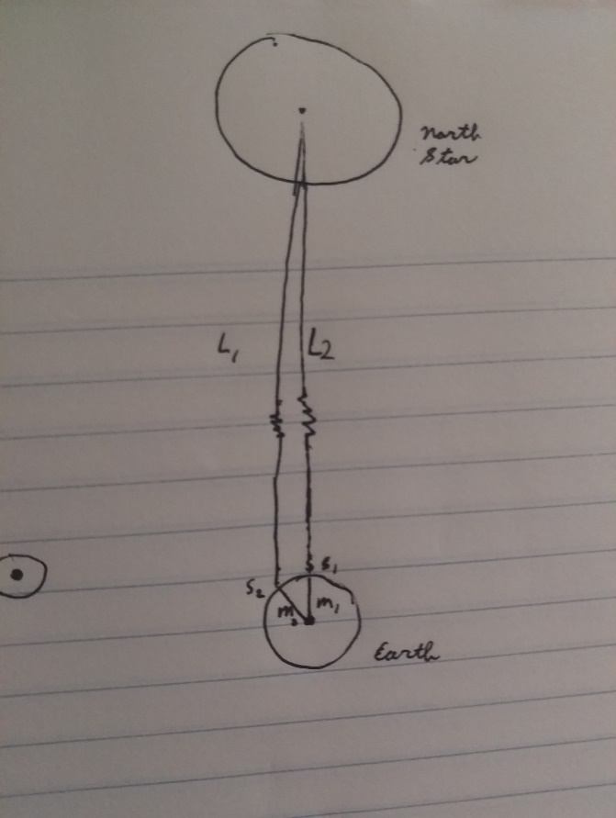

The elevation angle is given as:

Where:

For distance objects such as stars (not the Sun):

For the North Star, δ = 90°. Thus:

1. 5.5.1
   1. Go outside at night and identify Sirius, Polaris, Orion (early in the spring term, not in the summer), Jupiter (depending on the month), Venus, and the moon.
   2. Compute the look angles to a star of your choice based on your location. 2b. Check your answers against the USNO Astronomical Observations web site at http://www.usno.navy.mil/USNO/astronomical-applications 2c. Go outside and look at the star, verifying that your az/el computations are correct. If you use a magnetic compass, correct for magnetic variation
   3. Using NASA’s website for guidance on when and where to look, view the International Space Station.
   4. If you can borrow a pair of binoculars, look at the moons of Jupiter.
   5. Explain why the moon’s orbital period is 28 days, in apparent violation of Kepler’s third law
   6. Comment on your observations in a paragraph or two.

The star I chose for this exercise is Altair. On October 8th the star has the following SHA and declination:



The GHAϒ for 6PM UTC (2PM EST) ( row 18) is:



SHA = 62° 5.4 = 62.09°  
 Dec = 8° 55.2 = 8.92°  
 GHAϒ = 287° 33.3 = 287.555°  
 LONG = -77.0369°  
 LAT = θe = 38.9072°

After calculating these values, my Az + El seem to be accurate for the projection of the star, Altair. Using an Android app that tracks celestial bodies, at 2PM EST the star appears to be slightly above the horizon at almost an easterly direction which correlates with the calculations of Az and El above. See screenshot from app below:

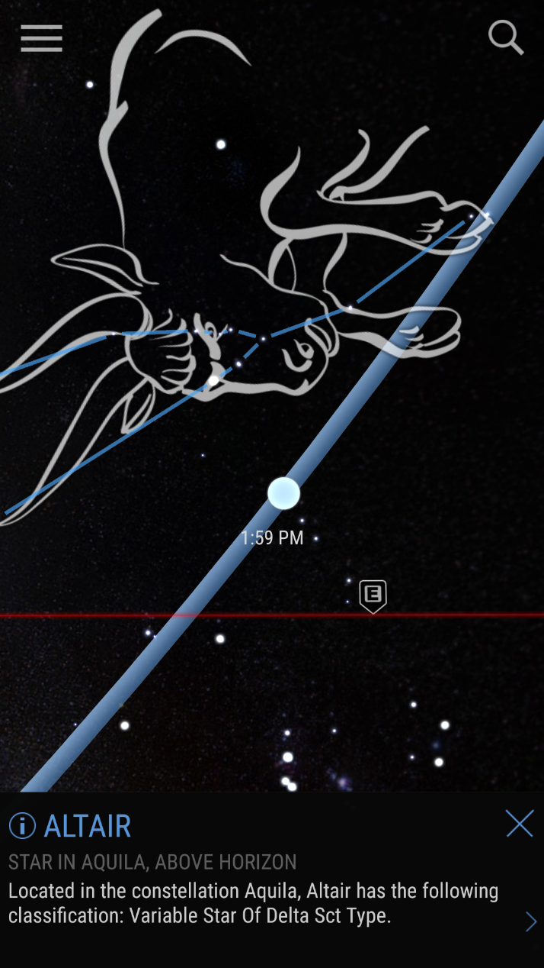

I was not able to see many planets out tonight with the exception of Mars. Unfortunately, by the time I got to observing Jupiter and its moons sank beneath the horizon. The Earth’s moon is just a day from being a New Moon which made it difficult to see as well. Although I didn’t pick a good time for my lookup values for Altair, I was excited to see my calculated values seemingly line up with my observations from my Android tracker app. Next time I will be sure to pick a time from the almanac which corresponds to the EST timezone which I am in (currently location is DC as of making these observations).

The moons has a sidereal month of only 28 days rather than a synodic month of 30 days for a similar reason that a sidereal Earth day is shorter than a synodic day. The moon has to travel just a tiny bit further than 360° to actually make one full rotation around the Earth (from New Moon to next New Moon).