Module 06 – Assignment

Modern Navigation Systems – EN.525.645.81

Submitted: 10/12/2018

**Kyle Mercer**

1. Solve for vx2 + vy2 to second order to show that vnew = v0.

Since we have:

$$v_{x}=v_{0}\cos\left(\frac{v_{0}t}{r}\right)$$

$$v_{y}=-v_{0}\sin\left(\frac{v_{0}t}{r}\right)$$

Thus:

$$v_{x}^{2}+v_{y}^{2}=v_{0}^{2}\cos^{2}\left(\frac{v_{0}t}{r}\right)+{\left(-v_{0}\right)}^{2}\sin^{2}\left(\frac{v_{0}t}{r}\right)$$

$$v_{x}^{2}+v_{y}^{2}=v_{0}^{2}\left(\cos^{2}\left(\frac{v_{0}t}{r}\right)+\sin^{2}\left(\frac{v_{0}t}{r}\right)\right)=v_{new}^{2}$$

1. Integrate vx and vy to show that x2 + y2 = r02
2. For the constraint that mg = mv02/r, compute v0 if the acceleration due to gravity is g = 9.8 m/sec2 and r is the radius of the earth.
$$mg=\frac{mv_{0}^{2}}{r}$$

$$v_{0}=±\sqrt{gr}=±\sqrt{9.8×6.371e6}=7901.6\frac{m}{s}$$

3. Show that 2πrearth/v0 = Torbit = 84.4 minutes, the period of a Shuler pendulum.

$$\frac{2πr_{0}}{v_{0}}=\frac{2π\left(6.371e6\right)}{7901.6}=5066.06s=84.43 min$$

For a Shuler pendulum, r = re:

1. Use the Excel spreadsheet (attached above) to plot graphs, which should be pasted into a single Word or pdf file, that illustrate all of the features listed in slide 4 of this sub-module.

Circular orbit:  
(y0 = 6378144, u0 = 7901.6)

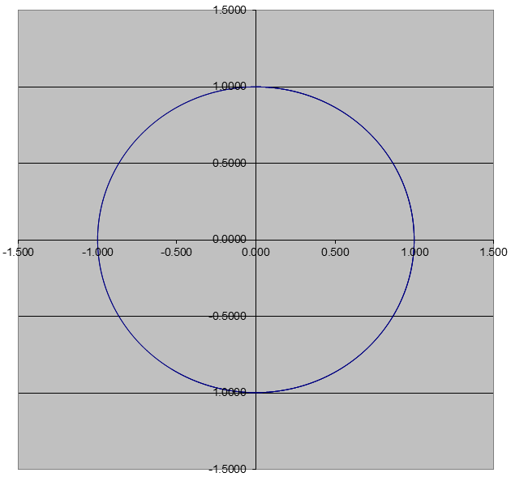

Elliptical orbit  
(u0 = 8600, Δt = 0.34)

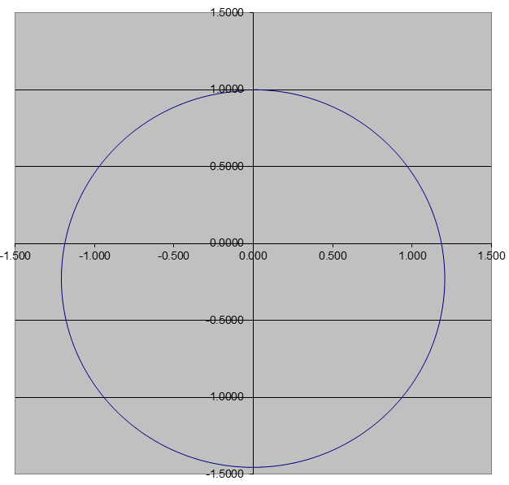

Elliptical orbit turned circular with new R0 (apogee radius)  
(R0 = 9.283e6, Δt = 0.6, u0 = 6550)

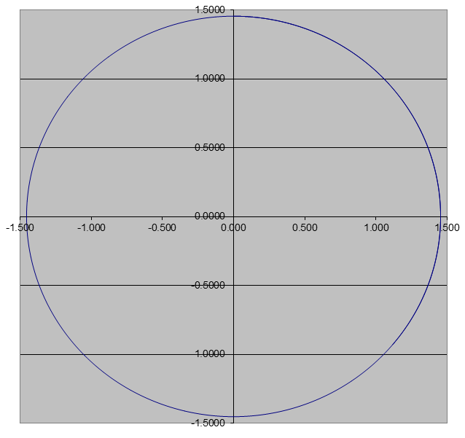

De-Orbiting maneuver:  
(u0 = 5300)

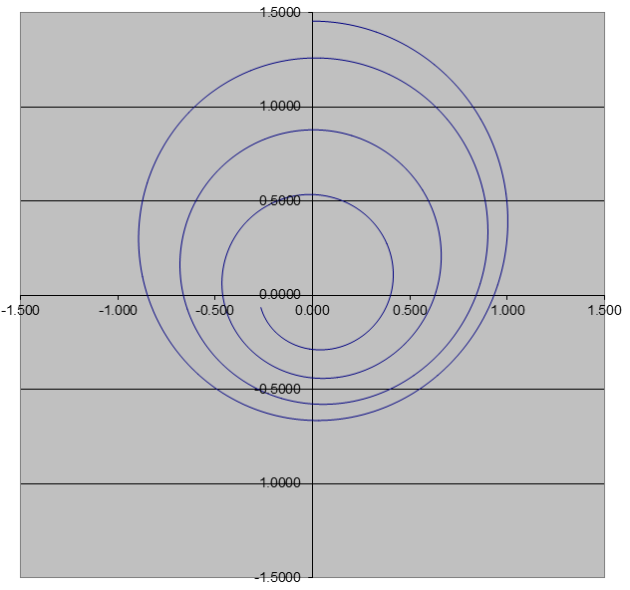

Satellite moved to different slot in orbit

1. Circular orbit:  
   (y0 = 6378144, u0 = 7901.6)



1. Increase altitude of orbit (slightly elliptical):  
   (y0 = 6500000)

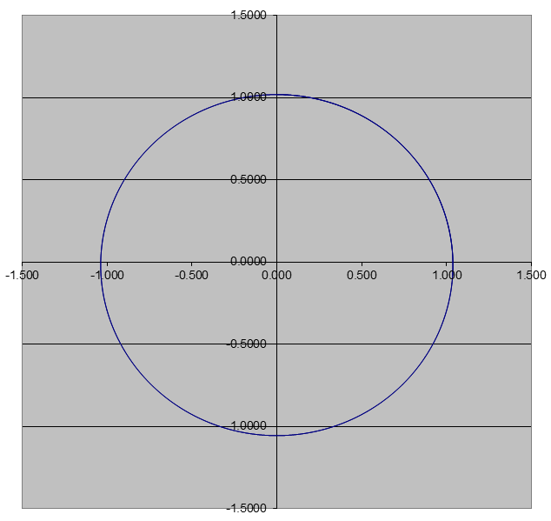

1. Wait for proper alignment of anomaly and revert to original altitude  
   (y0 = 6378144)



1. Explain why the moon’s orbital period is 28 days, in apparent violation of Kepler’s third law.

The moons has a sidereal month of only 28 days rather than a synodic month of 30 days for a similar reason that a sidereal Earth day is shorter than a synodic day. The moon has to travel just a tiny bit further than 360° to actually make one full rotation around the Earth (from New Moon to next New Moon). This is because the Earth is revolving around the sun as the moon is revolving around the Earth which means the moon must travel slightly further to compensate for the distance traveled by the Earth.

Using Kepler third law equation we have:

$$T^{2}=\frac{4π^{2}}{G\left(M_{1}+M_{2}\right)}a^{3}$$

Where both M’s are the mass of the Earth and the Moon and a is the semi-major axis distance between the two bodies.

$$T=\sqrt{\frac{4π^{2}}{G\left(M_{1}+M_{2}\right)}a^{3}}=\sqrt{\frac{4π^{2}}{G\left(5.972e24+7.347e22\right)}{384400000}^{3}}=2.3574e6 sec$$

$$\frac{T}{60×60× 24}=27.2854 days≠28 days$$