Module 08 – Assignment

Modern Navigation Systems – EN.525.645.81

Submitted: 11/3/2018

**Kyle Mercer**

1. Reproduce the calculations and results of the sextant example in the Nautical Almanac. (See the PDF file attached above, and use the year 2000 data provided with the file. To check your work, use the 2018 Almanac and its example, which includes the solution.)

Initial values:  
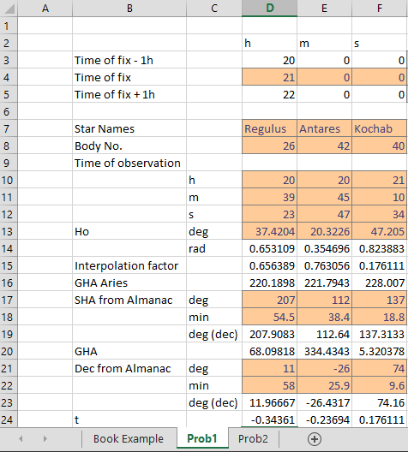

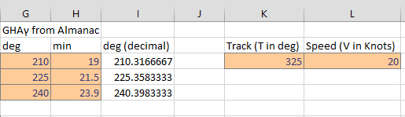

Iterative algorithm

Iteration 1  
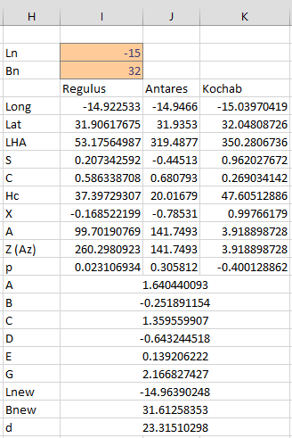

Iteration 2

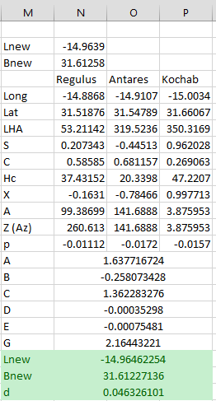

1. Next, identify the latitude and longitude of your location using Google Earth or other application. Then, go outside and pick a few stars that by now you have learned to name. (The available stars will depend on the season.) Estimate the azimuth and elevation to each star. Record the time.

|  |  |
| --- | --- |
| Current Latitude | Current Longitude |
| 38°58'44.4"N | 76°31'32.1"W |

Measured Azimuth with compass and Elevation with smartphone accelerometer/gyro

|  |  |  |  |
| --- | --- | --- | --- |
| Date: Oct 26 at 8:30PM | Mirfak | Altair | Hamal |
| Measured Azimuth | ~50° | ~230° | ~85 |
| Measured Elevation | 31.8° | 50.5° | 33.5° |

1. Calculate the Hc and azimuth to each star for this actual location and time. Compare, in tabular form, to your estimates from above. These calculated values of Hc are to be used as the values of Ho in your computations.

Initial values

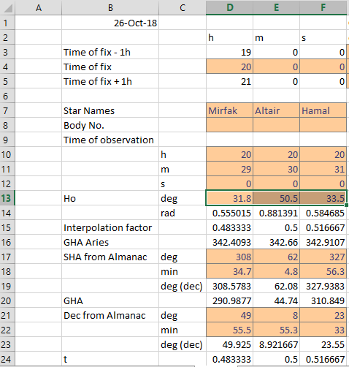

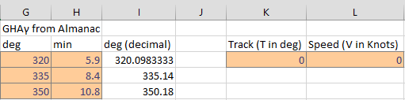

1. Calculate new values of Hc for each star under the assumption that you are at 0 degrees longitude and 0 degrees latitude for the same instant in time. These incorrect values are then used, with your Ho values, to drive the algorithm in the Nautical Almanac (from the PDF file referenced above). Using several iterations of this algorithm, show that the algorithm eventually converges to your correct position.

|  |  |
| --- | --- |
| Actual latitude | Actual Longitude |
| 38.978° | -76.5245° |

Iteration 1

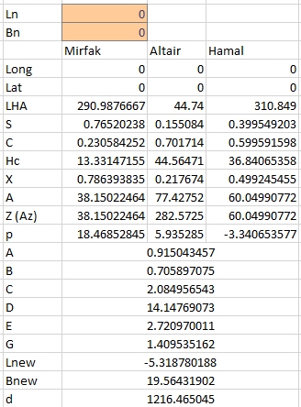

Iteration 2 and 3

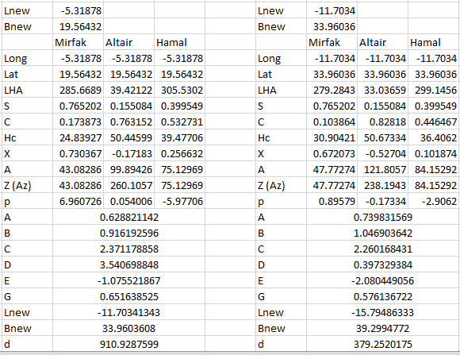

4th and final iteration

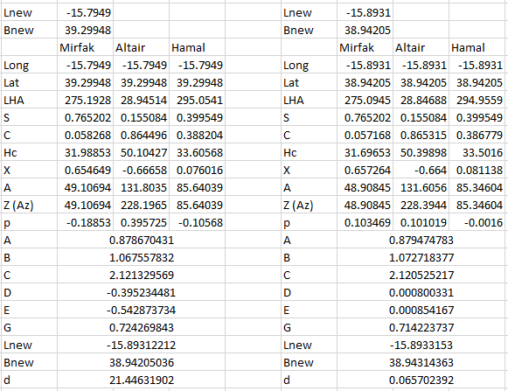

The calculated latitude (Bnew) converged to the exact latitude after 4 iterations. The longitude calculated converges to the western section of the globe. Because of this, the actual longitude is determined from the calculated longitude of -15.8933°. Thus the calculated position is determined to be:

|  |  |
| --- | --- |
| Calculated latitude | Calculated Longitude |
| **38.9431°N** | 90° + -15.8933° = **74.1067°W** |

1. Estimate the eccentricity e of the earth’s orbit around the sun by taking account of the differing lengths of the seasons. You might find it useful to play with the orbit propagator simulation from Module 6 to generate an appropriate orbit, then match the orbital anomaly during the different seasons to the equinoxes and solstices shown on a modern calendar. Or, you can deduce this from the equation of time corrections in the Nautical Almanac.

The eccentricity of the Earth is the deviation of the Earth’s rotation form a perfectly circular one around the sun. The eccentricity, e, of the Earth is:

$$e≈0.0167$$

One way to potentially estimate this is by taking the ratio of the number of days in the summer in the northern hemisphere to the number of days in winter.

Length of a summer in the northern hemisphere: 89 to 93 days  
Length of a winter in the northern hemisphere: 89 days

The eccentricity range is obtained by the following equation:

$$e≈1-\frac{winter days}{summer days}=1-\frac{89}{x}$$

The plot shows the value of e for the above range of summer days. Note the red diamond marks the current eccentricity of the Earth (0.0167) for a value of x = 90.5 days.

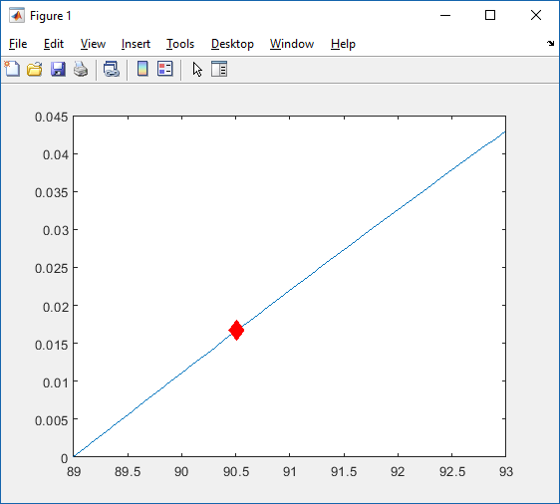

1. Knowing the longitude of Washington, DC, estimate the date for which the data from the Washington Post in this sub-module are measured.

The longitude of Washington DC is: -77.036555°

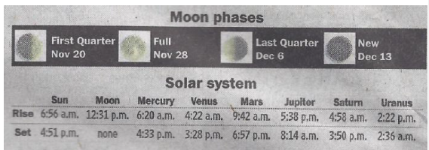

The difference between sun rise and sun set is:

$$6:56-16:51=9:55$$

The offset for solar noon is:

$$\frac{9:55}{2}=4:30+22=4:52$$

Thus solar noon should occur at the sunrise time plus the offset:

$$6:56+4:52=11:48$$

The difference between solar noon and clock noon (ei. Equation of time) is:

$$12:00-11:48=+00:12$$

In the 2017 Nautical Almanac, this value for the equation of time occurs around **October 10th**

1. In navigation problems, it is common to divide by the sine or cosine of an angle. For a 1% measurement error in the measurement of θ, plot the corresponding estimation error in the function f(θ) = 1/cos(θ) for 0 < θ < 90 degrees.

The following MATLAB code will produce a graph of the function f(θ) with a 1% measurement error applied to θ for 0° < θ < 90°

|  |
| --- |
| theta = [0.001:0.01:89.99];  err = 0.01.*(rand(1,length(theta))*2.-1);  theta_err = theta.*err+theta;  f = 1./cosd(theta_err);  plot(theta, f) |

The resulting plot shows significant amounts of estimation error as a noisy θ approaches 90°.

