Module 10 – Assignment

Modern Navigation Systems – EN.525.645.81

Submitted: 11/19/2018

**Kyle Mercer**

1. Go to the USNO website and determine the times of sunrise, noon, and sunset on June 2, 1804, at lat/long 38° 36′ / 91° 57′ W. Noon is when the azimuth at which the sun is observed in 180 degrees.

The position lat/long 38° 36′ / 91° 57′ W is at about UTC -6 hours (91°/15° per hr ≈ 6.1hrs). After plugging in multiple values around morning, noon, and evening for UTC -6 I converge onto the following times:

|  |  |  |  |
| --- | --- | --- | --- |
|  | Sunrise | Noon | Sunset |
| HC | 0° 00.0’ | 73° 38.4’ | 0° 00.0’ |
| Zn | 61.1° | 180.0° | 299.0° |
| UTC Time of Event | 10:49:15 UTC | 18:05:25 UTC | 25:21:46 UTC |

1. Determine an estimate for local noon by finding the mid-point between sunrise and sunset. What is the difference between your two values for noon? This difference should be equivalent to the equation of time. (Refer to Module 8 for a discussion of the Equation of time.)

An equation of time of -5.5 seconds seems reasonable for values in the Nautical Almanac.

1. Using the az/el predictions of the USNO calculator, compute vectors to the sun and moon and use the vector dot product to compute the “lunar distance” between the sun and moon at noon GMT on June 2nd 1804 (cf. equation 2.20 from the primary text as explained in Module 2 and the attached spread sheet moon angles rev 5a).

|  |  |  |  |  |
| --- | --- | --- | --- | --- |
| 12:00 GMT (38° 36′ / 91° 57′ W) | Zn | HC | GHA | Dec |
| Sun | 71.15° | 12° 39.1’ | 0° 37.2’ (0.62°) | 22° 12.5’ (22.208°) |
| Moon | 154.2° | 50° 35.1’ | 75° 52.6’ (75.877°) | 2° 01.6’ (2.0267°) |

The Cartesian coordinates are calculated for the Moon and Sun

Thus the geocentric lunar distance is calculated using the dot product:

1. Compare your result for the equation of time correction from assignment 10.1 with the corresponding entry in the 1804 Almanac.

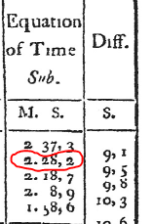

The equation of time from the 1804 Almanac for June 2nd comes out to be -2:28.2. It is possible that this discrepancy is due to the inaccurate choice of times for sunrise and sunset. Sunrise and sunset values were chosen based upon the elevation angle to the sun being 0°, which may not take into consideration the radius of the Sun, causing the timing to be off by a few minutes.

1. Compare your result for the lunar distance computation from assignment 10.1 with the corresponding entry in the 1804 almanac.

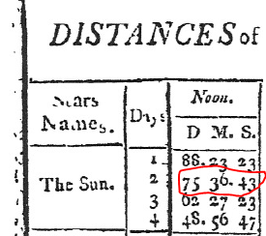

The solution for the geocentric lunar distance was slightly less than the 75° 36.43’ lunar distance given in the 1804 Nautical Almanac. I am unaware if the value provided by the almanac is from the perspective of the user or from the center of the earth, this could explain the small discrepancy. In addition, the lunar distance as obtained from the almanac does not take into the account the observer’s location on the Earth.

1. Plot the lunar distance as a function of time for June 1804 on the same graph as a plot of GHAϒ for the same period of time.

The following MATLAB code was used to plot the graph:

|  |
| --- |
| days =  1  2  3  4  11  12  13  14  15  16  17  gha1 =  69.7600  70.7458  71.7314  72.7169  79.6167  80.6025  81.5881  82.5736  83.5592  84.5422  85.5306  ld1 =  88.3897  75.6119  62.4564  48.9464  47.6078  60.0964  72.1544  83.8281  95.1842  106.2989  117.2614 |

The values for the lunar distance (ld) were obtained from the Almanac. The values for the GHA of Arise was obatined from: <https://www.celnav.de/longterm.htm>

The curved blue scatter plot is representative of the Lunar Distance and the orange-brown scatter plot is representative of the GHAϒ for the following days of June in 1804: 1, 2, 3, 4, 11, 12, 13, 14, 15, 16, and 17 according to the almanac.

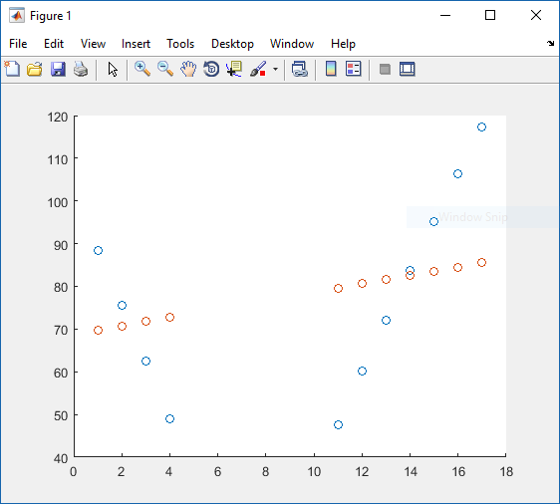

1. Comment on your results with respect to the use of the lunar distance for determining GHAϒ.

By computing the lunar distance between the sun and the moon, you can get a reference for angle between the two celestial bodies. The lunar distance appears to vary periodically for the sun and moon whereas the GHA of Arise is increasing roughly linearly. If you calculate the rate of change across lunar distance measurements then there is a potential relationship between it and the GHA of Arise. If we treat the GHA of Arise as the derivative of lunar distance then the GHA of Arise’s second derivative being positive indicates that the lunar distance will have a concave shape. This is the behavior we see in the plot.

1. Compute the lunar parallax correction given in the celestial data from the USNO website using Richharia’s equations as described in the sub-module 10C on slide 11. How do the results from the Richharia equations relate to the PA correction from the USNO website tool and explained in the Nautical Almanac?

The method here is to calculate the elevation angle to the moon η and then substitute that for the value of H (the apparent altitude of the moon. The data being confirmed will be for the date of June 2nd 1804 at the reference lat/long 38° 36′ / 91° 57′ W.

Where:  
 Declination δ = 2.0267°  
 Earth station latitude θe = 38.6  
 Moon’s longitude (GHA?) ϕs = 75.8767°  
 Earth station longitude ϕe = 91.95°

The parallax in altitude is given in the nautical almanac as

From the 1804 Nautical Almanac the HP (Horizontal parallax) of the moon at UTC noon time is 0.9867°.

Thus:

The PA given from the UNSO website for the same time and place for the moon is a close 37.9 minutes.

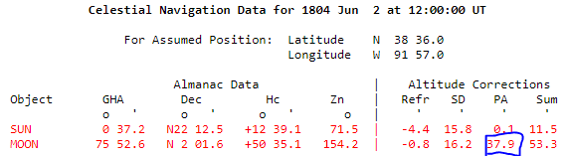

1. Using the included spreadsheet with the USNO data for two stars that are different from Altair and Arcturus, repeat the Newton’s method exercise demonstrated in the sub-module. Compute a value for latitude. Then, look up the GHAϒ in the Nautical Almanac that corresponds to the time used with the USNO app in order to derive a value for longitude and to verify the assumed value of GMT/UTC.

Star data from the USNO website used as input to the spreadsheet:  
Data/time parameters: November 16th, 2018 @ 00:00:00 UTC  
Location: 40°N, 60°W

|  |  |  |  |  |
| --- | --- | --- | --- | --- |
| Hamal | SHA1 | 327.9383 | δ1 | 23.55 |
| Mirfak | SHA2 | 308.5767 | δ2 | 49.9267 |
| Hamal | η1 | 54.8183 |  |  |
| Mirfak | η2 | 49.8833 |  |  |

Lat/Long convergent results:

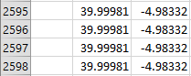

GHAϒ for November 16th, 2018 @ 00:00:00 UTC: 55.0167°

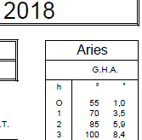

Confirming the longitude by taking the spreadsheet result and subtracting it from the GHAϒ, we get the true longitude of the observer.

1. Using the spread sheet moon angles rev 5a or your own equations, compute the lunar distance between the sun and moon for this value of GMT/UTC, and show that this value changes when the value of GMT/UTC changes. This demonstrates how the lunar distance can be used to determine GMT/UTC and longitude, hence validates the method of lunars. Note that we have dodged the question of “clearing the lunars,” a necessary step when relating actual measured lunar distances with the geocentric values deduced from Almanac data (cf. problem 1, above).

Celestial body chosen: Mirfak  
Time entered into UNSO: 00:00:00  
Location: 40°N, 60°W  
Delta T: +3 hours



The lunar distance between the star, Mirfak, and the Moon changes by about one degree. Mirfak has a high declination so its angle with the Moon does not change as rapidly as I would’ve have hoped to see. However the results were roughly confirmed visually using my SkyView Android app.

1. Using the attached spread sheet Moon Angles Rev 5a, re-compute the lunar distances for June 2, 1804 for two or three samples of data that you select from Table 3 of the Measure article. Include the effects of parallax and semi-diameter following the directions from the Nautical Almanac. This will require some experimenting in order to get the correct data from either the Nautical Almanac or the USNO web tool. Comment on how to use the semi-diameter data properly when computing a lunar distance.

Sample 1 USNO Parameters:

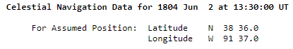

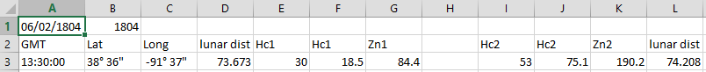

Sample 2 USNO Parameters:

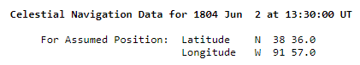



The refraction, parallax, and the semi-diameter are conveniently aggregated together for the needed offset to add into Hc. The Sum offset was added into the minutes cell for the Hc values for the corresponding Moon and Sun measurements.

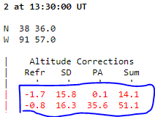

The semi-diameter value for the Sun may be taken directly from the Nautical Almanac tables. The Moon’s semi-diameter correction may be computed as:

Where HP may be taken directly from the Nautical Almanac tables.

1. Compute latitude from the Lewis and Clark data using the noon measurement of the elevation of the sun from the Kindle page included a previous slide. Include the effects of declination and index error. Draw a sketch that shows the angles involved, and illustrates why the declination of the sun is required.

Date/time: June 2nd 1804, 12:00:00  
HS = 37° 28’ 00”  
H = HS + 2° = 39° 28’ 00”  
Declination from Almanac: 22° 12’ 26”

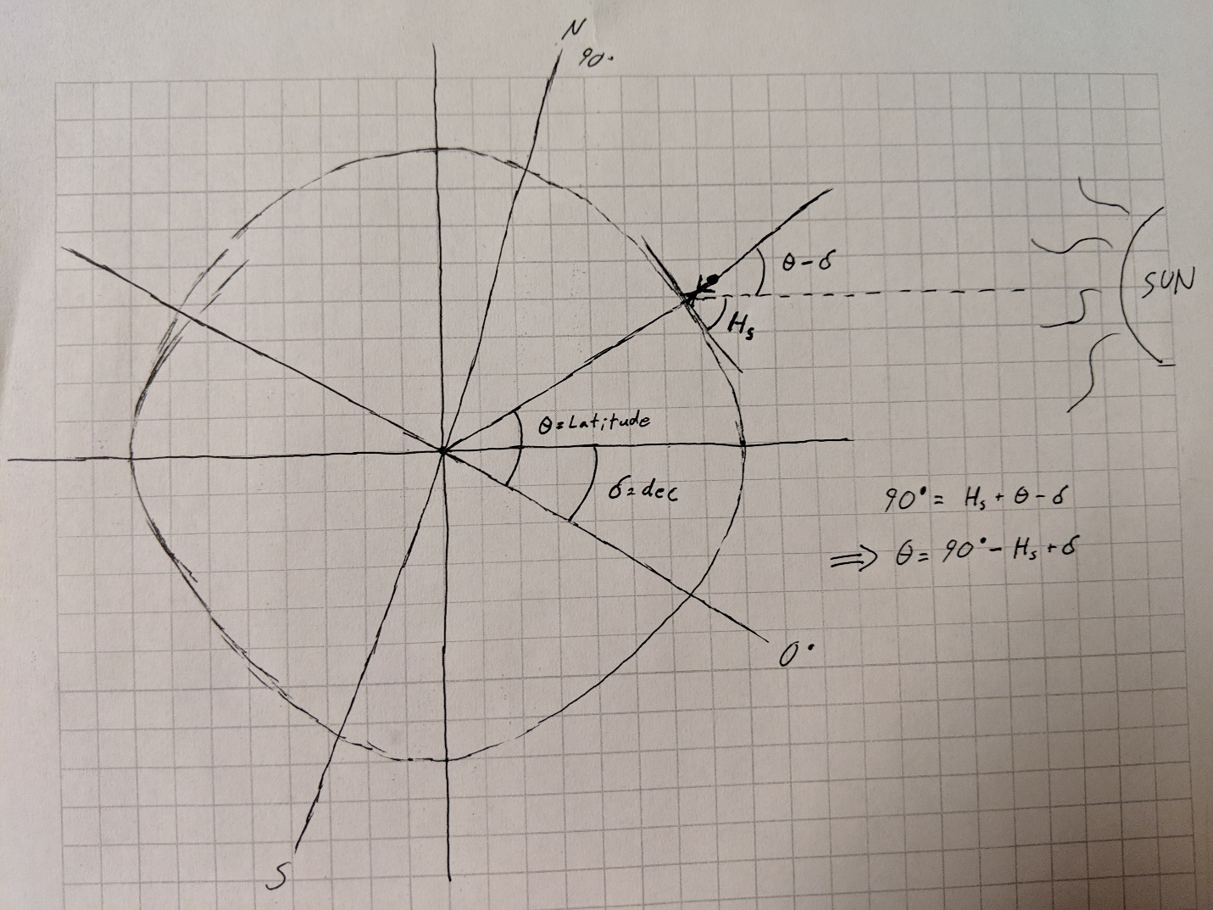

Using the sketch as a reference, we can calculate the latitude as:

1. Using Google Earth or other online resources, look up details of the confluence of the Osage and Missouri Rivers. Comment on your observations and conclusions.

This is a very interesting structure. The pictures below show a snapshot the confluence both from Google maps as well as a photograph of the two bodies of water meeting. It was said that the point of convergence was quite accurately measured to be 38°31'6.9". This is equivalent to 38.5186°, while Google maps drop point at the convergence point shows it to be 39.593°.

