Module 10 – Assignment

Modern Navigation Systems – EN.525.645.81

Submitted: 11/22/2018

**Kyle Mercer**

1. Using material from earlier modules, compute the orbital radius and height above the earth for a GPS satellite based on its orbital period of 12 hours.

Looking back at Module 5, we have the equation for the orbital radius L in terms of the orbital period, T:

$$L=\sqrt[3]{\frac{GM_{e}T^{2}}{4π^{2}}}$$

For T = 12 hrs = 43,200 seconds:

$$L=\sqrt[3]{\frac{GM_{e}{\left(43200\right)}^{2}}{4π^{2}}}=26,609,680 meters=26,609km$$

The height above the Earth is thus:

$$26,609km-R_{E}=26,609km-6,371km=20,238km$$

1. Estimate the ground footprint, in square miles, of a single satellite using simple trigonometry to determine what percentage of the earth’s surface can be “seen” from a single satellite.

See diagram for a rough sketch of system being estimated.

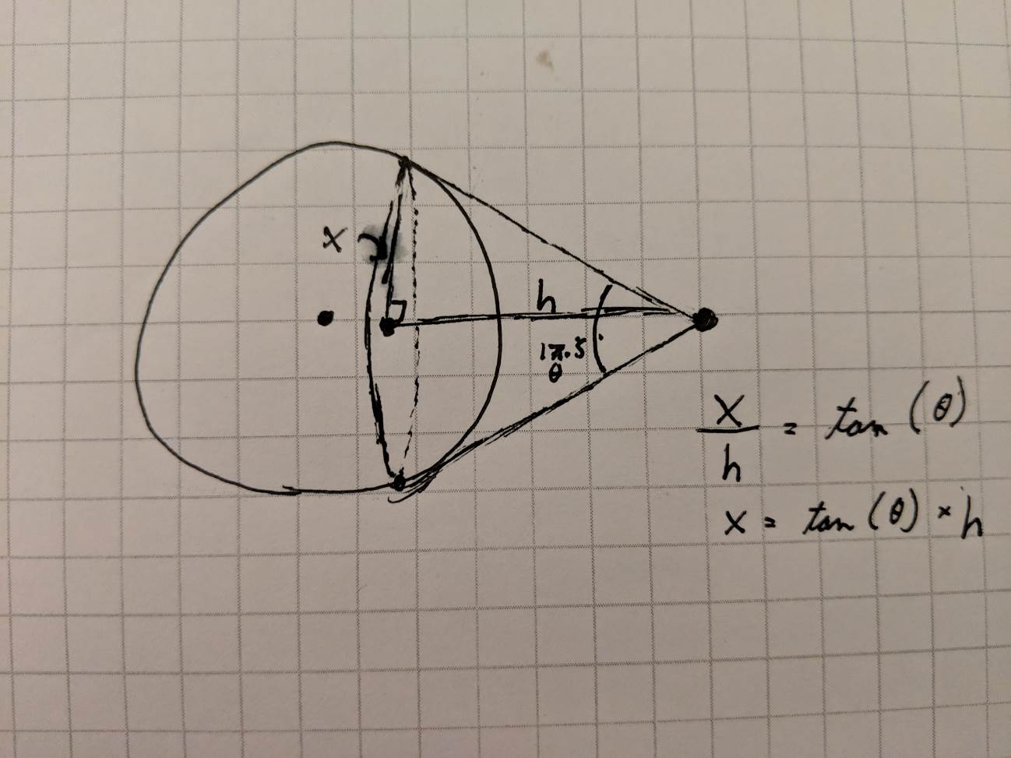

For this problem, we assume a 17.3 boresight angle view of the satellite to the Earth. We also assume that h is somewhere roughly between 20,238km and 26,609km as found in the previous problem, say the average.

$$h=\frac{\left(20238+26609\right)}{2}=23424km$$

We first find the radius of the cone’s base, x:

$$\tan\left(\frac{θ}{2}\right)=\frac{x}{h}$$

$$x=\tan\left(\frac{θ}{2}\right)×h=3563km$$

Thus the surface area of the imaginary cone projected onto the sphere is estimated by:

$$SA≈πx^{2}≈39,892,687km^{2}$$

This value is slightly larger in reality since the cone’s base is not taking into account, the curvature of the Earth.

The total surface area of the Earth is given as:

$$SA_{E}=510.1e6 km^{2}$$

Thus the rough percentage coverage of the Earth that can be seen by the satellite is:

$$\frac{SA_{E}}{SA}=8\%$$

1. Continue this “back of the envelope” analysis to estimate the total number of GPS satellites that are needed in order for a GPS receiver to have visibility of at least four satellite simultaneously for “almost” 100% of the time from “almost” anywhere on earth.

Assuming an SA that is more realistic for a non-flat earth model, let SA = 45e6 km2.

If we visualize the Earth projected on a flat surface the coverage map of a single GPS satellite can be approximated to a round square shape.

