Assignment 12 - Solutions

Modern Navigation Systems – EN.525.645.81

Submitted: 11/30/2018

**Kyle Mercer**

1. Compute the Schuler period and compare it to the orbital period of a satellite orbiting a smooth, spherical earth at sea level.

The period of a pendulum of length r is equivalent to the period of a satellite orbiting a smooth, spherical Earth at sea level. The period of a Schuler pendulum is computed with the equation of a pendulum.

For a Shuler pendulum, r = re:

1. Explain why figure skaters spin faster when they draw their arms in.

The expression for angular momentum is:

$$mr^{2}ω=Iω$$

When a figure skater draws their arms closer to his or her body then integral of MR­2is smaller simply by virtue of them bringing their arms close to their body. Total angular momentum is always conserved; however, the moment of inertia l, I, is brought down because of r decreasing. As a result, since moment of inertial is decreasing – and because angular is conserved in a system then ω must increase which causes a skater to rotate faster as a result.

1. Explain why tightrope walkers throw their balance pole up in the air in a “torque-free maneuver,” then rotate quickly underneath before catching the pole, in order to change directions on the tightrope.

The long balancing pole which tightrope walkers use droops in order to lower their center of gravity. The pole is very long and has a large moment of inertial. Rotating with the pole in hand would require a very large amount of torque and could easily destabilize the tightrope walker trying to make that maneuver. Once in a rotation, the tightrope walker would need to counteract the rotation by applying an opposite torque to the system which would cause them to lean to one side. If they lean too much than gravity may cause them to fall.

1. Explain succinctly the relationship between medical MRI, microwave YIG filters, mechanical gyroscopes, and the precession of the orbit of a planet (including earth) around the sun. In particular, why is it that GHAϒ implies a vector that points to the constellation Aries, when in fact it currently does not. (Hint, read the very end of the Measure article from the earlier module).

The incredible relationship between all of the listed items is that they each one is either the direct result of or takes advantage of the concept of precession, or the rotation of a spinning body around a second axis. For instance, MRIs use precession of protons in order to detect radio waves which inside of a scanner.

GHAϒ was coined mostly likely back when the reference vector actually pointed to directly to the Aries constellation. Due to the gradual precession of the Earth around its axis over a couple thousand years, that reference vector has changed to the constellation of Pisces.

1. Give an example where a gyroscope is used as a sensor, and an example where the angular momentum of the gyroscope actually serves to stabilize a platform.

An example of where a gyroscope is used as a sensor is on an aircraft to measure angular momentum. This sensor is usually a MEMs type device.

An example of where the angular momentum of a gyroscope serves to stabilize a platform is on a boat. Boats may be equipped with gyro stabilizers in order to prevent large rocking behaviors at resonating frequencies. Another example is an aerial camera stabilizer used to smooth our camera frames.

1. Read online about Hale and Lindy Boggs. Do you think the wreckage of the involved aircraft will ever be found?

The Democratic Representative was on a charter Cessna 310 flying from Anchorage Juneau. Below shows a map along with a great circle distance route they might have taken:

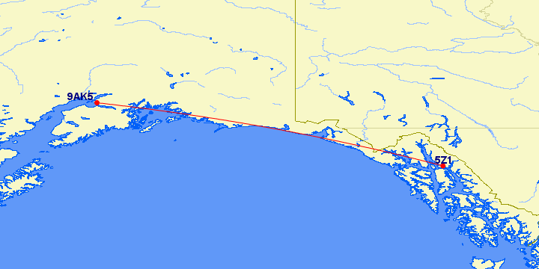

It is hard to say whether the wreckage with ever be found since the flight path seems to take the plane over water approximately 50% of the time. If the wreckage occurred on land then then the cooler climate of Alaska may preserve the wreckage long enough until someone eventually stumbles upon it.

1. Find and read about the rescue of Abby Sunderland. Who do you think should have paid for the rescue?

Given the apparent oversights and negligence of Abby’s sail-prep team it would seem that there might be reasonable fault on those individuals (as well as Abby’s family) for allowing her to pursue such a journey. The total cost of the rescue was estimated at approximately $300,000 which was taxed to the people of France and Australia. I believe that, even in this case of negligence, the cost for the rescue still should have been paid for by the two countries. The international treaty in place that protects individuals of this cost still applies in this case and makes sense for a general purpose case of search and rescue. If each search and rescue cost was fought over, the parties involved would probably spend more money on litigation costs than the cost of the actual rescue.

1. Track down details of the civil aviation incident over Washington DC that involved an inadvertently transmitting ELT. Comment on how a design deficiency in a deployed system can lead to a mishap decades later.

Design deficiencies in a deployed system can cause problems many years later. Generally this is due to poor hardware or software design considerations. In addition, residual bugs in a software application can lead to serious consequences even after the system has gone through hundreds of hours of testing. In this case, the transmission of ELT with a broken transponder prevented any ground stations from making contact with the aircraft.

1. Explain what is meant by the “change in clock phase” by plotting sin(ωt + φ(t)) for a randomly changing phase φ against the function sin(ωt). Choose your parameters carefully so as to illustrate the relevance of “phase jitter” to precision timing. Think in terms of a random walk for which the mean position is not fixed.

The MATLAB code along with the plot illustrates the sine plot with a randomly changing phase superimposed over a perfect sine wave. With enough jitter (phase noise) your sampler that is reading the sine wave might have a cycle slip.

|  |
| --- |
| %% Inputs  numCycles = 4;  theta = 0:0.1:numCycles * 2*pi;  omega = 1;  phaseNoiseRange = 3; % Eg. if 1, noise will range from -0.5 to 0.5    %% Begin Script  phaseNoise = rand(1, length(theta))*phaseNoiseRange - phaseNoiseRange/2;  pureWav = sin(omega*theta);  phaseNoiseWav = sin(omega*theta + phaseNoise);    plot(theta, pureWav, theta, phaseNoiseWav);  legend('Pure Sine Wave','Sine Wave w/ Phase Noise'); |

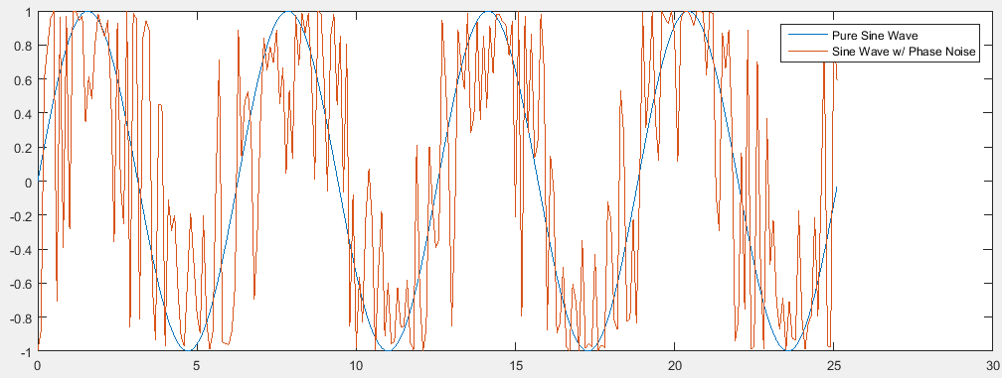

1. What is a “cycle-slip”? Note that carrier phase GPS tracking is quite accurate unless there is a cycle slip.

A cycle slip is a phenomenon seen with clock jitter or phase noise where the phase completely slips a whole 2π ahead or behind the otherwise phased locked signal. This can cause significant disruption or errors in the devices which employ the clock signals for timing.