Assignment 13 – Solutions

Modern Navigation Systems – EN.525.645.81

Submitted: 12/1/2018

**Kyle Mercer**

1. For an arc-length of 45 degrees on the surface of the earth, verify that setting R/r = 1 yields the negative elevation values and straight line distances illustrated earlier in this sub-module.

$$η=\arctan\left[\frac{\sin{η_{S}}-\frac{R}{r}}{\cos{η_{S}}}\right]=-22.5°$$

Where:

$η_{S}=\arcsin\left[\sin{δ}\sin{θ_{e}}+\cos{δ}\cos{θ_{e}}\cos{ϕ_{se}}\right]$ $\frac{R}{r}$ = 1  
 δ = 0° (for terrestrial nav is the latitude? of point B, placed at the equator)  
 θe = 45°N (chosen for the latitude of point A)  
 ϕse = 0° (point A and B are at same longitude)

The straight line distance chord C is obtained from the formula:

$$C=2r\sin{\frac{θ}{2}}$$

$$C=3030 miles$$

Where:  
 r = radius of the Earth (3959mi)  
 θ = 45°

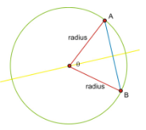

Figure 1: <https://www.ck12.org/trigonometry/length-of-a-chord/lesson/Length-of-a-Chord-TRIG/>

1. What is the difference between the straight line distance and the arc-length?

As shown in Figure 1 a straight line distance is the chord which goes through the Earth from point A to point B (the blue line in the figure). The arc length is the path taken around the great circle distance to get from point A to point B (the green line in the figure).

1. For a tower or aircraft of height h above the surface of the earth, estimate how far it is to the visible horizon. This problem is hugely important with respect to line of sight communication and navigation.

The curvature of the Earth and an observer and tower is illustrated below.

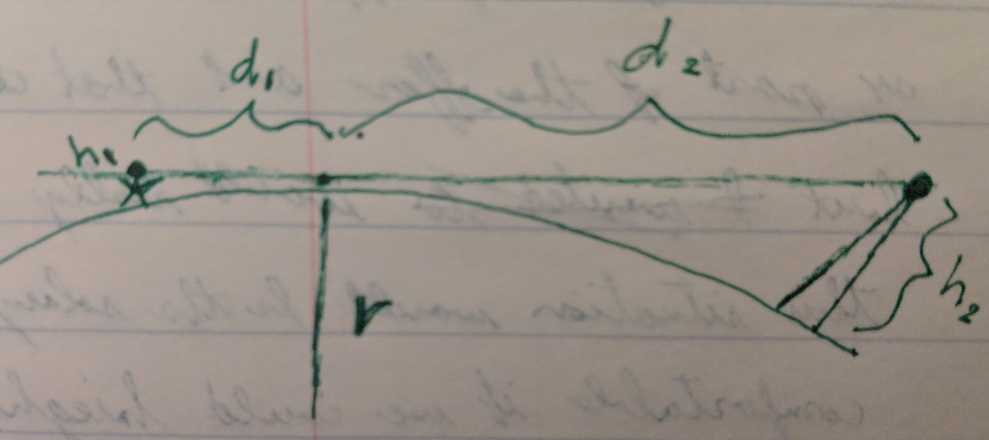

The approximate curvature of the Earth is ~8inches per mile. For an observer of height h1 and a tower/aircraft of height h2, and for a distance d1 from the observer to the horizon and d2 from the tower/aircraft to the same horizon point we have the following expressions:

$$d_{1}=\sqrt{h_{1}inch÷\frac{8inch}{mi^{2}}}=\sqrt{\frac{h_{1}}{8}}miles$$

$$d_{2}=\sqrt{\frac{h_{2}}{8}}$$

Thus:

$$d_{1}+d_{2}=\frac{\sqrt{h_{1}}+\sqrt{h_{2}}}{2\sqrt{2}}$$

1. Use your Nautical Almanac skills and the online tools at USNO to determine whether the planet on slide 8 is Venus or is it Jupiter.

There are a few factors about this picture which help narrow down the parameters of the USNO search.

1. The image appears to be taken during the day
2. The image is taken at NASA’s JPL lab in Pasadena, CA (PST)
3. The Moon and the unknown body appear to be close to one another in the sky
4. The unknown body has a slightly higher elevation that the moon

According to USNO, based upon the assumed month/day/year the photo was taken the moon was only visible above the horizon on the 10th from 8PM onward until dark. In the summer there is still daylight at 8PM. According to USNO at this time Venus is not visible in the sky, but Jupiter is. Jupiter is also higher in elevation than the Moon which corroborates the details in the photo. Therefore, my guess is that the unknown body in the photo is actually…Jupiter! ☺

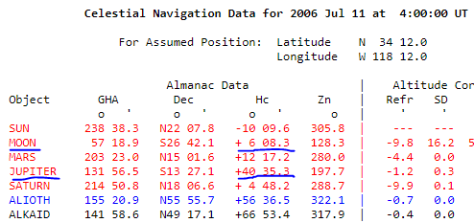

1. Surf the web, and read about the USS Enterprise and when it went aground while crossing under the Golden Gate Bridge.

This was an interesting read. It appears that the Captain, Captain R.J. Kelly took full responsibility for the accident which beached one of the first nuclear powered aircraft carriers under the Golden Gate Bridge. More notably, the ship had been on tour in the Pacific and Indian Ocean for 8 months before returning to the United States, where 4,500 crewmen were eagerly waiting to make it back to their families.

1. Read about how the USS Intrepid became stuck in the mud in New York, and how the Navy dealt with this.

After being stuck in the mud for about a month, powerful tugboats were finally able to pull the USS Intrepid from its Manhattan berth where it was destined for New Jersey for a much needed set of repairs. This was the second attempt it took the Navy to finally free her. To help assist with the released they cleared the water from the bottom hulls to add buoyancy and waited until high tide where the water was higher to give them more of a chance to free her.

1. Identify what the round forward-facing window on the bridge of the freighter is and what it does.

From searching the web it sounds like what we are describing is known as a “porthole.” This is a cutout in a ship’s hull to allow the admittance of light and fresh air to occupants of the lower levels of the ship. This is, however, not on the bridge of the ship. Possibly, the reason for having a porthole on the bridge of a ship would be for similar functions as a porthole in the hull since there may not have been windows that could open and close on the bridge.