Trip to the Mauna Kea Summit

Modern Navigation Systems – EN.525.645.81

Submitted: 12/1/2018

**Kyle Mercer**

# Overview

In the beginning of the Fall semester, I was lucky enough to have taken a vacation to the Hawaiian Islands with my family. While we were there we decided to take an excursion to the top of the Mauna Kea summit, one of the 5 mountains which make up the Big Island of Hawaii. We participated in the Stargazing Tour Adventure where we toured from our hotel in Kona, HI all the way up to the steep mountain of Mauna Kea and then partially back down to a via point on the mountain where we were able to stargaze with hobbyist telescopes. It was an incredible, once in a lifetime experience I will never forget.

# Detailed Narrative

## Journey to the Visitor Station

Our journey started at the rendezvous point in a Kona shopping center where we waited for our ride to arrive. We were instructed to wear long pants and a cover-up since the top of the mountain can easily drop to below-freezing temperatures. The problem was we were roasting in our clothes waiting in 90°F weather at the shopping center! Albeit, a small price for the experience we were about to undertake. Our tour guide, a Hawaiian native, picked us all up in a van and we drove about an hour to the Mauna Kea Visitor Information Station.

## The Visitor Station

Once at the visitor center we were allowed to get out and walk around in the center, shop, and then eat dinner. It was a bit overcast and about 50°F. This was at a 9000ft elevation. At this height, the oxygen in the air was already beginning to thin. Here are a few photos at the center.

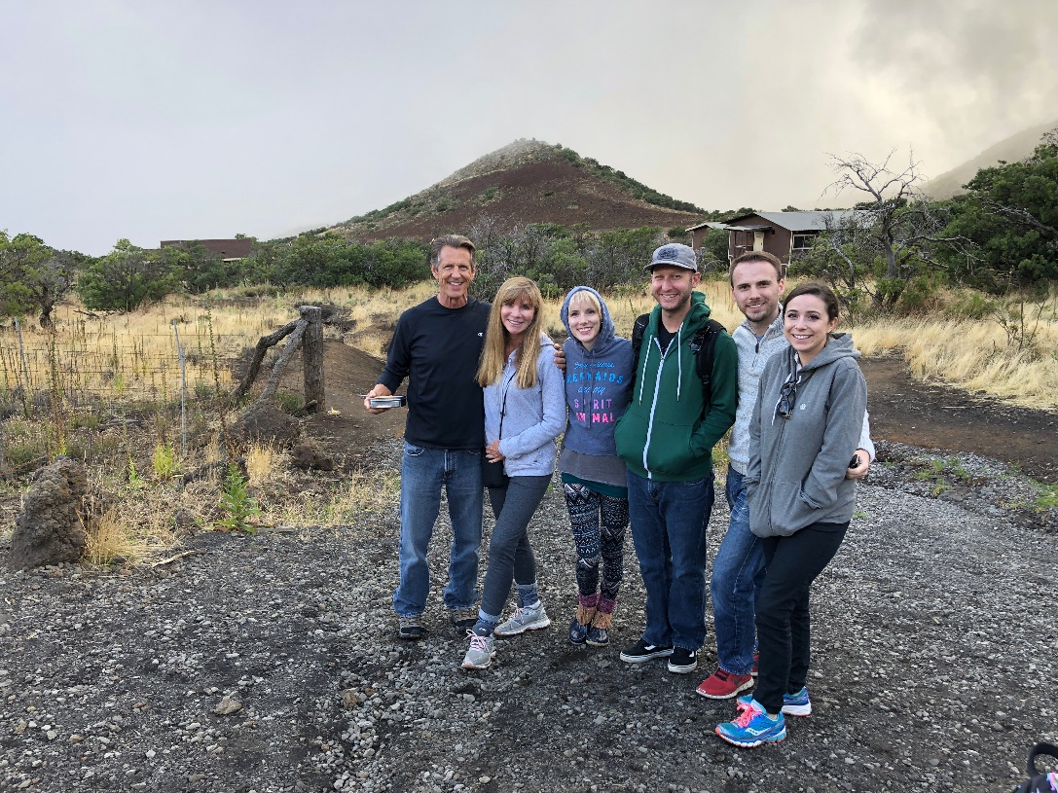

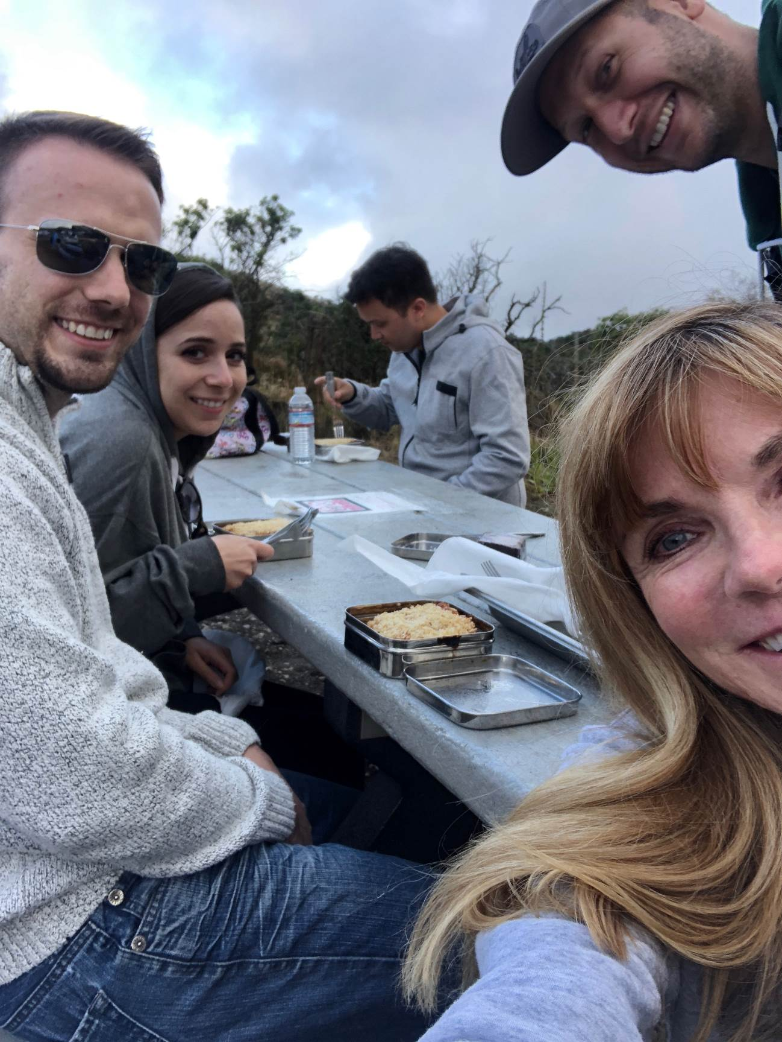

## Journey to the Summit

The road to the summit where the Mauna Kea observatories were located was a long and winding one. Our 4x4 large van took us safely up the dirt road. As we approached the summit I noticed the various steep, rounded structures which our tour guide described to us as ancient fissures where lava once spilled out. Here are a few photos from this leg of the journey. The left photo was taken at roughly 10,000ft and the right was roughly 12,000ft.

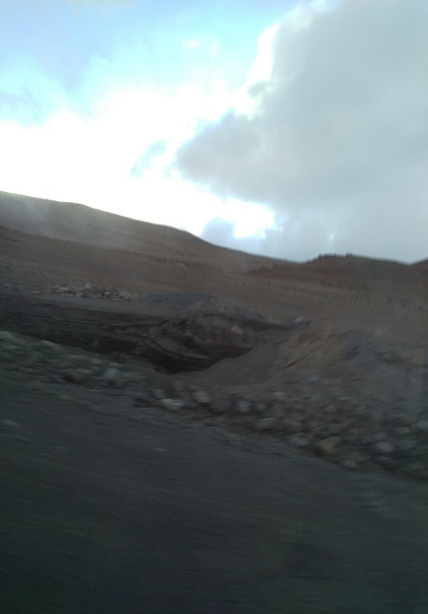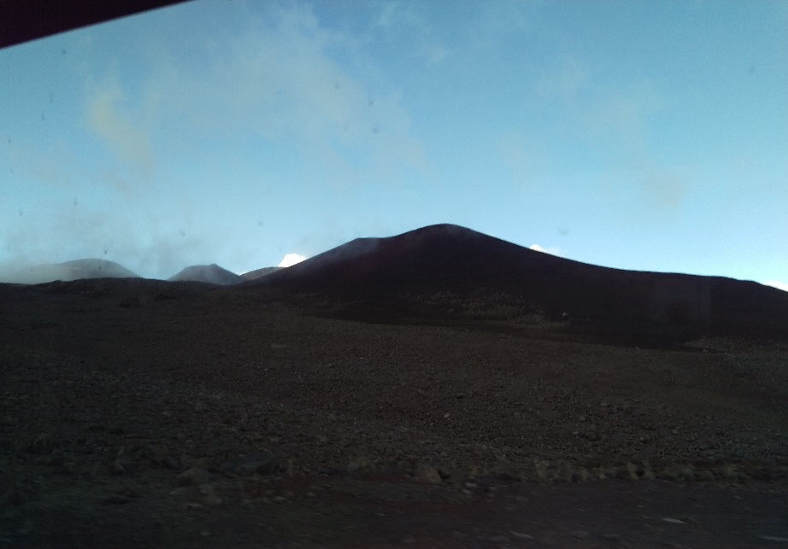

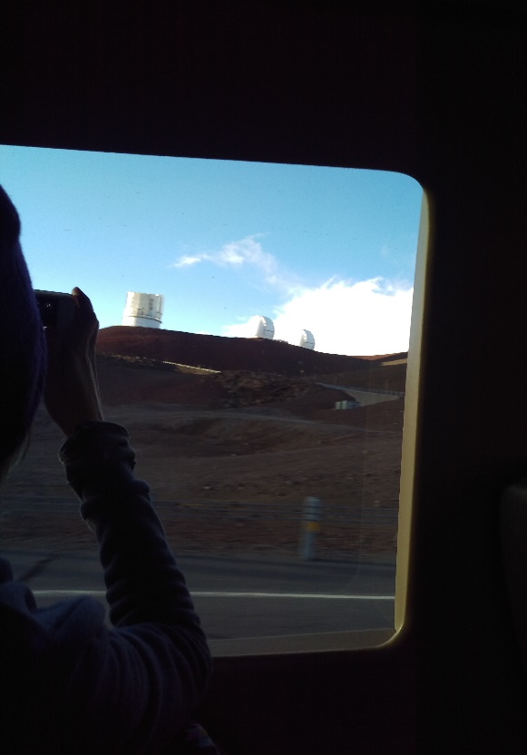

## Sunset at the Summit

Once at the summit we got the chance to step out into the frigid air and walk around. Although we were not allowed inside of the observatories, it was still an incredible sight to stand at such a high altitude where you could see the tops of clouds. Standing at that elevation of 14,000ft watching the sun set beneath the clouds was breathtaking (both literally and figuratively!). I found the lack of oxygen to be a slightly disorienting experience to say the least. Luckily I did not pass out. The following are my favorite photos from this excursion.

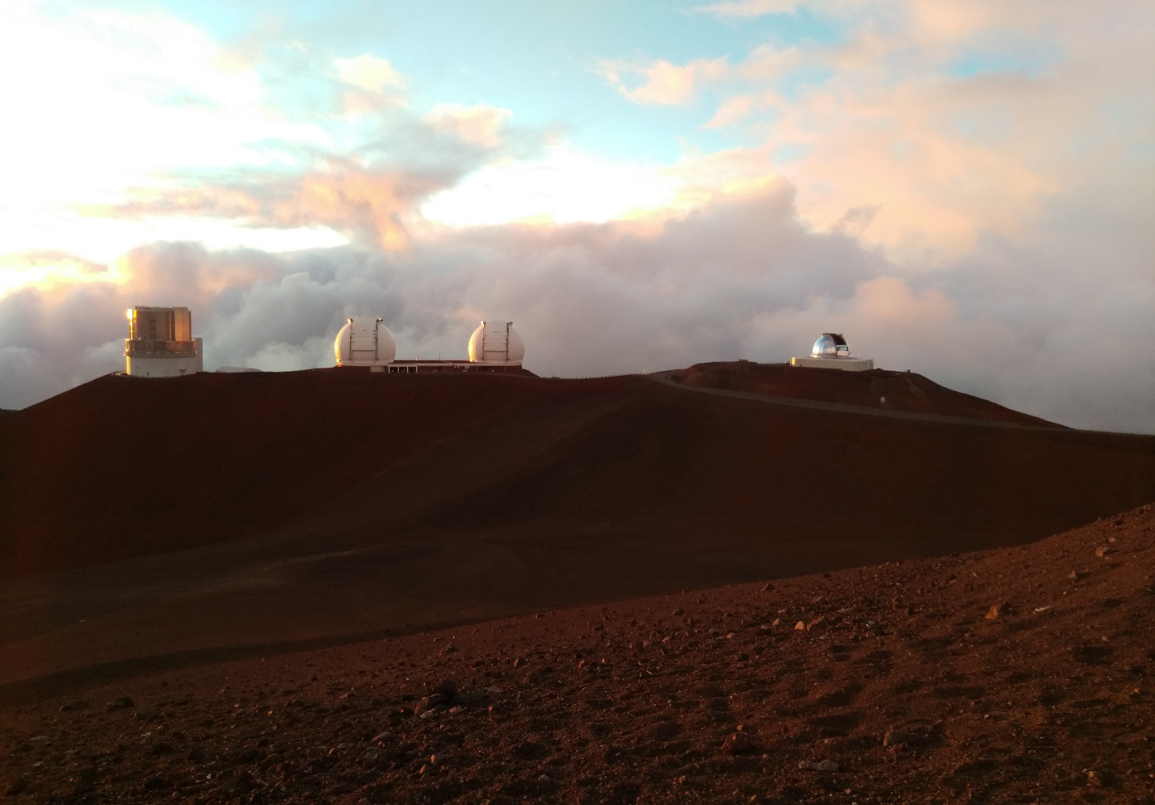

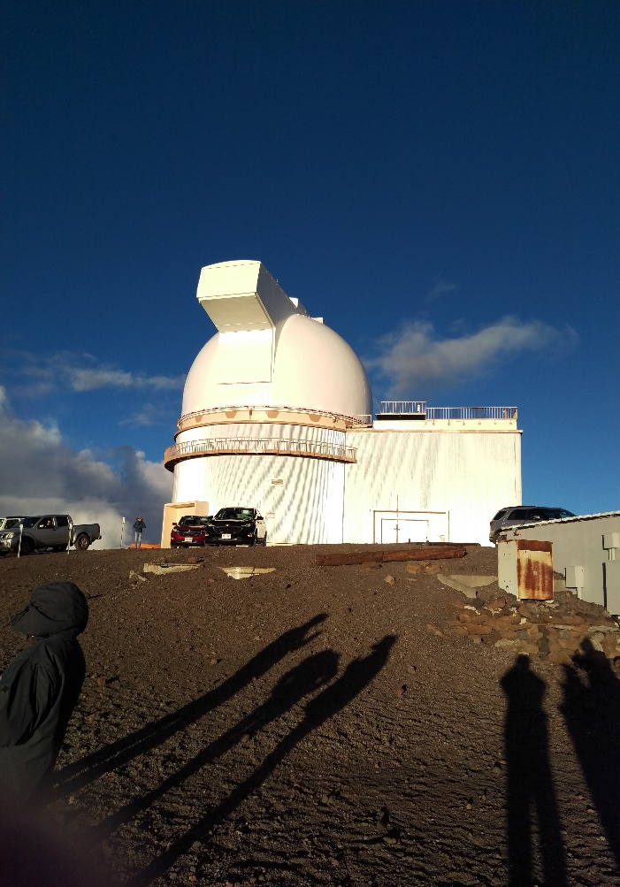

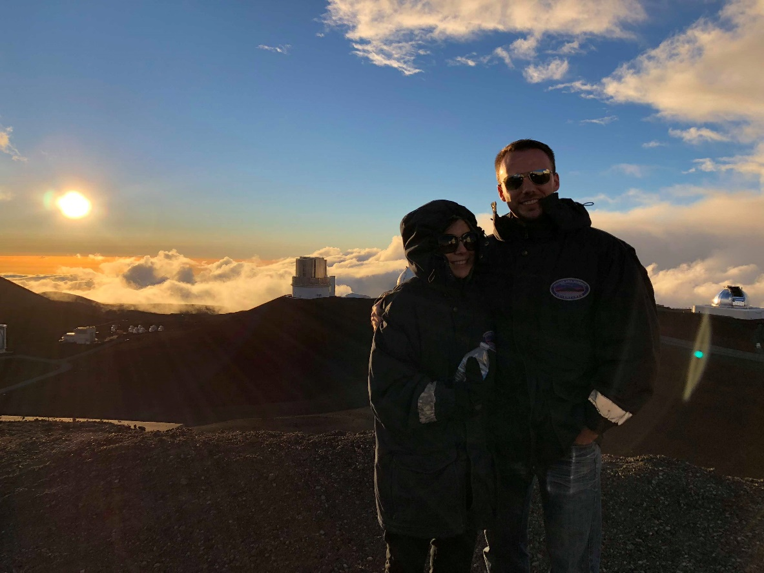

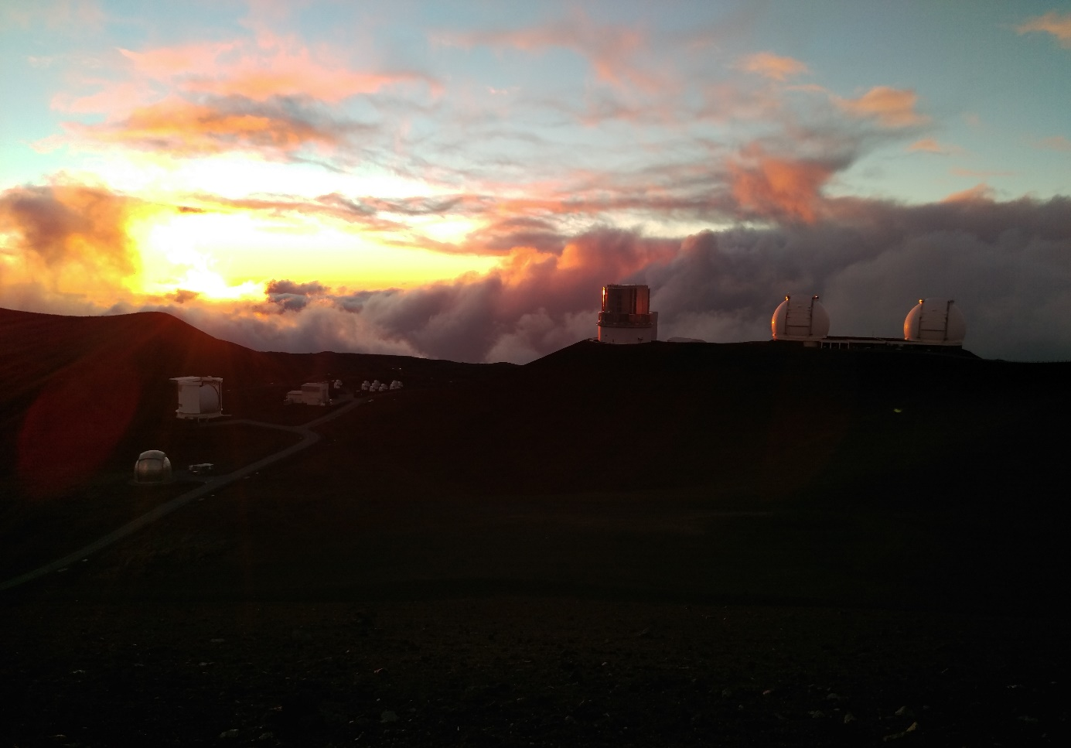

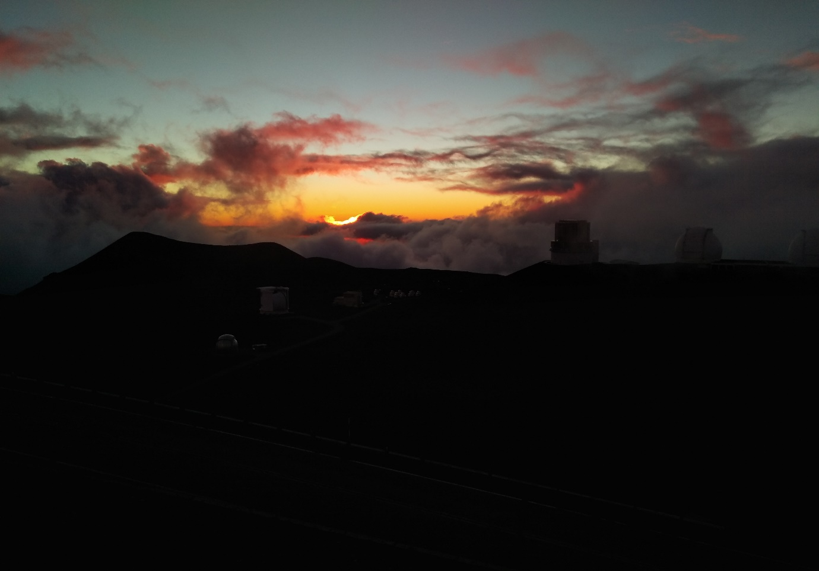

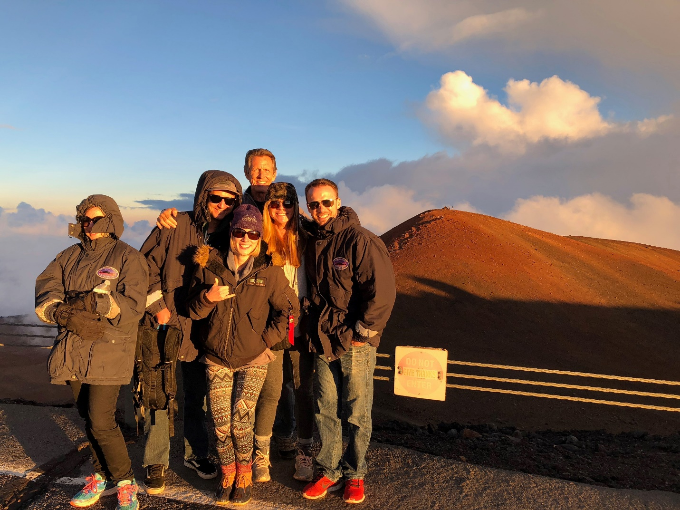

## Down to the Stargazing Stop

Once the sun set we all hopped back in the van and were taken down about 3000ft to a pull-off on the side of the dirt road. Our plan was to stargaze from this vantage point, however the clouds and fog descending from the mountain was not cooperating that night and made for bad visibility. Our tour guide was determined to get us some stargazing time. He knew of another remote spot not too far from the Mauna Kea access road (which also happened to be a girl scout camping site) where we could get a clear view of the sky without any light pollution to obscure our sight.

## Stargazing

Once we arrived at the site, our tour guide set up a sophisticated hobbyist telescope. This telescope had built in servos and tracker which could actually lock onto celestial objects and track them as the Earth rotated. We looked at Mars, Jupiter, and then Saturn. We also looked at a few stars including Antares (the brightest start in the Scorpius constellation) and a star that was popular amongst the ancient Polynesian navigators when they came to Hawaii. This star is the brightest red star in the Northern Hemisphere and it went by the Hawaiian name of Hokule’a. Our tour guide was very knowledgeable and taught us a lot about the early Hawaiian navigators. In fact, there is a very well-known hand gesture in Hawaiian culture known as the Shaka (commonly known as the “hang loose” gesture). This gesture takes on a lot of meanings in the Hawaiian culture including the universal symbol for hello, goodbye, love, and affection; however, one thing I was surprised to learn was that it was also used as a measurement reference for Ancient Hawaiians to locate Polaris! By taking your hand and making the Shaka symbol, extend your arm and place your pinkie finger on the horizon. Your thumb should roughly match up to the elevation of which Polaris is located (I tried it and it actually worked!). I found this to be a fascinating trick the early Hawaiian settlers used for navigational purposes.

  
Shaka gesture (Source link [here](https://www.carstickers.com/products/stickers/hawaiian-and-tropical-stickers/shaka-stickers/details/hang-loose-shaka-sticker-2491/))

# Tip for Travelers and Impressions

A few tips I would give to others interested in touring up to the Mauna Kea Summit would be:

* Bring more than just a “cover-up.” Despite them providing parkas you will still wish you had a few layers on.
* Bring a nice pair of (polarized) sunglasses. The glare at the summit is intense and you’ll need them to watch the sunset.
* Bring an extra bottle of water. After our dinner there are a few hours in between were you wished you had some.
* Don’t walk too fast at the summit. You run out of breath very fast and risk passing out!

As mentioned several times throughout this report, the entire journey was filled with moments that were both surreal and jaw-dropping. I would do it again in a heartbeat if given the chance. The experience combined my love for astronomy and yearn for adventure – and I learned so much in the process.