File Descriptors
A file descriptor is a non-negative integer. When we open an existing file or create a new file, the kernel returns a file descriptor to the process. When we want to read or write a file, we identify the file with the file descriptor that was returned by open or creat as an argument to either read or write.
By convention, UNIX System shells associate file descriptor 0 with the standard input of a process, file descriptor 1 with the standard output, and file descriptor 2 with the standard error. This convention is used by the shells and many applications; it is not a feature of the UNIX kernel.

open Function:

A file is opened or created by calling the open function.

#include <fcntl.h>
int open(const char *pathname, int oflag)
Returns: file descriptor if OK, 1 on error

The pathname is the name of the file to open or create. This function has a multitude of options,which are specified by the oflag argument. This argument is formed by ORing together one or moreof the following constants from the <fcntl.h> header:

O_RDONLY Open for reading only.
O_WRONLY Open for writing only.
O_RDWR Open for reading and writing.
O_APPEND Append to the end of file on each write.
O_CREAT Create the file if it doesn't exist. This option requires a third argument to the open function, the mode, which specifies the access permission bits of the new file.
O_EXCL Generate an error if O_CREAT is also specified and the file already exists. This
test for whether the file already exists and the creation of the file if it doesn't exist is an atomic operation.
O_TRUNC If the file exists and if it is successfully opened for either write-only or readwrite, truncate its length to 0.
O_NOCTTY If the pathname refers to a terminal device, do not allocate the device as the controlling terminal for this process.
O_NONBLOCK If the pathname refers to a FIFO, a block special file, or a character special file, this option sets the nonblocking mode for both the opening of the file and subsequent I/O.

creat Function
A new file can also be created by calling the creat function.

#include <fcntl.h>
int creat(const char *pathname, mode_t mode);

Returns: file descriptor opened for write-only if OK, 1 on error

Note that this function is equivalent to
open (pathname, O_WRONLY | O_CREAT | O_TRUNC, mode);

close Function
An open file is closed by calling the close function

#include <unistd.h>
int close(int filedes);

Returns: 0 if OK, 1 on error

Closing a file also releases any record locks that the process may have on the file. When a process terminates, all of its open files are closed automatically by the kernel

lseek Function
Every open file has an associated "current file offset," normally a non-negative integer that measures the number of bytes from the beginning of the file.
Read and write operations normally start at the current file offset and cause the offset to be incremented by the number of bytes read or written. By default, this offset is initialized to 0 when a file is opened, unless the O_APPEND option is specified.

An open file's offset can be set explicitly by calling lseek.

#include <unistd.h>
off_t lseek(int filedes, off_t offset, int whence);

Returns: new file offset if OK, 1 on error

The interpretation of the offset depends on the value of the whence argument.
If whence is SEEK_SET, the file's offset is set to offset bytes from the beginning of the file.
If whence is SEEK_CUR, the file's offset is set to its current value plus the offset. The offset can be positive or negative.
If whence is SEEK_END, the file's offset is set to the size of the file plus the offset. The offset can be positive or negative.

Example

#include "apue.h"
#include <fcntl.h>
char buf1[] = "abcdefghij";
char buf2[] = "ABCDEFGHIJ";
int
main(void)
{
int fd;
if ((fd = creat("file.hole", FILE_MODE)) < 0)
err_sys("creat error");
if (write(fd, buf1, 10) != 10)
err_sys("buf1 write error");
/* offset now = 10 */
if (lseek(fd, 16384, SEEK_SET) == -1)
err_sys("lseek error");
/* offset now = 16384 */
if (write(fd, buf2, 10) != 10)
err_sys("buf2 write error");
/* offset now = 16394 */
exit(0);
}

read Function
Data is read from an open file with the read function.

#include <unistd.h>
ssize_t read(int filedes, void *buf, size_t nbytes);

Returns: number of bytes read, 0 if end of file, 1 on error

If the read is successful, the number of bytes read is returned. If the end of file is encountered, 0 is returned. There are several cases in which the number of bytes actually read is less than the amount requested:
When reading from a regular file, if the end of file is reached before the requested number of
bytes has been read. For example, if 30 bytes remain until the end of file and we try to read
100 bytes, read returns 30. The next time we call read, it will return 0 (end of file) When reading from a terminal device. Normally, up to one line is read at a time. When reading from a network. Buffering within the network may cause less than the requested amount to be returned. When reading from a pipe or FIFO. If the pipe contains fewer bytes than requested, read will return only what is available. When reading from a record-oriented device. Some record-oriented devices, such as magnetic tape, can return up to a single record at a time. When interrupted by a signal and a partial amount of data has already been read. The read operation starts at the file's current offset. Before a successful return, the offset is incremented by the number of bytes actually read.

write Function
Data is written to an open file with the write function.

#include <unistd.h>
ssize_t write(int filedes, const void *buf, size_t nbytes);

Returns: number of bytes written if OK, 1 on error

The return value is usually equal to the nbytes argument; otherwise, an error has occurred. A
common cause for a write error is either filling up a disk or exceeding the file size limit for a given process

For a regular file, the write starts at the file's current offset. If the O_APPEND option was specified when the file was opened, the file's offset is set to the current end of file before each write operation. After a successful write, the file's offset is incremented by the number of bytes actually written.

File Sharing

The UNIX System supports the sharing of open files among different processes The kernel uses three data structures to represent an open file, and the relationships among them determine the effect one process has on another with regard to file sharing.

- Every process has an entry in the process table. Within each process table entry is a table of open file descriptors, which we can think of as a vector, with one entry per descriptor. Associated with each file descriptor are
a. The file descriptor flags
b. A pointer to a file table entry
2. The kernel maintains a file table for all open files. Each file table entry contains
a. The file status flags for the file, such as read, write, append, sync, and nonblocking;
b. The current file offset
c. A pointer to the v-node table entry for the file
3. Each open file (or device) has a v-node structure that contains information about the type of file and pointers to functions that operate on the file. For most files, the v-node also contains the inode for the file. This information is read from disk when the file is opened, so that all the pertinent information about the file is readily available. For example, the i-node contains the owner of the file, the size of the file, pointers to where the actual data blocks for the file are located on disk, and so on

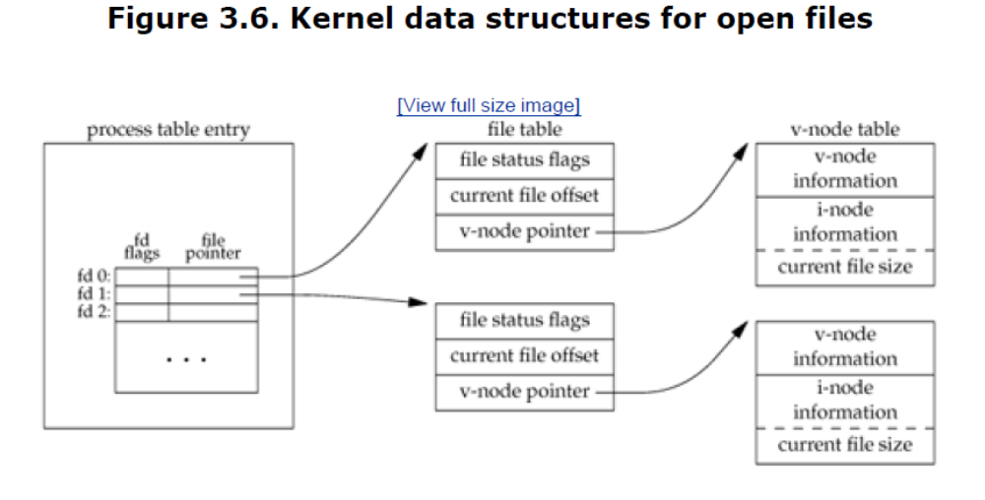

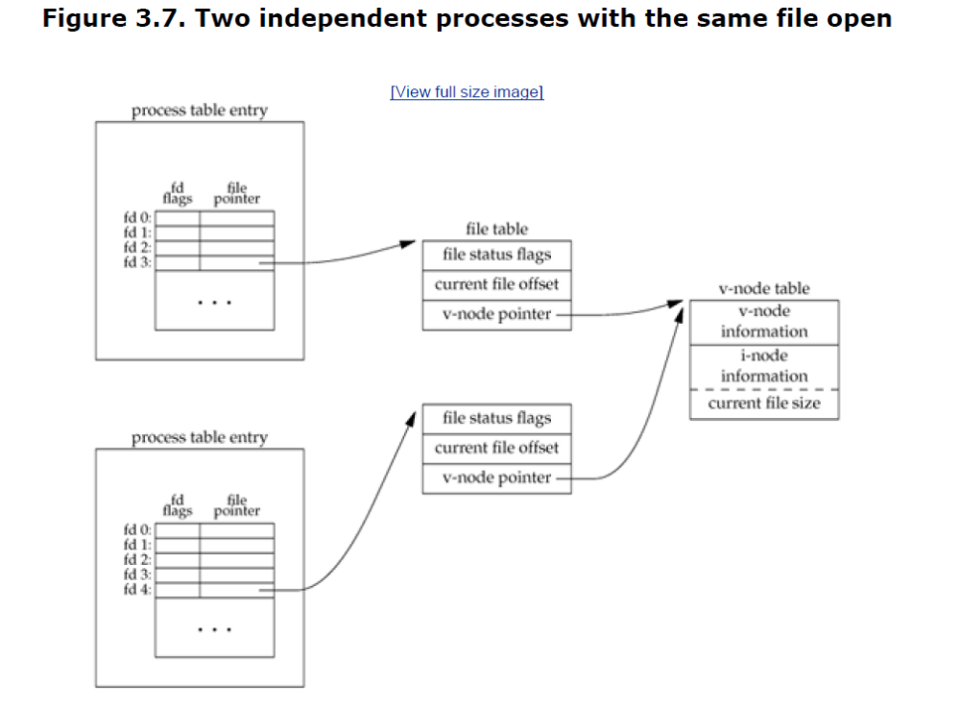

Given these data structures, we now need to be more specific about what happens with certain operations that we've already described.
- After each write is complete, the current file offset in the file table entry is incremented by the number of bytes written. If this causes the current file offset to exceed the current file size, the current file size in the i-node table entry is set to the current file offset (for example, the file is extended).
- If a file is opened with the O_APPEND flag, a corresponding flag is set in the file status flags of the file table entry. Each time a write is performed for a file with this append flag set, the current file offset in the file table entry is first set to the current file size from the i-node table entry. This forces every write to be appended to the current end of file.
- If a file is positioned to its current end of file using lseek, all that happens is the current file offset in the file table entry is set to the current file size from the i-node table entry.
- The lseek function modifies only the current file offset in the file table entry. No I/O takes place.

Atomic Operations

Appending to a File
Consider a single process that wants to append to the end of a file. Older versions of the UNIX System didn't support the O_APPEND option to open, so the program was coded as follows:
if (lseek(fd, 0L, 2) < 0) /* position to EOF */
err_sys("lseek error");
if (write(fd, buf, 100) != 100) /* and write */
err_sys("write error");

This works fine for a single process, but problems arise if multiple processes use this technique to append to the same file. (This scenario can arise if multiple instances of the same program are appending messages to a log file, for example.) Assume that two independent processes, A and B, are appending to the same file. Each has opened the file but without the O_APPEND flag. This gives us the same picture as Figure 3.7. Each process has
its own file table entry, but they share a single v-node table entry. Assume that process A does the lseek and that this sets the current offset for the file for process A to byte offset 1,500 (the current end of file). Then the kernel switches processes, and B continues running. Process B then does the lseek, which sets the current offset for the file for process B to byte offset 1,500 also (the current end of file). Then B calls write, which increments B's current file offset for the file to 1,600. Because the file's size has been extended, the kernel also updates the current file size in the v-node to 1,600. Then the kernel switches processes and A resumes. When A calls write, the data is written starting at the current file offset for A, which is byte offset 1,500. This overwrites the data that B wrote to the file.

The problem here is that our logical operation of "position to the end of file and write" requires two separate function calls (as we've shown it). The solution is to have the positioning to the current end of file and the write be an atomic operation with regard to other processes. Any operation that requires more than one function call cannot be atomic, as there is always the possibility that the kernel can temporarily suspend the process between the two function calls. The UNIX System provides an atomic way to do this operation if we set the O_APPEND flag when a file is opened. As we described in the previous section, this causes the kernel to position the file to its current end of file before each write. We no longer have to call lseek before each write.

pread and pwrite Functions

#include <unistd.h>
ssize_t pread(int filedes, void *buf, size_t nbytes, off_t offset);

Returns: number of bytes read, 0 if end of file, 1 on error

ssize_t pwrite(int filedes, const void *buf, size_t nbytes, off_t offset);
Returns: number of bytes written if OK, 1 on error
- Calling pread is equivalent to calling lseek followed by a call to read, with the following exceptions. There is no way to interrupt the two operations using pread.
- The file pointer is not updated.
- Calling pwrite is equivalent to calling lseek followed by a call to write, with similar exceptions

dup and dup2 Functions
An existing file descriptor is duplicated by either of the following functions.

#include <unistd.h>
int dup(int filedes);
int dup2(int filedes, int filedes2);

Both return: new file descriptor if OK, 1 on error

The new file descriptor returned by dup is guaranteed to be the lowest-numbered available file descriptor. With dup2, we specify the value of the new descriptor with the filedes2 argument. If filedes2 is already open, it is first closed. If filedes equals filedes2, then dup2 returns filedes2 without closing it.
The new file descriptor that is returned as the value of the functions shares the same file table entry as the filedes argument

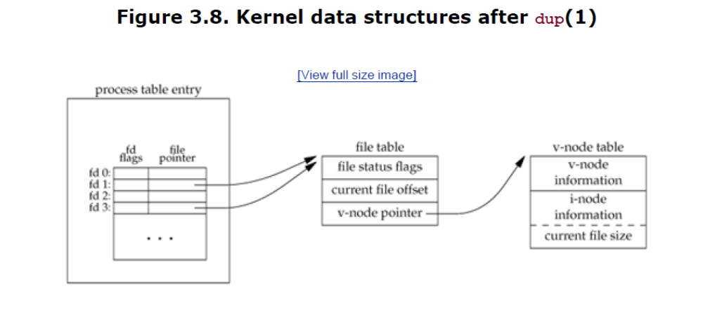

In this figure, we're assuming that when it's started, the process executes
newfd = dup(1);
We assume that the next available descriptor is 3 (which it probably is, since 0, 1, and 2 are opened by the shell). Because both descriptors point to the same file table entry, they share the same file status flagsread, write, append, and so onand the same current file offset.
Each descriptor has its own set of file descriptor flags. The closeon- exec file descriptor flag for the new descriptor is always cleared by the dup functions.
Another way to duplicate a descriptor is with the fcntl function.

Indeed, the call
dup(filedes);

is equivalent to

fcntl(filedes, F_DUPFD, 0);

Similarly, the call

dup2(filedes, filedes2);

is equivalent to

close(filedes2);

fcntl(filedes, F_DUPFD, filedes2);

sync, fsync, and fdatasync Functions

When we write data to a file, the data is normally copied by the kernel into one of its buffers and queued for writing to disk at some later time. This is called delayed write The kernel eventually writes all the delayed-write blocks to disk, normally when it needs to reuse the buffer for some other disk block. To ensure consistency of the file system on disk with the contents of the buffer cache, the sync, fsync, and fdatasync functions are provided.

The kernel eventually writes all the delayed-write blocks to disk, normally when it needs to reuse the buffer for some other disk block. To ensure consistency of the file system on disk with the contents of the buffer cache, the sync, fsync, and fdatasync functions are provided.

The sync function simply queues all the modified block buffers for writing and returns; it does not wait for the disk writes to take place.
The function sync is normally called periodically (usually every 30 seconds) from a system daemon, often called update. This guarantees regular flushing of the kernel's block buffers. The command sync(1) also calls the sync function.
The function fsync refers only to a single file, specified by the file descriptor filedes, and waits for the disk writes to complete before returning. The intended use of fsync is for an application, such as a database, that needs to be sure that the modified blocks have been written to the disk.
The fdatasync function is similar to fsync, but it affects only the data portions of a file. With fsync, the file's attributes are also updated synchronously.

fcntl Function
The fcntl function can change the properties of a file that is already open.

#include <fcntl.h>
int fcntl(int filedes, int cmd, ... /* int arg */ );

Returns: depends on cmd if OK (see following), 1 on error

- F_DUPFD Duplicate the file descriptor filedes. The new file descriptor is returned as the value of the function. It is the lowest-numbered descriptor that is not already open, that is greater than or equal to the third argument (taken as an integer). The new descriptor shares the same file table entry as filedes But the new descriptor has its own set of file descriptor flags, and its
- FD_CLOEXEC file descriptor flag is cleared.
- F_GETFD Return the file descriptor flags for filedes as the value of the function. Currently, only one file descriptor flag is defined: the FD_CLOEXEC flag.
- F_SETFD Set the file descriptor flags for filedes. The new flag value is set from the third argument (taken as an integer). Be aware that some existing programs that deal with the file descriptor flags don't use the constant FD_CLOEXEC. Instead, the programs set the flag to either 0 (don't close-on-exec, the default) or 1 (do close-on-exec).
- F_GETFL Return the file status flags for filedes as the value of the function
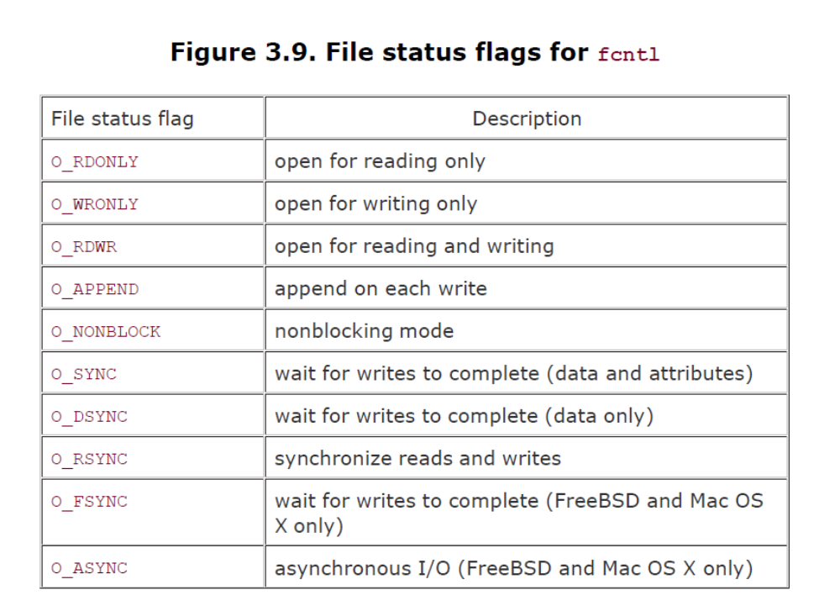

- F_SETFL Set the file status flags to the value of the third argument (taken as an integer). The only flags that can be changed are O_APPEND, O_NONBLOCK, O_SYNC, O_DSYNC, O_RSYNC, O_FSYNC, and O_ASYNC.
- F_GETOWN Get the process ID or process group ID currently receiving the SIGIO and SIGURG signals.
- F_SETOWN Set the process ID or process group ID to receive the SIGIO and SIGURG signals. A positive arg specifies a process ID. A negative arg implies a process group ID equal to the absolute value of arg. The return value from fcntl depends on the command. All commands return 1 on an error or some other value if OK. The following four commands have special return values: F_DUPFD, F_GETFD,F_GETFL, and F_GETOWN. The first returns the new file descriptor, the next two return the corresponding flags, and the final one returns a positive process ID or a negative process group ID.

Example
#include "apue.h"
#include <fcntl.h>
int
main(int argc, char *argv[])
{
int val;
if (argc != 2)
err_quit("usage: a.out <descriptor#>");
if ((val = fcntl(atoi(argv[1]), F_GETFL, 0)) < 0)
err_sys("fcntl error for fd %d", atoi(argv[1]));
switch (val & O_ACCMODE) {
case O_RDONLY:
printf("read only");
break;
case O_WRONLY:
printf("write only");
break;
case O_RDWR:
printf("read write");
break;
default:
err_dump("unknown access mode");
}
if (val & O_APPEND)
printf(", append");
if (val & O_NONBLOCK)
printf(", nonblocking");
#if defined(O_SYNC)
if (val & O_SYNC)
printf(", synchronous writes");
#endif
#if !defined(_POSIX_C_SOURCE) && defined(O_FSYNC)
if (val & O_FSYNC)
printf(", synchronous writes");
#endif
putchar('\n');
exit(0);
}

