Process Environment

main Function
A C program starts execution with a function called main. The prototype for the main function is
int main(int argc, char *argv[]);

where argc is the number of command-line arguments, and argv is an array of pointers to the arguments.

When a C program is executed by the kernel by one of the exec functions, a special start-up routine is called before the main function is called. The executable program file specifies this routine as the starting address for the program; this is set up by the link editor when it is invoked by the C compiler. This start-up routine takes values from the kernel the command-line arguments and the environment and sets things up so that the main function is called.

Process Termination
There are eight ways for a process to terminate. Normal termination occurs in five ways:
1. Return from main
2. Calling exit
3. Calling _exit or _Exit
4. Return of the last thread from its start routine
5. Calling pthread_exit from the last thread

Abnormal termination occurs in three ways:
6. Calling abort
7. Receipt of a signal
8. Response of the last thread to a cancellation request

Exit Functions
Three functions terminate a program normally: _exit and _Exit, which return to the kernel immediately, and exit, which performs certain cleanup processing and then returns to the kernel

#include <stdlib.h>
void exit(int status);
void _Exit(int status);
#include <unistd.h>
void _exit(int status);

All three exit functions expect a single integer argument, which we call the exit status. Most UNIX System shells provide a way to examine the exit status of a process.

If
(a) any of these functions is called without an exit status,
(b) main does a return without a return value, or
(c) the main function

is not declared to return an integer, the exit status of the process is undefined.
Returning an integer value from the main function is equivalent to calling exit with the same value.
Thus
exit(0);
is the same as
return(0);
from the main function.

atexit Function
A process can register up to 32 functions that are automatically called by exit. These are
called exit handlers and are registered by calling the atexit function.
#include <stdlib.h>
int atexit(void (*func)(void));

Returns: 0 if OK, nonzero on error

This declaration says that we pass the address of a function as the argument to atexit. When this function is called, it is not passed any arguments and is not expected to return a value. The exit function calls these functions in reverse order of their registration. Each function is called as many times as it was registered
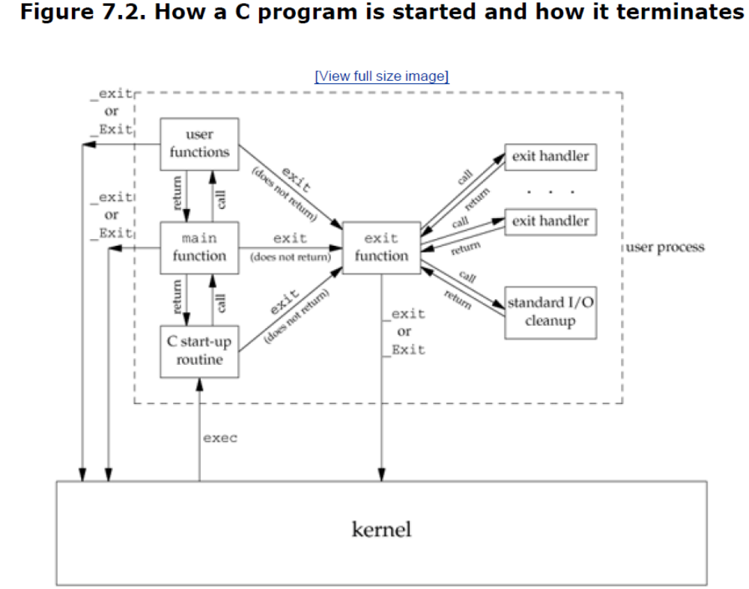

#include "apue.h"
static void my_exit1(void);
static void my_exit2(void);
int
main(void)
{
if (atexit(my_exit2) != 0)
err_sys("can't register my_exit2");
if (atexit(my_exit1) != 0)
err_sys("can't register my_exit1");
if (atexit(my_exit1) != 0)
err_sys("can't register my_exit1");
printf("main is done\n");
return(0);
}
static void
my_exit1(void)
{
printf("first exit handler\n");
}
static void
my_exit2(void)
{
printf("second exit handler\n");
}

Command-Line Arguments
When a program is executed, the process that does the exec can pass command-line arguments to the new program.

If we compile this program and name the executable echoarg, we have
$ ./echoarg arg1 TEST foo
argv[0]: ./echoarg
argv[1]: arg1
argv[2]: TEST
argv[3]: foo

#include "apue.h"
int
main(int argc, char *argv[])
{
int i;
for (i = 0; i < argc; i++) /* echo all command-line args */
printf("argv[%d]: %s\n", i, argv[i]);
exit(0);
}

Environment List

Environment list is array of character pointers, with each pointer containing the address of a null-terminated C string.
The address of the array of pointers is contained in the global variable environ:
extern char **environ;
For example, if the environment consisted of five strings, it could look like Figure below. Here w explicitly show the null bytes at the end of each string. We'll call environ the environment pointer, the array of pointers the environment list, and the strings they point to the environment strings

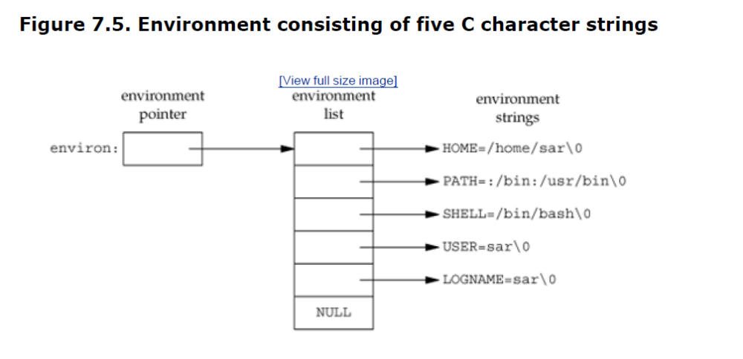

By convention, the environment consists of
name=value
strings, as shown in Figure Most predefined names are entirely uppercase, but this is only a convention.

Memory Layout of a C Program

C program has been composed of the following pieces:

- Text segment, the machine instructions that the CPU executes. Usually, the text segment is sharable so that only a single copy needs to be in memory for frequently executed programs, such as text editors, the C compiler, the shells, and so on. Also, the text segment is often readonly, to prevent a program from accidentally modifying its instructions.

- Initialized data segment, usually called simply the data segment, containing variables that are specifically initialized in the program. For example, the C declaration

int maxcount = 99;
appearing outside any function causes this variable to be stored in the initialized data segment with its initial value.

- Uninitialized data segment, often called the "bss" segment, named after an ancient assembler operator that stood for "block started by symbol." Data in this segment is initialized by the kernel to arithmetic 0 or null pointers before the program starts executing. The C declaration

long sum[1000];
appearing outside any function causes this variable to be stored in the uninitialized data segment.

- Stack, where automatic variables are stored, along with information that is saved each time a function is called. Each time a function is called, the address of where to return to and certain information about the caller's environment, such as some of the machine registers, are saved on the stack. The newly called function then allocates room on the stack for its automatic and temporary variables. This is how recursive functions in C can work. Each time a recursive function calls itself, a new stack frame is used, so one set of variables doesn't interfere with the variables from another instance of the function.

- Heap, where dynamic memory allocation usually takes place. Historically, the heap has been located between the uninitialized data and the stack.

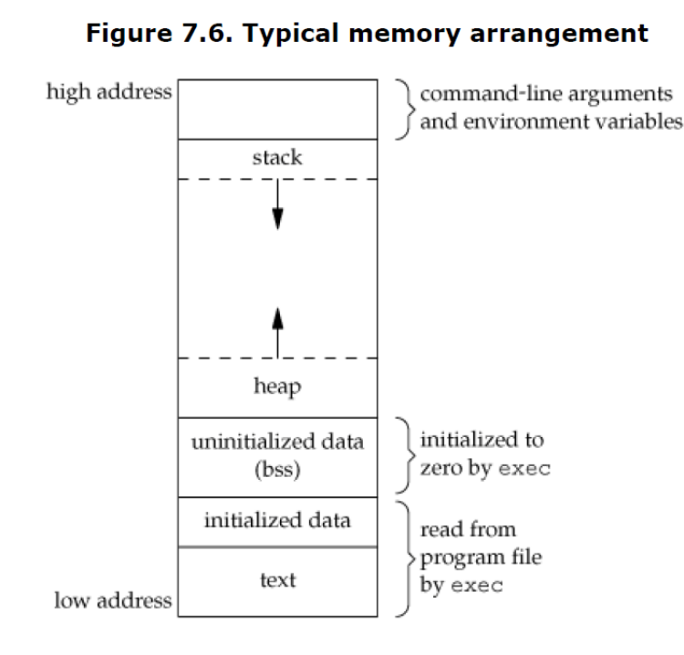

Shared Libraries
Shared libraries remove the common library routines from the executable file, instead maintaining a single copy of the library routine somewhere in memory that all processes reference. This reduces the size of each executable file but may add some runtime overhead, either when the program is first executed or the first time each shared library function is called. Another advantage of shared libraries is that library functions can be replaced with new versions without having to relink edit every program that uses the library.

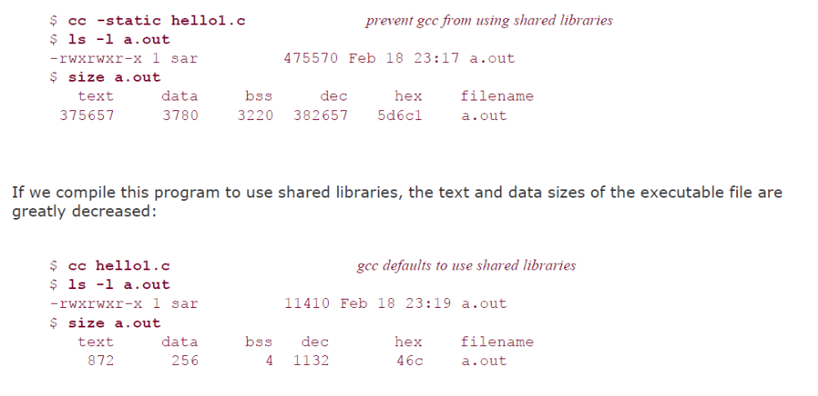

Memory Allocation

- malloc, which allocates a specified number of bytes of memory. The initial value of the memory is indeterminate.
- calloc, which allocates space for a specified number of objects of a specified size. The space is initialized to all 0 bits.
- realloc, which increases or decreases the size of a previously allocated area. When the size increases, it may involve moving the previously allocated area somewhere else, to provide the additional room at the end. Also, when the size increases, the initial value of the space between the old contents and the end of the new area is indeterminate.

#include <stdlib.h>
void *malloc(size_t size);
void *calloc(size_t nobj, size_t size);
void *realloc(void *ptr, size_t newsize);
All three return: non-null pointer if OK, NULL on error
void free(void *ptr);

Environment Variables
The environment strings are usually of the form
name=value

A function that we can use to fetch values from the environment

#include <stdlib.h>
char *getenv(const char *name);
Returns: pointer to value associated with name, NULL if not found

#include <stdlib.h>
int putenv(char *str);
int setenv(const char *name, const char *value,
int rewrite);
int unsetenv(const char *name);
All return: 0 if OK, nonzero on error

The operation of these three functions is as follows.

- The putenv function takes a string of the form name=value and places it in the environment list. If name already exists, its old definition is first removed.
- The setenv function sets name to value. If name already exists in the environment, then (a) if rewrite is nonzero, the existing definition for name is first removed; (b) if rewrite is 0, an existing definition for name is not removed, name is not set to the new value, and no error occurs.
- The unsetenv function removes any definition of name. It is not an error if such a definition does not exist.
Note the difference between putenv and setenv. Whereas setenv must allocate memory to create the name=value string from its arguments, putenv is free to place the string passé to it directly into the environment.
.
- If we're modifying an existing name:
- If the size of the new value is less than or equal to the size of the existing value, we can just copy the new string over the old string.
- If the size of the new value is larger than the old one, however, we must malloc to obtain room for the new string, copy the new string to this area, and then replace the old pointer in the environment list for name with the pointer to this allocated area.

- If we're adding a new name, it's more complicated. First, we have to call malloc to allocate room for the name=value string and copy the string to this area.
- Then, if it's the first time we've added a new name, we have to call malloc to obtain room for a new list of pointers. We copy the old environment list to this new area and store a pointer to the name=value string at the end of this list of pointers. We also store a null pointer at the end of this list, of course. Finally, we set environ to point to this new list of pointers.

- If this isn't the first time we've added new strings to the environment list, then we know that we've already allocated room for the list on the heap, so we just call realloc to allocate room for one more pointer. The pointer to the new name=value string is stored at the end of the list (on top of the previous null pointer), followed by a null pointer.

setjmp and longjmp Functions

In C, we can't goto a label that's in another function. Instead, we must use the setjmp and longjmp functions to perform this type of branching

#include <setjmp.h>
int setjmp(jmp_buf env);
Returns: 0 if called directly, nonzero if returning from a call to longjmp
void longjmp(jmp_buf env, int val);

We call setjmp from the location that we want to return to, which in this example is in the main function. In this case, setjmp returns 0 because we called it directly. In the call to setjmp, the argument env is of the special type jmp_buf. This data type is some form of array that is capable of holding all the information required to restore the status of the stack to the state when we call longjmp. Normally, the env variable is a global variable, since we'll need to reference it from another function.

getrlimit and setrlimit Functions
Every process has a set of resource limits, some of which can be queried and changed by the getrlimit and setrlimit functions.

#include <sys/resource.h>
int getrlimit(int resource, struct rlimit *rlptr);
int setrlimit(int resource, const struct rlimit *rlptr);
Both return: 0 if OK, nonzero on error

Three rules govern the changing of the resource limits.
- A process can change its soft limit to a value less than or equal to its hard limit.
- A process can lower its hard limit to a value greater than or equal to its soft limit. This lowering of the hard limit is irreversible for normal users.
- Only a superuser process can raise a hard limit.

The resource argument takes on one of the following values

RLIMIT_AS The maximum size in bytes of a process's total available memory
RLIMIT_CORE The maximum size in bytes of a core file.
RLIMIT_CPU The maximum amount of CPU time in seconds.
RLIMIT_DATA The maximum size in bytes of the data segment: the sum of the initialized
data, uninitialized data, and heap.
RLIMIT_FSIZE The maximum size in bytes of a file that may be created.
RLIMIT_LOCKS The maximum number of file locks a process can hold
RLIMIT_MEMLOCK The maximum amount of memory in bytes that a process can lock into memory.
RLIMIT_NOFILE The maximum number of open files per process.
RLIMIT_NPROC The maximum number of child processes per real user ID.
RLIMIT_RSS Maximum resident set size (RSS) in bytes. If available physical memory is low, the kernel takes memory from processes that exceed their RSS.
RLIMIT_SBSIZE The maximum size in bytes of socket buffers that a user can consume at any given time.
RLIMIT_STACK The maximum size in bytes of the stack.
RLIMIT_VMEM This is a synonym for RLIMIT_AS.
The resource limits affect the calling process and are inherited by any of its children. This means that the setting of resource limits needs to be built into the shells to affect all our future processes.

