Университет ИТМО

Факультет ФПИ и КТ

### Отчёт

### по лабораторной работе 1

**Системы Искуственного Интеллекта**

Студент:

Е Хэн

Преподаватель:  
Авдюшина Анна Евгеньевна

**Задача:**

Требуется создать базу знаний в языке программирования Prolog и реализовать набор запросов, используя эту базу знаний. Задача направлена на развитие навыков работы с фактами, предикатами, и правилами в логическом программировании. Любая, связанная с играми

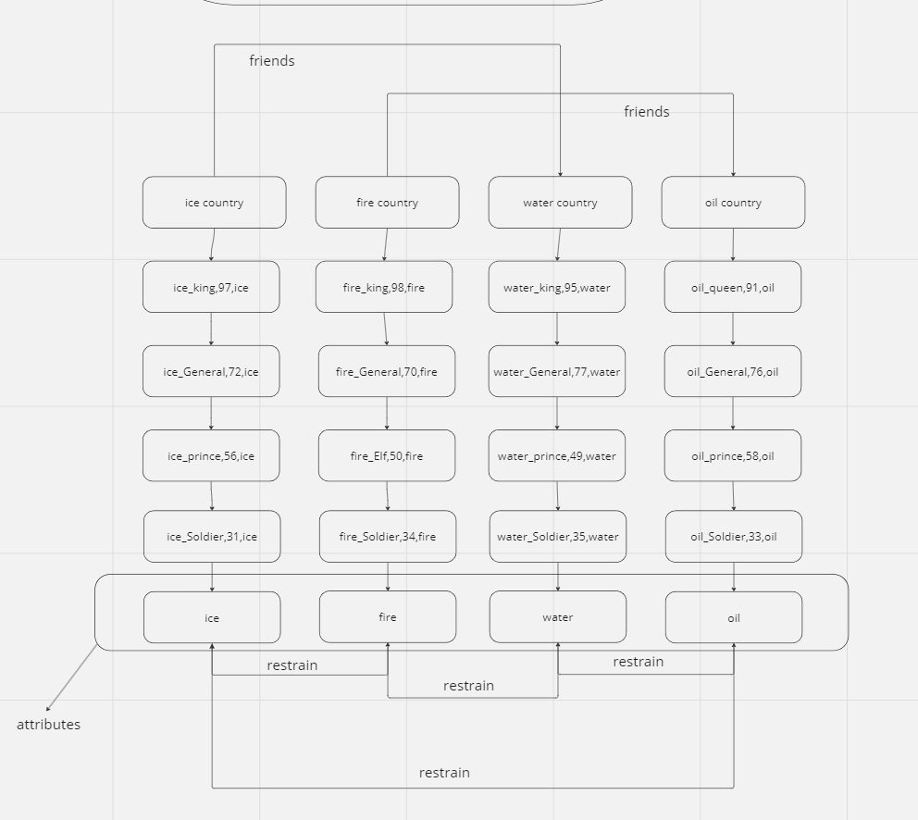

**Код:**

% facts

country(ice_country).

country(fire_country).

country(water_country).

country(oil_country).

ice_country(ice_king).

ice_country(ice_prince).

ice_country(ice_General).

ice_country(ice_Soldier).

fire_country(fire_king).

fire_country(fire_General).

fire_country(fire_Soldier).

fire_country(fire_Elf).

water_country(water_king).

water_country(water_prince).

water_country(water_General).

water_country(water_Soldier).

oil_country(oil_queen).

oil_country(oil_prince).

oil_country(oil_General).

oil_country(oil_Soldier).

level(ice_king,97,ice).

level(ice_prince,56,ice).

level(ice_General,72,ice).

level(ice_Soldier,31,ice).

level(fire_king,98,fire).

level(fire_General,70,fire).

level(fire_Soldier,34,fire).

level(fire_Elf,50,fire).

level(water_king,95,water).

level(water_prince,49,water).

level(water_General,77,water).

level(water_Soldier,35,water).

level(oil_queen,91,oil).

level(oil_prince,58,oil).

level(oil_General,76,oil).

level(oil_Soldier,33,oil).

good_relationship(water,ice).

good_relationship(ice,water).

good_relationship(fire,oil).

good_relationship(oil,fire).

good_relationship(fire,fire).

good_relationship(oil,oil).

good_relationship(ice,ice).

good_relationship(water,water).

good_relationship2(water_country,ice_country).

good_relationship2(ice_country,water_country).

good_relationship2(fire_country,oil_country).

good_relationship2(oil_country,fire_country).

restrain(water,fire).

restrain(fire,ice).

restrain(ice,oil).

restrain(oil,water).

attributes(water).

attributes(fire).

attributes(ice).

attributes(oil).

% rules

%if level A higher than level,we think A will defeat B

win(A,B):-level(A,Level1),level(B,Level2),Level1>Level2.

lost(A,B):-level(A,Level1),level(B,Level2),Level1<Level2.

tied(A,B):-level(A,Level1),level(B,Level2),Level1=Level2.

%when A is restrained by B, but A defeats B(in this situation，The level of A needs to be 5 higher than that of B )

was_restrained_but_defeating(A,B):-level(A,Level1,Attribute1),level(B,Level2,Attribute2),restrain(Attribute1,Attribute2),Level1-5>Level2.

%when A restrained B, and A defeats B(in this situation，The level of A can be 5 lower than that of B)

restrained_and_defeating(A,B):-level(A,Level1,Attribute1),level(B,Level2,Attribute2),restrain(Attribute1,Attribute2),Level1+5>Level2.

%when A is restrained by B, and A lost to B(in this situation，The level of A need to be 5 lower than that of B)

was_restrained_and_lost(A,B):-level(A,Level1,Attribute1),level(B,Level2,Attribute2),restrain(Attribute1,Attribute2),Level1-5<Level2.

%when A restrained B, and A lost to B(in this situation，The level of A can be 5 higher than that of B)

restrained_but_lost(A,B):-level(A,Level1,Attribute1),level(B,Level2,Attribute2),restrain(Attribute1,Attribute2),Level1+5<Level2.

% Master,Grandmaster,and Challenger(Master is from 30 to 55,Grandmaster is from 56 to 75,Challenger is from 76 to 99)

is_Master(A):- level(A,Level1,Attribute1),attributes(Attribute1),Level1>29,Level1<56.

is_Grandmaster(A):- level(A,Level1,Attribute1),attributes(Attribute1),Level1>55,Level1<76.

is_Challenger(A):- level(A,Level1,Attribute1),attributes(Attribute1),Level1>75,Level1<100.

% is_superiors means it means your superiors, you accept their jurisdiction

is_superiors(A,B):-level(A,Level1,Attribute1),level(B,Level2,Attribute2),Attribute1=Attribute2,Level1>Level2.

country_is_friends(A,B):-country(A),country(B),good_relationship2(A,B).

people_is_friends(A,B):-level(A,Level1,Attribute1),level(B,Level2,Attribute2),A\=B,Level1+Level2<999,good_relationship(Attribute1,Attribute2).