PESSTO SSDR3 : ESO Phase 3 Data Release Description

|  |  |
| --- | --- |
| Data Collection | PESSTO_MPHOT |
| Data Provider | Stephen J. Smartt (PI of PESSTO) |
| Date | 21.08.2017 |

Abstract

PESSTO (Public ESO Spectroscopic Survey of Transient Objects) began in April 2012 on the New Technology Telescope using the instruments EFOSC2 and SOFI. We typically target supernovae and optical transients brighter than 20.5m for classification and select science targets for detailed follow-up. We use standard EFOSC2 setups providing spectra with resolutions of 13-17Å between 3650-9995Å. A subset of the brighter science targets are selected for SOFI spectroscopy with the blue and red Grisms (resolutions 23-33Å) and imaging with broadband JHKs filters. This catalogue data release provides photometric lightcurve coverage for the PESSTO targets for which follow-up lightcurves have been completed. Photometric lightcurves for a total of 32 objects are now provided, 14 more than in the previous release.

Overview of Observations

As of 2016-05-01 PESSTO has classified 959 optical transients and has chosen around 154 targets for more detailed follow-up. The follow-up observations include spectroscopic and photometric time series data sets in the optical and near infra-red. The photometric datasets typically take longer to complete and release since objects can be followed for longer with photometry and often a template image (or series of images) is required to apply image subtraction methods to remove the host galaxy contamination. This means that fully calibrated photometric time series data often need to wait at least for the second season of observations so that template images which are free from supernova signal can be gathered. These template images need to be with the same camera to reduce colour effects when difference imaging is applied.

PESSTO targets transients which are brighter than around 21m for optical spectroscopy. While EFOSC2 can provide optical imaging (as discussed in Smartt et al. 2015), the majority of our targets can be followed photometrically with smaller aperture facilities. Use of multiple smaller facilities allows us to gather densely sampled lightcurves and also allows the NTT to concentrate on EFOSC2 spectroscopy and NIR observations with SOFI. EFOSC2 is employed for photometry when targets get too faint for the 1-2m telescopes we use. An example of the PESSTO legacy data set for SN2009ip (Fraser et al. 2013, 2015 ; see also Pastorello et al. 2012) is shown here in Figure 1.

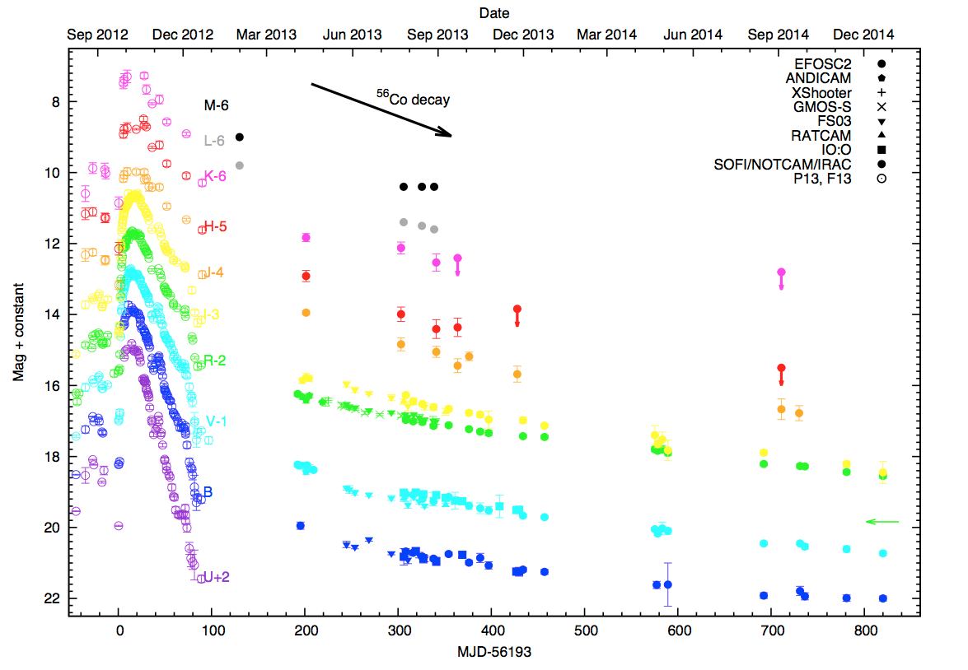

Figure 1 : reproduced from Fraser et al. (2015). Optical and near-infrared lightcurves for the PESSTO science target SN2009ip. The source of each data point is indicated by the key. All data taken by PESSTO and presented in Fraser et al. (2013) and Fraser et al. (2015) are provided in this release.

As photometric data are often, and indeed predominantly, provided from facilities other than the NTT and ESO, the image pixels are not all in the ESO archive. Those which are not ESO data are available on request from the PESSTO survey team. The detrended EFOSC2 images are available from [www.pessto.org](http://www.pessto.org) and the SOFI images are in the ESO archive as full science products. It is our intention to release all EFOSC2 images with trustworthy astrometric and photometric calibration. The calibration of all of the EFOSC2 images with an all-sky reference catalogue (from the Pan-STARRS1 telescope) is currently being investigated.

Release Content

The objects released are given in Table 1 below, with references to the published data where appropriate. The photometric measurements were carried out as described in the individual papers listed in Table 1. Photometry is usually a PSF fitting process unless specifically described otherwise in the papers. The processing of the various camera data are again included in the references. The description of the PESSTO processing of EFOSC2 and SOFI data is in Smartt et al. (2015).

Table 1 : Objects included in this release. The references provide the instrumental, reduction and calibration details. There are 6 unpublished lightcurves of type Ia SNe from Maguire et al. (2013), which are provided here with details of their instrumental source.

|  |  |
| --- | --- |
| Object | Reference |
| ASASSN-15lh (aka SN2015L) | Leloudas, G. et al., 2016 |
| CSS121015-004244+132827 | Benetti et al. 2014 |
| LSQ12btw | Pastorello et al. 2015a |
| LSQ12dlf | Nicholl et al. 2014 |
| LSQ12fxd | Unpublished lightcurve. Spectra and data described in Maguire et al. (2013). Data are from the Faulkes Telescope South and Spectral camera in filters *gri*. |
| LSQ12gdj | Scalzo et al. 2014 |
| LSQ13ccw | Pastorello et al. 2015a |
| LSQ13cuw (aka CSS131110-023957-083124) | Gall, E.E.E. et al., 2015 |
| LSQ13fn | Polshaw, J. et al., 2016 |
| LSQ14bdq | Nicholl, M. et al., 2015 |
| LSQ14mo | Leloudas, G. et al., 2015 |
| OGLE-2012-SN-006 | Pastorello et al. 2015b |
| OGLE-2013-SN-079 | Inserra et al. 2015 |
| OGLE16aaa | Wyrzykowski, Ł. et al., 2017 |
| PS15br | Inserra, C. et al., 2016b |
| PS15csd | Magee, M.R. et al., 2016 |
| SN2009ip | Fraser et al. 2013, Fraser et al. 2015 |
| SN2012ca | Inserra et al. 2014, Inserra, C. et al., 2016a |
| SN2012ec | Barbarino et al. 2015, Jerkstrand et al. 2015 |
| SN2012hd | Unpublished lightcurve. Spectra and data described in Maguire et al. (2013). Data are from the Faulkes Telescope South and Spectral camera in filters *gri*. Some photometric data also from the La Silla QUEST survey and broad *gr* filter (Baltay et al. 2013). |
| SN2012hn | Valenti et al. 2014 |
| SN2012hr | Unpublished lightcurve. Spectra and data described in Maguire et al. (2013). Data are from the LCOGT 1m telescope network. |
| SN2012ht | Unpublished lightcurve. Spectra and data described in Maguire et al. (2013). Data are from the Liverpool Telescope and IO:O camera, in filters *gri* |
| SN2013aj | Unpublished lightcurve. Spectra and data described in Maguire et al. (2013). Data are from the Liverpool Telescope and IO:O camera, in filters *gri*. Some data are provided from the SMARTS 1.3m telescope with ANDICAM and KPNO *R-*band filter. |
| SN2013ej | Yuan, F. et al., 2016, Valenti, S. et al, 2013 |
| SN2013fc | Kangas, T. et al., 2015 |
| SN2013hx | Inserra, C. et al., 2016 |
| SN2013U | Unpublished lightcurve. Spectra and data described in Maguire et al. (2013). Data are from the Liverpool Telescope and IO:O camera, in filters *gri.* |
| SN2015bn (aka PS15ae) | Nicholl, M. et al., 2016a, Nicholl, M. et al., 2016b |
| SN2015F | Cartier, R. et al., 2017 |
| SN2015H | Magee, M.R. et al., 2016 |
| SSS120810-231802-560926 | Nicholl et al. 2014 |

Previous Releases

The previous release of this catalogue contained the lightcurves of 18 objects. This new version adds the lightcurves of other 14 objects, with no changes to the already published lightcurves.

# Data Format

The multi-lightcurve catalogue, PESSTO_MPHOT, is provided as a FITS binary table and is structured following the standards described in Sec. 5 of Retzlaff et al. (2013). The table is stored as the single data extension within the FITS file and contains 43 columns and 2488 rows. Each row represents a *single epoch of photometry* measured for one of the 32 transients.

The columns are as follows, with the format of the catalogue entry in parentheses.

1. PHOT_ID: the unique identification for the single epoch of photometry within the lightcurve catalogue (J)

2. SOURCE_ID: the unique identification of the transient found within PESSTO_TRAN_CAT (the TRANSIENT_ID keyword value), the catalogue of transients classified and followed by PESSTO (A).

3. MJD*:*  the mean Modified Julian date of the epoch of photometry (E)

4.-43. The remaining 40 columns contain measured magnitudes in one of the 20 different filters that have been used in PESSTO follow-up and their errors (All columns have format E). The columns names provide the name of the filter and the magnitude-system employed (*Vega*, *AB* or *Swift*).

* The magnitudes in the *UBVRI* filters (e.g. U_VEGA_MAG, B_VEGA_MAG etc) are in the Landolt Vega magnitude system*.*
* The La Silla Quest Survey employs a broad filter covering roughly 400-700nm similar to the combined effect of Gunn *g* + *r* filters (see Baltay et al. 2013). The La Silla Quest photometry can be calibrated on a Vega magnitude or AB magnitude system and also converted to standard filters such as *V*, or *g*. There are a small number of photometric points for SN2012hd which are quoted in the natural AB magnitude based system of the filter (LSQGR_AB_MAG).
* Near infra-red magnitudes are in the 2MASS system which is normalised to Vega (hence they are referred to as J_VEGA_MAG etc).
* The magnitudes in the *ugriz* filters (U_AB_MAG, G_AB_MAG etc) are in the AB magnitude system and are generally based on SDSS reference stars. This means they are effectively on the SDSS AB magnitude scale. Note that the column headers are all in upper case but they refer to SDSS *ugriz*.
* Finally, a number of targets were also observed in the UV with Swift through the UVOT filters *uvw2*, *uvm1*, *uvw1* and the optical *u,b and v*. The magnitudes are in the Swift UVOT system (based on Vega magnitudes). The column names are *UVW2_SWIFT_MAG, V_SWIFT_MAG* etc.

Acknowledgements

If using these data, please cite this paper

*Smartt S.J., et al., 2015, A&A, submitted (arXiv:1411.0299): PESSTO : survey description and products from the first data release of the Public ESO Spectroscopic Survey of Transient Objects*

And add the following acknowledging statement in your articles

Based on data products from observations made with ESO Telescopes at the La Silla Paranal Observatory under programmes 188.D-3003 and 191.D-0935: PESSTO (the Public ESO Spectroscopic Survey for Transient Objects).

References

Baltay C. et al. 2013, PASP, 125, 683

Barbarino, C. et al., 2015, MNRAS, 448, 2312

Bennetti S., et al., 2014, MNRAS, 441, 289

Cartier, R. et al., 2017, MNRAS, 464, 4476

Fraser M., et al. 2013, MNRAS, 433, 1312

Fraser, M. et al., 2015. MNRAS, 453, 3886

Gall, E.E.E. et al., 2015, A&A, 582, 3

Inserra C., et al. 2015, ApJ, 799, 2

Inserra, C. et al., 2016, arXiv

Inserra, C. et al., 2016a, MNRAS, 459, 2721

Inserra, C., et al. 2014 MNRAS, 437, 51

Jerkstrand, A. et al., 2015. MNRAS, 448, 2482

Kangas, T. et al., 2015, MNRAS, 456, 323

Leloudas, G. et al., 2015, AJ, 815, 10

Leloudas, G. et al., 2016, Nat astron, 1, 2

Magee, M.R. et al., 2016, A&A, 589, 89.

Maguire K., et al. 2013, MNRAS, 436, 222

Nicholl M., et al. 2014, MNRAS, 444, 2096

Nicholl, M. et al., 2015, AJ, 807, 18

Nicholl, M. et al., 2016a, AJ, 826, 39

Nicholl, M. et al., 2016b, AJ, 828, 18

Pastorello A., et al. 2013, ApJ, 767, 1

Pastorello, A. et al., 2015a. MNRAS, 449, 1954

Pastorello, A. et al., 2015b. MNRAS, 449, 1941

Polshaw, J. et al., 2016, A&A, 588, 1

Retzlaff et al. 2013, GEN-SPE-ESO-33000-5335, Issue 5

Scalzo R., et al. 2014, MNRAS, 445, 30

Smartt, S.J. et al., 2015, A&A, 579, 40.

Valenti, S. et al., 2014, MNRAS Letters, 438, 101

Wyrzykowski, Ł. et al., 2017, MNRAS Letters, 465, 114

Yuan, F. et al., 2016.. MNRAS, 461, 2003