
THe School of Phish
COMP1004 Computing Practice – Project Report

January 1, 2006
Sam Vincent
University of Plymouth

Table of Contents
1. Introduction 2
2. Software Development Lifecycle 2
2.1 Waterfall 2
2.2 Agile 2
2.3 Applying the SDLC to This Project 3
3. Requirements Analysis 3
3.1 Functional Analysis 3
3.2 Non-Functional Analysis 4
3.3 User Stories 4
4. Sprint Plan and Implementation 5
Sprint 1 — Core Structure (Week 5) 5
Sprint 2 — SPA Logic and Interactivity (Week 6) 5
Sprint 3 — Feedback and Navigation (Week 7) 5
Sprint 4 — Content, Features, and Refinement (Weeks 8–9) 6
3. Reflection 6
4. UML Diagrams 7
4.1 Class Diagram 7
4.2 Activity Diagram 8
4.3 Use Case Diagram 9
5. Sitemap 10
6. Wireframes 10
6.1 Training View 10
6.2 Tips View 11
6.3 About View 12
7. Project Vision 12
8. Noted Issues and Constraints 13
9. Github Repository 13
10. References 13

1. Introduction
This report presents the final portfolio for the COMP1004 Computing Practice module. The project has a focus on self-management and the use of time across the Software Development Lifecycle (SDLC).
The School of Phish is an interactive phishing awareness trainer built as a Single Page Application (SPA). The application presents users with a series of simulated emails and challenges them to identify whether each is a legitimate communication or a phishing attempt. Following each decision, immediate feedback is provided explaining the correct answer and the indicators present in the email. A scoring system tracks performance across the session.
This report covers how the project was planned and executed against the SDLC, a reflection on the development process, the UML and design documentation produced, and a link to the public GitHub repository.

2. Software Development Lifecycle
The Software Development Lifecycle (SDLC) brings structure to software development to ensure quality, reliable software is produced within a defined scope. There are five core stages to the SDLC: Requirements Analysis, Design, Implementation, Testing, and Evolution. Without following this structure, projects can fail or take significantly longer than anticipated. There are various models of the SDLC, the most widely used being Waterfall and Agile.

2.1 Waterfall
The Waterfall model is one of the oldest and most structured approaches to software development. Each phase must be fully completed before the next begins, ensuring no overlap between stages. This gives clear expectations of what should be delivered at the end of each phase and means requirements are thoroughly documented upfront. However, the rigidity of Waterfall means that changes to requirements mid-project can be costly in both time and resource, as earlier phases may need to be revisited.

2.2 Agile
Agile is a needs-focused approach designed to produce working software quickly through short iterative cycles called sprints. Rather than defining all requirements upfront, Agile allows requirements to evolve as the project progresses. Each sprint produces a small, testable increment of working software. Agile teams use user stories to express requirements in plain language, taking the form “As a [who], I want to [what] so that [benefit/why]”. A product backlog holds all planned features, with each sprint drawing tasks from it based on priority.
A commonly used prioritisation technique in Agile is MoSCoW, which categorises requirements as Must have, Should have, Could have, and Won’t have. This helps teams focus on delivering the most critical features first and provides a clear rationale for what may not be included in the final product.

2.3 Applying the SDLC to This Project
An Agile approach was taken for this project, using iterative sprints to incrementally build and test the application. This was the most appropriate methodology given the evolving nature of the requirements; while the core concept was defined early, features such as the sneaky link simulation and theming system emerged and were refined during development rather than being fully specified upfront.
The planning phase covered the first two weeks, during which the project scope was defined, requirements were gathered and prioritised using MoSCoW, and initial research into phishing examples and email structures was carried out. The design phase followed, producing wireframes, UML diagrams, and a definition of the core data structures. From week five onward, implementation was structured into four sprints, each with a defined goal, backlog, and retrospective review.

3. Requirements Analysis

3.1 Functional Analysis
The following functional requirements were identified and prioritised using MoSCoW:
Requirement | Must | Should | Could
The application shall display simulated phishing and legitimate emails to the user | ✓
The application shall allow the user to classify each email as phishing or legitimate | ✓
The application shall provide immediate feedback explaining the correct answer and indicators present | ✓
The application shall track and display the user’s score throughout the session | ✓
The application shall allow navigation between Training, Tips, and About sections without page reloads | ✓
The application shall simulate deceptive hyperlinks to demonstrate URL spoofing |  | ✓
The application shall support dark and light display modes via a toggle |  | ✓
The application shall include a Phishing Tips page with awareness guidance |  | ✓
The application shall include difficulty levels with harder-to-spot phishing examples |  |  | ✓
The application shall store high scores between sessions |  |  | ✓

3.2 Non-Functional Analysis
- The application shall be implemented exclusively using vanilla HTML, CSS, and JavaScript
- The application shall function as a Single Page Application; all content updates dynamically without page reloads
- The application shall be responsive and function correctly on desktop browsers
- The application shall operate without a backend server or database dependency
- The application shall maintain readable, commented code in line with good software engineering practice

3.3 User Stories
- US01 — As a user, I want to read simulated emails so that I can practise identifying phishing attempts in a safe environment.
- US02 — As a user, I want to receive feedback after each decision so that I can understand what I got right or wrong and why.
- US03 — As a user, I want to hover over links and see where they actually lead so that I can practise spotting URL deception.
- US04 — As a user, I want to see my score so that I can track my progress through the training.

4. Sprint Plan and Implementation

Sprint 1 — Core Structure (Week 5)
Sprint Goal: Implement basic foundations
- Base HTML skeleton
- CSS layout and custom property theming structure
- Email JavaScript object definition
Increment: Static UI with email objects using placeholder data.
Sprint Review: The basic structure came together as planned. The email object design — with from, subject, body, isPhishing, and explanation fields — proved to be a clean and flexible structure that carried through the rest of the project without needing significant changes. The main thing identified for the next sprint was to get dynamic rendering working so the application felt interactive rather than static.

Sprint 2 — SPA Logic and Interactivity (Week 6)
Sprint Goal: Allow the user to interact with the email template
- Dynamic email rendering via renderEmail() function
- Mark as Legitimate and Mark as Phishing button handlers
- Scoring system implementation
Increment: Interactive SPA with working scoring system.
Sprint Review: The dynamic rendering and scoring logic both worked well and largely as intended from the first attempt. The innerHTML approach for rendering email bodies was a deliberate decision to allow rich formatting in the email content, and the XSS risk this carries was noted and mitigated by ensuring no user-supplied content is ever passed to innerHTML. The next sprint would focus on giving the user meaningful feedback and building out the navigation.

Sprint 3 — Feedback and Navigation (Week 7)
Sprint Goal: Give the user feedback on their choices and enable full SPA navigation
- Next email flow and DOM transition
- Feedback message area
- SPA view switching via JavaScript and CSS class toggling
- Phishing Tips and About pages
Increment: Fully playable prototype with working navigation.
Sprint Review: This was the most challenging sprint. A persistent bug caused the SPA navigation to appear functional — the active class was toggling correctly on the links — but the views were not displaying. The root cause turned out to be a mismatch between the data-view attribute values in the HTML and the IDs the JavaScript was searching for. Once identified, the fix was straightforward, but diagnosing it took time and reinforced the value of checking what the code is actually doing rather than what you expect it to be doing. The prototype was fully playable by the end of the sprint as planned.

Sprint 4 — Content, Features, and Refinement (Weeks 8–9)
Sprint Goal: Complete email content, add remaining features, and polish the UI
- 20 email scenarios written and implemented across a range of phishing types and legitimate correspondence
- Sneaky link simulation via handlePhishingLink() function
- Dark mode default with light mode toggle using CSS custom properties
- Google Fonts integrated
- Bug fixes and cross-browser testing
Increment: Content-complete, polished prototype ready for mid-project demonstration.
Sprint Review: The content phase went well. Writing 20 varied email scenarios — covering everything from advance-fee fraud to fake student finance communications — required research into real phishing tactics to ensure the scenarios were realistic and educational. The sneaky link feature came together cleanly and is one of the more distinctive aspects of the application. The theming system using CSS custom properties worked exactly as intended. The application was stable and ready for submission by the end of this sprint.

3. Reflection
This project has been one of the more rewarding things worked on during the first year, and also one of the more challenging. The concept came naturally from a background in IT support; having spent time explaining security risks to non-technical colleagues across the NHS and Ministry of Defence, building something that does that at scale felt genuinely worthwhile rather than just an academic exercise.
The early stages went well. Planning the email object structure and the SPA navigation felt logical, and having a clear mental model of how the three files would interact made the initial implementation straightforward. The scoring system and feedback logic came together quickly and largely worked as intended from the first attempt.
The most persistent challenge was the SPA navigation bug described in Sprint 3. It was a good lesson in the importance of methodical debugging — checking assumptions about what the code is doing rather than what you think it is doing. The CPD sessions on careers and project communication also influenced the approach taken throughout; particularly the focus on designing software with real users in mind. This shaped the decision to prioritise clarity and accessibility, ensuring the application would be usable for people at both ends of the digital confidence spectrum, from younger users who may be overly trusting online to older users who may feel less confident navigating internet security.
Due to ongoing health issues, attendance at some stand-up meetings during this phase was not possible. This was adapted to by managing time independently and breaking tasks into smaller steps, which significantly improved self-organisation. Scrum targets were adjusted accordingly and the intention is to engage more consistently with the supervision process going forward.
If starting again, more time would be spent on the initial HTML structure before writing any CSS or JavaScript. Several bugs were caused by structural inconsistencies that became harder to untangle once styling and logic were in place. Separating the email data into a JSON file from the outset would also make the codebase cleaner and more maintainable as the project grows.

4. UML Diagrams

4.1 Class Diagram
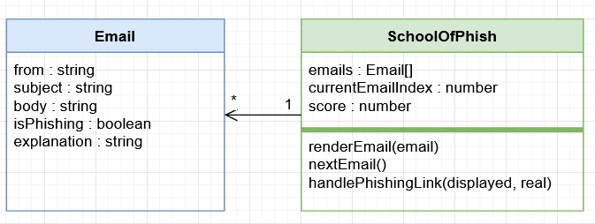

4.2 Activity Diagram
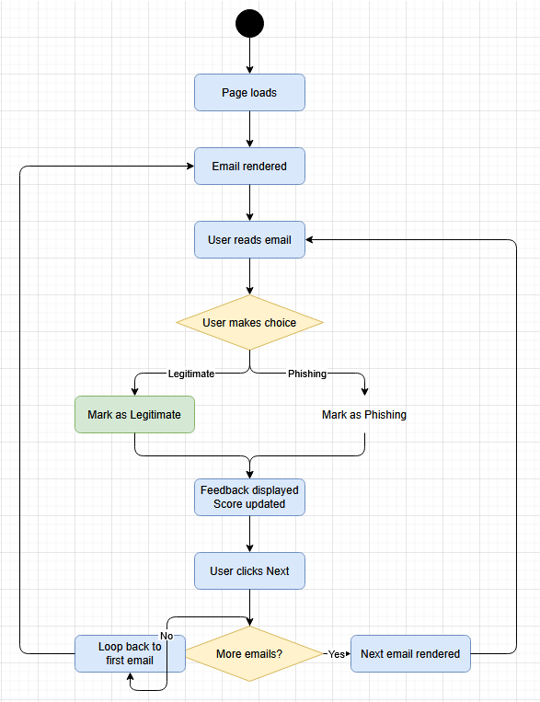

4.3 Use Case Diagram
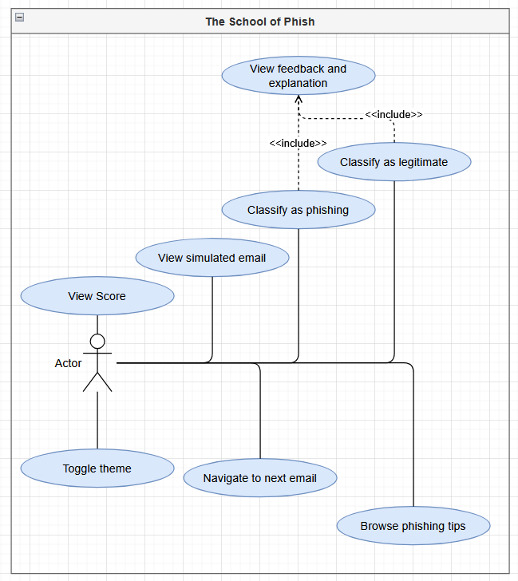

5. Sitemap
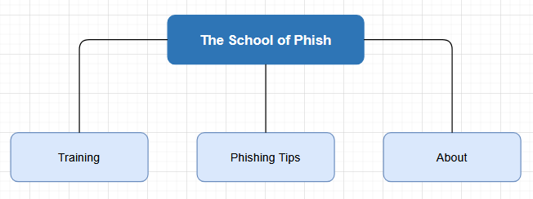

6. Wireframes

6.1 Training View
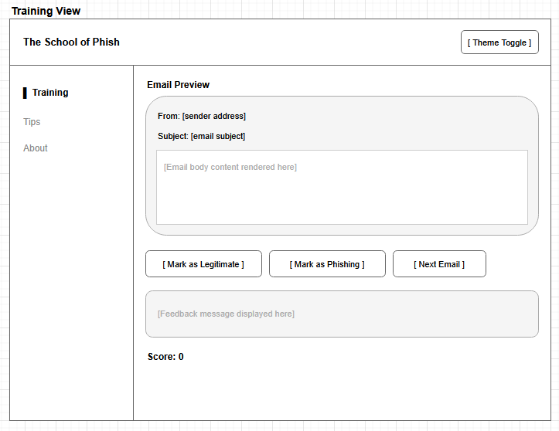

6.2 Tips View
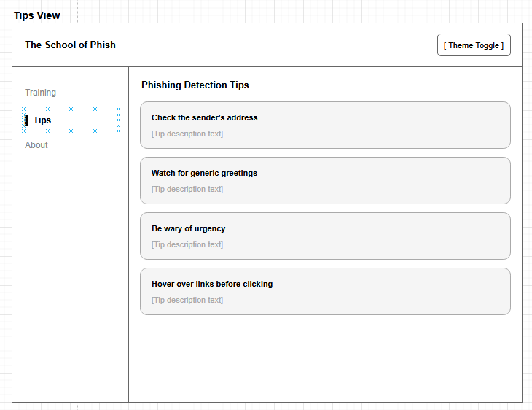

6.3 About View
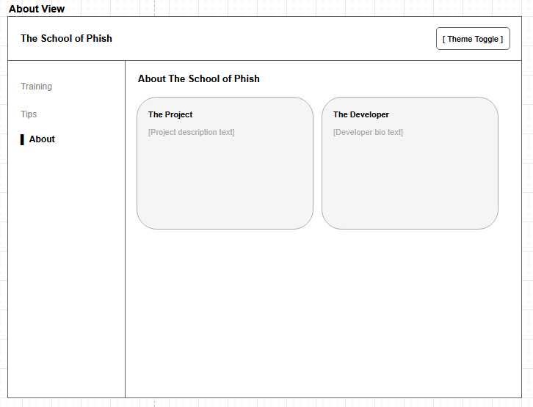

7. Project Vision
The aim of this project is to design, develop and implement a Single Page Application to help users better understand and identify common methods used in phishing scams and attacks. As phishing remains one of the most widespread forms of cyberattack, and having had personal experience of spreading awareness on this topic to both ends of the age spectrum, building an accessible, interactive training tool felt like a natural and meaningful project.
The application is built exclusively using technologies taught within this module; HTML and CSS for the design and UI, and JavaScript for the interactivity. It focuses on a clean, accessible interface with clear visual cues to ensure users can engage with the concepts regardless of their technical background.
Consideration must be given to the legal, social, and ethical dimensions of this project. From a legal perspective, the application collects no personal data, meaning GDPR compliance is straightforward. All email scenarios are entirely fictional and do not reproduce real correspondence. The Computer Misuse Act 1990 is not implicated as the application is a passive educational tool that provides no capability to conduct actual attacks.
Socially, phishing attacks disproportionately affect those with lower digital literacy. By providing a free, accessible training tool, The School of Phish aims to contribute to broader cyber resilience. Web accessibility was a key consideration throughout; the interface uses semantic HTML, clear visual hierarchy, and sufficient colour contrast in both dark and light modes, in line with the requirements of the Equality Act 2010.
Ethically, the simulation of phishing emails raises the question of whether such content could be misused. This was mitigated by using clearly fictional domains and paths throughout, making the educational intent unambiguous. The purpose of the application is entirely defensive.

8. Noted Issues and Constraints
The primary constraint on this project was the requirement to use only vanilla HTML, CSS, and JavaScript. This ruled out frameworks that might have simplified certain aspects of the implementation, such as component-based rendering or state management. Working within this constraint was ultimately beneficial as it required a deeper engagement with core web fundamentals.
The most significant issue encountered was the SPA navigation bug described in the Sprint 3 retrospective; a mismatch between data-view attribute values and section element IDs. This was resolved once the root cause was identified.
Health issues during the project limited attendance at some stand-up sessions and required the sprint plan to be managed independently during those periods. Tasks were broken into smaller steps to maintain progress and momentum throughout.

9. Github Repository
https://github.com/thespiderchef/school-of-phish

10. References
- NCSC Annual Review or Verizon DBIR — for phishing prevalence statistics
- Computer Misuse Act 1990 — https://www.legislation.gov.uk/ukpga/1990/18/contents
- UK GDPR — ICO guidance at https://ico.org.uk
- Equality Act 2010 — https://www.legislation.gov.uk/ukpga/2010/15/contents

