1) Download the audio from https://www.freeconferencing.com, three different logins, one for each call

2) rename the downloaded file to one of the following names, (year, month, date)
mon_bbscall_yyyy-mm-dd
wed_channel_yyyy-mm-dd
sun_gridhealing_yyyy-mm-dd

3a) I usually save the files in 2 places (one in my dropbox and another one on my computer (folder name - 2012originals)
The file in my dropbox I send a link to the transcriber, so she/he get fast access to it. It is also possible to setup up a system with shared dropbox folders for the audio to the transcribers.

3b) I also send the links of the Mon and Wed calls to Donn (dlhdonn@msn.com). Donn tries to improve the quality of the audio and I usually get the improved file back 1-3 days later. The filename have a name of " _Processed" after them. I save those files in another folder (2012 processed) and remove the word "_processed" from them. (more info in step 7)

4) I upload the original file to Egnyte and to Wynn's shared dropbox folder (public/2012calls)

a) In Egnyte I usually drag the file I want to upload and release it over the upload area (red arrow shown in picture). Be sure to be in the right folder(2012 folder this year, 2013 for next year etc)
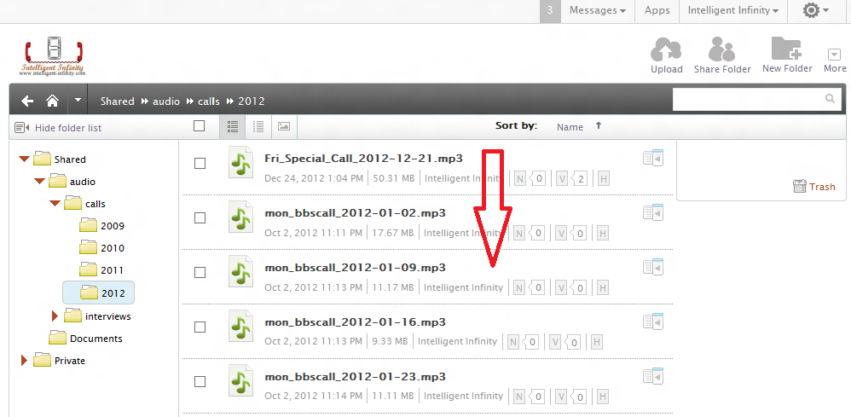
after upload is complete, you will see a new line on the top of the window (highlighted in yellow) that the upload is successful and to
Click Send link to this file.
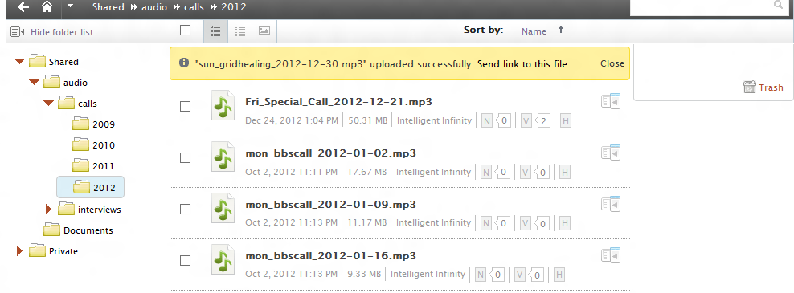

You then end up with this picture:
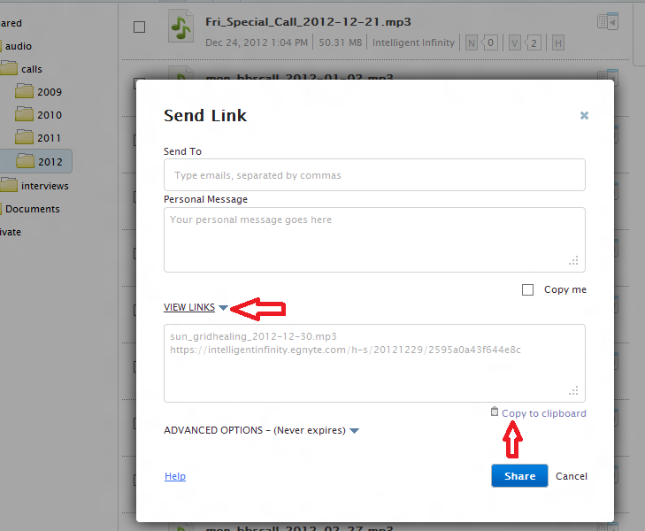

b) Then, click on the "View links" , and then wait for the link to show up, then click "Copy to clipboard"

c) Create a text file and open in up + Paste this into the text file and SAVE it.
For some reason we get a blank space after ".mp3" so I remove that before I save. In this example we have

sun_gridhealing_2012-12-30.mp3
https://intelligentinfinity.egnyte.com/h-s/20121229/2595a0a43f644e8c

5) Go to getresponse and create a newsletter for Spiritchannel (make sure you load the correct template).

a) Change the headline of the email to the correct date and call and insert / paste the text (as per the previous example...)

headline: Audio - Sunday Grid Healing - 2012-12-30
the following goes into the mail
sun_gridhealing_2012-12-30.mp3
select the text sun_gridhealing_2012-12-30.mp3 and press the link button in getresponse and paste the matching link in the small window that comes up:
https://intelligentinfinity.egnyte.com/h-s/20121229/2595a0a43f644e8c
(note: the date portion of the link I marked in red.. is when you shared it on Egnyte and does not have anything to do with the correct date of the file)

b) On the wed calls I have to listen to the audio(takes 1-1.5 hours depending on the quality of the call) and pick out the question asked and include them in the email. I also save the question in a text file for use when creating the web-archive (spiritchannel.net)

6) I keep a text file (2012Audio_URL.txt) with all the Egnyte links, so I will add the new one (keeping the date and link) to the same file.
Example: the last 4 lines in that file
2012-12-23__https://intelligentinfinity.egnyte.com/h-s/20121223/3804abcffcbe4e67
2012-12-24__https://intelligentinfinity.egnyte.com/h-s/20121225/4e6e5ea2bb24497e
2012-12-26__https://intelligentinfinity.egnyte.com/h-s/20121227/bcd2eb618ea749ba
2012-12-30__https://intelligentinfinity.egnyte.com/h-s/20121229/2595a0a43f644e8c

This file is used for creating the web-archive so it is important to save the links in the right format as shown above.

7) After I re-name and saved the processed file from Donn, I upload and overwrite the Dropbox file and Egnyte file. There is no need to get the link from Egnyte again as it is the same as before(the link is already in 2012Audio_URL.txt)

8) When the transcripts are available, Gary will send out the transcripts via email. I will go into getresponse and take the data to create the file for the web-archive page. (Go to messages -> my newsletters -> selects the transcript I want -> press "EDIT" -> press "Custom HTML" button.
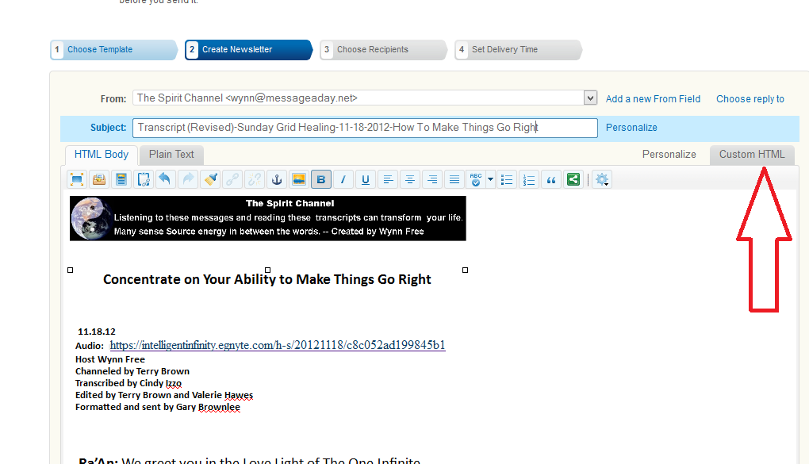

-> (putting my cursor in the area below on the page) press CTRA+A ("select all") on my keyboard, then CTRL+C (copy) -> then CTRL-P (paste) the information into a new textfile.

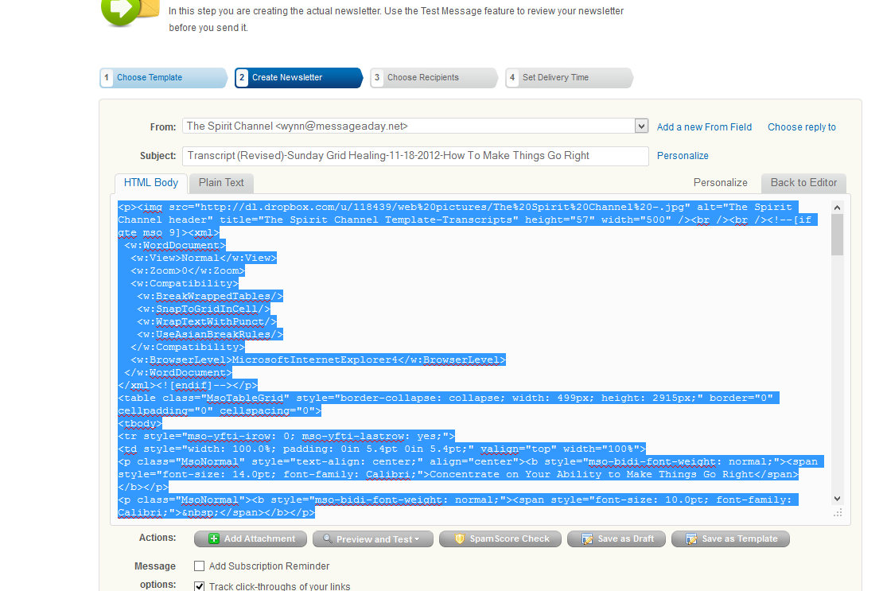

It is also possible for Gary to create the text file at the same time he is sending out the transcripts, so we can skip this step in the future.

9a) In the text file of the transcript, I add the following line to the top of it

<meta http-equiv="Content-Type" content="text/html; charset=iso-8859-1" />

+ make and empty line after

without the <meta line, some characters turn out strange on the website.

9b) Then I rename my text file to (in this example for Gary's Transcript 2012-11-18.html)

9c) I move the file into a folder I have named t (short for transcript) + upload to website/dropbox in the same t folder

9d) It is also possible to convert the text file to a pdf file and skip step 9a. I save those in a folder I have named d and upload to the folder with the same name on the website/dropbox.

