The Spot
strives to create a space where people can gather, unwind, and connect. Our mission is to support and celebrate our local community, bringing people together through kava, conversation, and connection. We create a welcoming, sober atmosphere, where people can enjoy their first or second chances.

What is Kava?
A traditional South Pacific root drink known for its calming, social, and mood-lifting effects. It’s been shared ceremonially for centuries in places like Fiji, Vanuatu, and Hawai’i.
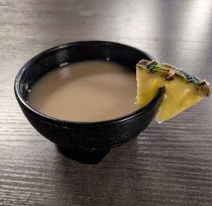
Drink it from a can or in the traditional style from a shell.
Enjoy relaxation without intoxication. Ease stress and anxiety without hangovers.

Spread the Word
As an independent and locally owned business, we rely on patrons like you to spread the word. If you enjoyed your time here, invite a friend. Consider leaving us an online review.
Google Reviews Become a Member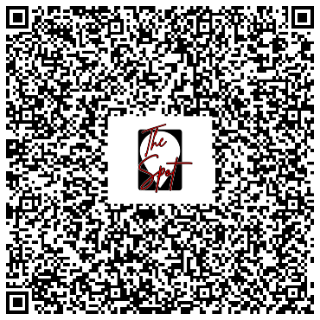 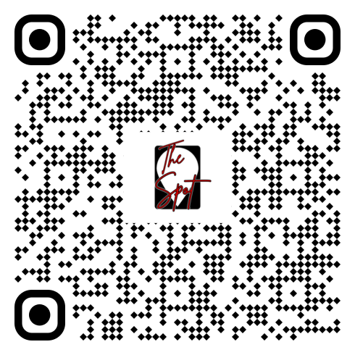
Hungry?
We serve made-to-order grilled cheese as well as cheesecake from Slice of Heaven in Derry, NH.

Craving more? You can order at the bar from our friends at Joanne’s Kitchen. Their full dinner menu is available to be delivered here to The Spot.
Scan the below QR code to view the menu online or get a printed copy at the bar.
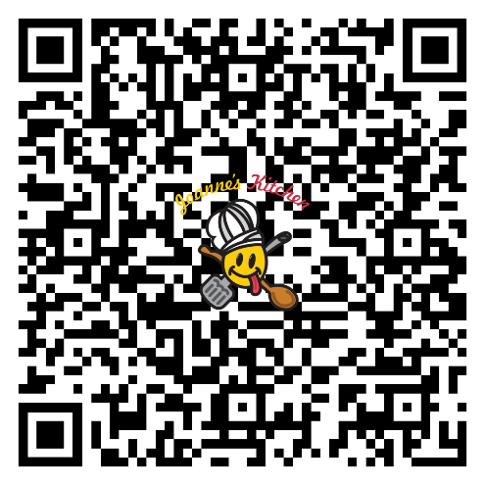

Coming Events
Visit https://thespotnashua.com to see a calendar of upcoming events. From karaoke to movie nights to open mic and comedy, The Spot is a place for people to explore their creativity and whimsy. See online for dates and details of what’s coming up.

Private Events
The Spot is available to host your private event. Talk to Mike or Mars about reserving the space at competitive rates. We can accommodate up to 95 guests. We have mic, music, and light setups. Let us make your special day the best it can be.

