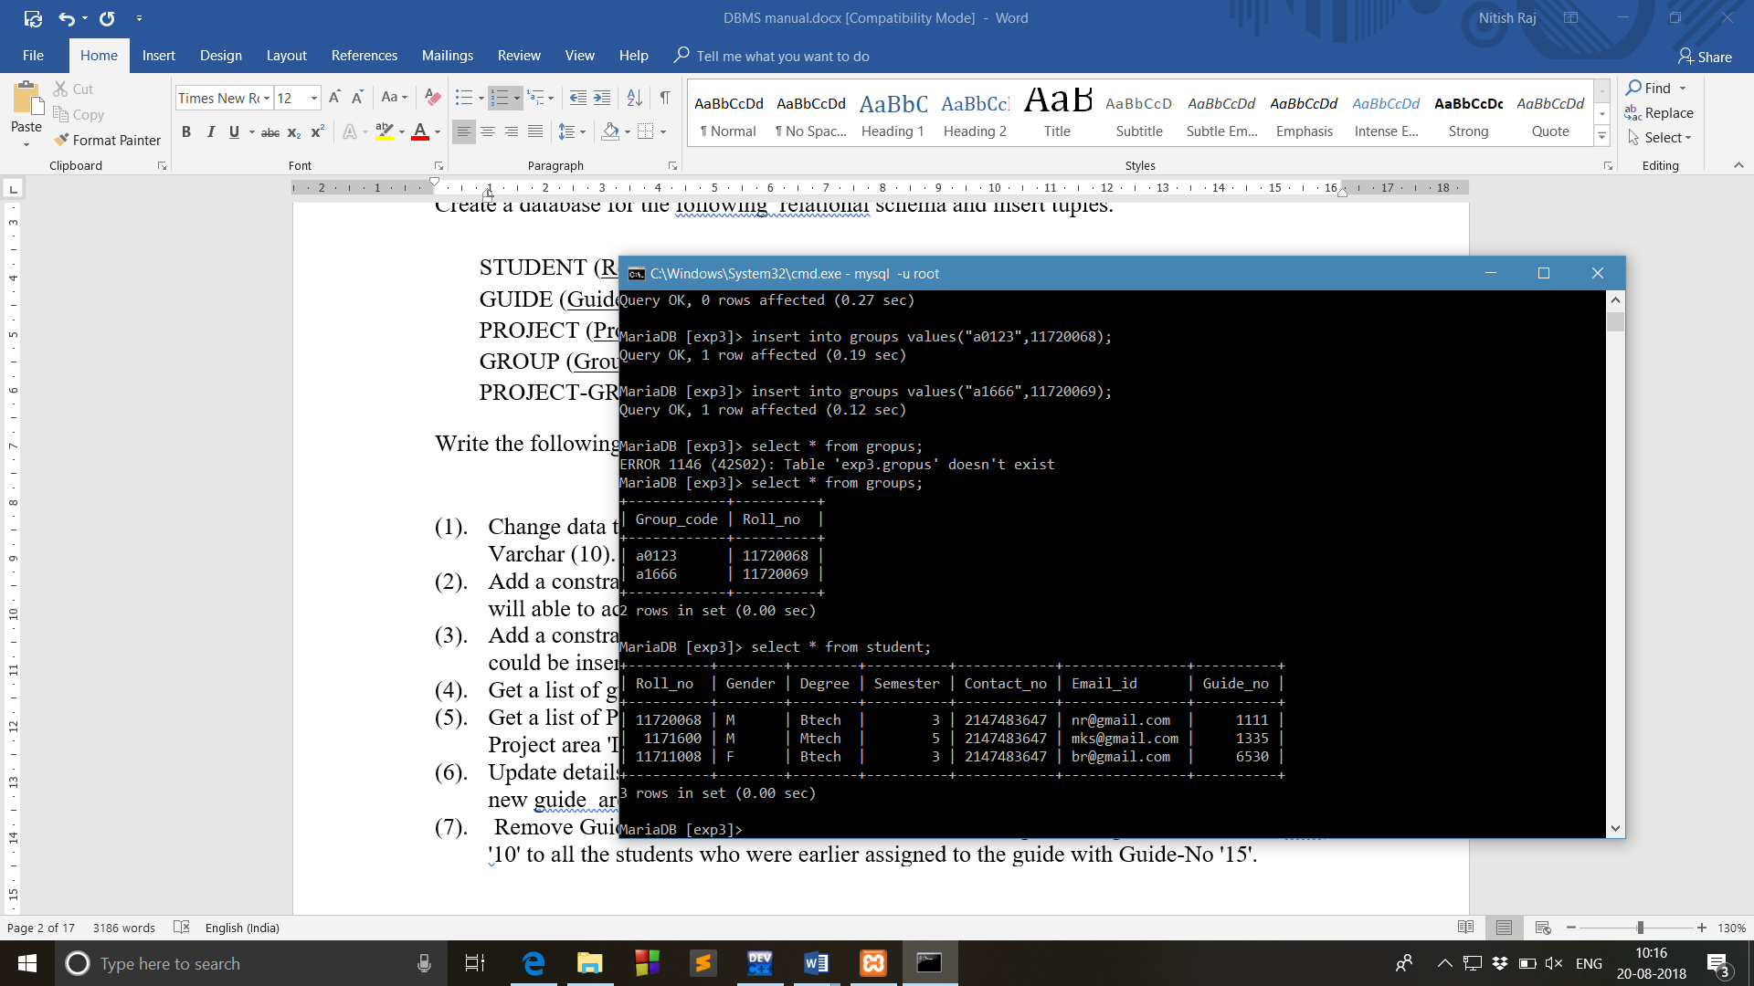

1. Change data type of the attribute Roll-No of the table Student from Number (10) to Varchar (10)

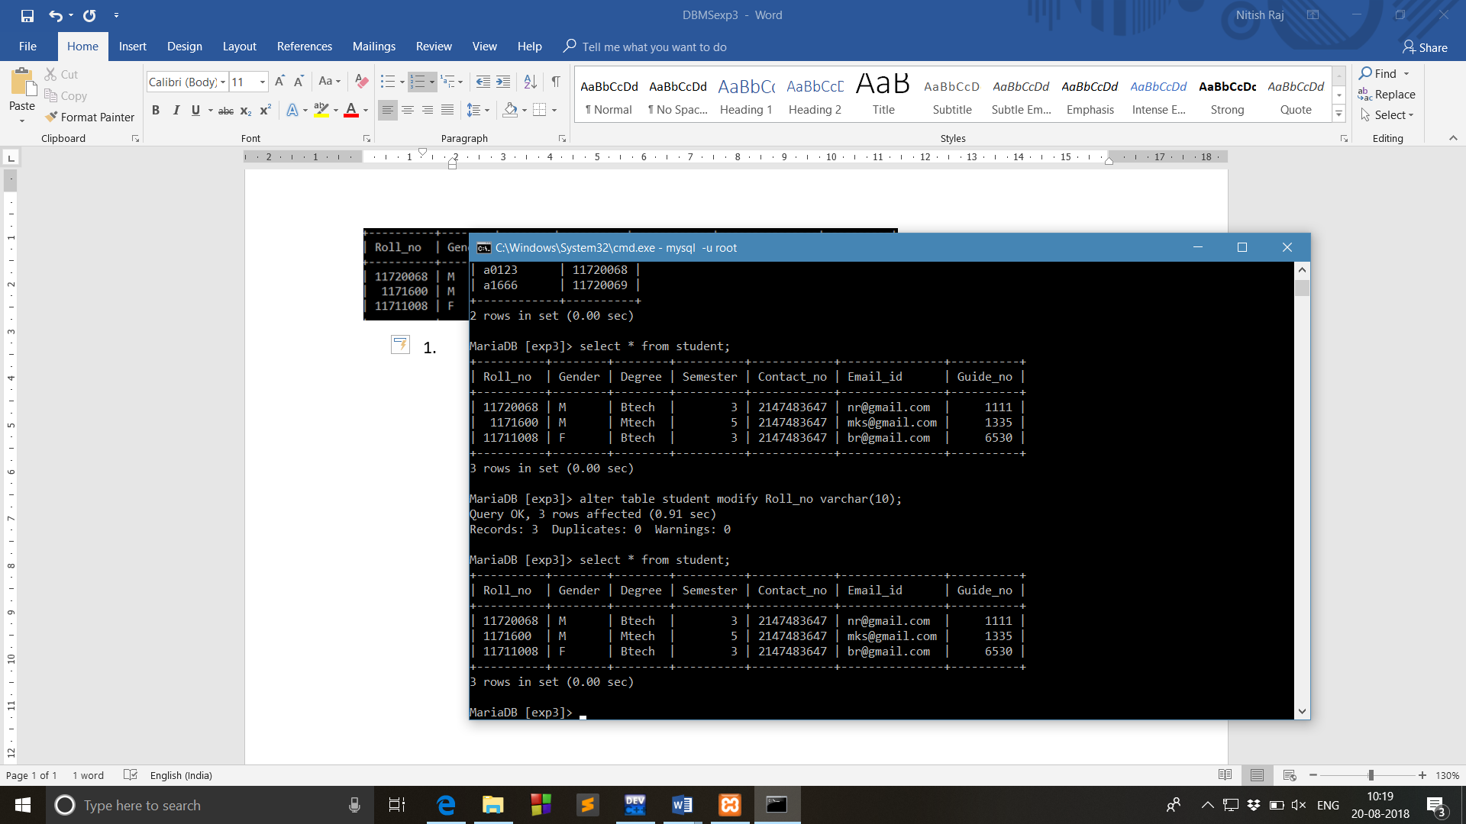

--------------------------------------------------------------------------------------------------------------------------------------

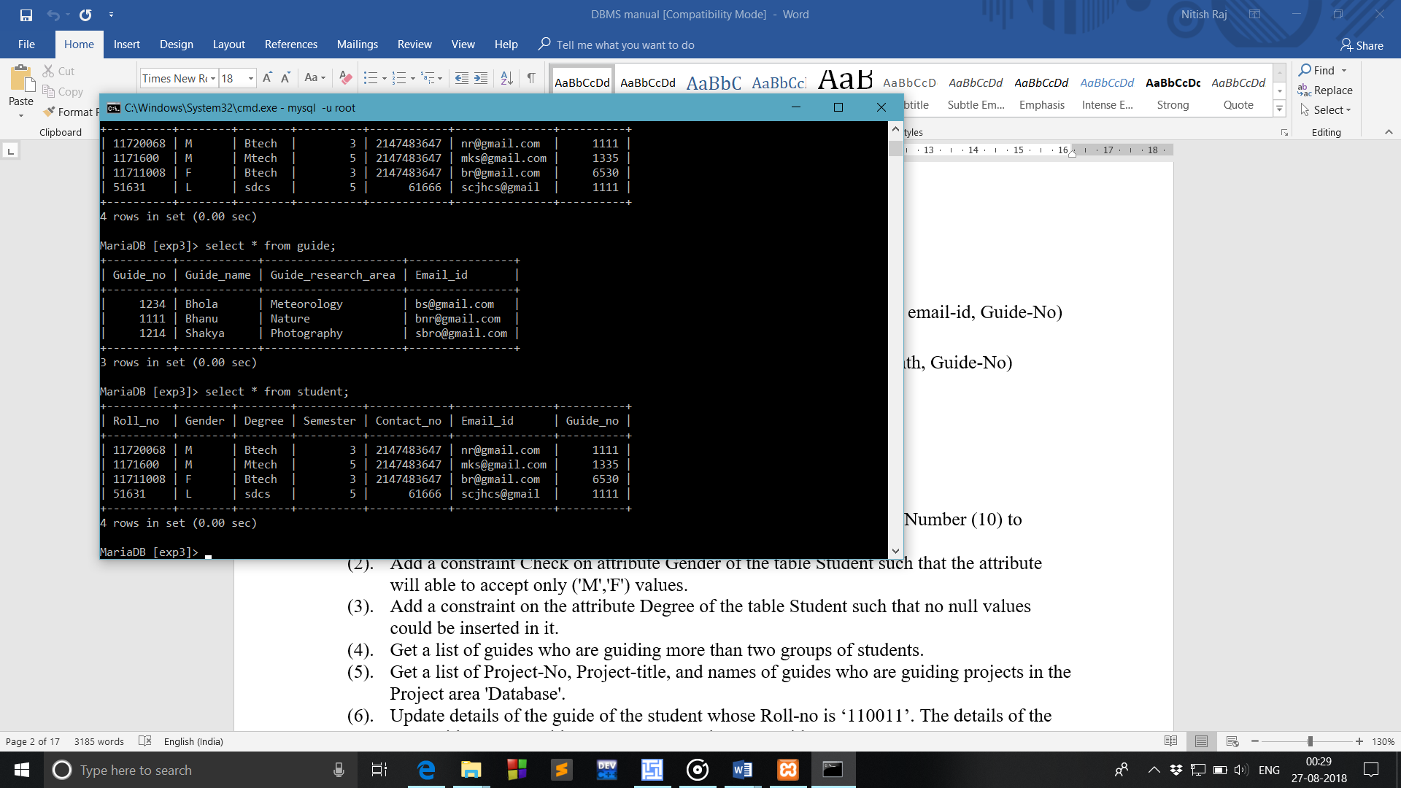

4. Get a list of guides who are guiding more than two groups of students.

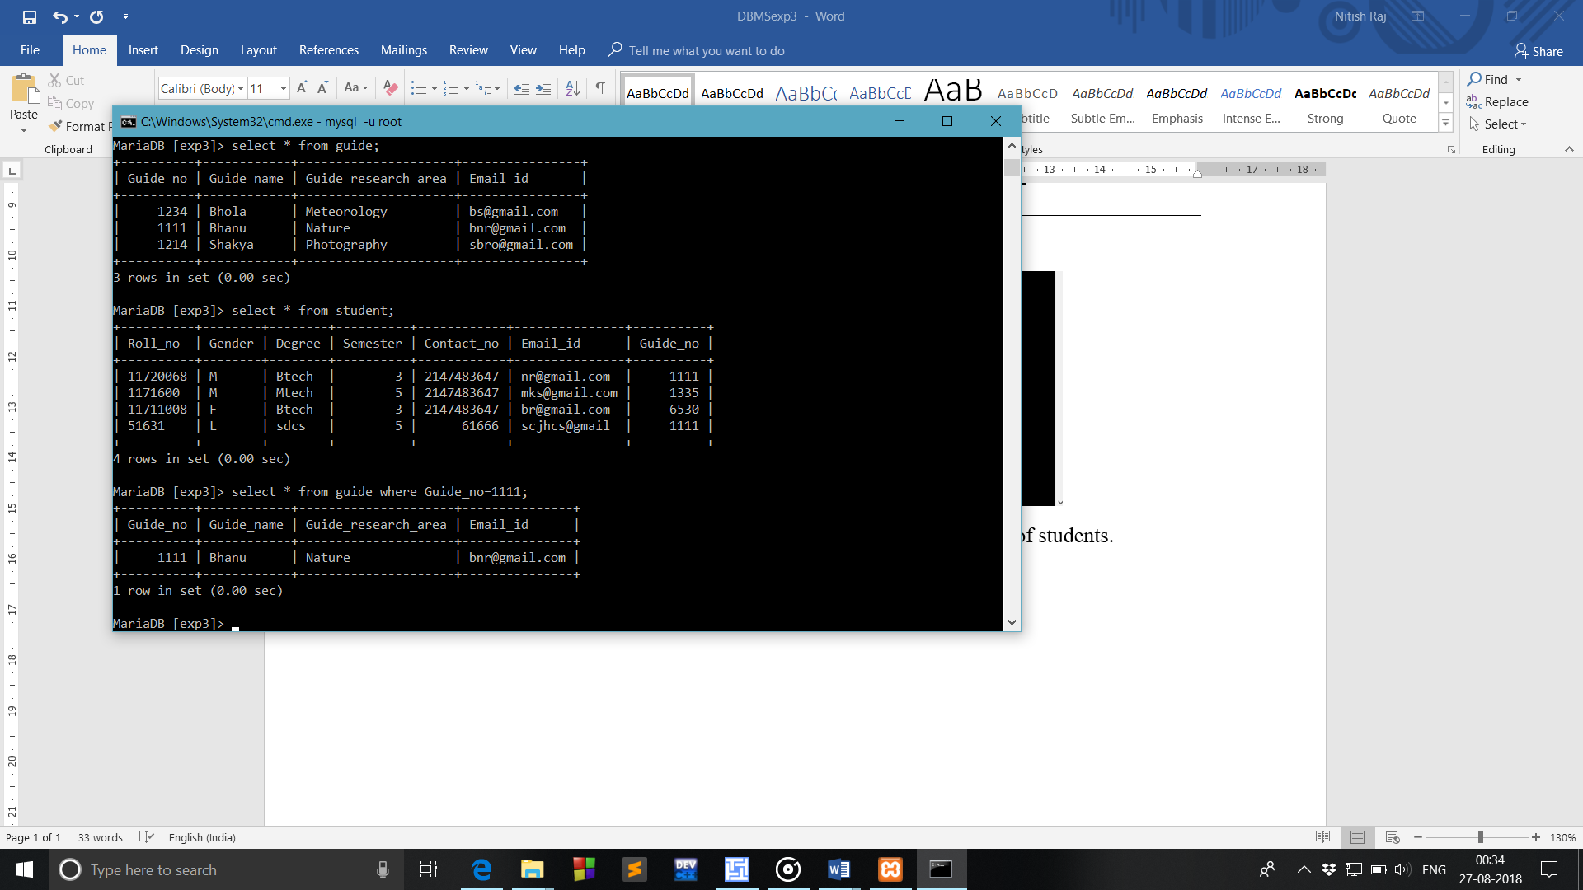

--------------------------------------------------------------------------------------------------------------------------------------

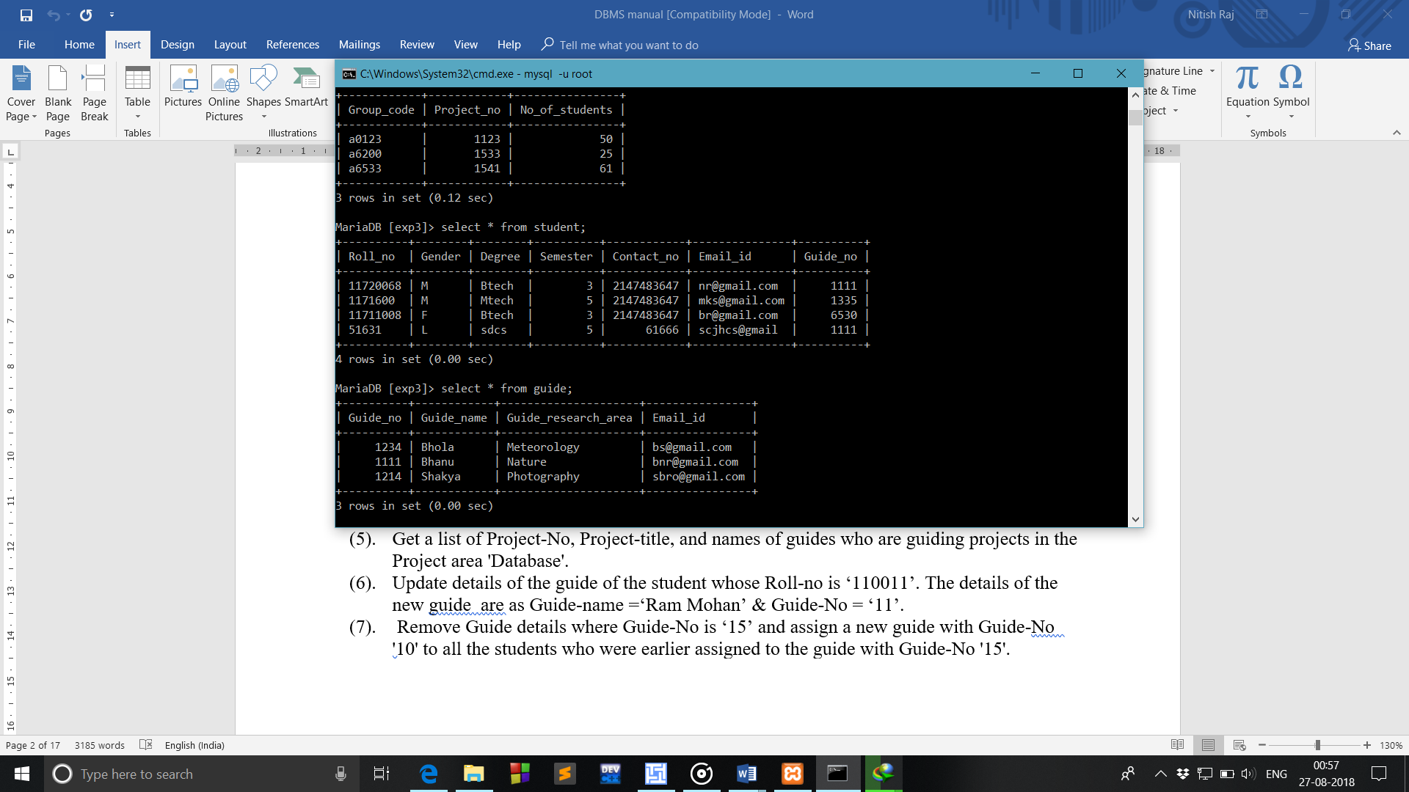

1. Remove Guide details where Guide-No is ‘1111’ and assign a new guide with Guide-No '2706' to all the students who were earler assigned to the guide with Guide-No '1111'.

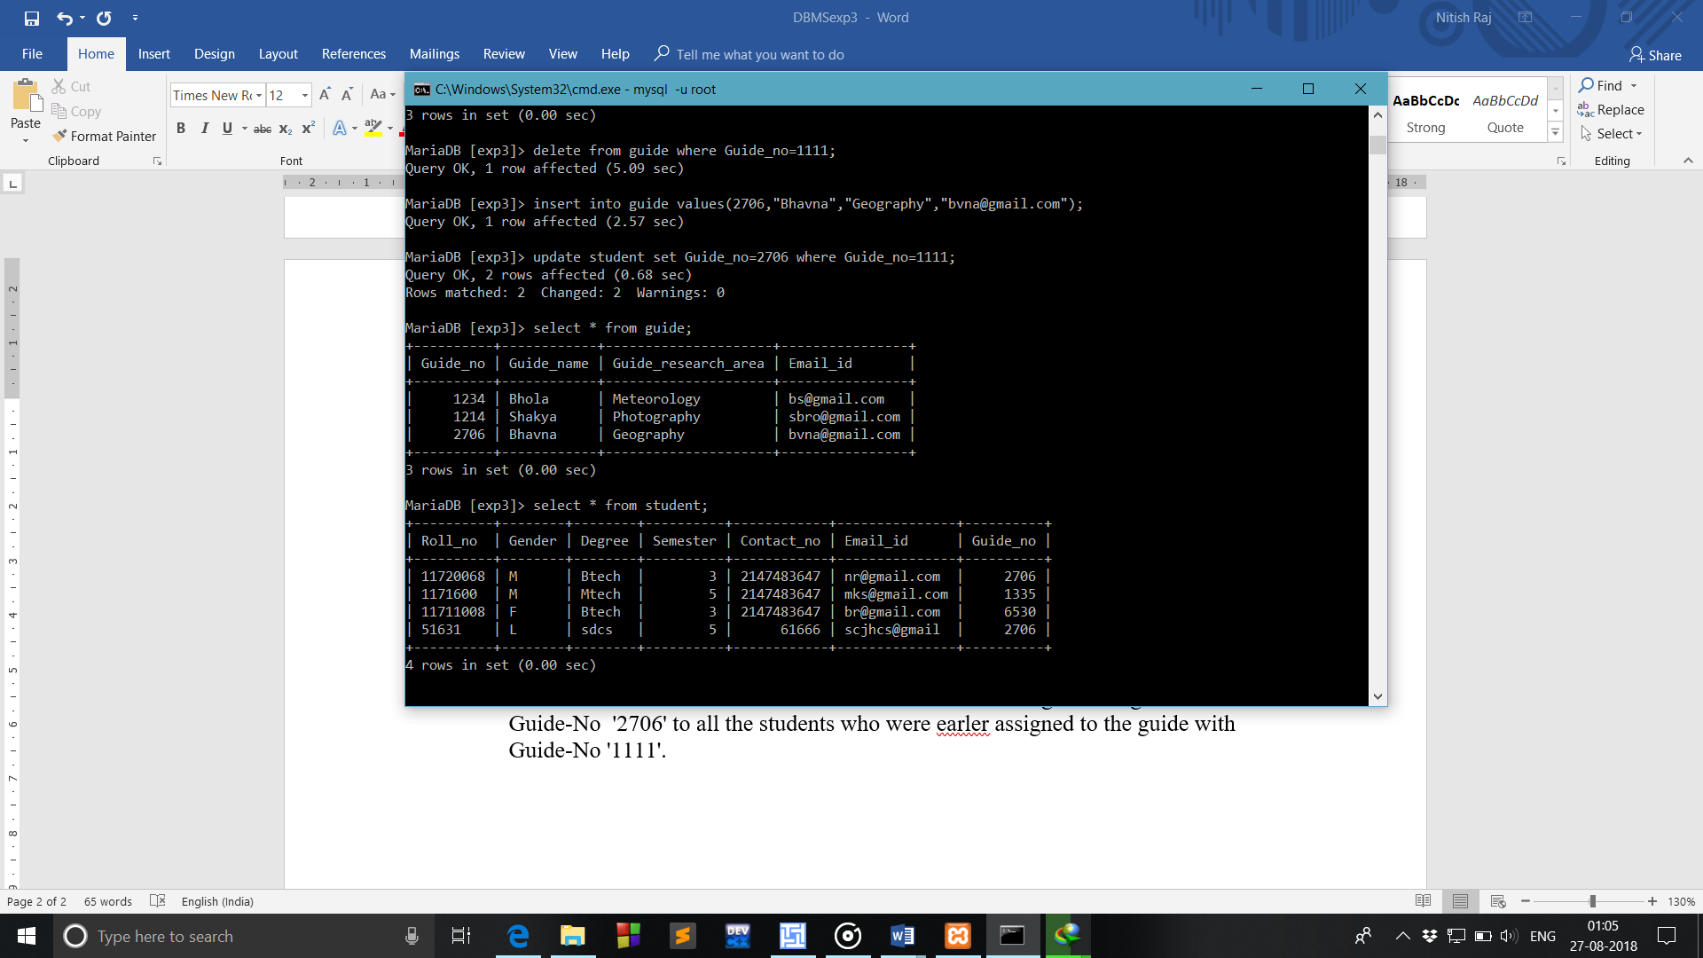

-----------------------------------------------------------------------------------------------------

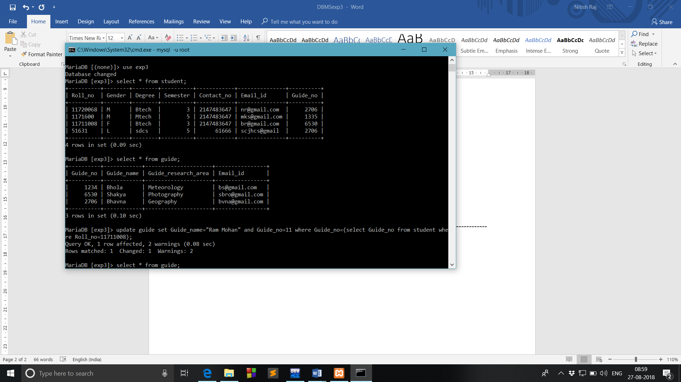

6. Update details of the guide of the student whose Roll-no is ‘11711008’. The details of the new guide are as Guide-name =‘Ram Mohan’ & Guide-No = ‘11’.

