**Portfolio Project Plan**

Student Number: [Your Student Number]

Module Name: Introduction to Programming

Submission Deadline:

**Table of Content**

**Introduction 3**

**Project Plan Cycle 3**

**Feasibility Report 5**

**Scope 5**

**Time 6**

**Budget 6**

**Resources 6**

**Risks 7**

**Stakeholders 9**

**Stakeholder Analysis 9**

**Project Goals 10**

**Project Goal: Design 10**

**Purpose 10**

**Advantage 10**

**Measurement 11**

**Reasonability 11**

**Feasible 11**

**Project Goal: Implementation/Development 12**

**Purpose 12**

**Advantage 12**

**Measurement 12**

**Reasonability 12**

**Feasible 13**

**Project Tasks 13**

**Gantt Chart 13**

**Detailed Task Breakdown 13**

**Project Schedule 15**

**Risk Management Plan 15**

**Risk Register 16**

**Risk Response Strategies 17**

**Critical & High Risks 17**

**Medium Risks 18**

**Low Risks 18**

**Contingency Planning 18**

# 

# Introduction

In this project plan, i will create a detailed digital portfolio to apply to IT apprentice jobs at Konnekted and other companies. The portfolio will represent the abilities, accomplishments, and the tasks done throughout the course of BTEC Level 2 First Extended Certificate in Information and Creative Technology.

The web-based solution that will comprise the digital portfolio will be a set of several HTML pages linked together, as it will be impressive to the recruiters and will show the technical competency appropriate to take an IT apprenticeship position. The project is based on the systematic procedure that includes the stages of design, development, testing, and assessment.

**Project Duration:** January 30, 2025 - June 17, 2025 (20 weeks)

**Target Audience:** IT recruiters and potential employers (primarily Konnekted)

**Platform:** Web-based portfolio accessible via browsers

# Project Plan Cycle

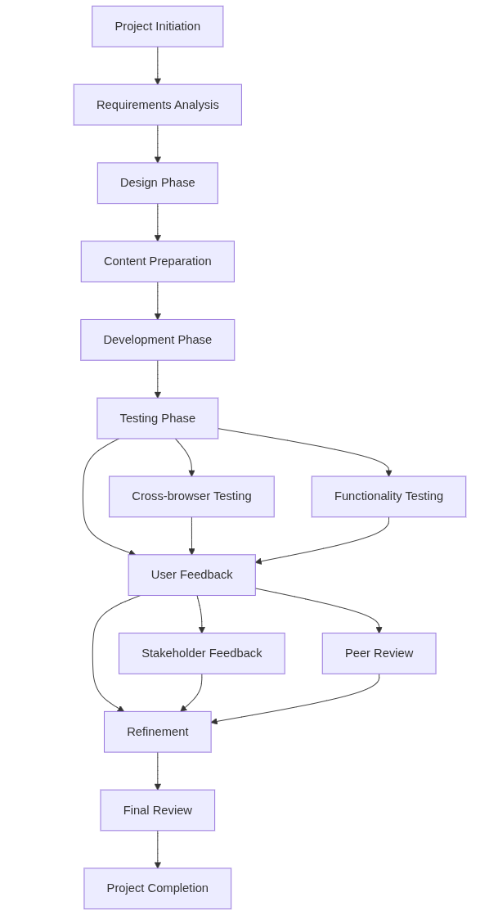

# Feasibility Report

## Scope

Development of the web-based portfolio is a complex and systematic process, and the project includes it all. This starts with meticulous design documentation that gives detailed storyboards, navigation charts and a complete listing of assets. These factors play an important role in establishing a foundation of a consistent user experience and visual design. The fundamental deliverable is an HTML-based web portfolio, comprising of at least eight completed screens that demonstrate the extent of the learner creative and technical potential.

The portfolio will incorporate the content of all the units of BTEC done to ensure comprehensive presentation of the skills gained during the course. To ensure accessibility and usability, the site will be tested in cross-browser compatibility, which ensures that the site works in a consistent manner across all the modern web browsers. As well, the project will include the collection and implementation of user feedback and will focus on the iterative design and the ability to respond to the needs of the users. The process will end with an overall project assessment, which will critically examine how well the portfolio achieves its targets and areas that can be improved in future.

Nevertheless, some sophisticated features are absent in the project. It does not include backend database integration and dynamic server-side capabilities, i.e. no real-time data storage and user authentication system will be used. More so, advanced JavaScript frameworks like React, Angular, or Vue are out of the scope of this project. Finally, this initiative does not include mobile application development, so the scope of the effort is concentrated on desktop and browser-based web solutions.

## Time

The project is conducted in 20 weeks between January 30 and June 17, 2019, and is separated into four primary stages. The Design Phase takes 5 weeks (January 30 to March 4) and involves planning, designing storyboards and asset preparation. This will be followed by a 10-week Development Phase (March 5 to May 14) where the HTML-based portfolio will be constructed, and contents will be incorporated therein. Testing and Refinement (May 15 to June 3) is allocated the following 3 weeks, which will deal with cross-browser testing and the implementation of user feedback. The last 2 weeks (June 4 to June 17) comprise the Final Review Phase, during which the project is reviewed and displayed in its final version.

## Budget

The project runs on zero cost budget and makes full use of the available free resources. The software licenses will not be charged since the creation will be based on free technologies like HTML, CSS, and open-source text editors. Hosting is done by school's servers and so there is no cost of hosting. Domain registration is free (a free subdomain is utilized). On the same note, the asset generation tools are procured on free or open-source platforms. Therefore, the overall estimated budget will be 0, which proves that the accessible resources will be used efficiently without affecting the quality of the project.

## Resources

To successfully complete this project there will be several resources that are required for this.

These resources are as follows:

Technical Resources:

* Software: HTML/CSS editors, image editing software, browsers for testing and Microsoft Word
* Hardware: Desktop computers, various devices for testing
* Network: School internet connection and server space

Content Resources:

* Work samples from completed BTEC units
* Personal achievements and qualifications
* Images, audio, and video content
* Documentation and written work

## Risks

Technical challenge of cross-browser compatibility is one of the high-risk factors. As the project needs to work effectively with various web browsers, the differences in the rendering of HTML and CSS might cause the problems with the layout or even break the functionality. This is a risk that will need proper testing and maybe code modifications to provide a uniform user experience across all major browsers.

Delays in preparation of content by other BTEC units is another high-risk issue. The web portfolio depends much on the accomplished work of different units. failure to have this content prepared in time may push the integration to be delayed and have an impact on the entire project schedule.

The other medium risk is the problems in conversion of format of asset. Images and multimedia files might be in a format that cannot be deployed on the web, or that need to be optimized. Ineffective conversion tools may cause delays and extra work. This problem can be avoided by using standard formats early on.

Minor design changes depending on the feedback are one of the low-risk issues. Although design revision is expected to be an iterative process, regular minor changes may be time-consuming and lead to scope creep. Having a clear design vision and focusing on the necessary changes will allow reducing disruption.

Lastly, the risk of hardware or software access is minimal. Minor access to computers, software tools or the internet may act as a hindrance to the process particularly when the work must be completed beyond the school hours.

## Stakeholders

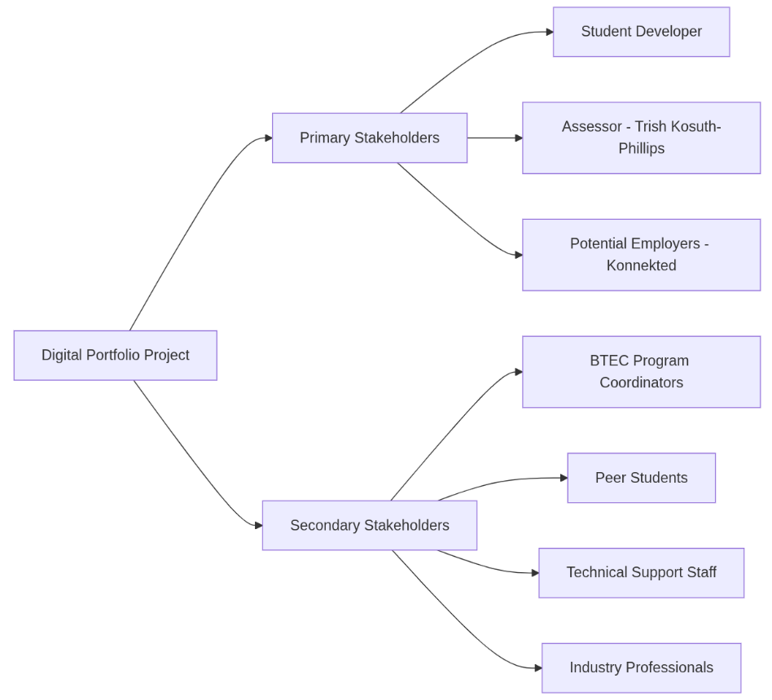

### Stakeholder Analysis

Primary stakeholders: They directly influence the success and assessment of the project. This can be the supervisor of the project, the instructors of the course and assessors who will check and grade the portfolio. They have expectations and need which are supposed to be critically considered during the project so that the product could be of academic quality and achievement of learning goals.

Secondary stakeholders: They contribute a background role in the project. This group can be classmates, peers, or technical support people who can play a role by providing feedback, confirming design choices, or helping with technical issues. Although they do not directly influence the outcome of the project, their feedback can greatly contribute to its quality and practicability.

The communication with stakeholders is ensured by means of the regular updates in the form of project documentation, status reports, and presentations. This brings about transparency and keeps all informed of the progress and enables prompt feedback and changes to be incorporated during the various stages of the project.

# Project Goals

## Project Goal: Design

### Purpose

This stage aims at developing a thorough design documentation that clearly describes the structure, the look and feel of the digital portfolio. It is a stage of planning that acts as a basis of all the further development work as the final product will be organized and will correspond to its aim.

### Advantage

A major benefit of this method is that there is a definitive development plan, which enables a leaner and more efficient construction process. It also saves the development time and gives a professional look which is well expected by the employers when it is properly planned. Also, a well-documented project will help communicate with stakeholders easily and make the approval process less complicated.

### Measurement

Success in this phase will be measured against a number of criteria: whether all design deliverables have been completed, whether a storyboard, a navigation chart, an asset list and alternative solutions have been explored. The quality of the design is approved by the assessor, and the possibility to justify the design decisions indicates a good sense of the target audience. Following the schedule, where the deadline is March 4, 2025, is also the significant sign of the successful planning.

### Reasonability

Regarding reasonability, the 5-week period is deemed as enough to have adequate and careful development of design. All the necessary tools and skills are already present, and the frequent advice of the assessor makes sure that the progress is maintained according to the expectations. The design is also complex enough to match the skill level of the developer now.

### Feasible

Lastly, it is completely possible to have the design documentation phase. No technical impediments exist to accomplishing the needed work, and all the software and tools are easily available. Assessment criteria are clearly outlined, and the project timeline has enough time to carry out this stage successfully.

## Project Goal: Implementation/Development

### Purpose

This stage aims at converting the accepted design plans into a completely operational web-based digital portfolio. The portfolio will present the BTEC coursework and the personal work of the student and can be regarded as not only a technical skills demonstration, but also a professional showcase of future possibilities.

### Advantage

The benefits of this development stage are great. It also shows practical skills in web development, leaving a practical asset that could be attached in job applications or university submissions. The end product showcases the technical competency of the student and becomes a permanent record of their work which can aid in further career growth.

### Measurement

Success metrics will entail successful completion of a fully functional portfolio with all the required pages completed and passed cross-browser compatibility tests. User satisfaction will also be considered as an essential indicator, and the desired result is to receive at least 80 percent positive feedback. It is also necessary that all the course work of the corresponding BTEC units should be wholly incorporated, and the final deliverable should satisfy the stated assessment criterion i.e. 2B.P3, 2B.P4 and 2B.P5.

### Reasonability

The 10 weeks development period is sound in regard to the extent of the work. The HTML and CSS skills required are within the existing skills of the student. Regular testing at built-in checkpoints should help to ensure that problems are detected at an early stage, and an iterative development process should provide opportunities to continually improve a product in response to feedback and technical insights.

### Feasible

The stage is quite possible, since the technology stack selected corresponds to the current skills of the student. All the required development tools are easily accessible, and the content assets can be readied parallel with the technical effort. Moreover, the technical support is available in case of difficulties, which assists in achieving gradual progress and successful result.

## Project Tasks

### Gantt Chart

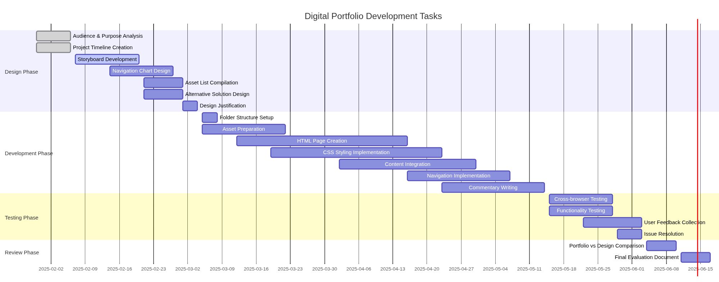

### Detailed Task Breakdown

1. Design Phase Tasks (Weeks 1-5)

* Evaluate target audience requirement and purpose of the portfolio
* Structure and user flow navigation design
* Complete asset list and source documentation
* Develop project schedule and milestones
* Record alternative design methods.
* Create 8+ screen storyboard layout and content
* Compose design rationale speaking to the needs of the audience

2. Development Phase Tasks (Weeks 6-15)

* Establish rational folder system on web files
* Get all digital assets ready and streamline them
* Develop HTML pages as per requirements of storyboard
* Combine material covered in all BTEC units finished
* Create navigation system between all pages
* Apply CSS styling to make them look similar
* Compose explanatory commentaries on every section

3. Testing Phase Tasks (Weeks 16-18)

* Portfolio test on browsers and systems.
* Collect opinions of the representative of the target audience
* Perform full functionality testing
* Solve emerging problems and make corrections

4. Review Phase Tasks (Weeks 19-20)

* Final portfolio against the original design
* Measure project success and recording lessons learned
* Be ready with suggestions on improvement in future

### Project Schedule

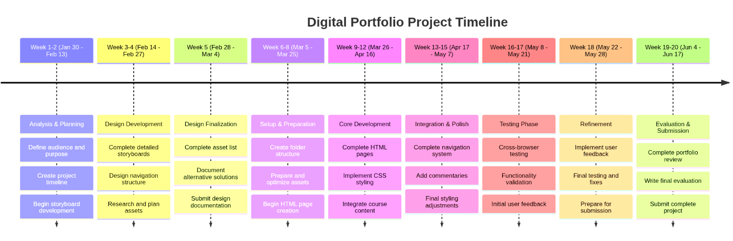

### Risk Management Plan

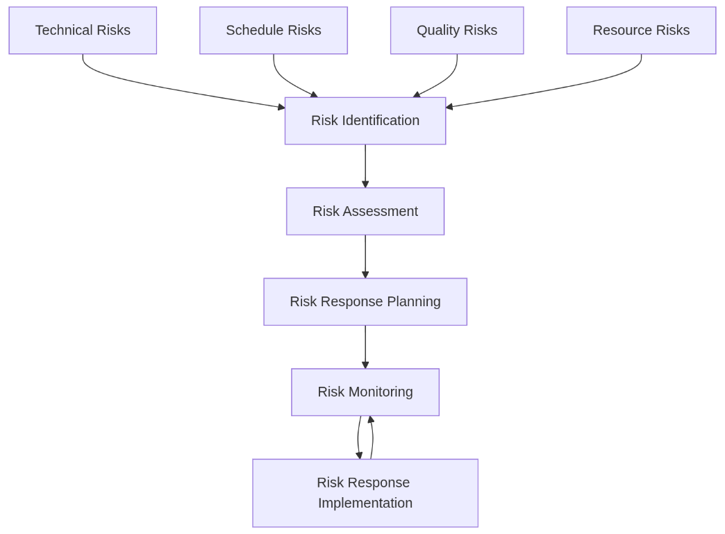

### Risk Register

|  |  |  |  |  |  |
| --- | --- | --- | --- | --- | --- |
| **Risk ID** | **Risk Description** | **Probability** | **Impact** | **Risk Level** | **Mitigation Strategy** |
| **R001** | Cross-browser compatibility issues | High | High | Critical | Early testing across browsers, progressive enhancement approach |
| **R002** | Insufficient content from other units | Medium | High | High | Early coordination with other unit instructors, alternative content preparation |
| **R003** | Technical skills gaps in HTML/CSS | Medium | Medium | Medium | Additional tutorials, peer assistance, assessor guidance |
| **R004** | User feedback collection delays | Medium | Medium | Medium | Multiple feedback channels, early recruitment of testers |
| **R005** | Asset preparation time overruns | High | Medium | Medium | Parallel asset preparation, simplified alternatives ready |
| **R006** | Server/hosting technical issues | Low | High | Medium | Backup hosting options, local development environment |
| **R007** | Design changes affecting timeline | Medium | Low | Low | Design freeze after approval, change control process |
| **R008** | Hardware/software access problems | Low | Medium | Low | Alternative access arrangements, portable development setup |

### Risk Response Strategies

### Critical & High Risks

According to the project, there are some critical and high-risk areas that need to be proactively managed. The former, R001 (Cross-browser compatibility), can be handled by applying progressive enhancement strategies and by testing early and often to ensure rendering problems between various browsers are detected. The second, R002 (Content availability), is a threat because it relies on the content of other BTEC units. To handle this, communication with related instructors will be necessary and backup material will be made ready in advance to avoid delays.

### Medium Risks

The medium level risks should also be well planned. R003 (Skills gaps) might occur when the technical skills are not sufficient with regard to the project requirements. To reduce this, more learning time will be allocated, and support resources will be used. R004 (Feedback delays) can be addressed by initiating the feedback gathering procedure as soon as possible and through numerous avenues, including peer reviews and surveys, to receive prompt input. R005 (Asset preparation) risks are mitigated by asset creation efforts in collaboration with developing and preparing less complex alternatives.

### Low Risks

The issues that are in the low-risk category are ones that are continuously monitored, and in case they occur, they are addressed through normal response procedures. These involve the minor disturbances which may not have major effects to the time scale and quality of the entire project.

### Contingency Planning

In case of an eventuality, a comprehensive contingency plan is at hand. The schedule has a 2-week buffer to accommodate delays without impacting on the final delivery. To maintain the project on track, features that are not necessary can be eliminated, if needed. Reduced design options are made on essential parts, so that important functions would be retained. Also, there is a good support system put in place, with frequent contact with the assessor, peers and the technical support personnel.