Cloud Data Centres
Lab 2

1. Publishing and Exposing Ports

1.1 Publishing Ports
This was trivial to do, had no issues at all.
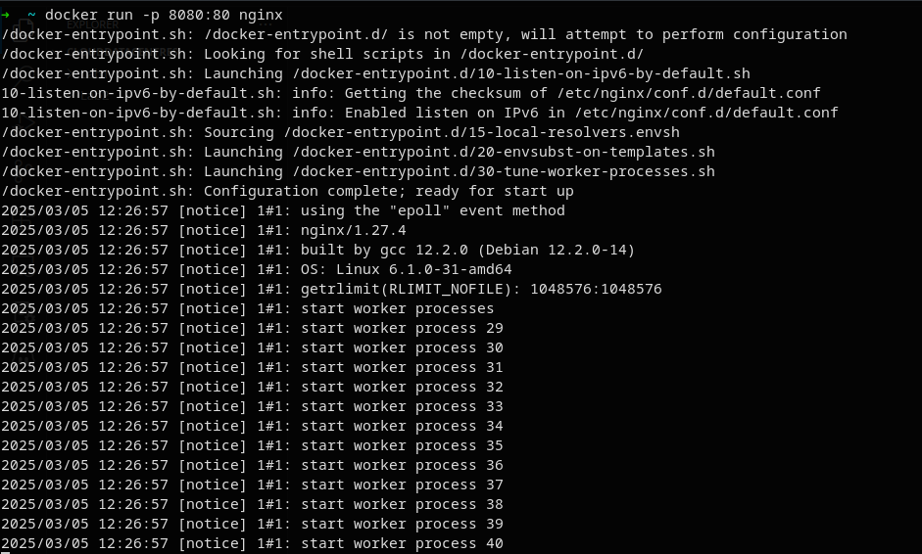

1.2 Ephemeral Ports
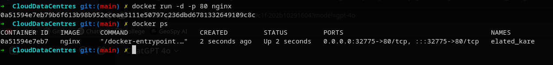
Had some issues making it run in the background so I could check the port via docker ps. Adding the -d flag allowed it to run detached so I could view the port. Other than that, no issues.

1.3 Publishing All Ports
This one had no issues.

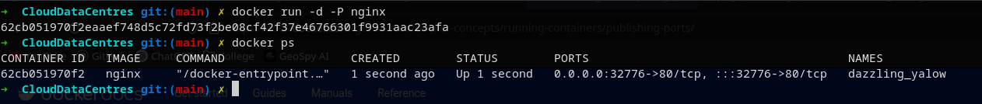
1.4 Final step
Now it was time to actually run the welcome-to-docker container.
It first downloaded the image since it was not found locally, it then went and ran the container on host port 8080 and container port 80.

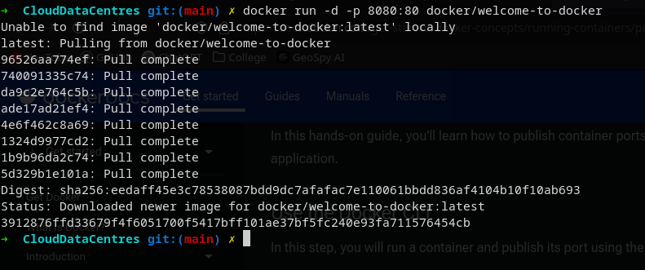
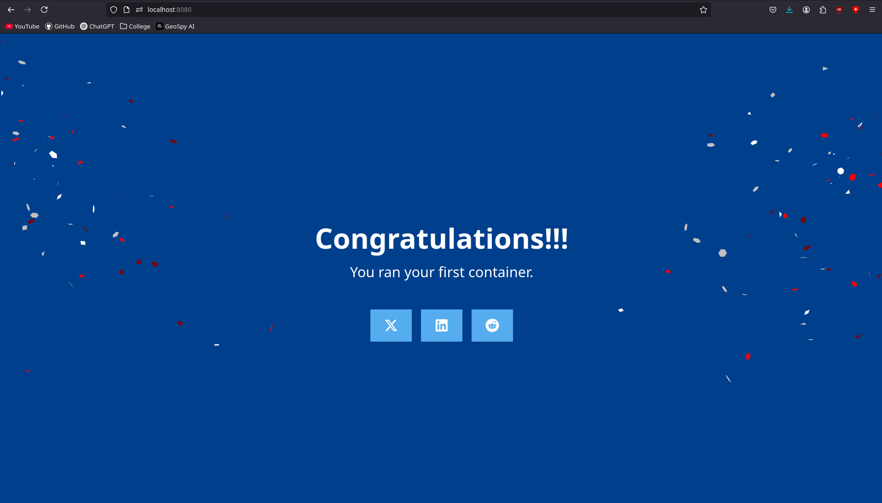
1.5 Docker Compose
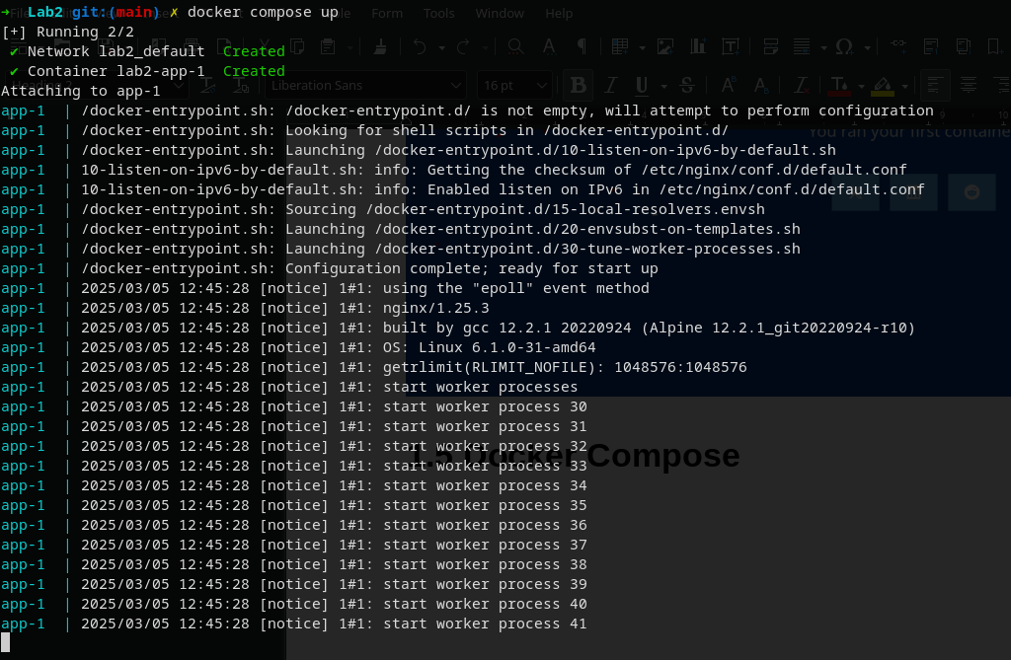
Using docker compose was also very simple and had no issues.

2. Overriding Container Defaults

2.1 Running Multiple Postgres Databases

