**Bash**

1. Task A.
2. Task B.
3. Task C.
4. Task A.

**Create a script that uses the following keys:**

1. When starting **without parameters**, it will display a list of possible keys and their description.

2. The **--all** key displays the IP addresses and symbolic names of all hosts in the current subnet.

3. The **--target** key displays a list of open system TCP ports.

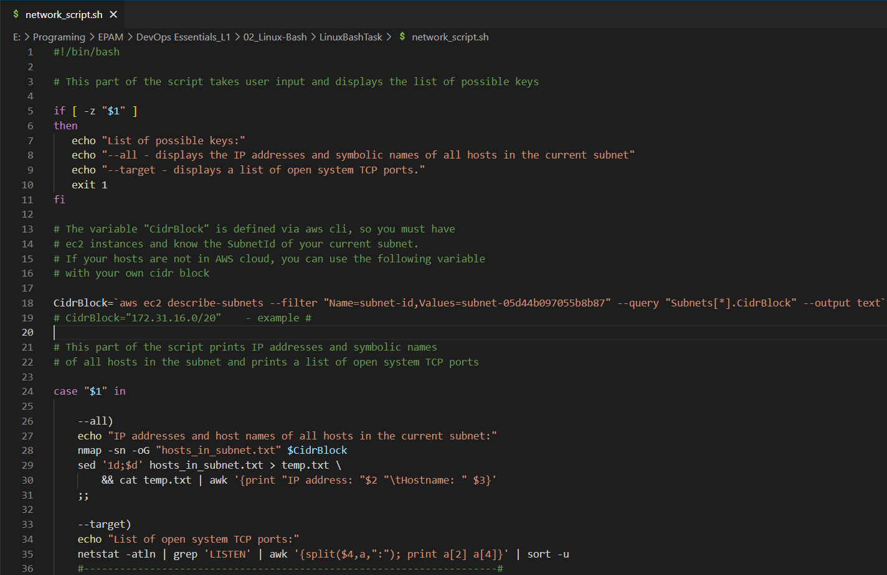

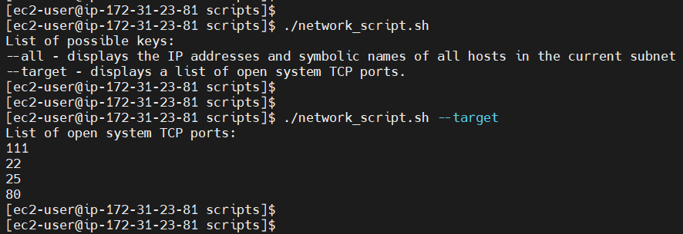



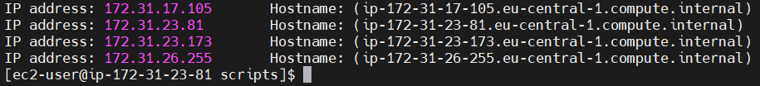

1. Task B.

**Using Apache log example create a script to answer the following questions:**

1. From which ip were the most requests?

$ cat example_log.log | awk '{print $1}' | sort | uniq -c | sort -nr -k1 | head -n1

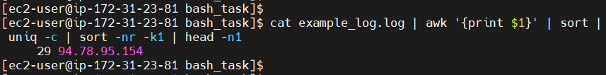

1. What is the most requested page?

$ cat example_log.log | awk '{print $11}' | sort | uniq -c | sort -nr | head -n2 | tail -n1

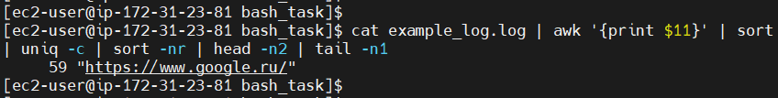

1. How many requests were there from each ip?

$ cat example_log.log | awk '{print $1}' | sort | uniq -c | sort -nr -k1

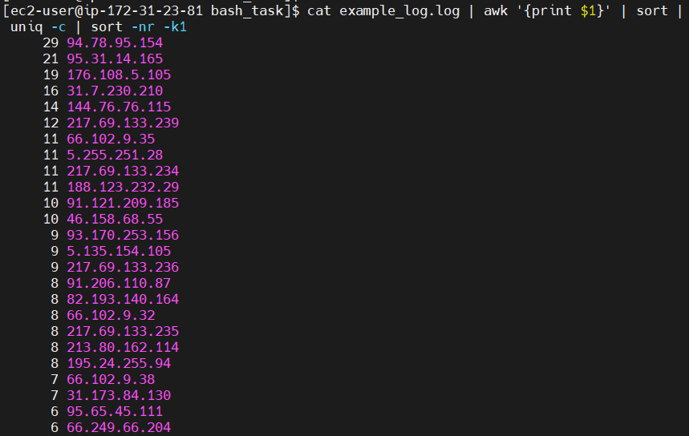

1. What non-existent pages were clients referred to?

$ cat example_log.log | awk '$9 == 404 {print $9 "\t" $11}' | sort -n | uniq

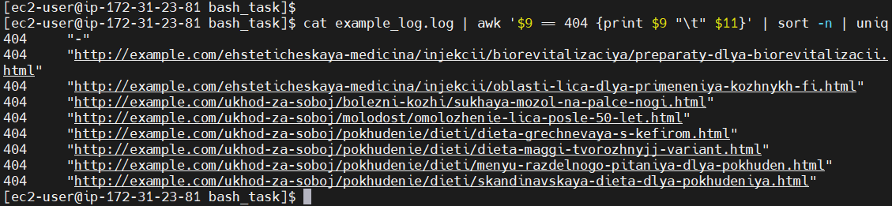

1. What time did site get the most requests?

$ cat example_log.log | awk -F':' '{print $2 ":" $3}' | uniq -c | sort -nr | head -n1

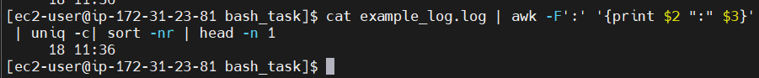

6. What search bots have accessed the site? (UA + IP)

$ cat example_log.log | awk '{print $1 "\t" $12 $14 $15}' | sed -n /bot/p | sort | uniq

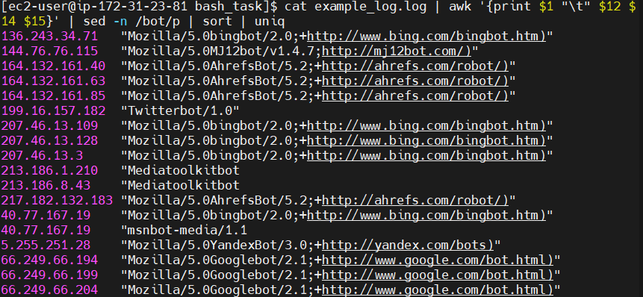

* **Bash script for task B:**

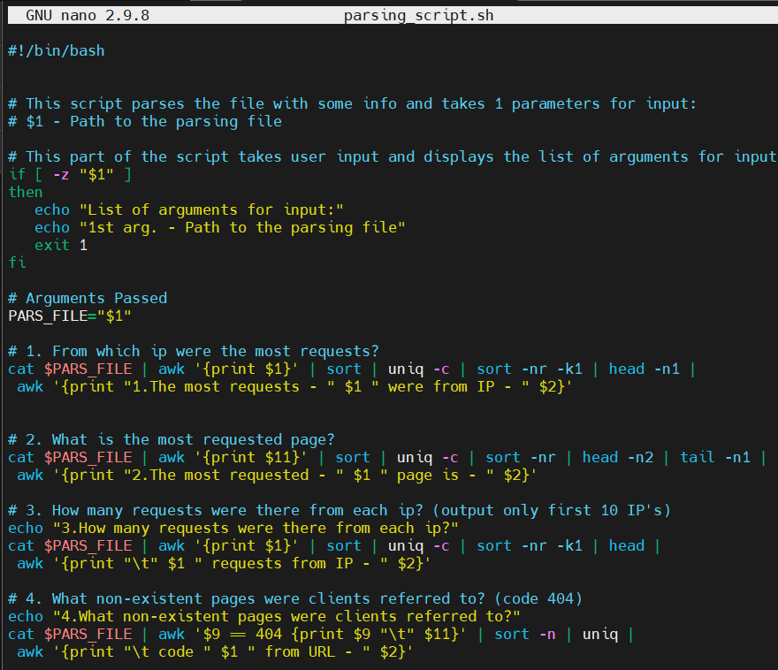

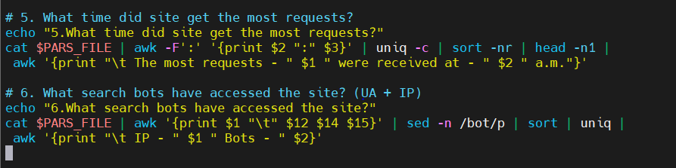

* **Run script for task B:**

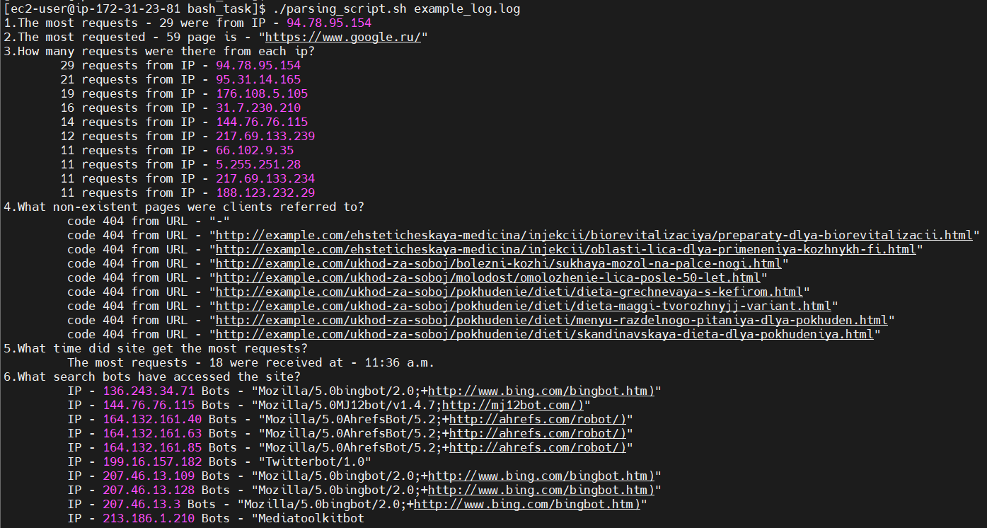

1. Task C.

**Create a data backup script that takes the following data as parameters:**

1. Path to the syncing directory.

2. The path to the directory where the copies of the files will be stored.

In case of adding new or deleting old files, the script must add a corresponding entry to the log file cat. [The command to run the script must be added to crontab with a run frequency of one minute].

* **Script**

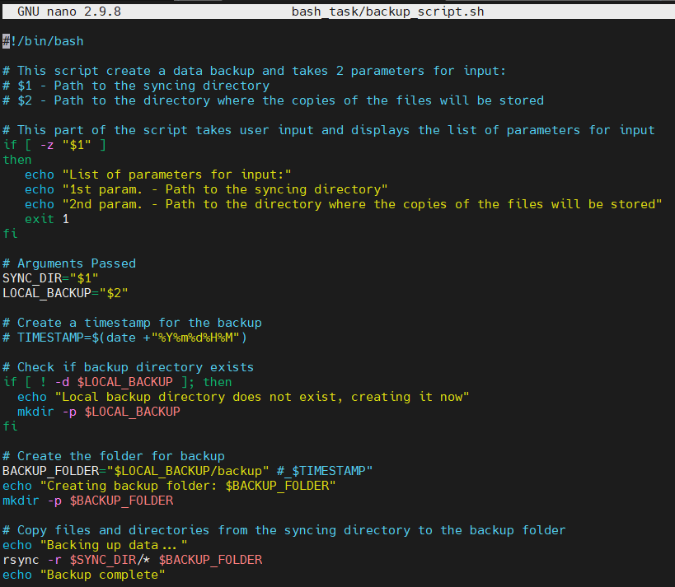

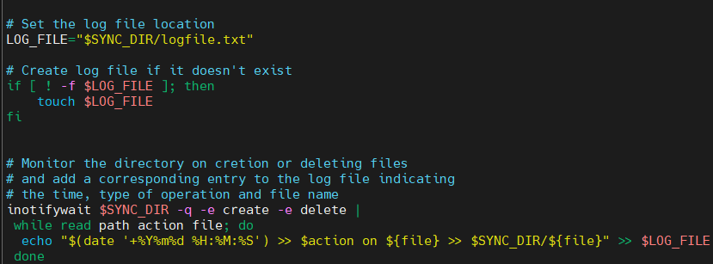

* **Example of the script working**

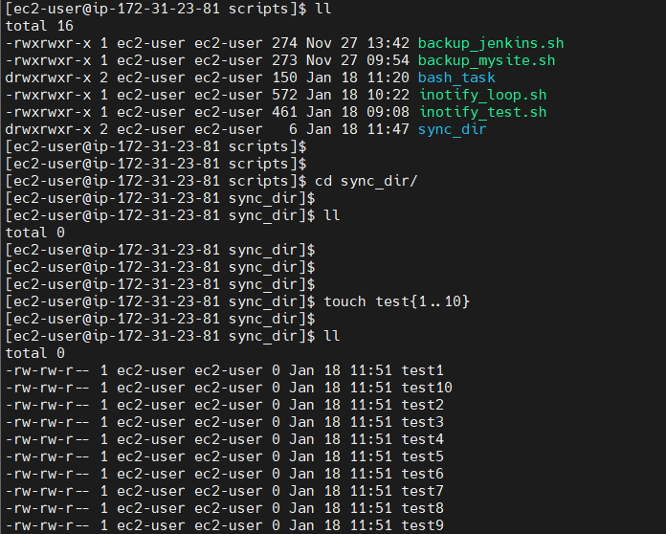

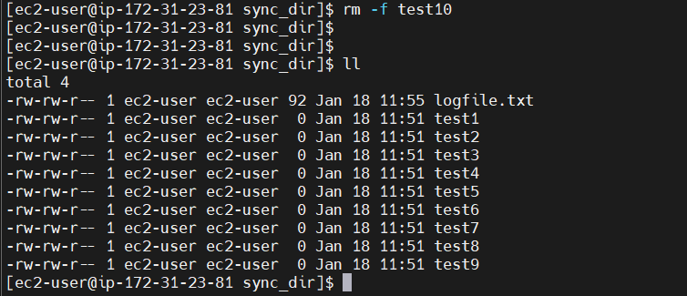

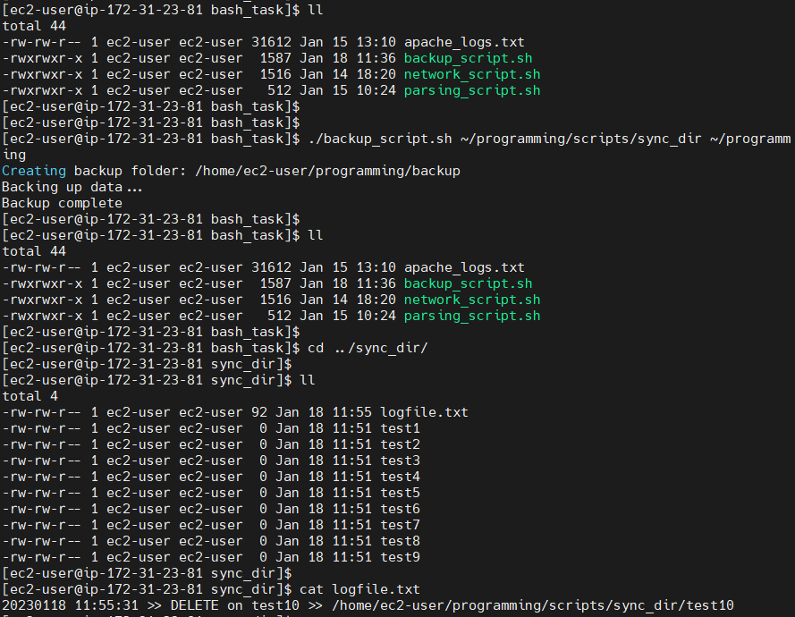

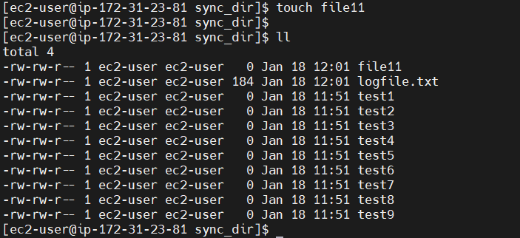

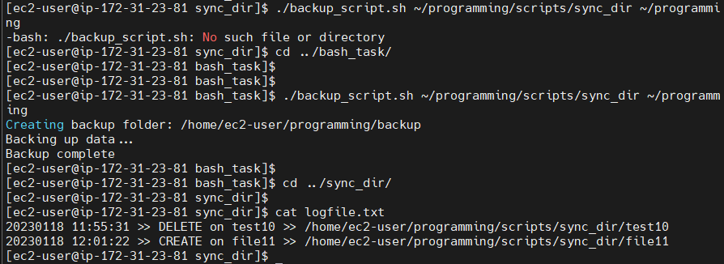

* **Crontab (run the script frequency of one minute)**

