- Connecting to broker and subscribing using different QOS
  - QoS – 0
Only get ack for the subscription. (first 3 lines are connection ack and subscribe)
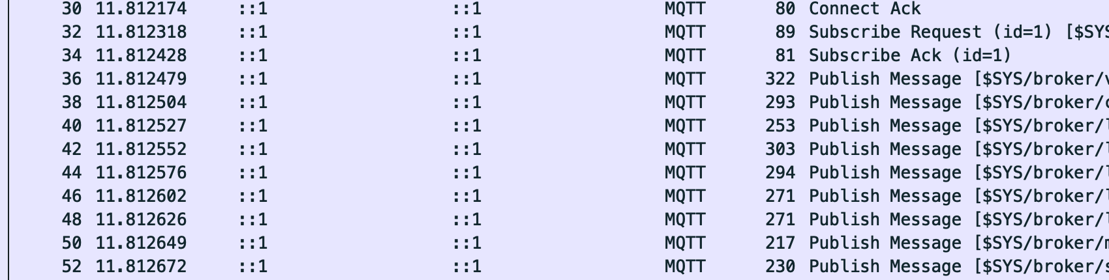
  - QoS – 1
Broker gets an ack by the receiver
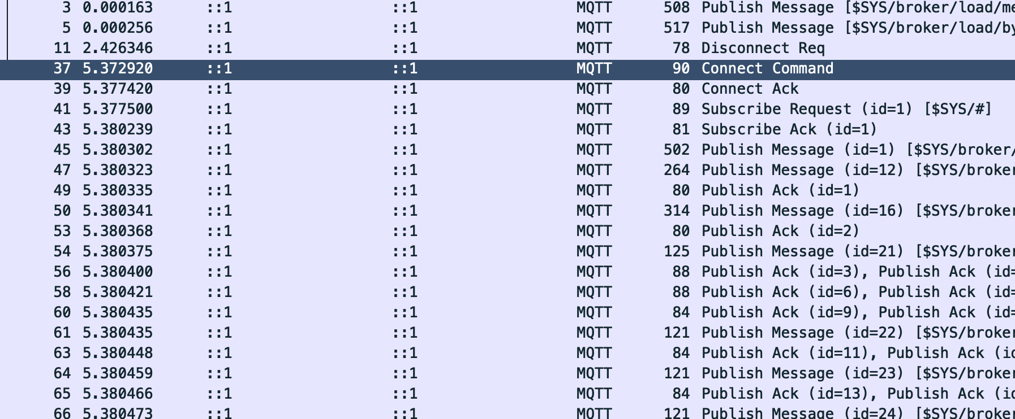

  - QoS – 2
  - Publisher sends PUBLISH
  - Broker replies with PUBREC(which it gets from the receiver)
  - Publisher sends PUBREL
  - Broker replies with PUBCOMP(which is then sent to the receiver)
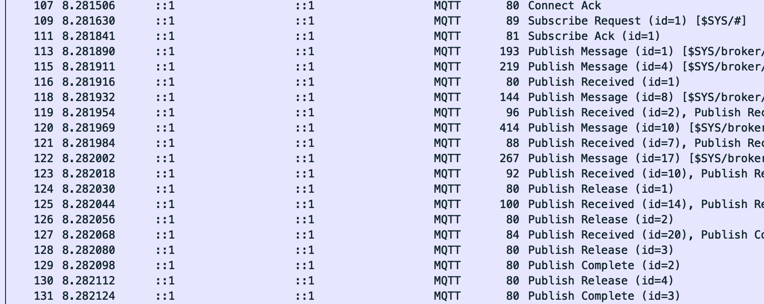
MQTT defines three levels of Quality of Service (QoS) to control message delivery:
- QoS 0 (At most once): Messages are sent once with no acknowledgment. Fastest and lightest, but offers no delivery guarantees. Best for non-critical updates (e.g., sensor telemetry).
- QoS 1 (At least once): Each message must be acknowledged by the receiver using a PUBACK packet. The sender retries until acknowledged. This can lead to duplicate messages if ACKs are delayed or lost.
- QoS 2 (Exactly once): Ensures that each message is received only once, through a four-part handshake (PUBLISH → PUBREC → PUBREL → PUBCOMP). Highest overhead, but essential for financial or control systems where duplicates must be avoided.
Wireshark captures confirm these differences — QoS 0 shows just PUBLISH, QoS 1 includes PUBACK, and QoS 2 spans multiple stages. Message order is not strictly guaranteed by any QoS; if ordering matters, application logic must handle it.
In practice:
- Use QoS 0 when speed is more important than reliability (e.g., live sensor data).
- Use QoS 1 for most cases where you want reliable delivery and can handle duplicates.
- Use QoS 2 when message duplication would cause serious problems.

- My computer malfunctioned and I lost a lot of progress from the report. I will show some post analysis for the first 5 test runs in the report. But the code can give a more complete summary.

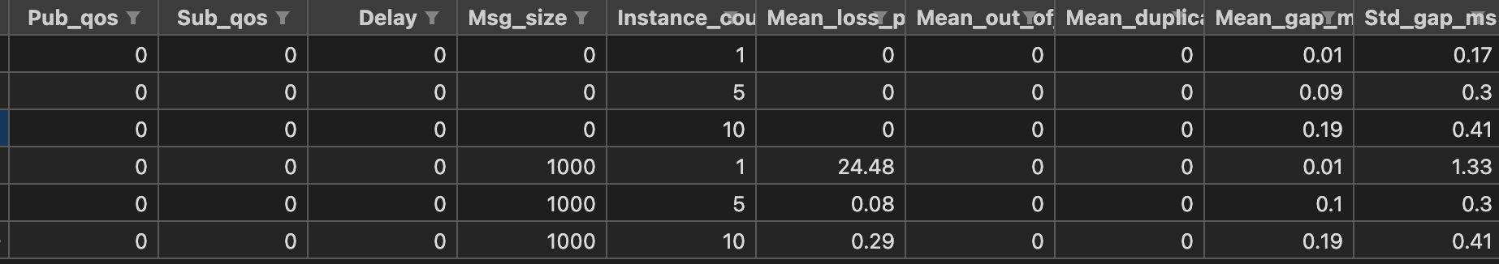

As the message size increases, the amount of messages that are lost also increases.
As the number of instances increases, the gap between send and receive also increases.

