**iNeuron – FSDS 2.0 Assignment 1 – Antash Kishore Sinha**

1. In the below elements which of them are values or an expression? eg:- values can be integer or string and expressions will be mathematical operators.

*

'hello'

-87.8

-

/

6

**Sol.**

Based on the given definitions

‘hello’, -87.8, and 6 are values

*, -, and / are expressions

**2. What is the difference between string and variable?**

**Sol.**

**Strings** represent sequence of characters which are enclosed in “single” or “double” quotes. They are immutable. Different operations such as concatenation, slicing, formatting, etc. can be performed on strings.

**Variables** are used to represent a value in the form of any data type such as strings, integer, decimal, etc. Variable is a box/container which stores a value of any data type in the memory during programming. They are created using assignment operator (=).



In the above example shown, ‘a’ is variable, and values assigned to it (‘my’,’name’,’is’,’antash’) are string data types.

**3. Describe three different data types.**

**Sol.**

Three different data types are –

* **Integer (int)** – These data types represent positive or negative whole numbers, not having any fractional part. Operations such as addition, subtraction, multiplication, division, etc. can be easily performed with them
* **Decimal point (float)** – These data types represent numbers in decimals or fractions. They are used when precision is required, such as in the case of laboratory measurements, real world data, etc. They can include exponent when representing very large or very small numbers. Arithmetic operations such as trigonometric functions, cubic roots, etc. can be performed on floating point numbers.
* **Text characters (string)** – These data types are used to represent, store, and manipulate textual data (sequence of characters). These are enclosed in either single quotes (‘’) or double quotes (“”). Operations such as concatenation, slicing, formatting, etc. are performed on them.

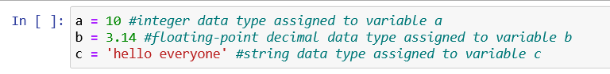

**4. What is an expression made up of? What do all expressions do?**

**Sol.**

Expressions are made up of literal values (numeric values), operators (+, -, /, <,>, =, =!, etc.), variables, and functions (length (len), maximum (max), minimum (min), etc.). They can be either as simple as single number and/or variable, or complex combination of all.

Expressions allow to perform calculations, make decisions, control program flow, and represent and manipulate data during programming. They help in evaluation/calculation of a single value. They are the fundamental building blocks creating algorithms, and implementing logics in python programming.



5. This assignment statements, like spam = 10. What is the difference between an expression and a statement?

**Sol.**

An expression is a combination of values, variables, operators, and function calls that evaluate a single value. It can be as simple as a single variable or a literal value, or it can be a complex combination of multiple components. It is evaluated to produce a single value of specific data type.

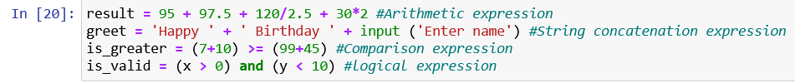

A statement on the other hand is a complete unit of code that performs an action or a series of action. It is used to control the flow of the code execution, perform actions, or manipulate the data. It does not necessarily produce a single value.

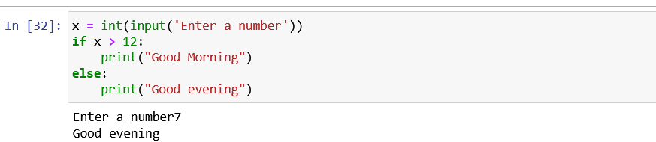

Expressions are used within statements to compute values or determine behaviour of the program. Statements, on the other hand are building blocks of program, containing expressions, defining logic and structure.

**6. After running the following code, what does the variable bacon contain?**

bacon = 22

bacon + 1

Sol.

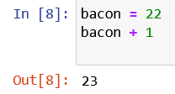

The variable ‘bacon’ still contains the value 22 only as it hasn’t been reassigned the result value. To contain the new value, it has to be reassigned as

bacon = bacon + 1

**7. What should the values of the following two terms be?**

'spam' + 'spamspam'

'spam' * 3

**Sol.**

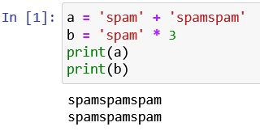

The first operation is string concatenation. While the second operation is string repetition/ multiplication operation. In both the case, we get the output as ‘spamspamspam’.

**8. Why is eggs a valid variable name while 100 is invalid?**

**Sol.**

For naming a variable (identifiers), there are certain rules to be followed, which are:

* The name can contain lower case letters (a – z), Upper case letters (A – Z), digits (0-9), and underscore (_)
* The name can not start with a digit and can not contain special characters ($%#^&)
* The variable name can not be a reserved word/keyword (input, print, if, elif, etc.)

Here, since ‘eggs’ satisfies the naming rules, it is a valid variable name. However, 100 is a digit and contradicts the second rule, hence it is invalid.

9. What three functions can be used to get the integer, floating-point number, or string version of a value?

**Sol.**

Three functions required are

* int – integer values
* float – floating-point number
* str – string

**10. Why does this expression cause an error? How can you fix it?**

'I have eaten ' + 99 + ' burritos.'

**Sol**.

In this expression, string values and integer value (99) are being tried to be concatenated. A string (str) can concatenate (can be linked) with string only, and same goes with integer value. Hence, due to this a TypeError is shown.

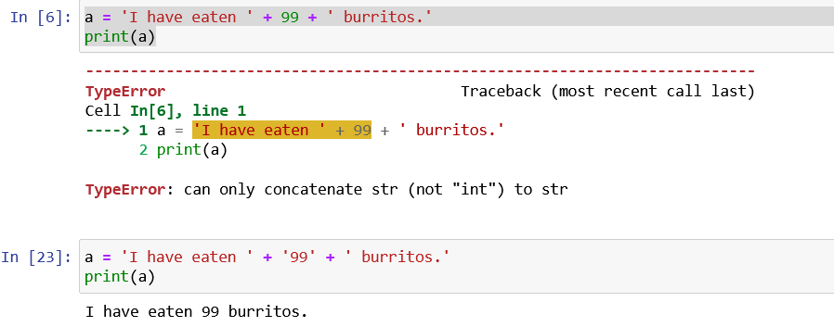

It can be fixed by adding commas, and converting 99 to a string value as shown below.

‘I have eaten’ + ‘99’ + ‘burritos’