# **Shared Libs and Project Executable that runs with shared libs**

## creattion of shared libs

* g++ -pie --shared names.cpp -o names.so

## compiling executable using shared libs

* gpp -o main.o -c main.cpp
* gpp -o main main.o names.so

## running the newly created executable that uses the shared libs at runtime

* 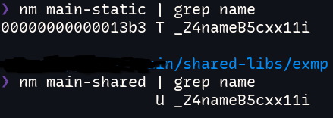LD_LIBRARY_PATH=. ./main-shared