Detecting Emotions with ML Algorithms: FER2013 vs KDEF
Assignment 2 report (draft) ·Acar, s.; Chandrasekaran, V.; da Silva Couto, H. | 5ARE0 (2026-GS1) Data analysis and learning methods | October 17, 2026

1. Introduction
This report studies facial expression recognition with classical machine learning on two datasets, FER2013 and KDEF, and asks which challenges are specific to each dataset and how well knowledge transfers between them. Section 2 covers the FER2013 baseline classifiers. Sections 3 to 7 cover the KDEF study, cross-dataset generalization, the fuzzy classifier, the creative challenge and the real-time demo. [TODO: One or two sentences summarising our overall main findings once all tasks are done.]

2. Task 1: FER2013 baseline

2.1 Data and protocol
FER2013 [REF] contains 48×48 grayscale face crops labelled with seven emotions. We use the provided split: 28,709 training images, 3,589 validation images (PublicTest) and 3,589 test images (PrivateTest). The training split was used to fit all models, the validation split for model selection and hyperparameter tuning, and the test split was used only once, for the final evaluation of the selected model.
The classes are strongly imbalanced (Table 1). Happy is the largest class (7,215 training images) while Disgust has only 436 (1.5% of the training set). Task 1 deliberately uses no class weighting, so that the plain baseline can later be compared with balancing strategies in the creative challenge (Task 5).
Class | Angry | Disgust | Fear | Happy | Sad | Surprise | Neutral
Train | 3,995 | 436 | 4,097 | 7,215 | 4,830 | 3,171 | 4,965
Validation | 467 | 56 | 496 | 895 | 653 | 415 | 607
Table 1: FER2013: class counts.
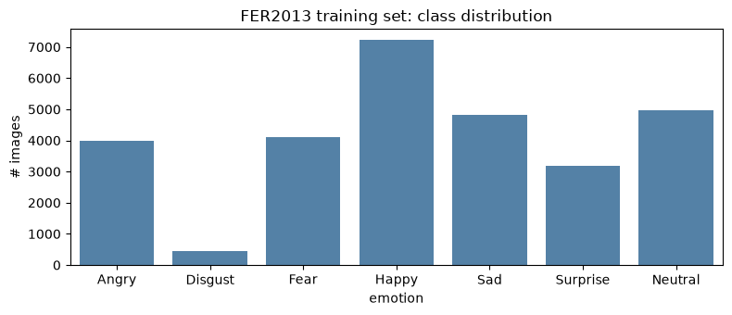
Figure 1: FER2013 training set: class distribution

2.2 Features and classifiers
Three feature types were extracted, each compared with three classifiers (3 × 3 = 9 models):
- HOG (900 dimensions): histogram of oriented gradients on the 48×48 image, 9 orientations, 8×8 pixel cells, 2×2 blocks with L2-Hys normalisation. HOG encodes local edge orientation (mouth corners, brows, eye shape, wrinkles) and the block normalisation gives some robustness to illumination.
- Facial landmarks (136 dimensions): the 68 dlib landmarks, centred and scaled to [-1, 1]. The whole 48×48 image is passed to dlib as the face box, so the same procedure can be reused in the real-time demo.
- PCA (100 dimensions): raw pixels scaled to [0, 1], projected with whitened PCA. PCA is fitted inside the scikit-learn pipeline on the training data only, which avoids leakage into the validation and test sets.
The classifiers are multinomial Logistic Regression (C = 1, standardised inputs), an RBF-kernel SVM (C = 1, gamma = "scale", standardised inputs) and a Random Forest (300 trees, sqrt features, no scaling). All use a fixed random seed (42).

2.3 Results on the validation set
Table 2 shows accuracy, balanced accuracy and macro-F1 for all nine combinations. Macro-F1 was the selection criterion, because it weights all seven classes equally and is therefore not dominated by Happy.
Features | Classifier | Accuracy | Balanced acc. | Macro-F1
HOG | Logistic Regression | 0.434 | 0.397 | 0.396
HOG | SVM | 0.542 | 0.482 | 0.505
HOG | Random Forest | 0.482 | 0.414 | 0.440
Landmarks | Logistic Regression | 0.430 | 0.360 | 0.354
Landmarks | SVM | 0.452 | 0.362 | 0.352
Landmarks | Random Forest | 0.465 | 0.410 | 0.430
PCA | Logistic Regression | 0.382 | 0.299 | 0.287
PCA | SVM | 0.476 | 0.410 | 0.430
PCA | Random Forest | 0.452 | 0.397 | 0.424
Table 2: validation results for all feature and classifier combinations. metric heatmaps of each feature-model combination on validation set are in Appendix A
Best classifier. The RBF-SVM is the best classifier on two of the three feature types (HOG: 0.505 macro-F1; PCA: 0.430, tied with landmarks + RF) and the best overall. Its non-linear kernel can model the non-linear relation between local gradient patterns and expression, which the linear Logistic Regression cannot: Logistic Regression is the weakest or near-weakest classifier for every feature type (0.287 to 0.396 macro-F1). The Random Forest is competitive only on landmarks, where it is the best classifier (0.430) and clearly beats the SVM (0.352). A plausible reason, which we have not tested, is that the forest can pick out a few informative coordinates from the 136 landmark values while the RBF kernel, with standardised inputs and equal weight on all coordinates, is diluted by the many uninformative ones. The SVM is also by far the most expensive model to train (741 s on HOG versus 48 s for the forest and 13 s for Logistic Regression), which matters for tuning and for the real-time application.
Best features. HOG is the best representation for all three classifiers (e.g. 0.505 versus 0.430 for PCA and 0.352 for landmarks with the SVM). We attribute this to HOG capturing local texture and edge information that distinguishes expressions (open mouth, raised or furrowed brows, wrinkles around eyes and nose), with some invariance to illumination. Landmarks discard all texture, and at 48×48 pixels the dlib landmark detector has to work with very low resolution, so the landmark positions are noisy. Landmarks are also computed with the full image as a face box, which assumes FER crops are well aligned; this is not always true (Section 2.5). PCA is a holistic linear projection of raw pixels, so it is sensitive to misalignment, pose and lighting, and keeps variance that is not necessarily relevant for expression.

2.4 Hyperparameter tuning and final test result
We tuned the regularisation constant of the selected HOG + SVM model over C ∈ {1, 5, 10}, using validation macro-F1 as criterion. To keep the search tractable, the grid was run on a random 5,000-image subset of the training set, so the scores in that grid (about 0.38 to 0.40 macro-F1) are lower than the full-data baseline and are only meaningful relative to each other. C = 5 and C = 10 were tied (0.402) and both better than C = 1 (0.381); we chose C = 5, which gives a simpler model with lower risk of overfitting than C=10. The final model was then refit on the full training split and evaluated once on the private test split:
Model | Accuracy | Balanced acc. | Macro-F1
HOG + SVM (C = 5), test set | 0.574 | 0.549 | 0.568
Table 3: final test performance of the selected model. The confusion matrix is in Appendix B.
The test score is higher than the validation score (0.505 macro-F1). Part of the difference is the tuned C, and part of it, as discussed in Section 2.6, comes from exact duplicates between the training and test splits. The gap between accuracy and balanced accuracy on the validation set (0.542 versus 0.482) is caused mainly by the low recall of Disgust (25%).

2.5 Which emotions are hardest to distinguish?
Averaging per-class F1 over the nine validation models gives the following ordering from hardest to easiest: Fear (0.26), Disgust (0.27), Angry (0.30), Sad (0.35), Neutral (0.42), Surprise (0.60), Happy (0.62). For the selected model on the test set, per-class F1 ranges from 0.75 for Happy and 0.73 for Surprise down to 0.43 to 0.46 for Angry, Sad and Fear.
- Happy and Surprise are relatively easier to classify. Both have distinctive, large-scale configurations: a raised, widened mouth with visible teeth for Happy, and wide-open eyes and mouth for Surprise. Happy additionally has the most training data.
- Fear, Angry and Sad are harder and are confused with each other and with Neutral. The most frequent errors of the selected model on the validation set are Fear to Sad (24% of all Fear); Sad to Neutral (19%); Angry to Sad (18%); Sad to Happy (17%); and Neutral to Sad (17%); the test set shows the same pattern (Appendix A). These classes are expressed through subtle, low-intensity changes around the brows and eyes, which are hard to resolve at 48×48 pixels. Fear also shares features with Surprise (wide eyes, open mouth). Sad and Neutral faces are visually close, so Neutral is a frequent "sink" class.
- Disgust is rare, so it behaves differently. With 436 training images the classifier rarely predicts it: on validation, precision is 1.00 but recall only 0.25 (macro-F1 contribution 0.40), meaning that when it predicts Disgust it is right, but it misses most Disgust faces. On the test set recall is higher (0.51), but with only 55 test images this estimate is very noisy. Disgust is the clearest case where class balancing should help (Task 5).

2.6 Evidence from error analysis
Illumination and contrast has a small effect on error. We grouped validation images into quintiles of mean brightness and of contrast (pixel standard deviation) and computed the error rate of HOG + SVM in each group. The effect is small: the error rate is about 0.46 to 0.49 for the three darkest quintiles and falls to about 0.42 to 0.44 for the brightest two, and it rises slightly from about 0.44 to 0.48 as contrast increases. A difference of around five percentage points shows that illumination matters, but it is not the main source of error.
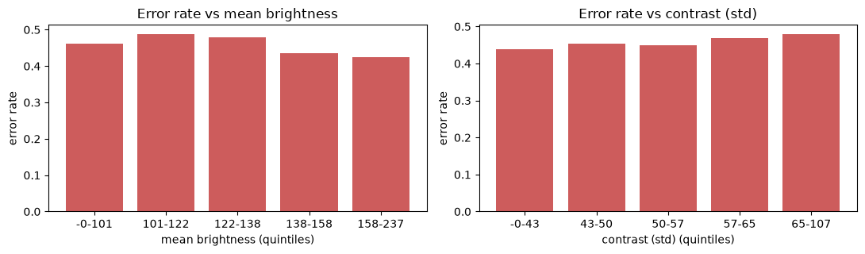
Figure 2: Error rate against lighting
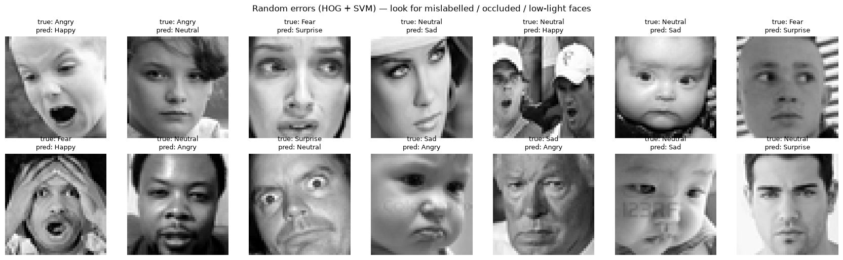
The gallery shows several recurring problems that are properties of the dataset rather than of the model:
- Ambiguous or questionable labels. A screaming infant with a wide open mouth is labelled Angry and predicted Happy, and several wide-eyed, open-mouthed faces are labelled Neutral or Fear. Some labels are debatable even for a human observer.
- Occlusion and context. Hands covering the face, hats, and images with two faces in the crop.
- Non-frontal pose and head tilt, which break the assumption of aligned faces made by landmarks, HOG and PCA alike.
- Population and artefacts. Infants and elderly faces, and overlaid text or watermarks (for example a timestamp over a baby's face).
The gallery is a random sample of errors, since SVC without probability estimates cannot rank errors by confidence; it should be read as qualitative evidence, not as a count of mislabelled images.
There are duplicates between train and test. An MD5 hash check found that 288 test images (8.0%) are exact duplicates of training images, and 96.9% of these duplicates carry the same label as the training copy. The selected model reaches 95.8% accuracy on these duplicated images but only 54.1% on the other 3,301 test images (macro-F1 0.950 versus 0.504, balanced accuracy 0.951 versus 0.486). The reported test score of 0.568 macro-F1 is therefore somewhat optimistic; on the de-duplicated test images, the corresponding figures are 0.541 accuracy, 0.486 balanced accuracy and 0.504 macro-F1. The same effect appears on the validation set, where removing duplicates lowers the macro-F1 of HOG + SVM from 0.505 to 0.438. The drop is largest for Random Forest models (0.10 to 0.11), which memorise training samples, and smallest for Logistic Regression and landmark + SVM models (about 0.01); the rankings between models are largely preserved, with HOG + SVM remaining best. Removing duplicates is a data curation step we will consider in Task 5.

2.7 Summary and limitations
HOG + RBF-SVM is the best FER2013 baseline (test: 0.574 accuracy, 0.549 balanced accuracy, 0.568 macro-F1; 0.504 macro-F1 after removing train duplicates). HOG is the strongest feature type for every classifier, the SVM is the strongest classifier on HOG and PCA, and the Random Forest is best on landmarks. Happy and Surprise are recognised reliably while Fear, Angry, Sad and Disgust are not. Limitations: (i) the hyperparameter search was small (only C, on a 5,000-image subset); (ii) only the selected model was evaluated on the test split; (iii) no class balancing was applied, which disadvantages Disgust; (iv) the landmark features rely on a detector applied to 48×48 images and the whole image as face box.

3. Task 2: KDEF study
[To be written. Required content: best FER2013 feature representation and classifiers retrained on KDEF (frontal pose only); subject-independent 80/20 split by subject identity; the provided preprocessing (face crop with margin, grayscale, resize to 48×48, FER normalisation). Report accuracy, balanced accuracy, macro-F1 and confusion matrices. Discuss: why KDEF is easier or harder than FER2013 (controlled lighting, posed and acted expressions, frontal pose, fewer subjects, balanced classes); which models change ranking compared with FER2013; which emotions are recognised well in both datasets.]

4. Task 3: Cross-dataset generalization
[To be written. Required content: best KDEF configuration retrained on preprocessed KDEF and evaluated on FER2013 (and FER → KDEF if reported); the adaptations needed to run the model (image size, grayscale, normalisation, feature extraction on the same format); definition of domain shift (differences in acquisition, cropping and alignment, resolution, colour, subject population, posed versus in-the-wild expressions); why performance degrades; which features transfer best (HOG versus landmarks versus PCA).]

5. Task 4: Explainable fuzzy classifier
[To be written. Required content: 3 to 10 handcrafted geometric features (e.g. mouth opening, mouth width, eye opening, eyebrow height, smile ratio) from landmarks; fuzzy classifier built on KDEF (pyFUME or ANFIS); resulting rules and membership functions; do the rules agree with expectation (e.g. high mouth opening and wide mouth for Happy and Surprise)? performance and limitations.]

6. Task 5: Creative challenge
[To be written. Pick at least two techniques: e.g. class balancing (motivated by the Disgust recall of 0.25 in Section 2.5), removing train/test duplicates (Section 2.6), data augmentation, label verification, a larger hyperparameter search (C and gamma), feature combination (HOG + landmarks), and use of KDEF-derived features. Compare each against the Section 2 baseline with the same metrics, preferably on validation and then once on test.]

7. Task 6: Real-time demo
[To be written. Required content: did the best model perform well on live webcam input (yes or no, and why); problems encountered (face detection, lighting, camera resolution, latency, domain shift between the webcam and FER2013, prediction flicker); fine-tuning or adaptations made (e.g. face crop margin, temporal smoothing, faster model).]

8. Conclusions
[To be written.]

Statement on the use of AI
[Replace with the default technology statement from the assignment: "During the preparation of this work, I/We used [TOOL / VERSION] in order to [REASON]. The following parts of the assignment were affected/generated by AI tool usage: [PARTS]. After using this tool/service, [NAME(S)] evaluated the validity of the tool's outputs, including the sources that generative AI tools have used, and edited the content as needed. As a consequence, [NAME(S)] take(s) full responsibility for the content of their work."]

Appendix A: metric heatmaps of each feature-model combination on validation
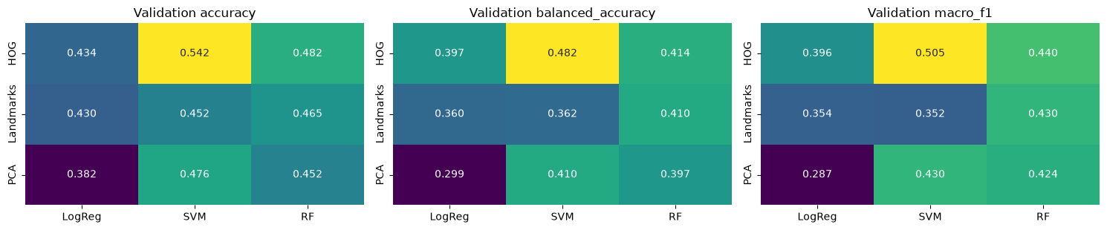

Appendix B: Confusion matrices
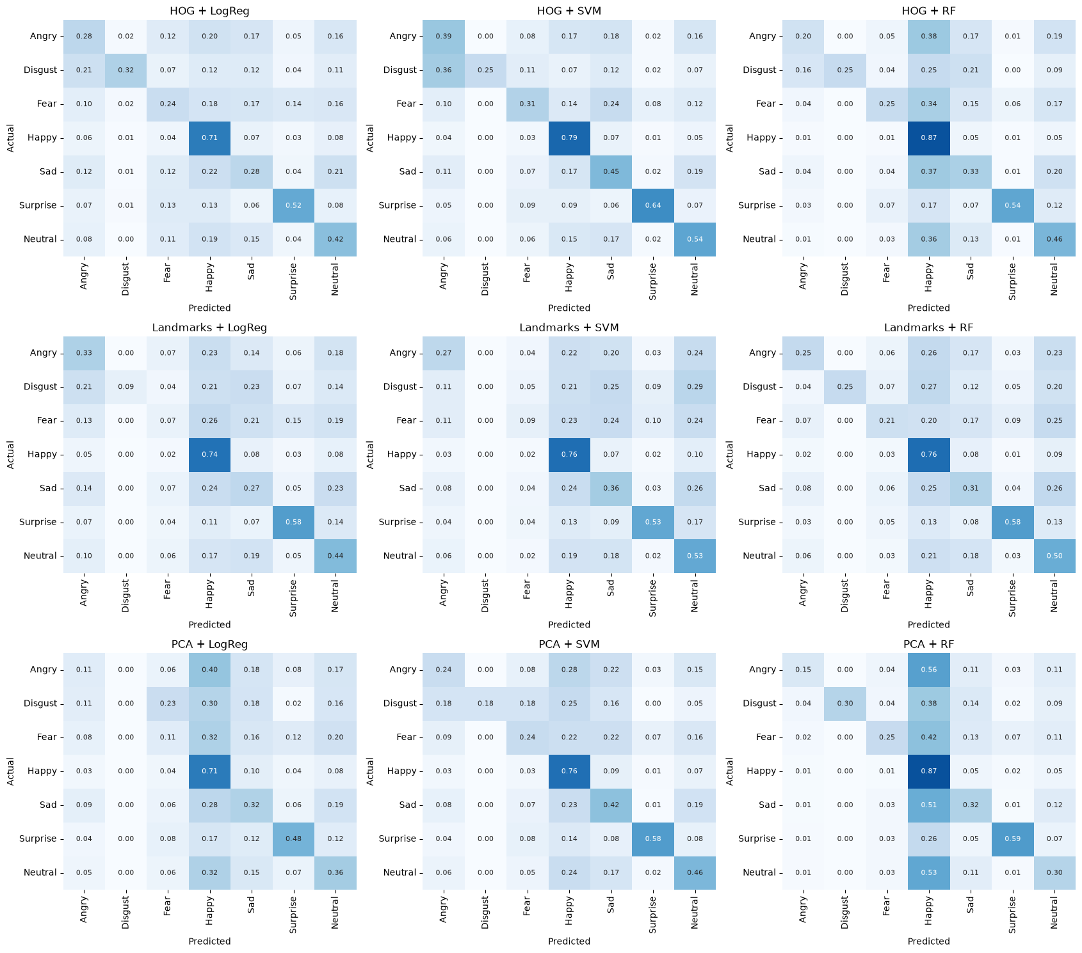

References

