Assignment 2: Detecting Emotions with ML Algorithms
Cross-Dataset Generalization of Facial Expressions

Su Acar (2475901)
Vikram Chandrasekaran (2542544) Henrique DaSilva Couto (2463334)
5ARE0 – Data Analysis & Learning Methods Assignment 2 – Group 5
October 25, 2026

Example citations for later on (remove this later): (Goodfellow et al., 2013) (Goeleven et al., 2008)
(Goeleven et al., 2008; Goodfellow et al., 2013)

Introduction and research questions
This report studies facial expression recognition with classical machine learning on two datasets, FER2013 and KDEF, and asks which challenges are specific to each dataset and how well knowledge transfers between them. The FER2013 baseline classifiers are covered in Task 1; Tasks 2 to 6 cover the KDEF study, cross-dataset generalization, the fuzzy classifier, the creative challenge and the real-time demo. [Replace: One or two sentences summarising the overall main findings once all tasks are done.]
The primary question is how datasets and feature/model choices affect within-dataset accuracy and cross-dataset generalization. Secondary questions concern which emotions and representations are most transferable, whether interpretable facial geometry is useful, and how reliable a trained model remains under webcam conditions. [Replace: Add source-supported motivation and APA citations to FER2013/KDEF after Zotero export.]

Datasets, preprocessing and experimental protocol
FER2013. Images are grayscale, 48 × 48, with seven labels: angry, disgust, fear, happy, sad, surprise and neutral. Use the provided Training split to fit models, PublicTest for model selection/tuning, and untouched PrivateTest only for final evaluation.
KDEF. Use only straight/frontal (S) faces, across seven comparable expressions (KDEF “Afraid” maps to FER “fear”). Divide by identity: 80% of subjects for training, 20% for testing, with no subject overlap.
Common representation. Detect and crop KDEF faces with a margin preserving forehead and jaw; convert to grayscale, resize to 48 × 48 and apply the same normalization as FER. Apply identical feature extraction at training and inference. Fit any scaling, PCA or learned transformation only on training data.
Fuzzy classifier protocol. For Task 4, geometric features were extracted directly from original-resolution frontal KDEF images, rather than the FER-compatible 48 × 48 images. Both acquisition sessions for each identity remained in the same partition. Model selection used training subjects only, preserving the held-out KDEF subjects for final evaluation.
FER2013 class balance. We use the provided split: 28,709 training images, 3,589 validation images (PublicTest) and 3,589 test images (PrivateTest). The classes are strongly imbalanced (Table 8). Happy is the largest class (7,215 training images) while Disgust has only 436 (1.5% of the training set). Task 1 deliberately uses no class weighting, so that the plain baseline can later be compared with balancing strategies in the creative challenge (Task 5).
[Replace: Detected-face failures, deduplication/quality checks, exact train/validation/test protocol, seeds, tools, versions and potential limitations. Provide one dataset example if it supports a claim.]

Task 1: FER2013 baseline (20%)
Features. Three feature types were extracted, each compared with three classifiers (3 × 3 = 9 models):

  - HOG (900 dimensions): histogram of oriented gradients on the 48 × 48 image, 9 orientations, 8 × 8 pixel cells, 2 × 2 blocks with L2-Hys normalization. HOG encodes local edge orientation (mouth corners, brows, eye shape, wrinkles) and the block normalization gives some robustness to illumination.
  - Facial landmarks (136 dimensions): the 68 dlib landmarks, centred and scaled to [−1, 1]. The whole 48 × 48 image is passed to dlib as the face box, so the same procedure can be reused in the real-time demo.
  - PCA (100 dimensions): raw pixels scaled to [0, 1], projected with whitened PCA. PCA is fitted inside the scikit-learn pipeline on the training data only, which avoids leakage into the validation and test sets.
Classifiers. Multinomial Logistic Regression (C = 1, standardized inputs), an RBF-kernel SVM (C = 1, γ = “scale”, standardized inputs) and a Random Forest (300 trees, sqrt features, no scaling). All use a fixed random seed (42).
Results on the validation set. Table 1 shows accuracy, balanced accuracy and macro-F1 for all nine combinations. Macro-F1 was the selection criterion, because it weights all seven classes equally and is therefore not dominated by Happy.

Table 1: FER2013 PublicTest (validation) results for all nine feature–classifier combinations, with default settings. The selected model is in bold. Metric heatmaps are in Appendix A.2.
Features | Classifier | Accuracy | Bal. acc. | Macro-F1
HOG | Logistic Regression | 0.435 | 0.397 | 0.395
HOG | SVM | 0.542 | 0.482 | 0.505
HOG | Random Forest | 0.482 | 0.414 | 0.440
Landmarks | Logistic Regression | 0.470 | 0.397 | 0.394
Landmarks | SVM | 0.500 | 0.409 | 0.401
Landmarks | Random Forest | 0.514 | 0.456 | 0.474
PCA | Logistic Regression | 0.382 | 0.299 | 0.287
PCA | SVM | 0.477 | 0.410 | 0.430
PCA | Random Forest | 0.454 | 0.395 | 0.423

Best classifier. The RBF-SVM is the best classifier on two of the three feature types (HOG: 0.505 macro-F1; PCA: 0.430) and the best overall. Its non-linear kernel can model the non-linear relation between local gradient patterns and expression, which the linear Logistic Regression cannot: Logistic Regression is the weakest or near-weakest classifier for every feature type (0.287 to 0.395 macro-F1). The Random Forest is competitive only on landmarks, where it is the best classifier (0.474) and clearly beats the SVM (0.401). A plausible reason, which we have not tested, is that the forest can pick out a few informative coordinates from the 136 landmark values, while the RBF kernel, with standardized inputs and equal weight on all coordinates, is diluted by the uninformative ones. The SVM is also by far the most expensive model to train (438 s on HOG, against 36 s for the forest and 6 s for Logistic Regression).
Best features. HOG is the best representation for Logistic Regression and the SVM (for example 0.505 against 0.430 for PCA and 0.401 for landmarks with the SVM). For the Random Forest, landmarks are the best representation (0.474 against 0.440 for HOG). We attribute the HOG result to its capture of local texture and edge information that distinguishes expressions (open mouth, raised or furrowed brows, wrinkles around the eyes and nose), with some invariance to illumination. Landmarks discard texture, and at 48 × 48 pixels the dlib detector works with very low resolution, so the landmark positions are noisy. Landmarks are also computed with the full image as the face box, which assumes FER crops are well aligned; this is not always true (see the error analysis below). PCA is a holistic linear projection of raw pixels, so it is sensitive to misalignment, pose and lighting.
Hyperparameter tuning and final test result. Each classifier was tuned on the feature set where it did best on validation. The SVM grid covered C ∈ {1, 5, 10} and γ ∈ {0.5, 1, 2} × 1/900, tuned on a 10,000-image subsample of the training set; the Logistic Regression grid covered C ∈ {0.01, 0.1, 1, 10}; and the Random Forest grid covered maximum depth (unlimited or 25) and minimum leaf size (1, 3 or 5). The best settings were refit on the full training split and scored on validation: the SVM reached 0.562 macro-F1 (C = 10, γ = 1/900), against 0.505 by default; Logistic Regression (C = 0.01) reached 0.411; and the landmark Random Forest (maximum depth 25, minimum leaf 1) reached 0.477. Each tuned model was then evaluated once on the private test split (Table 2).
The test score of the SVM is higher than its validation score (0.568 against 0.562 tuned, and 0.505 default). The paired bootstrap difference between the SVM and the landmark Random Forest is +0.081 with interval [+0.057, +0.105], so the SVM’s lead on the test split is unlikely to be noise. The gap between accuracy and balanced accuracy on validation (0.542 against 0.482) is caused mainly by the low recall of Disgust (25%).
Which emotions are hardest to distinguish? Averaging per-class F1 over the nine validation models gives

Table 2: Final test performance of each tuned classifier on the PrivateTest split, with 95% bootstrap intervals for macro-F1 (1,000 resamples). The confusion matrices are in Appendix A.
Features | Classifier | Accuracy | Bal. acc. | Macro-F1 | 95% interval
HOG | SVM (C = 10) | 0.575 | 0.550 | 0.568 | [0.544, 0.590]
Landmarks | Random Forest | 0.517 | 0.468 | 0.487 | [0.461, 0.512]
HOG | Logistic Regression | 0.438 | 0.376 | 0.378 | [0.355, 0.400]

the following ordering from hardest to easiest: Fear (0.26), Disgust (0.27), Angry (0.32), Sad (0.38), Neutral (0.43), Surprise (0.62), Happy (0.64). For the SVM on the test set, F1 is 0.75 for Happy and 0.73 for Surprise, and 0.43 to 0.46 for Angry, Sad and Fear.
  - Happy and Surprise are relatively easier to classify. Both have distinctive, large-scale configurations: a raised, widened mouth with visible teeth for Happy, and wide-open eyes and mouth for Surprise. Happy additionally has the most training data.
  - Fear, Angry and Sad are harder and are confused with each other and with Neutral. The most frequent errors of the validation SVM are Fear to Sad (24% of all Fear), Sad to Neutral (19%), Angry to Sad (18%), Sad to Happy (17%) and Neutral to Sad (17%); the test set shows the same pattern (Appendix A). These classes are expressed through subtle, low-intensity changes around the brows and eyes, which are hard to resolve at 48 × 48 pixels. Fear also shares features with Surprise (wide eyes, open mouth), and Sad and Neutral faces are visually close, so Neutral is a frequent “sink” class.
  - Disgust is rare (436 training images), so the classifier rarely predicts it. On validation the SVM has precision
1.00 but recall 0.25: when it predicts Disgust it is right, but it misses most Disgust faces. On the test set recall is 0.51, but with only 55 test images this estimate is noisy. Class balancing was tested in Task 5 and did not help.
Evidence from error analysis. Illumination and contrast have a small effect on error. We grouped validation images into quintiles of mean brightness and of contrast (pixel standard deviation) and computed the error rate of the SVM in each group. The error rate is about 0.46 to 0.49 for the three darkest quintiles and about 0.42 to
0.44 for the brightest two, and it rises slightly from about 0.44 to 0.48 as contrast increases (Figure 2). The effect is around five percentage points, so illumination matters but is not the main source of error.
Figure 3 shows recurring problems that are properties of the dataset rather than of the model: ambiguous or questionable labels (a screaming infant labelled Angry and predicted Happy; several wide-eyed, open-mouthed faces labelled Neutral or Fear), occlusion and context (hands over the face, hats, two faces in the crop), non-frontal pose and head tilt, which break the aligned-face assumption of all three feature types, and population and artefacts (infants and elderly faces, overlaid text or watermarks). The gallery is a random sample of errors, so it is qualitative evidence, not a count of mislabelled images.
Duplicates. FER2013 contains exact copies of images across splits, and some copies carry different labels, which is direct evidence of label noise. Of the 3,301 non-duplicated test images, the SVM reaches 54.2% accuracy and 0.505 macro-F1; the 288 duplicated test images (8.0%) reach 95.5% accuracy and 0.943 macro-F1, and 96.9% of the duplicates carry the same label as the training copy. The reported test score of 0.568 macro-F1 is therefore optimistic, and the non-duplicated score of 0.505 is the fairer estimate. On validation, 280 of 3,589 images (7.8%) also appear in training, and removing them lowers the SVM’s macro-F1 from 0.505 to 0.438. The drop is largest for the Random Forests (0.097 to 0.110), which memorize training samples, and smallest for Logistic Regression and landmark SVM (0.008 to 0.010). We treat cleaning the training set as a data curation step in Task 5.
Summary and limitations. The tuned HOG + RBF-SVM is the best FER2013 baseline (test: 0.575 accuracy, 0.550 balanced accuracy, 0.568 macro-F1; 0.505 macro-F1 without duplicates). HOG is the strongest feature type for Logistic Regression and the SVM, and landmarks are the strongest for the Random Forest; the SVM is the strongest classifier on HOG and PCA. Happy and Surprise are recognized reliably, while Fear, Angry, Sad and Disgust are not. For the demo, prediction time is 0.15 ms per image for Logistic Regression, 32 ms for the SVM, and 27 ms plus 11 ms of feature extraction for the Random Forest. Limitations: (i) the SVM was tuned on a 10,000-image subsample; (ii) the final test was run once per model, with no further selection; (iii) no class balancing was used, which disadvantages Disgust; (iv) the landmark features depend on a detector applied to 48 × 48 images with the whole image as the face box.

Task 2: KDEF dataset study (15%)
Use the best FER2013 feature representation and retrain the corresponding classifiers on preprocessed frontal KDEF images. Partition subjects 80/20 so each subject appears in exactly one split; document counts and

random seed. [Replace: Explain KDEF model selection without test-set leakage.]

Table 3: KDEF held-out subject test set, with FER-selected feature representation.
Classifier | Accuracy | Bal. acc. | Macro-F1
Logistic Regression | – | – | –
SVM | – | – | –
Random Forest | – | – | –
[Replace: Explain why controlled KDEF imagery differs from in-the-wild FER2013, whether model ranking changes, the easiest/hardest emotions, and which emotions might transfer well. Cite KDEF confusion matrices in Appendix A.]

Task 3: Cross-dataset generalization (20%)
Test both directions required by the assignment protocol: FER→KDEF (FER-trained model applied to cropped/preprocessed frontal KDEF) and KDEF→FER (retrain the KDEF-selected configuration on its training subjects, then evaluate on FER). Keep matching 48 × 48 grayscale normalization and class mapping throughout; do not adapt the test-domain examples using ground-truth labels. Keep FER PrivateTest untouched until final evaluation.

Table 4: Within- and cross-dataset performance, on explicitly stated held-out sets.
Train → evaluation | Accuracy | Bal. acc. | Macro-F1
FER → FER (PrivateTest) | – | – | –
KDEF → KDEF (test subjects) | – | – | –
FER → KDEF (test subjects) | – | – | –
KDEF → FER (PrivateTest) | – | – | –

[Replace: List any model/input adaptations, define domain shift, quantify transfer degradation against in-domain comparisons, analyze per-emotion confusion, and explain which features transfer best and why. Note crop/alignment, resolution and grayscale/RGB as confounders.]

Task 4: Explainable fuzzy classifier (10%)
Features and protocol. We extracted seven geometric features from the 68 dlib facial landmarks: mouth width, mouth opening, left and right eye opening, eyebrow height, mouth width-to-height ratio (smile ratio), and mouth-corner asymmetry. Most distances were normalized by face width, while eye opening was normalized by eye width. All 980 frontal KDEF images were processed successfully, without landmark detection failures.
The predefined subject-independent split contained 56 training subjects (784 images) and 14 held-out test subjects (196 images). Within the training partition, 44 subjects (616 images) were used for fitting and 12 (168 images) for validation. MinMax scaling was fitted only on the corresponding training partition.
Fuzzy model. We trained seven one-versus-rest Takagi–Sugeno fuzzy models with PyFUME, one for each emotion. Each model uses Gaussian membership functions in its rule antecedents and a learned linear consequent. The numerical outputs are combined through fuzzy inference, and the emotion with the highest output score is selected. These scores are not calibrated probabilities.
We compared two and three clusters per emotion using macro-F1 on validation subjects. The three-cluster configuration was selected before testing and subsequently refitted on all 784 training images.

Table 5: Subject-independent KDEF fuzzy classification results.
Split | Clusters | Images | Acc. (%) | Bal. acc. (%) | Macro-F1
Validation | 2 | 168 | 71.43 | 71.43 | 0.6881
Validation | 3 | 168 | 73.21 | 73.21 | 0.7087
Final test | 3 | 196 | 63.27 | 63.27 | 0.6082
Rule interpretation. The final system contains 21 fuzzy rules, three per emotion. A representative rule from the happiness model is:

Happy, Rule 1 (abridged): IF mouth width belongs to cluster 1 (Gaussian centre 0.762) AND mouth opening belongs to cluster 1 (centre 0.204), together with the remaining geometric conditions, THEN calculate the happiness score using the fitted linear consequent.
This rule dominated 94.6% of happy training images but only 2.2% of other images. Its relatively wide-mouth configuration is consistent with smiling. The strongest rules for fear and sadness showed weaker separation, and overlapping membership functions limit their linguistic interpretation.
Evaluation and limitations. On unseen subjects, happiness (28/28), surprise (26/28) and disgust (23/28) achieved the highest recall. Fear (7/28) and sadness (8/28) were more difficult: 14 fearful faces were classified as surprise, and 12 sad faces as neutral. The roughly ten-percentage-point accuracy decrease from validation to testing indicates limited generalization across individuals. Although the fuzzy antecedents are inspectable, the linear consequents and interactions between the seven models complicate explanations of individual predictions.

Task 5: Creative challenge (25%)
We started from the Task 1 baseline and tested one change at a time, using a fast Logistic Regression and the validation split (PublicTest) to decide. The test split was used once, for the final model.

Changes tested.
  - Feature engineering (kept). The 136 landmark values were appended to the 900 HOG features (1,036 features). HOG describes texture around the mouth and eyes, and landmarks describe the shape of the face, so the two carry different information.
  - Data cleaning (kept). Training images were fingerprinted with MD5 hashes. Duplicates with the same label were reduced to one copy, and images whose copies disagreed in label were removed (107 images), reducing the training set from 28,709 to 27,434 images. The gain is within the noise level (Section 3).
  - Class balancing (rejected). Balanced class weights lowered both macro-F1 and Disgust F1, so the switch was left off.
  - Augmentation (not run). Horizontal-flip copies were considered but not run. They would double the training set, and the RBF-SVM training time is already the limiting factor.

Table 6: Validation (PublicTest) ablation with Logistic Regression. Each row adds one change to the rows above it.
Variant | Accuracy | Macro-F1 | Disgust F1 | Training images
Baseline (HOG) | 0.435 | 0.395 | 0.324 | 28,709
+ landmarks | 0.497 | 0.453 | 0.325 | 28,709
+ cleaning (kept) | 0.500 | 0.455 | 0.325 | 27,434
+ class balancing (rejected) | 0.469 | 0.424 | 0.242 | 27,434
Final model. The tuned Task 1 SVM (C = 10) was retrained on the kept changes: 1,036 features and the cleaned training set. Because the feature count rose from 900 to 1,036, γ was rescaled by 900/1036 to keep the kernel width comparable (γ ≈ 9.7 × 10−4). This rescaling is a heuristic and was not tuned. On validation, the model reaches 0.607 accuracy and 0.598 macro-F1, against 0.562 for the tuned Task 1 SVM. On the test split, evaluated once, it reaches 0.594 accuracy, 0.572 balanced accuracy and 0.592 macro-F1, against 0.568 for the Task 1 SVM.
Interpretation. Adding landmarks is the main gain (+0.058 macro-F1 for Logistic Regression), and it is consistent with the landmark-based Random Forest in Task 1, which is the best classifier on landmarks. Cleaning changes the score by 0.002, which we treat as no effect. Class balancing hurt, even though Disgust recall was low (0.25) in Task 1. The notebook does not analyze why, so we leave the mechanism open. The test gain of 0.024 macro-F1 over Task 1 is not tested for significance, and the Task 1 bootstrap interval for macro-F1 is about
±0.023. Two limitations apply. The ablation uses Logistic Regression, not the final SVM, and each step is a single run. The test split still contains the 8% of images that also appear in training (Section 3). KDEF-derived features were not used in the final model.

Task 6: Real-time webcam demo (10%)
Adapt the best selected model into a command-line executable Python file that opens the laptop webcam and performs live emotion recognition. Preserve the exact training face crop, alignment, feature extraction, normalization and class mapping in the inference path.

[Replace: State demo command, chosen model/.pkl, hardware/OS, measured or observed FPS/latency (if available), stability, real-world behavior, lighting/pose/occlusion issues and what was fine-tuned. Explain whether the model performed well enough, and why.]

Discussion, limitations and conclusion
[Replace: Synthesize: best features/classifiers on each dataset; relative difficulty of each emotion; changes of ranking; strongest and weakest transfers; fuzzy interpretability versus performance; benefits and costs of creative improvements; webcam readiness. Contrast dataset-specific and common limitations. Draw conclusions only from actual measurements and concrete error examples.]

Declaration of AI tool use
During the preparation of this work, I/We used [NAME TOOL / SERVICE / VERSION OF AI TOOL] in order to [REASON]. The following parts of the assignment were affected/generated by AI tool usage: [INTRODUCTION / METHODS / xxx, DISCUSSION]. After using this tool/service, [NAME STUDENT(S)] evaluated the validity of the tool’s outputs, including the sources that generative AI tools have used, and edited the content as needed. As a consequence, [NAME STUDENT(S)] take(s) full responsibility for the content of their work.

References
Goeleven, E., De Raedt, R., Leyman, L., & Verschuere, B. (2008). The Karolinska Directed Emotional Faces: A validation study. Cognition & Emotion, 22 (6), 1094–1118. https://doi.org/10.1080/02699930701626582 Goodfellow, I. J., Erhan, D., Carrier, P. L., Courville, A., Mirza, M., Hamner, B., Cukierski, W., Tang, Y., Thaler, D., Lee, D.-H., Zhou, Y., Ramaiah, C., Feng, F., Li, R., Wang, X., Athanasakis, D., Shawe-Taylor, J., Milakov, M., Park, J., . . . Bengio, Y. (2013). Challenges in Representation Learning: A Report on Three Machine Learning Contests. In M. Lee, A. Hirose, Z.-G. Hou, R. M. Kil, D. Hutchison, T. Kanade, J.
Kittler, J. M. Kleinberg, F. Mattern, J. C. Mitchell, M. Naor, O. Nierstrasz, C. Pandu Rangan, B. Steffen,
M. Sudan, D. Terzopoulos, D. Tygar, M. Y. Vardi, & G. Weikum (Eds.), Neural Information Processing
(pp. 117–124, Vol. 8228). Springer Berlin Heidelberg. https://doi.org/10.1007/978-3-642-42051-1_16

Confusion matrices for reported models
Confusion matrices for every model reported in the main text, exported by the notebooks. FER→KDEF has not been run yet: [Replace: add its confusion matrix once run].

  - Dataset and error-analysis figures (Tasks 1 and 3)

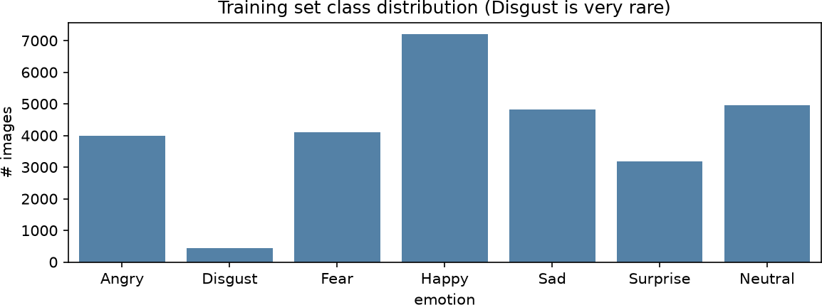

Figure 1: FER2013 training set: class distribution.

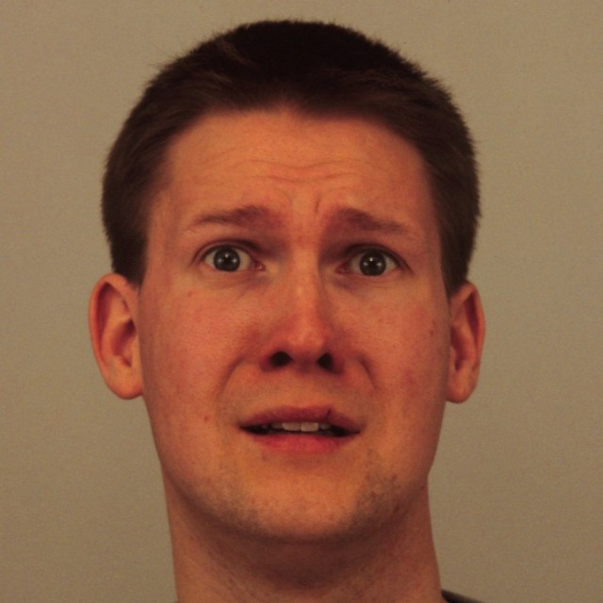
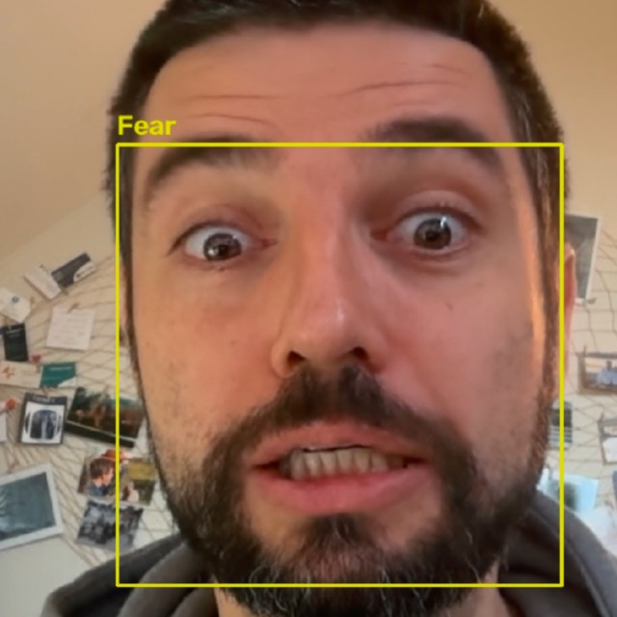
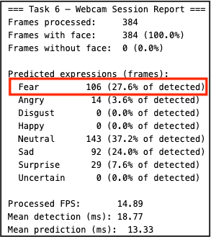
Posed expression KDEF reference Webcam capture Prediction

Fear

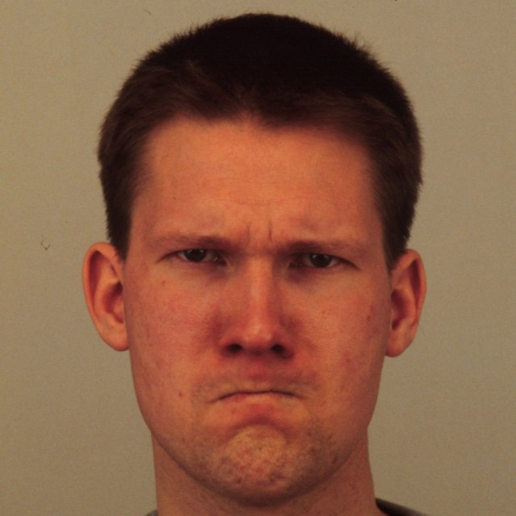
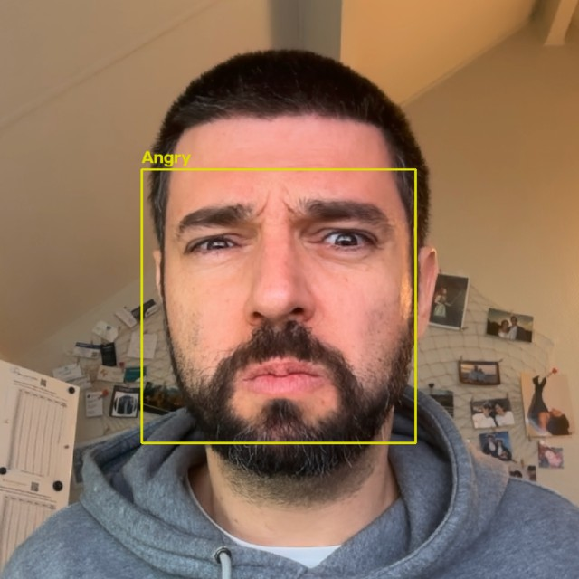
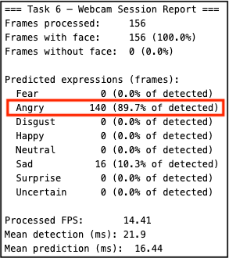
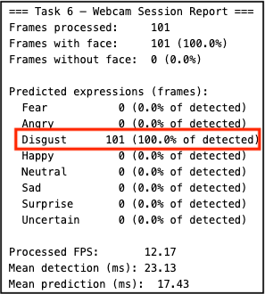
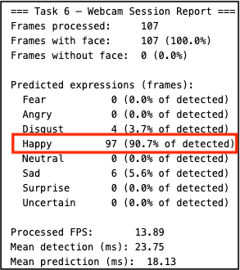
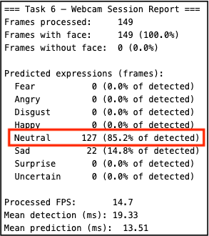
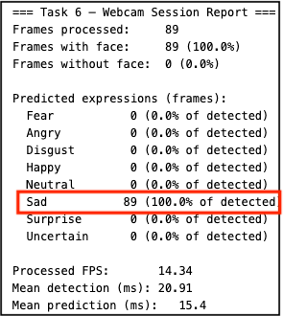
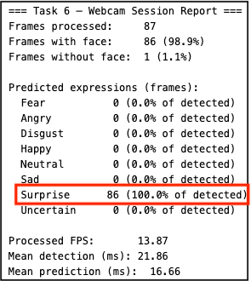
Angry

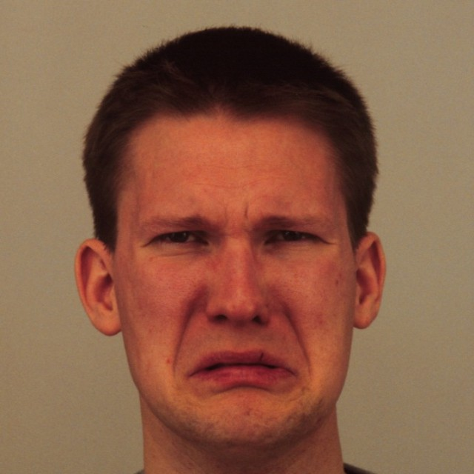
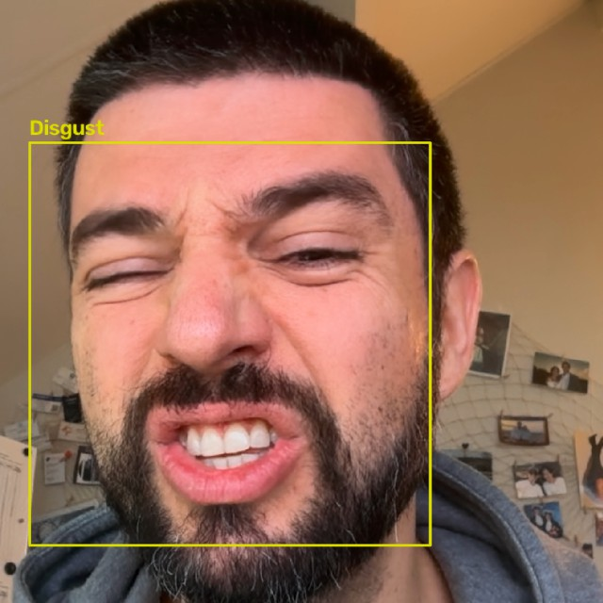
Disgust

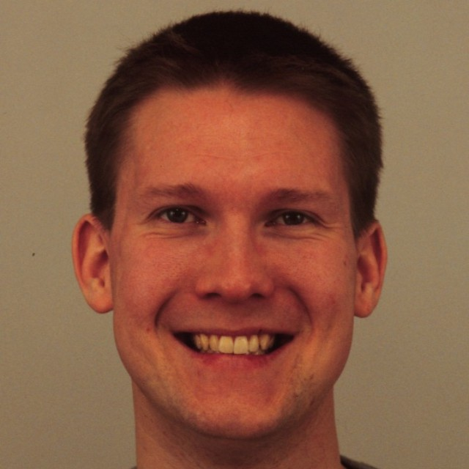
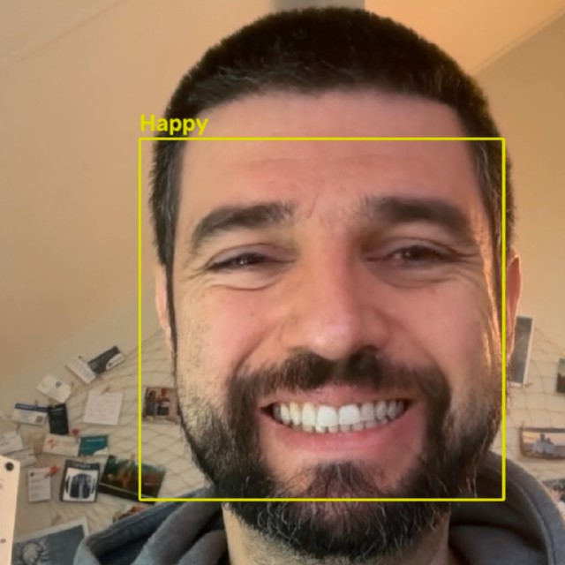
Happy

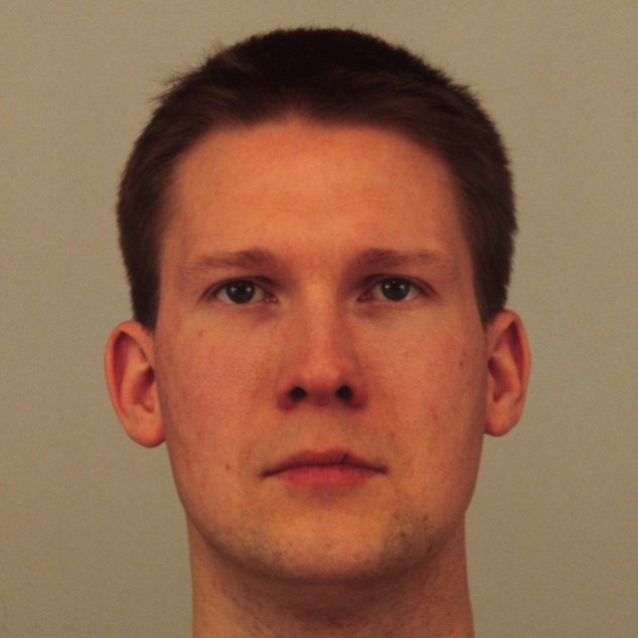
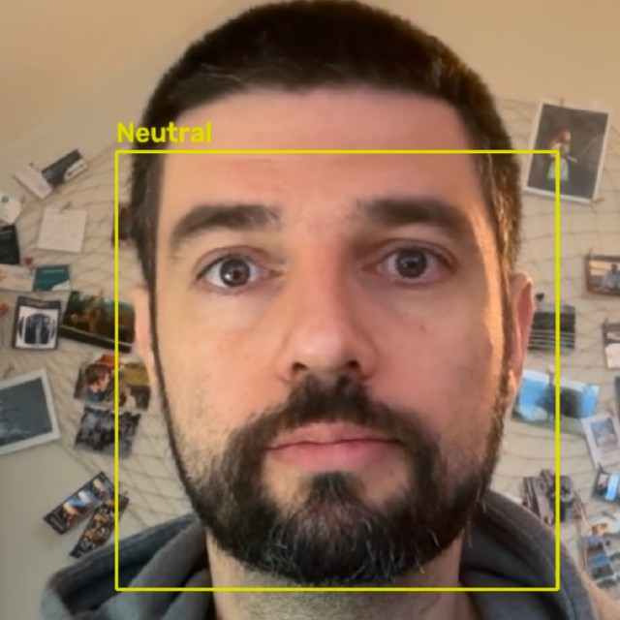
Neutral

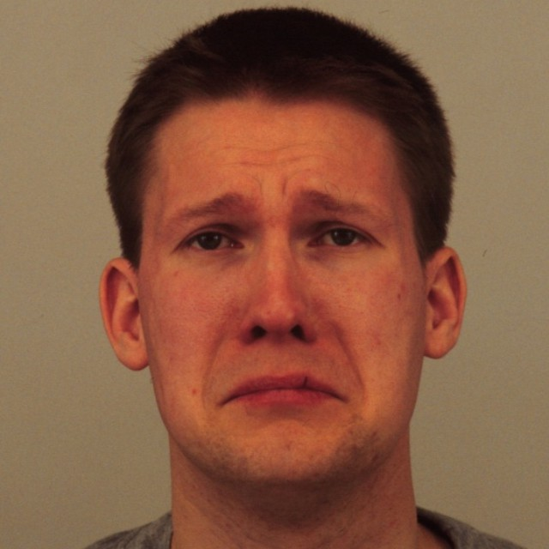
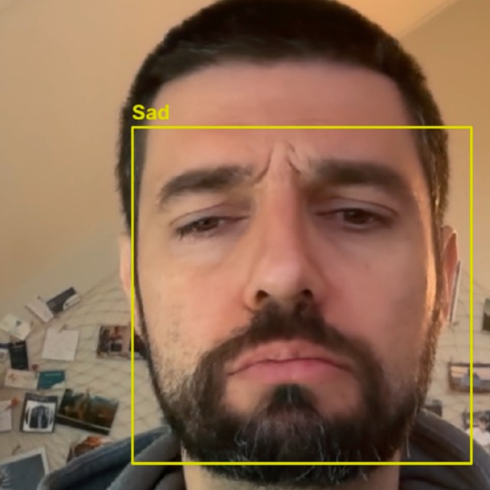
Sad

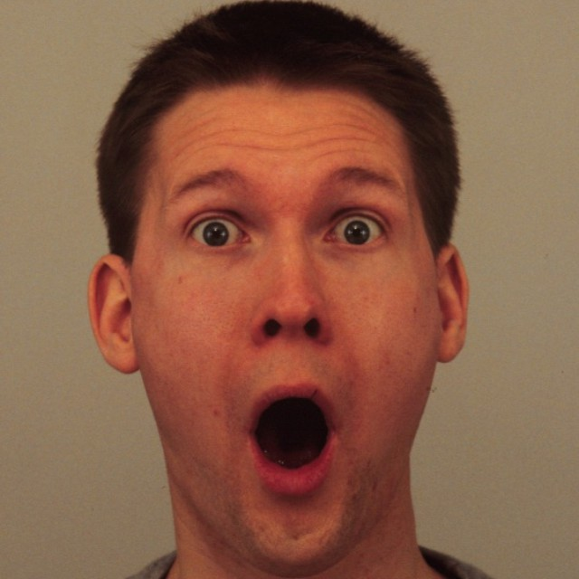
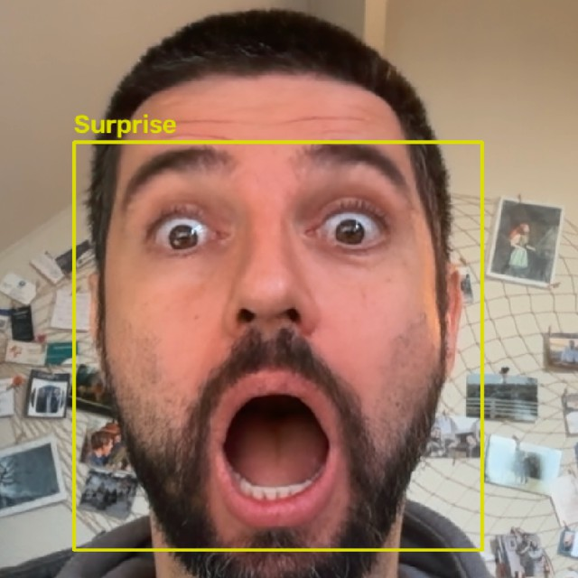
Surprise

Table 7: Qualitative comparison of posed KDEF expressions, corresponding webcam expressions, and fuzzy classifier predictions. KDEF subject M11, acquisition A, frontal pose. This illustrative experiment does not establish classification accuracy.

Table 8: FER2013 class counts per split.
Split Angry Disgust Fear Happy Sad Surprise Neutral

Train | 3,995 | 436 4,097 | 7,215 4,830 | 3,171 | 4,965
Validation | 467 | 56 496 | 895 653 | 415 | 607
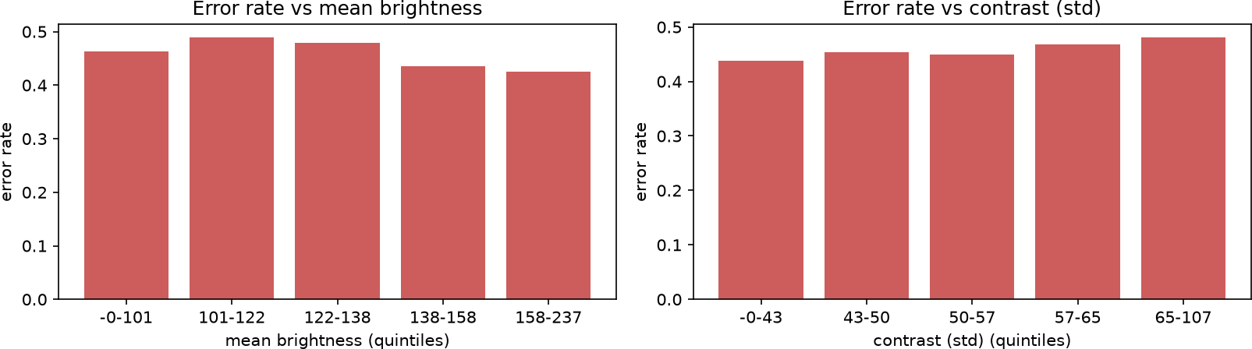

Figure 2: Error rate against lighting (HOG + SVM, validation split).

  - Validation metric heatmaps (FER2013)
  - FER2013 baseline models (PublicTest; tuned models on PrivateTest)
  - KDEF study, cross-dataset and creative models
  - Fuzzy classifier: held-out KDEF subjects

Table 9: Final fuzzy classifier confusion matrix (counts; 196 test images from 14 unseen subjects). Rows are true labels and columns are predictions.
True / Pred. | Af | An | Di | Ha | Ne | Sa | Su
Afraid | 7 | 1 | 2 | 0 | 2 | 2 | 14
Angry | 0 | 14 | 10 | 0 | 2 | 2 | 0
Disgust | 0 | 3 | 23 | 1 | 0 | 1 | 0
Happy | 0 | 0 | 0 | 28 | 0 | 0 | 0
Neutral | 0 | 3 | 0 | 0 | 18 | 6 | 1
Sad | 0 | 6 | 2 | 0 | 12 | 8 | 0
Surprise | 0 | 0 | 0 | 0 | 1 | 1 | 26
Af: afraid; An: angry; Di: disgust; Ha: happy; Ne: neutral; Sa: sad; Su: surprise.

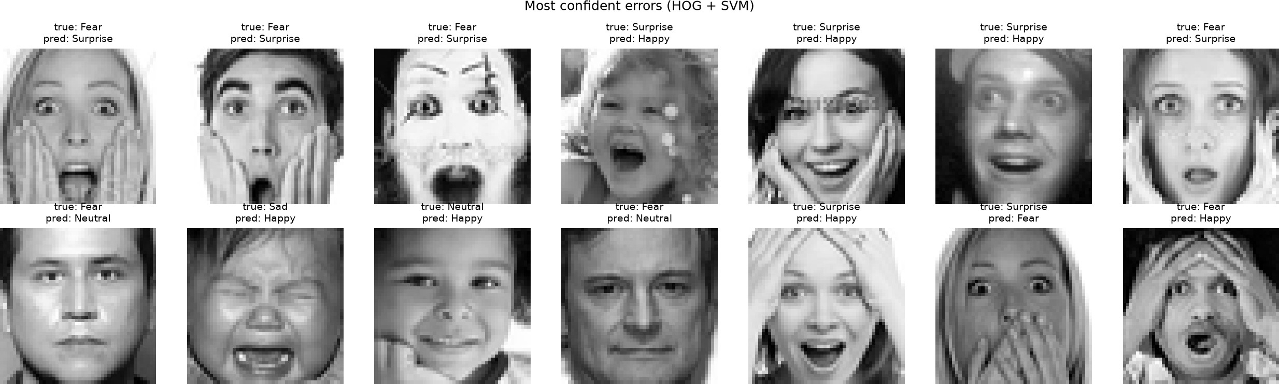

Figure 3: Random sample of misclassified FER2013 validation images.

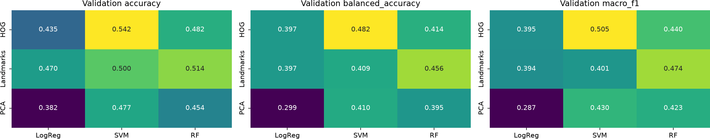

Figure 4: Metric heatmaps of each feature–classifier combination on the FER2013 PublicTest (validation) split.

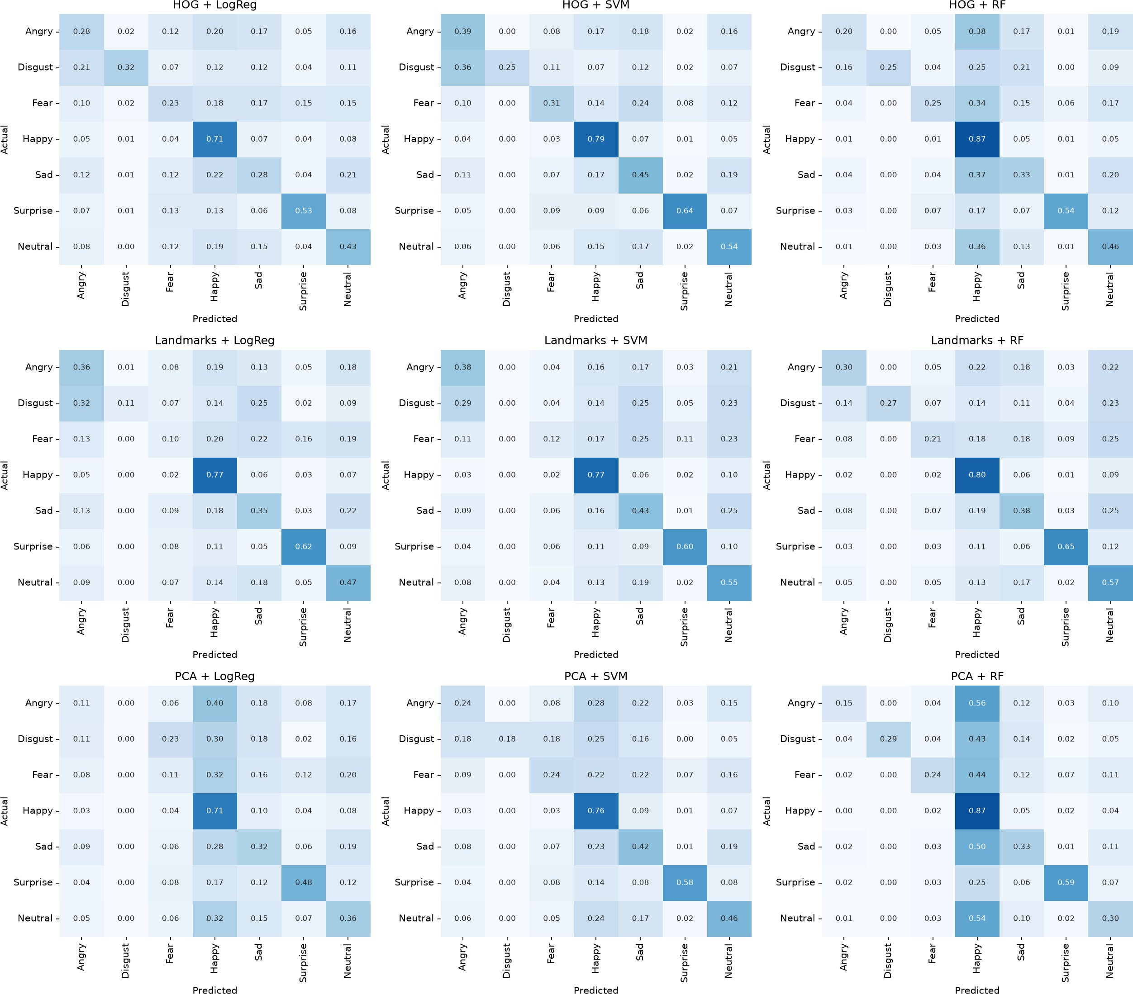

Figure 5: Confusion matrices of all nine FER2013 baseline models on the PublicTest (validation) split. Rows are true labels and columns are predictions; values are row-normalized.

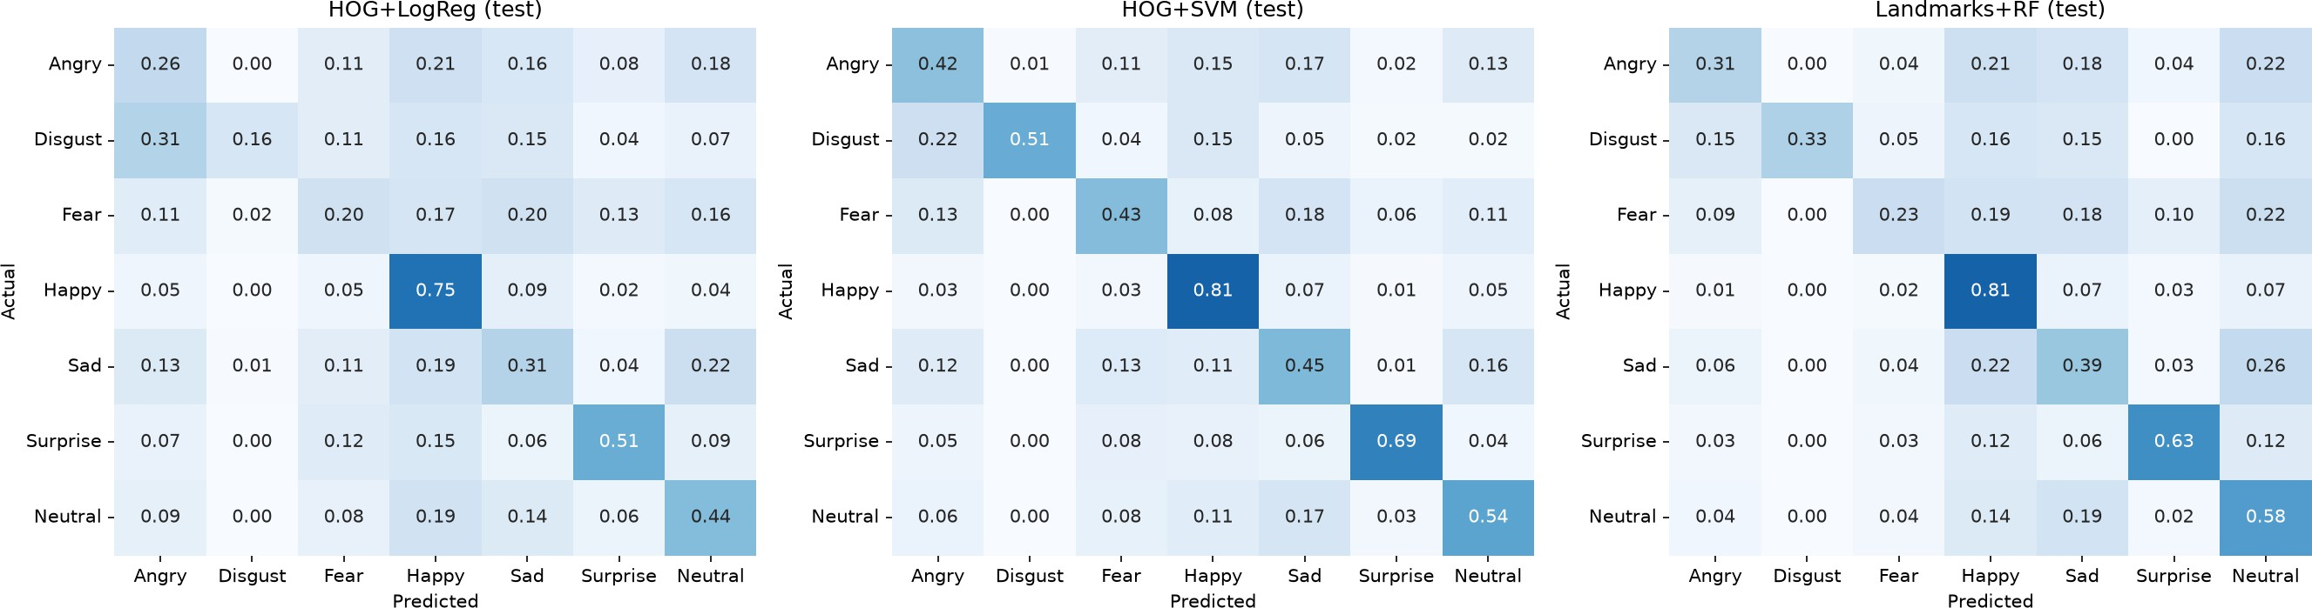

Figure 6: Confusion matrices of the three selected FER2013 models on the PrivateTest split, used for the final evaluation (Table 2). Rows are true labels and columns are predictions; values are row-normalized.

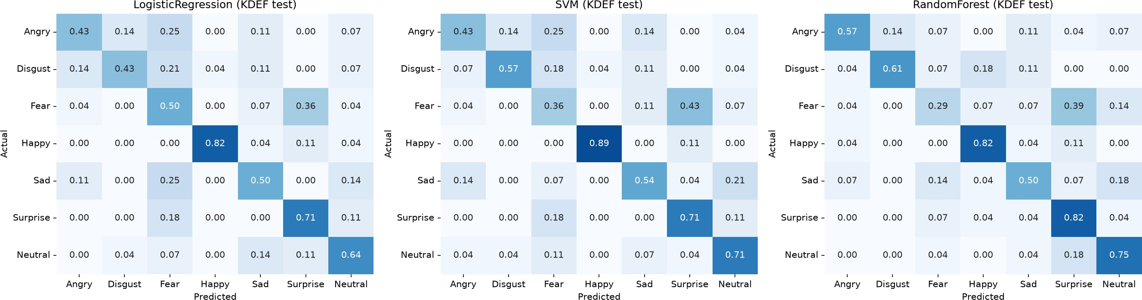

Figure 7: KDEF test subjects (196 images): Logistic Regression, SVM and Random Forest with HOG features, left to right.

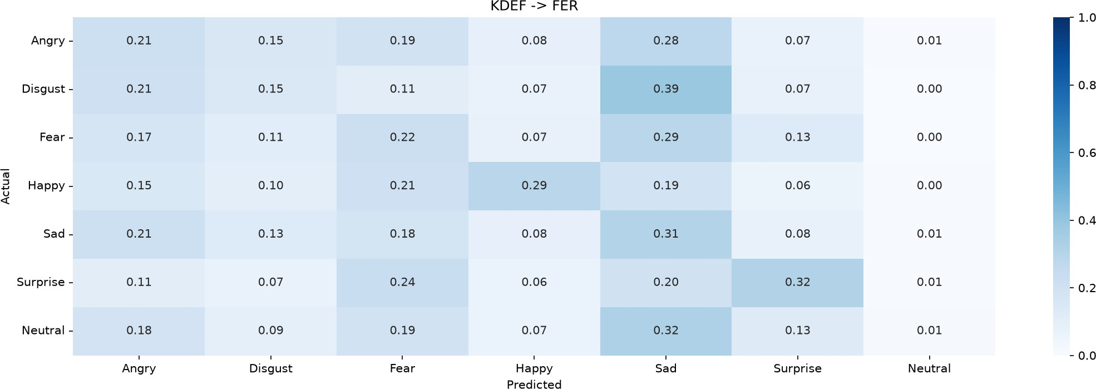

Figure 8: KDEF→FER: the Task 2 SVM trained on all KDEF frontal images, evaluated on all FER2013 images. Rows are true labels, row-normalized.

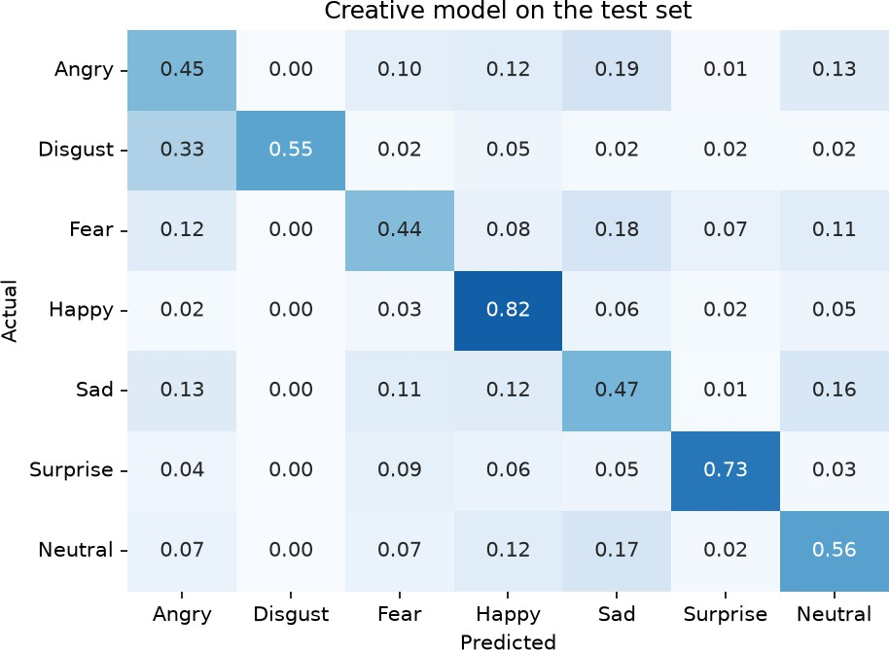

Figure 9: Creative-challenge final model (SVM on HOG + landmarks, cleaned training set), PrivateTest split.

