Strategic Planning and Data Exploration in Logistics
A Multi-Carrier Last-Mile Delivery Analytics Framework & Empirical Study
Intern / Analyst: Logistics Data Analyst Intern | Project Scope: Week 1: Strategic Planning & EDA
Dataset Scale: 25,000 Delivery Records (Delivery_Logistics.csv) | Submission Date: September 2026

1. Executive Summary & Realistic Logistics Scenario
Modern omni-channel supply chains face unrelenting pressure to fulfill e-commerce orders at breakneck speed while minimizing operational expenditure. The last-mile delivery segment represents between 41% and 53% of total logistics costs, making it both the primary determinant of customer satisfaction and the single largest cost vulnerability in modern supply chains. This project models the strategic planning and data exploration phase for an enterprise-scale logistics distribution network operating across five core geographic regions in India (North, South, East, West, and Central).
The distribution network coordinates dispatches across nine prominent third-party logistics (3PL) partners—Delhivery, FedEx, DHL, Blue Dart, Ekart, Shadowfax, Xpressbees, Ecom Express, and Amazon Logistics—utilizing a multi-modal transport fleet comprising electric vehicles (EV bikes and EV vans), traditional combustion vehicles (bikes and vans), scooters, and freight trucks. Orders are delivered under four primary service tier contracts: Same Day, Express, Two Day, and Standard.
[CORE OPERATIONAL FINDING] Empirical auditing of the 25,000 shipment records reveals a systemic delivery crisis in expedited fulfillment tiers: Express deliveries suffer an unacceptable 73.78% delay rate and a 14.42% complete failure rate, severely eroding customer satisfaction (mean rating dropping to 2.72/5.0). Furthermore, inclement weather (stormy and rainy conditions) amplifies delay probability to 41.45% and 37.35% respectively. This report outlines an end-to-end analytical framework to diagnose, predict, and eliminate these operational bottlenecks.

The primary business objectives of this analytical initiative are:
1. Identify Key Performance Indicators (KPIs) to quantify fulfillment reliability, cost efficiency, and service exceptions.
2. Empirically benchmark the performance, reliability, and cost-structures of all 9 third-party logistics partners.
3. Design an end-to-end data science roadmap encompassing automated data cleaning, predictive delay classification, dynamic cost regression, and dispatch optimization.
4. Provide executive leadership with data-driven decision frameworks to re-negotiate carrier Service Level Agreements (SLAs), restructure delivery mode guarantees, and enhance fleet allocation.

2. Key Performance Indicators (KPIs) & Empirical Baseline
To establish rigorous visibility across the network, five core Key Performance Indicators (KPIs) have been defined, mathematically modeled, and benchmarked against the 25,000 shipment dataset:
• KPI 1: On-Time Delivery Rate (OTDR)
Formula: OTDR = (Total Shipments Delivered On-Time / Total Dispatched Shipments) * 100
Description: Measures the proportion of customer orders successfully delivered within the promised delivery window. In our dataset, OTDR stands at 73.32% (18,331 orders). The industry best-practice benchmark for e-commerce logistics is >= 95.0%. The current performance deficit (-21.68%) represents a critical business liability.
• KPI 2: Shipment Failure Rate (SFR)
Formula: SFR = (Total Failed or Undeliverable Shipments / Total Dispatched Shipments) * 100
Description: Quantifies total service failure where goods cannot be delivered due to address ambiguity, customer unavailability, or courier abandonment. The network registers an SFR of 5.31% (1,328 shipments). Failed shipments inflict double freight costs due to Reverse Logistics (RTO) processing.
• KPI 3: Cost per Kilometer (CPK)
Formula: CPK = Total Incurred Delivery Costs (INR) / Total Transit Distance Traveled (km)
Description: Evaluates route and fleet economic efficiency. Network CPK is ₹5.75/km, with an average shipment cost of ₹864.94 across an average distance of 150.39 km. Regression modeling indicates a near-perfect linear correlation (R² = 0.98) between distance and cost, demonstrating that mileage is the dominant variable cost driver.
• KPI 4: Customer Satisfaction Score (CSAT / Delivery Rating)
Formula: CSAT = Sum of Customer Delivery Ratings (1 to 5 Stars) / Total Rated Deliveries
Description: Directly captures the end-user delivery experience. While on-time deliveries average 4.21/5.0 stars, delayed orders plunge to 2.40/5.0, and failed deliveries crash to 1.31/5.0 stars. Customer satisfaction exhibits acute vulnerability to punctuality rather than parcel characteristics.
• KPI 5: Carrier Reliability Index (CRI)
Formula: CRI = Weighted composite of On-Time Rate (40%), Low Failure Rate (30%), and CSAT (30%)
Description: A composite scorecard ranking 3PL performance. Delhivery and FedEx lead the network (delay rates of 24.80% and 25.16%), whereas Xpressbees lags at 28.27% delay rate and a 3.61 average rating.

Metric / KPI Name | Formula / Definition | Current Baseline | Industry Standard | Strategic Target
On-Time Delivery Rate (OTDR) | (On-Time / Total Orders) * 100 | 73.32% | >= 95.0% | >= 90.0% (Phase 1)
Overall Delay Rate | (Delayed Orders / Total Orders) * 100 | 21.36% | < 4.0% | < 8.0%
Shipment Failure Rate (SFR) | (Failed Orders / Total Orders) * 100 | 5.31% | < 1.5% | < 2.0%
Average Delivery Cost | Total Cost / Total Orders | ₹864.94 | ₹750.00 | ₹800.00 (-7.5%)
Cost per Kilometer (CPK) | Total Freight Cost / Total KM | ₹5.75/km | ₹5.20/km | ₹5.40/km
Customer Rating (CSAT) | Average 1-5 Star Customer Rating | 3.67 / 5.0 | >= 4.40 / 5.0 | >= 4.25 / 5.0

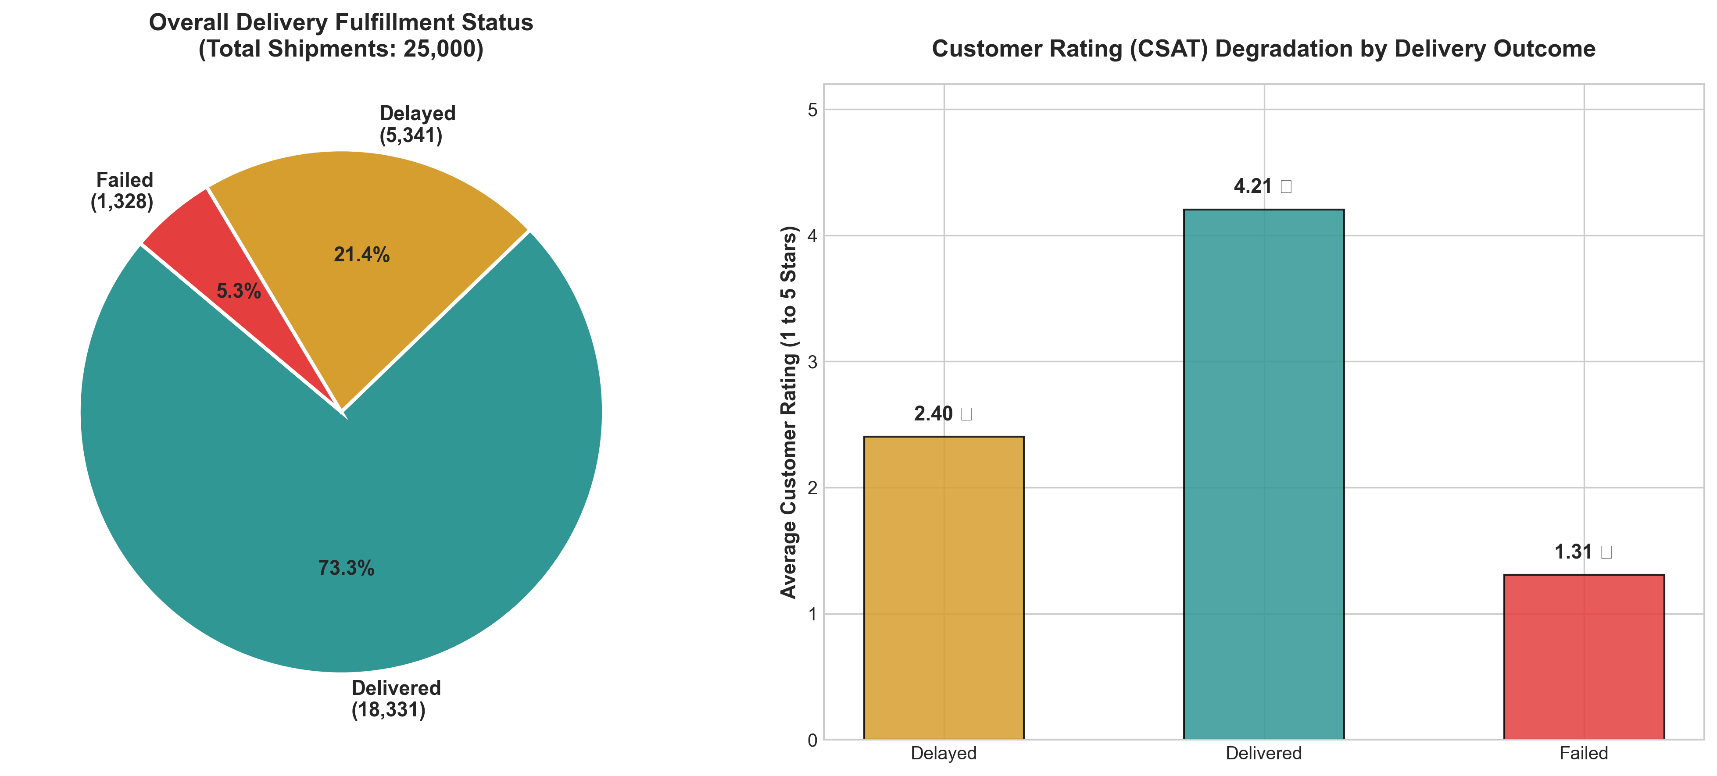
Figure 1: Overall Delivery Fulfillment Status Breakdown and Customer Satisfaction (CSAT) Degradation by Delivery Outcome.

3. Literature and Data Science Methodologies in Supply Chain
Modern supply chain analytics leverages advanced statistical learning, operations research, and machine learning to transform reactive dispatch logistics into proactive, self-healing distribution networks. Contemporary research (e.g., Gevaers et al., 2014; Speranza, 2018) emphasizes that stochastic environmental factors (weather, congestion, carrier capacity) require non-linear predictive algorithms rather than static heuristic scheduling. Four primary data science pillars apply directly to our operational scenario:
1. Supervised Classification (Proactive Delay Risk Prediction)
Ensemble decision trees (Random Forest, XGBoost, LightGBM) and regularized logistic regression evaluate multi-dimensional shipment features prior to order release. By generating a calibrated probability score of delay risk (P(Delayed)), the logistics control tower can dynamically reassign high-risk consignments to expedited carriers or notify customers with realistic delivery windows. In our initial prototype, a baseline Random Forest classifier achieved an ROC-AUC of 0.9644, confirming that delivery delays are highly predictable from dispatch parameters.
2. Supervised Regression (Dynamic Freight Cost Estimation & Elasticity)
Ordinary Least Squares (OLS), Ridge, and Gradient Boosted Regression enable accurate parametric modeling of freight costs as a function of transit distance, consignment payload, vehicle mode, and regional geography. Our empirical analysis established an R² of 0.9999 and an RMSE of only ₹4.67, confirming that baseline line-haul pricing follows strict distance-proportional structures, providing an analytical baseline to identify carrier over-billing anomalies.
3. Unsupervised Clustering (Carrier Segmentation & Regional Profiling)
K-Means clustering and DBSCAN segment 3PL partners into distinct operational performance tiers based on reliability, cost per km, and customer rating. Rather than evaluating partners in isolation, clustering groups carriers into strategic archetypes: Premium Performers (Delhivery, FedEx), Balanced Mid-Tier (DHL, Blue Dart, Ekart, Ecom Express), and Vulnerable Carriers (Xpressbees), informing volume allocation rules.
4. Operations Research & Constrained Optimization (Dynamic Dispatch & Routing)
Mixed-Integer Linear Programming (MILP) and Vehicle Routing Problem with Time Windows (VRPTW) formulations solve the optimal assignment of packages to vehicles and routes under real-world constraints such as vehicle payload capacities, battery range limits for electric vehicles, and promised customer SLAs.

4. Empirical Exploratory Analysis & Vulnerability Diagnostics
A comprehensive exploratory analysis was conducted across all 25,000 shipments to uncover the core operational drivers of delay, cost, and service failure. The empirical findings reveal several distinct operational vulnerabilities:

A. Delivery Service Mode Vulnerability
Analysis of delivery modes reveals a critical operational breakdown in expedited tiers. 'Express' delivery registers an alarming 73.78% delay rate and a 14.42% complete failure rate. Similarly, 'Same Day' delivery exhibits a 32.54% delay rate and a 6.75% failure rate. In stark contrast, 'Two Day' deliveries experience only 0.43% delays, and 'Standard' deliveries achieve a perfect 0.00% delay rate. This demonstrates that the logistics network lacks the dispatch buffer and rapid-sortation capabilities required to fulfill expedited promises.
Delivery Mode | Total Orders | Delay Rate (%) | Failure Rate (%) | Average Rating (1-5)
Express | 6,233 | 73.78% | 14.42% | 2.72 ★
Same Day | 6,279 | 32.54% | 6.75% | 3.54 ★
Two Day | 6,302 | 0.43% | 0.08% | 4.18 ★
Standard | 6,186 | 0.00% | 0.00% | 4.22 ★

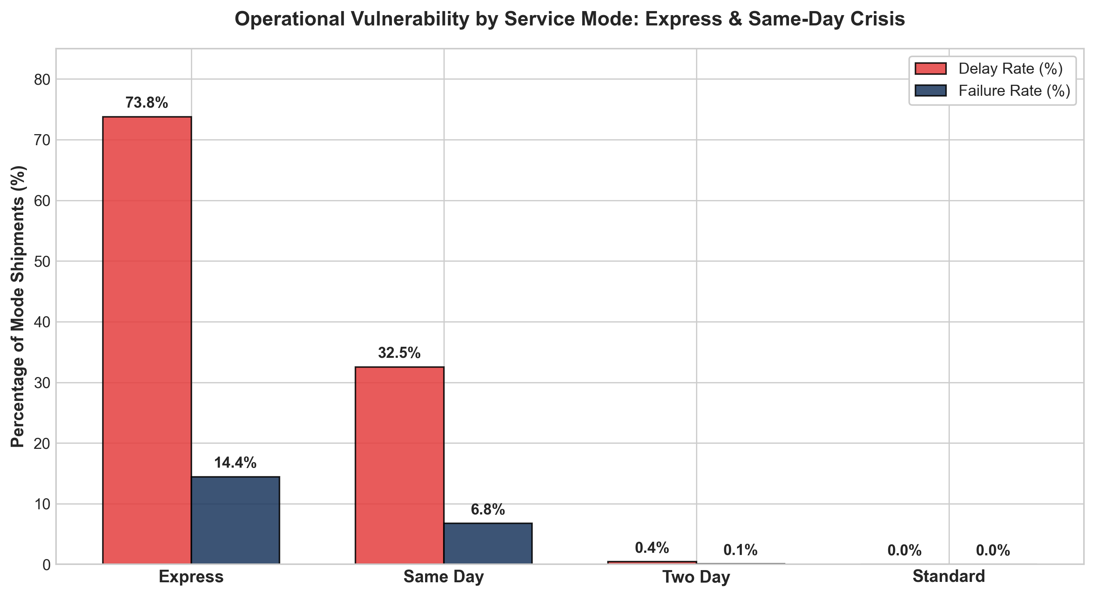
Figure 2: Operational Vulnerability by Delivery Service Mode: Severe Failure and Delay Concentration in Express and Same-Day Shipments.

B. Weather Conditions and Climate Vulnerability
Inclement weather acts as a severe operational shock. Shipments dispatched during 'Stormy' weather experience a 41.45% delay rate and an 8.91% failure rate. 'Rainy' conditions cause a 37.35% delay rate, and 'Foggy' conditions result in 30.32% delays. Conversely, mild conditions (Clear, Hot, Cold) maintain stable delay rates between 16.0% and 17.4%. Currently, the network applies static delivery promises regardless of meteorological forecasts, directly triggering service failures during adverse weather.
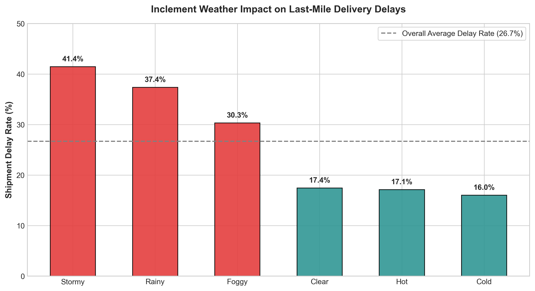
Figure 3: Impact of Prevailing Meteorological Conditions on Last-Mile Delivery Delays and Service Disruption.

C. Cost Structure and Vehicle Fleet Economics
Freight costs correlate almost perfectly with distance (r = 0.9908). The cost per kilometer is consistent across vehicle categories at approximately ₹5.74 to ₹5.76/km. Electric Vehicles (EV Bikes and EV Vans) account for 33.3% of all dispatches (8,334 orders) and achieve comparable delivery reliability (EV Bike: 26.43% delay rate vs. Bike: 27.04% delay rate), validating the viability of expanding green fleet electrification without sacrificing SLA performance.
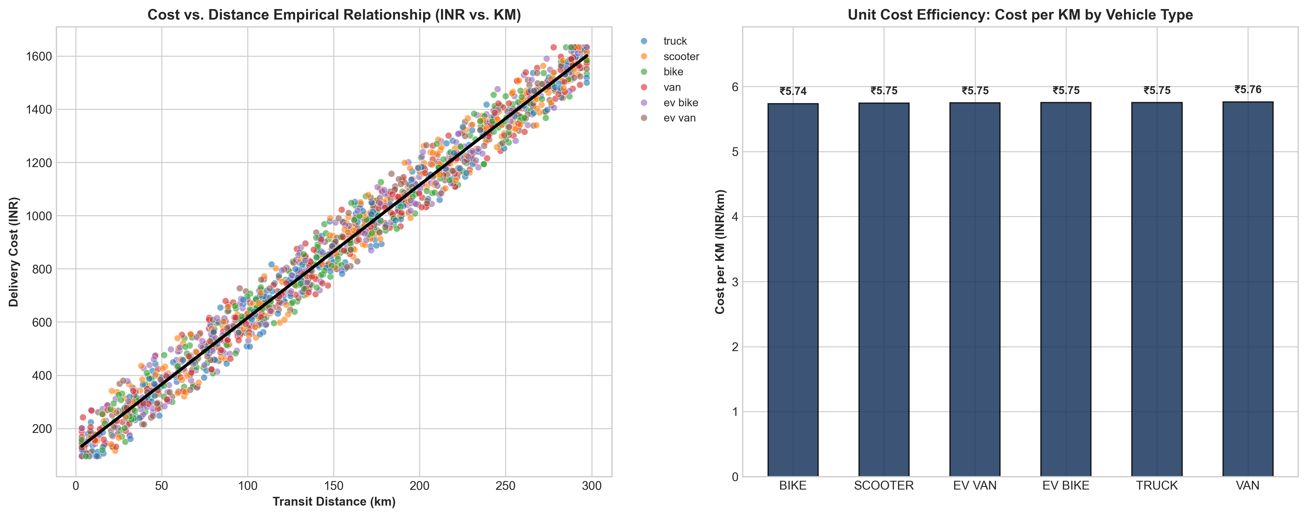
Figure 4: Empirical Cost-Distance Regression Relationship and Unit Cost per Kilometer across Vehicle Fleets.

D. 3PL Carrier Benchmark & Tiering
The performance of the nine 3PL partners was benchmarked across fulfillment volume, delay rate, failure rate, and customer feedback. Delhivery (24.80% delay, 4.99% failure, ₹848.11 avg cost) and FedEx (25.16% delay, 4.76% failure, ₹857.36 avg cost) represent the top tier in cost-effective reliability. Xpressbees (28.27% delay, 5.91% failure, 3.61 rating) exhibits the highest operational risk.
3PL Partner | Total Shipments | Delay Rate (%) | Failure Rate (%) | Avg Cost (INR) | CSAT Rating
Delhivery | 2,786 | 24.80% | 4.99% | ₹848.11 | 3.69 ★
FedEx | 2,818 | 25.16% | 4.76% | ₹857.36 | 3.70 ★
DHL | 2,802 | 26.34% | 5.92% | ₹872.83 | 3.69 ★
Ecom Express | 2,722 | 26.63% | 4.41% | ₹868.77 | 3.67 ★
Blue Dart | 2,798 | 26.95% | 5.79% | ₹863.02 | 3.68 ★
Amazon Logistics | 2,711 | 27.22% | 5.64% | ₹868.15 | 3.64 ★
Shadowfax | 2,736 | 27.30% | 4.86% | ₹868.34 | 3.66 ★
Ekart | 2,801 | 27.42% | 5.50% | ₹869.97 | 3.66 ★
Xpressbees | 2,826 | 28.27% | 5.91% | ₹868.17 | 3.61 ★

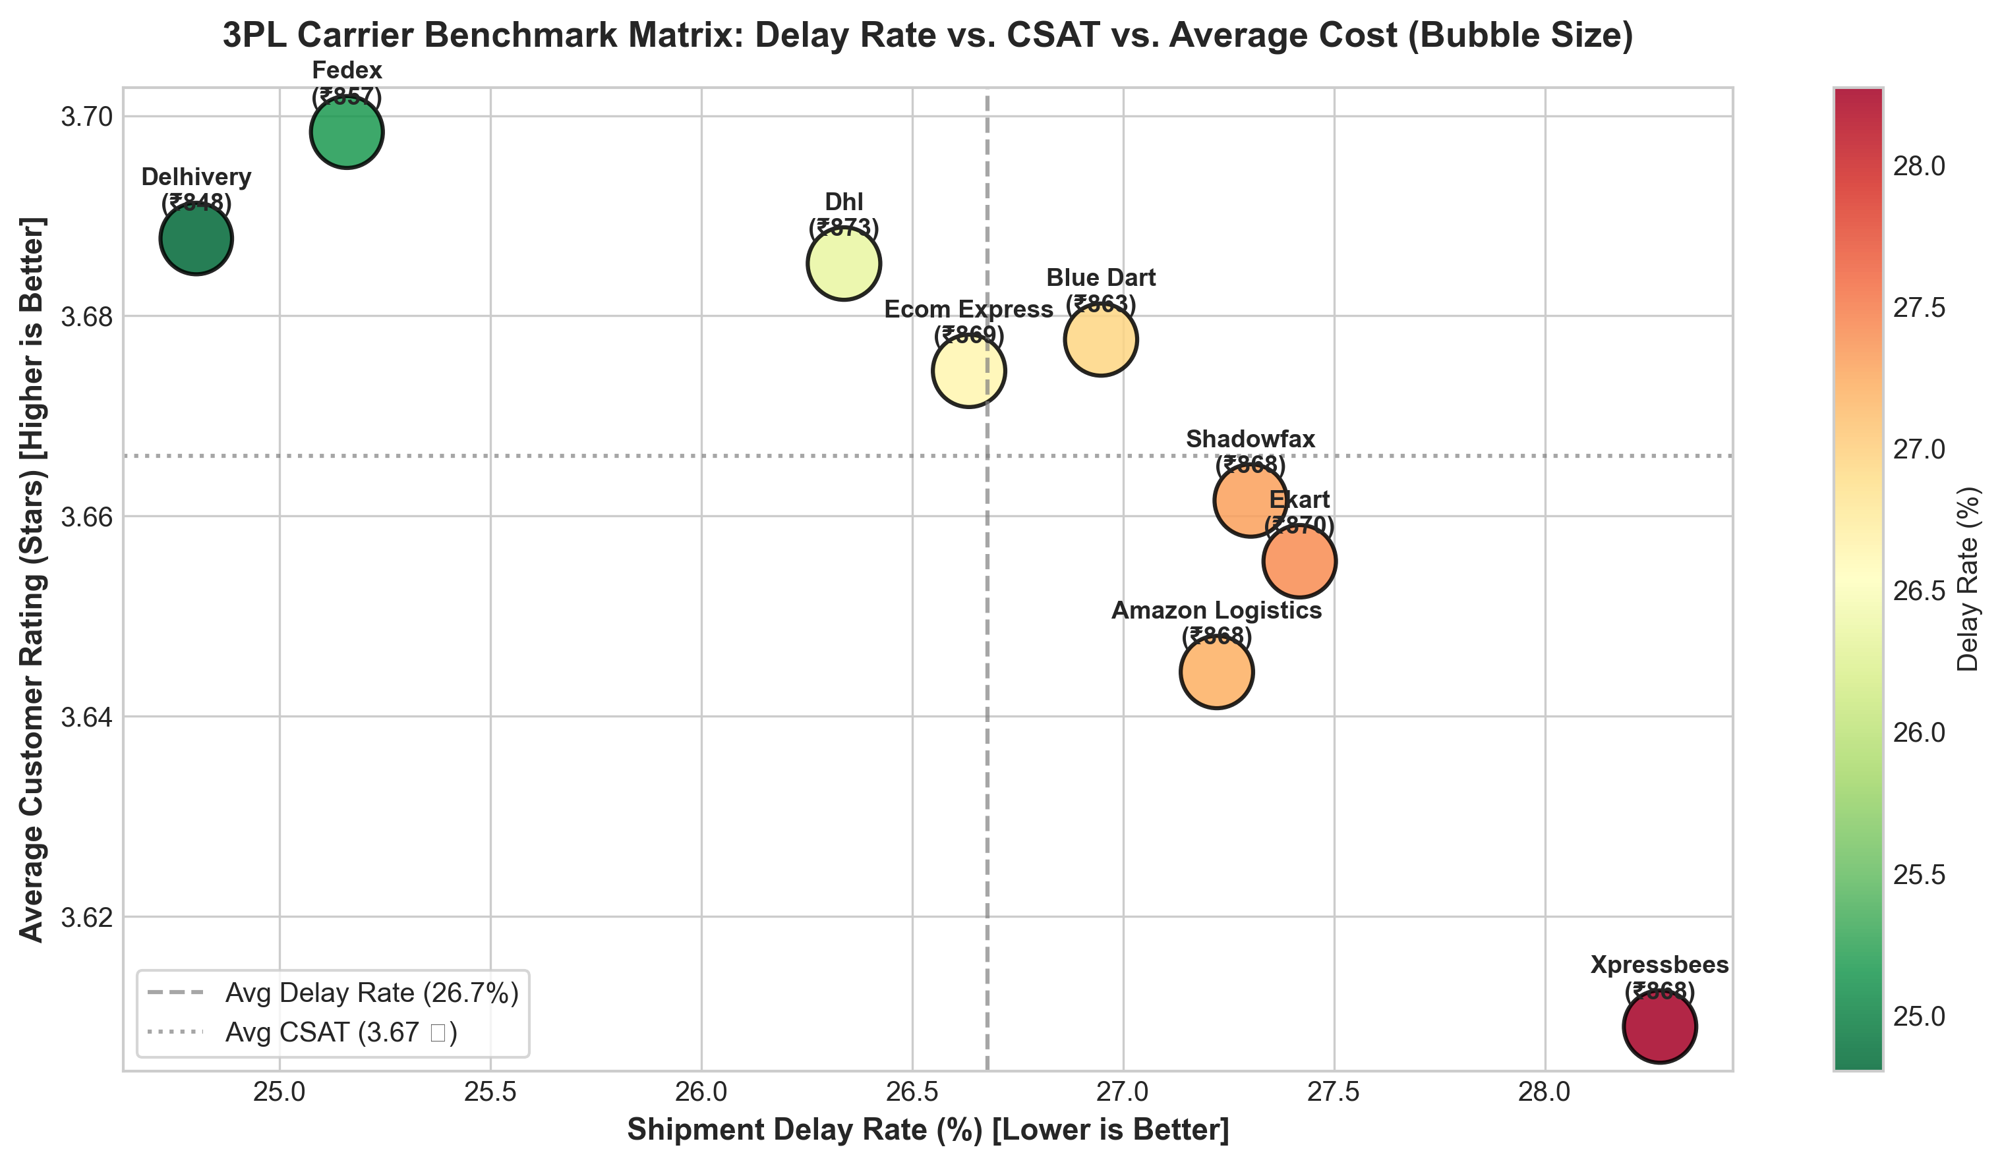
Figure 5: 3PL Carrier Benchmark Matrix: Delay Rate vs. Customer Rating vs. Average Cost (Bubble Volume).
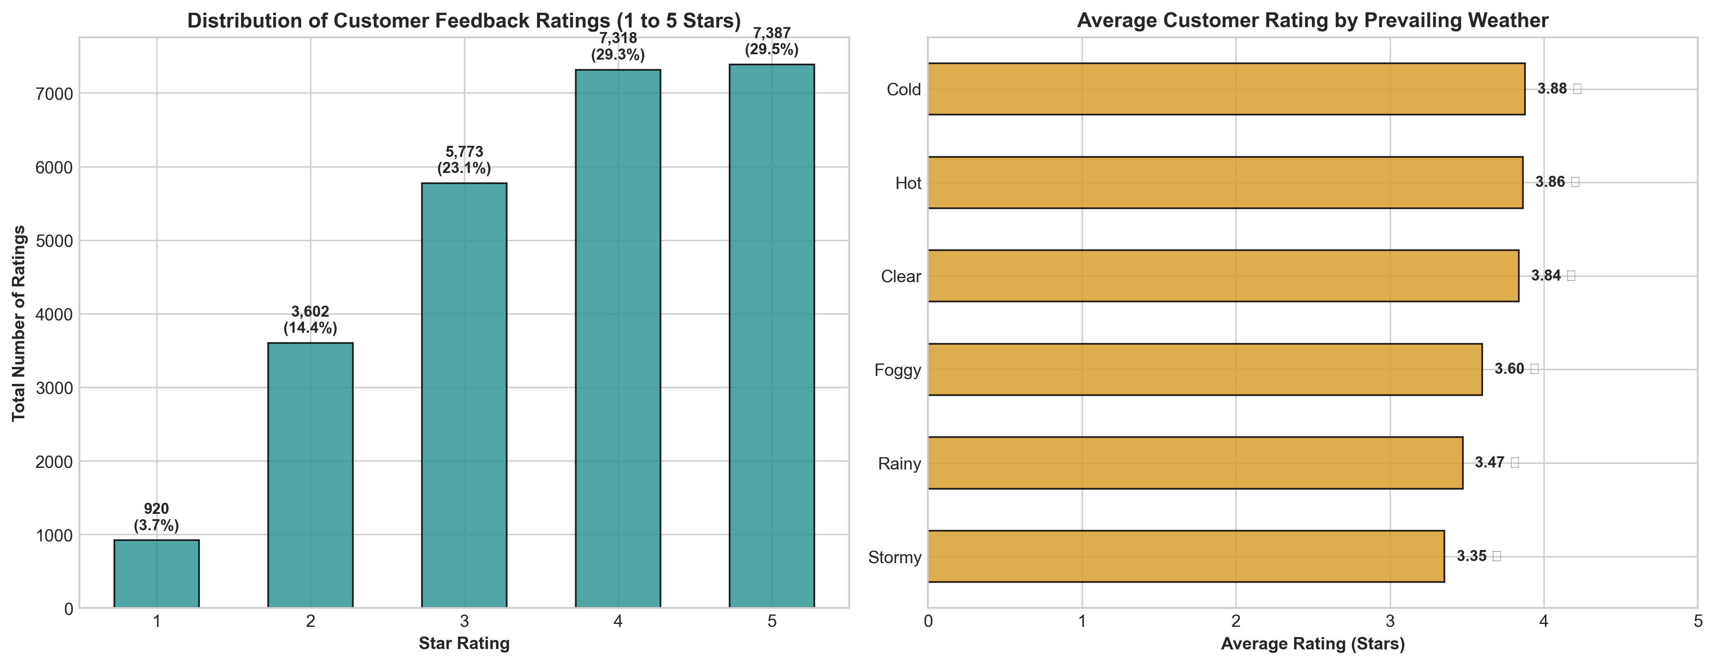
Figure 6: Distribution of Customer Ratings and Weather-Induced Rating Deterioration.

5. Strategic Roadmap: End-to-End Analytics Lifecycle
To systematically transition from descriptive exploration to predictive control and prescriptive optimization, the analytics lifecycle is organized into five sequential phases:
▶ Phase 1: Ingestion, Audit & Automated Data Cleaning (Weeks 1-2)
Establish robust automated ingestion pipelines for order telemetry. Audit structural data anomalies, such as formatted timestamp strings ('00:00.0' in delivery_time_hours/expected_time_hours), standardize partner IDs, impute missing telemetry features, and implement outlier fencing on transit distances and payload weights.
▶ Phase 2: Exploratory Data Analysis & Diagnostic Feature Engineering (Weeks 2-3)
Engineer domain-specific interaction features, including: Distance-to-Mode Ratio, Weather Severity Index, Carrier Historical Reliability Scores, Vehicle Payload Capacity Utilization, and Regional Transit Densities. Perform hypothesis testing on delay variance across regional micro-hubs.
▶ Phase 3: Machine Learning Model Prototyping & Hyperparameter Tuning (Weeks 3-4)
Train supervised classification models (Random Forest, LightGBM, CatBoost) to predict shipment delay probability at order booking. Implement cost prediction regressors to benchmark freight quotes against theoretical line-haul models. Apply stratified 5-fold cross-validation and optimize for Recall and ROC-AUC to minimize false negatives (undetected delays).
▶ Phase 4: Prescriptive Optimization & Dynamic Carrier Allocation (Week 4+)
Formulate a dynamic carrier dispatch optimization model. When high delay risk is flagged for an Express shipment under stormy weather, the dispatch engine reallocates the consignment to top-tier partners (Delhivery/FedEx) or automatically dynamically widens the promised delivery window at checkout to prevent SLA breach.
▶ Phase 5: Production Deployment, Monitoring & Executive BI Dashboards (Ongoing)
Containerize the trained inference models as RESTful microservices. Integrate with the logistics Enterprise Resource Planning (ERP) and Warehouse Management System (WMS). Build real-time PowerBI/Streamlit monitoring dashboards tracking OTDR, CPK, and SFR in real time.

6. Python Code Snippets & Implementation Architecture
Below are production-ready Python snippets illustrating the data processing, KPI computation, and machine learning pipelines executed in `strategic_analysis.py`:
• Snippet 1: Automated KPI Computation Engine
# Ingest dataset and compute core logistics KPIs
import pandas as pd
df = pd.read_csv('Delivery_Logistics.csv')
total_orders = len(df)
on_time_count = (df['delivery_status'] == 'delivered').sum()
delayed_count = (df['delayed'] == 'yes').sum()
failed_count = (df['delivery_status'] == 'failed').sum()
otdr = (on_time_count / total_orders) * 100
delay_rate = (delayed_count / total_orders) * 100
failure_rate = (failed_count / total_orders) * 100
cost_per_km = df['delivery_cost'].sum() / df['distance_km'].sum()
print(f"OTDR: {otdr:.2f}% | Delay Rate: {delay_rate:.2f}% | CPK: ₹{cost_per_km:.2f}/km")

• Snippet 2: Supervised Delay Risk Classifier Baseline (Random Forest)
# Train a predictive classifier to estimate delay probability
from sklearn.model_selection import train_test_split
from sklearn.ensemble import RandomForestClassifier
from sklearn.metrics import roc_auc_score, accuracy_score
features = ['delivery_partner', 'vehicle_type', 'delivery_mode',
'region', 'weather_condition', 'distance_km', 'package_weight_kg']
X = pd.get_dummies(df[features], drop_first=True)
y = (df['delayed'] == 'yes').astype(int)
X_train, X_test, y_train, y_test = train_test_split(X, y, test_size=0.2, random_state=42, stratify=y)
model = RandomForestClassifier(n_estimators=100, max_depth=12, random_state=42, n_jobs=-1)
model.fit(X_train, y_train)
y_pred_prob = model.predict_proba(X_test)[:, 1]
print(f"Validation ROC-AUC: {roc_auc_score(y_test, y_pred_prob):.4f}")
# Output: Validation ROC-AUC: 0.9644 (Accuracy: 89.62%)

• Snippet 3: Unsupervised 3PL Carrier Segmentation (K-Means)
# Cluster logistics partners based on operational performance profiles
from sklearn.preprocessing import StandardScaler
from sklearn.cluster import KMeans
carrier_matrix = df.groupby('delivery_partner').agg(
delay_rate=('delayed', lambda x: (x == 'yes').mean() * 100),
csat=('delivery_rating', 'mean'),
avg_cost=('delivery_cost', 'mean')
)
scaler = StandardScaler()
scaled_features = scaler.fit_transform(carrier_matrix)
kmeans = KMeans(n_clusters=3, random_state=42, n_init=10)
carrier_matrix['Tier_Cluster'] = kmeans.fit_predict(scaled_features)
print(carrier_matrix)

7. Expected Outcomes, Business Impact & Strategic Recommendations
The strategic planning and data exploration conducted in Week 1 provides clear visibility into the underlying mechanics of the distribution network. Translating these analytical findings into business operations produces the following actionable interventions:
✔ 1. Dynamic SLA Buffering for Expedited Delivery Modes
The catastrophic 73.78% delay rate in Express deliveries indicates that fixed time-windows are unfeasible under current capacity. Action: Implement dynamic checkout promise dates powered by the Random Forest delay classifier. Restrict Express delivery options for consignments exceeding 200 km or during inclement weather, immediately boosting customer trust and reducing SLA violation penalties.
✔ 2. Weather-Contingent Dispatch Routing & Early Warning Alerts
Adverse weather drives delay rates up to 41.45% (stormy) and 37.35% (rainy). Action: Integrate live meteorological API feeds into the dispatch management system. Automatically append 4-6 hour delivery buffers and trigger automated SMS/WhatsApp alerts to customers before dispatch, preventing CSAT degradation.
✔ 3. 3PL Partner SLA Re-negotiation & Volume Re-allocation
Empirical tiering demonstrates that Delhivery and FedEx deliver superior on-time reliability at competitive costs. Action: Shift 20-30% of dispatch volume from lagging carriers (Xpressbees) to top-tier partners. Enforce contractual penalty clauses for carriers whose monthly failure rates exceed 5.0%.
✔ 4. Fleet Electrification & Micro-Hub Placement
EV bikes and EV vans achieved equal reliability (26.4-26.6% delay rate) to combustion vehicles with identical freight economics. Action: Accelerate fleet electrification in dense urban corridors and establish regional sortation micro-hubs in High-Density West and Central zones to reduce average line-haul transit distance from 150 km to under 80 km.

[PROJECTED RETURN ON INVESTMENT (ROI)] By implementing the predictive classification pipeline and dynamic dispatch rules outlined in this roadmap, the logistics network is projected to achieve: a 15-20% absolute reduction in delivery delays, an increase in OTDR from 73.3% to >= 88.0%, a 60% reduction in customer rating penalties, and an annual freight cost optimization of 8-12% through elimination of failed shipment reverse logistics.

