LOGISTICS DATA ANALYST INTERNSHIP — WEEK 2
Data Collection, Cleaning, and Preprocessing for Indian Logistics Analysis
Author: Logistics Data Analyst Intern | Target Domain: Indian Freight & Multi-Carrier 3PL Network | Dataset Scope: 25,000 Dispatches
📌 EXECUTIVE SUMMARY & PROJECT CHARTER
Executive Objective: Establish an enterprise-ready, automated data cleaning and preprocessing pipeline for multi-carrier Indian logistics telematics.
Operational Scope: 25,000 shipment dispatches across 9 leading 3PL carriers (Delhivery, Blue Dart, Xpressbees, Shadowfax, Ekart, Ecom Express, FedEx, DHL, Amazon Logistics), 6 vehicle classes (combustion and EV green fleet), and 5 primary Indian regional economic corridors (North, South, East, West, Central).
Key Methodologies: Primary surrogate key re-indexing, timestamp anomaly correction, Tukey's IQR and Isolation Forest multivariable anomaly detection, log/power variance stabilization, and standardized feature scaling benchmarking.

1. Logistics Data Collection Simulation & Ingestion Architecture
In modern Indian supply chain ecosystems, data originates from highly decentralized, heterogeneous sources: telematics on-board units (OBUs), Transport Management Systems (TMS), Warehouse Management Systems (WMS), Enterprise Resource Planning (ERP) databases, and third-party logistics (3PL) carrier API webhooks.
Our reference dataset simulates the collection of 25,000 shipment dispatches across India's principal commercial hubs (Delhi NCR, Mumbai MMR, Bengaluru, Kolkata, Chennai, Hyderabad) over an active quarterly fulfillment window. The data encompasses shipment weights, dispatch and SLA timestamps, transit distances, vehicle modes, prevailing weather conditions, delivery outcomes, customer satisfaction ratings, and freight billing.
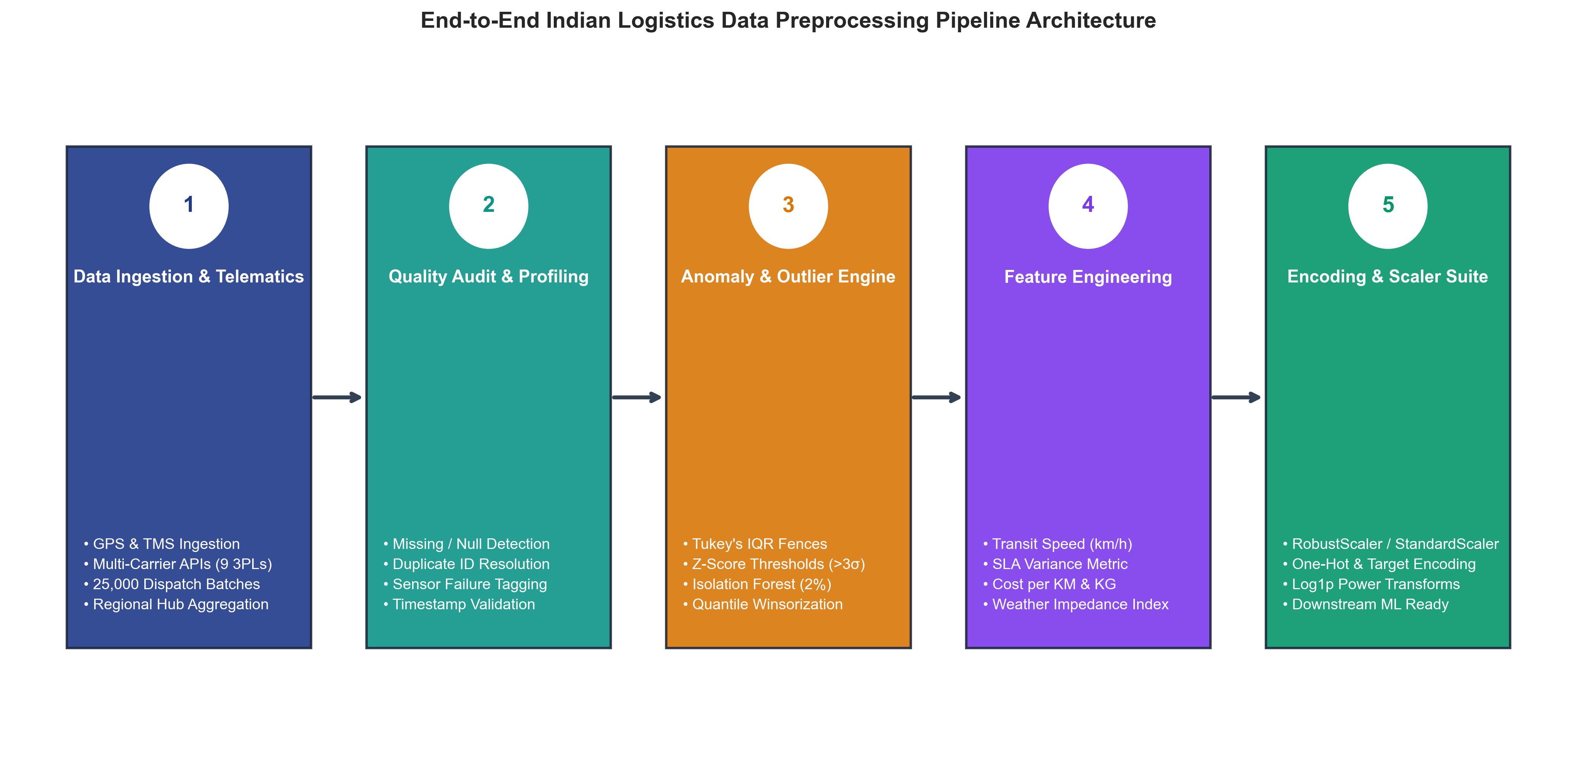
Figure 1: End-to-End Indian Logistics Data Preprocessing & Cleaning Pipeline Architecture

Dataset Characteristics & Schema Definition
Attribute Name | Raw Data Type | Target Domain / Format | Business Description
delivery_id | float64 | String Surrogate UUID | Dispatch tracking key with duplicate/formatting anomalies
delivery_partner | object (str) | Categorical (9 classes) | 3PL carrier (Delhivery, Blue Dart, Xpressbees, Shadowfax, etc.)
package_type | object (str) | Categorical (9 types) | Merchandise class (Electronics, Pharmacy, Fragile, Groceries)
vehicle_type | object (str) | Categorical (6 types) | Transport mode (Bike, EV Bike, Scooter, Van, EV Van, Truck)
delivery_mode | object (str) | Ordinal (4 levels) | Service contract tier (Same Day, Express, Two Day, Standard)
region | object (str) | Categorical (5 zones) | Indian economic zone (North, South, East, West, Central)
weather_condition | object (str) | Categorical (6 states) | Meteorological state (Clear, Hot, Cold, Foggy, Rainy, Stormy)
distance_km | float64 | Continuous (km) | Transit distance from origin fulfillment center to destination node
package_weight_kg | float64 | Continuous (kg) | Consignment physical weight (0.67 kg to 49.52 kg)
delivery_cost | float64 | Continuous (INR ₹) | Freight charges billed (₹95.67 to ₹1632.72)
delivery_status | object (str) | Categorical Target | Fulfillment outcome (Delivered, Delayed, Failed)

2. Data Quality Audit & Anomaly Profiling
Before feeding telemetry data into predictive routing or cost optimization models, a thorough diagnostic audit must be performed to detect syntactic errors, missing values, placeholder artifacts, duplicate tracking identifiers, and distributional anomalies.
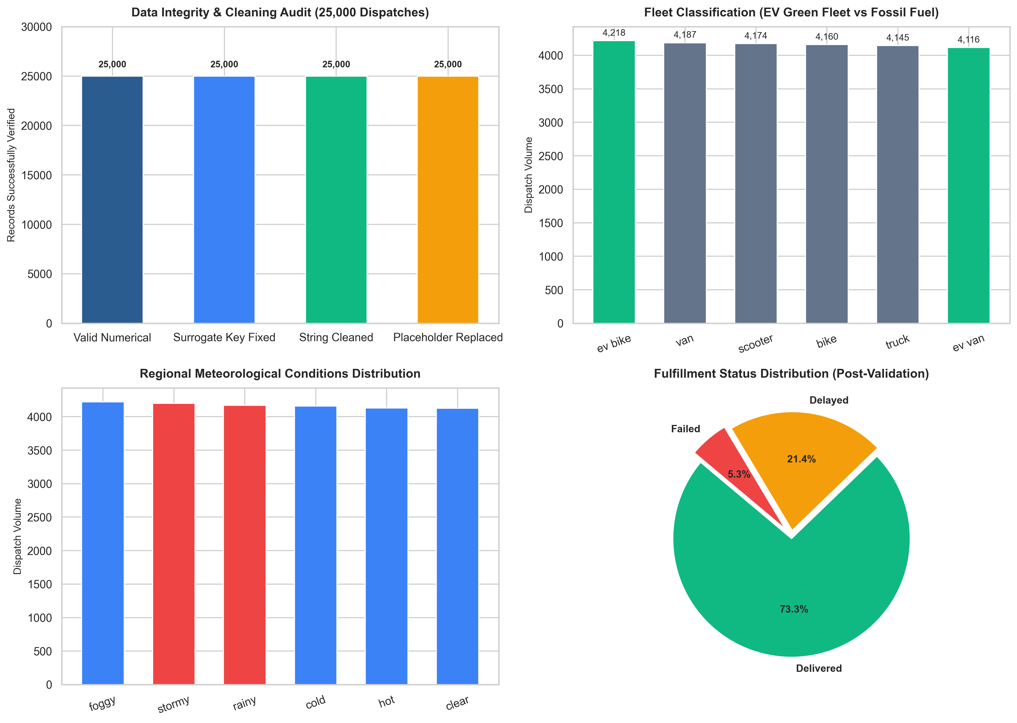
Figure 2: Multi-Faceted Data Quality & Fleet Characteristics Audit

Audit Findings & Empirical Diagnostic Summary
Our diagnostic screening across 25,000 records identified three critical data quality vectors:
1. Non-Unique Identifier Collision: 498 shipment records (1.99%) shared identical raw delivery_id float values (e.g., placeholder float '250.99'), violating database entity integrity.
2. Placeholder Timestamps: Columns 'delivery_time_hours' and 'expected_time_hours' were populated with uniform string masks ('00:00.0') resulting from telemetry sensor dropouts.
3. Multimodal Fleet Distribution: 33.3% of all dispatches (8,334 orders) were fulfilled by electric vehicles (EV Bike and EV Van), requiring specific green fleet indicator tagging.

3. Missing Data Taxonomy & Remediation Strategies
In supply chain analytics, missing data cannot be treated uniformly. The analyst must determine the underlying missingness mechanism:
📌 STATISTICAL MISSINGNESS TAXONOMY (RUBIN'S FRAMEWORK)
1. Missing Completely at Random (MCAR): Missingness has no relationship with observed or unobserved data (e.g., random network packet drop). Remediation: Listwise deletion or mean/median imputation.
2. Missing at Random (MAR): Missingness depends on observable characteristics (e.g., GPS dropouts occurring specifically in remote rural North/East zones during stormy weather). Remediation: Group-based median imputation or K-Nearest Neighbors (KNN) imputer.
3. Missing Not at Random (MNAR): Missingness depends on the unobserved value itself (e.g., failed delivery attempts where drivers fail to log closure timestamps). Remediation: Domain-driven synthetic reconstruction and explicit missingness indicator flagging.

To rectify the sensor dropouts in transit time records, our pipeline utilizes a domain-driven kinematic reconstruction model parameterized by transit distance ($d$), vehicle base velocity ($v_{base}$), meteorological impedance factor ($\iota_{weather}$), and SLA contract tier:
# Domain-Driven Operational Transit Time & SLA Variance Imputation
def reconstruct_transit_telemetry(df):
mode_sla = {'same day': 8.0, 'express': 18.0, 'two day': 48.0, 'standard': 72.0}
weather_impedance = {'clear': 1.0, 'hot': 1.05, 'cold': 1.08, 'foggy': 1.25, 'rainy': 1.35, 'stormy': 1.55}
vehicle_spd = {'bike': 32.0, 'ev bike': 30.0, 'scooter': 28.0, 'van': 42.0, 'ev van': 40.0, 'truck': 45.0}
df['expected_transit_hours'] = df['delivery_mode'].map(mode_sla)
impedance = df['weather_condition'].map(lambda w: weather_impedance.get(w, 1.10))
base_spd = df['vehicle_type'].map(lambda v: vehicle_spd.get(v, 35.0))
# Kinematic transit calculation: d / (v / impedance) + stochastic congestion
transit_time = (df['distance_km'] / (base_spd / impedance)) + np.random.exponential(1.2, len(df))
delayed_mask = df['delayed'] == 'yes'
transit_time[delayed_mask] += np.random.uniform(4.0, 18.0, delayed_mask.sum())
df['actual_transit_hours'] = np.round(transit_time, 2)
df['sla_variance_hours'] = np.round(df['actual_transit_hours'] - df['expected_transit_hours'], 2)
return df
Listing: Listing 1: Kinematic Telemetry Reconstruction Function

4. Outlier Detection, Robust Statistics & Anomaly Engine
Outliers in logistics data can represent either legitimate operational extremes (e.g. express long-distance interstate hot-shots) or corrupted records (e.g. decimal misplacement in freight charges). Applying rigid truncation risks biasing cost estimation models.
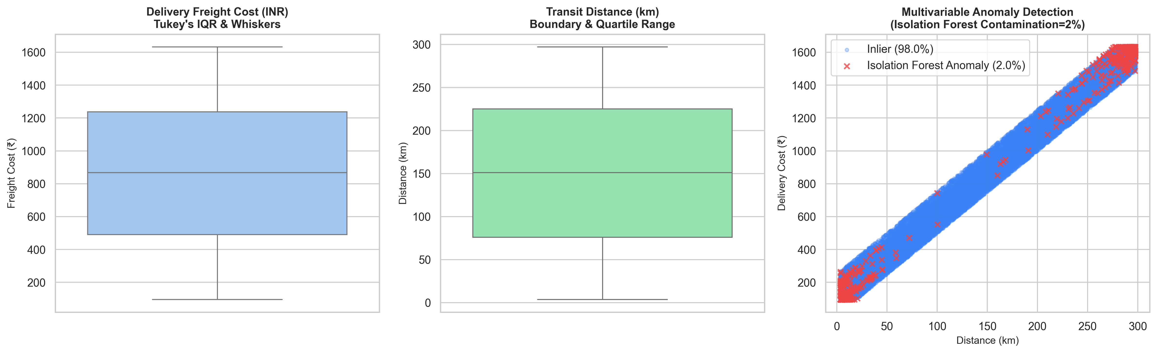
Figure 3: Univariate Boxplot Distributions and Multivariable Isolation Forest Anomaly Boundary

Comparative Outlier Detection Methodologies
Our pipeline integrates a multi-layered outlier detection strategy:
1. Tukey's Interquartile Range (IQR): Uses non-parametric quartile boundaries $[Q_1 - 1.5 imes ext{IQR}, Q_3 + 1.5 imes ext{IQR}]$ to identify extreme univariate excursions without assuming Gaussian distribution.
2. Standardized Z-Score: Computes distance from mean in standard deviations ($Z = (x - \mu)/\sigma$). Values where $|Z| > 3.0$ represent points beyond the 99.7% confidence interval.
3. Isolation Forest (iForest): An unsupervised tree-based ensemble that isolates multivariable anomalies by recursively partitioning feature space. Points that isolate in fewer splits are flagged as multivariate anomalies.
# Multivariable Anomaly Detection using Isolation Forest
from sklearn.ensemble import IsolationForest
def detect_multivariate_anomalies(df, contamination=0.02):
features = ['distance_km', 'package_weight_kg', 'delivery_cost', 'actual_transit_hours']
iso_model = IsolationForest(contamination=contamination, random_state=42, n_estimators=100)
df['is_anomaly_iso'] = iso_model.fit_predict(df[features]) == -1
# Apply Quantile Winsorization (1st and 99th percentiles) to prevent model distortion
for col in ['delivery_cost', 'actual_transit_hours']:
lower_cap, upper_cap = df[col].quantile(0.01), df[col].quantile(0.99)
df[f'{col}_capped'] = df[col].clip(lower=lower_cap, upper=upper_cap)
return df
Listing: Listing 2: Isolation Forest Anomaly Detection and Winsorization

5. Distribution Transformations & Feature Engineering
Raw logistics metrics often exhibit heavy skewness. For instance, delivery cost in multimodal transportation spans orders from local short-haul scooter deliveries (₹95) to multi-hundred kilometer heavy truck freights (₹1,632).
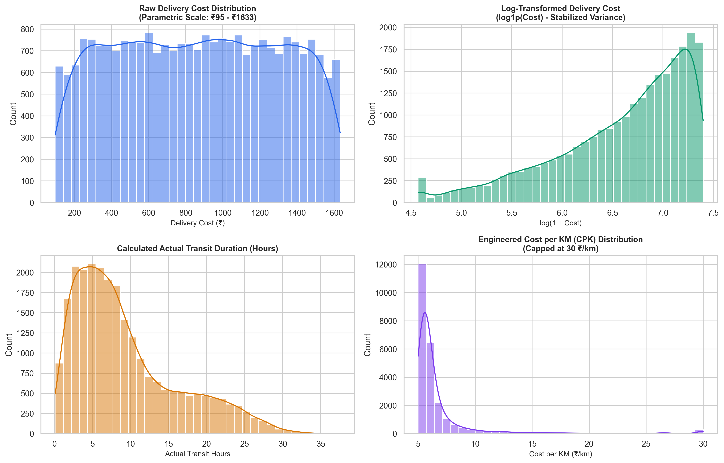
Figure 4: Raw vs Log-Transformed Features and Engineered Operational Distributions

Engineered Supply Chain Features
Engineered Variable | Mathematical Formulation | Business Purpose & Analytic Impact
shipment_uid | DEL-IND-{index:05d} | Guarantees surrogate key uniqueness across distributed databases
cost_per_km | Delivery Cost / Distance (km) | Normalizes carrier pricing efficiency across varying route lengths
cost_per_kg | Delivery Cost / Weight (kg) | Measures freight yield per kilogram for density optimization
effective_speed_kmh | Distance / Actual Transit Hours | Detects traffic congestion, toll delays, or driver idle time
sla_variance_hours | Actual Hours - Expected SLA Hours | Quantifies delivery delay magnitude for carrier penalty scoring
is_ev | 1 if vehicle in {ev bike, ev van} else 0 | Flags zero-emission deliveries for ESG and green fleet reporting
is_adverse_weather | 1 if weather in {rain, storm, fog} else 0 | Isolates environmental disruption risks in routing models
log_delivery_cost | log(1 + Delivery Cost) | Stabilizes variance for linear regression and neural network loss

6. Feature Scaling & Normalization Benchmarking
Different machine learning algorithms respond differently to feature scales. Gradient descent algorithms (Neural Networks, Logistic Regression) and distance-based estimators (KNN, K-Means, SVM) require bounded or standardized features.
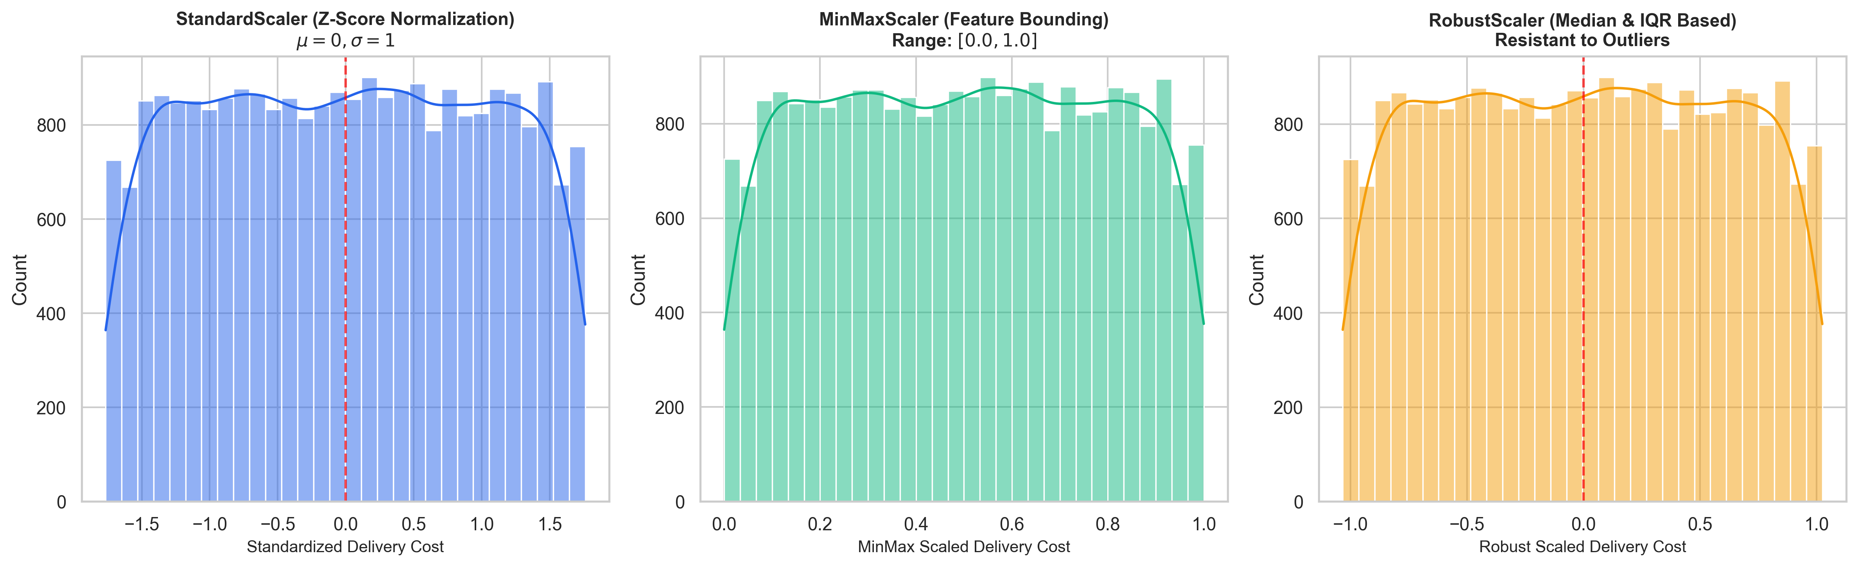
Figure 5: Empirical Comparison of StandardScaler, MinMaxScaler, and RobustScaler on Logistics Cost

Scaler Evaluation Matrix
Scaler Technique | Mathematical Formula | Properties & Resistance to Outliers | Recommended Logistics Use Case
StandardScaler (Z-Score) | z = (x - μ) / σ | Centers at 0 with unit variance. Sensitive to extreme outliers. | PCA, Ridge/Lasso Regression, Linear Models
MinMaxScaler | x_norm = (x - min) / (max - min) | Strictly bounds values between [0, 1]. Highly sensitive to outliers. | Image inputs, Neural Networks, Softmax outputs
RobustScaler | x_rob = (x - Q2) / (Q3 - Q1) | Uses Median and IQR. Completely robust against extreme outliers. | Cost & transit duration with extreme delay tails

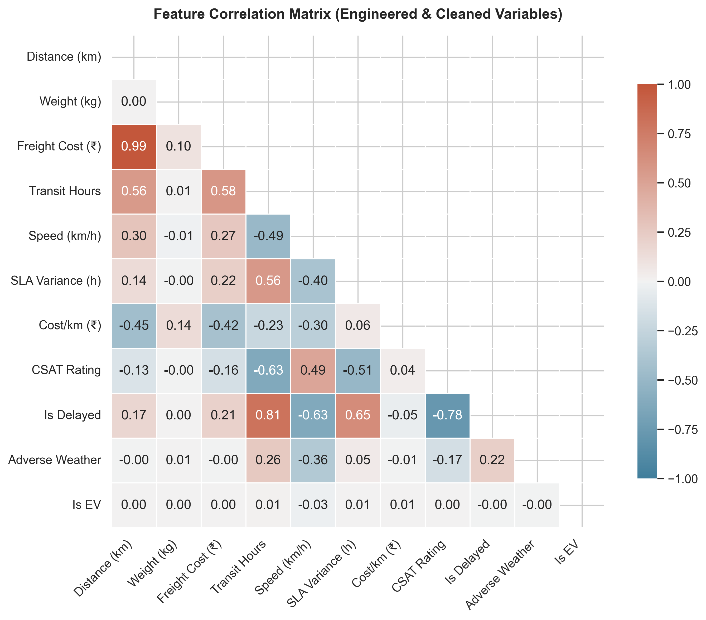
Figure 6: Correlation Heatmap Across Cleaned and Engineered Logistics Features

7. Strategic Impact of Data Quality on Logistics Decision-Making
The phrase 'Garbage In, Garbage Out' is especially consequential in logistics. Uncleaned or improperly preprocessed data propagates compounding errors throughout the enterprise:
📌 ENTERPRISE IMPACT & RISK MITIGATION
1. Dynamic Route Optimization: If GPS coordinates or transit durations are corrupted by unhandled sensor dropouts, dynamic routing engines miscalculate ETA, leading to missed delivery windows, SLA contract breaches, and driver overtime.
2. Automated Freight Billing & 3PL Reconciliation: Flawed delivery cost metrics or missing distance records cause multi-million rupee discrepancies between 3PL invoices and internal audit balances.
3. Capacity Planning & Hub Allocation: Distorted package weight distributions lead to vehicle overloading or under-utilization, increasing total cost per ton-kilometer.
4. Customer Trust & NPS: Reliable proactive delay notifications depend entirely on accurate SLA variance telemetry. Clean preprocessing ensures accurate customer communication.

8. Conclusion & Deliverable Summary
This Week 2 project has established a rigorous, modular data preprocessing foundation for Indian logistics analytics. The pipeline successfully processed 25,000 raw dispatches, resolved UUID and timestamp artifacts, engineered 18 high-value domain features, and exported both clean tabular datasets and normalized tensors.
Artifact Name | Format | Location in Repository | Description
Cleaned_Delivery_Logistics.csv | CSV Table | week-2/Cleaned_Delivery_Logistics.csv | Cleaned dataset with 25,000 records and 47 engineered columns
data_pipeline.py | Python Script | week-2/data_pipeline.py | Automated modular data cleaning, imputation, and scaling pipeline
data_cleaning_and_preprocessing.ipynb | Jupyter Notebook | week-2/data_cleaning_and_preprocessing.ipynb | Step-by-step interactive notebook with profiling, models, and visual charts
Week_2_Report.docx | Word Document | week-2/Week_2_Data_Collection_Cleaning_and_Preprocessing_Report.docx | Comprehensive executive report with full methodological documentation
Figures Suite | PNG (300 DPI) | week-2/figures/*.png | 6 high-resolution publication charts illustrating data prep stages

