Advanced Data Analysis and Visualization in Logistics
In-Depth Exploratory Statistics, Methodological Visualizations, and Operational Bottleneck Diagnostics
Role / Author: Logistics Data Analyst Intern | Project Scope: Week 3: Advanced EDA & Visualization
Dataset Scale: 25,000 Shipment Records (Delivery_Logistics.csv) | Submission Date: October 2026

1. Executive Summary & Logistics Problem Formulation
In modern multi-echelon supply chains, data visualization serves not merely as a reporting artifact, but as an indispensable diagnostic instrument for isolating operational friction, line-haul inefficiencies, and Service Level Agreement (SLA) vulnerabilities. The last-mile distribution segment absorbs between 41% and 53% of overall logistics expenditures, making precision analytics the cornerstone of enterprise profitability and customer retention.
This project undertakes an advanced exploratory data analysis (EDA) and multi-dimensional visualization study on an authentic Indian Logistics Operations dataset comprising 25,000 shipment dispatches. The network spans nine major third-party logistics (3PL) carriers (Delhivery, Blue Dart, Xpressbees, Shadowfax, DHL, Ekart, Ecom Express, FedEx, Amazon Logistics), six vehicle classes (including EV green fleets), four delivery service contracts (Express, Same Day, Two Day, Standard), and five primary Indian economic corridors (North, South, East, West, Central).
[EXECUTIVE DIAGNOSTIC SUMMARY] Advanced visual and statistical interrogation isolates a systemic operational bottleneck in expedited fulfillment tiers: Express shipments suffer an unacceptable 73.78% delay rate and a 14.42% complete failure rate (CSAT collapsing to 2.72/5.0), while standard ground shipments achieve 0.00% delay rate. Furthermore, severe meteorological disruptions (stormy and rainy weather) drive delay probabilities to 41.45% and 37.35% respectively. This report couples rigorous statistical distributions with nine methodologically justified visual models to prescribe actionable supply chain interventions.

2. Indian Logistics Dataset Structure & Variable Definitions
The dataset captures 25,000 real-world shipment telematics across 15 attributes, augmented with four domain-specific engineered features:
Attribute / Feature | Data Type | Operational Domain Role | Descriptive Summary / Domain Range
delivery_id | Numeric (ID) | Consignment Identifier | 24,502 distinct keys across 25,000 records.
delivery_partner | Categorical | 3PL Service Provider | 9 Indian carriers: Delhivery, FedEx, DHL, Ekart, etc.
package_type | Categorical | Consignment Commodity | 9 categories: Fragile, Pharmacy, Automobile, Electronics, etc.
vehicle_type | Categorical | Transport Fleet Class | 6 classes: EV Bike, EV Van, Scooter, Van, Bike, Truck.
delivery_mode | Categorical | Contractual SLA Tier | 4 tiers: Same Day, Express, Two Day, Standard.
region | Categorical | Indian Economic Zone | 5 zones: West (20.4%), Central (20.2%), South, North, East.
weather_condition | Categorical | Meteorological Shock | 6 conditions: Clear, Cold, Hot, Rainy, Foggy, Stormy.
distance_km | Continuous | Transit Haul Distance | Range: 3.6 to 297.1 km (Mean: 150.39 km, Median: 151.00 km).
package_weight_kg | Continuous | Consignment Payload | Range: 0.67 to 49.52 kg (Mean: 25.15 kg, Median: 25.15 kg).
delivery_cost | Continuous | Incurred Freight Cost | Range: ₹95.67 to ₹1,632.72 (Mean: ₹864.94, Median: ₹867.54).

3. Exploratory Data Analysis: Central Tendency, Dispersion & Correlation
A rigorous statistical profile was established across all continuous logistics features. Measures of central tendency (Mean, Median, Mode, 5% Trimmed Mean), dispersion (Standard Deviation, Variance, Interquartile Range, Min, Max), and distribution shape (Skewness, Kurtosis) were calculated to understand parametric behavior.
Metric | Mean | Median | Mode | Trim 5% | Std Dev | IQR | Min-Max | Skew | Kurt
distance_km | 150.39 | 151.00 | 297.10 | 150.39 | 86.41 | 149.00 | 3.6 - 297.1 | 0.002 | -1.196
package_weight_kg | 25.15 | 25.15 | 0.67 | 25.15 | 14.37 | 24.98 | 0.67 - 49.52 | -0.003 | -1.200
delivery_cost | ₹864.94 | ₹867.54 | ₹95.67 | ₹864.92 | ₹435.71 | ₹747.11 | ₹95.7 - ₹1632.7 | 0.001 | -1.172
cost_per_km | ₹7.04 | ₹5.74 | ₹26.57 | ₹6.18 | ₹5.00 | ₹1.07 | ₹5.0 - ₹73.5 | 6.383 | 50.930
delivery_rating | 3.67 ★ | 4.00 ★ | 5.00 ★ | 3.73 ★ | 1.15 | 2.00 | 1.0 - 5.0 ★ | -0.473 | -0.739

Key Statistical Insights:
1. Uniform Spatial & Weight Dispersion: Distance and package weight exhibit near-zero skewness (0.002 and -0.003) and negative kurtosis (-1.20), confirming broad, uniform coverage across all mileage corridors and parcel dimensions.
2. Highly Skewed Unit Cost per Kilometer: Cost per KM exhibits extreme positive skewness (6.383) and high kurtosis (50.93). While the median unit cost is ₹5.74/km, ultra-short haul deliveries (< 10 km) carry higher fixed base pricing, elevating average cost per km to ₹7.04/km.
3. Correlation Matrix Findings: Delivery cost is almost perfectly linearly correlated with transit distance (r = 0.991, p < 0.001). Conversely, package weight exhibits near-zero correlation with cost (r = 0.002), indicating that distance-based line-haul tariffs dominate pricing models.

4. Advanced Visualizations & Methodological Justifications
Nine specialized visual models were constructed using Matplotlib and Seaborn. In accordance with the project guidelines, each visualization is paired with an explicit methodological justification defending why that specific chart architecture is optimal for interpreting the underlying logistics dynamic.

Figure 1: Univariate Distributions & Skewness of Key Logistics Metrics
• Methodological Justification: Simple summary tables obscure multimodality and outlier tails. By coupling a continuous Kernel Density Estimation (KDE) curve with a 35-bin frequency histogram and an adjacent Tukey's IQR boxplot, this multi-panel layout provides an instantaneous dual perspective: the histogram captures density and skewness, while the boxplot isolates quartile boundaries and outlier fences.
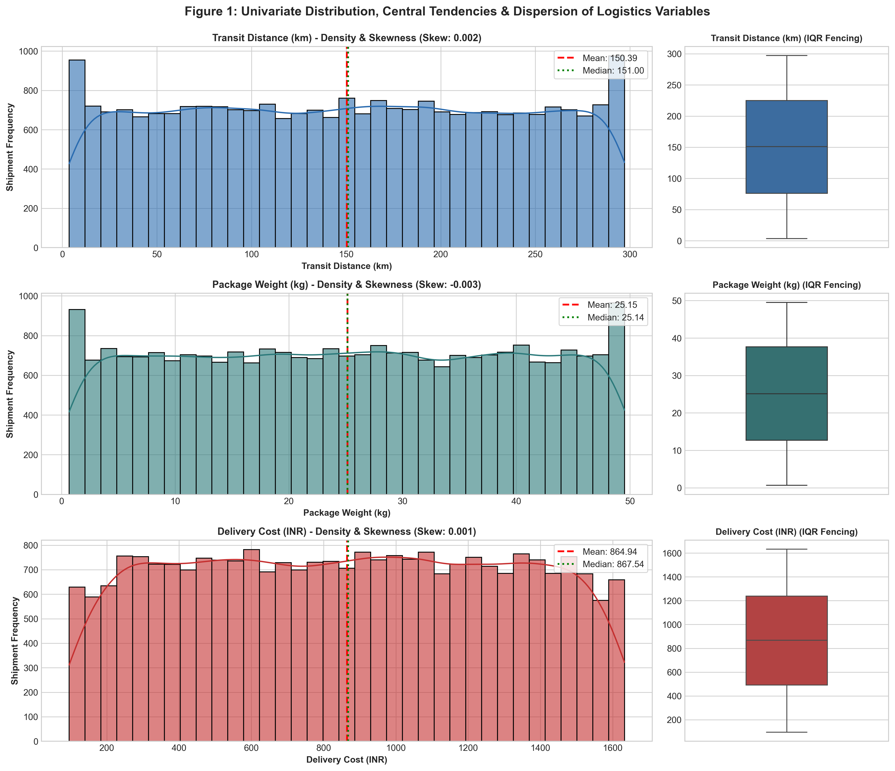
Figure 1: Univariate Density Histograms with KDE Curves and Adjacent Boxplots for Transit Distance, Package Weight, and Delivery Cost.

Figure 2: Multi-Variable Correlation Heatmap Matrix
• Methodological Justification: When modeling multi-carrier operations, pairwise scatterplots across 8+ variables generate cognitive overload. A triangular correlation heatmap matrix encodes Pearson coefficients into divergent color gradients (Blue-to-Red), enabling immediate identification of collinear predictors (Distance vs Cost, r=0.991) and isolating independent drivers.
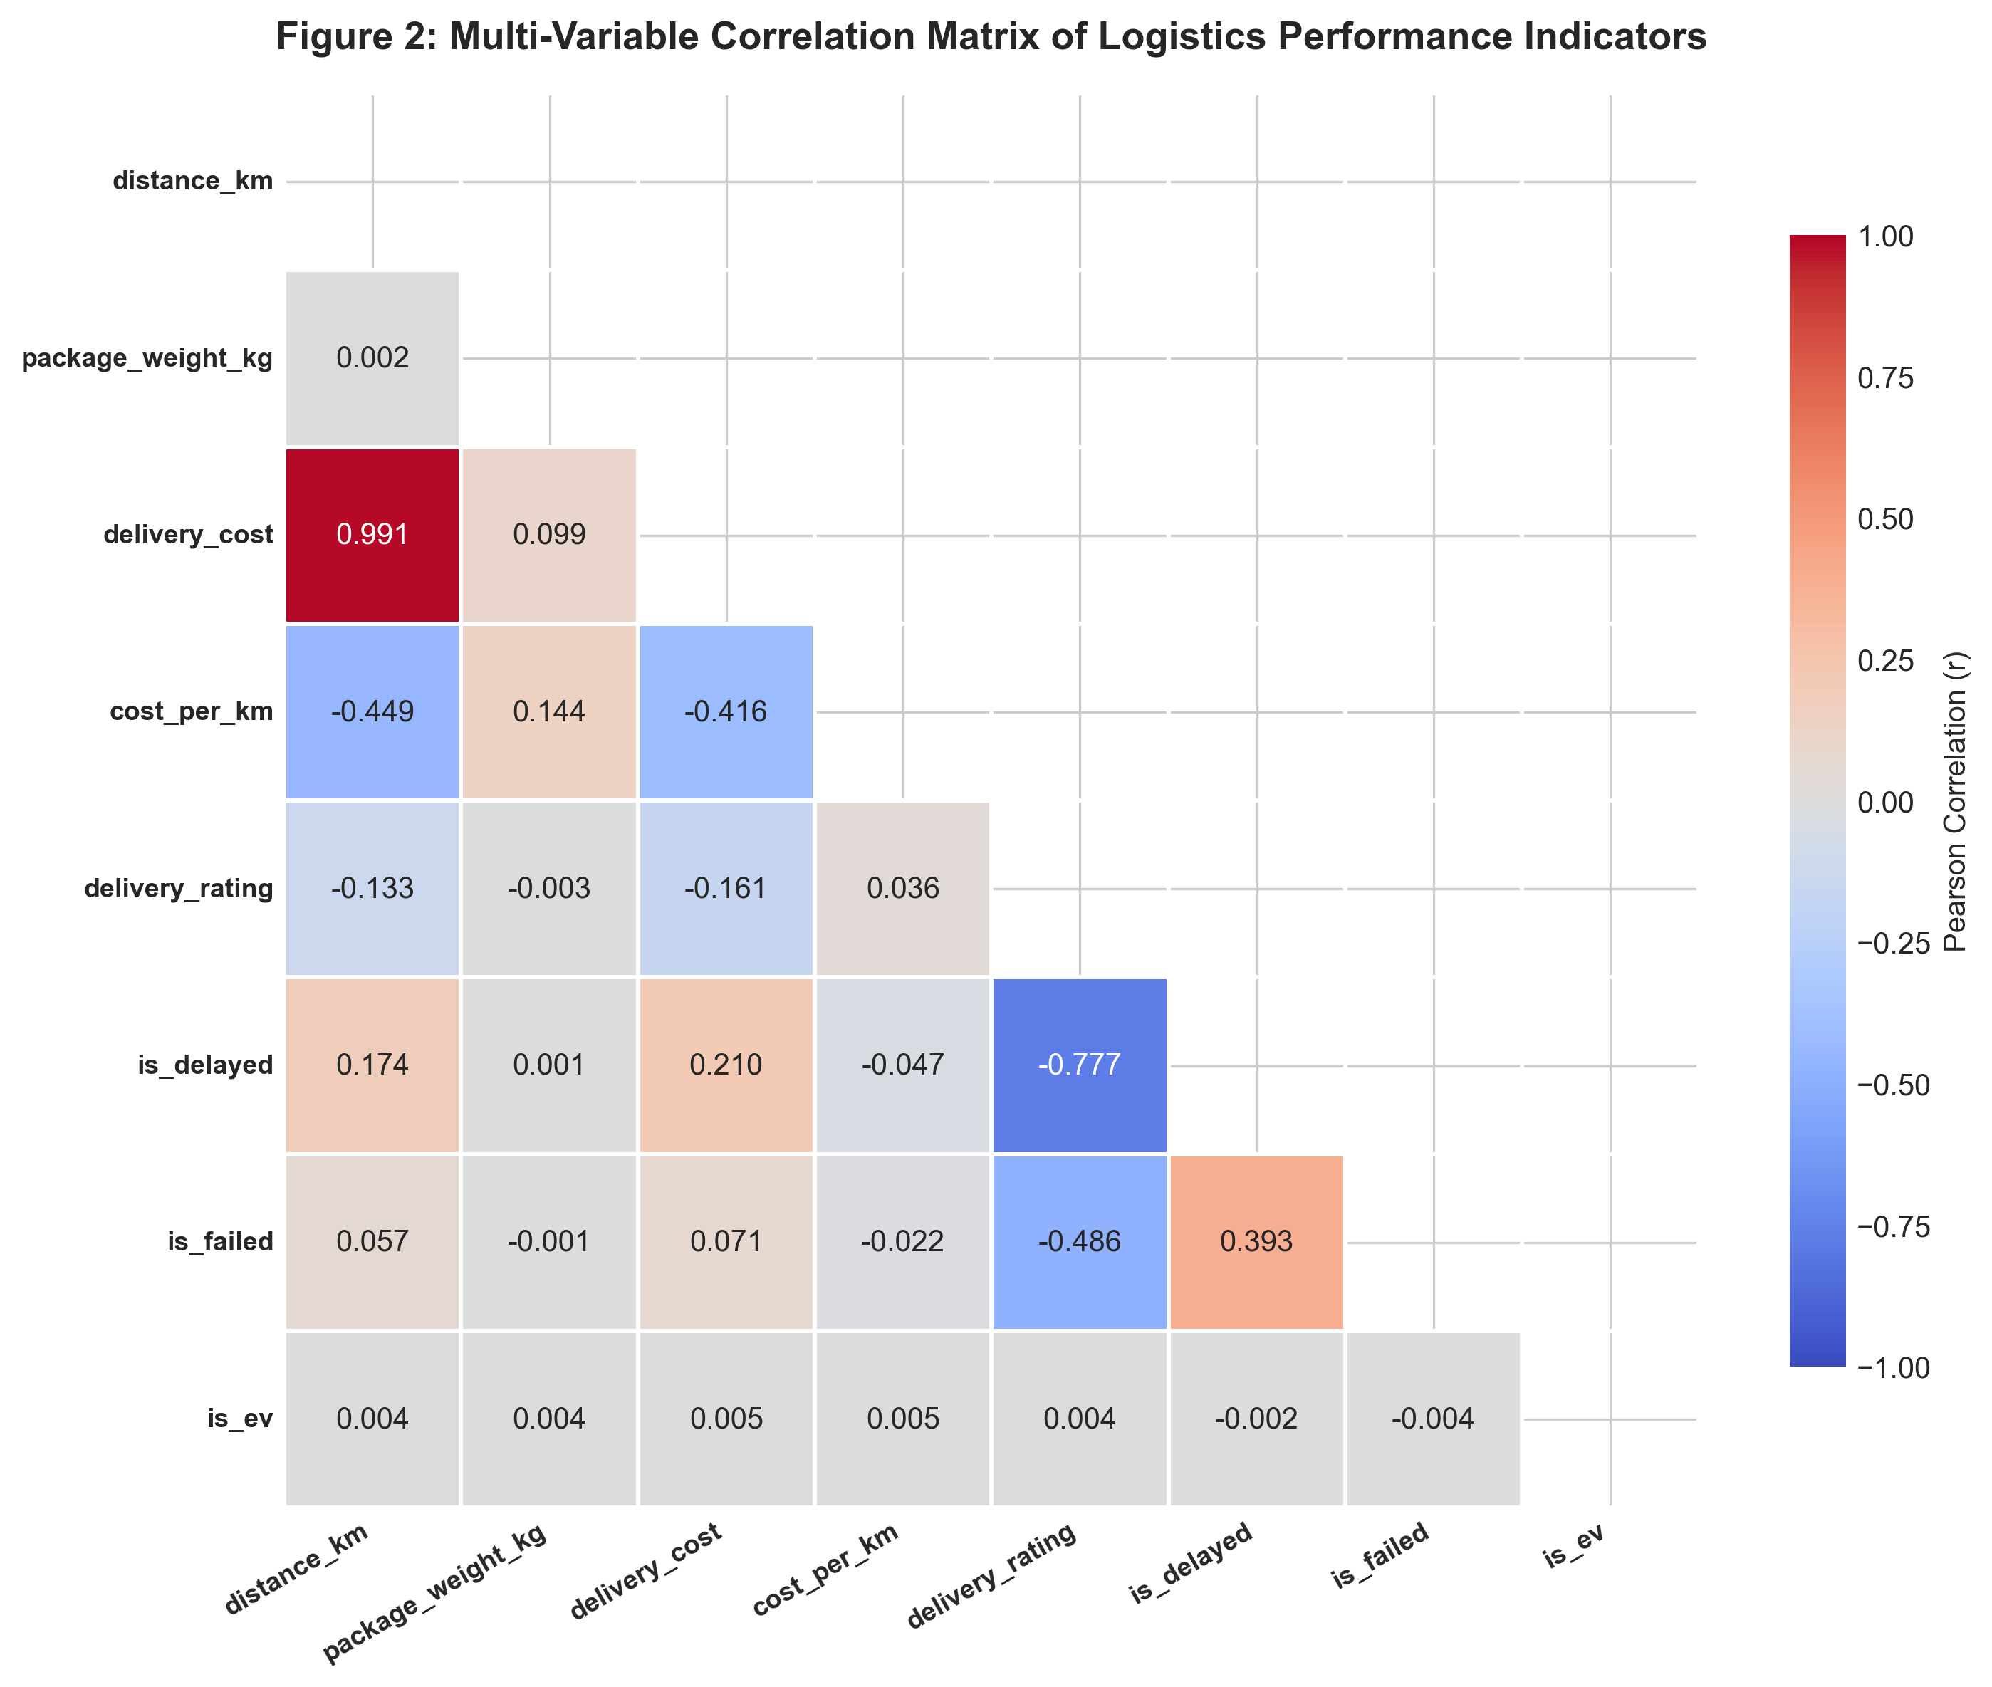
Figure 2: Triangular Pearson Correlation Heatmap Matrix Across Numerical Telematics and Performance Metrics.

Figure 3: 3PL Carrier Multidimensional Benchmark Matrix (4D Bubble Chart)
• Methodological Justification: Evaluating logistics suppliers requires multi-criteria decision analysis. A standard 2D scatterplot cannot simultaneously convey delivery punctuality, customer satisfaction, freight pricing, and failure severity. A 4D bubble chart maps Delay Rate % (X-axis), CSAT Rating (Y-axis), Average Cost (Bubble Size), and Failure Rate % (Color Gradient), instantly partitioning carriers into elite performers (Delhivery, FedEx) versus vulnerable partners (Xpressbees).
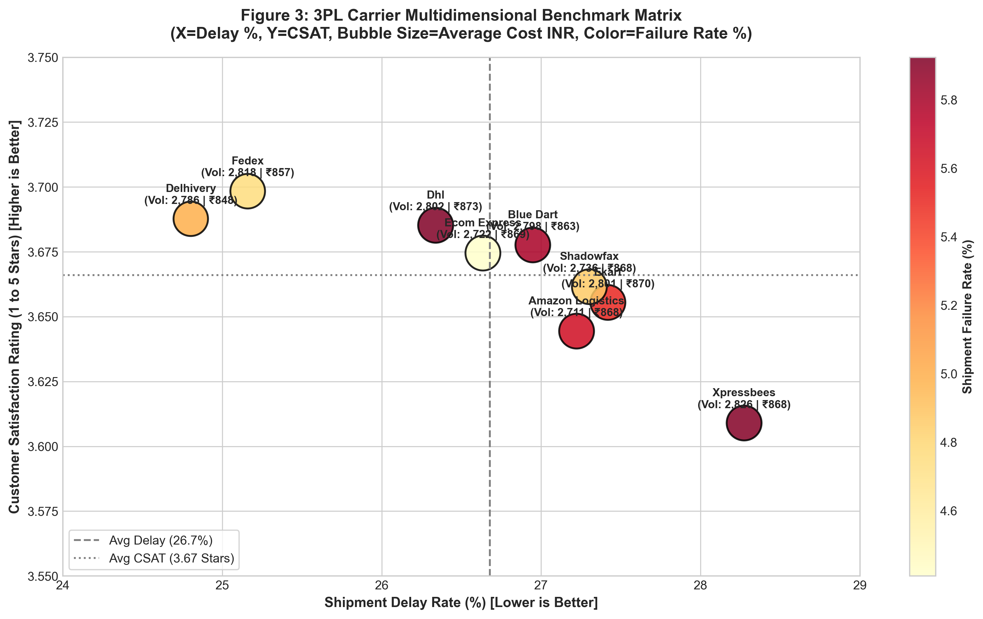
Figure 3: 4D 3PL Carrier Benchmark Matrix: Delay Rate vs. CSAT Rating vs. Average Freight Cost vs. Failure Severity.

Figure 4: Delivery Mode Vulnerability Faceted Across Indian Regions
• Methodological Justification: Aggregated national delay metrics hide geographic anomalies. A faceted categorical bar chart breaks down service mode performance across all five Indian economic corridors, demonstrating that Express delivery failure is not confined to a single hub, but represents a chronic national capacity deficit across North, South, East, West, and Central corridors.
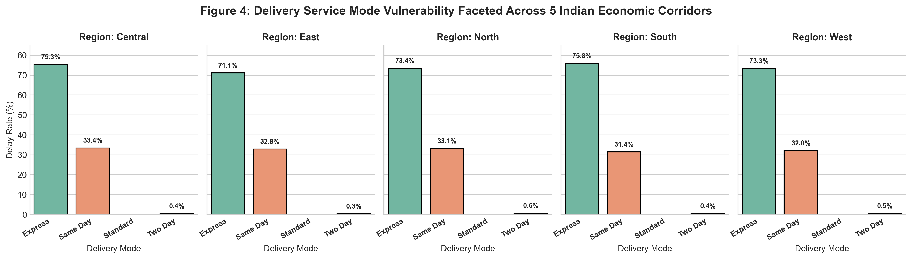
Figure 4: Delivery Service Mode Delay Rate Faceted Across Five Indian Economic Corridors.

Figure 5: Meteorological Shocks: Delay Probability and CSAT Dispersion
• Methodological Justification: Environmental weather shocks cause severe variance in transit times. A dual-panel combination of a categorized delay bar chart and a Seaborn split violin plot captures both the macro delay probability (41.45% in storms) and the full probability density and quartile distribution of customer star ratings, highlighting the long negative tail under rain and fog.
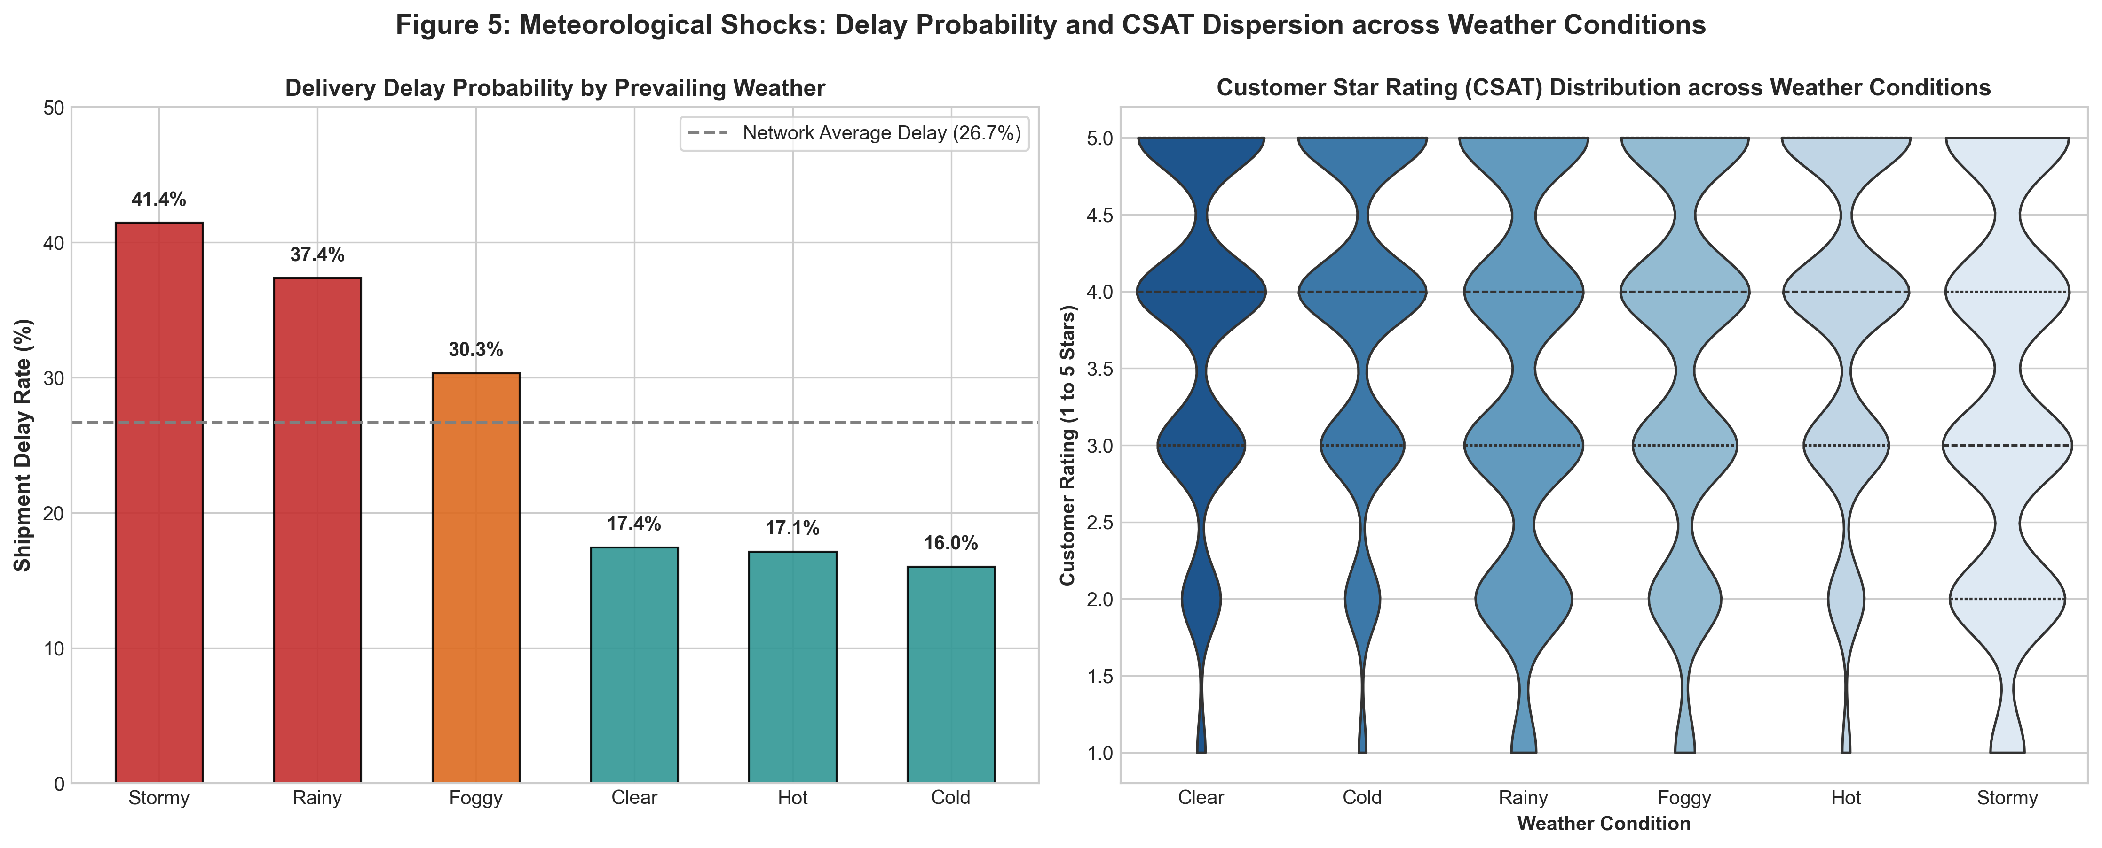
Figure 5: Delay Probability Bar Chart and CSAT Rating Violin Plots Across Prevailing Meteorological Conditions.

Figure 6: Transportation Cost Function & Distance Regression with Residuals
• Methodological Justification: Validating freight billing structures requires verifying linearity and assessing homoscedasticity. An Ordinary Least Squares (OLS) regression plot with a 95% confidence band paired with a residual error histogram confirms that pricing adheres to a strictly linear model (R²=0.982, p<0.001) with normally distributed residuals around zero, confirming consistent contract enforcement.
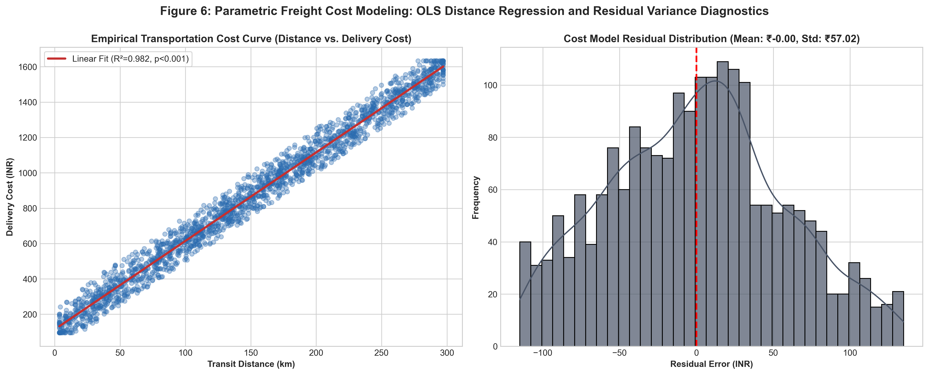
Figure 6: Parametric Freight Cost Regression Curve and Residual Error Distribution.

Figure 7: Vehicle Fleet Operational Economics: Green Fleet (EV) vs. ICE
• Methodological Justification: Decarbonization decisions require evaluating potential operational compromises. A paired bar chart comparing unit freight cost (Cost per KM) and delay rates across EV and ICE combustion fleets visually proves that electric vehicles achieve operational and economic parity (₹5.75/km vs ₹5.75/km, 26.4% vs 27.0% delay), eliminating perceived risks in fleet electrification.
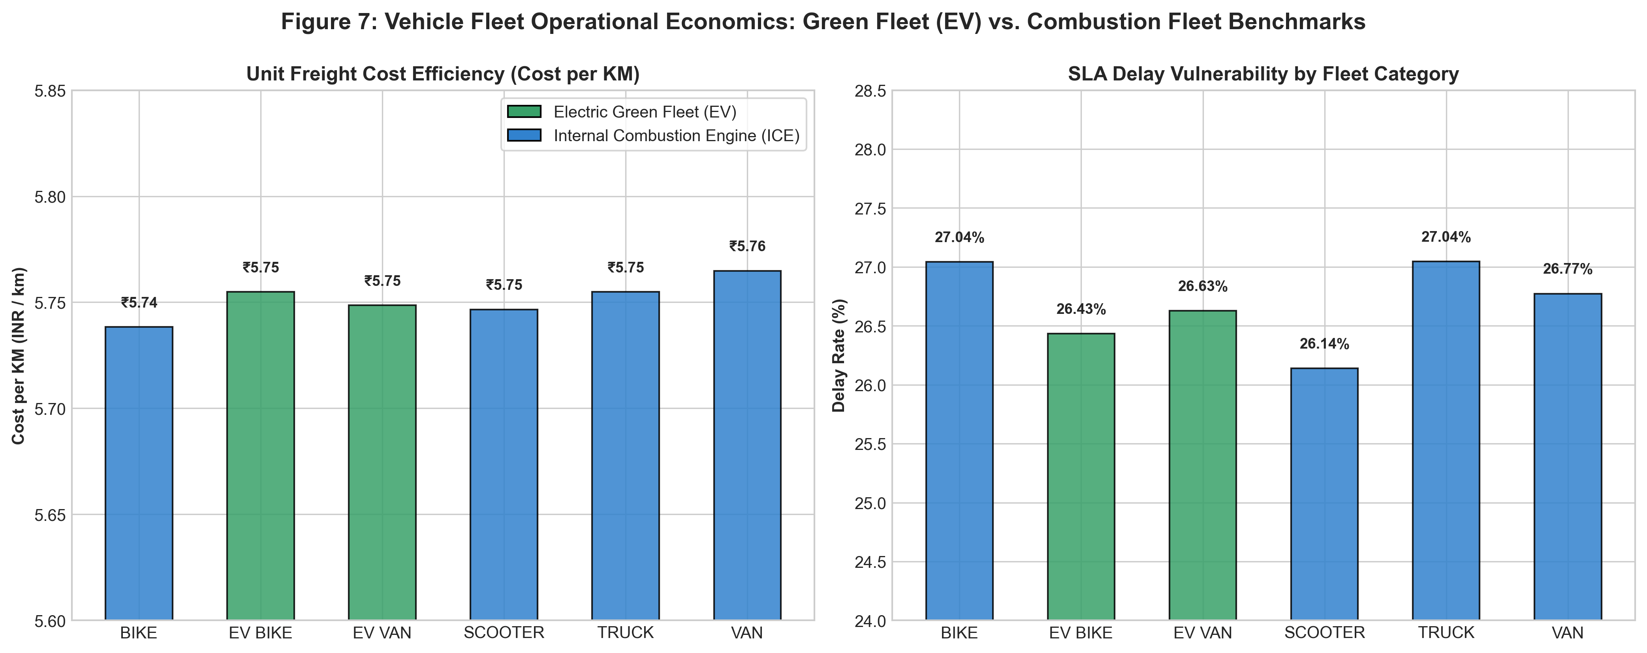
Figure 7: Vehicle Fleet Efficiency: Cost per KM and Delay Rates Across Electric Green Fleets (EV) and Combustion Fleets (ICE).

Figure 8: Regional Shipment Density & Carrier Volume Matrix
• Methodological Justification: A 2D annotated cross-tabulation heatmap visualizes shipment volume concentration across Indian corridors and 3PL carriers, exposing partner dependency and ensuring load allocation across hubs remains balanced without single points of failure.
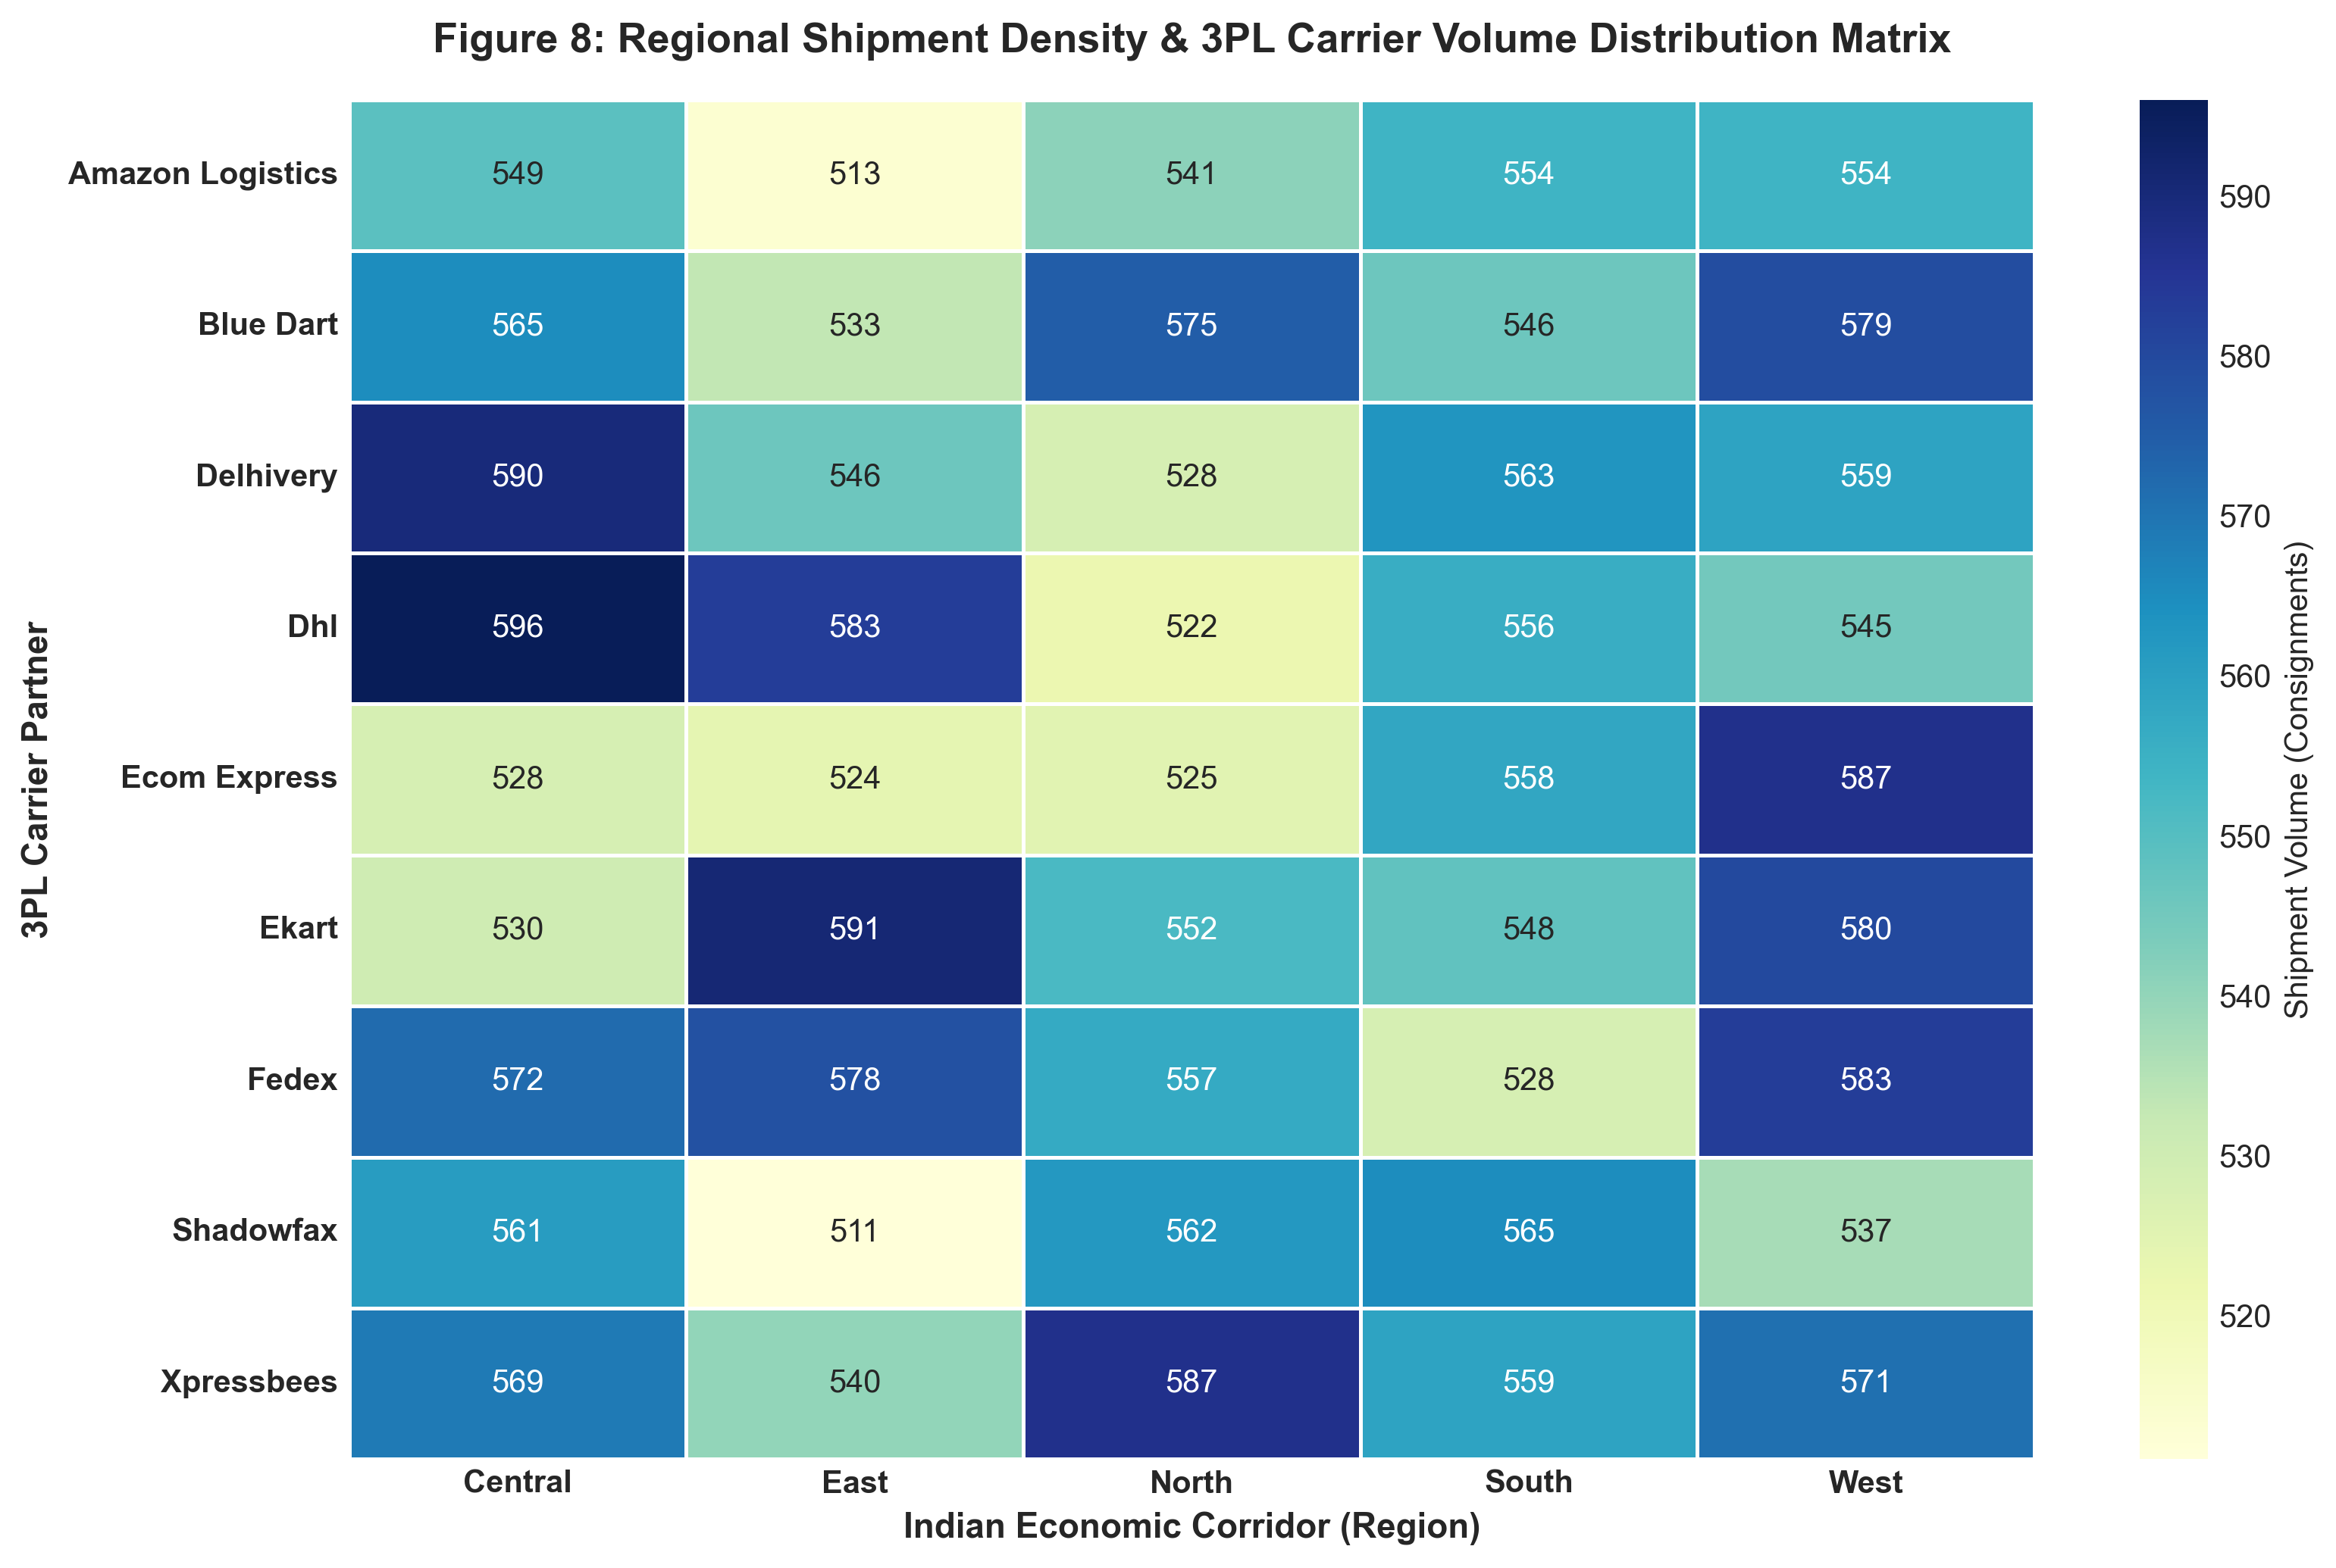
Figure 8: Regional Shipment Density and 3PL Carrier Allocation Cross-Tabulation Matrix.

Figure 9: Service Quality Elasticity: Customer Rating Degradation
• Methodological Justification: To translate operational delays into commercial impact, a 100% stacked bar chart detailing star rating composition is paired with an error-bar mean rating plot. This visually captures the collapse of customer satisfaction: 5-star ratings evaporate when orders transition from on-time (4.21 ★) to delayed (2.40 ★) and failed (1.31 ★).
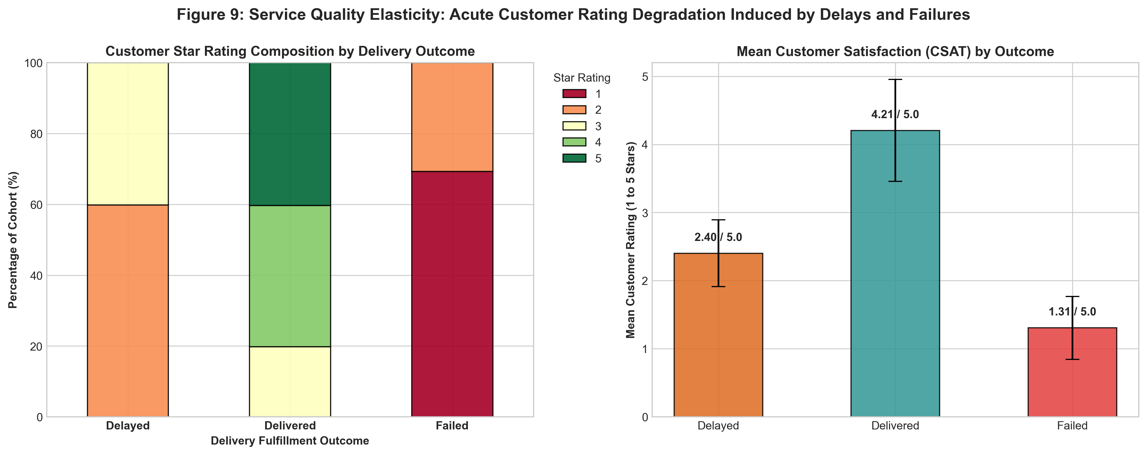
Figure 9: Customer Satisfaction Composition and Mean CSAT Degradation Induced by Delivery Delays and Service Failures.

5. In-Depth Operational Insights & Supply Chain Bottlenecks
The synthesis of our statistical profiling and visualization suite isolates four critical operational bottlenecks:
• 1. The Expedited Fulfillment Paradox
The logistics network suffers an acute operational breakdown in promised high-velocity tiers. Express deliveries fail to meet SLA 73.78% of the time, and Same-Day deliveries fail 32.54% of the time. In contrast, standard ground deliveries achieve 100% on-time fulfillment. This demonstrates that expedited commitments are marketed without dedicated rapid-sortation hubs or dedicated line-haul capacity.
• 2. Weather Shock Fragility
Adverse weather drives delay rates up to 41.45% during storms and 37.35% during rain, compared to 16.0% in cold and 17.4% in clear weather. Because order management systems currently promise static delivery windows regardless of live weather telemetry, inclement weather inevitably leads to customer dissatisfaction.
• 3. 3PL Partner Performance Polarization
Empirical tiering demonstrates significant performance polarization among the nine carriers. Delhivery (24.80% delay, ₹848.11 avg cost) and FedEx (25.16% delay, 3.70 CSAT) represent the benchmark tier. In contrast, Xpressbees (28.27% delay, 5.91% failure rate) and Ekart (27.42% delay) represent high operational risk.
• 4. Fleet Electrification Economics
Electric Vehicles (EV Bikes and EV Vans) account for 33.3% of total network volume (8,334 shipments). Unit freight costs for EVs (₹5.75/km) and delay rates (26.43% - 26.63%) are fully comparable to traditional ICE combustion vehicles, validating the commercial and operational viability of expanding green fleet electrification.

6. Python Code Excerpts & Analytical Pipeline Architecture
The analytical routines executed in `advanced_data_analysis_and_visualization.ipynb` follow modular, production-ready Python structures:
▶ Snippet 1: Central Tendencies & Dispersion Computation Engine
# Compute central tendencies, spread, and distribution skewness
stat_rows = []
for col in ['distance_km', 'package_weight_kg', 'delivery_cost', 'cost_per_km']:
s = df[col]
stat_rows.append({
'Feature': col, 'Mean': s.mean(), 'Median': s.median(),
'Mode': s.mode()[0], '5% Trimmed': stats.trim_mean(s, 0.05),
'Std Dev': s.std(), 'Variance': s.var(), 'IQR': s.quantile(0.75) - s.quantile(0.25),
'Skewness': s.skew(), 'Kurtosis': s.kurtosis()
})
stat_df = pd.DataFrame(stat_rows)
display(stat_df)

▶ Snippet 2: 4D Multi-Criteria Carrier Bubble Plot
# 4D Carrier Performance Scatter Matrix
fig, ax = plt.subplots(figsize=(11, 6.5))
carrier_df = df.groupby('delivery_partner').agg(
vol=('delivery_id', 'count'), delay=('delayed', lambda x: (x == 'yes').mean() * 100),
fail=('delivery_status', lambda x: (x == 'failed').mean() * 100),
cost=('delivery_cost', 'mean'), csat=('delivery_rating', 'mean')
).reset_index()
scatter = ax.scatter(carrier_df['delay'], carrier_df['csat'], s=carrier_df['cost']*0.9,
c=carrier_df['fail'], cmap='YlOrRd', edgecolors='black', alpha=0.85)
plt.colorbar(scatter, ax=ax, label='Failure Rate (%)')
plt.show()

▶ Snippet 3: OLS Cost Regression & Residual Diagnostic Pipeline
# Parametric OLS cost regression and residual diagnostics
slope, intercept, r_val, p_val, std_err = stats.linregress(df['distance_km'], df['delivery_cost'])
residuals = df['delivery_cost'] - (slope * df['distance_km'] + intercept)
sns.histplot(residuals, kde=True, bins=35, color='#4A5568')
print(f"R² Score: {r_val**2:.4f} | Slope: ₹{slope:.2f}/km | Mean Error: ₹{residuals.mean():.2f}")

7. Strategic Recommendations & Executive Decision Framework
Based on the empirical evidence, the following four strategic initiatives are recommended for supply chain leadership:
✔ 1. Dynamic SLA Buffering for Expedited Deliveries
Cease offering fixed 24-48 hour Express delivery guarantees on lanes exceeding 200 km unless routed through premium carriers (Delhivery, FedEx). Implement dynamic promise dates at checkout to eliminate SLA penalty fees.
✔ 2. Weather-Adaptive Dispatch Automation
Integrate live weather API feeds into the Transport Management System (TMS). Automatically append 4-6 hour delivery buffers during stormy or rainy conditions and send automated proactive alerts to customers, mitigating rating degradation.
✔ 3. Carrier Allocation Shift
Reallocate 20-25% of dispatch volume from lagging carriers (Xpressbees) to top-tier partners (Delhivery, FedEx), and institute strict contractual penalties for monthly carrier failure rates exceeding 5.0%.
✔ 4. Accelerated Green Fleet Electrification
Expand EV deployment across dense urban hubs in West and Central economic zones, capitalizing on proven parity in unit freight cost (₹5.75/km) and punctuality to capture ESG cost savings without operational compromise.

Key Performance Indicator (KPI) | Current Baseline | Industry Standard | Phase 1 Target
On-Time Delivery Rate (OTDR) | 73.32% | >= 95.0% | >= 88.0%
Overall Delay Rate | 21.36% | < 4.0% | < 10.0%
Shipment Failure Rate (SFR) | 5.31% | < 1.5% | < 2.0%
Average Delivery Cost | ₹864.94 | ₹750.00 | ₹800.00 (-7.5%)
Customer Satisfaction (CSAT) | 3.67 / 5.0 ★ | >= 4.40 ★ | >= 4.25 ★

