**Task Description**

**Project:**

Database Setup and Configuration

**Description:**

* Create a simple database using a popular database management system (e.g., MySQL, PostgreSQL).
* Perform basic configuration settings, including setting up a user, defining tables, and establishing basic relationships.

**Skills Emphasized:**

* Database creation, user management, basic schema design.

**Task 1**

Create a simple database using a popular database management system (e.g., MySQL, PostgreSQL).

***Step 1: MySQL setup***

In order to create a database, we need a database management system installed on our system, which in my case is MySQL. Then, we open MySQL Workbench which is installed after we install MySQL in our system.

*(Note: MySQL Workbench is a GUI tool for MySQL which allows to design, create and browse database schemas, work with database objects and insert data as well as design and run SQL queries to work with stored data.)*

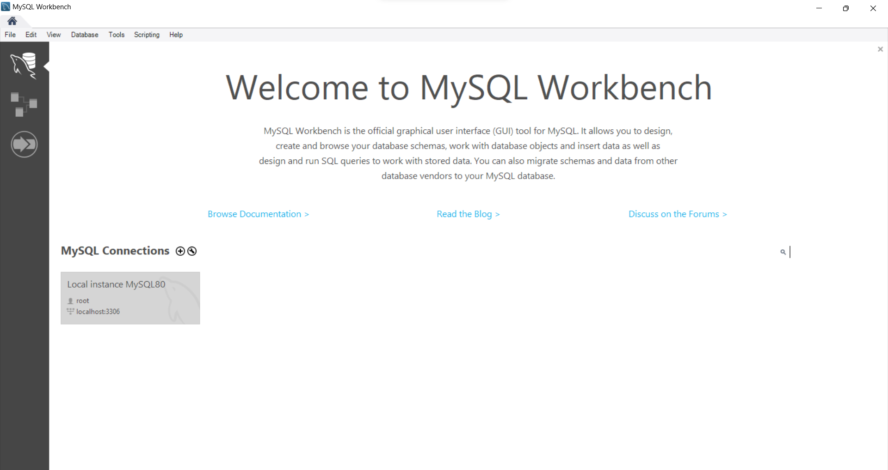

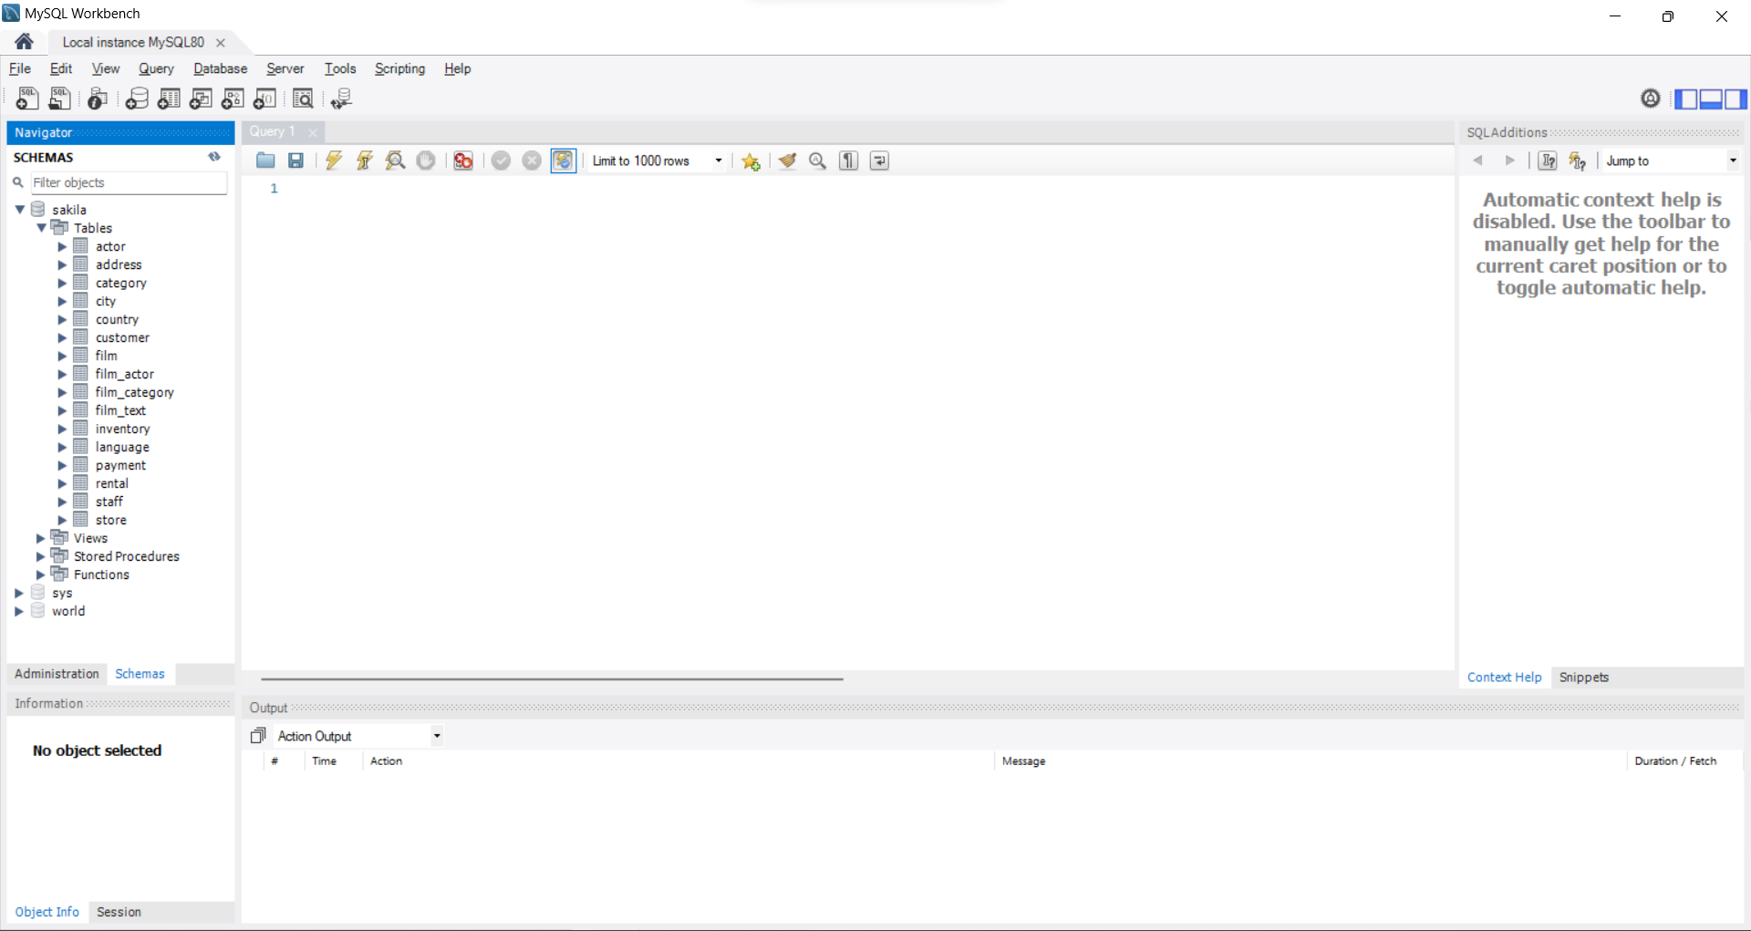

***Step 2: Database Creation***

As seen on the screenshot above, we can see some sample databases that are present in default.   
In order to create our own database, we click on icon on the menu bar, which says “New Schema”. It creates a new schema on the connected server.

Then, we name the schema (database) as per required.

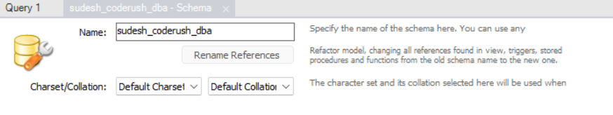Then a pop-up will be displayed which asks to apply SQL Script to Database.  
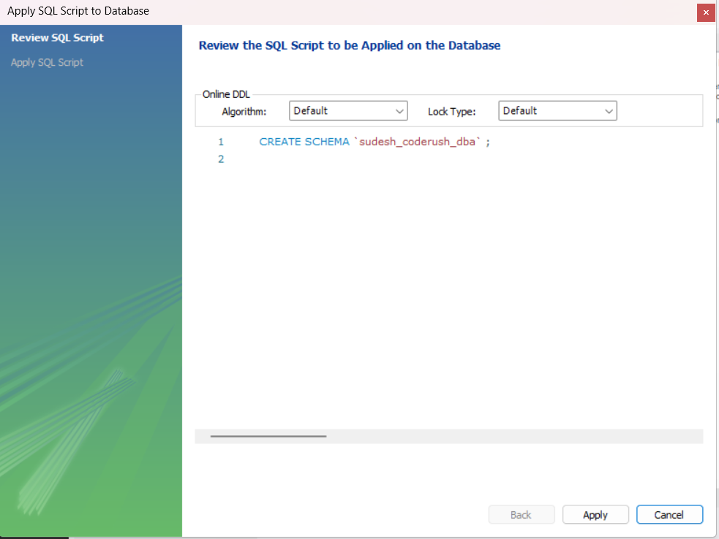

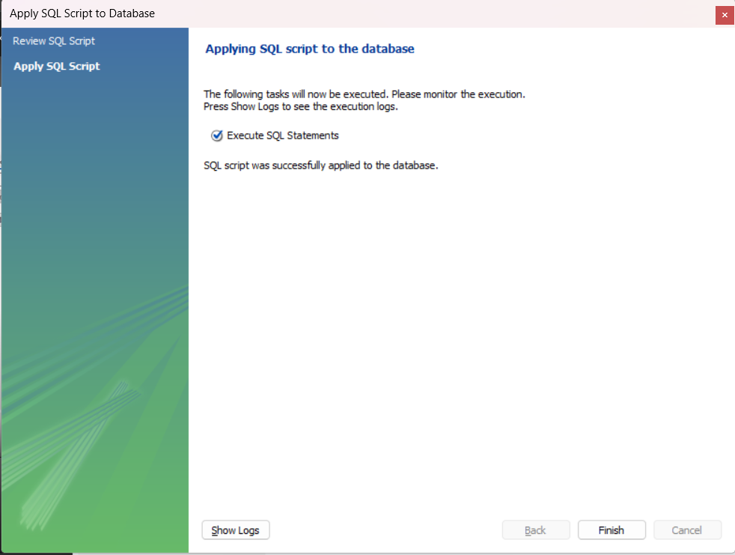

After applying the Script, we get our new database present under the Schemas Section.

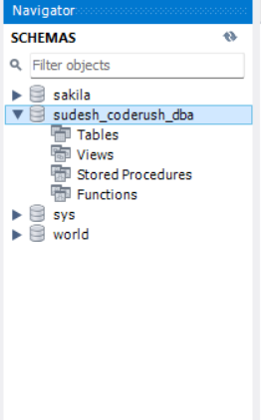

***Step 3: Table Creation***

Now, we while the new schema we just created is active, we insert table by clicking on icon on the menu bar.

A tab will be displayed in which we need to fill in the details such as the name of the table, the attributes that the table contains along with the data types of those attributes and constraint keys which specifies the types of data, as shown in the screenshot below.

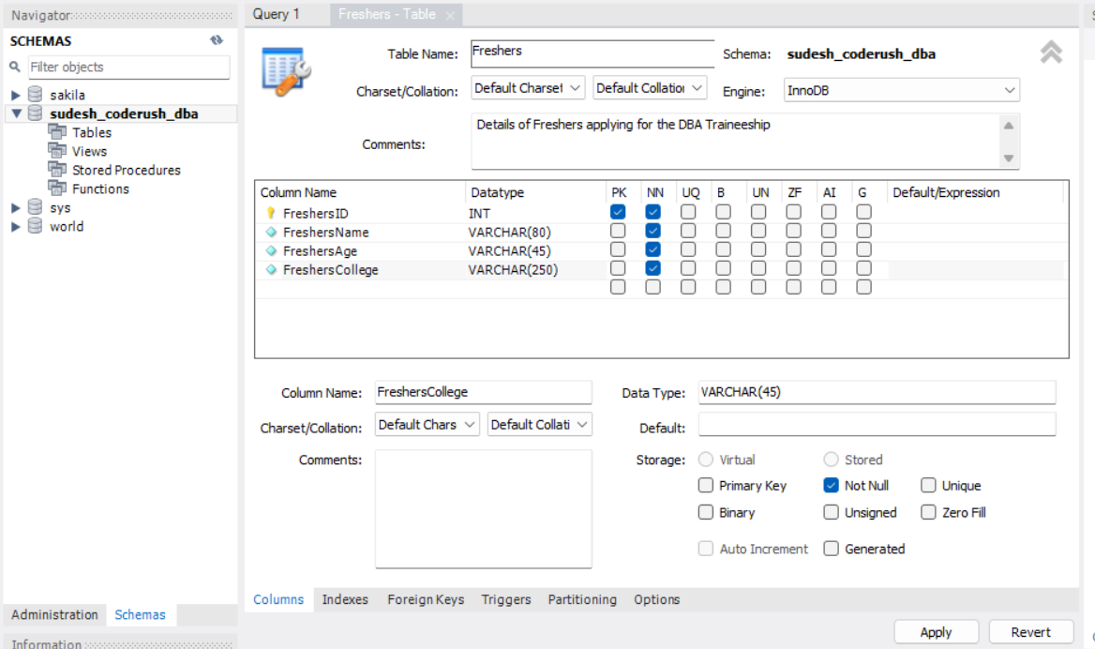

After applying the changes, a pop up will be displayed to confirm the changes as:

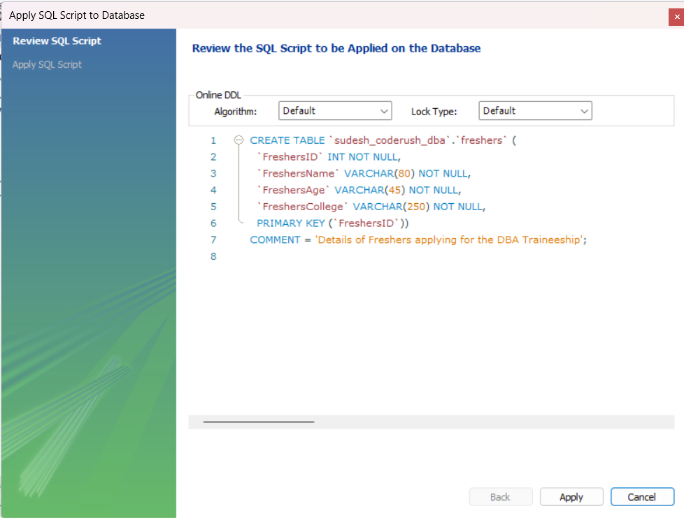

After applying the changes, we get a new set of table named ‘freshers’ in our database.  
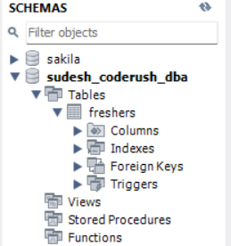

The table can be accessed with the following query as:

SELECT * FROM sudesh_coderush_dba.freshers;

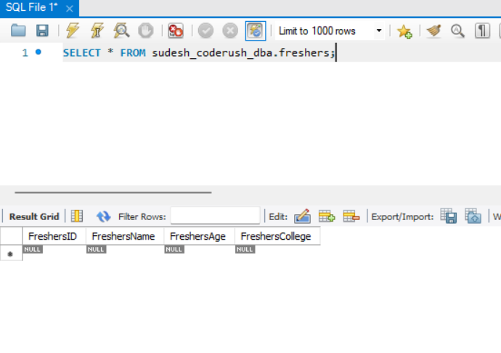

***Step 4: Data Insertion***

Now, we manually insert data into the columns of the table as:  
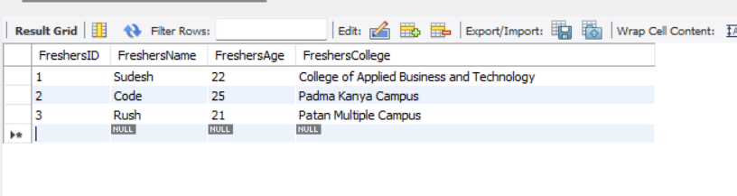

This will ask for confirmation after applying the changes as:

INSERT INTO `sudesh_coderush_dba`.`freshers` (`FreshersID`, `FreshersName`, `FreshersAge`, `FreshersCollege`) VALUES ('1', 'Sudesh', '22', 'College of Applied Business and Technology');

INSERT INTO `sudesh_coderush_dba`.`freshers` (`FreshersID`, `FreshersName`, `FreshersAge`, `FreshersCollege`) VALUES ('2', 'Code', '25', 'Padma Kanya Campus');

INSERT INTO `sudesh_coderush_dba`.`freshers` (`FreshersID`, `FreshersName`, `FreshersAge`, `FreshersCollege`) VALUES ('3', 'Rush', '21', 'Patan Multiple Campus');

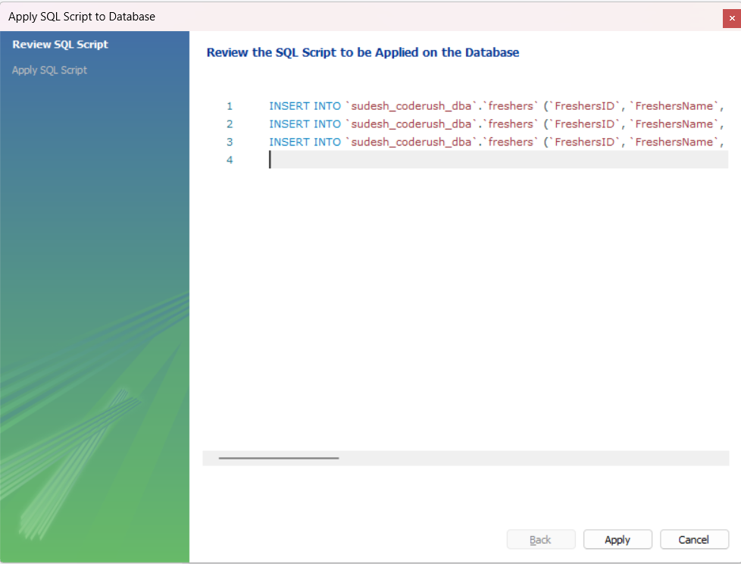

This creates a table with the given values by the user. After we access the table, this is what we will be shown.  
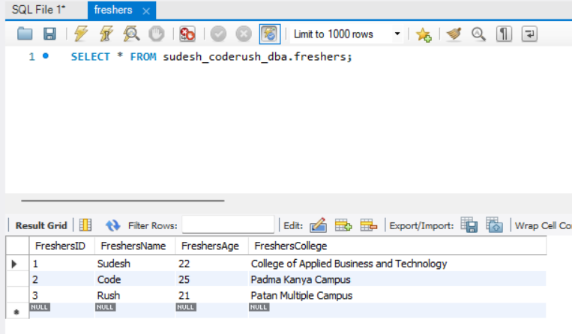

In the same way, we can create more tables in the database.

**Task 2**

Perform basic configuration settings, including setting up a user, defining tables, and establishing basic relationships.

***User Creation:***

Under the ‘Administration’ tab, we can see an option called “Users and Privileges” under “Management”. After clicking on it, the users are displayed as:

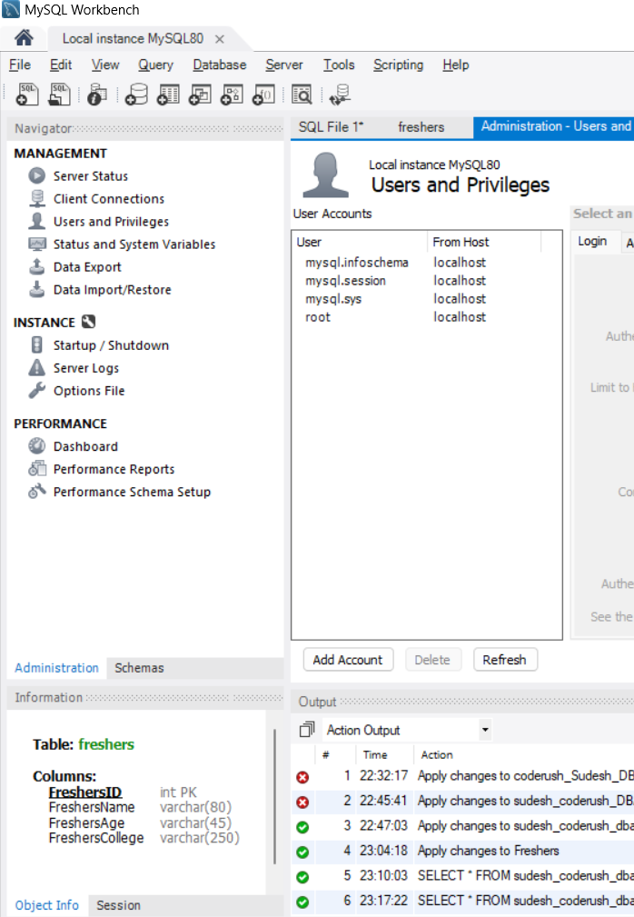

Now, in order to create a new user, we click on “Add Account” option under the Users and Privileges tab, which displays:

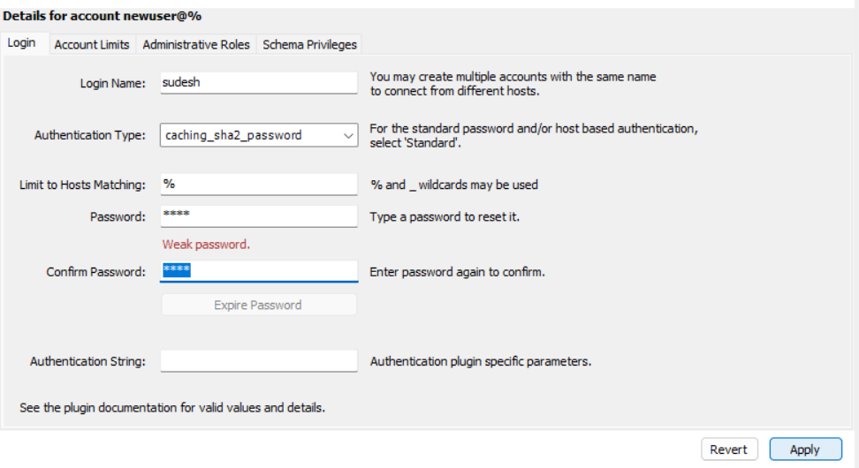

Here, we enter the name for our new user, along with the authentication type and a password for the new user and click on apply to save the new user.



Now, this would show the new user in the users list.

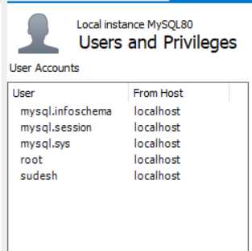

***Defining tables:***