**TASK 1**

1. **What is DevOps? How does DevOps Work?**

DevOps is a set of practices that combines software development (Dev) and information technology operations (Ops) to improve the software development process and increase the speed of software delivery. DevOps is a cultural shift that emphasizes collaboration and communication between development and operations teams, with the goal of delivering high-quality software at a faster pace.

DevOps works by breaking down the traditional barriers between development and operations teams, and by using tools and automation to streamline the software development process. DevOps teams work to create a culture of collaboration and shared responsibility, where developers and operations staff work together to build and deploy software. They use automation tools to automate tasks such as testing, building, and deploying code, which helps to speed up the development process and reduce errors.

1. **Describe the DevOps lifecycle.**

The DevOps lifecycle is the process of developing and managing software. It involves several stages:

Planning: Setting goals, defining requirements, and creating a roadmap for the project.

Development: Writing and testing the code, building the software, and collaborating with other team members to resolve issues.

Testing: Verifying that the software works as intended, and that there are no bugs or errors.

Deployment: Deploying the software to production environments using automated deployment tools.

Operation: Managing and monitoring the software in production environments, using monitoring tools to identify and resolve issues.

Monitoring: Gathering feedback on the software's performance and usage patterns.

1. **Describe DevOps Principles.**

DevOps principles are a set of values and practices that guide the culture and processes of DevOps. The following are the key principles of DevOps:

Collaboration: Work together and share responsibility.

Automation: Use tools and scripts to streamline tasks.

Continuous Integration and Delivery: Deliver updates frequently and with value to users.

Continuous Monitoring: Keep an eye on the software in production to identify issues and fix them quickly.

Infrastructure as Code: Treat infrastructure as a code artifact that can be version-controlled, tested, and deployed like any other software.

Lean Thinking: Use lean thinking principles to increase efficiency and reduce waste.

1. **Explain the benefits of DevOps.**

Faster time-to-market: DevOps helps teams deliver software updates more quickly through automation and collaboration.

Higher quality software: DevOps practices catch issues earlier in development, reducing bugs and defects in production.

Improved collaboration and communication: DevOps break down silos and encourages closer collaboration and communication between teams.

Better feedback loops: DevOps promotes continuous monitoring and feedback, allowing teams to address issues quickly and make improvements based on user feedback.

Increased efficiency: DevOps automates tasks and eliminates wasteful processes, helping teams work more efficiently.

More reliable infrastructure: Treating infrastructure as code allows for version control and consistent deployment, resulting in more reliable infrastructure.

Cost savings: DevOps reduces waste and increases efficiency, leading to cost savings for organizations.

**TASK 2**

1. **Installing VMware Workstation or VirtualBox.**
2. Download the installation file
3. Run the installation file
4. Accept the license agreement
5. Choose the installation location
6. Choose the setup type
7. Configure shortcuts
8. Install VMware Workstation
9. Finish the installation
10. **Creating Virtual Machine of CentOS 7.**
11. Open VMware Workstation
12. Create a new virtual machine

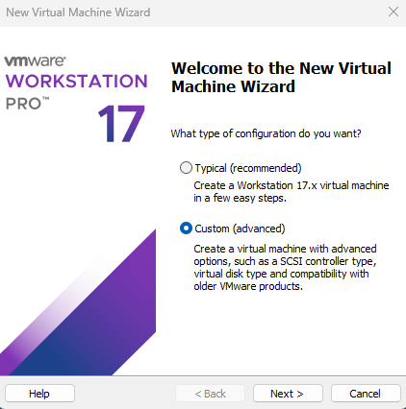

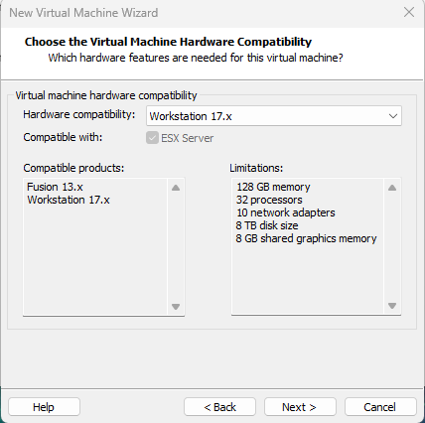

1. Choose the installation media

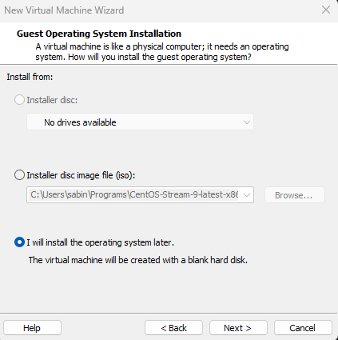

1. Select the guest operating system

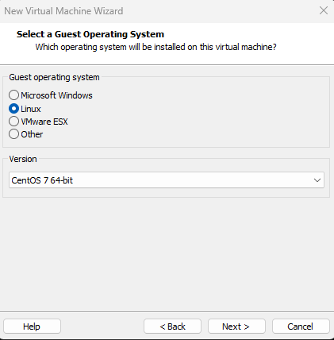

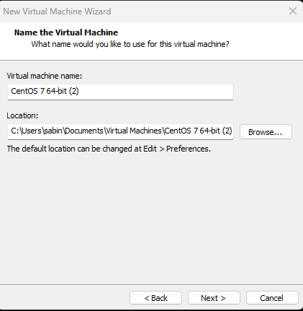

1. Configure the virtual machine hardware

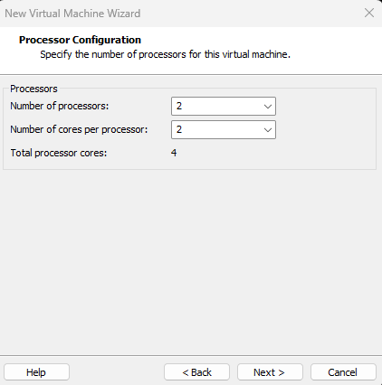

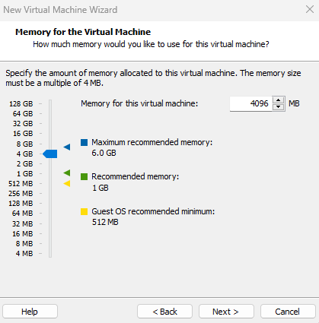

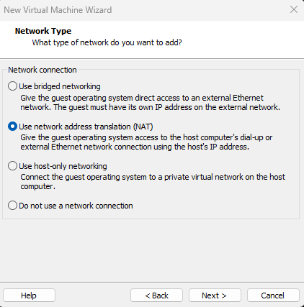

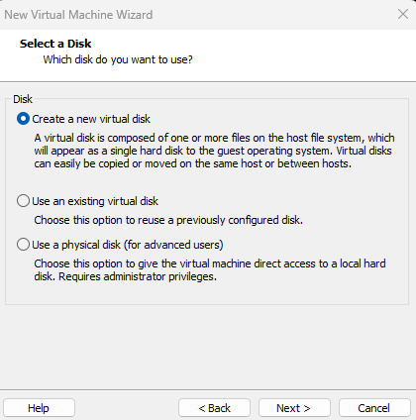

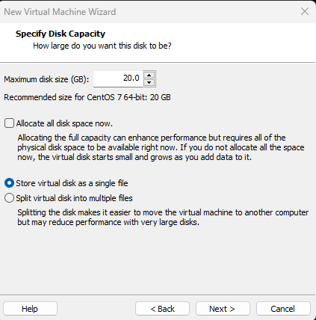

1. Customize other settings
2. Finish creating the virtual machine

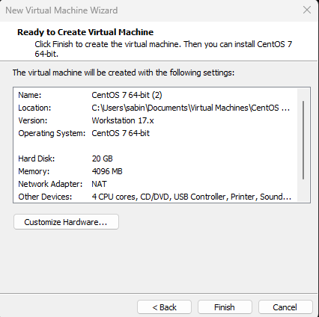

1. Start the virtual machine
2. Install CentOS 7

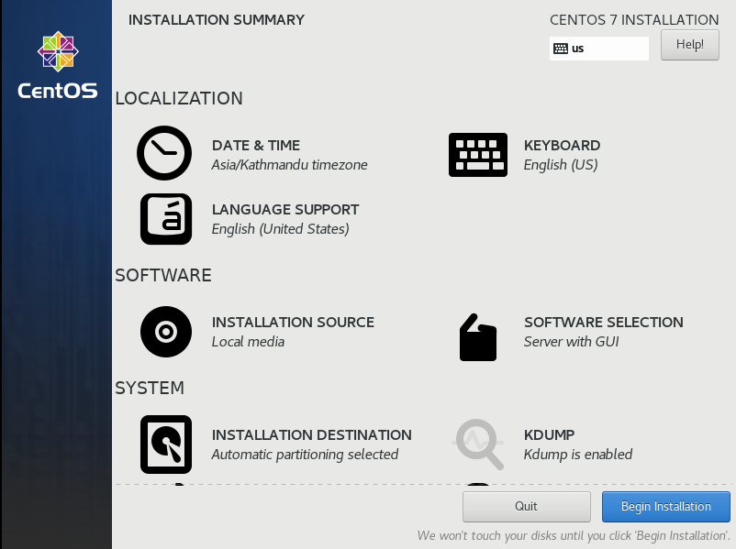

1. Complete the installation

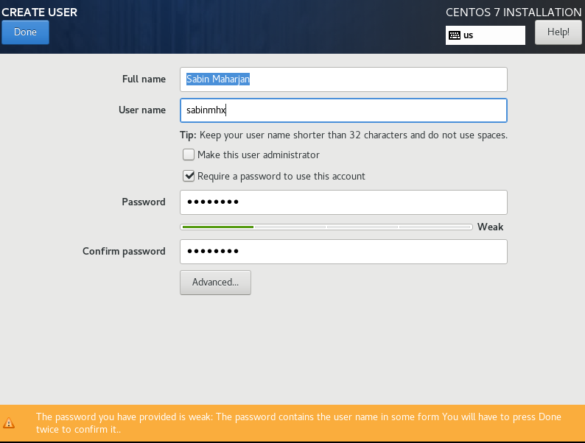

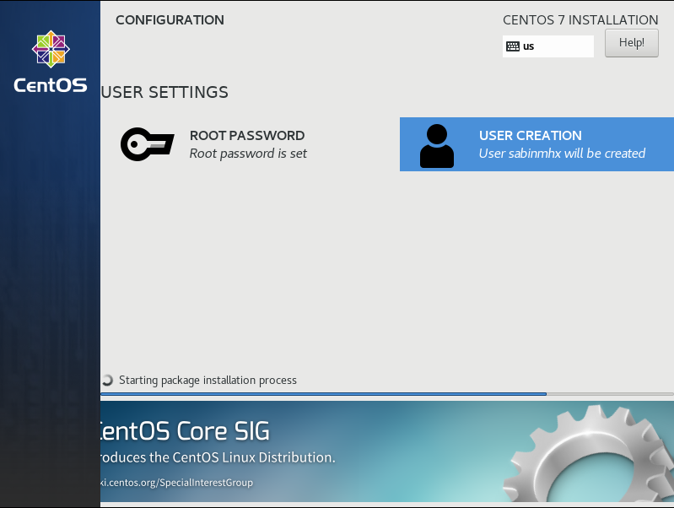

1. **Assign the hostname of Linux machine as <yourname>.devops.com**

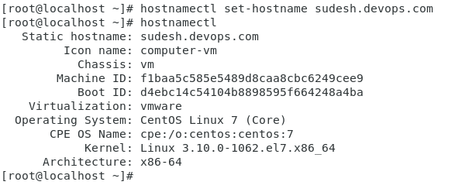

1. **Configure your network interface with static ip address and start the network service.**

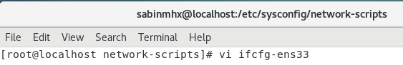

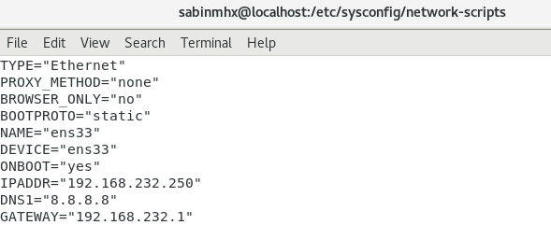

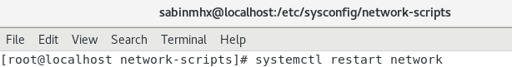

1. **Map your static ip address to your hosts name in configuration file /etc/hosts**

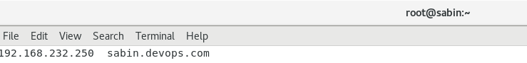

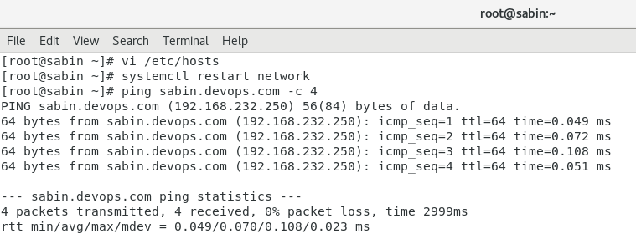

**TASK 3**

1. **Write brief history of Linux.**

Linux is a free and open-source operating system created by Linus Torvalds in 1991. It was made as an alternative to proprietary operating systems like Windows and macOS. Linux is known for its stability, security, and flexibility, and is widely used in many industries. It is available in many different versions called distributions, and the Linux community continues to contribute to its development.

1. **Describe briefly about the following Linux Filesystems Hierarchy:** /boot, /root, /user, /home, /usr/bin, /bin, /user/sbin, /sbin, /usr/lib64, /lib64, /usr/lib, /lib, /dev, /etc, /media, /mnt, /opt, /proc, /tmp, /var, /run
2. /boot: Contains files needed for the boot process, including the Linux kernel and bootloader.
3. /root: Home directory for the root user, which is the system administrator.
4. /user: A directory that typically contains subdirectories for user-specific data and programs.
5. /home: Home directories for regular users on the system.
6. /usr/bin: Contains executable files for system-wide use.
7. /bin: Contains essential executable files required for booting and system maintenance.
8. /usr/sbin: Contains system administrator executables that are not essential for the system boot process.
9. /sbin: Contains essential system administrator executables required for system booting and maintenance.
10. /usr/lib64: Contains shared libraries for 64-bit applications.
11. /lib64: Contains shared libraries for 64-bit essential executables.
12. /usr/lib: Contains shared libraries for system-wide use.
13. /lib: Contains shared libraries for essential executables.
14. /dev: Contains device files for hardware devices.
15. /etc: Contains system configuration files.
16. /media: Mount point for removable media devices.
17. /mnt: Mount point for temporary filesystems.
18. /opt: Contains optional software packages.
19. /proc: A virtual filesystem that contains system process information.
20. /tmp: A directory for temporary files.
21. /var: Contains variable files, including logs and other data that changes frequently.
22. /run: Contains system runtime data.
23. **Login from root user then create folders according to following tree structure.**

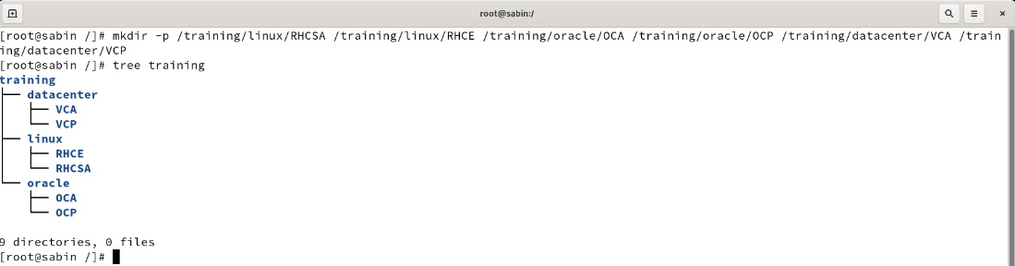

1. **Copy all the files that have .conf filename extensions inside /etc directory to /root/backup directory.**

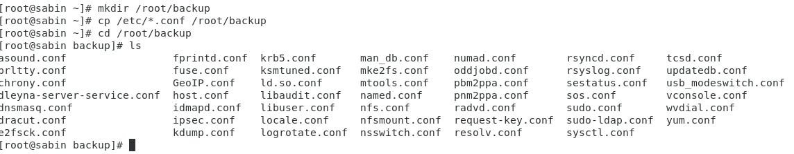

1. **Create a directory /root/selected then move all files of /root/backup directory that have ‘o’ or ‘a’ as the second character of their file name to /root/selected directory.**

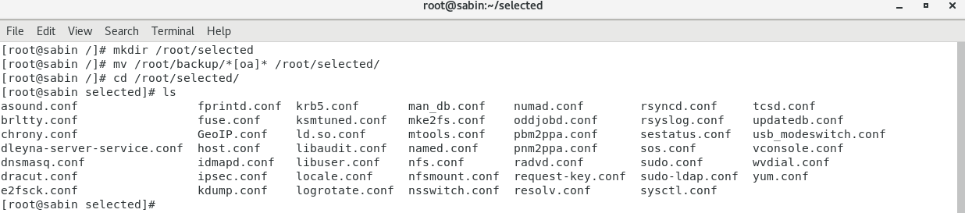

1. **Remove second character with r in path /root/backup.**

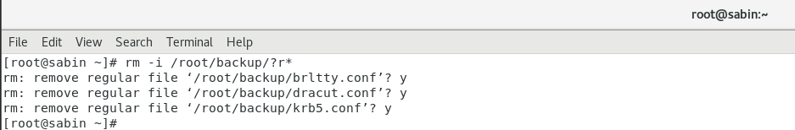

1. **Remove all files and directories in path /root/backup.**

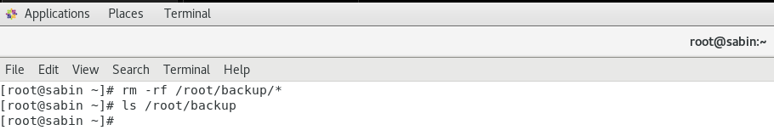

TASK 4

1. **Create a user named student.**

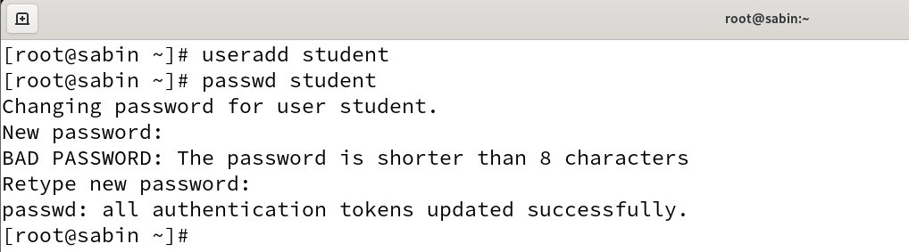

1. **Login from student user then create files and folders according to following tree structure. [where, d→ directory and f→ file]**

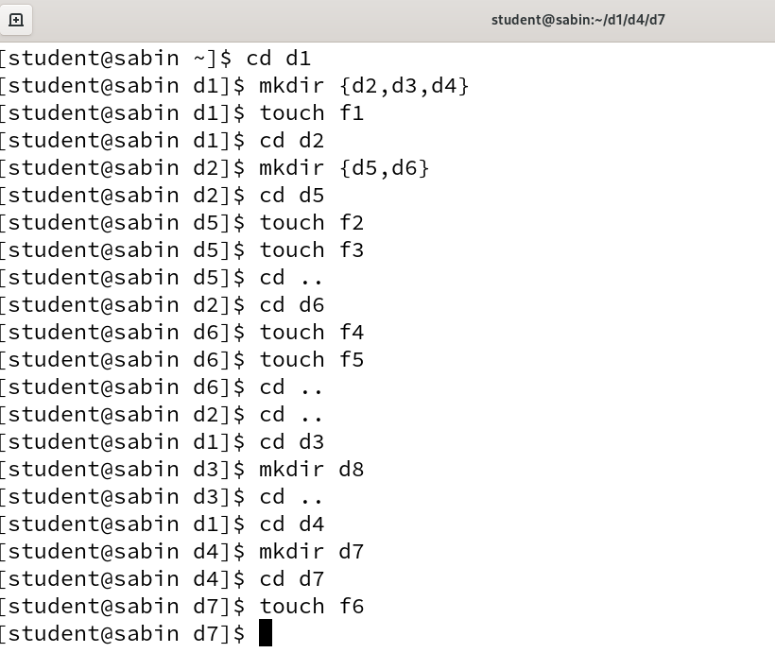

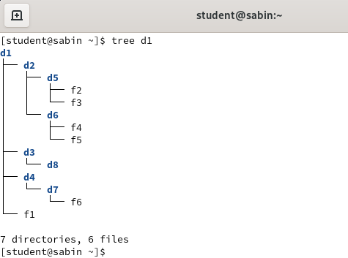

1. **Change the permission of the file f1 so that the owner will get full permission, group member will get read and execute permission and others will get read-only permissions.**

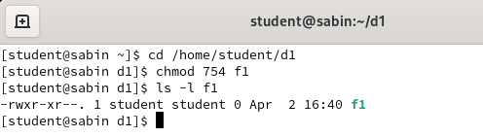

1. **Change permission of the file f2 such that the owner’s and group members will get read and write permission but others will get no permission.**

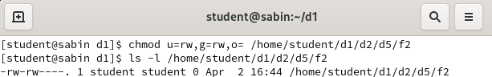

1. **Change permission of directory d3 such that all categories of users will get full permissions.**

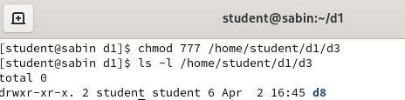

**TASK 5**

1. **Create group for each department (production, marketing, sales)**

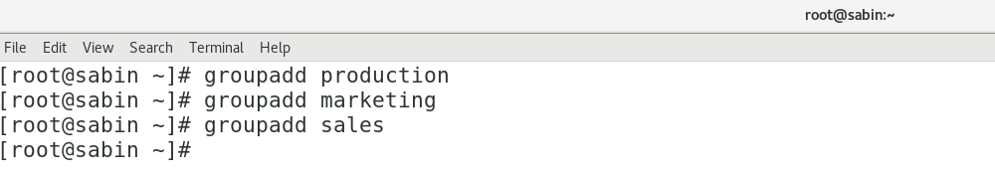

1. **Create user account (user1, user2, user3, user4, user5, user6, manager, boss) for each employee assigning them respective group.**

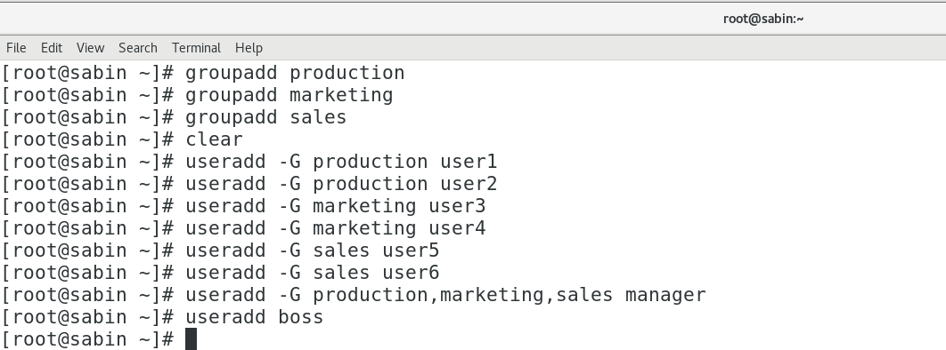

1. **Create common directory (production, marketing and sales) for each department.**

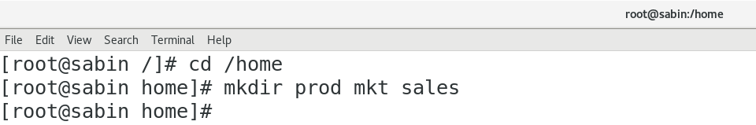

1. **Change ownership of group directories such that boss will become the owner and the respective groups will be group owner.**

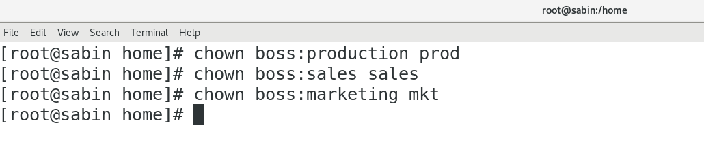

1. **Change the permission of the group directories such that only the owner and group member will get full permission and others will not get any permission.**

