# **IMPACT OF PERSONALITY TRAITS ON ACADEMIC PERFORMANCE**

Submitted to

Ms. Renuka Timilsena

Faculty of Research

Submitted by

Roshima Lama – 19119

BBA 6th sem

Gangahiti, Chabahil, Kathmandu

May 2023

# **ACKNOWLEDGEMENTS**

The research on the impact of personality traits on academic performance has been assigned as a part of the curriculum of Bachelor of Business Administration. It is a great opportunity for me to cover various areas and topics in order to conduct the very research.

I would like to acknowledge with gratitude Ms. Renuka Timilsena, my respected teacher, who has always been helpful and a source of encouragement to complete the research. Without her sincere guidance the research would have been incomplete. The satisfaction that accompanies the successful completion of any task would be incomplete without the mention of people whose ceaseless cooperation made it possible, whose guidance and encouragement crown all efforts with success. I would like to thank my college for giving me the opportunity to conduct this very academic research. Most importantly I would like to thank my friends who endlessly supported and guided me for the completion of this report.

Thank You.

# **EXECUTIVE SUMMARY**

This research investigates the impact of personality traits on academic performance. This is relational research in nature as it examines the relation between personality traits and academic performance. This is cross sectional research as data collection is done only once from the respondents throughout the research. Data is gathered from individuals who are currently studying in bachelors' level program and their response is treated as an individual data source. So, the unit of analysis of this research is individual level.

Data analysis is done through descriptive and inferential methods. In descriptive method, mean and standard deviation is calculated and in inferential method correlation and regression is calculated. Data analysis is done through STATA software. This gives the study a quantitative and empirical direction for results. Major findings were that there is a positive relationship between personality traits and academic performance. This means that the personality traits of an individual can affect their academic performance. This research is beneficial to all the students who are studying at their bachelor's level.

# **TABLE OF CONTENTS**

**IMPACT OF PERSONALITY TRAITS ON ACADEMIC PERFORMANCE** i

**ACKNOWLEDGEMENTS** ii

**EXECUTIVE SUMMARY** iii

**TABLE OF CONTENTS** iv

**CHAPTER I** 1

**INTRODUCTION** 1

**1.1 Context Information** 1

**1.2 Objective of the study** 2

**1.3 Literature survey** 2

**1.4 Theoretical framework** 10

**1.5 Conceptual model** 11

**1.6 Hypothesis** 12

**1.7 Research Methodology** 12

**1.7.1 Research Design** 12

**1.7.2 Population and Sample** 13

**1.7.3 Measure** 13

**1.7.4 Data Collection Method** 13

**1.7.5 Data Analysis** 14

**CHAPTER II** 15

**DATA PRESENTATION AND ANALYSIS** 15

**2.1 Respondent’s profile** 15

**2.1.1 Age distribution** 15

**2.1.2 Gender** 16

**2.1.3 Educational Qualification** 17

**2.2 Data Presentation** 17

**2.2.1 Enjoys learning new things** 18

**2.2.2 Take initiation and participate in new activities** 19

**2.2.3 Stepping out of comfort zone** 20

**2.2.5 Enjoy socializing** 22

**2.2.6 Working on group projects with classmates** 23

**2.2.7 Avoiding conflict with others** 24

**2.2.8 Getting along with classmates and teachers** 25

**2.2.9 Considerate of other’s people feelings** 26

**2.2.10 Feel calm and relaxed while doing academic works** 27

**2.2.11 Not easily irritated by the small things** 28

**2.2.12 Not affected by the negative outcomes of my studies** 29

**2.2.13 Seek feedback from teachers on studies** 30

**2.2.14 Follow an organized study schedule** 31

**2.2.15 Understand deeply about the study materials** 32

**2.2.16 Submit assignments on time** 33

**2.2.17 Feels motivated for exams** 34

**2.2.18 Take study notes** 35

**2.2.19 Prioritizing study outcomes** 36

**2.2.20 Take suggestions and feedback positively** 37

**2.3 Data analysis** 37

**2.3.1 Descriptive analysis** 38

**2.3.2 Correlation Analysis** 38

**2.3.3 Regression Analysis** 39

**CHAPTER III** 41

**CONCLUSION** 41

**REFERENCE**

**APPENDIX**

# **CHAPTER I**

# **INTRODUCTION**

## **Context Information**

Personality traits reflect people's characteristics, pattern of thoughts, feelings and behavior and the way they respond to respective situations. The personality traits of an individual can differ from person to person. Most college students, professors, university presidents and admissions officers would agree that student success is determined by multiple factors, such as students’ attitudes and interests, class attendance, study behaviors, management of conflicting roles, time management, and coordination and cooperation with other students (Credé & Kuncel, 2008; Dollinger, Huber, & Matyja, 2008). These factors predict grade point average (GPA), a critical outcome that determines graduation status, admission into graduate school and employment potential.

Personality characters are one of the major forces that can create an impact on the student’s academic performance. Personality can be measured by an individual characteristic and behavior. Academic performance is a major issue among students, parents, teachers, schools, colleges and universities. Personality traits are enduring personal characteristics that are revealed in a particular pattern of behavior in a variety of situations. One popular and widely used personality trait model is Five Factor Model (FFM) (Goldberg, 1993; Costa & McCrae, 1992).

Academic performance is a major concern of the people nowadays. Many spends a lot of money in order to secure good education either for their children's or themselves and those who can afford it even invest on education abroad as they believe this will enhance their performance and which in turn gives an added advantage in terms of securing gainful employment. Various Researchers have studied hundreds of American English adjectives used to describe personality traits. Research has identified five factors that account for nearly all of the variability of the complete word list.

These five factors can be named extraversion, agreeableness, conscientiousness, neuroticism (or its opposite pole, emotional stability), and intellect or openness to experience (John et al., 2008). The five-factor model of personality extraversion, agreeableness, conscientiousness, neuroticism and openness to experience. Openness is the individual’s propensity to have intellectual curiosity, active imagination, and attentiveness to feelings and sensitivity to esthetics.

Conscientiousness is the tendency to be organized, ambitious, determined, reliable and purposeful. Neuroticism is related to an individual’s inclination towards experiencing negative effects such as guilt, anger, fear, disgust, sadness and embarrassment. Extraversion is the tendency to be talkative, assertive, active, excited and to prefer being in large groups and to like people. Agreeableness is the tendency to be trusting, altruistic and cooperative (Major, Turner, & Fletcher, 2006). This Five Factor Model is one of the most extensively accepted models of personality.

## **Objective of the study**

* **-**to investigate the impacts of personality traits on academic performance

## **1.3 Literature survey**

Academic performance has always been considered to be a very important factor in the educational life of an individual, because good academic record over years predicts future success of a person because it occupies a very important place in education as well as in the learning process Singh (2014). Many researchers have linked academic performance with personality traits of an individual. Personality has been recognized as a determining factor on how people learn (Lawrence, 1997; Myer et al, 1998)

Academic performance is a major issue among students, teachers, parents, school administrators, and the community at large. Attempts have been made by researchers to unravel the complexities surrounding academic performance. Psychologists have put forward a lot of reasons why these disparities in performance exist. A lot of attention had been paid to external factors such as type of school, teaching methods, school location, instructional materials, teachers experience, and so on (WAEC, 2005).

The word personality comes from the Latin word persona which means mask. It was used in ancient Latin theatres to represent a particular character. Personality represents a stable set of characteristics responsible for a person’s identity. Though the dimensions of personality are beyond one’s control, they strongly influence one’s attitudes, expectations and assumptions and behaviour (Kinicki, 2008). Personality captures what people are like and ability captures what people can do (Colquitt, 2009). Personality has to do with individual differences among people in behaviour patterns, cognition and emotion (Mischel, 2004).

The personality should play a major role in adapting to the school environment and thereby achieving academic performance. Success or failure generally expresses the relationship of an individual to certain activities, depending on how much he has achieved the established goal. According to the vocabulary (Průcha, Walterová & Mareš, 1995), academic performance can mean that the pupils‘requirements are met by the pupils, which is reflected in the positive or negative assessment of the pupils 'benefit and results from the teacher‘s evaluation.

On the other hand, school failure is when the pupils 'performance does not meet these requirements (Kačáni, 1999). Academic performance is still very much debated and still an under-clarified term. This term has several alternatives: academic success (Smidt, 2014), academic performance (Conrad, 2006) or academic achievement (Verešová, 2015). However, in most cases it is conceived as GPA, i.e., grade point average.

Academic performance is considered one of the most important outcomes in educational settings. Many factors can affect academic performance, including environmental factors, cognitive abilities, and personality traits. Personality traits are stable patterns of thoughts, feelings, and behaviors that influence how individuals interact with their environment.

Educational institutions try to find variety of factors influencing academic performance in students, however are not sure about the precise outcomes of these factors (Rawat, Reddy, Mishra, & Sultana, 2015). Many recent studies have exposed significant link between personality and academic performance in students (Duckworth & Seligman, 2005; Wagerman & Funder, 2007). Conard (2006) states that the personality measures are highly significant predictors of students’ academic performance and hence can be a useful tool for assisting students in their career development and academics.

Not only personality traits have significant importance in future career of students, personality has a great influence on students’ success in school (De Raad & Schouwenburg, 1996). Also, personality has minimal link with people’s cognitive ability and intelligence and therefore there exists a historically proven clear segregation between intelligence and personality traits (Allport & Odbert, 1936).

Personality can be conceptualized using personality traits. Personality traits are recurring regularities and trends in a person (Colquitt, 2009). Personality traits are enduring personal characteristics that are revealed in a particular pattern of behaviour in a variety of situations. One popular and widely used personality trait model is Five Factor Model (FFM) (Goldberg, 1993; Costa & McCrae, 1992). Various Researchers have studied hundreds of American English adjectives used to describe personality traits.

Research has identified five factors that account for nearly all of the variability of the completeword list. These five factors can be named extraversion, agreeableness, conscientiousness, neuroticism (or its opposite pole, emotional stability), and intellect or openness to experience (John et al., 2008).Many personality psychologists (Costa & McCrae, 1992; Goldberg, 1992) agree that said five domains capture the most basic individual differences in personality traits and different alternative trait models can be conceptualized in terms of the Big Five structure. The Big Five structure does not imply that personality differences can be summarised to only five traits. Rather, these five dimensions represent personality at a very broad level of generalisation and each dimension summarizes a large number of distinct, more specific personality characteristics. These overarching domains represent the basic structure behind all personality traits (O’Connor, 2002). O’Conner and Paunonen (2007) found that personality of an individual has significant influence on his academic performance which forms the behavior of a person that will affect a person’s learning habit which will lead to academic success (Soraya hakimi et al. 2011)

Extraversion

Extraversion includes traits like being sociable, talkative, gregarious, assertive, active, ambitious and expressive (Barrick & Mount, 1991). They have a strong desire for praise, social recognition, status and power. Extraversion is associated with adjective traits such as talkative, sociable, passionate, bold, and dominant (Colquitt, 2009). Extraversion is marked by noticeable engagement with the external world. Extraverts enjoy being with people. They are full of energy and often experience positive emotions. They tend to be action-oriented, assertive and enthusiastic individuals who are likely to say yes to opportunities for excitement. When in a group, these individuals like to talk a lot, assert themselves, and draw attention to themselves (Friedman & Schustack, 2016).

Extraversion is another factor that exerts extremely strong and broad influence on learners’ academic achievement. This is a broad trait and, like introversion, exists on a continuum of behaviour and attitudes. Extraverts are relatively outgoing, gregarious, sociable, and openly expressive. It is “characterized by sociability, spontaneity and adventurousness (Clark & Schroth 2010). It is important to understand that agreeableness is a personality trait manifesting itself in individual characteristics that are perceived as kind, sympathetic, cooperative, warm, and considerate. Every student that cooperates with the set standard and is considerate in his/her academic biding excels in the long run.

Agreeableness

Agreeableness include personality traits such as being courteous, trusting, flexible, cooperative, soft hearted, forgiving, good natured, and tolerant (Barrick & Mount, 1991). Agreeableness has adjectives such as kind, cooperative, sympathetic, helpful, courteous, and warm (Colquitt, 2009). Agreeableness is the tendency to be trusting, altruistic and cooperative (Major, Turner, & Fletcher, 2006). Agreeableness reflects individual differences in concern with cooperation, collaboration and social harmony. Individuals high on Agreeableness value getting along with others. Agreeable individuals are considerate, friendly, generous and helpful. They are willing to compromise their happiness for others benefit. Agreeable people also have an optimistic view of human nature. They believe people are basically honest, decent, and trustworthy (Barrick & Mount, 1991).

Agreeableness measures the extent of a person's warmth and kindness. The more agreeable someone is, the more likely they are to be trustworthy, helpful and compassionate. Disagreeable people are cold and suspicious of others, and they are less likely to cooperate. Agreeableness encapsulates constructs of sympathy, cooperativeness, and helpfulness towards others. It is described as the degree to which a person is good natured, warm and co-operative as opposed to irritable, uncooperative, inflexible, unpleasant and disagreeable (Noftle & Robins, 2007). Poropat (2014) believed that high agreeableness facilitates learning and therefore enhances academic performance of students. De Raad & Schouwenberg (2000) argued that agreeableness has positive effect on academic performance because it encourages team work.

Conscientiousness

Conscientiousness is the tendency to be organized, ambitious, determined, reliable and purposeful. Conscientiousness is the trait that is associated with diligence, self-discipline, punctuality, and general competence (McCrae & Costa, 2003). Conscientiousness is the personality dimension that correlates the strongest, out of all personality dimensions, with overall academic performance (Barrick et al., 2001; Hurtz & Donovan, 2000). Steel (2007) found that conscientiousness has two attributes: sustained effort and goal setting which contribute towards academic success. MacCann (2012) argued that conscientious students tend to have high scores. Conscientiousness includes traits such as being hardworking, thorough, organized, responsible, careful, and persevering (Barrick & Mount, 1991).

Conscientiousness is associated with trait like being dependable, organized, reliable, ambitious, and hardworking (Colquitt, 2009). Conscientiousness concerns the way in which people control, regulate, and direct their impulses (Friedman & Schustack, 2016). The benefits of high conscientiousness are obvious. Individuals high on conscientiousness achieve high levels of success through purposeful planning, persistence and perseverance. Others regard them as intelligent and reliable (Colquitt, 2009).

Neurotocism

Neuroticism (polar opposite of emotional stability) includes traits like being anxious, depressed, emotional, angry, embarrassed, worried, and insecure (Barrick & Mount, 1991). Neurotic individuals are limited in social skills and avoid situations that demand taking control. Neuroticism has to do with traits like bring nervous, moody, emotional, insecure, and unstable (Colquitt, 2009). Neuroticism (polar opposite of emotional stability) means the tendency to experience negative feelings. Individual with high on neuroticisms are less emotionally stable. These individuals may experience some negative feeling such as anxiety, anger, or depression, and they are likely to experience several of these emotions (Friedman & Schustack, 2016).

Neuroticism is defined as “individual differences in one’s disposition towards constructing, perceiving and feeling realities in threatening, disturbing or problematic ways” (Hakimiet al., 2011). In line with the earlier studies, (Furnham & Monsen,2009) opined that neuroticism and academic performance were negatively correlated due to the fact that the stress level that neurotic learners experienced was much higher than the facilitating level. It is good to understand that neuroticism factor, to a large extent, affects both the physical and psychological potential of an individual.

Openness to experience

Openness refers to being intellectually inquisitive and having a strong desire to have variety (Komarraju & Karau, 2005). A great number of studies (Busato, Prins, Elshout, & Hamaker, 2000; Busato, 2000; Chamorro-Premuzic & Furnham, 2003; Zhang, 2003) associated it with higher achievement. Openness to experience, however refers to appreciation for art, emotion, adventure, unusual ideas, curiosity and variety of experience. It reflects the degree of intellectual curiosity, creativity and a preference for novelty and variety a person has. It also can be described as the extent to which a person is imaginative or independent and depicts his personal preference for a variety of activities, including his school routine which has significant influence on his academic achievement.

Openness to experience includes traits like being imaginative, curious, original, intelligent, broad minded and artistically sensitive (Barrick & Mount, 1991). Openness has to do with curious, imaginative, creative, complex, refined, sophisticated (Colquitt, 2009). Openness to Experience describes a personality trait that differentiates imaginative, creative people from down-to-earth, conventional people. Open individuals are intellectually curious, sensitive to beauty, and appreciative of art. They tend to be more aware of their feelings, compared to closed people. They tend to think and act in individualistic and non-traditional ways (Friedman & Schustack, 2016).

Personality traits and Academic Performance

Many studies have been conducted on relation between academic performance and personality (O’Connor & Paunonen, 2007). Although there are many personality testing models, however, the Five Factor Model is by far the most extensively researched and accepted personality models (Kuncel, Credé, & Thomas, 2005). Moreover, several studies concludes that there is a significant influence of Big Five personality traits on academic performance in students (Chamorro-Premuzic & Furnham, 2008; Cobb-Clark & Schurer, 2012; Gray & Watson, 2002; Hodson, Hogg, & MacInnis, 2009; Komarraju, Karau, Schmeck, & Avdic, 2011; Noftle & Robins, 2007). However, due to the variations in results, the validity of the Big Five model can be considered complex. Also, the relationship between academic performance and Big Five personality traits may vary because of variety of tools used for measuring academic performance internationally. GPA, SAT score, test scores, course grades can all be predictors of academic performance Major et al. (2006) found that openness, conscientiousness and extraversion were the three key personality traits which predicted motivation to learn in people whereas neuroticism is found to have a negative relation with academic performance and motivation to learn (Colquitt, LePine, & Noe, 2000).

Similarly, Bartone, Eid, Helge Johnsen, Christian Laberg, and Snook (2009) found that conscientiousness is the most noticeable and influential factor in academic settings whereas, extraversion has greater dominance in business settings. It seems reasonable to assume that students who are high on extraversion should have higher academic performance because of their proactive, loud and sociable personalities. This idea, which appears to be valid in the present academic environment, was well supported by De Raad and Schouwenburg (1996). On the other hand, Eysenck (1992) suggested that highly extrovert students would rather perform bad academically because of their pursuit to socialize and involvement in other activities – which too seems logical but requires context specific study. Moreover, most literature suggests that conscientiousness is found to have the most significant and positive relationship with academic performance in most of the studies (Chamorro‐Premuzic & Furnham, 2003; Noftle & Robins, 2007). This correlate persists in conscientious students because of the inherent existence of self-control (Roberts, Chernyshenko, Stark, & Goldberg, 2005) self-discipline and achievement orientation in their nature (Chamorro-Premuzic & Furnham, 2004). Here, self-control is found to have a greater relation with academic grades of students (Tangney, Baumeister, & Boone, 2004). Also, conscientiousness is associated with goal setting and sustained effort, both of which are the primary components of academic success (Steel, 2007).

Another research also shows Conscientiousness to be the sole predictor of academic success. Extraversion is positively correlated with academic performance (yet correlation is weak and insignificant). Agreeability and Neuroticism, have negative correlations with academic performance (Buju, 2013). However, a research proves that conscientiousness not important for academic success. Neuroticism, Introversion, Agreeableness and Openness to experience have observable ties to academic performance but conscientiousness is relatively unimportant for success (Nye et al., 2013).

In an attempt to understand whether students’ personality and mental abilities influence their academic performance, a preliminary study was conducted on 121 undergraduate students. It was found that the Personality traits of the low and high achieving students are the same except for assertiveness. In addition, there exist significant relationships between personality traits and cognitive abilities only in low achievers (Dzulkifli & Alias, 2012). It is also important to consider that there are factors which are more closely related with academic performance as compared to others and hence effect more on the academic structures, systems and policies (Rawat et al., 2015).

Although academic performance is found to be associated with willingness to perform such as initiative, attendance, attitude towards study, involvement in non-academic activities, (Willingham, Pollack, & Lewis, 2002) however, one of the most dominant and frequently used measures of academic performance used in research is GPA (Kuncel et al., 2005). Judge and Ilies (2002) found that there exists a multiple correlation in the measures of five factor model to statistically predict goal setting motivation. Here, goal setting motivation is a person’s willingness to perform as an aspect of his or her personality. Therefore, it somehow justifies the use of five factor model to predict academic performance as well (Poropat, 2009).

## **1.4 Theoretical framework**

Academic performance refers to a student's level of achievement in their academic endeavors, typically measured through grades, test scores, and other assessments. It encompasses a range of skills and abilities, including but not limited to understanding of course material, critical thinking, analytical skills, problem-solving abilities, written and oral communication skills, time management, and study habits. Academic performance is an important indicator of a student's progress and achievement in their studies. It typically refers to a student's grades and test scores, but it can also encompass other measures of academic achievement such as research projects, presentations, and other assignments. Effective academic performance requires a range of skills and abilities, including strong reading, writing, and analytical skills, critical thinking, problem-solving, and effective time management.

Personality traits refer to enduring patterns of thoughts, feelings, and behaviors that characterize an individual's way of relating to the world. They are relatively stable over time and across situations and can influence a wide range of aspects of a person's life, including their academic performance, social relationships, and career success. There are many ways to classify personality traits, but one common framework is the Five-Factor Model, which includes five broad dimensions of personality: Openness to experience reflects a person's willingness to explore new ideas, experiences, and perspectives. People who score high in openness tend to be imaginative, curious, and creative, while those who score low tend to be more traditional and conservative in their thinking.

Conscientiousness reflects a person's level of organization, responsibility, and self-discipline. People who score high in conscientiousness tend to be reliable, hardworking, and goal-oriented, while those who score low tend to be more impulsive and disorganized. Extraversion reflects a person's level of sociability, assertiveness, and enthusiasm. People who score high in extraversion tend to be outgoing, talkative, and energetic, while those who score low tend to be more reserved and introspective. Agreeableness a person's level of kindness, compassion, and cooperation. People who score high in agreeableness tend to be empathetic, friendly, and cooperative, while those who score low tend to be more competitive and independent. Neuroticism reflects a person's level of emotional instability and reactivity. People who score high in neuroticism tend to be more anxious, moody, and reactive to stress, while those who score low tend to be more emotionally stable and resilient.

There is a positive relationship between personality traits and academic performance. Specifically, students who exhibit certain personality traits tend to perform better academically than those who exhibit other traits.One of the most important personality traits related to academic performance is conscientiousness. Students who are highly conscientious tend to be responsible, organized, and self-disciplined, which can lead to better study habits and higher academic performance. Another important personality trait related to academic performance is openness to experience. Students who score high on this trait tend to be curious, imaginative, and willing to explore new ideas, which can lead to greater engagement with academic material and a more positive attitude towards learning.

Other personality traits that have been linked to academic performance include emotional stability (i.e., low neuroticism), agreeableness, and extraversion. Students who are emotionally stable tend to be more resilient in the face of academic challenges, while those who are agreeable may be better able to work collaboratively with others on group projects. Extraversion has been linked to greater classroom participation and engagement, which can contribute to academic success.

Overall, while personality traits are not the sole determinant of academic performance, they can play an important role in shaping students' attitudes towards learning and study habits. So, there exists a positive relationship between personality traits and academic performance.

## **Conceptual model**

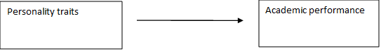

**Independent variable Dependent variable**

### **Hypothesis**

H0 = There exists no relationship between personality traits and academic performance.  
H1= There exists positive relationship between personality traits and academic performance.

## **Research Methodology**

Methods are practical approaches that are used to create and analyze data (Bricks and Mills, 2011). Research methodology is defined as a systematic way to solve a research problem by collecting data using various techniques, providing an interpretation of the collected data, and drawing conclusions about the research data (Ramroodi, 2021). Research methodology is the primary principle that will guide your research. It becomes the general approach in conducting research on your topic and determines what research method you will use (Dawson, 2019).

The research methodology is the systematic, theoretical analysis of the procedures applied to a field of study (Kothari, 2004).Research gives us the information and knowledge to solve problems and make decisions. To differentiate between research that attempts to advance our knowledge and research that seeks to apply pre-existing information to real-world situations. (Goodrich, 2021).

### **1.7.1 Research Design**

The major purpose of this study is to conduct hypothesis testing as it explains the nature of relationships between dependent and independent variables where the dependent variable includes the academic performance and independent variable include personality traits. Here the relational study design is called for as to know the impact of the personality traits that is associated with the academic performance. This study was conducted in the natural environment of the organization with minimal interference were work proceeds normally. Thus, study settings were non-contrived i.e., field study. A cross-sectional study will be pursued because of the time, effort and cost involved in collecting data over several periods of time. And, because keeping track of the variables studied here, over a period is not required. Data will be gathered from everyone; each individual’s response should be treated as an individual data source because here individual academic performance is of major study for the research.

### **1.7.2 Population and Sample**

The population for this study will include all the student's studying bachelor in Tribhuvan University in Kathmandu. There are altogether 322540 students studying bachelor in Nepal. Therefore, the population for this study was 70 students studying bachelor level in management and information technology field in Kathmandu area. Convenience sampling design will be used here because it is a valid method where the units are available; the participants are willing to take part in the research and samples can be taken and it have the limitation of time and resources.

### **1.7.3 Measure**

There are five independent variables and one dependent and all of them are subjective or abstract in nature. Thus, they need to be operationalized for measurement purposes. For each of the variables a questionnaire containing 10 items is created. All the questionnaires are based on 5-point Likert scale.

### **1.7.4 Data Collection Method**

There are two methods of collection of data, and they are: primary sources and secondary sources of data collection

Primary sources of data in research refer to original data collected by the researcher for a specific research study. This type of data is more reliable and accurate because it has not been altered or interpreted by anyone else. Primary data refers to the firsthand data gathered by the researcher himself. Primary sources of data may include interviews, questionnaires, and observations.

Secondary data is research data that has previously been gathered and can be accessed by researchers. A secondary source of data refers to any information that has been previously collected and analyzed by someone else for a different purpose. Secondary sources of data can be useful in research because they provide a wealth of information that has already been synthesized and analyzed. Examples of secondary sources of data include books, academic articles, government reports, and databases.

The primary source of data collection method was used as the research is relational study where there are individuals who are participating in this research and can control over the quality of data collected, ensuring that it is accurate and reliable. It provides the most up-to-date information available since it is collected in real-time and specifically for research study. It provides deeper insights into the attitudes, behaviors, and opinions of the population being studied, providing richer and more reliable data. Data collection was mainly based on primary sources which include questionnaires survey. For collecting the data, a list of questionnaires was prepared based on literature review and guidance of supervisor.

### **1.7.5 Data Analysis**

The data will mainly be analyzed for the purpose of testing hypothesis written using the software package “STATA”. Relational statistics will be done at the beginning for the collected data where percentage of students having personality traits will be found out, to be kept in the sampling section of the research report. Then, inferential statistics will be conducted to test the two hypotheses of this study. This analysis is started with a correlational analysis which will be done using STATA. But since correlational analysis is not considered a robust test, hypothesis won't be tested just based on this and it will be used, to get an idea of relationship between two variables comparing the significance level. Then regression analysis will be run to test all hypothesis of this study. To test the hypotheses H0 and H1, simple regression analysis individually as all these hypotheses just require identifying relationship between one independent variable and a dependent variable.

# **CHAPTER II**

# **DATA PRESENTATION AND ANALYSIS**

## **2.1 Respondent’s profile**

A structured questionnaire was used to collect the responses from the targeted sample size of 70 was taken from students studying bachelor level in management and information technology. Following table represents the demographic study of the respondents.

### **2.1.1 Age distribution**

Figure 2.1.1   
Age

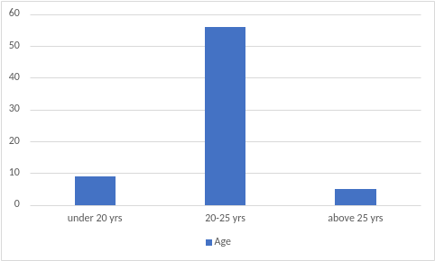

Source: Field survey 2023

From the collected data of 70 respondents, 9 persons (12.90 %) have the age below 20 years, 56 persons (80 %) have the age ranging from 20-25 years, 5 persons (7.10%) have the age of 25 years and above.

### **2.1.2 Gender**

Here the gender distribution of all the respondents taken for this research is presented.

Figure 2.1.2  
Gender

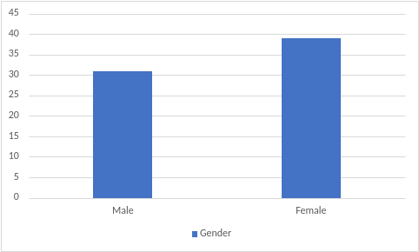  
Source: Field survey 2023

From the collected data of 70 respondents, 39 persons are female which comprises 55.70% of the total respondents and 31 persons are male which comprises 44.30% of the total respondents.

### **2.1.3 Educational Qualification**

Here the education qualifications of all the respondents taken for the research is presented.

Figure 2.1.3  
Educational qualification 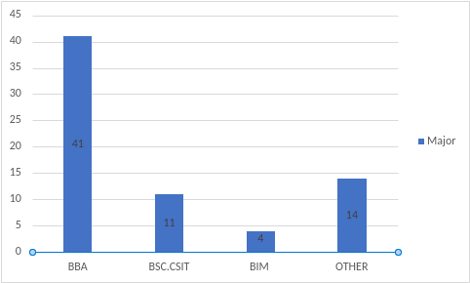  
Source: Field survey 2023

From the collected data of 70 respondents, 41 persons are doing major in BBA which comprise 58.60% of the total respondents, 11 persons are doing major in BSC.CSIT which comprise 15.70% of the total respondents, 4 persons are doing major in BIM which comprise 5.70% of the total respondents and 14 persons are doing major in other courses which comprise 20% of the total respondents.

## **2.2 Data Presentation**

This section presents the presentation of data after administering the questions to respondents. Percentage, pie-chart are used for the purpose of proper presentation of data.

### **2.2.1 Enjoys learning new things**

Here the respondents who enjoy learning new things that they are not used to are presented.

Figure 2.2.1  
Enjoy learning new things that they are not used to are presented 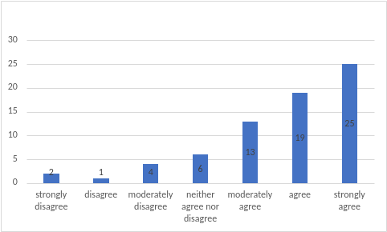Source: Field Survey 2023

From the collected data of 70 respondents, 2 people strongly disagreed, 1 person disagreed, 4 people moderately disagreed, 6 people were neutral, 13 people moderately agreed, 19 people agreed and 25 people strongly agreed with the statement.

### **2.2.2 Take initiation and participate in new activities**

Here the respondents who take initiation and participate in extra and new activities.

Figure 2.2.2  
Take initiation and participate in extra and new activities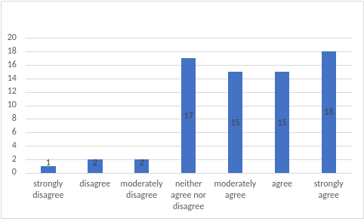  
Source: Field Survey 2023

From the collected data of 70 respondents, 1 people strongly disagreed, 2 people disagreed, 2 people moderately disagreed and 17 people stayed neutral, 15 people moderately agreed as well as 15 people agreed, and 18 people strongly agreed with the statement.

### **2.2.3 Stepping out of comfort zone**

Here the respondents who like to step out of comfort zone and try new things are presented.

Figure 2.2.3  
Like to step out of comfort zone and try new things 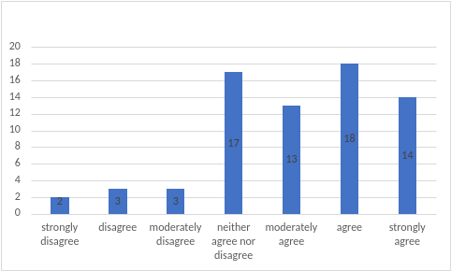Source*:* Field survey, 2023

From the collected data of 70 respondents, 2 people strongly disagreed, 2 people disagreed, 3 people moderately disagreed and 17 people stayed neutral where 13 people moderately agreed, 18 people agreed and 14 people strongly agreed on this statement.

**2.2.4 Comfortable with public speaking**

Here the respondents who are comfortable with public speaking are represented.

Figure 2.2.3  
Comfortable with public speaking

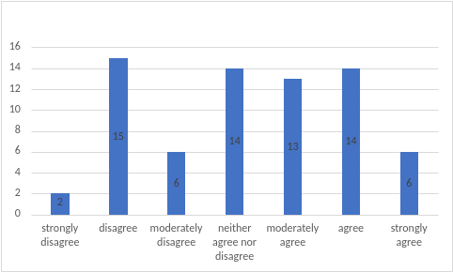

Source: Field Survey 2023

From the collected data of 70 respondents, 2 people strongly disagreed, 15 people disagreed, 6 people moderately disagreed and 14 people neither agreed nor disagreed whereas 13 people moderately agreed, 14 people agreed and 6 people strongly agreed with the statement.

### **2.2.5 Enjoy socializing**

Here the respondents who enjoy socializing with the classmates are presented.

Figure 2.2.5  
Enjoy socializing with the classmates 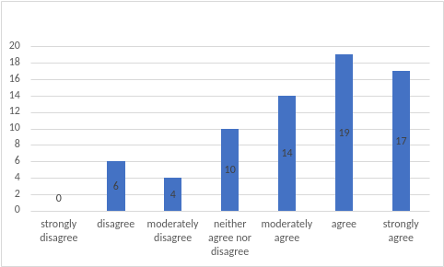

Source: Field Survey, 2023

From the collected data of 70 respondents, 0 people strongly disagreed, 6 people disagreed, 4 people moderately disagreed, 10 people stayed neutral, 14 people moderately agreed, 19 people agreed and 17 people strongly agreed to this statement.

### **2.2.6 Working on group projects with classmates**

Here the respondents who like to work on group projects with their classmates are presented.

Figure 2.2.6  
Like working on group projects with classmates

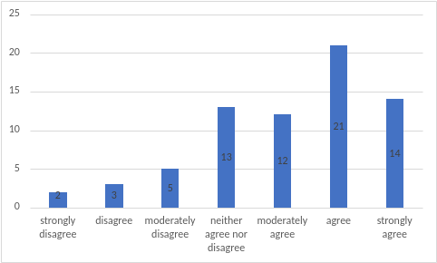

Source: Field Survey, 2023

From the collected data of 70 respondents, 2 people strongly disagreed, 3 people disagreed, 5 people moderately disagreed and 13 people stayed neutral whereas 12 people moderately agreed, 21 people agreed and 14 people strongly agreed with this statement.

### **2.2.7 Avoiding conflict with others**

Here the respondents who try to avoid conflict with others are presented.

Figure 2.2.7  
Try to avoid conflict with others 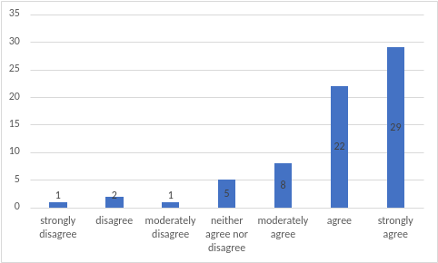

Source: Field Survey, 2023

From the collected data of 70 respondents, 1 person strongly disagreed, 2 people disagreed, 1 person moderately disagreed, 5 people stayed neutral whereas 8 people moderately agreed, 22 people agreed and 29 people strongly agreed with this statement.

### **2.2.8 Getting along with classmates and teachers**

Here the respondents who get along with their classmates and teachers well are represented.

Figure 2.2.8  
Get along with classmates and teachers well

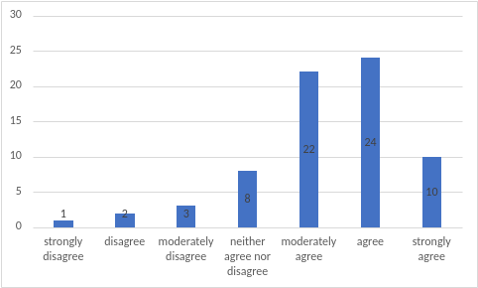

Source: Field Survey, 2023

From the collected data of 70 respondents, 1 person strongly disagreed, 2 people disagreed, 2 people moderately disagreed, 8 people stayed neutral whereas 22 people moderately agreed, 24 people agreed and 10 people strongly agreed with this statement.

### **2.2.9 Considerate of other’s people feelings**

Here the respondents who tries to be considerate of other’s people feelings are represented.

Figure 2.2.9  
Try to be considerate of other’s people feelings 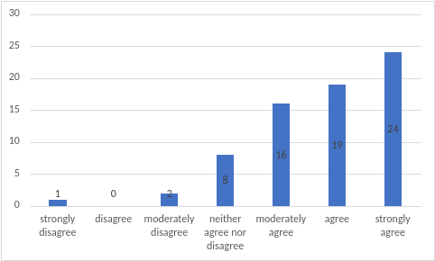

Source: Field Survey, 2023

From the collected data of 70 respondents, 1 person strongly disagreed, 0 people disagreed, 2 people moderately disagreed, 8 people stayed neutral whereas 16 people moderately agreed, 19 people agreed and 24 people strongly agreed with this statement.

### **2.2.10 Feel calm and relaxed while doing academic works**

Here the respondents who feel calm and relaxed while doing assignments, tests and exams.

Figure 2.2.9  
Feel calm and relaxed while doing assignments, tests and exams

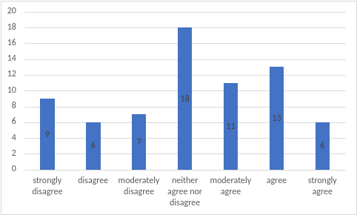

Source: Field Survey, 2023

From the collected data of 70 respondents, 9 people strongly disagreed, 6 people disagreed, 7 people moderately disagreed, 18 people stayed neutral whereas 11 people moderately agreed, 13 people agreed and 6 people strongly agreed with this statement.

### **2.2.11 Not easily irritated by the small things**

Here the respondents who do not get easily irritated by the small things are presented.

Figure 2.2.11   
Do not get easily irritated by the small things

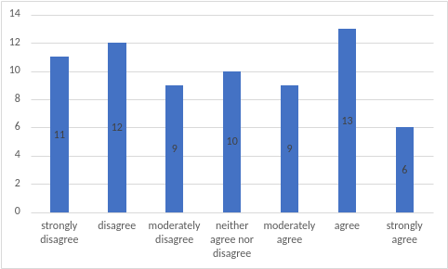

Source: Field Survey, 2023

From the collected data of 70 respondents, 11 people strongly disagreed, 12 people disagreed, 9 people moderately disagreed, 10 people stayed neutral whereas 9 people moderately agreed, 13 people agreed and 6 people strongly agreed with this statement.

### **2.2.12 Not affected by the negative outcomes of my studies**

Here the respondents who do not get affected by the outcome of their studies and take measures are presented

Figure 2.2.12  
Do not get affected by the outcome of their studies and take measures 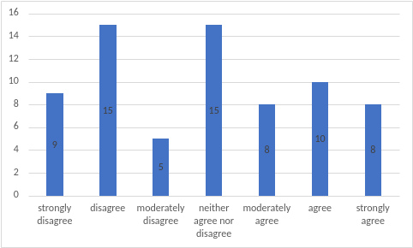

Source: Field Survey, 2023

From the collected data of 70 respondents, 9 people strongly disagreed, 15 people disagreed, 5 people moderately disagreed, 15 people stayed neutral whereas 8 people moderately agreed, 10 people agreed and 8 people strongly agreed with this statement.

### **2.2.13 Seek feedback from teachers on studies**

Here the respondents who like to contact and seek feedback from teachers on their studies are presented.

Figure 2.2.13  
Like to contact and seek feedback from my teachers on my studies 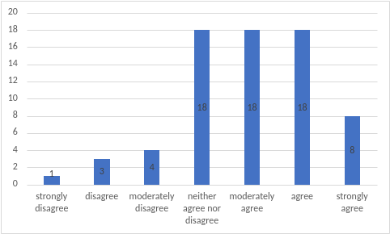

Source: Field Survey, 2023

From the collected data of 70 respondents, 1 person strongly disagreed, 3 people disagreed, 4 people moderately disagreed, 18 people stayed neutral whereas 18 people moderately agreed, 18 people agreed and 8 people strongly agreed with this statement.

### **2.2.14 Follow an organized study schedule**

Here the respondents who like to follow an organized and well-maintained study schedule are presented.

Figure 2.2.14  
Like to follow an organized and well-maintained study schedule

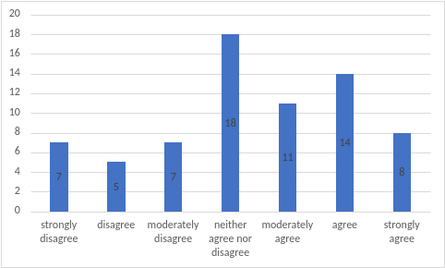

Source: Field Survey, 2023

From the collected data of 70 respondents, 7 people strongly disagreed, 5 people disagreed, 7 people moderately disagreed and 18 people stayed neutral whereas 11 people moderately agreed, 14 people agreed and 8 people strongly agreed with this statement.

### **2.2.15 Understand deeply about the study materials**

Here the respondents who like to understand deeply and in details about the study materials are presented.

Figure 2.2.15   
Like to understand deeply and in details about the study materials

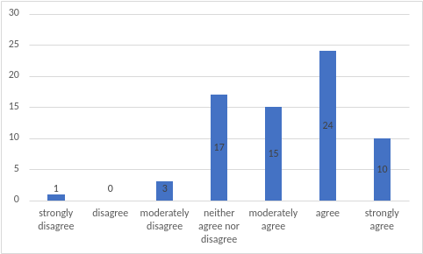

Source: Field Survey, 2023

From the collected data of 70 respondents, 1 person strongly disagreed, 0 people disagreed, 3 people moderately disagreed and 17 people stayed neutral whereas 15 people moderately agreed, 24 people agreed and 10 people strongly agreed with this statement.

### **2.2.16 Submit assignments on time**

Here the respondents who submit my assignments on time are presented.

Figure 2.2.16

Submit assignments on time 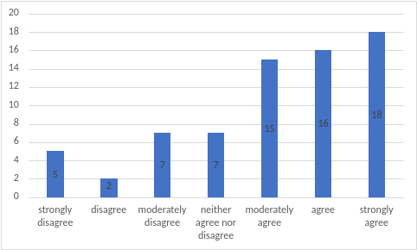

Source: Field Survey, 2023

From the collected data of 70 respondents, 5 people strongly disagreed, 2 people disagreed, 7 people moderately disagreed and 7 people stayed neutral whereas 15 people moderately agreed, 16 people agreed and 18 people strongly agreed with this statement.

### **2.2.17 Feels motivated for exams**

Here the respondents who feel motivated to study and succeed in my semester examinations are presented.

Figure 2.2.17

Feel motivated to study and succeed in my semester examinations 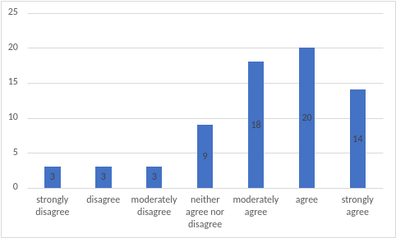

Source: Field Survey, 2023

From the collected data of 70 respondents, 3 people strongly disagreed, 3 people disagreed, 3 people moderately disagreed and 9 people stayed neutral whereas 18 people moderately agreed, 20 people agreed and 14 people strongly agreed with this statement.

### **2.2.18 Take study notes**

Here the respondents who take study notes for each subject are presented.

Figure 2.2.18

Take study notes for each subject 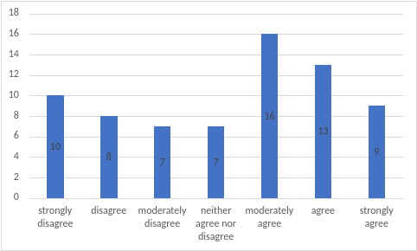

Source: Field Survey, 2023

From the collected data of 70 respondents, 10 people strongly disagreed, 8 people disagreed, 7 people moderately disagreed and 7 people stayed neutral whereas 16 people moderately agreed, 13 people agreed and 9 people strongly agreed with this statement.

### **2.2.19 Prioritizing study outcomes**

Here the respondents who prioritize their study outcomes and take effective measures to improve it are presented.

Figure 2.2.19  
Prioritize study outcomes and take effective measures to improve it 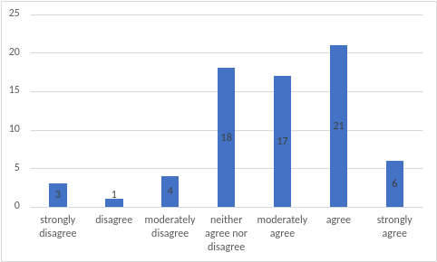

Source: Field Survey, 2023

From the collected data of 70 respondents, 3 people strongly disagreed, 1 person disagreed, 4 people moderately disagreed and 18 people stayed neutral whereas 17 people moderately agreed, 21 people agreed and 6 people strongly agreed with this statement.

### **2.2.20 Take suggestions and feedback positively**

Here the respondents who take suggestions and feedbacks from my teachers and classmates on their studies positively

Figure 2.2.20

Take suggestions and feedbacks from my teachers and classmates on studies their positively 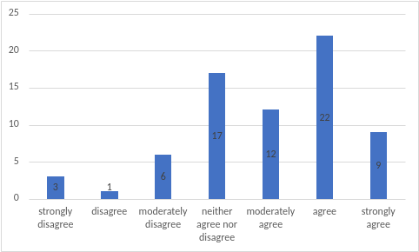

Source: Field Survey, 2023

From the collected data of 70 respondents, 3 people strongly disagreed, 1 person disagreed, 6 people moderately disagreed and 17 people stayed neutral whereas 12 people moderately agreed, 22 people agreed and 9 people strongly agreed with this statement.

## **2.3 Data analysis**

This section presents the analysis of data after administering the questions to respondents. STATA software was used to analyze the collected data from the questionnaire and results are explained using statistical tools.

### **2.3.1 Descriptive analysis**

Table 2.3.1  
Descriptive analysis

|  |  |  |  |  |  |
| --- | --- | --- | --- | --- | --- |
| Variable | Obs | Mean | Std. Dev. | Min | Max |
| Academic performance | 70 | 4.86 | 1.308323 | 1 | 6.8 |
| Personality traits | 70 | 4.91619 | .784445 | 3.133 | 6.3333 |

This table shows that the mean of academic performance is 4.86 and the mean of personality traits is 4.91619.

### **2.3.2 Correlation Analysis**

Correlation analysis refers to the method of statistical evaluation used to study the strength of a relationship between two numerically measured, continuous variables. Using STATA software, the relationship between dependent variable i.e., academic performance and independent variable i.e., personality traits is identified which is illustrated as below:

Table 2.3.2  
Correlation

|  |  |  |
| --- | --- | --- |
|  | Academic performance | Personality traits |
| Academic performance | 1.0000 |  |
| Personality traits | 0.3525 | 1.0000 |

The correlation coefficient table shows that consumer buying behavior and perceived brand image are moderately correlated.

### **2.3.3 Regression Analysis**

Regression Analysis refers to a statistical tool used to determine the probable change in one variable for the given amount of change in another. Using STATA software, the following results were obtained through regression analysis.

Table 2.3.2

|  |  |
| --- | --- |
| Number of obs | 70 |
| F (1,68) | 9.65 |
| Prob > F | 0.0028 |
| R-squared | 0.1243 |
| Adj.R-squared | 0.1114 |
| Root MSE | 1.2333 |

Regression

|  |  |  |  |
| --- | --- | --- | --- |
| Source | SS | df | MS |
| Model  Residual | 14.6791368  103.428864 | 1  68 | 14.6791368  1.52101271 |
| Total | 118.108001 | 69 | 1.71171016 |

|  |  |  |  |  |  |  |
| --- | --- | --- | --- | --- | --- | --- |
| Academic performance | Coef. | Std. Err. | t | P > | t | | [95% Conf. | Interval] |
| Personality traits | .5879809 | .1892689 | 3.11 | 0.003 | .2103006 | .9656612 |
| _cons | 1.969374 | .9420859 | 2.09 | 0.040 | 0.89471 | 3.84927 |

Interpretation I: Since, prob > t = 0.003 which is less than 0.05, the model is fit i.e., there is significant relationship between academic performance and personality traits.

Interpretation II: Since, R-squared = 0.1243, it means that 12.43 % of variance in dependent variable (academic performance) is explained by the independent variable (personality traits)

Interpretation III: Since p >|t|= 0.003 which is less than 0.05. So, alternative hypothesis(H1) is accepted, and null hypothesis(H0) is rejected.

The alternative hypothesis is accepted. It shows that there is a positive relationship between personality traits and academic performance.

# **CHAPTER III**

# **CONCLUSION**

The major objective of this study is to analyze the impact of personality traits on academic performance. The result of components of study such of personality traits was found to be positively related to academic performance.

As the conceptual model basically presents the relation between personality traits and academic performance which was identified in literature review too because the result of the study illustrated that personality traits has significant impact on academic performance. To influence academic performance in a positive manner, there can be good and proper guidance to students' personality traits to improve academic performance. Through the questionnaire, data was collected from sample size of 70 which was analyzed in STATA using descriptive and inferential statistics. Based on literature and the analysis it can be concluded that there is a positive relationship between personality traits and academic performance. Hence, personality traits have a positive relationship with academic performance in the Kathmandu area.

# **REFERENCE**

Abolmaali, K., Rashedi, M. and Ajilchi, B. (2014) Explanation of Academic Achievement Based on Personality Characteristics Psycho-Social Climate of the Classroom and Students’ Academic Engagement in Mathematics. *Open Journal of Applied Sciences*, 4, 225-233.

Al-Naim, A., Al-Rashed, A., Aleem, A., Khan, A., Ali, S. I., & Bogam, R. (2016). Personality traits and academic performance of medical students in Al-Ahsa, Saudi Arabia. International Journal of Scientific Research, 5(4), 425–427.

Barrick, M. R., & Mount, M. K. (1991). The Big Five Personality Dimensions and Job Performance: *A Meta-Analysis. Personnel Psychology*, 44, 1-25.

Barza, A. and Galanakis, M. (2022) The Big Five Personality Theory and Organizational Commitment. *Psychology*, 13, 413-419.

Borgatta E, Lambert W. Handbook of personality theory and research.

Chamorro-Premuzic, T., & Furnham, A. (2003). Personality Traits and Academic Examination Performance. *European Journal of Personality,* 17, 237–250

Chamorro-Premuzic, T., and Furnham, A. (2003). Personality predicts academic performance: Evidence from two longitudinal university samples. *Journal of research in* *personality,* 37, 319-338

Costa, P. T., & McCrae, R. R. (1992). Normal personality assessment in clinical practice: The NEO personality inventory. *Psychological Assessment Resources*, 4, 5-13.

Conard, M.A. (2006). Aptitude is not enough. How personality and behavior predict academic performance. *Journal of research in personality*, 40, 339-346.

Dawson, C. (2009) Introduction to Research Methods. De Feyter T, Caers R, Vigna C, Berings D. Unraveling the impact of the Big Five personality traits on academic performance: The moderating and mediating effects of self-efficacy and academic motivation. *Learn Individual Differences.* 2012;22(4):439–48.

Duff, A., Boyle, E., Dunleavy, K., Ferguson, J. The relationship between personality, approach to learning and academic performance. *Personality and Individual Differences*, 2004, 36, 1907–1920.

Furnham, A., Monsen, J., Ahmetoglu, G. Typical intellectual engagement, Big Five personality traits, approaches to learning and cognitive ability predictors of academic performance. *British Journal of Educational Psychology*, 2009, 79(4), 769-782.

Friedman, H., & Schustack, M. (2016). Personality: Classic Theories and Modern Research. London: Pearson Education.

Kothari, C.R. (2004). Research methodology: Methods and techniques (2nd revised edition).

Martey, E. M. & Aborkwa-Larbi, K. (2016). Assessing the Impact of Personality Traits on Academic Performance: Evidence from Tertiary Students in Ghana. International Journal of Research in Engineering, IT and Social Sciences, 6(3), 1-17.

Major, D. A., Turner, J. E., & Fletcher, T. D. (2006). Linking Proactive Personality and the Big Five to Motivation to Learn and Development Activity. *Journal of Applied Psychology*, 91, 927-935.

McCrae, R. R., & Costa, P. T. (1990). Personality in adulthood. New York: The Guilford Press.

McCrae, R. & John, O. P. (1992). An introduction on five factor model and its implications. Journal of Personality, 60, 169-175.

O’Connor, M.C., Paunonen, S.V. (2007). Big Five personality predictors of post-secondary academic performance. *Personality and Individual Differences*, 43, 971–990.

Olowookere, E. I., Alao, A. A., Adekeye, O. A. & Ayorinde, E. (2017). Influence of gender and personality characteristics on students’ academic performance.

Poropat, A.E. (2009). A Meta-Analysis of the Five-Factor Model of Personality and Academic Performance. *Psychological Bulletin,* 135(2), 322-338.

Open Journal of Applied Sciences, 4, 225-233. Al-Naim, A. F., Al-Rahed, A. S., Aleem, A. M., Khan, A. S., Ali, S. I & Bogam, R. R. (2016). Personality Traits and Academic Performance of Medical Students in AlAhsa, *Saudi Arabia. IJSR - International Journal of Scientific Research,* 5(4), 423-427.

Vedel, A. (2014). The big five personality traits and tertiary academic performance: A systematic review and meta-analysis. *Personality and Individual Differences*, 71, 66–76.

# **APPENDIX**

Date: May, 2023

Dear respondent,

I am a student at the College of Applied Business. This study is purely of academic nature with the main purpose to identify if the personality traits create an impact on student academic performance in bachelor level of students in Kathmandu area. Thus, this questionnaire is designed to assess these factors that create an impact on academic performance of the bachelor level of students.

I would like to request you to support by providing your valuable response. Please go through the statements and choose the alternative as honestly as possible. There are no right or wrong answers to the questions. I assure you that your responses are kept strictly confidential and will only be used for the purpose as stated above. It will take you about 15 minutes to complete this questionnaire survey.

Thank you for your cooperation

__________________________

Section I: Personality traits

Please choose the option that best represents the extent to which you agree or disagree to the statements below regarding personality traits.

7-point Likert scale is given, and it is simply represented as follows:

1: Strongly Disagree

2: Disagree

3: Moderately Disagree

4: Neither Agree nor Disagree

5: Moderately Agree

6: Agree

7: Strongly Agree

|  |  |  |  |  |  |  |  |  |
| --- | --- | --- | --- | --- | --- | --- | --- | --- |
| 1 | I enjoy learning new things that I am not used to | 1 | 2 | 3 | 4 | 5 | 6 | 7 |
| 2 | I like to initiate and take part in extra and new activities | 1 | 2 | 3 | 4 | 5 | 6 | 7 |
| 3 | I like to step out of my comfort zone and try new things | 1 | 2 | 3 | 4 | 5 | 6 | 7 |
| 4 | I am comfortable with public speaking | 1 | 2 | 3 | 4 | 5 | 6 | 7 |
| 5 | I enjoy socializing with my classmates | 1 | 2 | 3 | 4 | 5 | 6 | 7 |
| 6 | I like working on group projects with my classmates | 1 | 2 | 3 | 4 | 5 | 6 | 7 |
| 7 | I often try to avoid conflict with others | 1 | 2 | 3 | 4 | 5 | 6 | 7 |
| 8 | I get along with my classmates and teachers well | 1 | 2 | 3 | 4 | 5 | 6 | 7 |
| 9 | I try to be considerate of other’s people feelings | 1 | 2 | 3 | 4 | 5 | 6 | 7 |
| 10 | I feel calm and relaxed while doing assignments, tests and exams | 1 | 2 | 3 | 4 | 5 | 6 | 7 |
| 11 | I do not get easily irritated by the small things | 1 | 2 | 3 | 4 | 5 | 6 | 7 |
| 12 | I am not affected by the negative outcomes of my studies and take effective measures | 1 | 2 | 3 | 4 | 5 | 6 | 7 |
| 13 | I like to contact and seek feedback from my teachers on my studies | 1 | 2 | 3 | 4 | 5 | 6 | 7 |
| 14 | I like to follow an organized and well-maintained study schedule | 1 | 2 | 3 | 4 | 5 | 6 | 7 |
| 15 | I like to understand deeply and in details about the study materials | 1 | 2 | 3 | 4 | 5 | 6 | 7 |

Section II: Academic performance

Please choose the option that best represents the extent to which you agree or disagree to the statements below regarding academic performance.

7-point Likert scale is given, and it is simply represented as follows:

1: Strongly Disagree

2: Disagree

3: Moderately Disagree

4: Neither Agree nor Disagree

5: Moderately Agree

6: Agree

7: Strongly Agree

|  |  |  |  |  |  |  |  |  |
| --- | --- | --- | --- | --- | --- | --- | --- | --- |
| **1** | I submit my assignments on time | 1 | 2 | 3 | 4 | 5 | 6 | 7 |
| **2** | I feel motivated to study and succeed in my semester examinations | 1 | 2 | 3 | 4 | 5 | 6 | 7 |
| **3** | I take study notes for each subject | 1 | 2 | 3 | 4 | 5 | 6 | 7 |
| **4** | I prioritize my study outcomes and take effective measures to improve it | 1 | 2 | 3 | 4 | 5 | 6 | 7 |
| **5** | I take suggestions and feedbacks from my teachers and classmates positively | 1 | 2 | 3 | 4 | 5 | 6 | 7 |

Section III: About Yourself

Please choose the option representing the information about you.

1. Age:

a. Below 20 b. 21-25 years c. above 25 years

2. Gender:

a. Male b. Female c. Others

3. Academic major under bachelor level

a. BBA

b. BSC.CSIT

c. BIM

d. Other

Thank you for participating in this survey.