|  |
| --- |
| Chamber of Commerce  Site Plan  Sierra Angell – WDD230 – Winter 2020 |
|  |

## Site purpose

The Mililani Chamber of Commerce is a website designed to give local information about the city of Mililani. It gives information on the city itself, some local businesses, and gives people viewing the website the ability to join the chamber. It fosters the strength of the businesses within the chamber and illustrates the networking of the area.

|  |
| --- |
| Target Audience  * Members of the Mililani Chamber of Commerce, or those who might want to join * Adults, probably closer to middle age than just starting out, 30-50 years of age * Both men and women with an interest in local economy * Business owners who want to network and create opportunity and help the community |

## Site Map

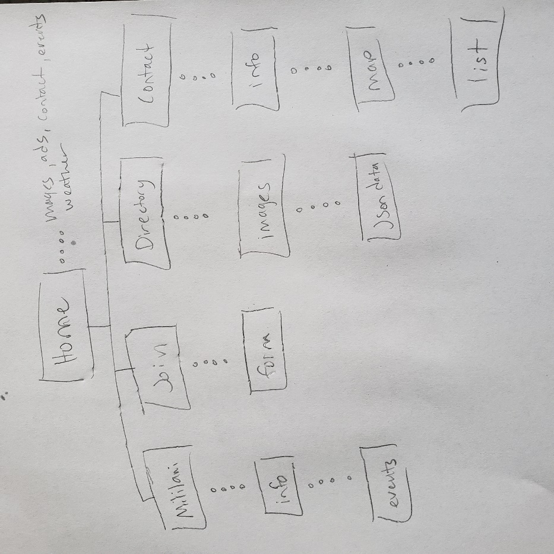

## Color scheme

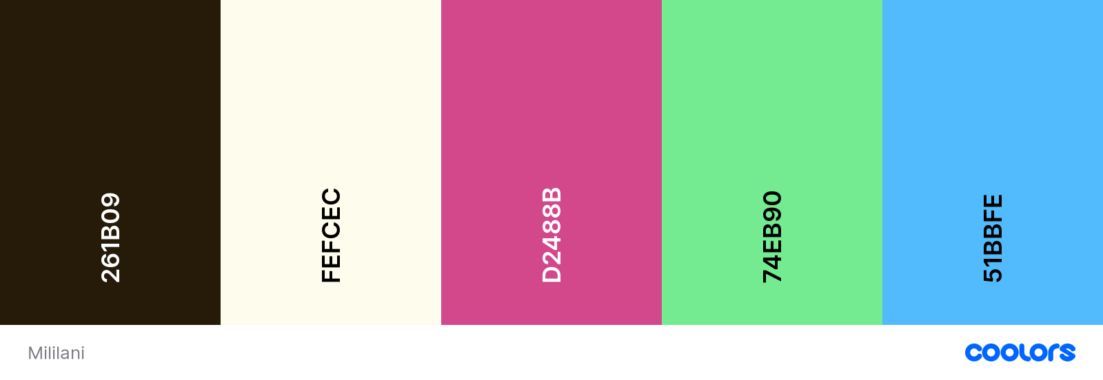

Body background color, reversed fonts - #FEFCEC

Header/footer backgrounds, main font – #261B09

Smaller headers, borders, accent points - #D2488b, #74EB90, #51BBFE as layout dictates

## Typography

EB Garamond – Serif font used lightly for main header and a few subheaders.



Montserrat – Used for the majority of the site, including body copy and smaller lines.



## Wireframes

Desktop home –

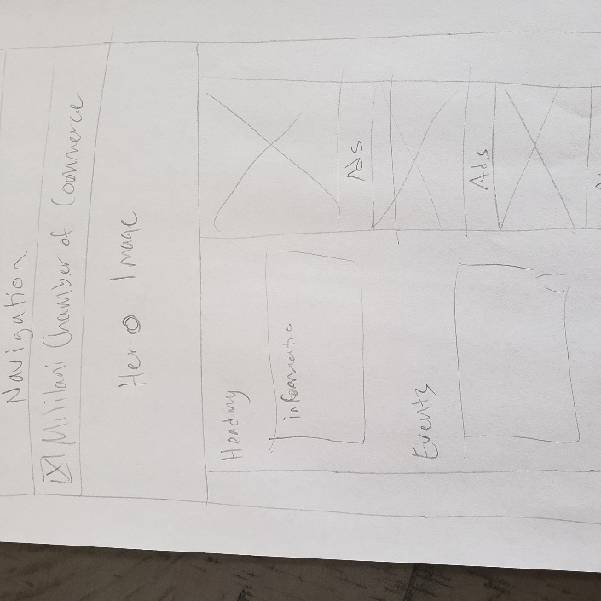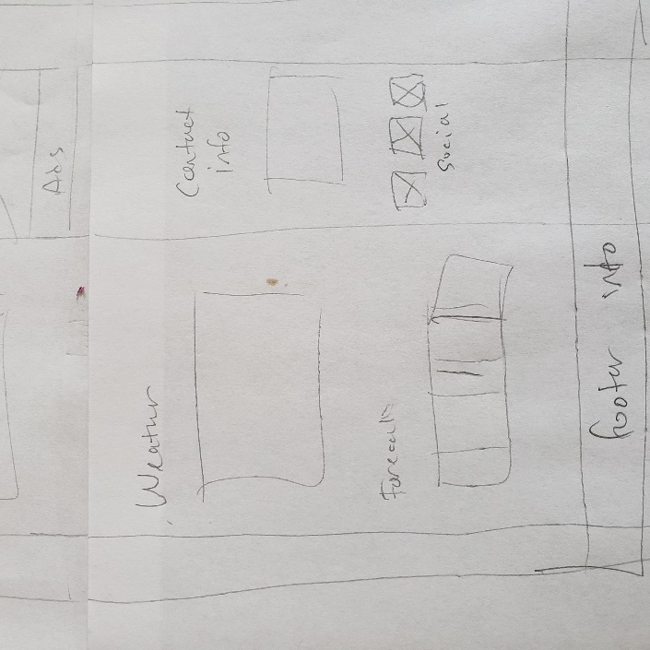

Tablet home –

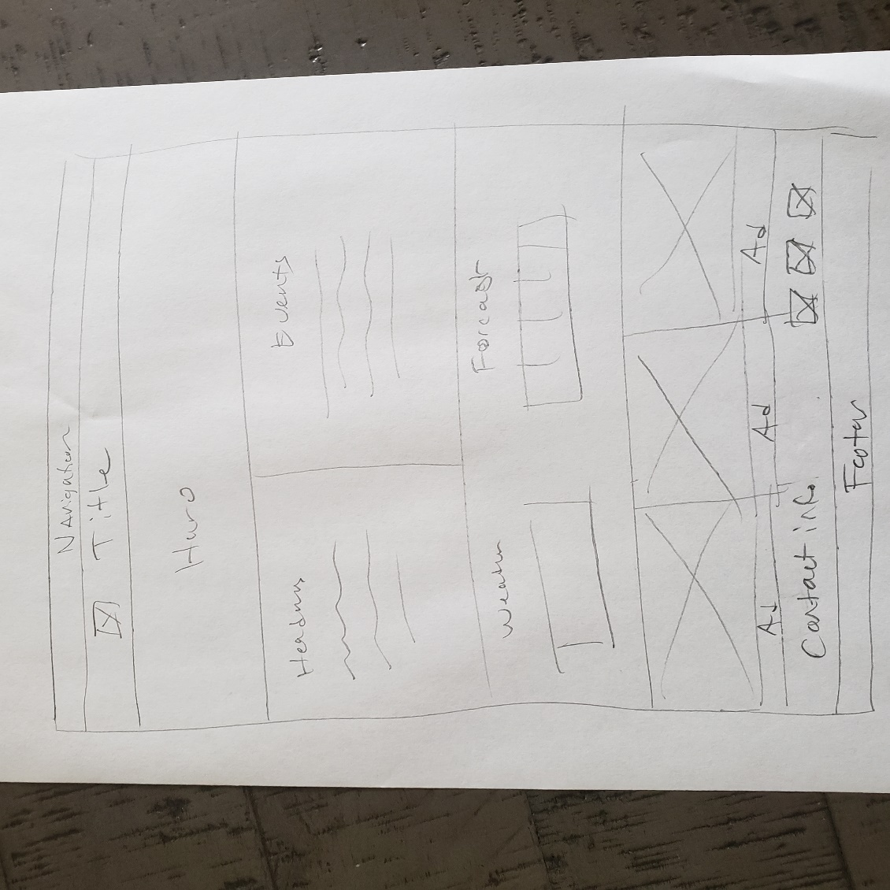

Mobile home –

