**Messaging and Voice for Underwater Systems (MVUS)**

**Project By.**

Suryasaradhi

***Introduction***

The proposed solution is a hybrid system consisting of RF, Light and Acoustic systems to enable communication underwater. The technology uses RF to communicate when outside water, and uses an acoustic/Light hybrid mechanism underwater, RF can’t be used underwater due to its high attenuation.

All code/circuit diagrams/prototype photos/details/software foundations can be found here: <https://github.com/thesunRider/MVUS.git>

***Visualisations***

Visualisations of the device attached to the diver suit is below:

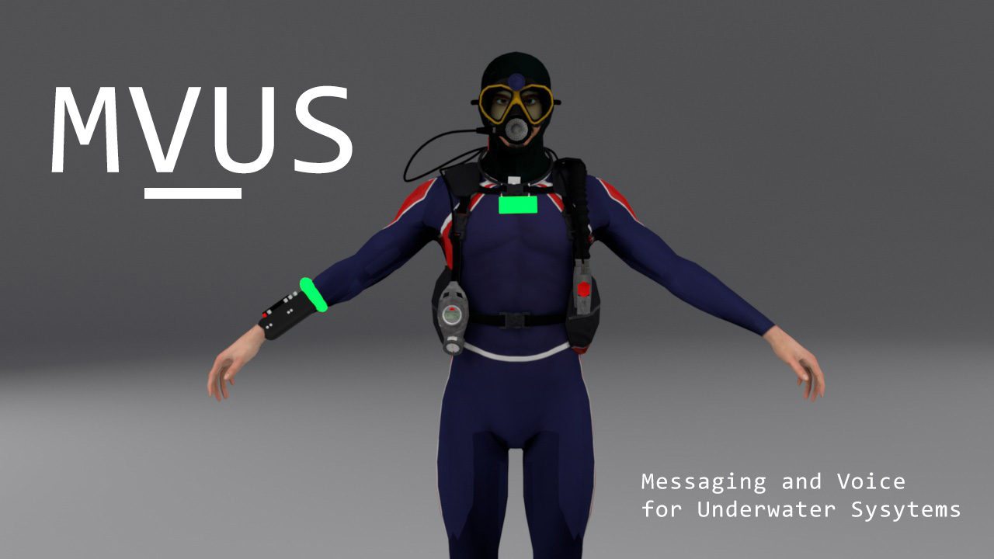

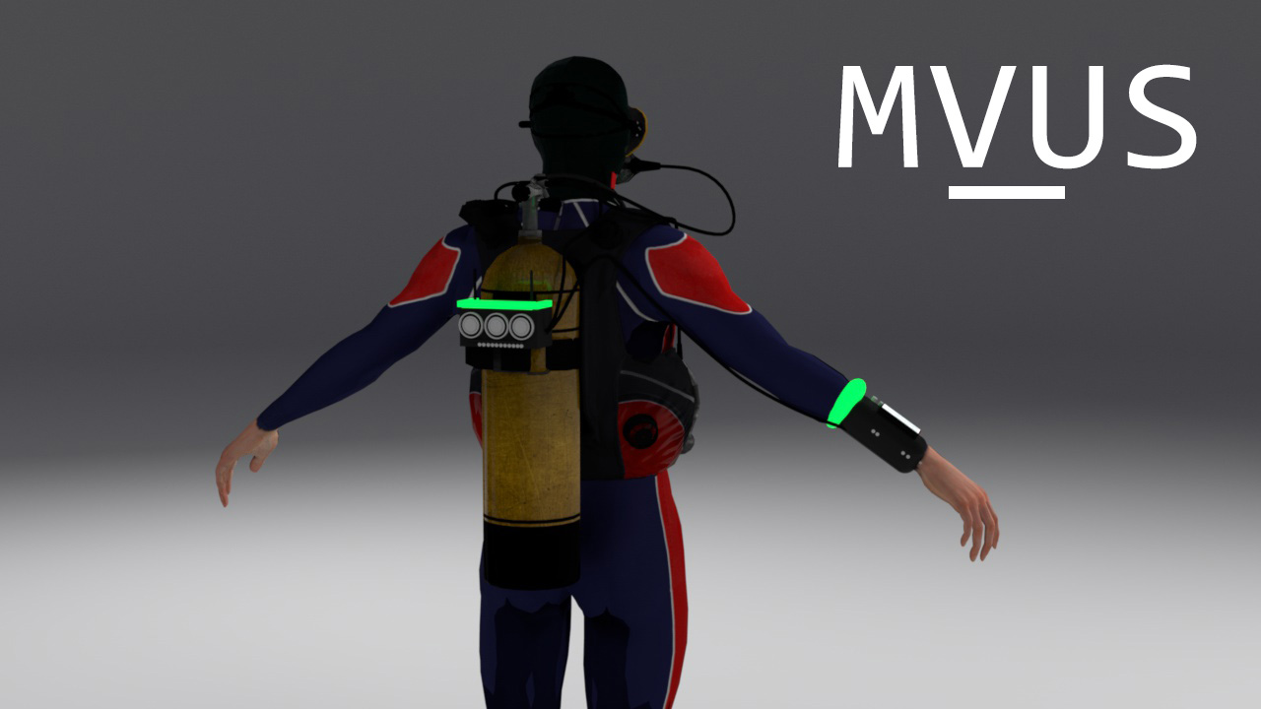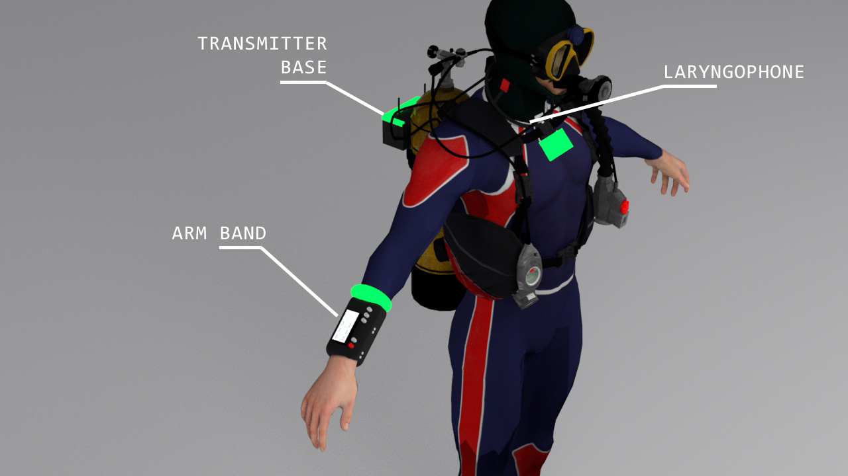

The system consists of three devices:

1. Arm Band
2. Transmitter Base
3. Laryngophone

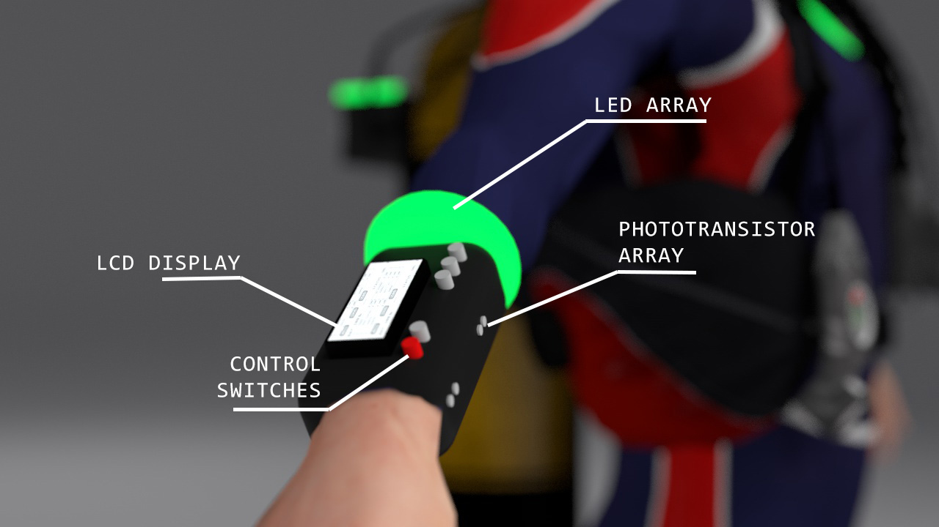

The Arm Band consists of a display interface , control switches ,a LED BAND Array and a Phototransistor Array. The LCD Display is used to monitor the network setting, see who all are online in the communication network, features like switching to chat with a single member, Muting, Checking remaining battery power, Changing communication modes ,etc can be done here by using the control switches to navigate the device. The phototransistor array and the LED array are used to communicate with near field Light communication.

The included communication modes in the device are:

1. Acoustic Mode
2. Light Mode
3. RF Mode
4. Auto Mode
5. Hybrid Auto

Each settings will toggle a different channel , Auto mode toggling the default communication channel based on speed and reliability, while hybrid auto mode uses all communication modes in tandem to provide for the fastest reliable communication, Switching off from Hybrid Mode can help consuming power, as other modes will communicate via a single channel only and switch off the others, this can be done in situation where more stealth is needed for operations or the user is running low on power indicated by the battery monitor in the LCD display.

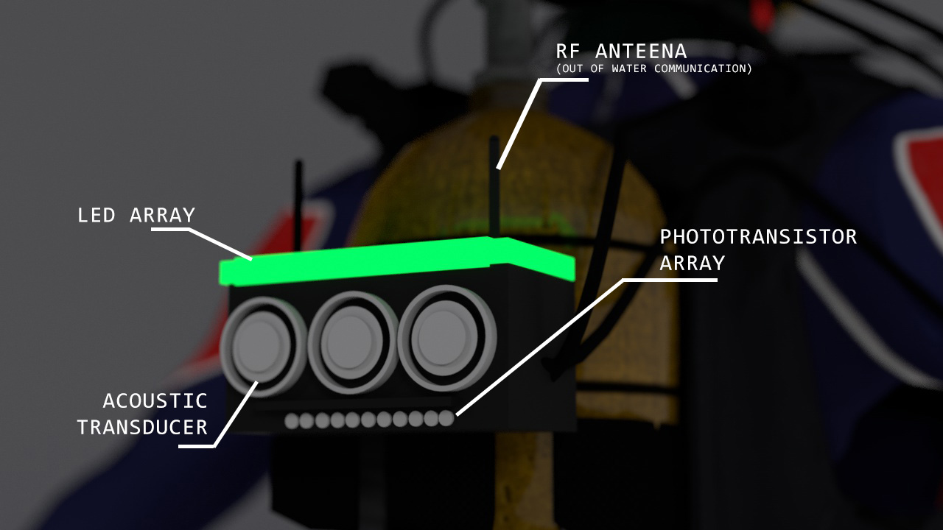

The Transmitter Base (above) is the consists of the core of the system consuming the most power, We have three acoustic transducers which can act as transceivers by clever use of circuitry.

The total power output of the Transducers scale up to 3W ,enough to sent waves across 1KM distance ,The received signals from the three transducers are analysed separately and the average signal is taken thus cutting down the noise. The Transmitter base also consist of high power LED array pumping 2W of power the LED Array is capable of sending light 180 degree coverage, beneath the transducers lie a phototransistor array made to pick up the faintest of light signals. Apart from transmitting the Light and Acoustic waves the transmission base boasts two 2.7ghz antennas which is capable of providing a range of up to 2km’s for out of water communications.

The Transmission base can be mounted by means of suction , using magnets attached to its base or can even be tied down to the divers suite. The processor is a raspberry pi which controls all logic in the system is inside the transmitter base.

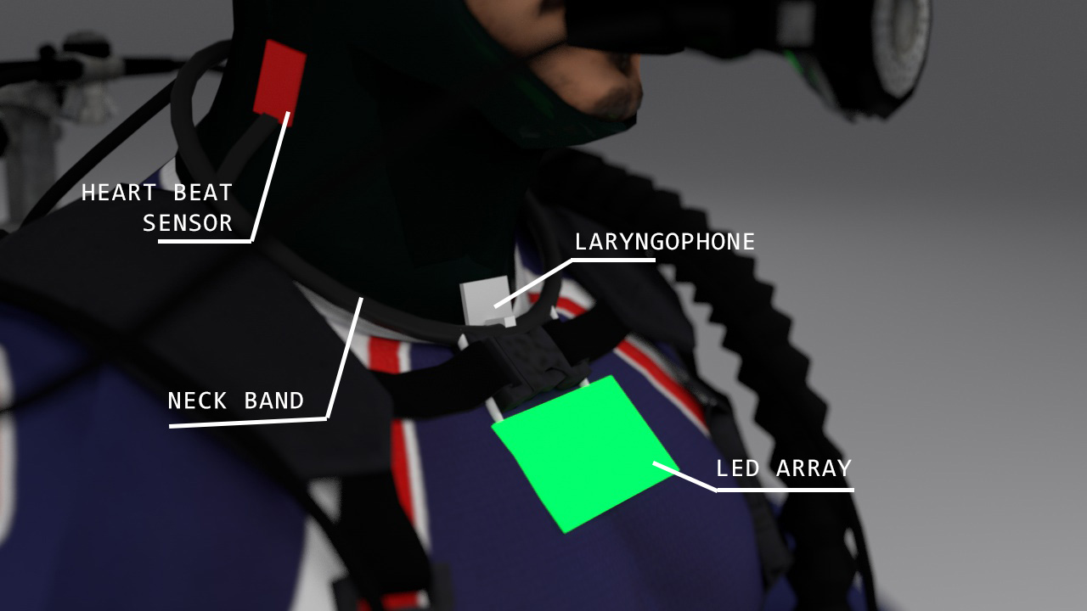

The Neck band (above) consists of a Laryngophone which is able to directly procure the sound of the user through vibration of tissues ,without the need of an air coupling ,thus eliminating noise influence from the surroundings. The neck band also houses a small LED panel as well as a Heart beat sensor that measures the pulse rate from the carotid triangle which do have a pulsating artery.

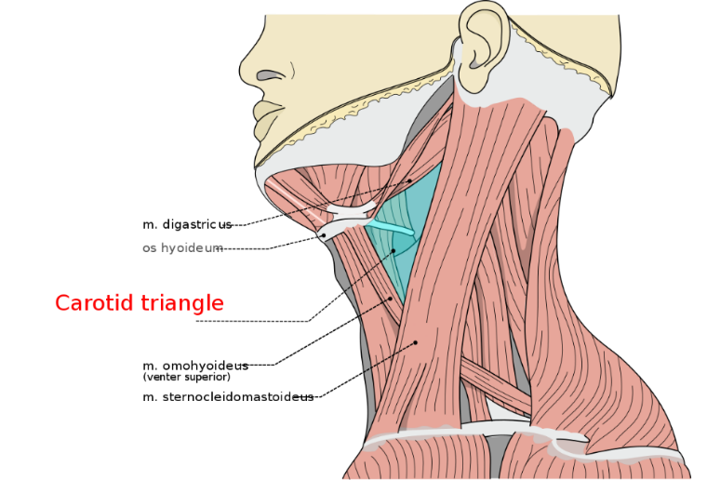

***Working***

The device mainly consists of :

* LED Array’s attached to the diver’s suit along with phototransistors which facilitates for near light based communication
* RF antennas which would be used for communication out of water.
* Three acoustic transducers which would act as transceivers.
* Laryngophone to extract sound through conduction.
* Heart Beat sensor to monitor heart rate.
* A Control Panel (Arm Band) to change settings of the device and to monitor the current network status.

The control flow of the entire system goes as such:

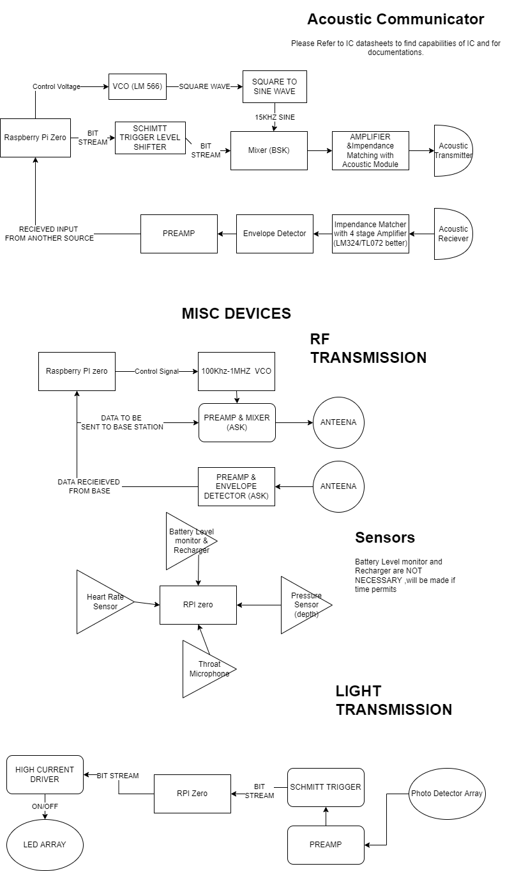

Work done is given **DONE** tag and those on progress is given **PROGRESS** tag on their corresponding headings

***Software Prototyping***

1. ***Simulations (DONE)***

Although the time frame was very limited we were able to come up with a couple of discrete prototypes which demonstrate how could we implement the solution practically. As first steps we came up with simulations to our design, the circuit simulations were made in proteus to determine the power output and to select the required components. We used an underwater simulation model from [here](https://github.com/vinittech/Underwater-Broadband-Communication) with shipping mode 2 and model as fisher-Simmons, to determine what our expected range would be providing our operation frequency of 15khz for the transducer at the power output of 3W. We came to a conclusion that attenuation was very low for the taken frequency , 3db/Km maximum @ 80meter depth at a temperature of 2 degree Celsius. This was confirmed by using an underwater acoustic attenuation calculator found [here](http://resource.npl.co.uk/acoustics/techguides/seaabsorption/).

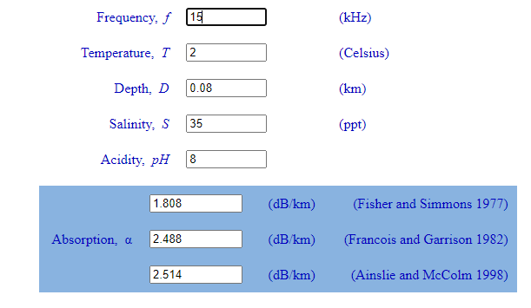

We were sending out waves of 85db’s and the receiver was capable of receiving upto -23db ’s with proper amplifiers. Hence a 3db attenuation does’t cost much decay to the wave’s propagation thus making communication feasible. Furrthermore the simulation models ran on matlab shows that with a 15khz carrier wave we will be able to achieve feasible power input at the reciever ,We simulated for 3 models dealing with underwater acoustics. You can see the transmitter power and frequency emission and its corresponding power at reception in the following simulated graphs:

*Ansile Model with shipping 2 (range = 1km):*

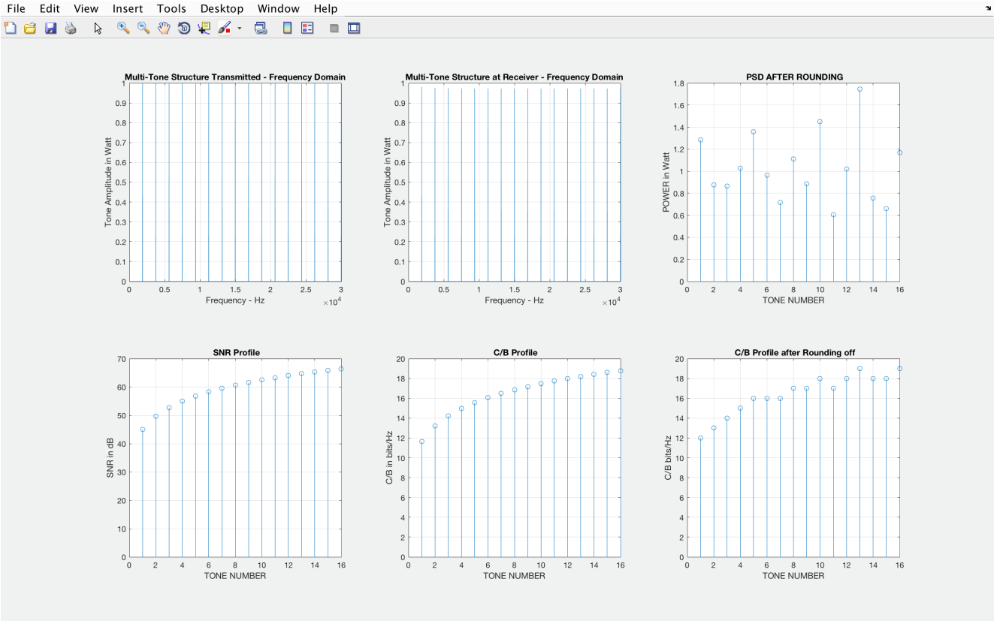

*Fisher Simmons Model with shipping 2 (range = 1km):*

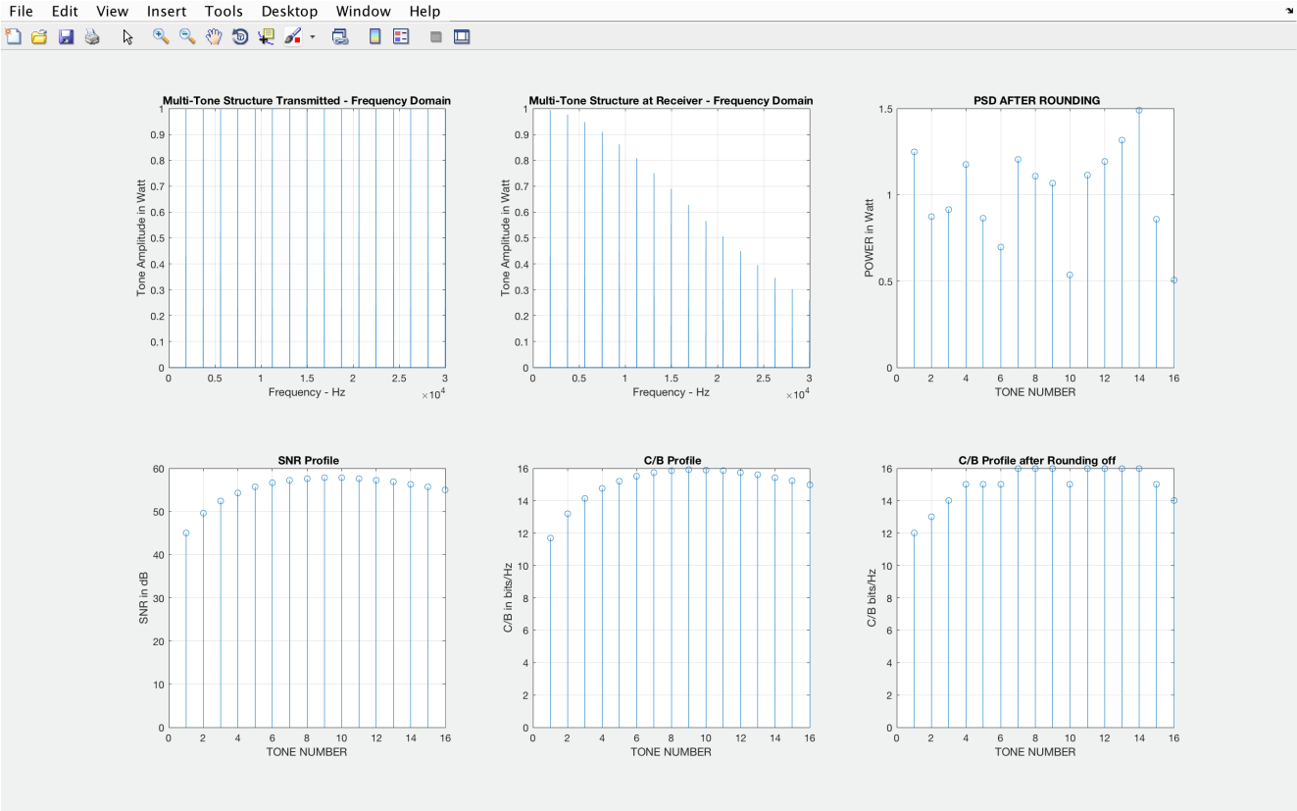

*Thorp Model with shipping 2 (Range = 1km):*

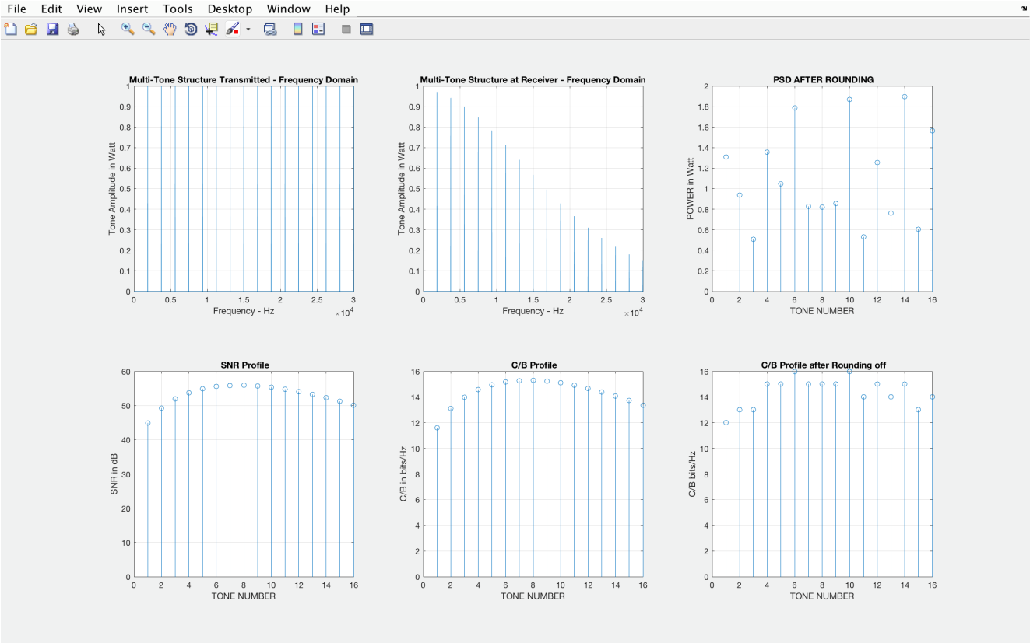

Its clearly visible from the simulated graphs that even with attenuation and background noise taking account into the simulation we are able to receive the signal in a feasible form within the transducer specifications to turn it back to our original data.

1. ***Protocol (PROGRESS)***

For Stability and reliability of communication we are dealing with two protocols, One for light and RF while the other for acoustic. For Light based communication and RF communication the protocol is completely digital consisting of binary stream ,the communication happens by sending frames, each frame contains:

|  |  |  |  |  |  |  |  |  |
| --- | --- | --- | --- | --- | --- | --- | --- | --- |
| **START** | **CLK_SYN** | **ADR_SRC** | **ADR_DST** | **FRM_ID** | **DATA** | **RPTR_FRM** | **CRC** | **END** |

The frame packets are explained as follows:

**START:** Starting of a frame packet

**CLK_SYN:** 100 Clock Pulses to Sync the receiver to the Transmitter

**ADR_SRC:** Address of the transmitter

**ADR_DST:** Address the packet is destined to reach

**FRM_ID:** The Packet Unique ID

**DATA:**  The data to be sent

**RPTR_FRM:** The retransmitted Frame

**CRC:** Cyclic Redundancy Check (CRC calculation only includes **DATA**)

**END:** End of the packet

The **FRM_ID** is a unique number corresponding to each new frame, if the received data’s CRC doesn’t match with the **CRC** packet data then the Receiver asks the transmitter to sent the data again.

**RPTR_FRM** corresponds to another frame embedded within this frame, this frame may come from another transmitter ,this node is optionally filled, this is added so that each transmitter can also act as a repeater of other transmitter effectively increasing the range of the system.

For acoustic system we have a compressed digital protocol so as to make communication faster ,as we cant take much space for frames due to limited data rate. Acoustic communication protocol is as follows:

|  |  |  |  |  |  |  |
| --- | --- | --- | --- | --- | --- | --- |
| **START** | **CLK_SYN** | **ADR_SRC** | **ADR_DST** | **DATA** | **PAD_DATA** | **END** |

The frame packets are explained as follows:

**START:** Starting of a frame packet

**CLK_SYN:** 10 Clock Pulses to Sync the receiver to the Transmitter

**ADR_SRC:** Address of the transmitter

**ADR_DST:** Address the packet is destined to reach

**DATA:**  The data to be sent

**PAD_DATA:** Optional Padding Data to fill up the frame buffer

**END:** End of the packet

1. ***Data Encoding (DONE)***

Human Speech is around 2-4Khz, thus for ASK (Amplitude Shift Keying to be done) a carrier wave with 10x frequency need to be taken, We are using a 15khz carrier, so the extracted signal will be very vague, Therefore instead of ASK we have chosen to carry out BSK (Binary Shift keying) ,sending data digitally in acoustic medium.

Using latest ML technologies (LYRA Audio Encoding) we are able to encode a 320kbps audio to a 3kbps audio losslessly , i.e. a 3khz clock cycle would be enough to sent high quality audio, If even we tried ASK there would be severe loss in audio quality once the receiver gets it, but if we are capable of using digital transmission in the same frequency domain with better quality,thus that should be preferred, the technology exists and that is why we were going with BSK instead of lossy ASK. BSK is actually a subdomain of ASK but there are just two shifting levels instead of a large range as in ASK and the frequency range is fixed ,i.e the bandwidth is a narrow channel, decreasing the power requirement of transmitter. Furthermore sending data digitally will ease the cryptography, as all data can be encrypted before transmission using an RSA key shared by the users in the network. This would not have been possible using raw analogue signals.

***Hardware Prototyping***

We use a raspberry PI ‘zero as the brain of our system due to its small form factor, a better arm processor with sleep mode could/should to be more power efficient.

* ***Acoustic Transmitter (DONE)***

Using an MC1496 ,a balanced modulator/demodulator we were able to achieve ASK (below) in Double Sideband Suppression ,by adding a potentiometer we were able to tune the sideband power,

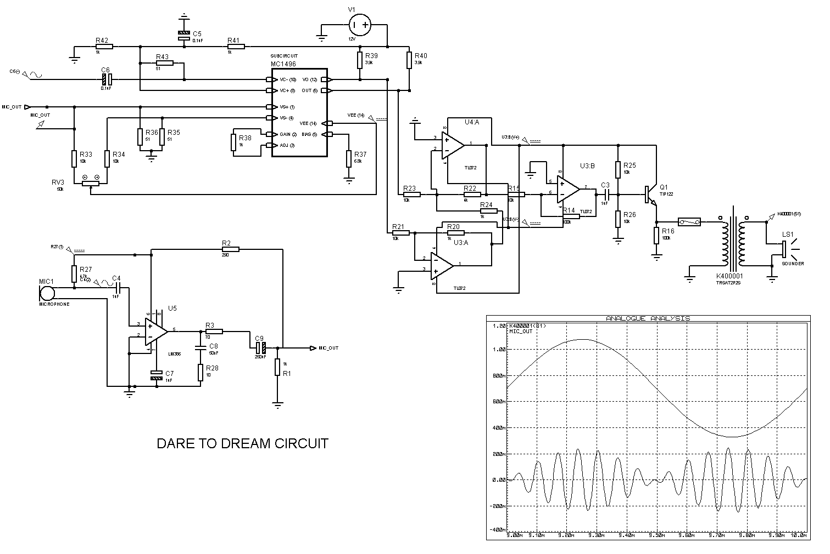

From the graph it is evident that the 3khz signal is getting amplitude modulated with a 15khz carrier , This signal is then fed through a power amplifier network TDA2002 ,then through an impedance matching transformer to the transducer to achieve maximum power transfer. In our case we used a KA400001 1:10 impedance matching transformer.

* ***Acoustic Receiver (PROGRESS)***

Using the same IC as a product detector we were able to extract the signal from the carrier without any crude envelope detector designs. Another advantage of this design is the need of not having to sync the clock, since the receiver and the sender knows the transmission frequency to be 40khz , A PLL can be left running at 40khz, feeding the output of the receiver OPAMP to a PLL the output ,the received signal can be easily freed of any frequency noise. The output of the PLL was then fed to the product demodulator to extract the data signal. So as to compensate for doppler shift a Frequency to voltage converter IC was used, and the voltage at 40khz was noted for reference, whenever there is doppler shift the incoming frequency changes so as the voltage of the Frequency to voltage converter, So the processor would simply divide the current voltage with the reference voltage to get the stretching factor which would be multiplied in the time domain with the input data thus syncing the data to the original source. Afterwards the data is converted back from bitstream to LYRA audio ,then played back.

* ***Light Transmitter (DONE)***

|  |
| --- |
| For transmission using light in the 495–570 nm (GREEN) spectrum region was selected as it has the minimum loss in water.  Light absorption in water (picture from M.Chaplin, Water Structure and... |  Download Scientific Diagram  We went with a simple switching approach for the Light Transmitter all, the LED Arrays will be connected in parallel to a power transistor TIP122 ,which should operate at 10Mhz to achieve high speed transmission, The data was fed into the transistor by means of a common use transistor BC547 which would help in achieving the current to drive the base of TIP122. A Raspberry PICO is used to achieve a 10Mhz SPI whose Master OUT is being used to drive the transistor. By using our special protocol we are able to sync the SPI’s clock in the MOSI channel itself.   * ***Light Receiver (DONE)***   Similar to the Light transmitter the approach we took to make the light receiver was straight forward, instead of biasing all the photo-transistor to a single source, we made it such that the array of phototransistor signals will be picked up by the microcontroller residing at the origin ,ie the light signals picked up by the phototransistors at the armband will be processed there and the data is sent to the main processor. The Light receiver will be amplified by using transistors in Schmitt configurations which a PLL will filter to contain 10MHZ signals only. The output bitstream is passed onto as interrupts to the raspberry PICO which communicates with the Raspberry PI main processor via SPI interface.   * ***RF Transmitter & Receiver (DONE)***   We are using NRF24 modules to communicate via RF, these modules allow high baud rate communication and can act as transceivers making them suitable for the RF transceiver’s job. The setup is a straight forward SPI interface, which would be controlled by the main processor:  nRF24 on Raspberry Pi | The bright side  ***Optional hardware (PROGRESS)***   * ***RF buoy (DONE)***   This is a NRF module connected with an acoustic receiver floating on the surface of water. The transducer will go 1 meter deep in water through a pipe to fetch acoustic waves more clearly, while the RF antenna will float above water. The RF Buoy will have a GPS system and a LED beamer so as to make it easily locatable.   * ***Acoustic Repeater (PROGRESS)***   In situations where more than 1km range is required, an acoustic repeater must be used. This device consists of two transducers one to act as a receiver and the other to retransmit the received data with higher power. The repeater will be a device that would be able to hold its depth via a pressure controlled feedback system. The Acoustic Repeater will also help to keep the acoustic wave above the thermocline level so that the wave doesn’t refract to the sea bed due to the wave speed gradient. For easy finding once deployed the acoustic Repeater will have an LED beamer. |
|  |

***Scope of Future Work***

Most of the hardware is done, finishing the protocol,fabricating the PCB’s remain and running real underwater tests remain. The protocols are made in such a way that they can be easily integrated with each other, Faster means of communication using better protocols needs to be researched. Since we were solely biasing ideas based on simulations and models tests needs to be done in real to make sure that the simulation values come close to real life expectations. Developing a 3d printable laryngophone is also a part of the development timeline.

***Challenges Faced***

Due to the prevailing covid situation , for prototyping none of the orders couldn’t reach us, We ordered a 15khz piezo electric transducer for testing,but the delivery was delayed to January next year so e prototyped using a 3khz piezo which we had with a 1khz modulating wave, which worked just fine. For designing custom laryngophones we used a small diameter piezo element with a broader resonance peak which was hard to amplify. All impedance matchings were done using careful study and by AC analysis using simulations.