I Built a Mini SOC in VirtualBox and Attacked Myself (On Purpose)
Rina S. Aranas
So I’ve been working toward a SOC analyst role, and I kept hearing the same advice: stop reading about detection and go build something that generates real alerts. So I did. Two VMs, one Wazuh install, and an afternoon of attacking my own Ubuntu box from Kali. Here’s the whole journey — including every single thing that went wrong, because honestly, that’s the part that taught me the most.

The Setup
Nothing fancy — just VirtualBox on my Windows laptop:
- Ubuntu VM — the "server." This is where Wazuh lives (manager, indexer, dashboard, all on one box).
- Kali VM — the "attacker." Nmap, Hydra, and an SSH client.
- Both talking to each other over a VirtualBox host-only network, 192.168.56.0/24.
The plan: get the two VMs talking to each other, install Wazuh on Ubuntu, then throw some basic attacks at it from Kali and watch the alerts roll in.

Step 1: Just Getting the VMs to Ping Each Other
You’d think this would be the easy part. It mostly was, except Kali’s eth1 interface didn’t have an IP address at all when I first checked — ip a show eth1 came back basically empty. Turned out I needed to manually assign one, which worked but was temporary (gone on reboot), so I fixed it properly with NetworkManager instead. Once both VMs had addresses, ping between them worked cleanly, 0% packet loss both ways. Small win, but it felt good.
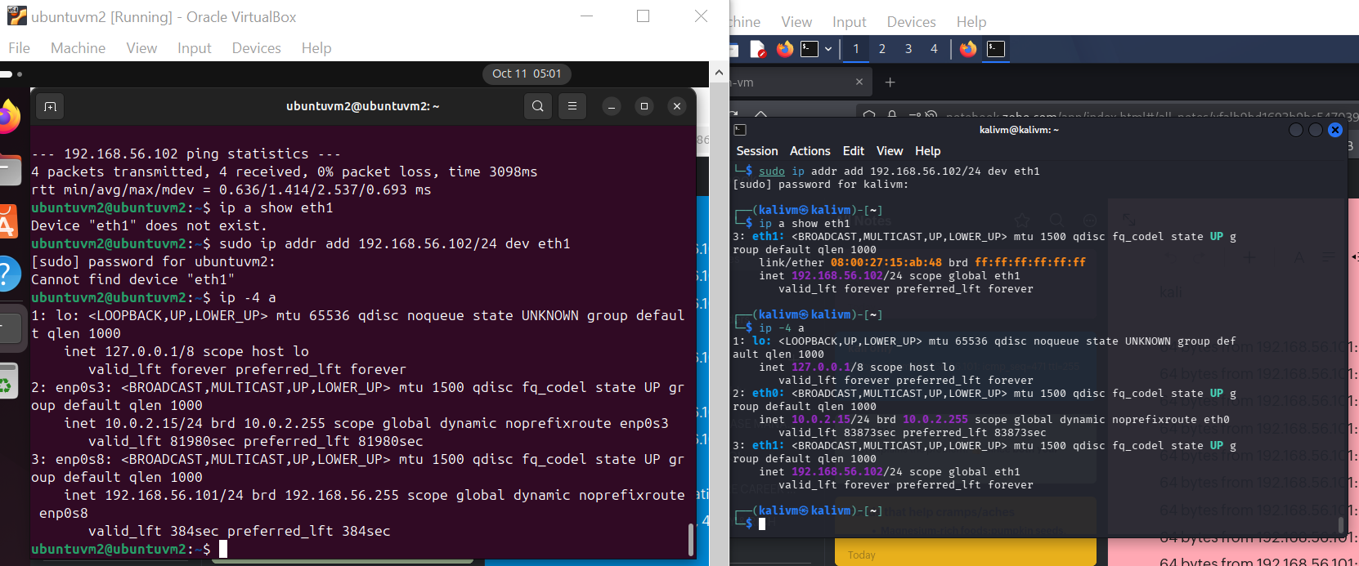
Both terminals side by side — Ubuntu and Kali, finally able to see each other on the host-only network.

Step 2: The SSH Install That Wouldn’t Install
Tried to install OpenSSH server on Ubuntu so Kali would have something to attack. Got hit with a 404 Not Found from the package mirror. Turns out my package index was just stale — the exact version the system remembered didn’t exist on the mirror anymore. The fix was almost embarrassingly simple: apt update, then retry the install.
Lesson learned: when apt throws a 404 on a specific package version, it’s usually not your fault — the index is just out of date. Refresh first, panic later.

Step 3: "Is SSH Even Running?"
After installing, systemctl status ssh showed inactive (dead), which made my stomach drop for a second. Turns out Ubuntu 24.04 uses socket activation — ssh.socket listens on port 22 and only spins up ssh.service when a connection actually comes in. So "dead" didn’t mean broken, it meant idle. A quick nc -zv from Kali confirmed the port was genuinely open.

Step 4: Running Out of Disk Space Before Even Installing Wazuh
Wazuh’s all-in-one install is genuinely heavy — indexer, manager, dashboard, all on one box. My Ubuntu VM only had 25 GB allocated, which felt tight. Resizing a live VM’s disk without blowing anything away turned out to be a two-step process: resize the virtual disk file on the host side with VBoxManage, then grow the actual filesystem inside Ubuntu with growpart and resize2fs.
I almost ran growpart against the wrong partition (sda1 is a tiny 1 MB boot partition, not the one you want) — always double-check with lsblk first. Worked perfectly once I pointed it at sda2, the actual root partition, and I ended up with a comfortable 35 GB with zero data loss.
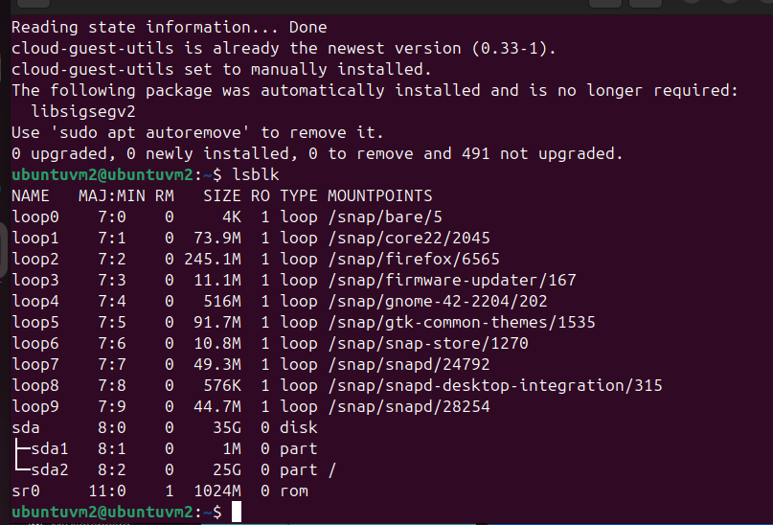
lsblk confirming the partition layout before growing sda2 to use the newly resized disk.
Also — fun fact — VBoxManage wasn’t even in my Windows PATH, so every command had to start with the full path until I fixed that with setx.

Step 5: Installing Wazuh (The Easy Part, Finally)
curl -sO the install script, run it with -a for all-in-one. About 10–15 minutes later, it spat out an admin username and a password I immediately copied somewhere safe.
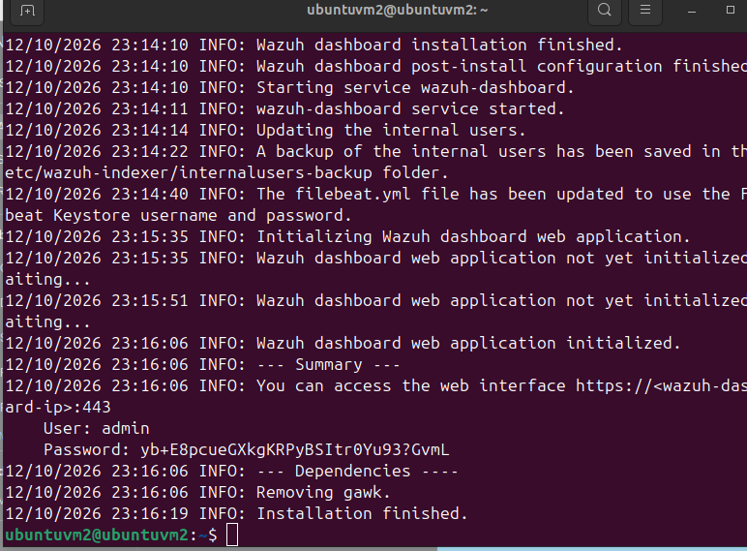
The installer’s final summary — dashboard URL, admin user, and the generated password.

Step 6: "No Agents Registered" — Wait, Did It Even Work?
The Overview page greeted me with: "This instance has no agents registered." My first instinct was to install the standalone wazuh-agent package to monitor the server itself. That backfired immediately — dpkg flatly refused, saying wazuh-agent conflicts with wazuh-manager.
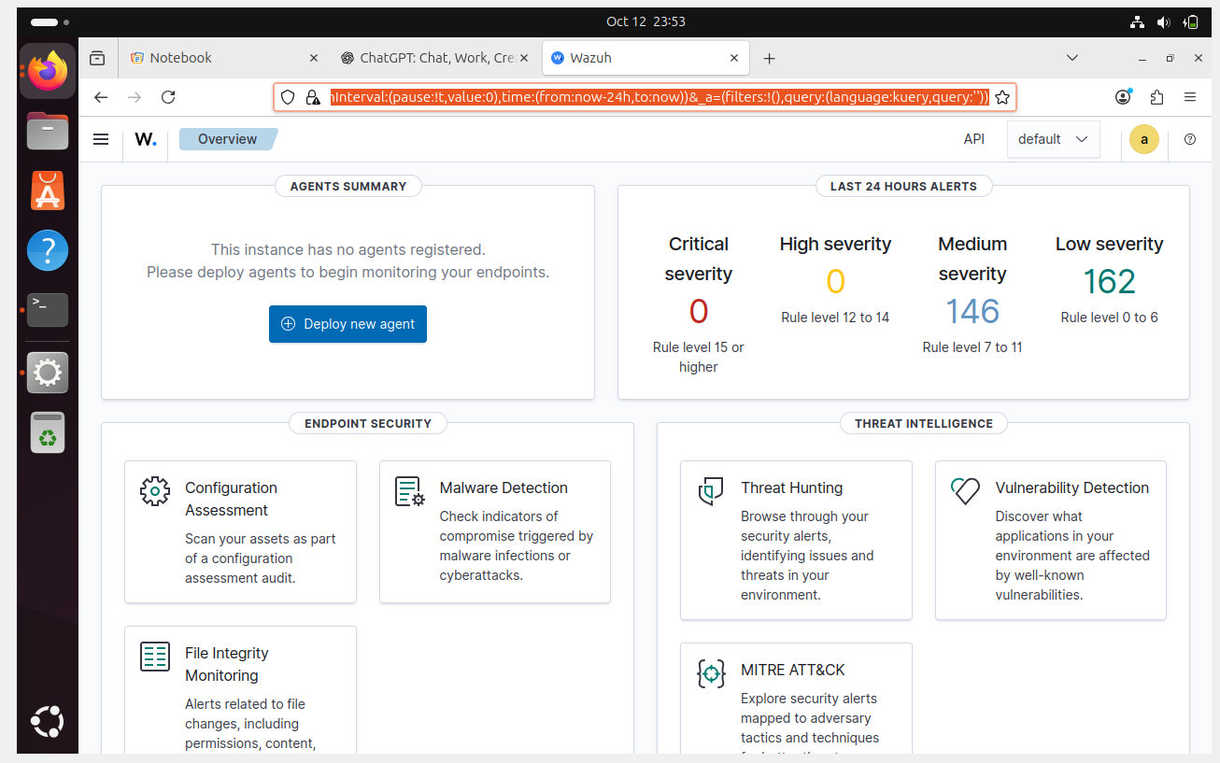
The dashboard’s initial state — no remote agents, but alerts already flowing from the manager’s own self-monitoring.
Turns out — and this took some digging — the wazuh-manager package already includes its own log collection for the host it’s installed on. Installing wazuh-agent on the same box is not just unnecessary, it’s actively blocked. The "no agents registered" message only refers to remote agents monitoring other machines. The manager watches itself automatically through its own localfile config, including a journald collector that catches basically everything — SSH, sudo, PAM, the works. I confirmed this by tailing the alert log directly and just... watching alerts appear in real time as I did normal things like running sudo. That was oddly satisfying.
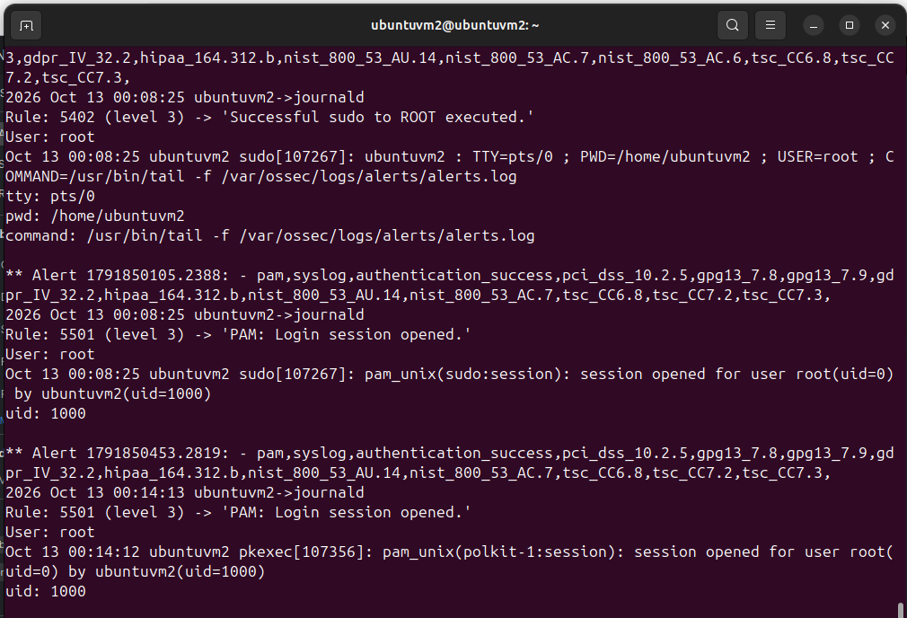
Live alerts.log output — proof the manager was watching itself the whole time, no separate agent needed.

Step 7: Kali Suddenly Couldn’t Reach the Internet
Mid-lab, I tried apt update on Kali and got a DNS resolution failure. Checked ip route and — nothing. No default route at all. Kali had a working host-only connection to Ubuntu but literally no route out to the internet.
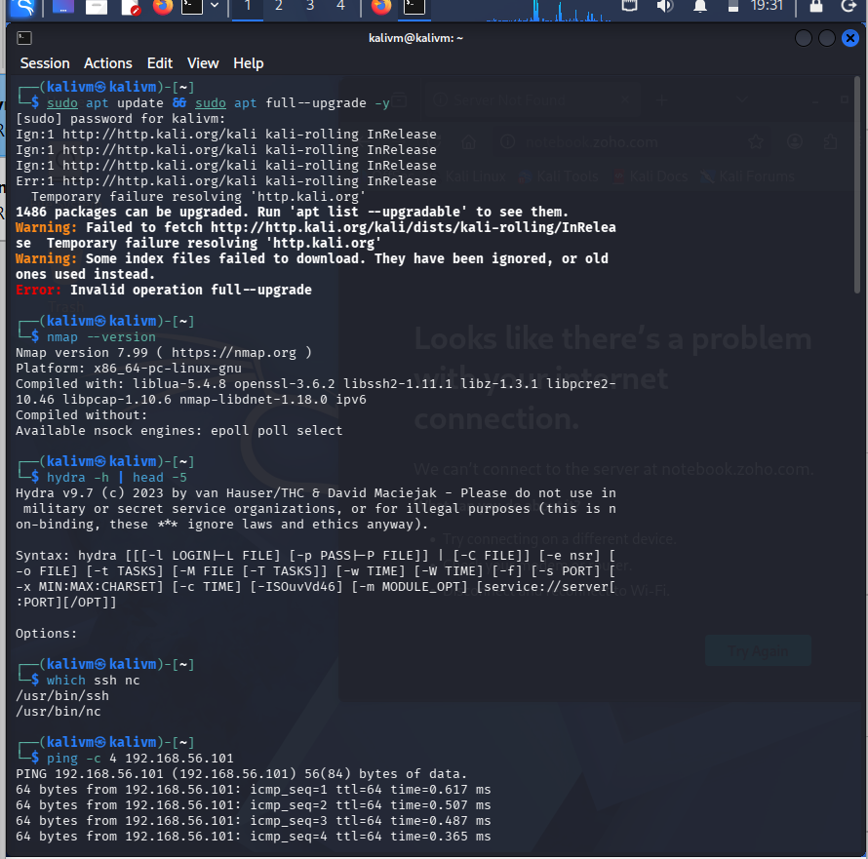
apt update failing on Kali — "Temporary failure resolving ’http.kali.org’."
A NAT adapter hiccup, apparently, because after some interface poking it sorted itself out and ping 8.8.8.8 started working again. Networking gremlins — sometimes the fix really is just "check again in a bit."
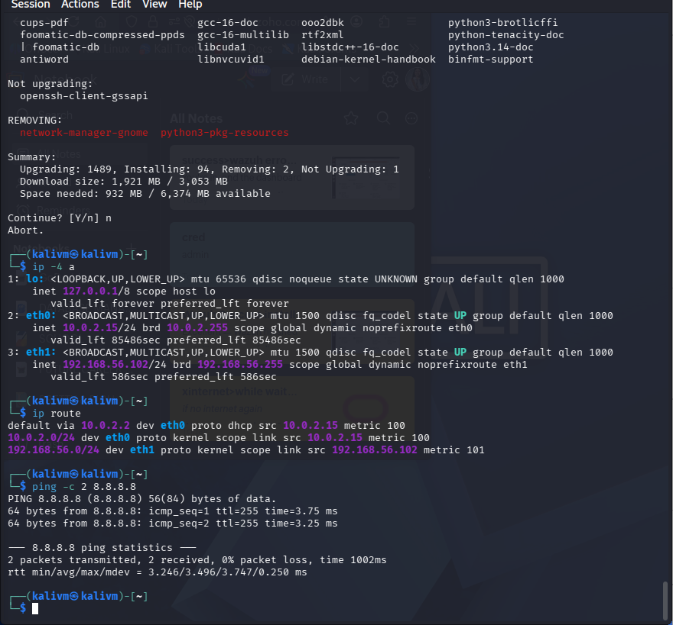
Kali’s network fully recovered — both interfaces up, default route present, internet reachable again.

Step 8: Finally, the Actual Attack
With everything working, here’s the fun part. From Kali: a manual SSH attempt with the wrong password a few times, and almost instantly, the Ubuntu alert log lit up.
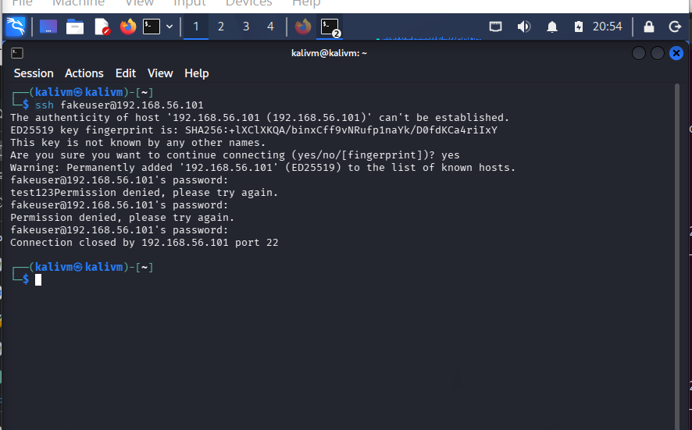
The SSH attempt from Kali, host-key prompt and all.
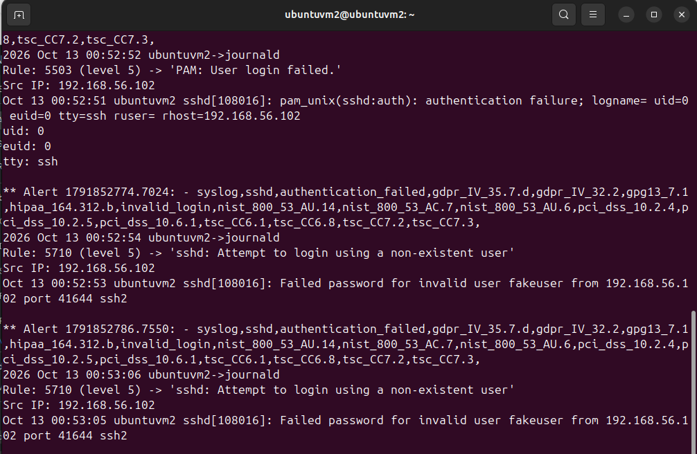
Rule 5710 — "sshd: Attempt to login using a non-existent user" — with Kali’s IP attributed correctly.
Then the real test — a Hydra brute-force with a tiny wordlist. First attempt failed because I’d forgotten my password file didn’t survive a reboot:
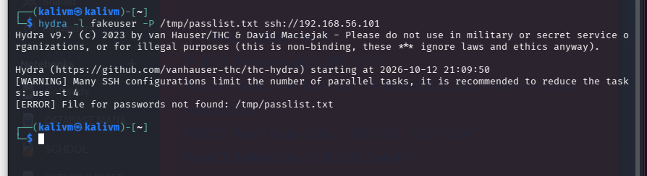
Hydra refusing to run — "File for passwords not found" — a quick reminder that /tmp doesn’t persist.
Recreated the wordlist and tried again — this time it ran clean.
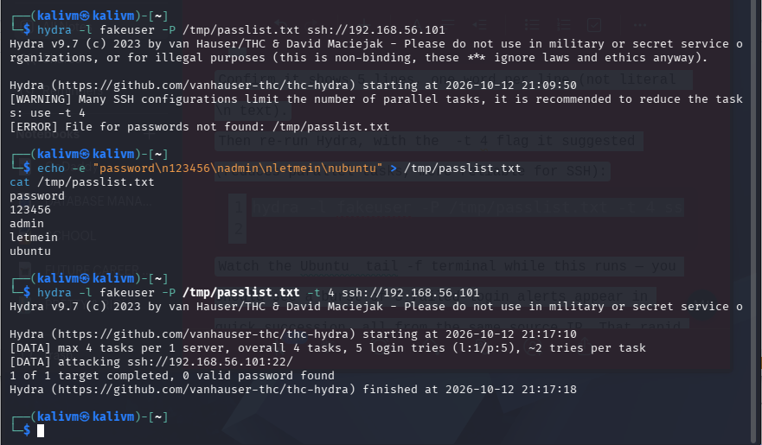
Hydra completing its run against the (intentionally fake) account — 5 tries, 0 valid passwords, as expected.
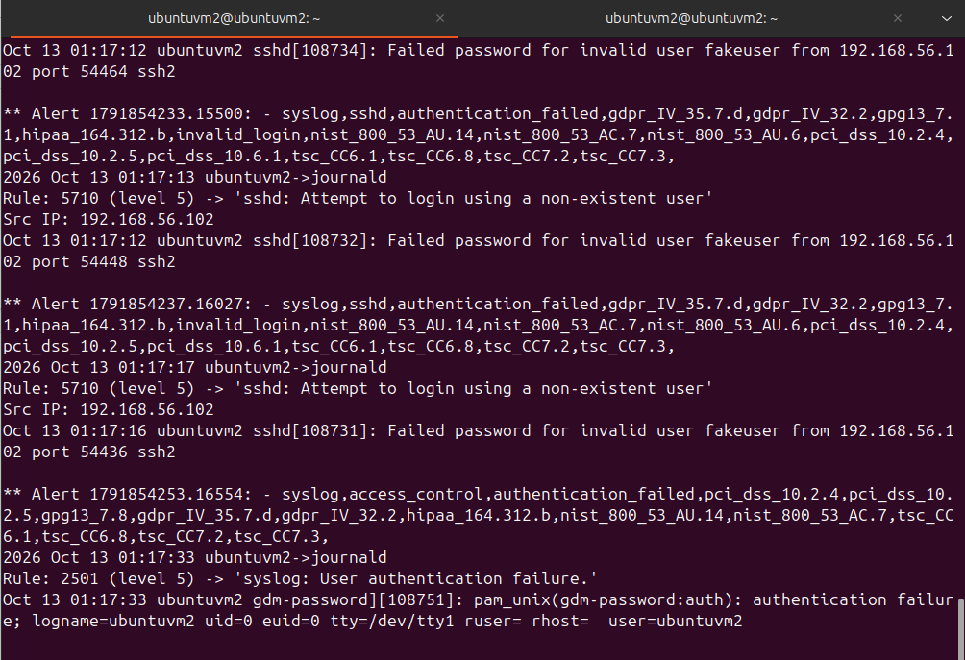
Same rule fired five times in a row, clustered within seconds — exactly the pattern that distinguishes "someone brute-forcing me" from "I fat-fingered my password once."
And for contrast, I logged in with the real password.
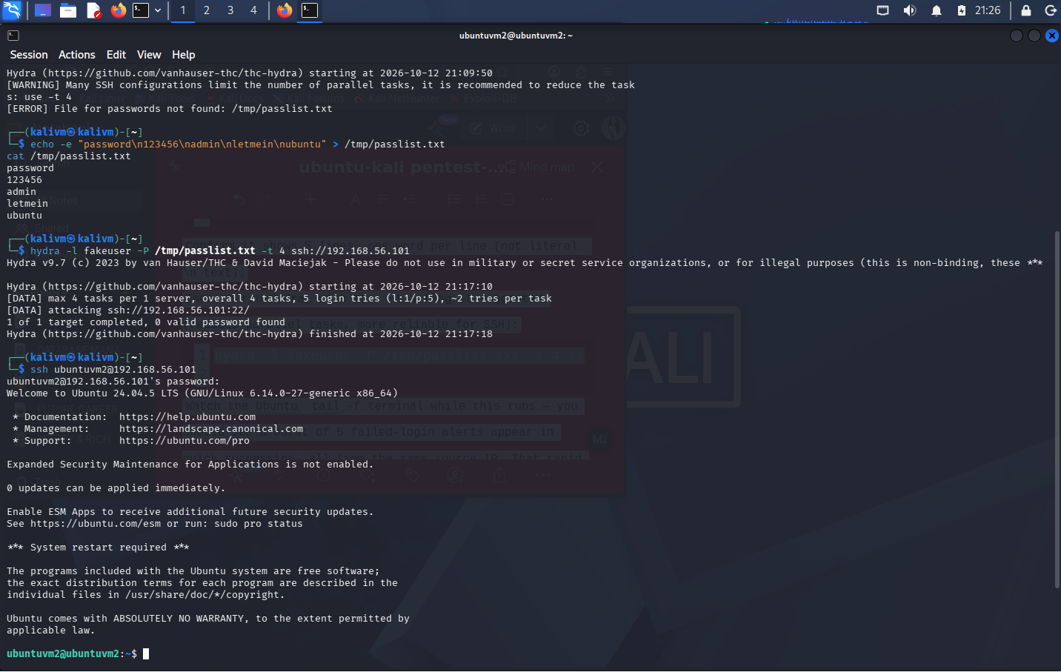
A legitimate SSH login with valid credentials, for comparison against the failed attempts above.
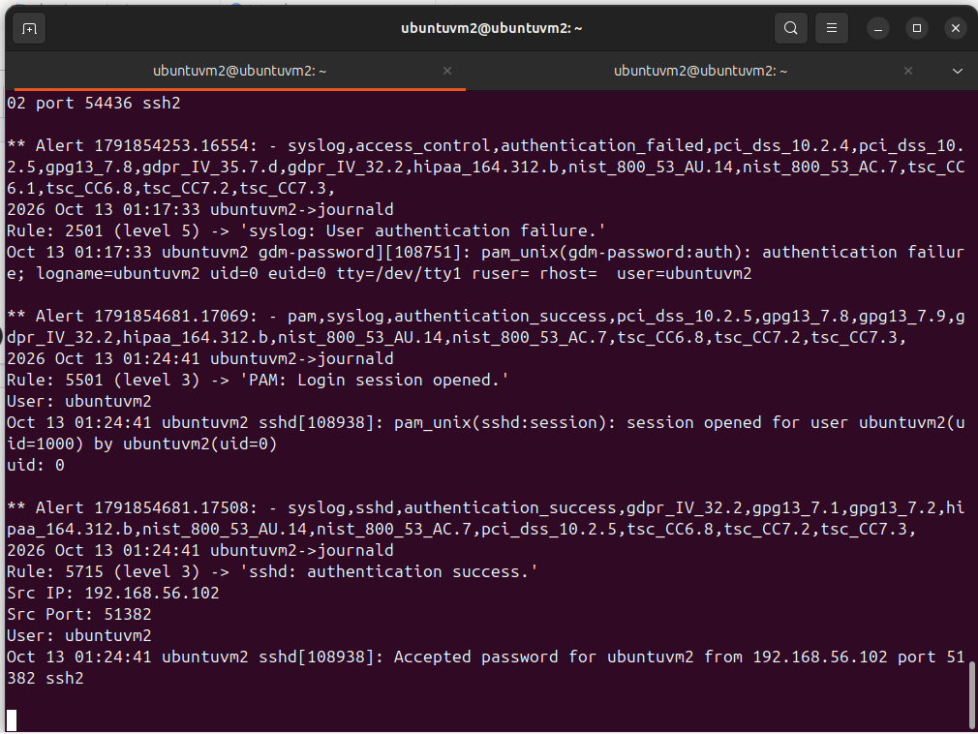
Rule 5715 — authentication_success — a different rule entirely, at a noticeably lower severity than the failed attempts.
That’s actually a neat detail: Wazuh treats failed logins against unknown usernames as more suspicious than successful ones, by design, even before you factor in volume or speed.

What I Actually Learned
Technically: how Wazuh’s local log collection works without a separate agent, how VirtualBox networking actually routes traffic, and how to read rule severity logic instead of just alert counts.
But honestly, the bigger lesson was about troubleshooting itself. Nearly every step had a hiccup — stale packages, disk space, missing routes, a package conflict I didn’t see coming — and every single one was solvable by reading the actual error message instead of guessing. That’s a very SOC-analyst skill in itself: don’t panic, read the output, fix the thing it’s actually telling you is broken.
Next up: adding a second machine as a real remote agent, and maybe writing a custom rule to auto-flag anything that looks like this Hydra pattern again.

