Detecting SSH Brute-Force Attacks with Wazuh in a Two-VM Lab
Rina S. Aranas | Aspiring SOC Analyst | portfolio.rinaaranas.site | github.com/thesunnymc

Objective
Build a self-contained home lab to practice the full detection lifecycle — from standing up a SIEM to generating and triaging real attack telemetry — using free, open-source tooling on commodity hardware.

Architecture
Component | Role | OS / Tooling
Ubuntu VM | Target + SIEM (all-in-one) | Ubuntu 24.04 LTS, Wazuh 4.14 (manager, indexer, dashboard)
Kali VM | Attacker | Kali Rolling, Nmap, Hydra, OpenSSH client
Both VMs run in Oracle VirtualBox on a host-only network (192.168.56.0/24), isolated from the internet, with a separate NAT adapter on each for package updates. This mirrors a common SOC lab pattern: an isolated segment for the target and detection stack, with controlled external access for maintenance only.
VM | Host-only IP | Resources
Ubuntu (server) | 192.168.56.101 | 8 GB RAM / 4 vCPU / 35 GB disk
Kali (attacker) | 192.168.56.102 | 4 GB RAM / 2 vCPU / 25 GB disk

Network Setup & Validation
Confirmed bidirectional reachability between both VMs via ICMP before introducing any detection tooling, to isolate network issues from application issues later.
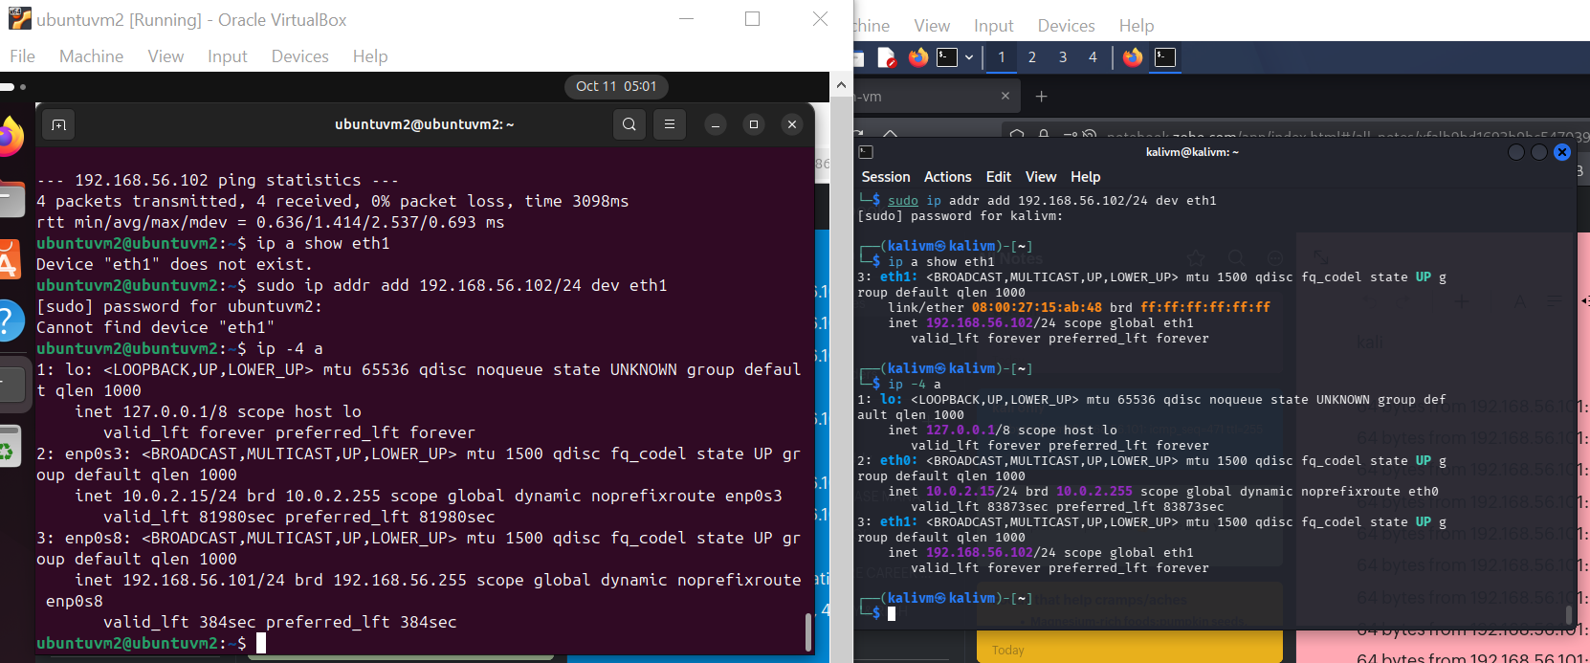
Figure 1 — Ubuntu and Kali terminals side by side, host-only interfaces configured and addressed.

Method
- Network validation — confirmed bidirectional reachability between both VMs via ICMP and TCP (port 22) before introducing any detection tooling.
- Wazuh deployment — installed the Wazuh all-in-one stack on Ubuntu using the official installation assistant (wazuh-install.sh -a), provisioning the manager, indexer, and dashboard on a single host.
- Self-monitoring configuration — verified that the Wazuh manager’s built-in localfile collectors (including journald) were already capturing authentication events on the host itself, without requiring a separate agent package.
- Baseline reconnaissance — ran an unauthenticated and version-detection Nmap scan from Kali against Ubuntu (nmap -Pn -sV -O).
- Single failed authentication — initiated one manual SSH login with an invalid username/password from Kali to confirm the detection pipeline end-to-end.
- Brute-force simulation — used Hydra with a small custom wordlist against the same invalid username to generate a clustered burst of failed-login events.
- Successful authentication — logged in with valid credentials to capture the contrasting "normal" signature.

SIEM Deployment
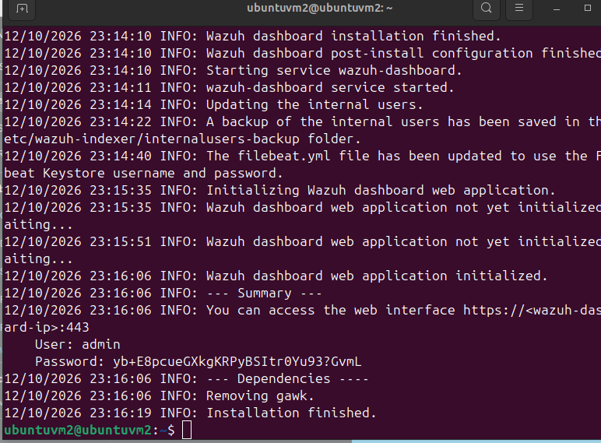
Figure 2 — Wazuh installation assistant completing the all-in-one install, with generated dashboard credentials.

Initial Dashboard State
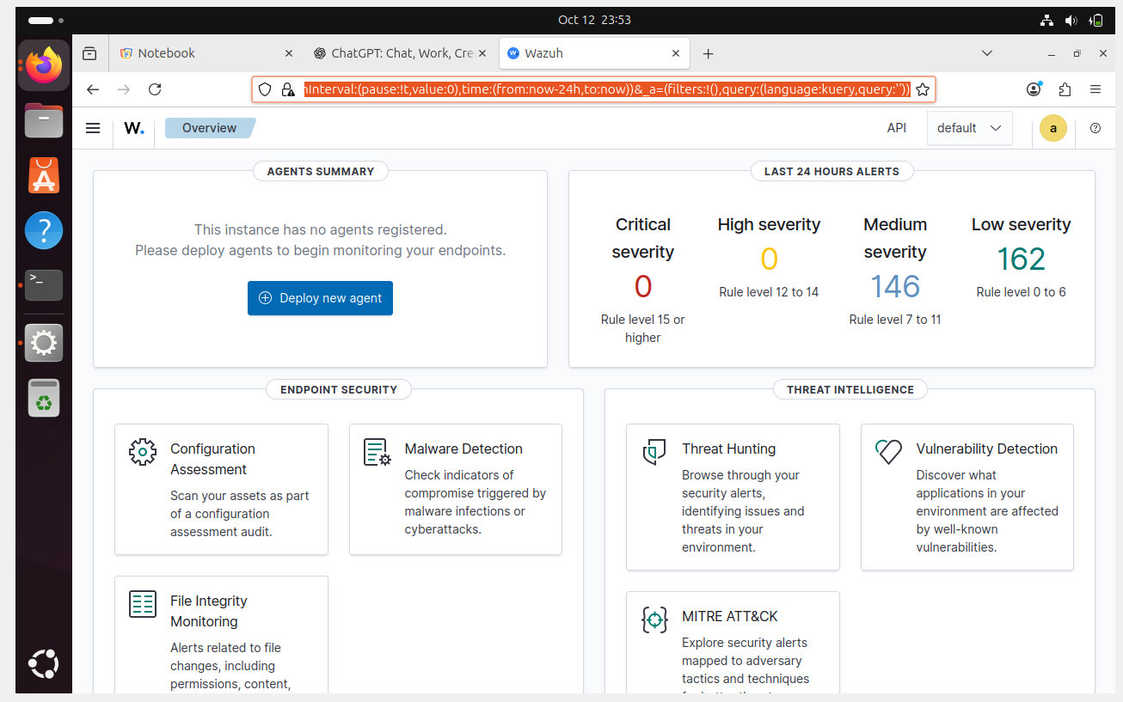
Figure 3 — Dashboard Overview immediately after install: no remote agents registered, baseline alert volume from internal auditing.

Self-Monitoring Verification
Rather than installing a separate wazuh-agent package (which conflicts with wazuh-manager on the same host), the manager’s own localfile collectors — including a journald source — were confirmed to be capturing system authentication events natively.
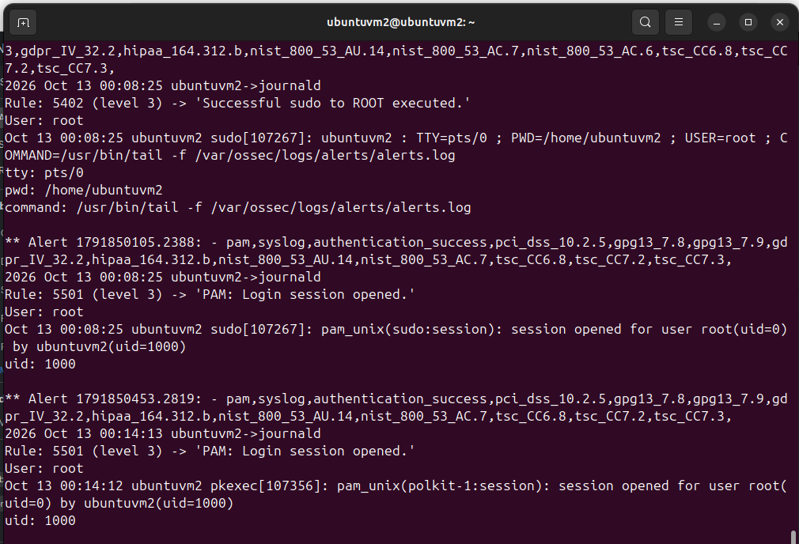
Figure 4 — Live-tailing /var/ossec/logs/alerts/alerts.log confirms the manager is ingesting its own PAM/sudo/journald events.

Detection Tests

Test 1 — Single Failed Login
A manual SSH attempt against a non-existent username from Kali, used to confirm the detection pipeline (journald → Wazuh manager → indexer → dashboard) end-to-end.
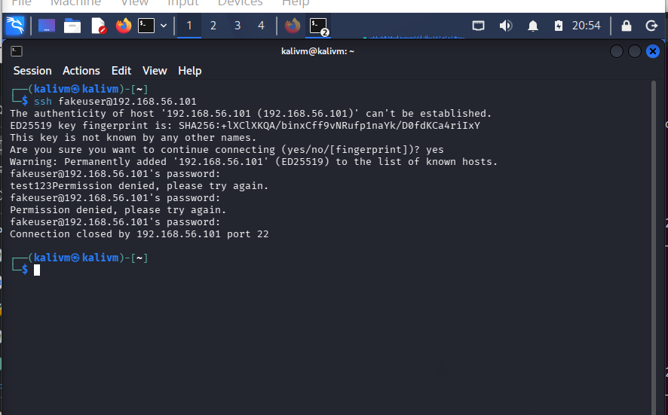
Figure 5 — SSH login attempt from Kali against 192.168.56.101 with an invalid username.
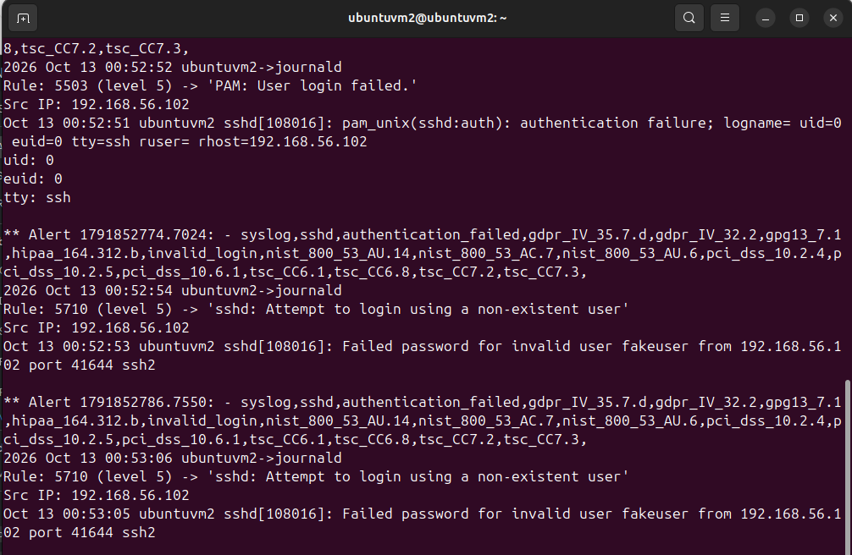
Figure 6 — Wazuh Rule 5710 (“sshd: Attempt to login using a non-existent user”) fires with the correct source IP attributed to Kali.

Test 2 — Brute-Force Simulation (Hydra)
Hydra was run against the same invalid username with a small custom wordlist to generate a clustered burst of failed logins, simulating a basic credential-guessing attack.
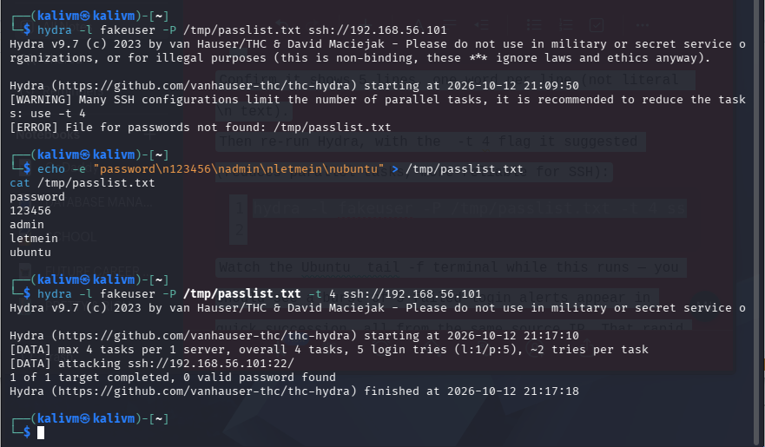
Figure 7 — Hydra completing its run: 5 login attempts, 0 valid passwords found (expected, since the account does not exist).
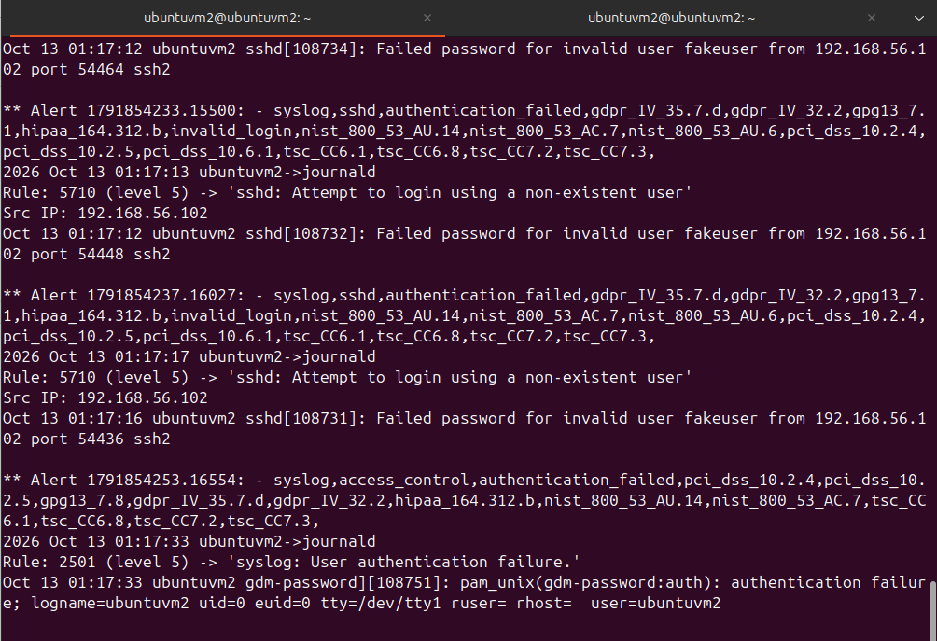
Figure 8 — The same Rule 5710 firing repeatedly in rapid succession, all attributed to the same source IP — the pattern that distinguishes brute-force from isolated login noise.

Test 3 — Successful Login (Contrast)
A legitimate login with valid credentials was captured for direct comparison against the failed/brute-force signatures above.
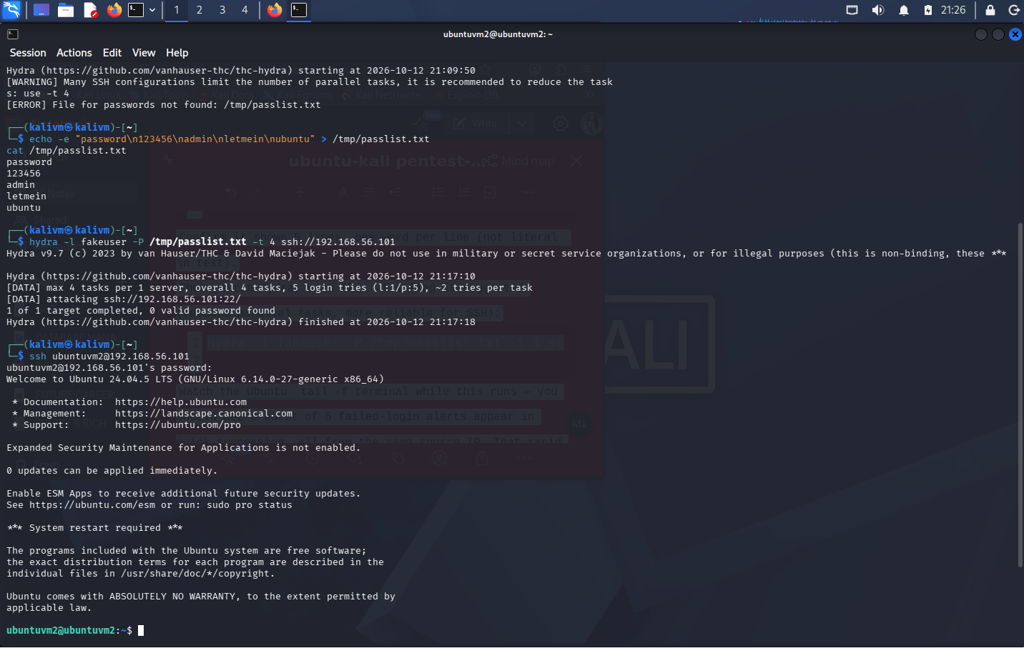
Figure 9 — Successful SSH authentication with valid credentials from Kali to Ubuntu.
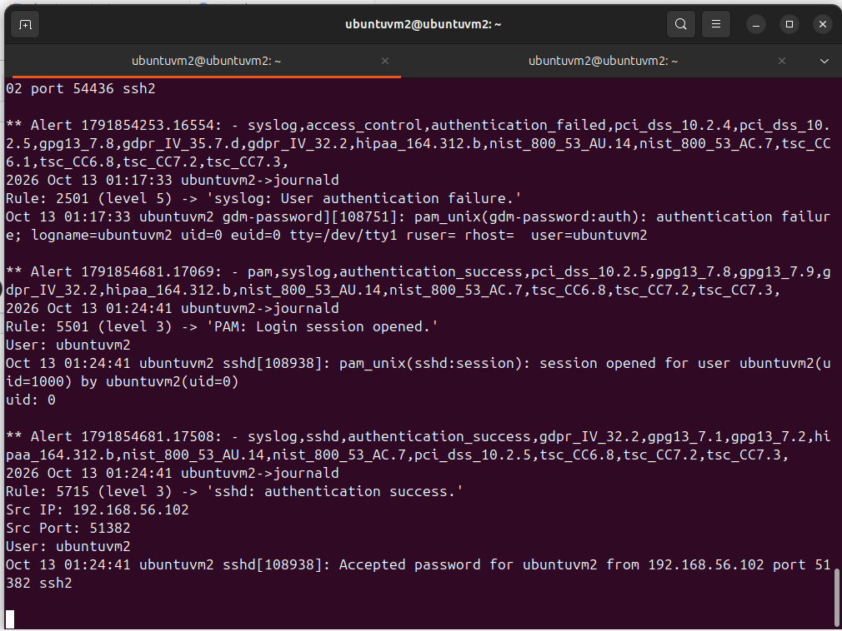
Figure 10 — Wazuh Rule 5715 (“sshd: authentication success”) — classified at a lower severity level than the failed-login rules above.

Results Summary
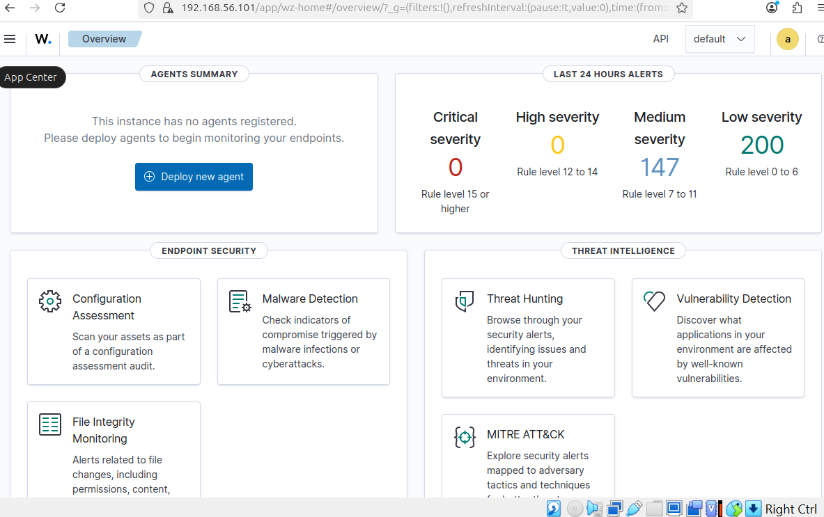
Figure 11 — Dashboard alert counters after all three tests, reflecting the cumulative detection activity.

Findings
Event | Wazuh Rule | Level | Classification
Failed login, non-existent user | 5710 | 5 | invalid_login
Failed login, generic | 5503 | 5 | authentication_failed
Successful login (valid user) | 5715 / 5501 | 3 | authentication_success
Key observation: Wazuh’s default ruleset assigns a higher severity (level 5) to failed logins against non-existent usernames than to successful logins (level 3). This reflects a deliberate detection design choice — attempts against unknown accounts are a stronger indicator of malicious reconnaissance or credential-guessing than routine authentication activity, even before any brute-force volume is considered. Each alert was automatically enriched with mappings to PCI-DSS, GDPR, HIPAA, and NIST 800-53 control references, supporting compliance-oriented triage.
The Hydra run against the dashboard’s alert counters showed a measurable, attributable increase in low-severity events, all correlated to the same source IP (192.168.56.102) within a narrow time window — the kind of clustering a SOC analyst would use to distinguish a brute-force attempt from isolated login noise.

Troubleshooting Log
Real environments rarely cooperate on the first try. Documenting failure points is as much a part of this exercise as the detection itself:
- Stale APT package index caused an initial openssh-server install to fail with 404 Not Found against a mirror; resolved with apt update before retrying.
- Disk undersized for a comfortable Wazuh install — resized the Ubuntu virtual disk from 25 GB to 35 GB via VBoxManage modifymedium --resize, then extended the guest partition in-place with growpart and resize2fs, with zero data loss or reboot required.
- Kali NAT adapter lost its default route after reconfiguration, producing "network unreachable" on outbound pings — diagnosed via ip route (no default via entry) and resolved at the VirtualBox adapter level.
- wazuh-agent package conflict — attempted to install a standalone agent on the Wazuh server itself for local monitoring, which dpkg correctly rejected as conflicting with the installed wazuh-manager package. Root cause: the manager already ships its own local log-collection daemons, so a separate agent is neither needed nor supported on the same host.
Each of these was root-caused using the tool’s own diagnostic output (dpkg conflict messages, ip route, df -h) rather than guesswork — a habit directly transferable to SOC triage work.

Skills Demonstrated
- Linux system administration (disk/partition management, systemd/journald, package management)
- Network troubleshooting (routing, NAT vs. host-only adapters, TCP/ICMP diagnostics)
- SIEM deployment and configuration (Wazuh manager, indexer, dashboard)
- Offensive tooling for defensive validation (Nmap, Hydra)
- Log analysis and alert triage, including severity/rule-logic interpretation
- Clear technical documentation of both successes and failure points

Next Steps
- Add a second monitored endpoint (Windows or additional Linux host) as a true remote Wazuh agent
- Build custom detection rules for failed-login thresholds (active response / auto-block)
- Map observed alerts to MITRE ATT&CK techniques using Wazuh’s built-in module
- Extend the wordlist and test against a hardened SSH configuration (key-only auth, fail2ban) to compare detection behavior

