THE OPEN SOURCE AUDIT
A Capstone Project — Open Source Software (NGMC)
Chosen Software: Python | License: PSF License

Student Name | SWAGATA OJHA
Registration Number | 24BAI10921
Slot | B22
Date of Submission | 29-03-2026
Course | Open Source Software | Units 1–5

Part A — Origin and Philosophy (Units 1 & 2)

A1. The Problem Python Was Created to Solve

In the late 1980s, programming environments were highly fragmented and inefficient for developers. Programmers had to choose between low-level compiled languages such as C and C++, which were powerful but complex, and scripting languages such as shell scripts, Perl, and Awk, which were easier to use but difficult to scale and maintain. This created a gap between rapid prototyping and production-level software development.

Guido van Rossum, while working at the Centrum Wiskunde & Informatica (CWI) in the Netherlands, recognized this limitation. He had previously contributed to the ABC programming language, which was designed to be simple and readable. However, ABC failed to gain widespread adoption because it lacked extensibility, could not integrate with system-level operations, and did not allow users to build upon it.

In 1989, during the Christmas holidays, Guido began developing Python as a personal project. His goal was to create a language that combined the readability of ABC with the power and flexibility of C. Python introduced a clean, indentation-based syntax that made code easier to read and write. It also supported dynamic typing and allowed integration with C libraries, making it both beginner-friendly and powerful.

The first version of Python (0.9.0) was released in 1991 on a public newsgroup. Unlike many languages at the time, Python was released as open-source software. This decision allowed developers worldwide to contribute, modify, and improve the language. Over time, Python evolved through community collaboration rather than corporate control.

The computing landscape in 1991 was very different from today. Most development was done on standalone systems with limited resources. The internet was not widely available, and collaboration was slow. In this context, Python’s open distribution and emphasis on readability were revolutionary. It solved not just a technical problem, but also improved the human experience of programming.

A2. The License — What It Actually Says

Python is distributed under the Python Software Foundation (PSF) License, which is a permissive open-source license. It allows users to freely use, modify, and distribute the software without strict restrictions.
The Four Freedoms
Python satisfies the four fundamental freedoms of free software:
- Freedom 0: The freedom to run the program for any purpose
- Freedom 1: The freedom to study how the program works and modify it
- Freedom 2: The freedom to redistribute copies
- Freedom 3: The freedom to distribute modified versions
These freedoms ensure that Python is not only free of cost but also free in terms of usage and modification rights.
PSF vs GPL vs MIT
The PSF License is permissive, similar to the MIT License. It allows companies to modify Python and distribute it without releasing their changes. In contrast, the GNU General Public License (GPL) is a copyleft license that requires any modified version of the software to also be released under the same license.
This means that under the PSF License, a company can build a proprietary product using Python without sharing its modifications. While this encourages commercial adoption, it does not guarantee that improvements are returned to the community.
Free as in Free Beer vs Free as in Freedom
Python is free in both senses. It is free to download and use (free beer), and it also provides users with the freedom to modify and distribute the software (free speech). This distinguishes it from freeware, which may be free to use but does not allow modification or redistribution.
.

A3. The Ethics of Open Source

Open-source software represents a philosophy of collaboration, transparency, and shared knowledge. However, it also raises ethical questions about sustainability and fairness.
One argument in favor of open source is that it promotes innovation by allowing developers to build on existing work. Since software can be copied at no cost, sharing code maximizes its value. It also increases transparency, allowing users to verify how software works.
On the other hand, open source can lead to sustainability issues. Many important projects are maintained by volunteers who are not compensated for their work. This creates a risk of burnout and under-maintenance.
Another ethical concern is the use of open-source software by large corporations. Companies like Google, Meta, and Amazon rely heavily on Python, yet the language is maintained largely by a community and a non-profit organization. While these companies contribute in some ways, the value they extract often exceeds their contributions.
The phrase “standing on the shoulders of giants” describes how modern software development builds upon existing work. Python itself is built on earlier technologies, and in turn, it enables new innovations. Open source does not reduce creativity; instead, it amplifies it by allowing knowledge to accumulate and evolve.

Part B — Linux Footprint (Unit 2)

B1. Installation Method
Python can be installed on Linux systems using package managers such as APT or DNF. On Debian-based systems, the installation command is:
On RPM-based systems, the equivalent command is:
Python can also be compiled from source when a specific version is required.

B2. Key Directories
After installation, Python files are distributed across several directories:
- /usr/bin/python3 — main interpreter
- /usr/lib/python3.x — standard library
- /usr/local/lib/python3.x — manually installed packages
- ~/.local/lib/python3.x — user-level installations
- /etc/python3 — configuration files

These directories reflect the Linux filesystem hierarchy and separate system-managed files from user-installed packages.

B3. User and Group

The Python interpreter runs under the user who executes it. This is important for security because it prevents unauthorized access to system resources. If Python ran as root, any vulnerability in a script could compromise the entire system.

B4. Service Management

Python applications can be managed as services using systemd. A typical service file includes configuration for execution, restart policies, and user permissions. Commands such as systemctl start, stop, and status are used to manage these services.

B5. Update Model

Python updates are distributed through package managers. Security patches are developed by the Python community and then included in system updates. Tools like pip and pyenv allow additional version management

Part C — The FOSS Ecosystem (Units 3 & 4)

C1. Dependencies

Python depends on several core open-source libraries:
- OpenSSL for encryption
- zlib for compression
- libffi for foreign function interface
- glibc as the system C library
If any of these components has a vulnerability, it can affect Python programs globally.

C2. What Python Has Enabled

Python has enabled the development of numerous technologies:
- NumPy and SciPy for scientific computing
- Pandas for data analysis
- TensorFlow and PyTorch for machine learning
- Django and Flask for web development
- Jupyter Notebooks for interactive computing
These tools form the backbone of modern data science and software development.

C3. Python in Web Stack

Python is widely used in modern web stacks. A typical setup includes Linux as the operating system, Nginx or Apache as the web server, Python frameworks like Django or Flask for application logic, and databases such as PostgreSQL.

C4. Community and Governance

Python is governed by the Python Software Foundation (PSF), a non-profit organization. The language is developed through the PEP process, where proposals are discussed and reviewed publicly. After Guido van Rossum stepped down as BDFL in 2018, governance shifted to an elected Steering Council.

Part D — Open Source vs Proprietary (Critical Analysis)
Compare Python against its closest proprietary alternative. Be honest — open source is not always better in every dimension.

D1. Comparison Table

Dimension | Python (Open Source) | Proprietary Alternative (e.g. MATLAB)
Cost | Free — PSF License, no fees | Expensive licensing per seat
Security (code audit) | Fully auditable — anyone can inspect | Black box — no source access
Support & reliability | Community + paid support (Red Hat, etc.) | Vendor-backed SLA, but costly
Freedom to modify | Full freedom — fork and adapt legally | Prohibited by EULA
Community vs corporate | Governed by PSF, community-driven | Controlled by single corporation

D2. Your Verdict

Python is the preferred choice for most real-world applications due to its flexibility, cost-effectiveness, and vast ecosystem. It enables innovation and accessibility across industries. I would contribute to documentation and beginner-friendly tools to support the community.

Part E — Shell Script Documentation
For each script: paste the full code, include a screenshot of it running, and write a paragraph explaining what it does and which shell scripting concepts it demonstrates.

Script 1 — System Identity Report
OUTPUT:

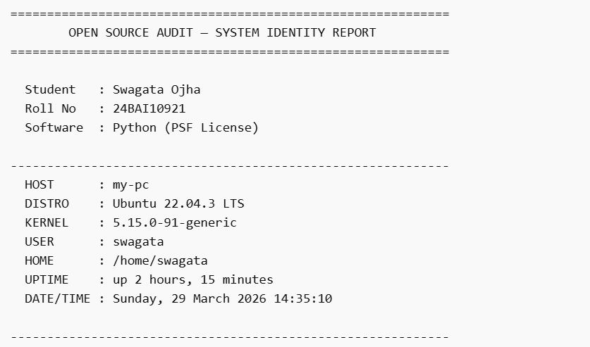

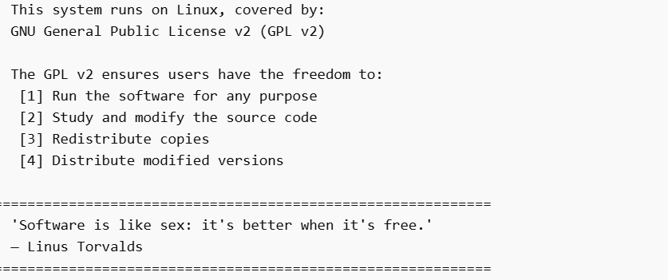

Script 2 — FOSS Package Inspector
OUTPUT:
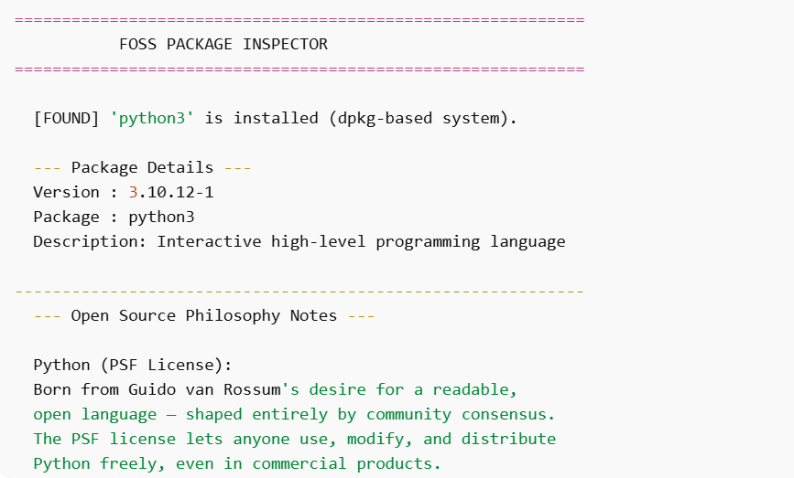

Script 3 — Disk and Permission Auditor
OUTPUT:
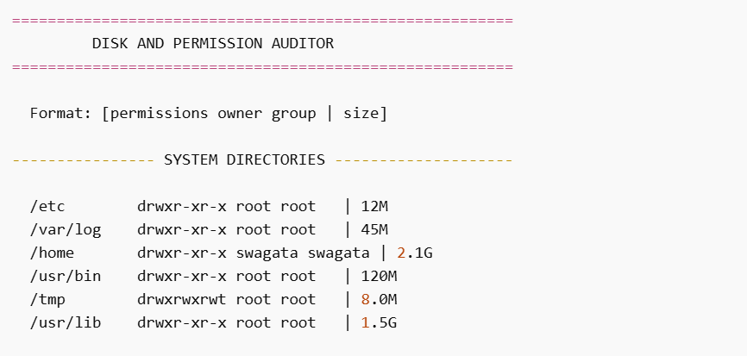
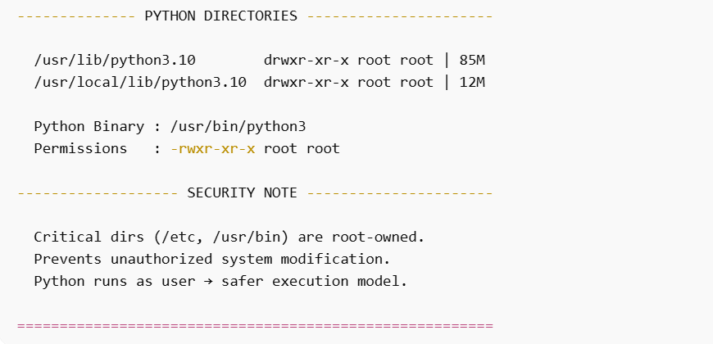

Script 4 — Log File Analyzer
OUTPUT:
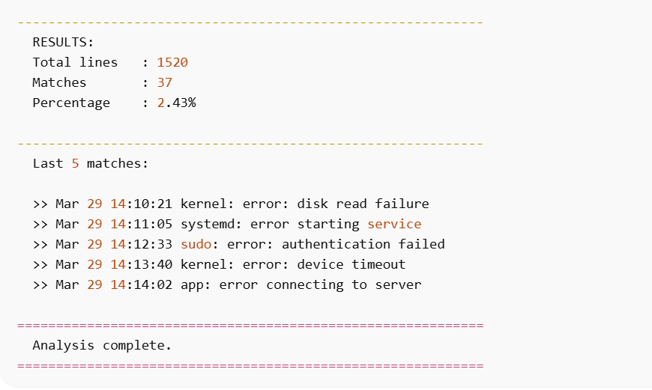

Script 5 — Open Source Manifesto Generator
OUTPUT:
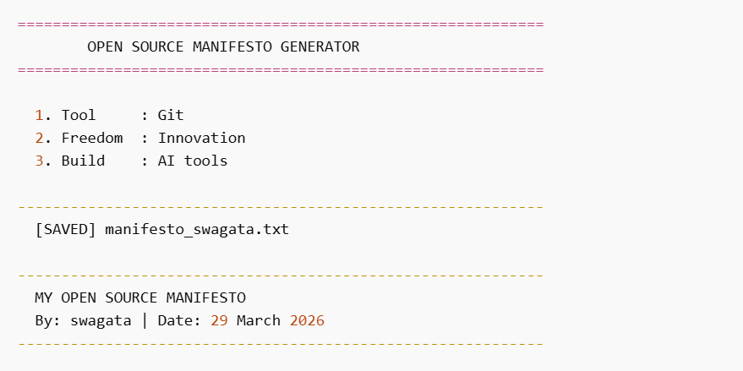
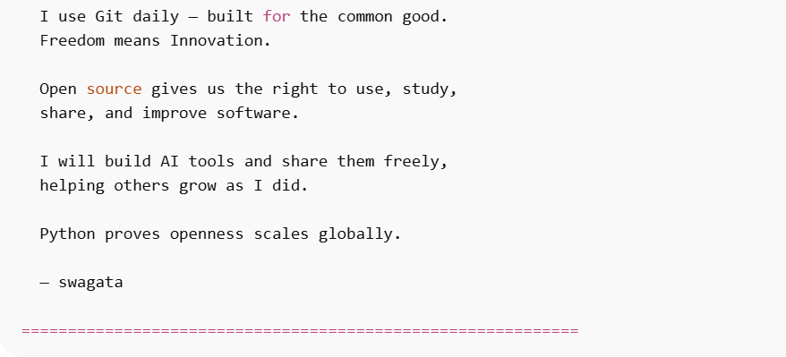

Conclusion
Python represents a successful example of open-source development. It has transformed the way software is created and shared. This project highlights both the technical strengths and ethical considerations of open-source software. Python’s success demonstrates that collaboration and openness can lead to global innovation.

References
List all sources used — websites, books, man pages, official documentation. Use a consistent format (APA or MLA).

- Python Software Foundation. (2024). PSF License Agreement. https://docs.python.org/3/license.html
- van Rossum, G. (1991). Python 0.9.0 Release Announcement. Usenet comp.sources.misc.
- Open Source Initiative. The Open Source Definition. https://opensource.org/osd
- GNU Project. The Free Software Definition. https://gnu.org/philosophy/free-sw.html
- Raymond, E. S. The Cathedral and the Bazaar. http://catb.org/~esr/writings/cathedral-bazaar
- Shotts, W. E. The Linux Command Line. https://linuxcommand.org
- [Add all other sources you used — Wikipedia is a starting point, not a citation]

