**Project 3: MESA Stellar Structure and Evolution**

**Keslie Babin, Trang Huynh**

**Background:**

In this lab we calculated the MESA evolution of a 1 and 15 solar mass star from zero age main sequence(ZAMS) to core He exhaustion in order to produce, for each model, an HR diagram, a plot of the evolution of central density versus central temperature, a Kippenhahn diagram, and fit an accurate polytropic model. We then will discuss the most prominent stages and evaluate a polytropic index for each model.

**Introduction:**

The process of stellar evolutions helps scientist to see how stars are born, how they age, and how they die over extremely large time scales. First, we copied the star/work directory from MESA and created our own file to run our data and produce our plots. We then edited the files: inlist, inlist_project, profiles_columns.list, history_columns.list, and inlist_pgstar for both a 1 solar mass star and 15 solar mass star from zero age main sequence (ZAMS) up to core He exhaustion. From these edits we were able to run our version of the code to produce an H-R diagram, a plot of the evolution of central density versus central temperature, and a Kippenhahn (KIPP) diagram for each star. Lastly, from this data we are able to calculate the polytropic index of both stars when the central hydrogen mass fraction drops below 0.6 using a program to fit a polytropic equation of state.

**Analysis:**

**Setting up the 1 and 15 solar mass evolution:**

We start by editing the “inlist_project” file within the copied MESA code. The

modifications made in the “&star_job” section was setting: “create_pre_main_sequence_model” to false, the “save_model_when_terminate” to true, the Save_model_filename to ‘15M_at_wd.mod’ or ‘1M_at_wd.mod’ for the 1 solar mass star, Change_net=true, New_net_name = ‘approx21.net’, and Pgstar_flag=true. Next we edited the “&controls” section within the same “inlist_project” file: We set the “initial_mass” for the 1 solar mass star to 1, and the 15 solar mass star to 15, next Set terminal_history = 50, and history_interval = 10.

**Producing the H-R plot:**

To show the H-R plot while running each code (1 solar mass and 15 solar mass)we went into the “inlist_pgstar” file and edited the “&pgstar” section: To show the plot we first set “HR_win_flag” to true and then set the boundaries for our plot, which can be shown in the code. To produce our actual H_R diagrams we imported our data from “LOGS” after running the codes and used the mesa_reader “MesaData” to use that data to produce the combined plot of both stars.

**Producing the evolution of central density versus central temperature plot:**

From the imported data from each star we are also able to produce plots for the evolution of central density versus central temperature. After importing the data, we simply plotted the central temperature data against the central density data for each star.

**Producing the Kipp diagram:**

To produce the Kippenhahn diagrams for each star we navigated to “pgstars.defaults” within MESA and found the section for producing the Kipp diagram and pasted these parameters in the “inlist_pgstar” section of our code. We then fixed the copied code to our specific parameters.

**Fitting the polytropic model:**

(include formulas for this part)

In the first step of fitting the polytropic model, we navigated to “&controls” within “inlist_project” under “when to stop” in the code we set the xa_central lower_limit_species(1) to ‘h1’ and the xa_central_lower limit(1) to 0.6. We next used the equation of state formula:

to find the polytropic index, n for each star model, as well as for a model for a white dwarf (final) phase of the 1 solar mass star model.

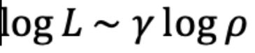

We did this by retrieving the profile data for each star, then defining an equation of state (EOS) function to produce a plot for each star.

**Discussion/Results:**

Figures 1 and 2 show the H-R Diagram plots produced by MESA when running the 1 solar mass and 15 solar mass evolution models.

Figure 1: MESA produced H-R Diagram for a 1 solar mass star.

Figure 2: MESA produced H-R Diagram for a 15 solar mass star.

Figures 3 and 4 show the TRho Profile plots that are also produced automatically by running the 1 solar mass and 15 solar mass evolution models.

Figure 3: TRho Profile plot for a 1 solar mass star. We can see on this plot that the mass of the He-core at the end of the H-core burning is 0.39 and the mass of the CO-core at the end of the He-core burning is 0.0 because the 1 solar mass star did not reach the helium core burning phase.

Figure 4: TRho Profile plot for a 15 solar mass star. We can see on this plot that the mass of the He-core at the end of the H-core burning is 4.76 and the mass of the CO-core at the end of the He-core burning is 2.75.

Figure 5 shows the H_R diagram produced using MESA reader.

Figure 5: Calculated H-R Diagram for 1 and 15 solar mass stars. For the 1M model, the luminosity increases significantly as its temperature decreases. For the 15M model, the temperature decreases significantly while its luminosity slightly changes.

Figures 6 and 7 show the plots of the evolution of central density vs central temperature for each model.

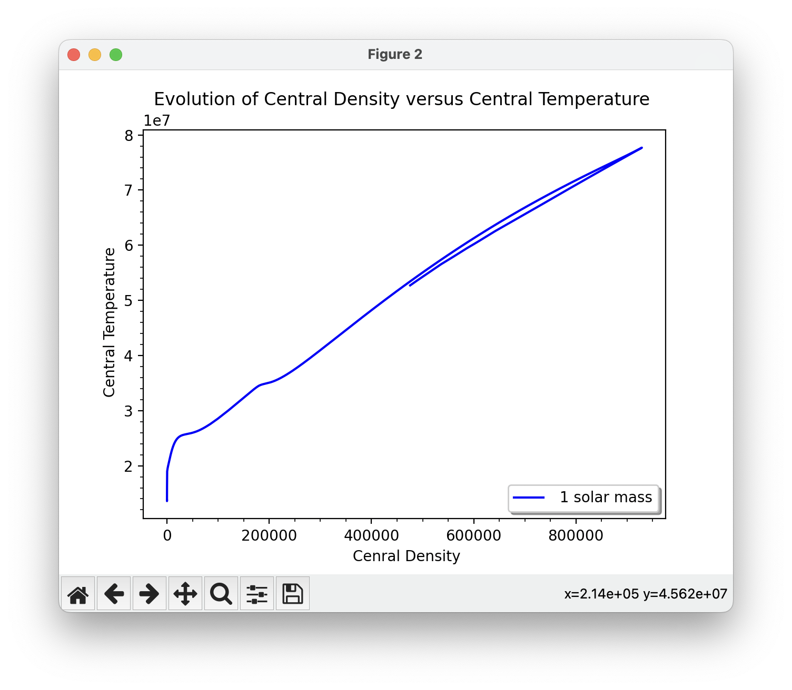

Figure 6: Evolution of central density vs central temperature for a 1 solar mass star.

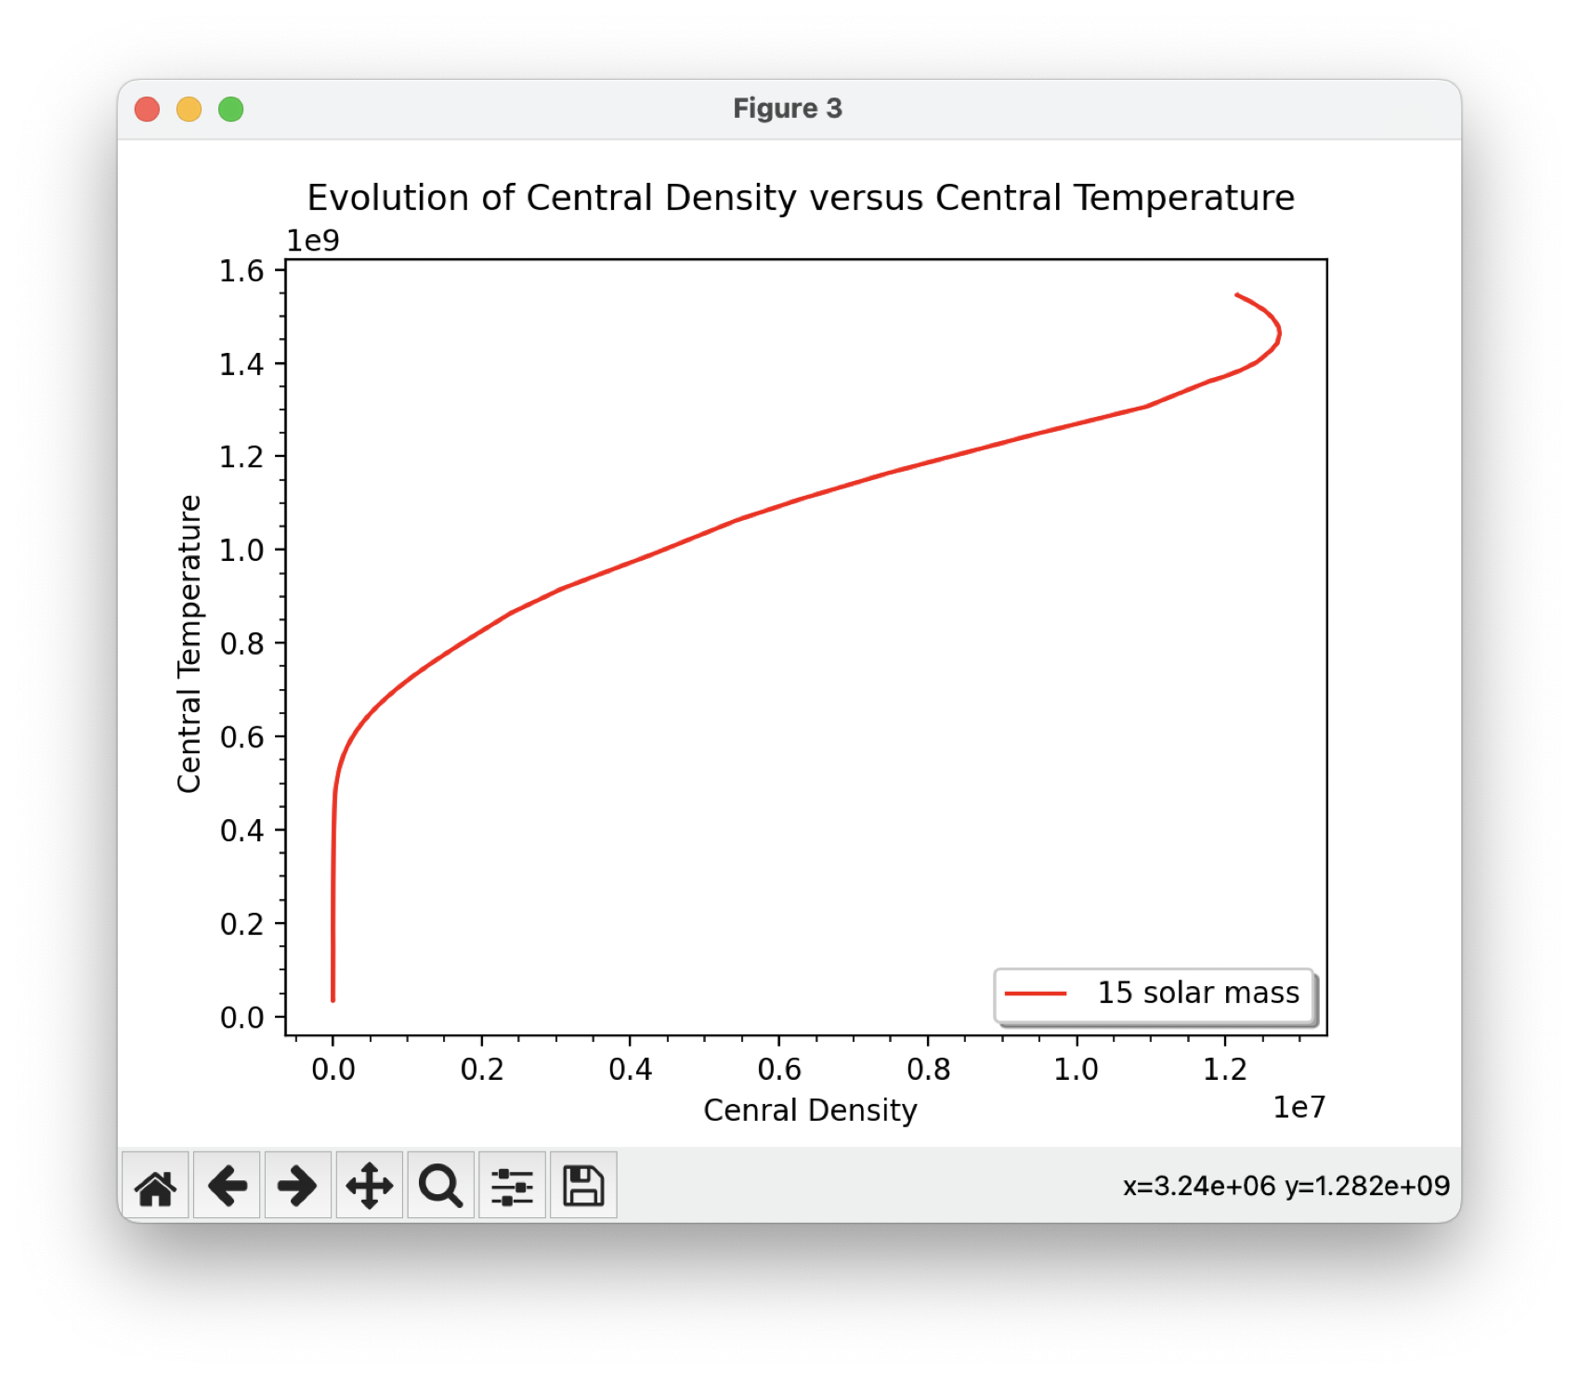

Figure 7: Evolution of central density vs central temperature for a 15 solar mass star. The 15 solar mass star reaches conditions of degeneracy when the mass of the Helium core reaches 8% the mass of the star. Because the density is so high, the core can no longer act as a perfect gas.

Figures 8 and 9 show the Kippenhahn diagrams for each model.

Figure 8: Kipp diagram for 1 solar mass star

Figure 9:Kipp diagram for 15 solar mass star

Figures 10, 11, and 12 show the equation of state (EOS) diagrams for each model.

Figure 10: EOS for 1 solar mass star. For this model the polytropic index n= -0.448+/-0.002 while  (gamma)=-1.232+/-0.014

Figure 11: EOS for 15 solar mass star. For this model the polytropic index n= -0.459+/-0.001 while  (gamma)=-1.179+/-0.006

Figure 12: EOS of a 1 solar mass star at white dwarf stage. For this model the polytropic index n=-1.884+/-0.027 while  (gamma)=0.469+/-0.007