1. Regression with Polynomial Basis Functions

C.

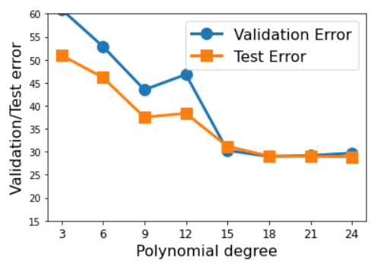

D.

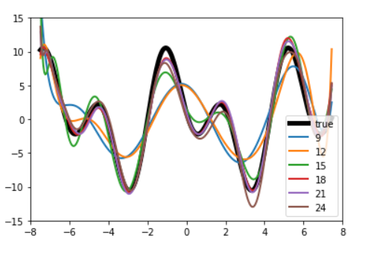

Discussion: **Polynomial degree 18** is the best value for line as it follows true line closely. Also has the least test and validation error.

1. Regression with Radial Basis Functions

C.

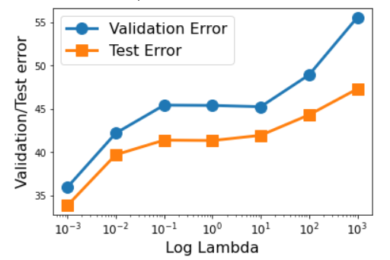

D.

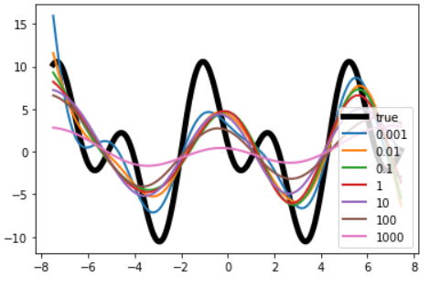

Discussion: **0.001 lambda** value seems the best fit out of other lambda values as it is not too close to overfit the model and not too far to underfit the model.