Problem 1. Slide_disp.m returns slide displacement which along with secant.m is used in dwell_width.m to calculate dwell width. But none of my value in secant is converging.

Problem 2.

Starting with the second-order Taylor's series approximation of f(x) around the point x = xn + δ:

To find the root of the equation f(x) = 0 using Halley's method, we use the following iterative formula:

where g(x) is an approximation of f(x)/f'(x) that improves the convergence of the iteration. We can use the second-order Taylor's series to derive g(x):

\begin{aligned}

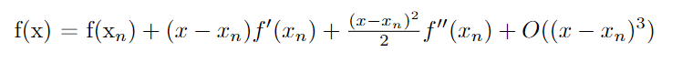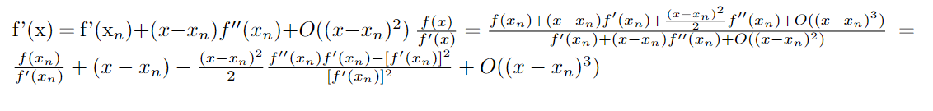Substituting this expression for g(x) into Halley's formula, we get:

where

