1. Create a free aws account by clicking on "Create Free Account" http://aws.amazon.com
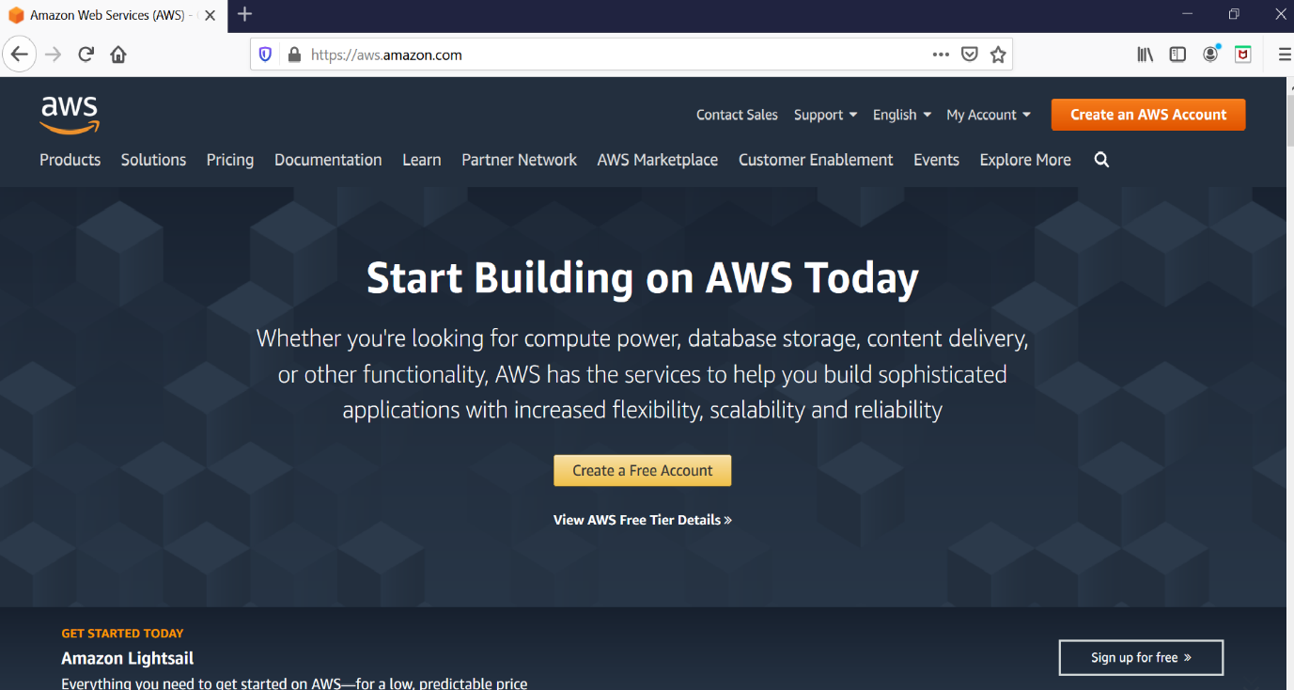

2. Fill your details to create an account. Details required are Email address and account name of your choice.
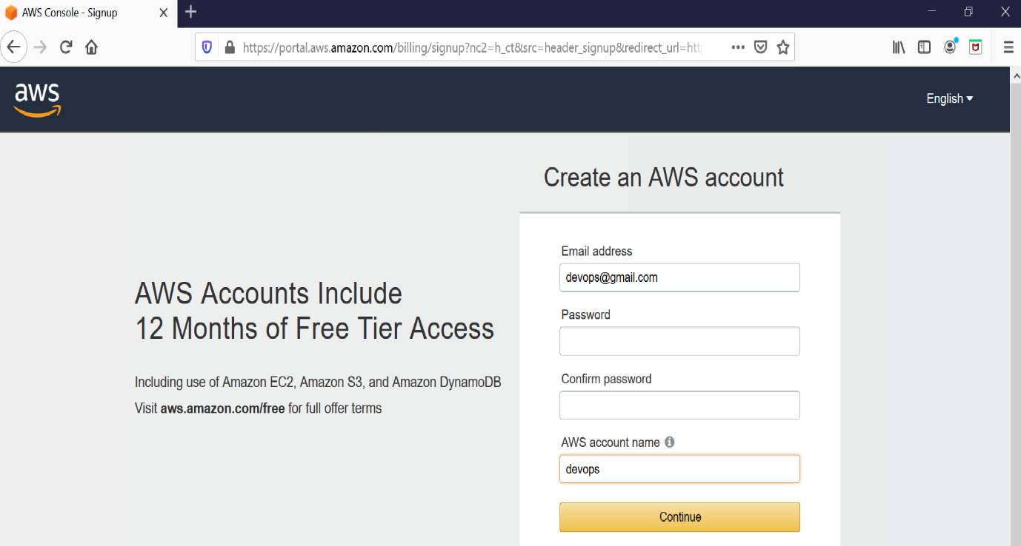

3. After submitting the data you will be taken to SignUp form which requires more details.
Select Account Type as `Personal`.Your address and Mobile number. (Need to provide a valid mobile number, You will receive a call in further setup)

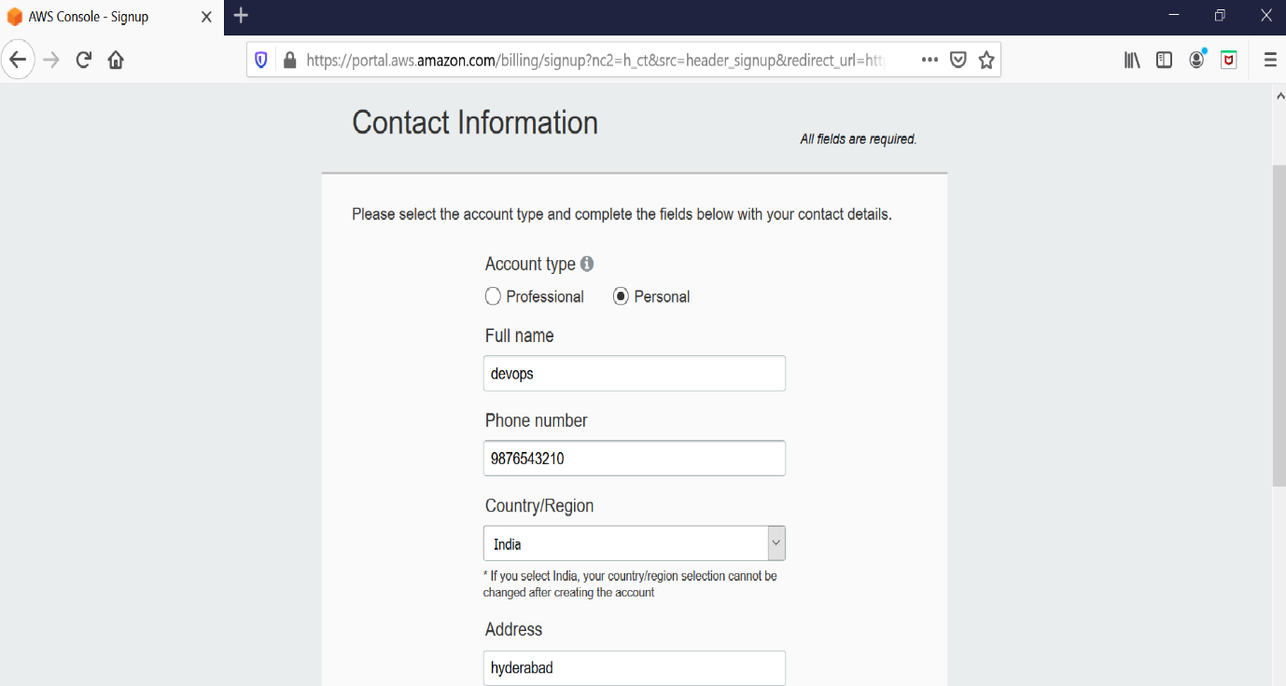

4. Next you will be prompt to provide the credit card details. So proceed by providing the details.
Provide credit/debit card details.
Select PAN number as NO

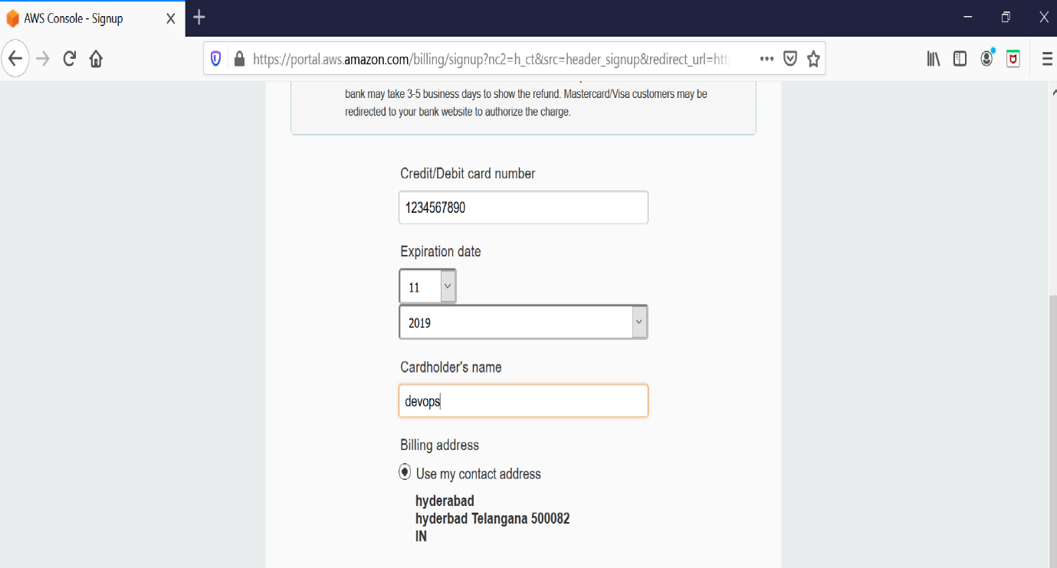

5. You will be redirected to your bank payment portal to provide OTP and after that select the plan as Basic.

6. Once your account is completed use the following link
https://aws.amazon.com/console/ and sign in to the console.

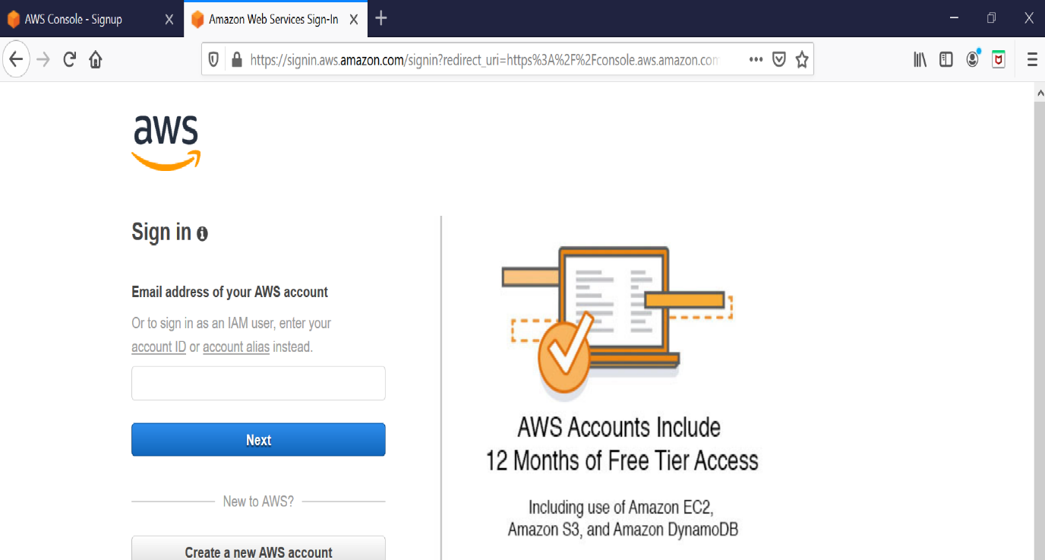

7. In the search box, search EC2 and click on it.
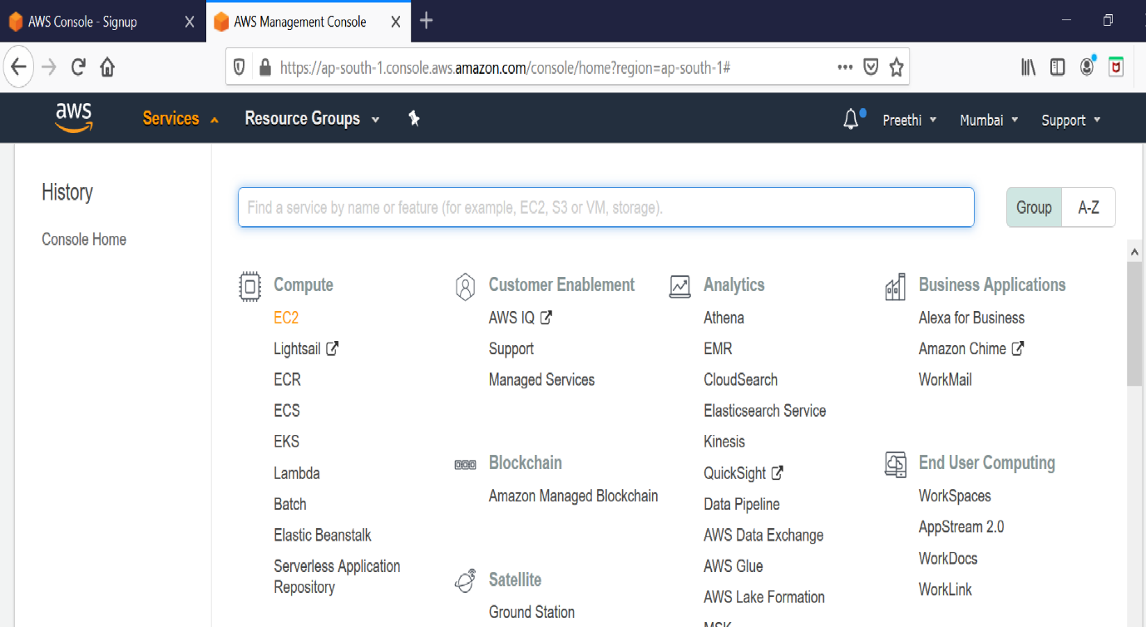
8. Click on launch Instance.
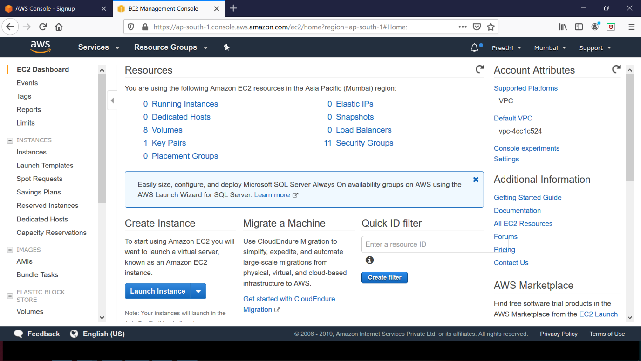
9. Select “Amazon Linux 2 AMI”
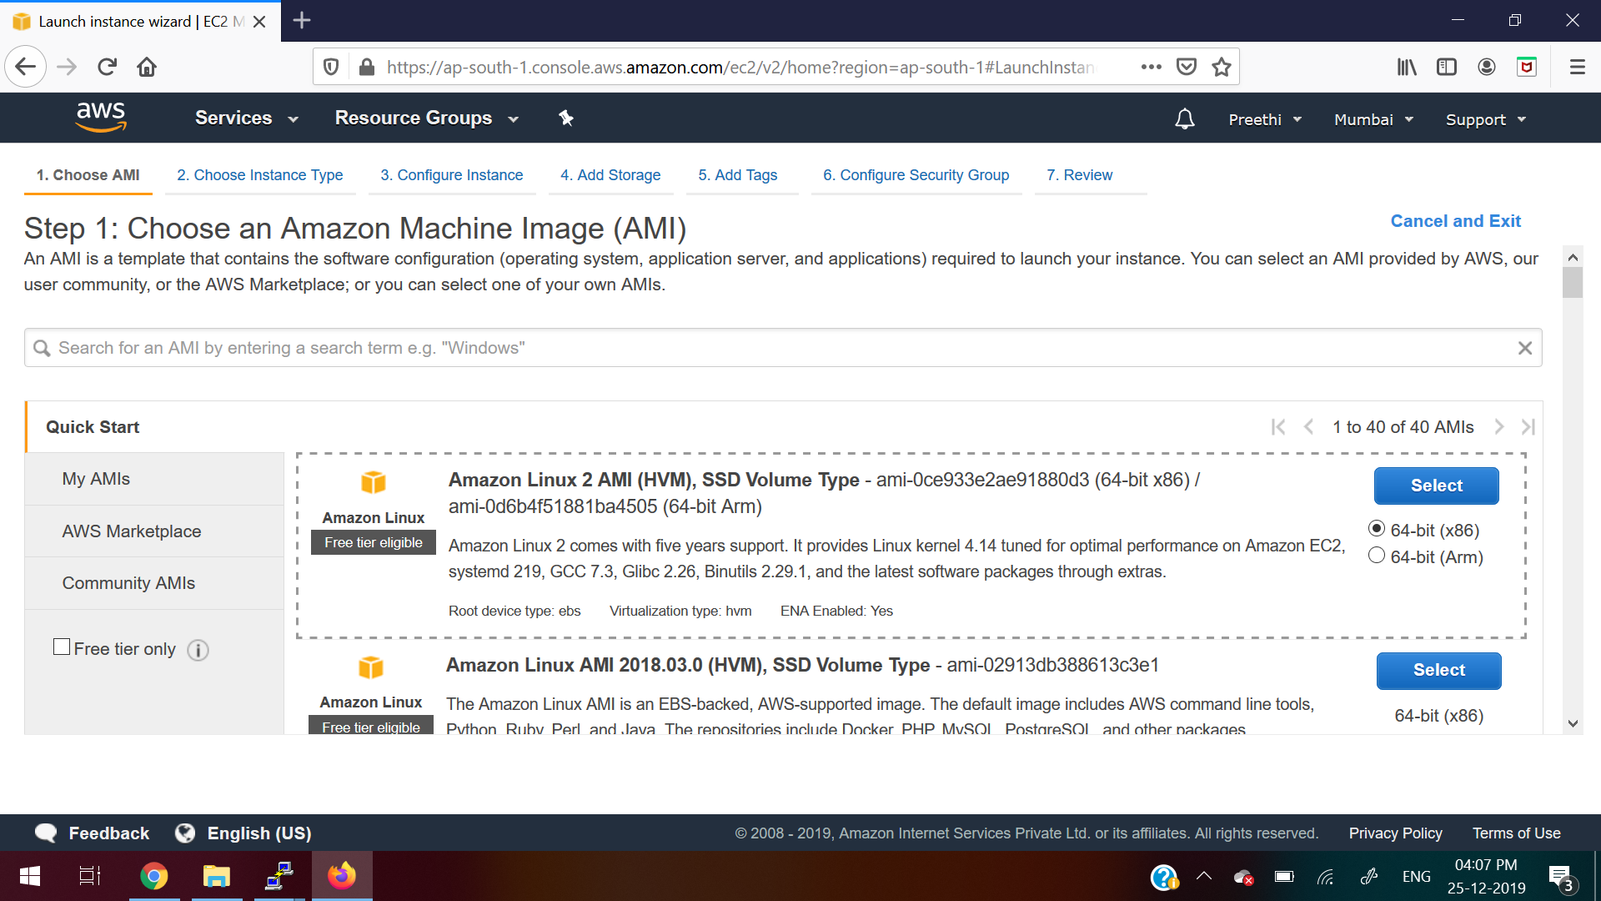
10. Keep it as default (Don’t do any changes)
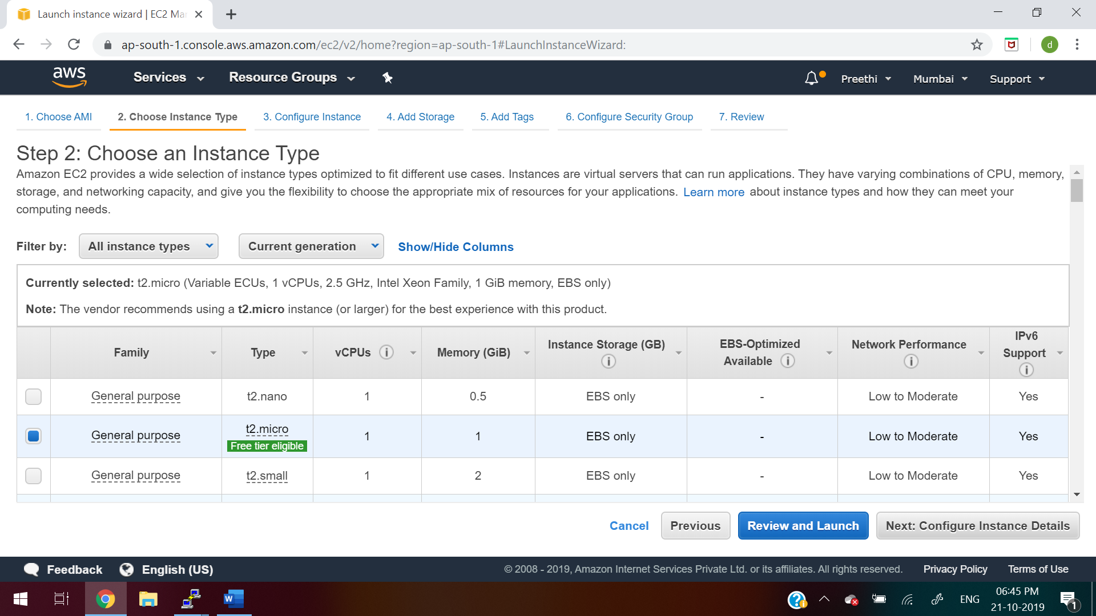
11. Keep it as default (Don’t do any changes)
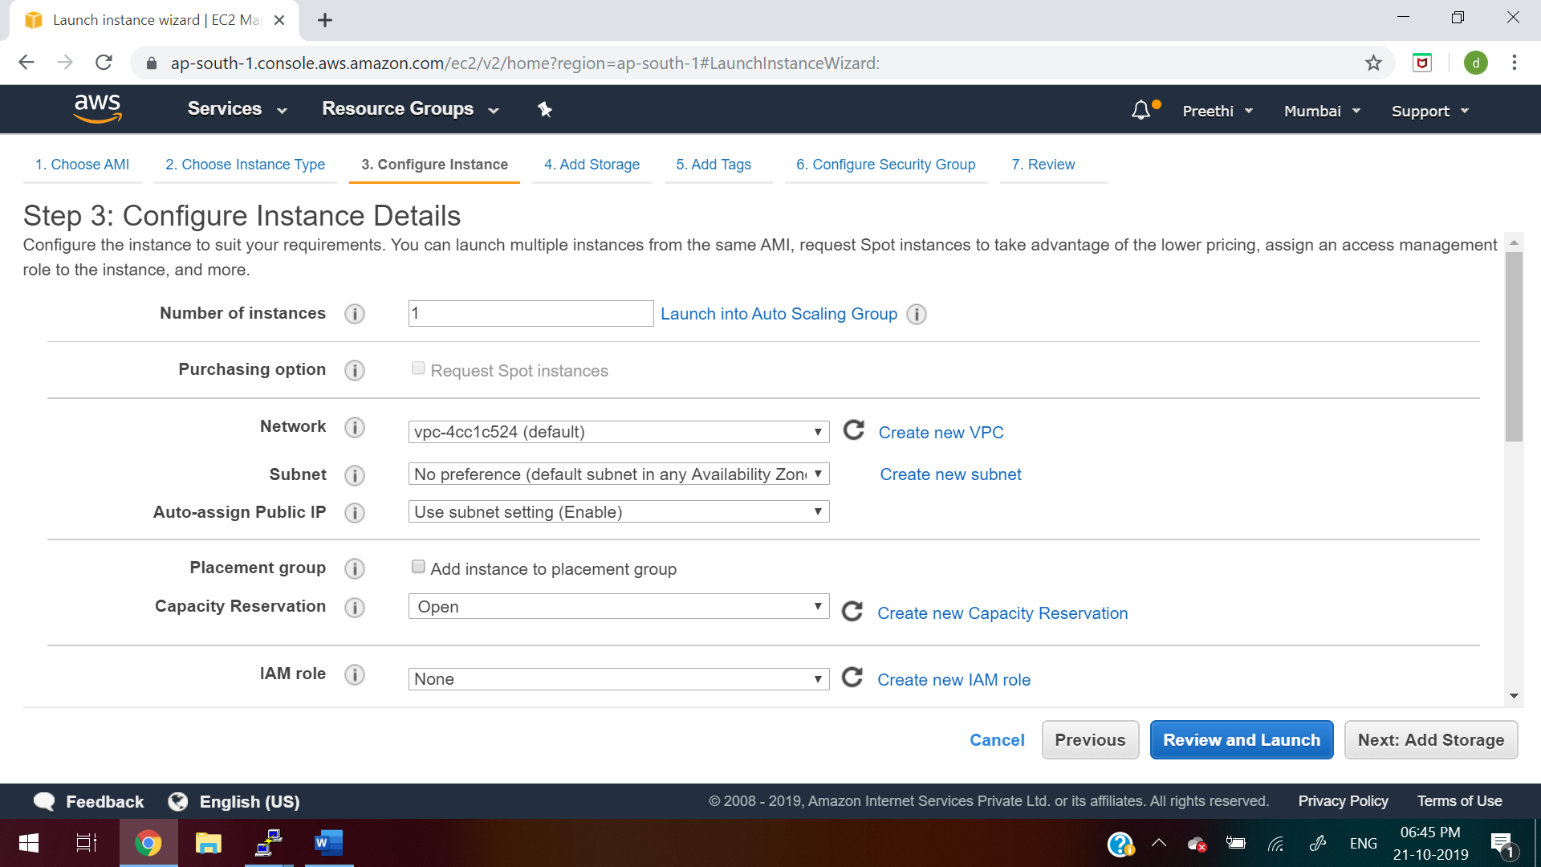
12. Keep it as default (Don’t do any changes)
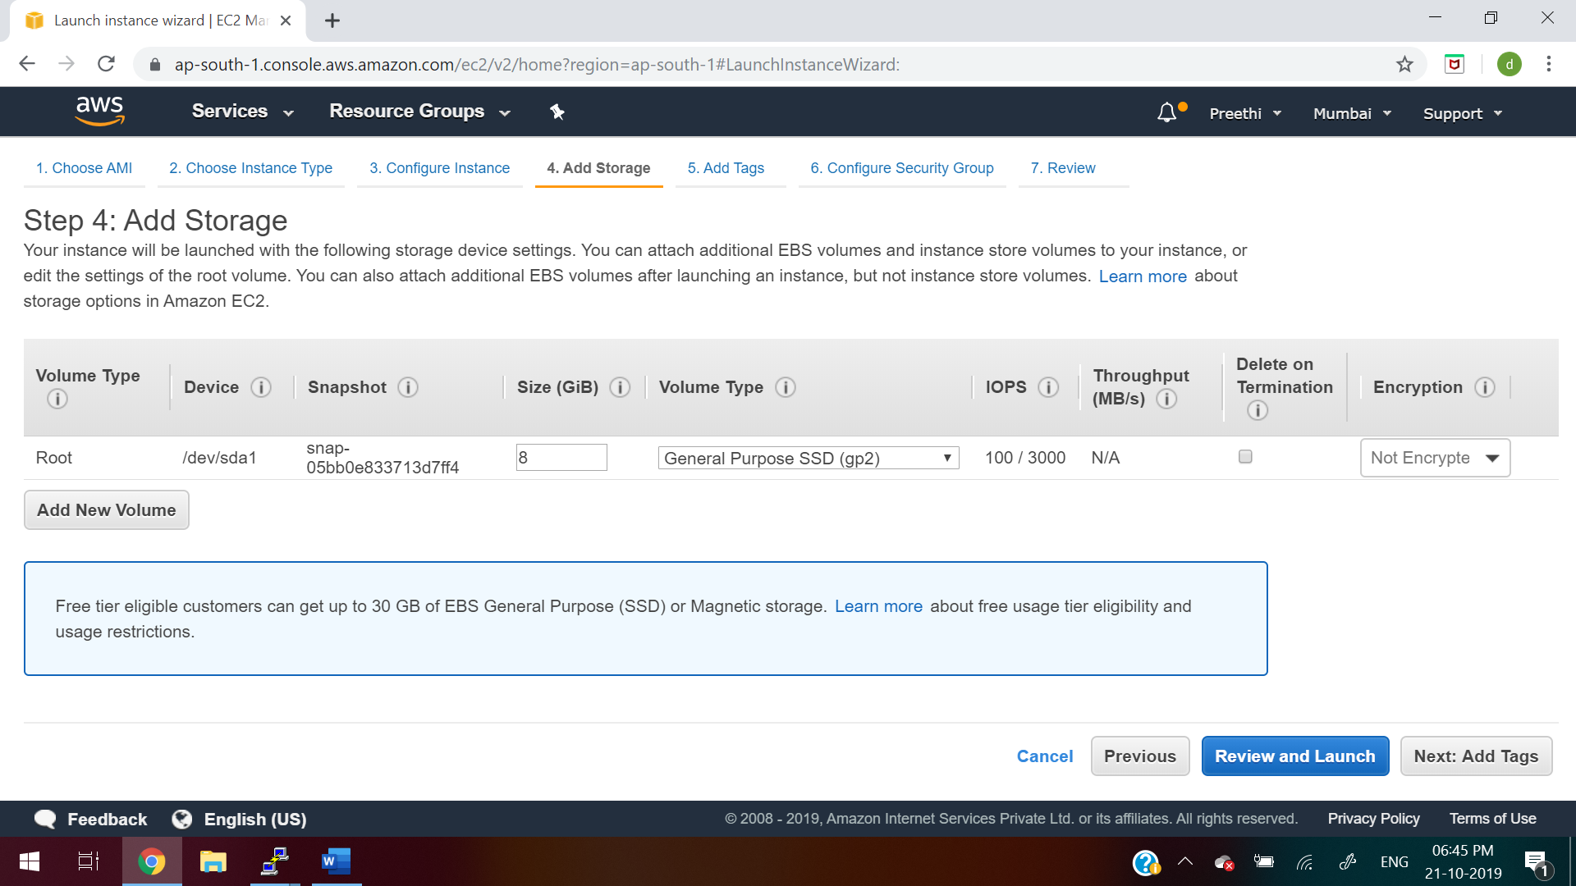
13. Keep it as default (Don’t do any changes)
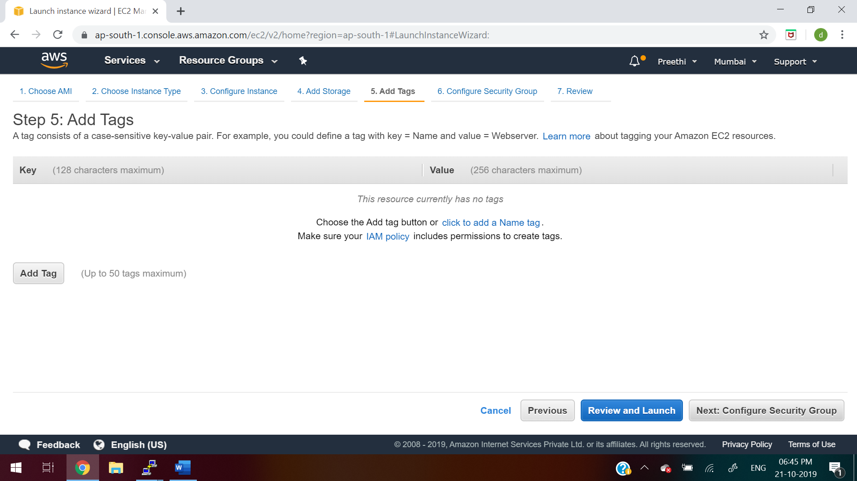
14. click on “Add Rule” button as below and click on “Review and Launch”
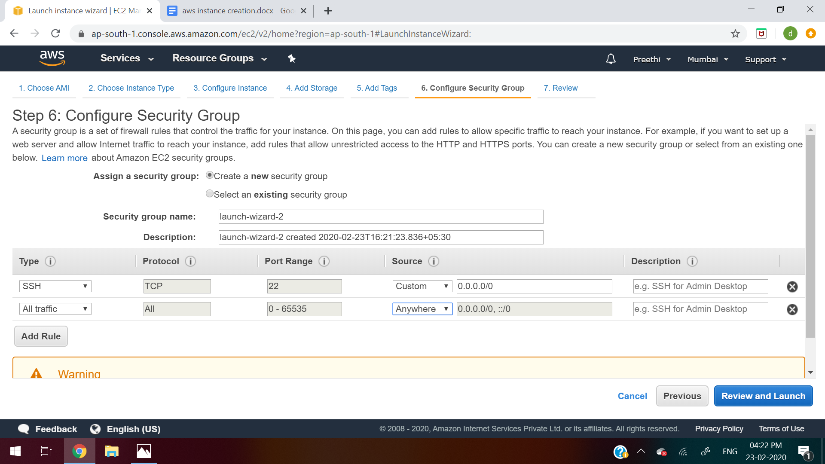
15. Click on Launch
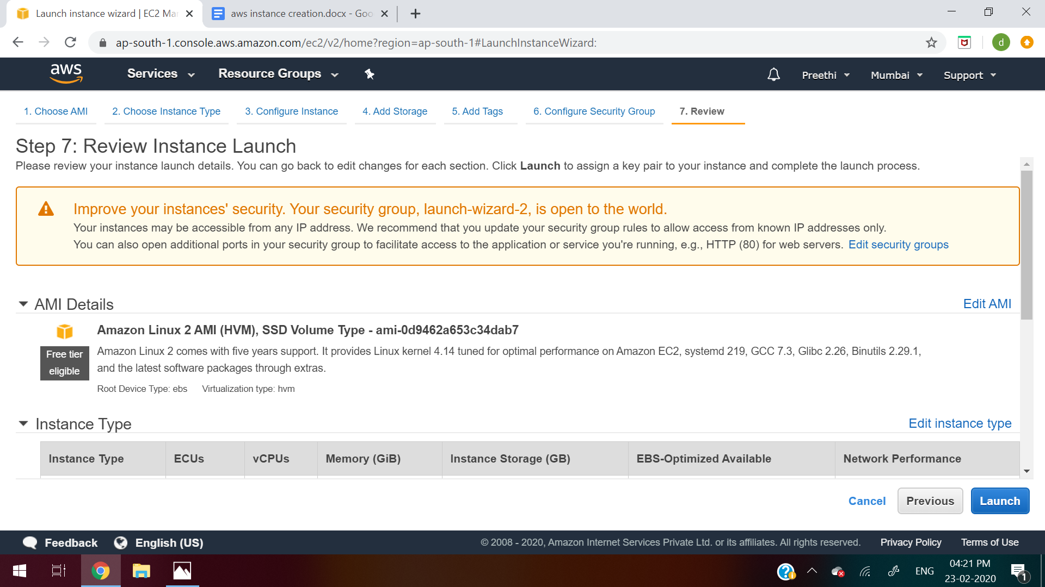
16. Click on “Create a new key pair”
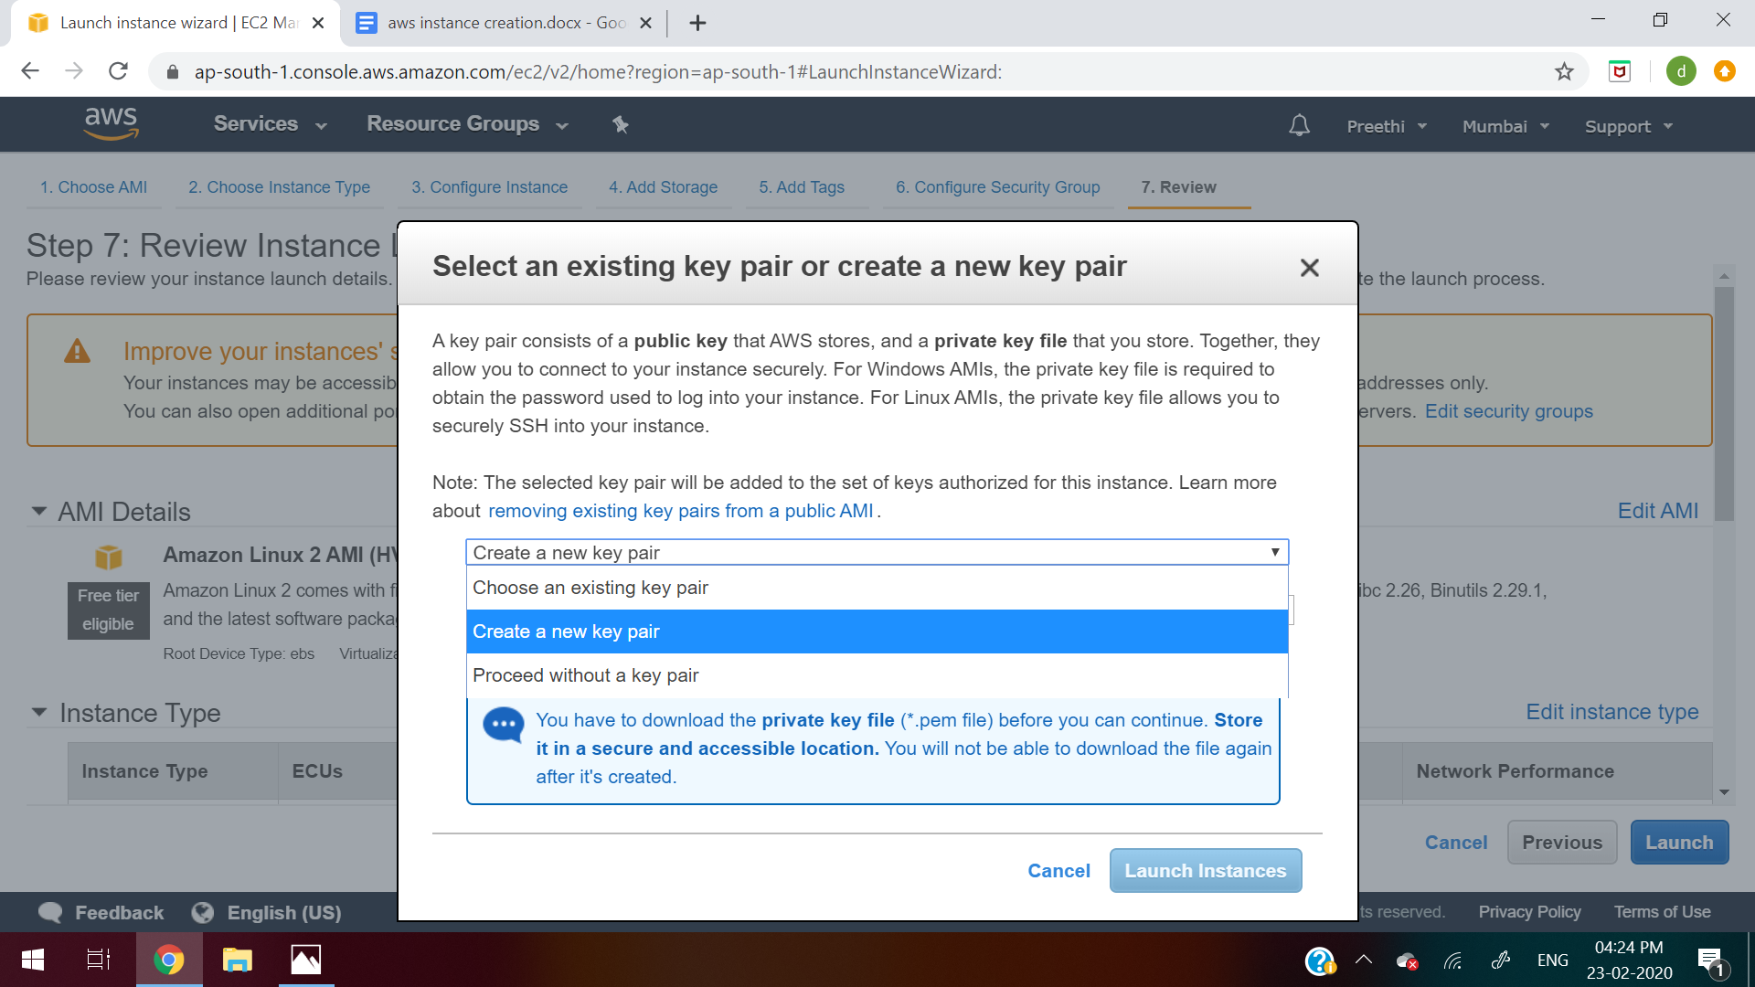
17.Give some name to the keypair like “aws_key” and then click on “Download the Keypair”
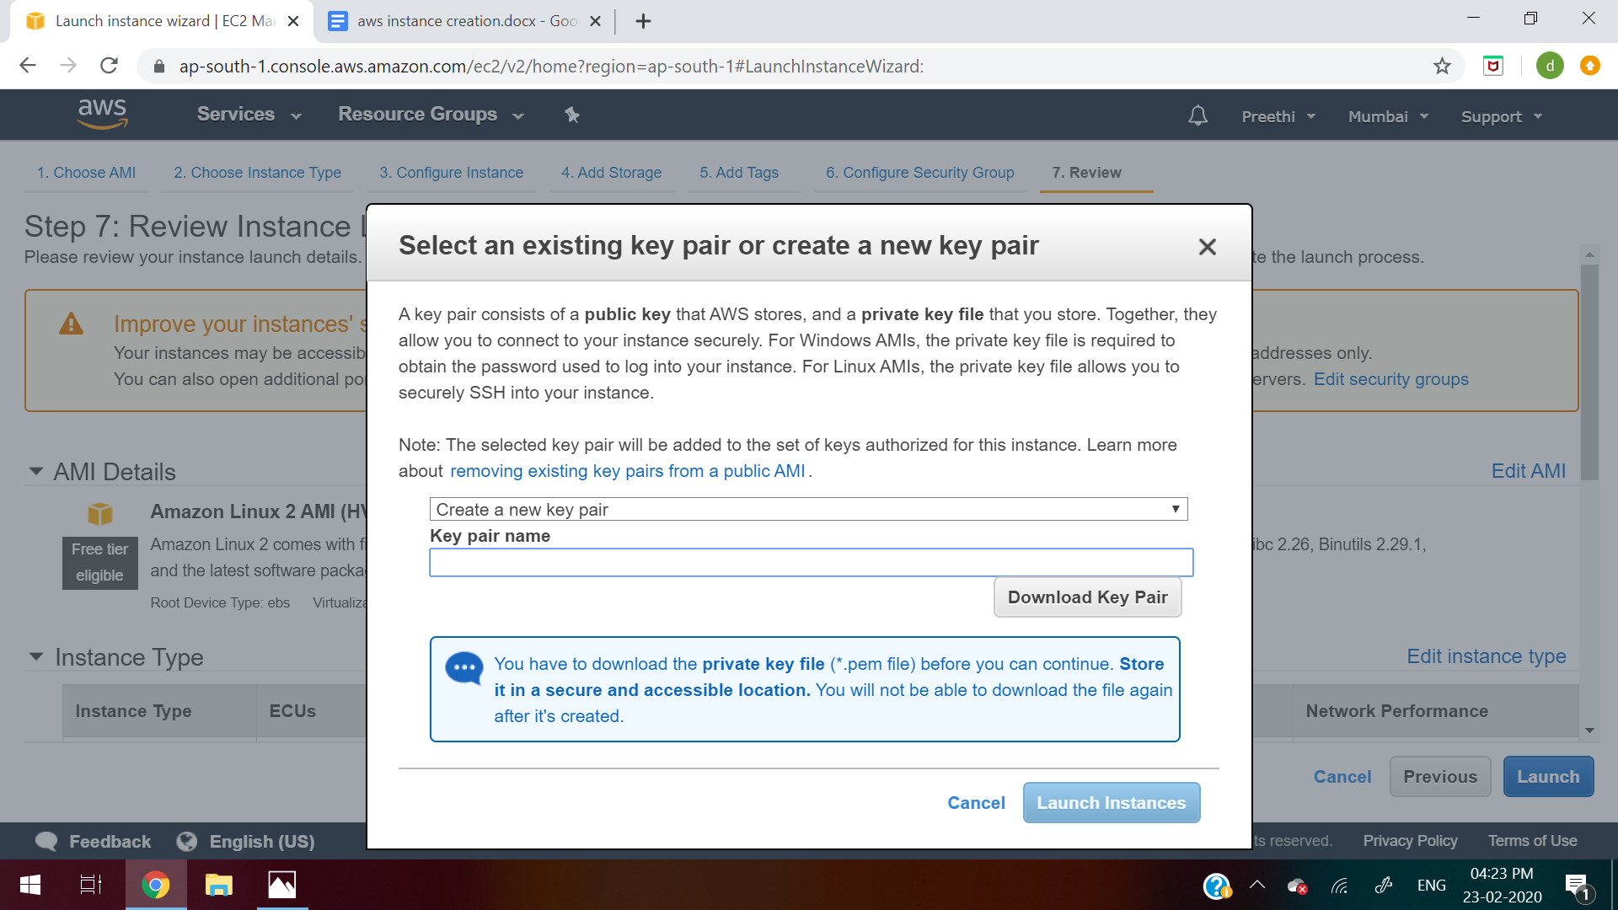
18. Click on Launch Instance
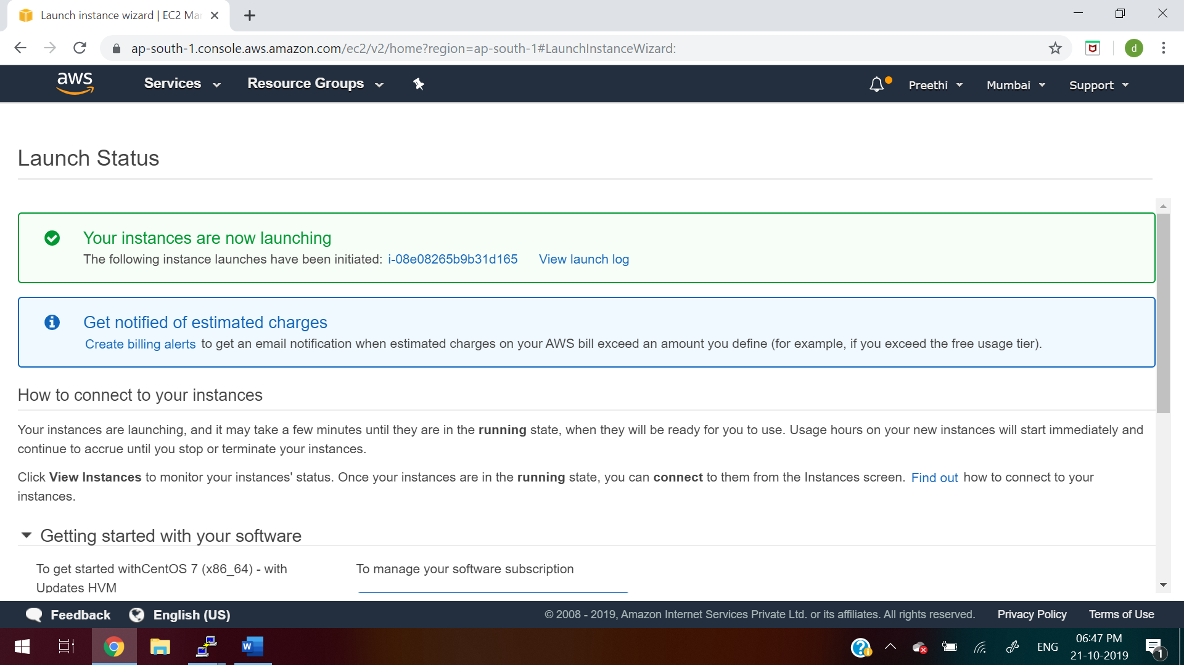
19. Download Puttygen from https://www.puttygen.com/
20. Click “load” in Putty Key Generator. Select the .pem file from your system downloaded in step 17
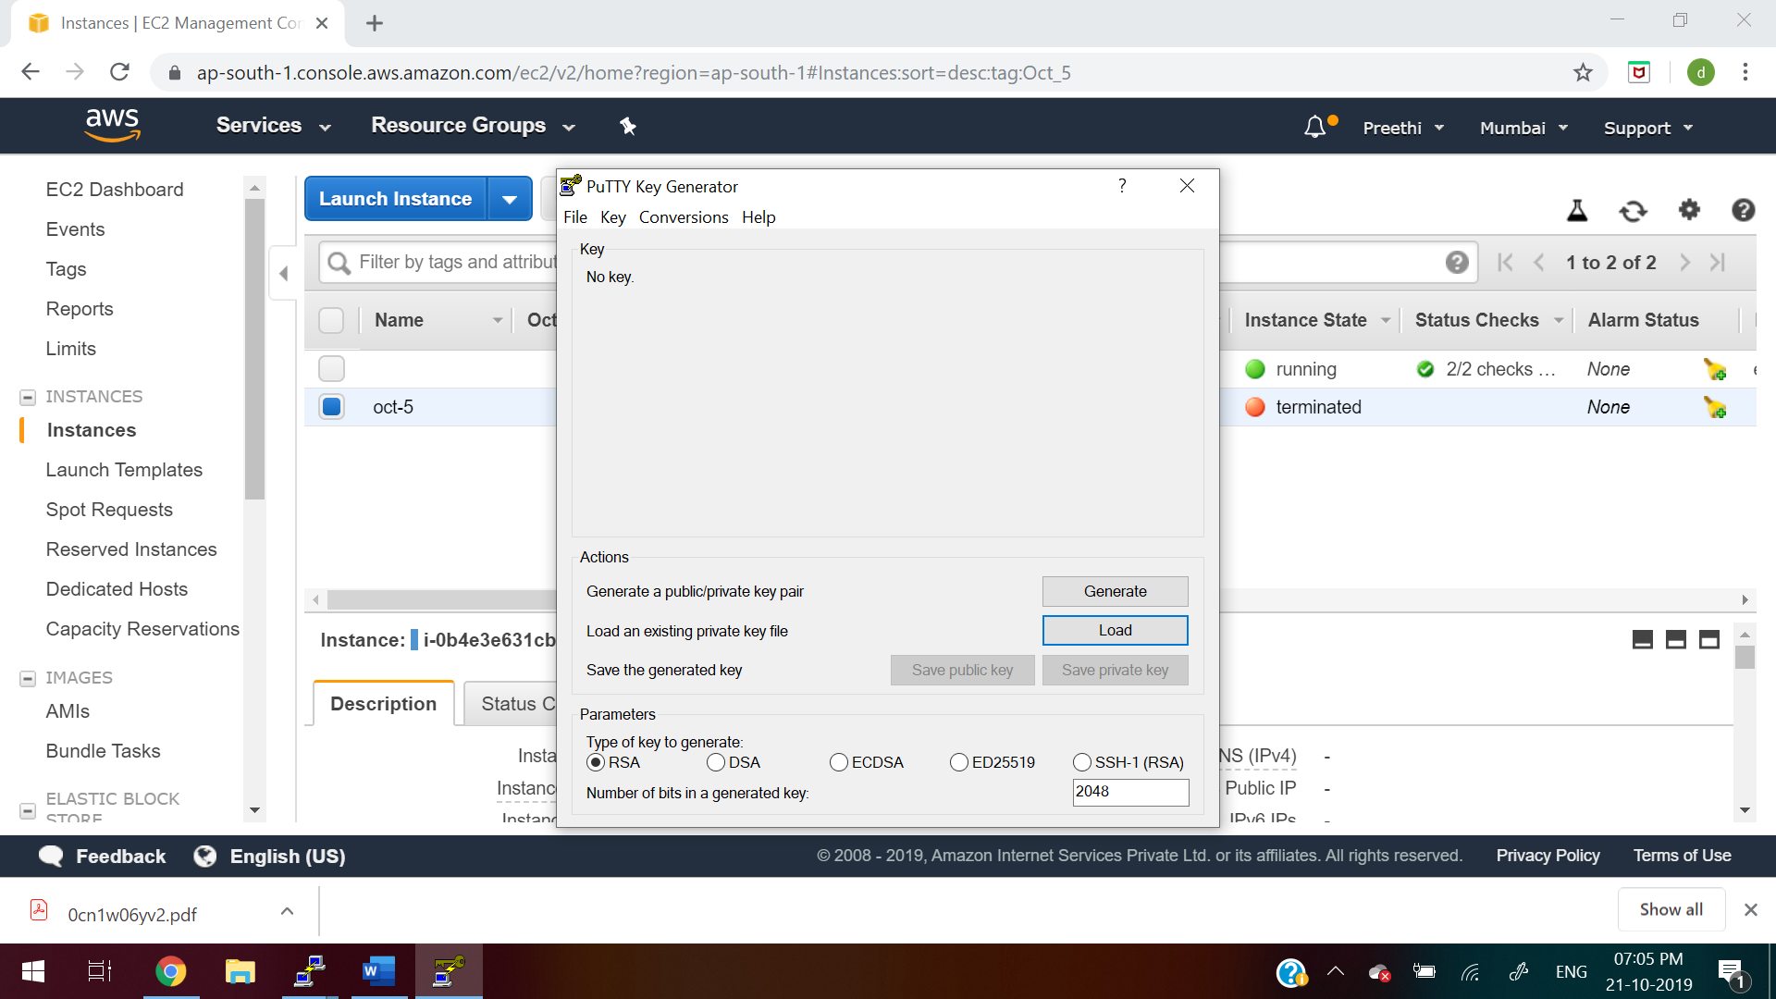
21. After that, follow the below steps:
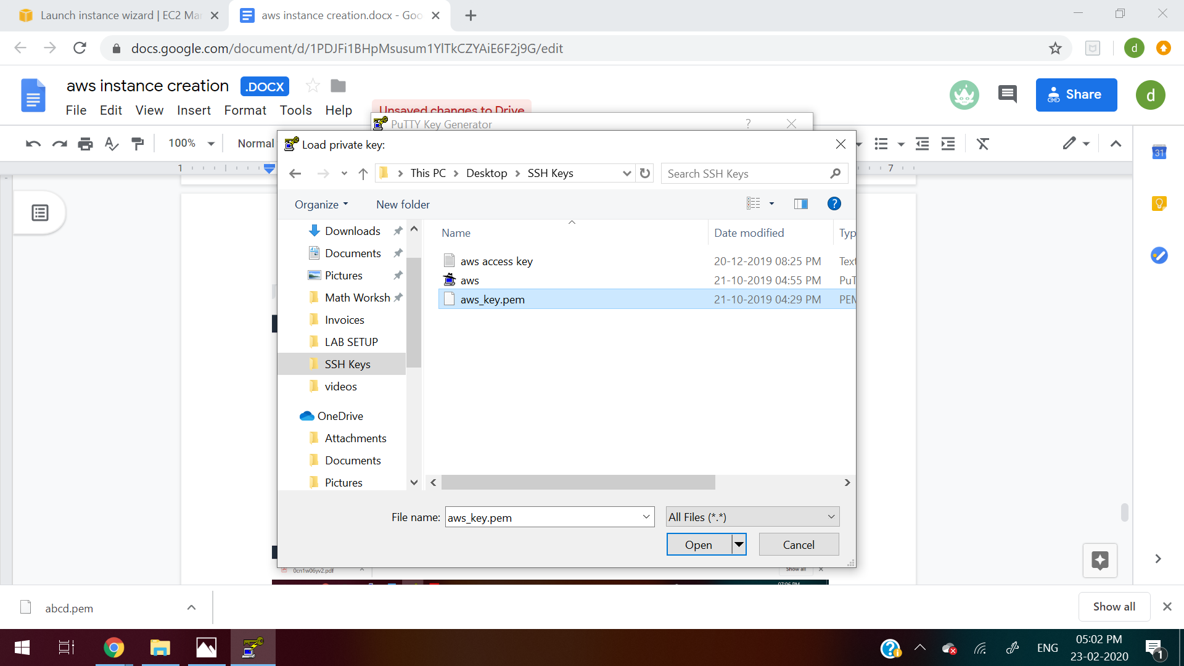
22. click on “Save private key”. Give name as aws.ppk file
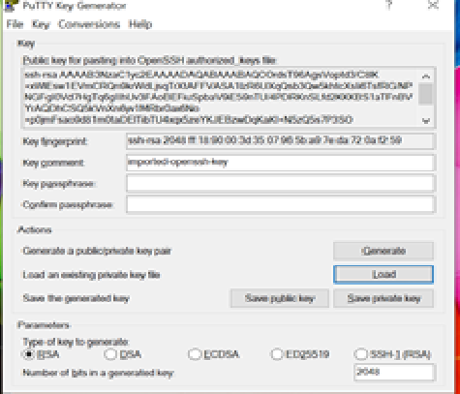
23. Go to Putty. In the host name, give Public Dns or Public IP
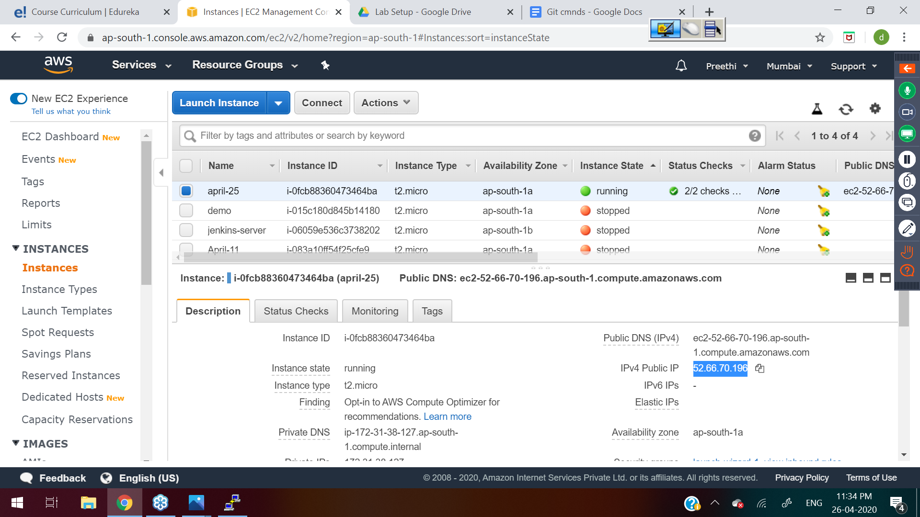
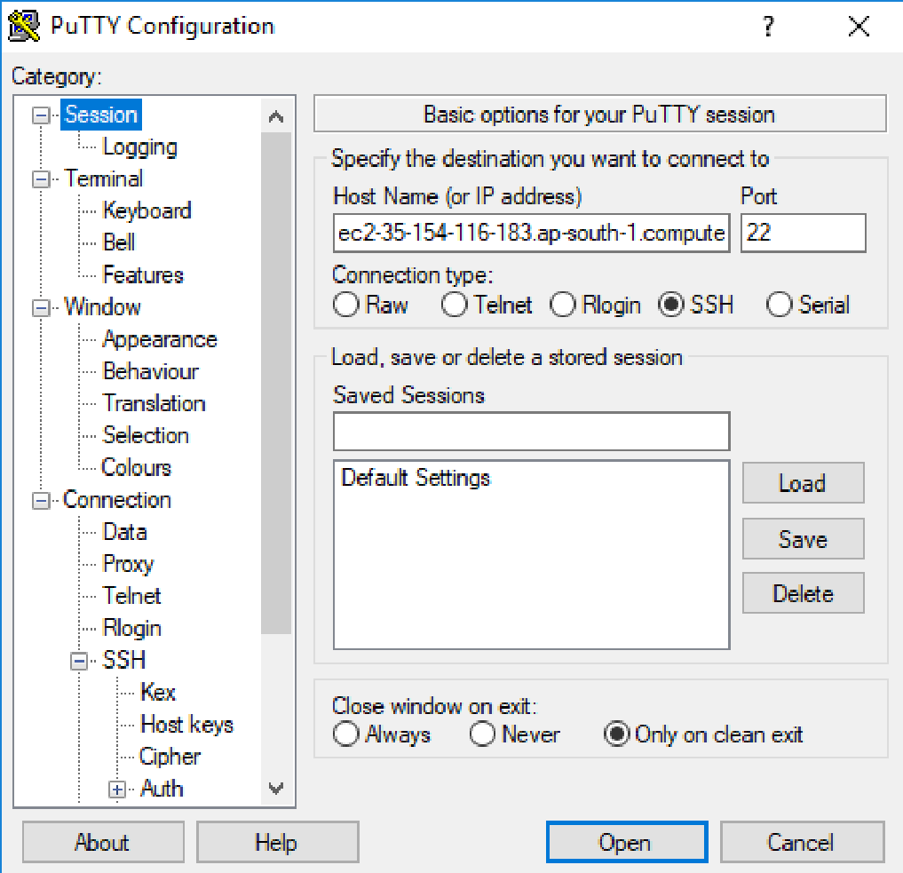
24. Now go to ssh->auth and browse the aws.ppk file generated in step 22
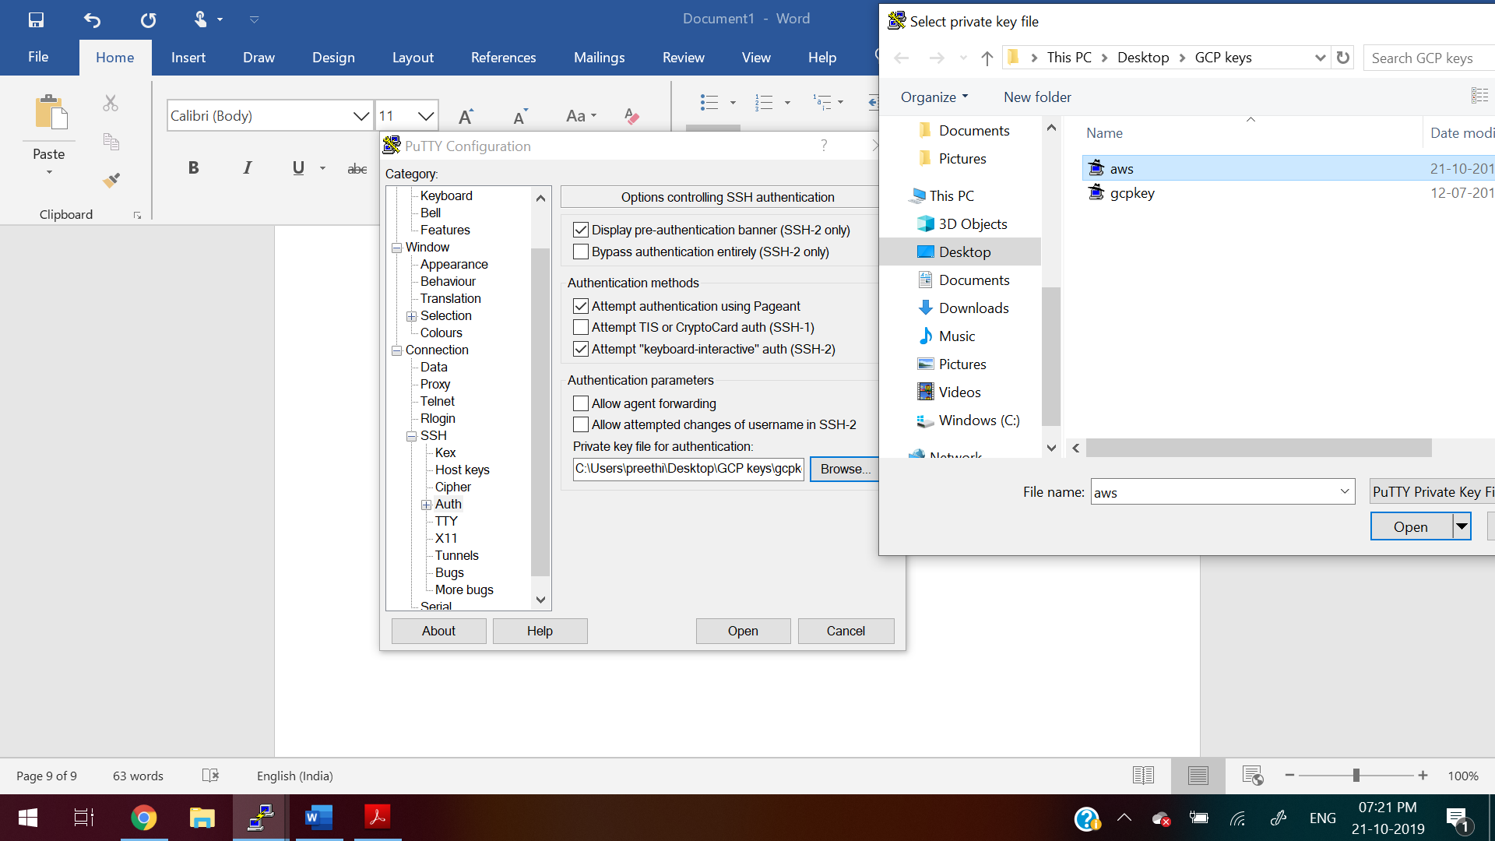
25.Give the username as “ec2-user” login
Then to switch as root user
sudo su -
For Reference:
https://linuxacademy.com/guide/17385-use-putty-to-access-ec2-linux-instances-via-ssh-from-windows/
https://docs.aws.amazon.com/AWSEC2/latest/UserGuide/putty.html

