Step1:

Data Ingested using COPY Data Factory Statement.

Azure SQL Table was created as Sink

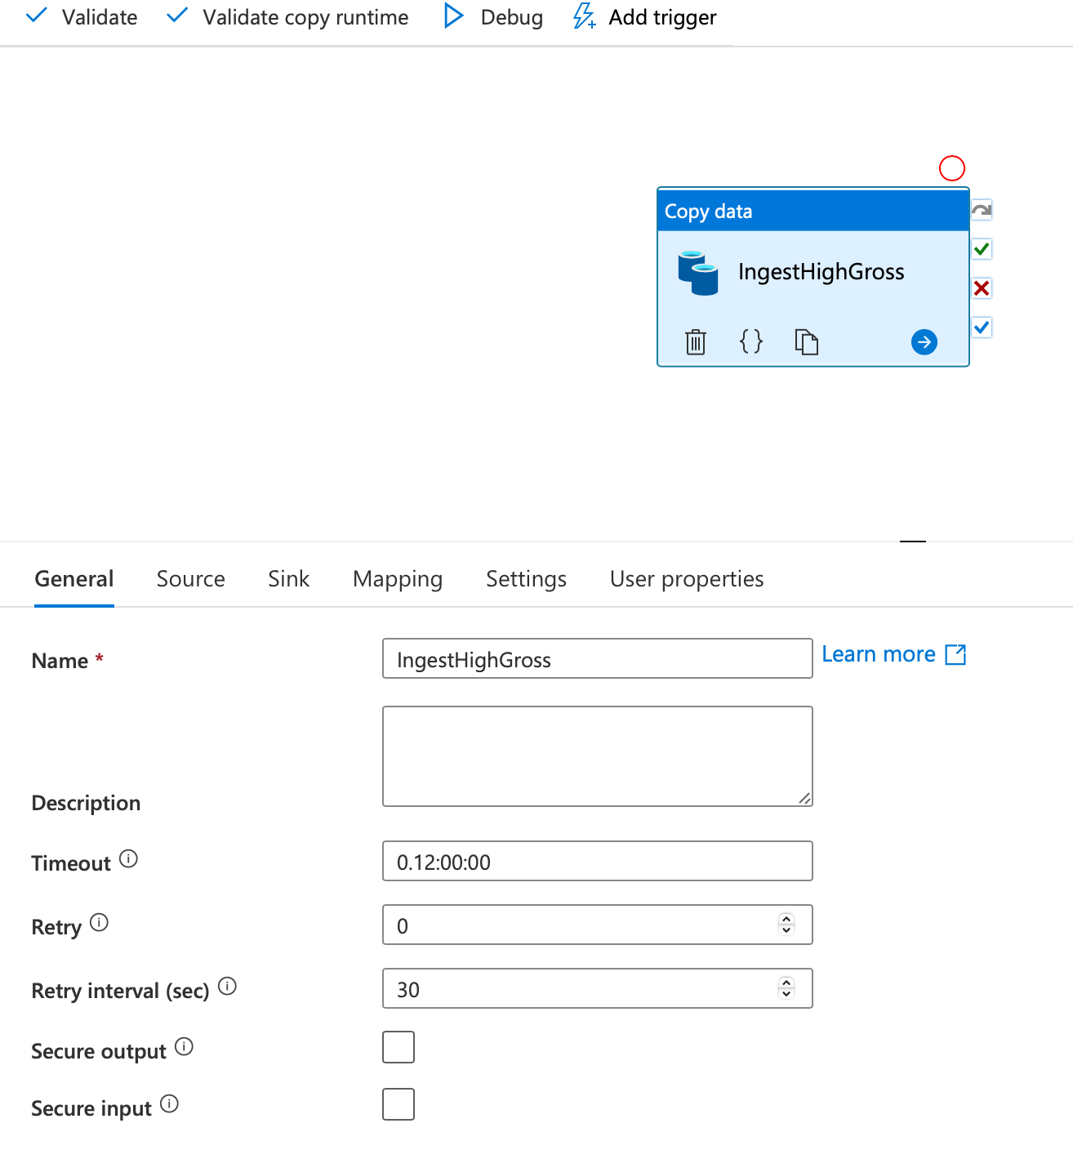

Step 2.

Modelled Data as One Dimension and One Fact.

The Dimension modelled is a SCD-Type1.

The Surrogate Key is derived from Business Key ‘Movie’.

The following is the Diagram.

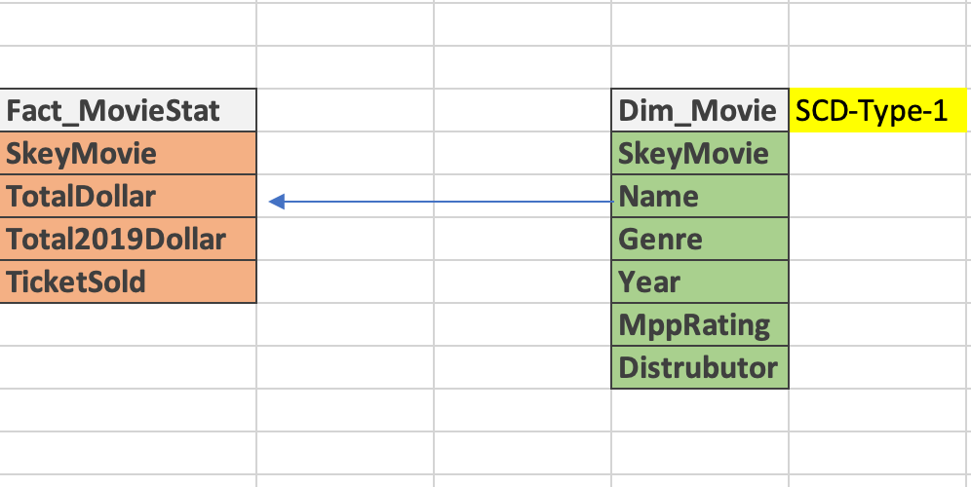

The Data was Transformed and ingested using Data Factory – Data Flow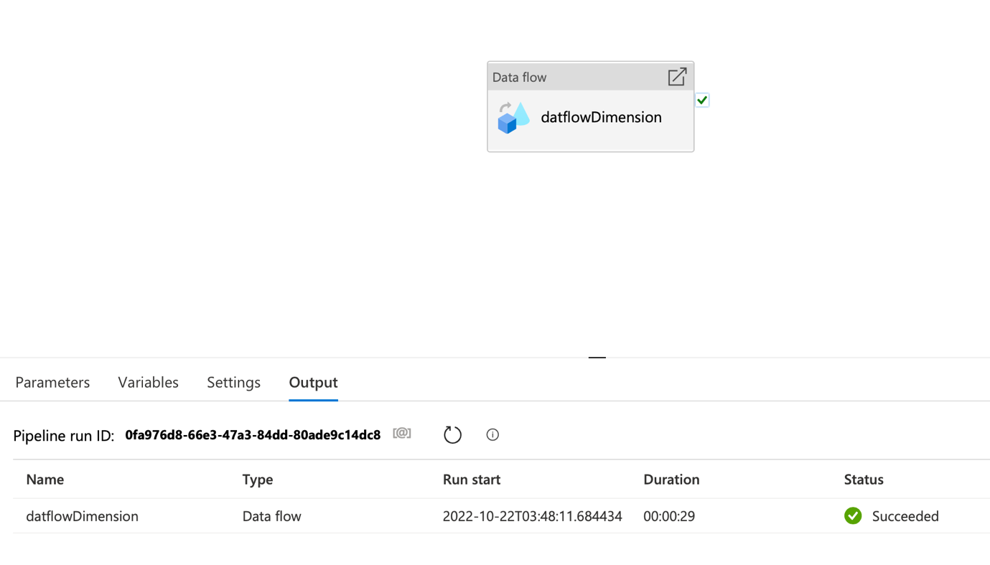

Step 3. Reporting

The following are Stored Procs for the Star Schema Reporting.

-- Run Report for Genre of Movies

----------------------------------------------------------------------------------------------------------

CREATE PROCEDURE dbo.GetMovieGenre

AS

BEGIN

DECLARE @SqlStatement NVARCHAR(MAX)

SET @SqlStatement = N'

SELECT dd.GENRE, sum(TICKETSSOLD) SOLD FROM [dbo].[Fact_moviestatistics] ff

right join [dbo].[DI_movie] dd on dd.SkeyMovie = ff.SkeyMovie

group by dd.GENRE order by sum(TICKETSSOLD) desc

'

EXEC(@SqlStatement)

END

EXEC dbo.GetMovieGenre

------------------------------------------------

-- Run Report for Dynamic Movie Name using Wild Card

----------------------------------------------------------------------------------------------------------

CREATE PROCEDURE dbo.GetMovieSummary

@MovieName nvarchar(200)

AS

BEGIN

--set @MovieName = '%' + @MovieName + '%'

DECLARE @SqlStatement NVARCHAR(MAX)

SET @SqlStatement = N'

SELECT dd.Movie, dd.GENRE, dd.MPAARating, dd.Year,(TOTALFORYEAR) TOTAL FROM [dbo].[Fact_moviestatistics] ff

right join [dbo].[DI_movie] dd on dd.SkeyMovie = ff.SkeyMovie

where dd.Movie like ''%'+@MovieName+'%'' order by TOTALFORYEAR desc

'

EXEC(@SqlStatement)

END

EXEC dbo.GetMovieSummary

N'Harry'

------------------------------------------------