We have below action List . This list we have imported to Database as master data.
Sl | ActionName | ShortName | Action Description
1 | DELETE | D | Warrant will be delete
2 | UPDATE | U | Warrant will open for Update
3 | JUDGE | J | Submit warrant to Judge
4 | PREVIEW | PV | Open warrant for preview (show what warrant will look like. With warrant narrative.
5 | PRINT | P | Print Warrant document all done
6 | CLONE | C | Copy warrant in Draft status ready to make changes
7 | RECALL | RE | After warrant is sent to judge but not active opon this will bring warrant back to dective
8 | CHANGE REVIEWER | CR | Change reviewer warrant sent to
9 | CHANGE DISTRICT ATTORNEY | CD | Change da warrant is sent to
10 | REVIEWER | R | Send warrant for review
11 | SEND EMAIL | SE | Send email
12 | SEND TEXT | ST | Send Text
13 | CHANGE JUDGE | CJ | Change judge warrant is sent to
14 | APPROVE WARRANT | AW | Approve warrant
15 | REJECT WARRANT | RW | Reject warrant
16 | ARCHIVE | A | Send warrant to archive
17 | DISTRICT ATTORNEY | DA | Send to District attorney

Please update action description against each action. If user performed any action , what will be the impact on system.

We have below Warrant Status List . This list we have imported to Database as master data.
SL | StatusName
1 | Draft Warrant
2 | Submit to Judge
3 | Judge Approved
4 | Judge Rejected
5 | Submit for Review
6 | Reviewer Approved
7 | Reviewer Rejected
8 | Submit to D.A.
9 | D.A. Approved
10 | D.A. Rejected
11 | Submit to S.A.
12 S.A. Approved
13 S.A. Rejected
14 Execute
15 Archive warrant

Please send updated action and warrant status list if above list does not contain all required item.

Below for Warrant Status and Action relation
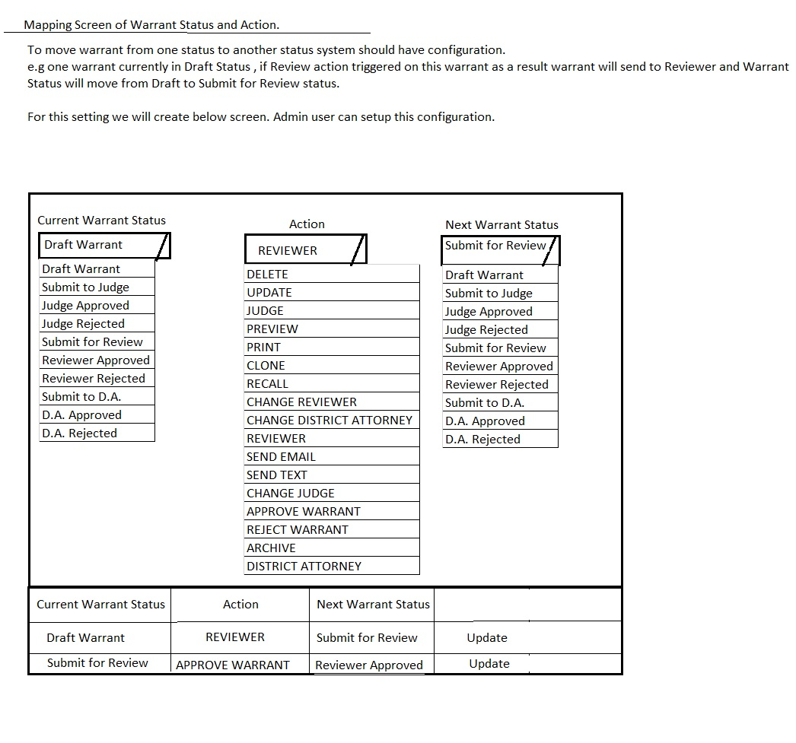
Please approve above Warrant Status and Action relation understanding
Need to add info for States att.
Same as DA

