CareActer

Final Report

10/18/2020

CSC 440 Applied Software Engineering

John Booker, Jakob Smith, Thomas Morris

Contents

I. Introduction 2

A. Problem Statement 2

B. Proposal 2

II. System Description 2

III. System Requirements 2

A. Functional Requirements 2

A. Non-Functional Requirements 16

B. Domain Requirements (op) 17

IV. Use Case Diagram 17

V. Class Diagram 18

VI. Sequence Diagrams 19

VII. Activity Diagrams 26

VIII. State Diagram 33

IX. Database Design 34

X. Conclusion 35

XI. Data Dictionary 35

# Introduction

## Problem Statement

It can be difficult to keep track of everything in Dungeon and Dragons (D&D) with only pencil and paper. The amount of space required continues to increase, and character sheets often have to be completely remade from all the erasing or need for space.

## Proposal

We propose a software to act as a character sheet and solve many of the headaches players face.

# System Description

The Care-Acter system shall allow a user to add, edit, and delete characters, items, and skills. The system will also have a character stats screen that can be edited. A description and name will be allowed for each item and skill. Characters can have a name, background, basic attributes, armor class (AC), speed, class, race, and alignment. Character information will be saved into a database. There will also be a dice roller for the user to simulate rolls of different die any number of times. For instance, they may roll 5 6-sided dice or 2 20-sided die, but not 3 8-sided AND 2 4-sided die.

# System Requirements

## Functional Requirements

1. The system shall allow a user to add a character.
   1. The user will select the “stats” option from the left-most selection box
   2. 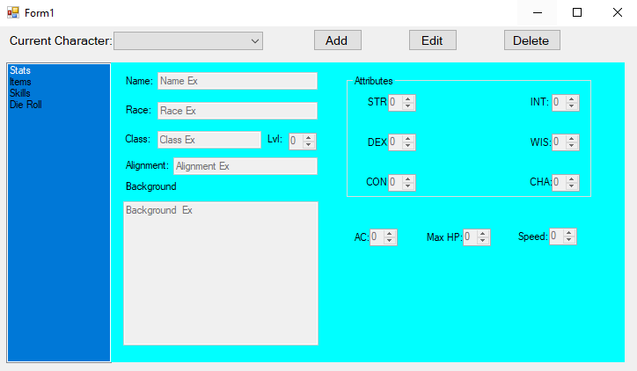The system shall the display to show a character stats menu.
   3. The user shall click the add button at the top of the screen
   4. 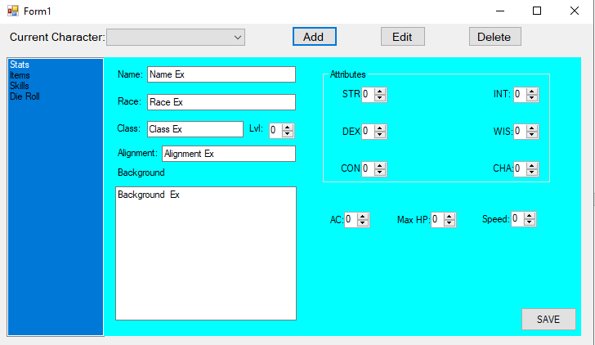The system shall make the entries in the stats panel editable
   5. The user shall fill change and fill in the desired information by typing, or pressing the up and down arrows.
   6. The user shall then press the save button.
   7. The system will display a popup box, saying if the operation was successful or not; depending if there was a name conflict.
      1. 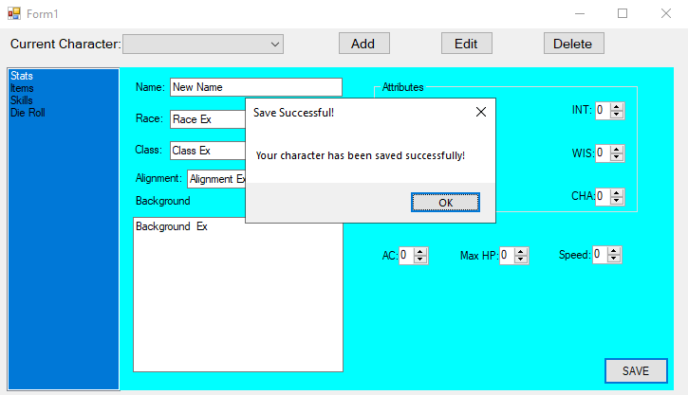If there was not a name conflict, the system displays a “Save Successful” pop up.
      2. 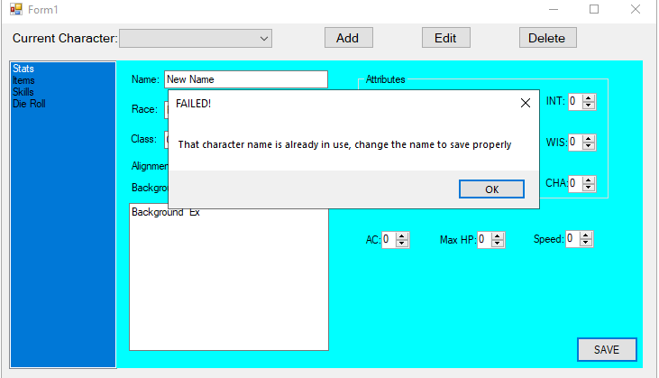If there is a name conflict, the system shall display a failure message, telling the user to choose another name.
         1. The user may edit the name and try to save again until it is successful, or abort the action.
      3. The user may close the pop-up boxes by pressing the “ok” button or the X.
2. The system shall allow a user to edit a character.
   1. The user shall select the desired character to edit from the top left drop down box.
   2. The user shall then select the stats option in the left-most selection box.
   3. The system will now show the stats associated with the character in the drop-down box.

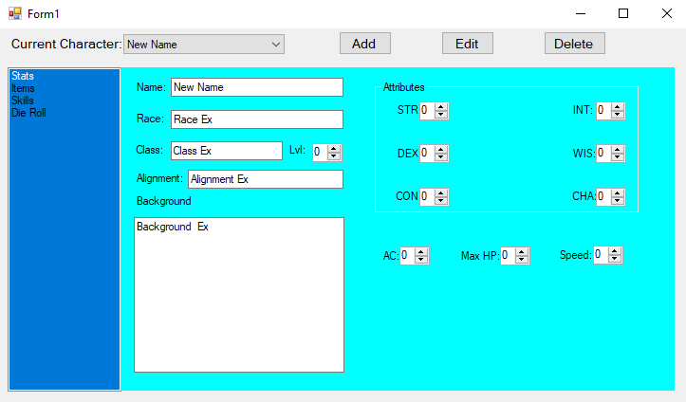

* 1. The user shall click the “Edit” button at the top of the screen.
  2. The system will now make the entities editable and display a “Save” button in the bottom right corner.

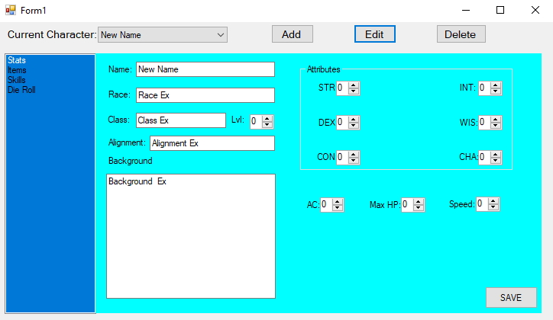

* 1. The user will edit the stats of the character and click the “Save” button.
  2. The system will check for conflicts and display the conclusion in a pop-up.
     1. If there is no error, a successful pop-up message appears

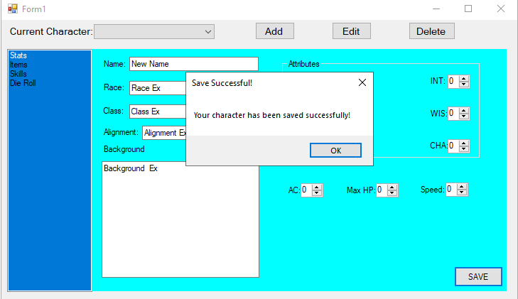

* + 1. If there is a name conflict, a failure pop-up appears

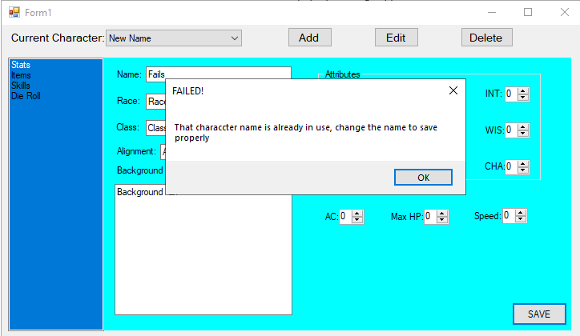

1. The system shall allow a user to delete a character.
   1. The user shall select the character they want to delete from the drop down box.



* 1. The user shall then go to the stats page.
  2. The system shall update the display with the drop-down character’s stats



* 1. The user shall then press the delete button at the top of the screen
  2. The system shall then delete the character along with all of it’s items and skills.

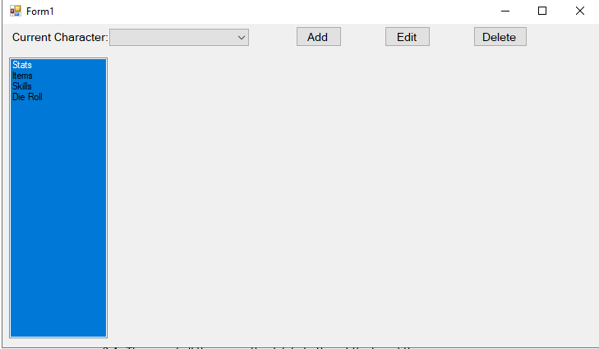

1. The system shall allow a user to add an item/skill.
   1. The user shall select the “Items” or “Skills” option from the left hand selection box
   2. The system shall then display a list of items or skills

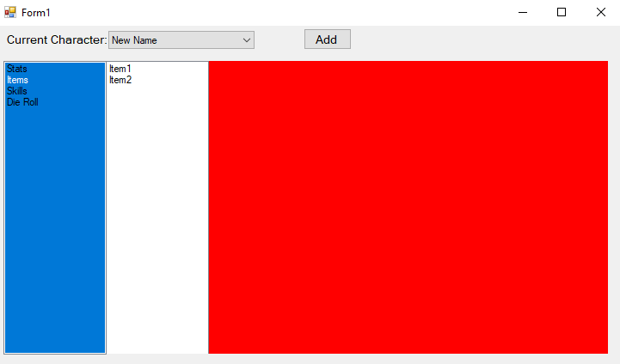

* 1. The user shall click the add button at the top of the screen
  2. The system shall display an are for input on the right side of the screen.

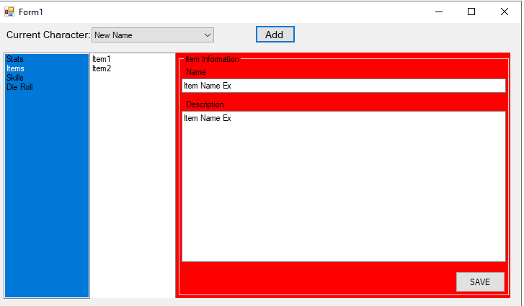

* 1. The user shall fill in the information and press the save button
  2. The system shall check for name conflicts, along with a pop-up with the outcome
     1. No conflict results in saving the item

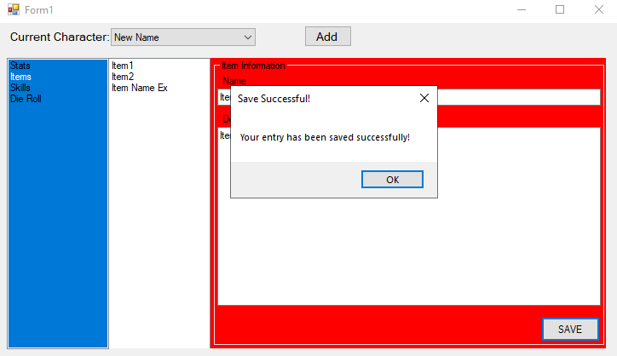

* + 1. A conflict results in prompting the user to change the name of the Item or Skill

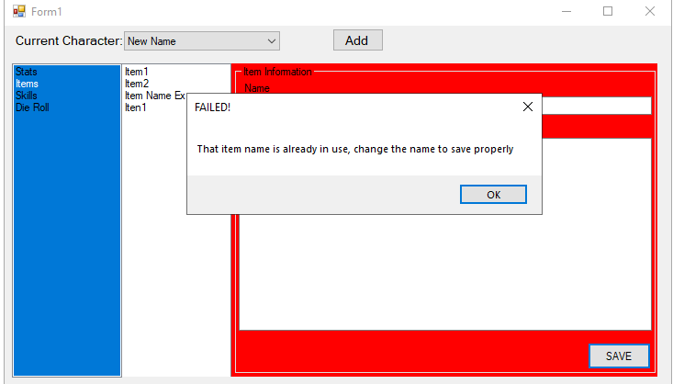

1. The system shall allow a user to edit an item/skill.
   1. The user shall select the items or skills selection from the left selection box
   2. The system shall update the display with a list of items or skills associated with the character from the drop-down box

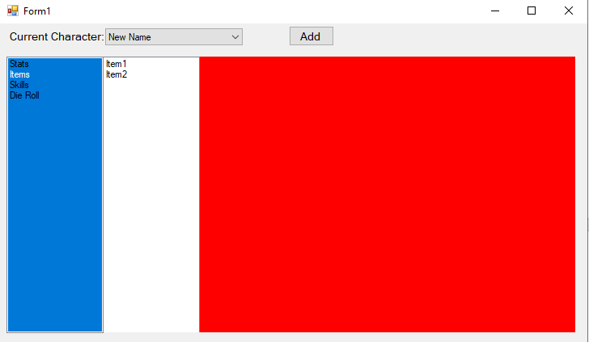

* 1. The user shall then select the option they wish to edit from the list of items/skills.
  2. The system shall highlight that option and display its information in the right panel

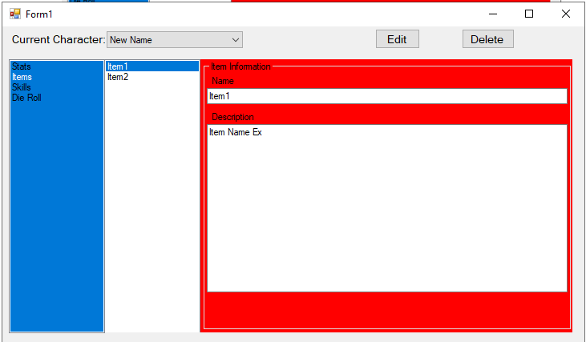

* 1. The user shall press the edit button on the top of the screen
  2. The system shall make the entities editable, and display a save button

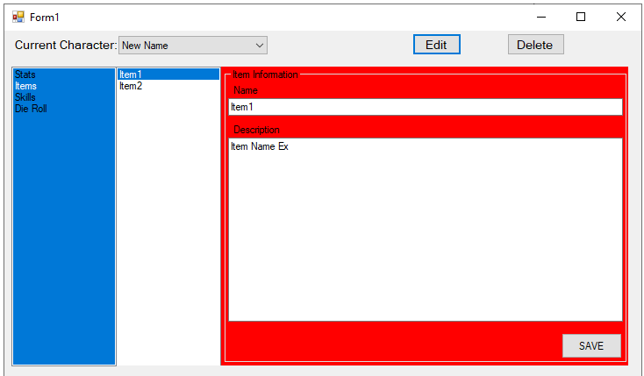

* 1. The user shall change desired information and press the save button
  2. The system shall check for name conflicts and display a popup with the conclustion
     1. No conflicts result in saving the edits

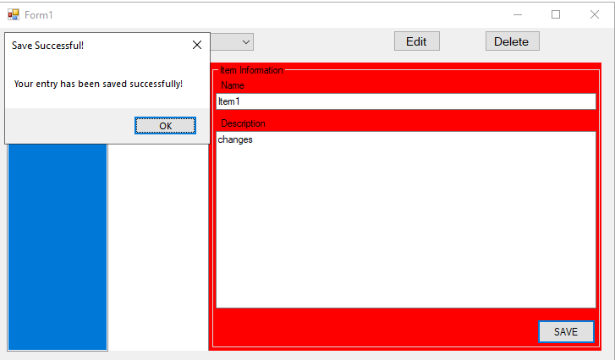

* + 1. Any conflicts result in prompting the user to change the name

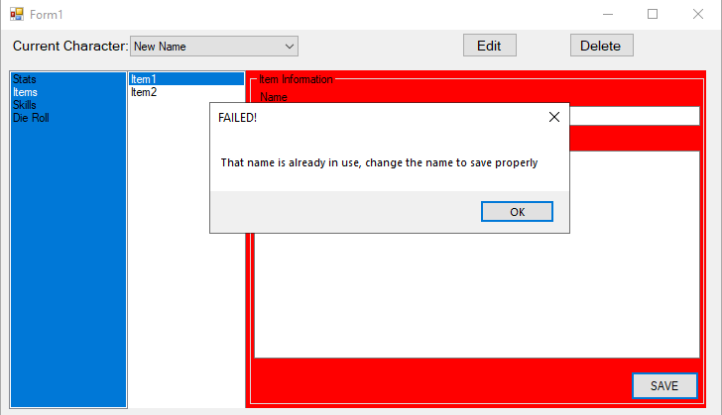

1. The system shall allow a user to delete an item/skill.
   1. The user shall select the items or skills option from the left selection box
   2. The system shall display the items or skills of the character selected in the drop down box

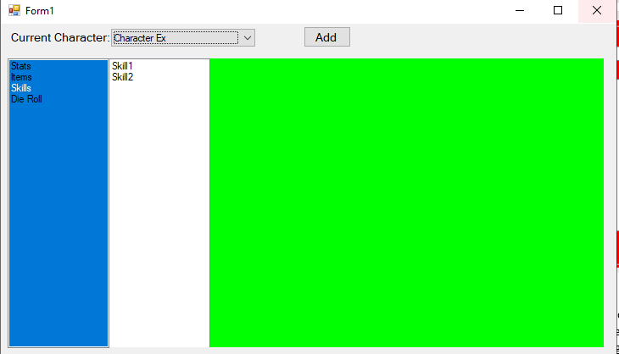

* 1. The user shall select the item/skill they wish to delete from the middle selection box
  2. The system shall display the information of the selected item/skill in the right panel

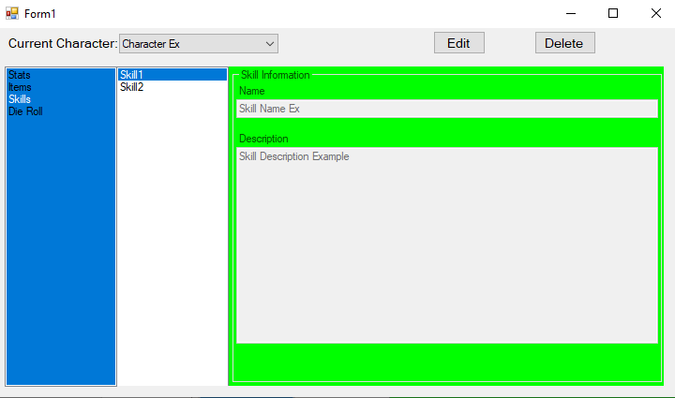

* 1. The user shall press the delete button at the top of the screen
  2. The system shall delete the selected item/skill

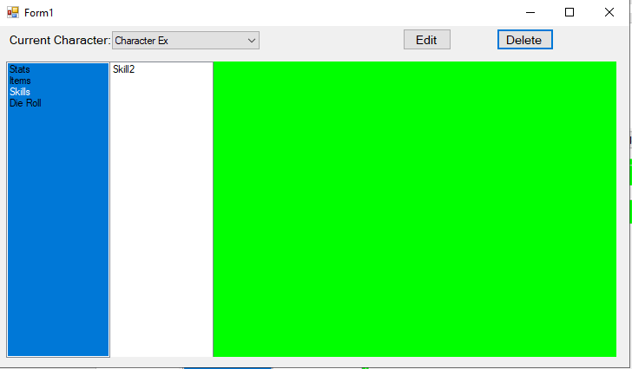

1. The system shall allow a user to simulate rolling different amounts and types of dice.
   1. The user shall select the “Die Roll” option from the left selection box
   2. The system shall display the dice rolling screen

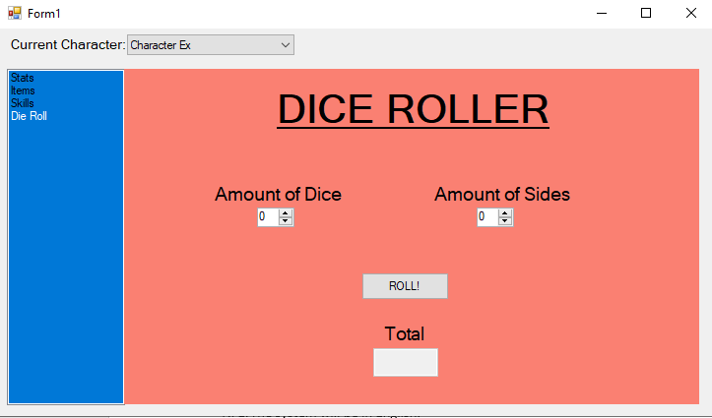

* 1. The user shall input the desired amount of die and the amount of sides on the die they wish to roll and press the “ROLL!” button
  2. The system shall simulate rolling the dice with a random function, and display the total summed amount of the rolls inside of the textbox below “Total”

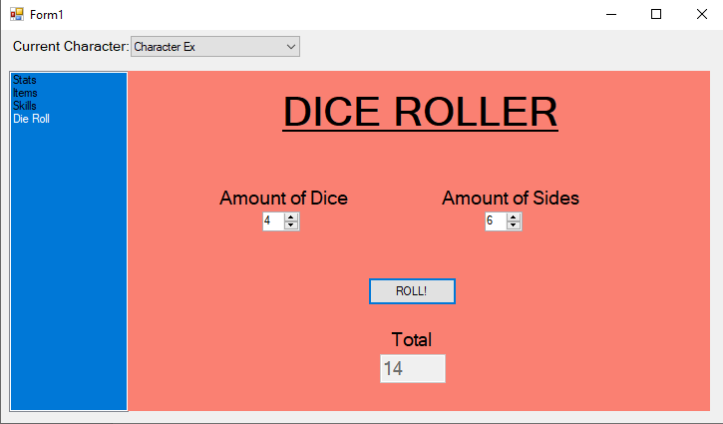

## Non-Functional Requirements

1. The system will be in English.
2. The system will be based on the 5th edition D&D character sheet.
3. The system will be named based, so no two creations under the same category may have the same name.

## Domain Requirements (op)

# Use Case Diagram



This diagram shows the expected behaviors a user is able to do in the CareActer system. The user will be able to do these actions: add, edit, and delete upon these entities: characters, items, and skills. The user will also be able to roll dice with a specified number of sides with varying amounts.

# Class Diagram

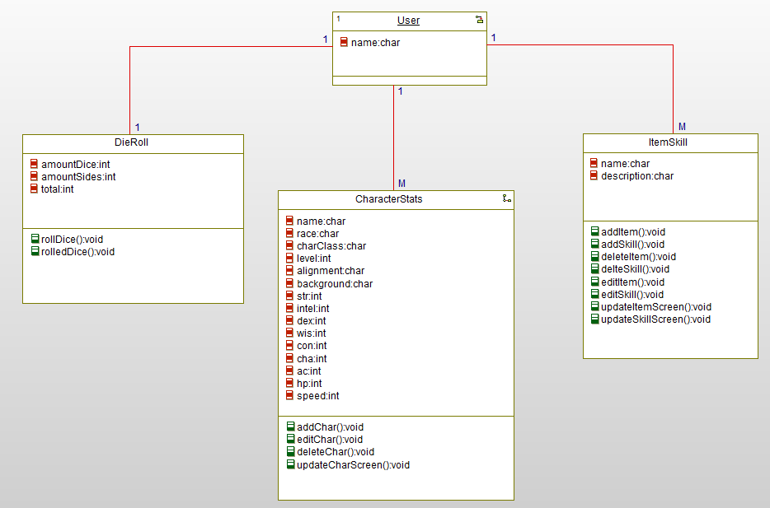

This diagram shows an overview of the system’s character, item/skill, and roll die classes. Inside of each class are the class’ operations.

# Sequence Diagrams

*Add Character* - This diagram shows the interactions that take place for a user to add a character to the character sheet.

*Add ItemSkill* - This diagram shows the interactions that take place for a user to add an item or skill to the character sheet.

*Delete Character* - This diagram shows the interactions that take place for a user to delete a character from the character sheet.

*Delete ItemSkill* – This diagram shows the interactions that take place for a user to delete an item or skill from the character sheet.

*Edit Character –* This diagram shows the interactions that take place for a user to edit a character on the character sheet.

*Edit ItemSkill* – This diagram shows the interactions that take place for a user to edit an item or skill on the character sheet.

*Roll Die* – This diagram shows the interactions that must take place for the user to roll dice on the character sheet.

# Activity Diagrams

*Add Character* - This diagram shows the activity flow of the system when a user adds a character to the character sheet.

*Add ItemSkill* - This diagram shows the activity flow of the system when a user adds an item or skill to the character sheet.

*Delete Character* - This diagram shows the activity flow of the system when a user deletes a character from the character sheet.

*Delete ItemSkill* - This diagram shows the activity flow of the system when a user deletes an item or skill from the character sheet.

*Edit Character* - This diagram shows the activity flow of the system when a user edits a character’s information on the character sheet.

*Edit ItemSkill* - This diagram shows the activity flow of the system when a user edits items or skills on the character sheet.

*Roll Die -* This diagram shows the activity flow of the system for the user to roll dice on the character sheet*.*

# State Diagram

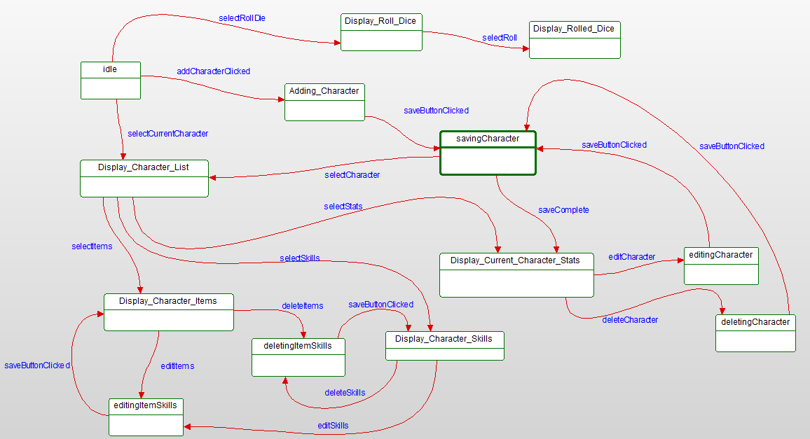

This diagram displays the state of the CareActer system during a specific user action or system behavior.

# Database Design



The Design of the Database.

Character Table:

|  |  |  |  |  |  |
| --- | --- | --- | --- | --- | --- |
| **CharacterName** | Race | Class | Level | Alignment | Background |

Attributes Table:

|  |  |  |  |  |  |  |  |  |
| --- | --- | --- | --- | --- | --- | --- | --- | --- |
| Strength | Dexterity | Constitution | Intelligence | Wisdom | Charisma | ArmorClass | MaxHP | Speed |

Skills Table:

|  |  |  |
| --- | --- | --- |
| **SkillName** | sDescription | CharacterName |

Items Table:

|  |  |  |
| --- | --- | --- |
| **ItemName** | iDescription | CharacterName |

Has Table:

|  |  |
| --- | --- |
| **SkillName** | CharacterName |

Contains Table:

|  |  |
| --- | --- |
| **ItemName** | CharacterName |

Comprised Table:

|  |  |
| --- | --- |
| **CharacterName** | CharacterName |

# Conclusion

The proposed system will allow users to keep track of their characters along with the skills and items of each one in a Dungeons and Dragons like game. This system is based on the D&D 5th edition character sheet and eliminates the need for much of the pencil and paper recording keeping. It solves the problems of paper character sheets by offering expanded space and easy deletion of content. The system will not play the game for a user but allows easier management of frequently dynamic elements than the pencil and paper version of a character sheet.

# Data Dictionary

Abort – an abort is done by selecting a different option from the left-hand selection box than the one the user is currently interacting with.

Character – added by a user. These have stats, items, and skills.

Conflict – In a character system, this means two creations under the same category have the same name.

Database - an organized collection of data, generally stored and accessed electronically from a computer system.

User – The person interacting with the system.