10/17/2020

CSC 440

Jakob smith, john booker, thomas morris

CareActer

User Manual

## Introduction

Welcome to CareActer, your new home for all character needs in your table-top gaming experience! In this quick guide, you will learn how to navigate the character selection screen, adding a character to your list and managing your character’s different needs including editing and deleting characters, skills, and items. Also included is a dice roller so you never have to worry about finding a D20 again! Let’s get started.

## Character Menu

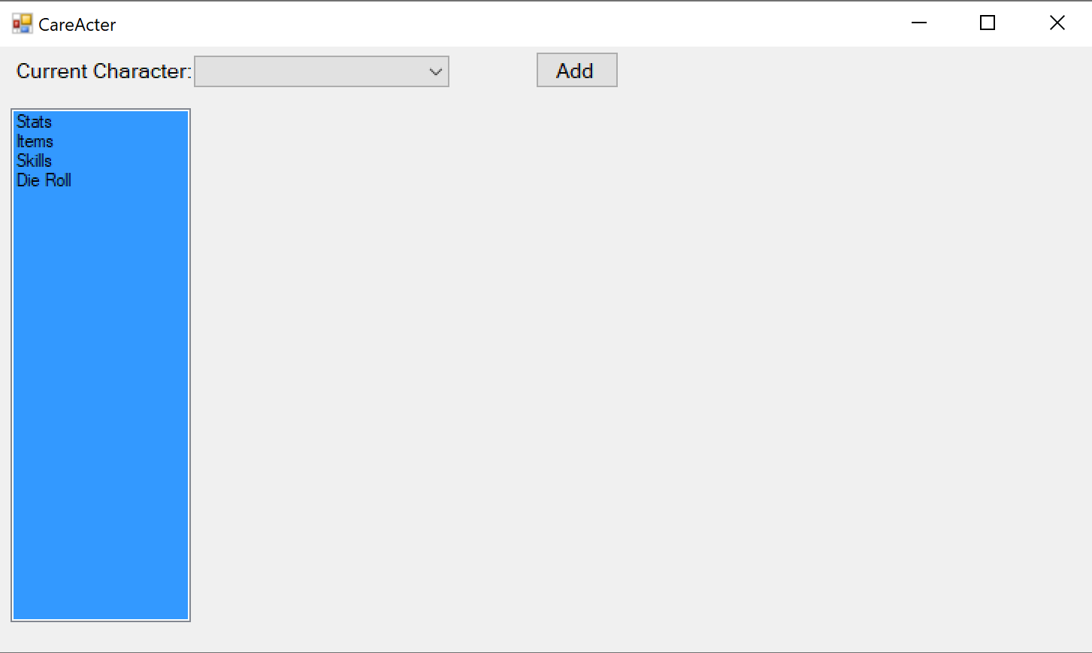

When you first boot up CareActer, you will be met with this screen. From here, you will click on the dropdown “Current Character” and select from a list of already created characters. If there are no characters available, you can always add one (see “Adding a Character”).

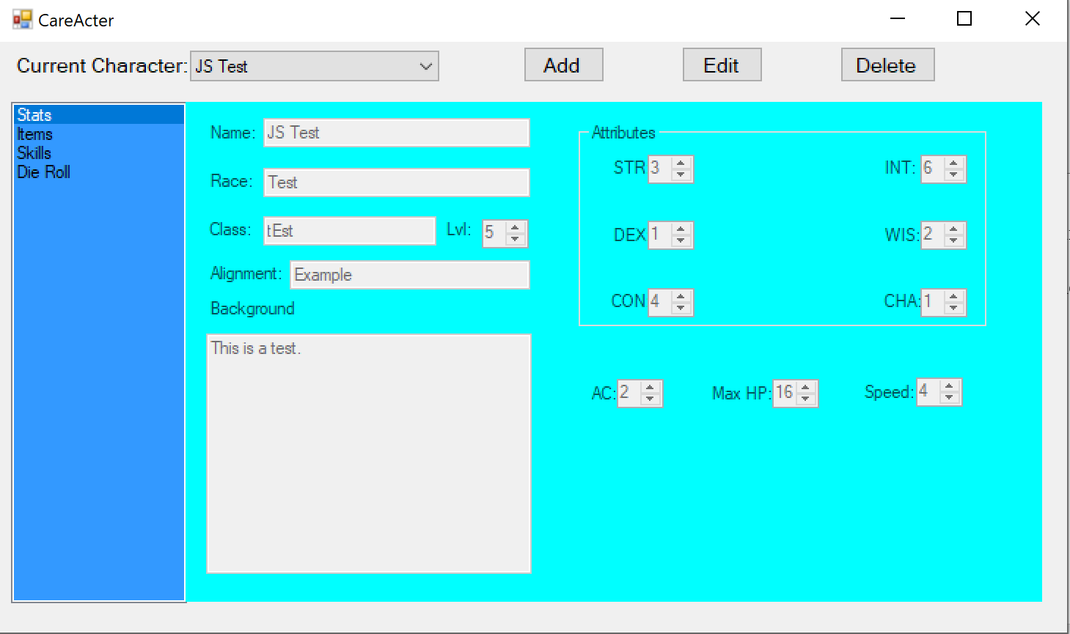

Upon selecting a character, you have access to three new tabs: Stats, Items and Skills. The Stats tab will display your character’s main info as well as their attributes. The Items tab will display any items that your character may have. The Skills tab will display any skills that your character may have acquired.

## Adding a Character

Looking to start a new campaign or just wanting to keep a character stored so you remember all the details? Let us look at how to create a character.



From the startup screen, you will see an “Add” button next to the dropdown menu for Current Character. Click on that button.

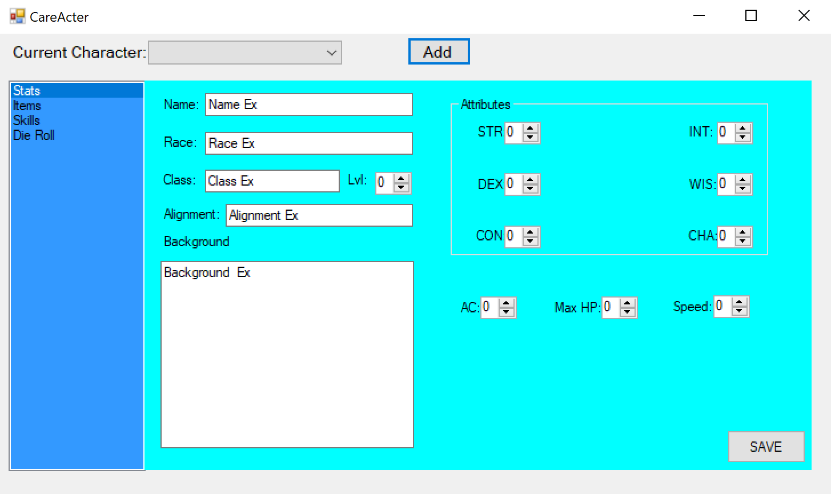

Clicking on the Add button will bring up a new character form for you to fill out. Names are important. Here at CareActer we want you to be as creative as possible with your characters, so you must have unique Character Names to be able to save your character. Try something new!

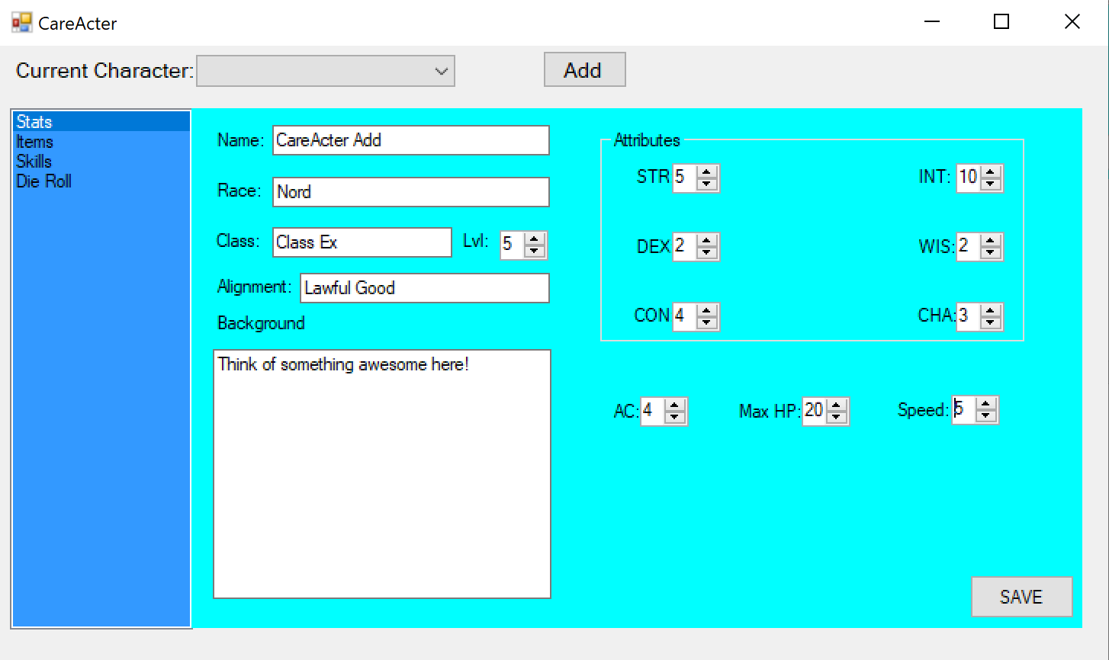

After filling in all of the details of your character, it is time to press the “Save” button at the bottom of your screen. Doing so will display the following confirmation page:

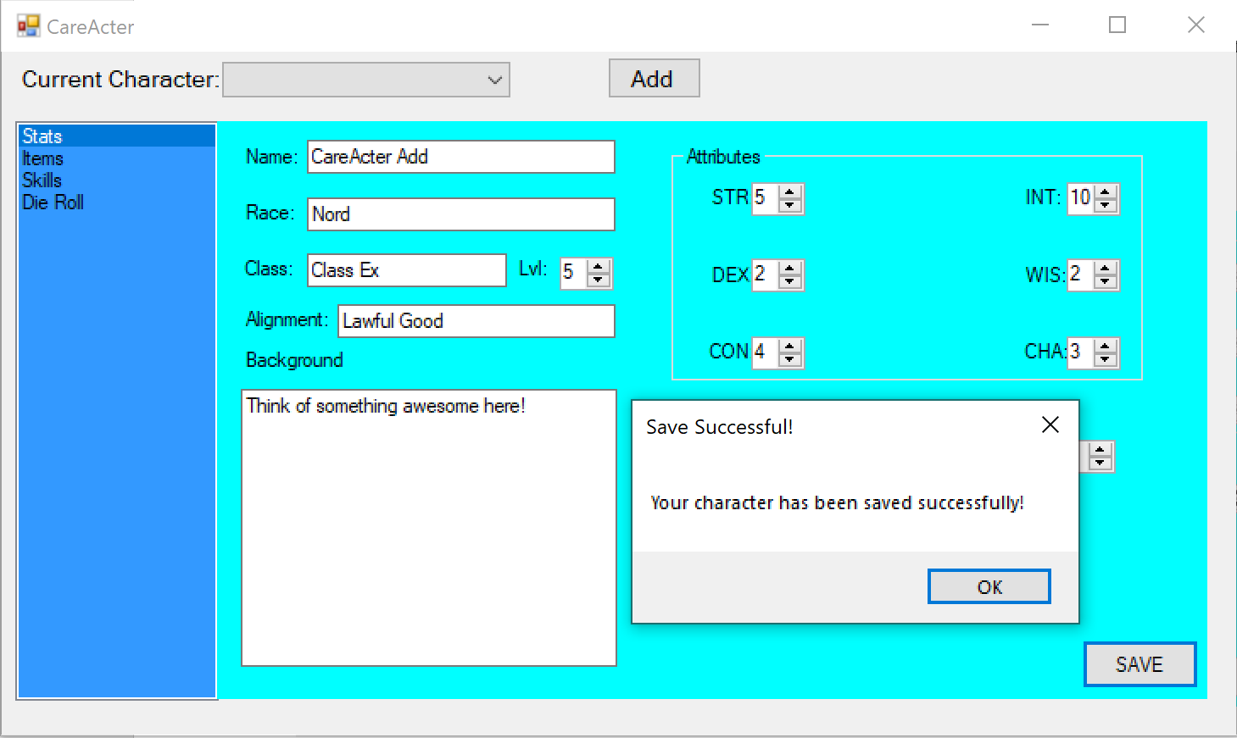

All right! Your character has been created. It will now be available in the Current Character dropdown menu.

Interested in adding a skill or an item to your character? The process is just as similar. Head on over to the item or skill tab.

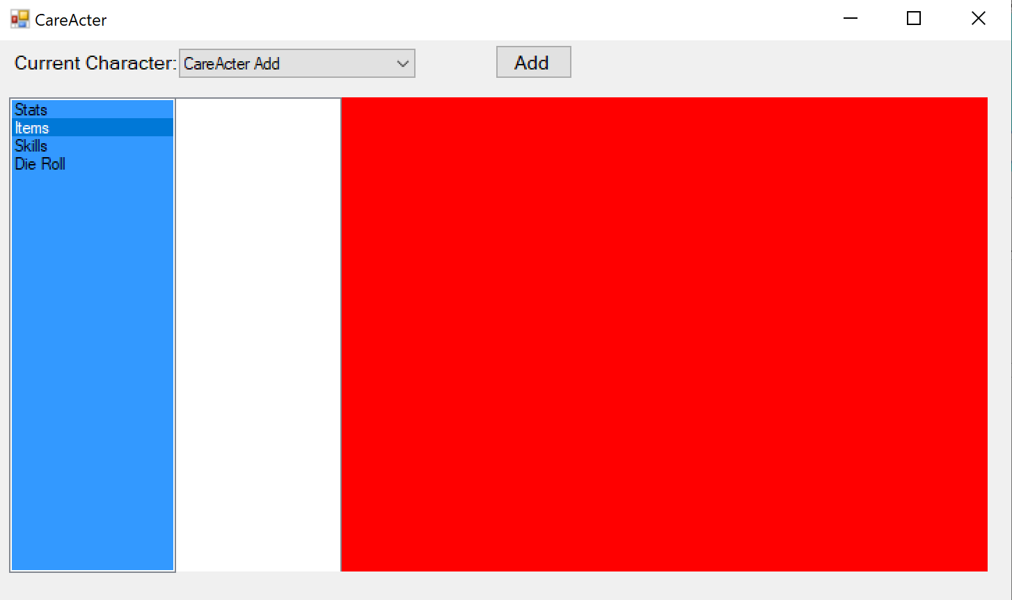

Click on the Add Button.

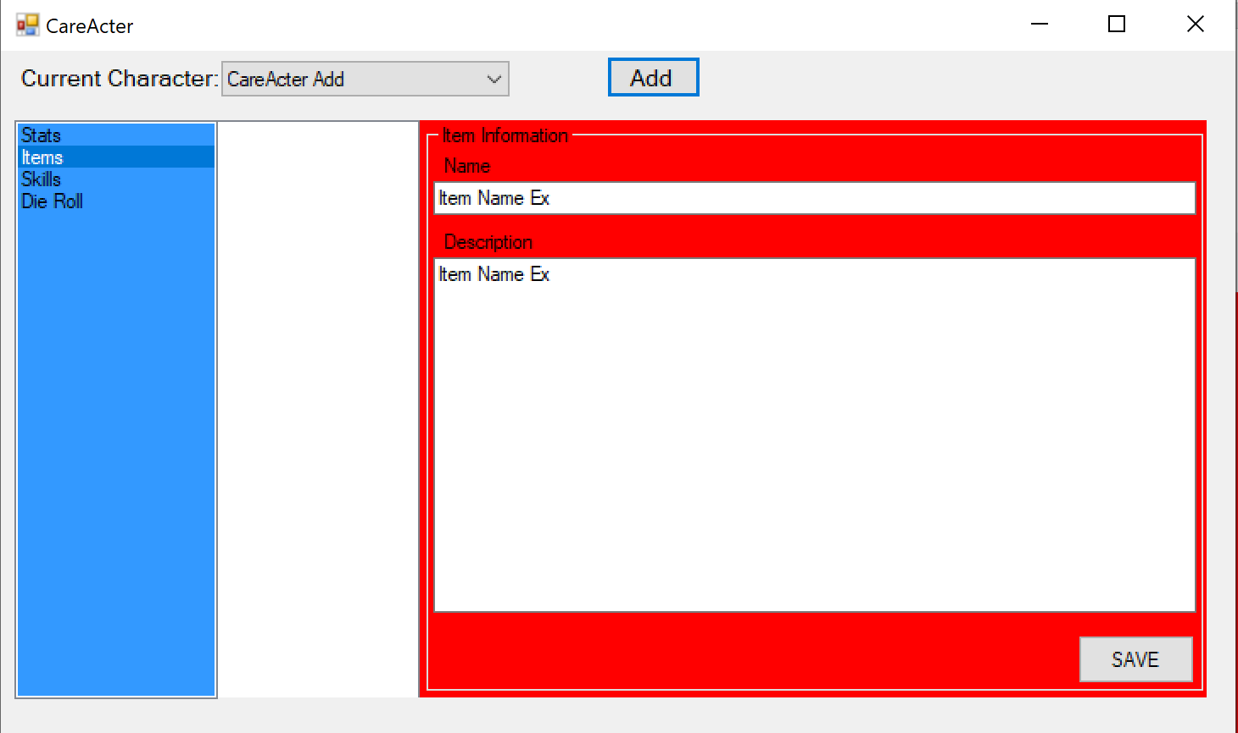

Fill in the Item Name and Description. When you are ready to save, click the “Save” button.

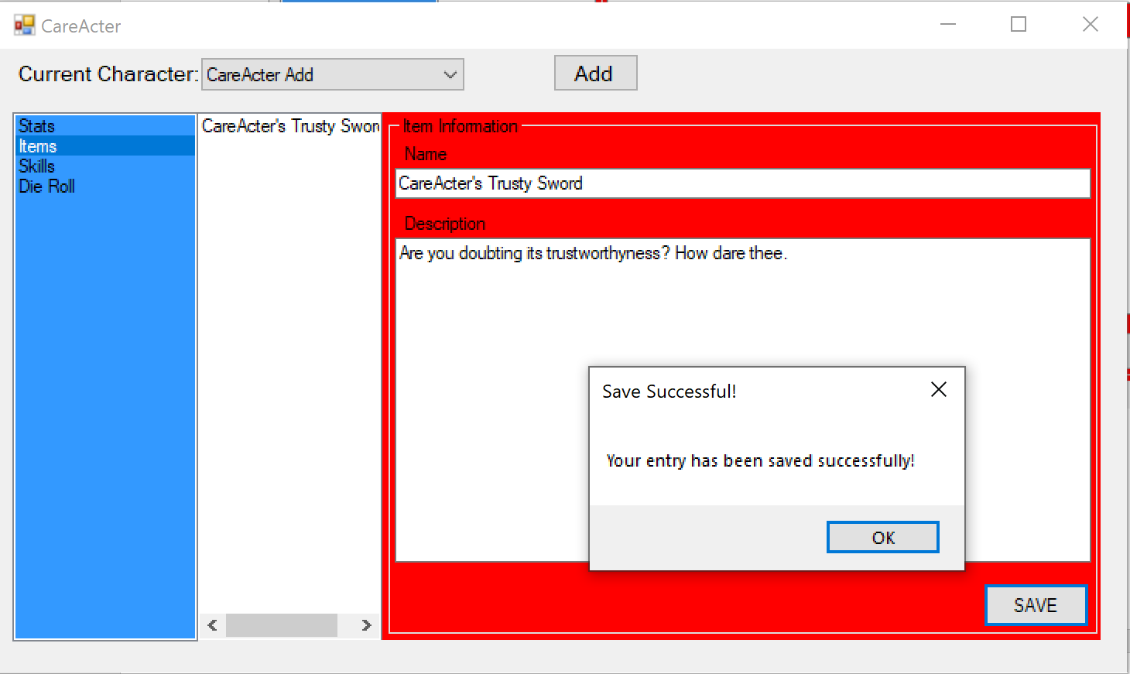

Your item or skill has just been saved!

## Editing a Character

Decided to change your character’s backstory or is it time to level up? Whatever the case, sometimes you need to edit a character. Here is how:

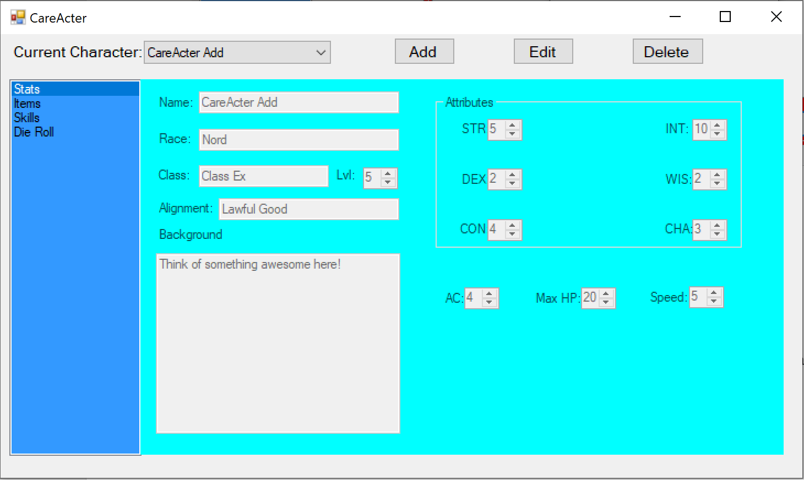

After Selecting a Character from the dropdown, click on the “Edit” Button.

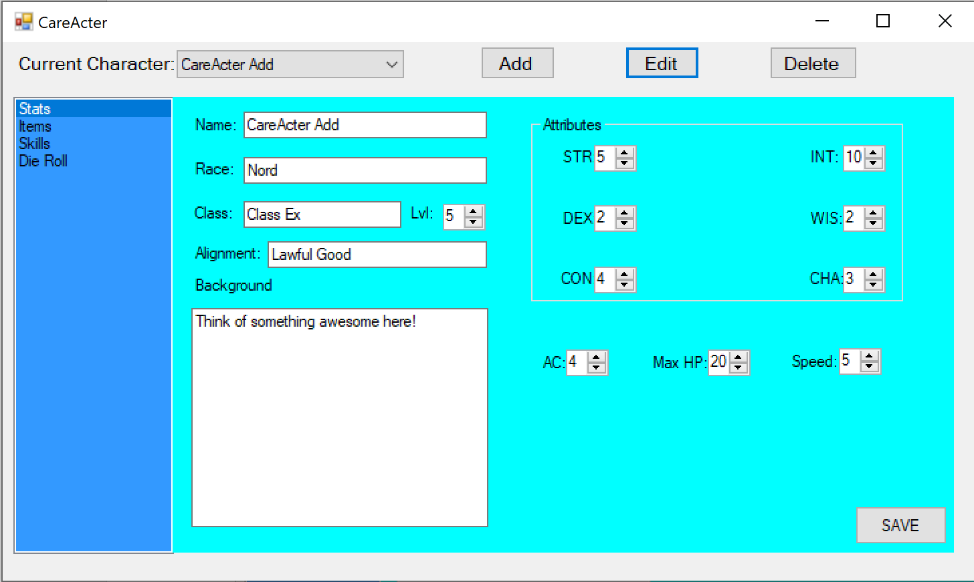

All fields are now able for you to edit! I am going to change the level from 5 to 10. When you are finished making changes, click on the “Save” button.

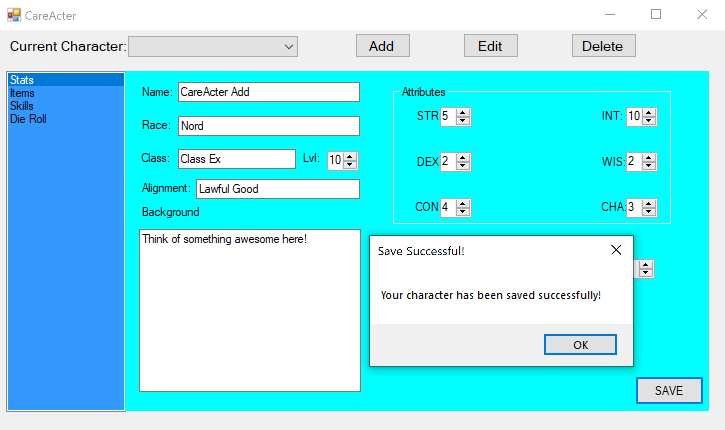

Congrats, your changes are now saved!

The process for a character’s items and skills is very similar. After selecting a character, head over to either the items or skills tab and select an item from the list.

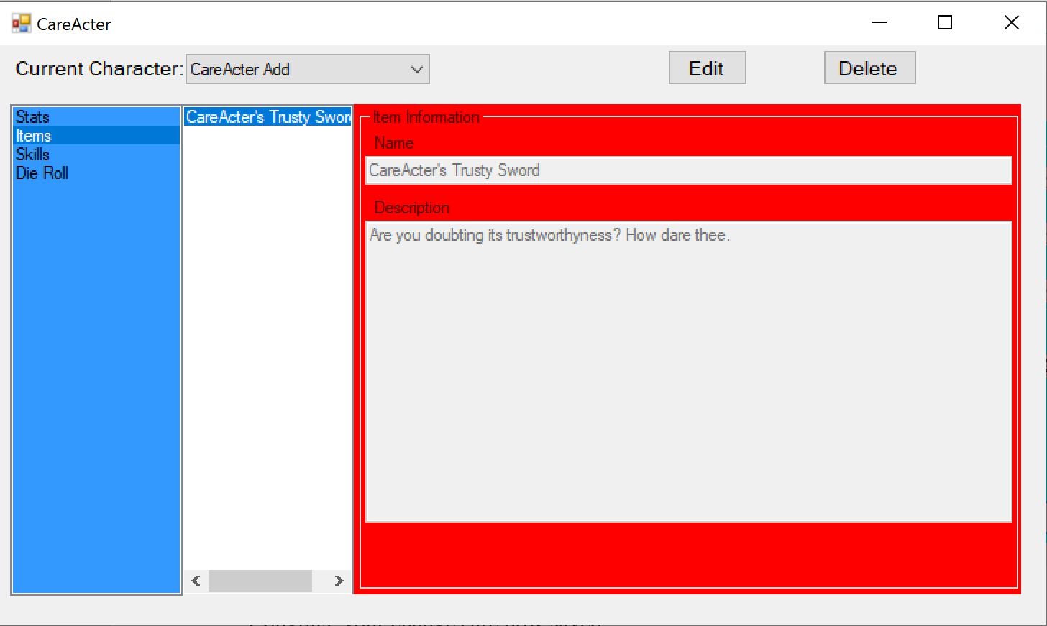

Click the “Edit” button. All text fields will be available for editing. When you are finished, click the “Save” Button.

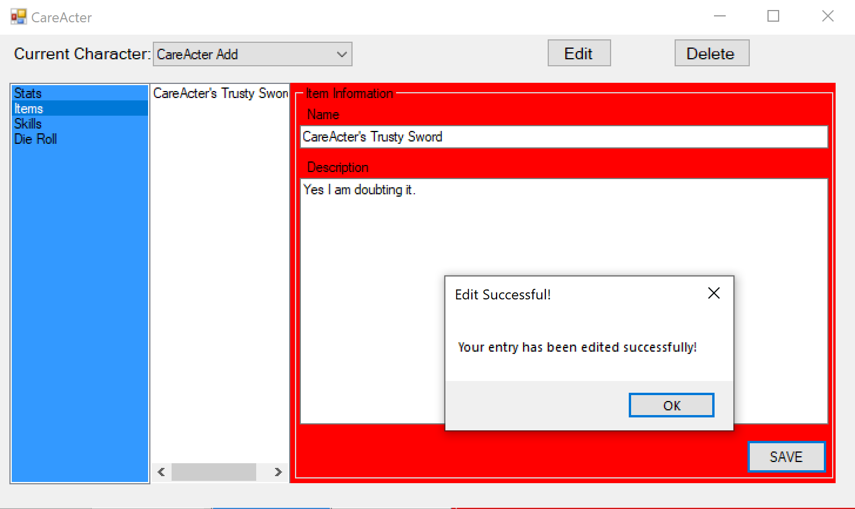

Your item or skill has now been saved successfully!

## Deleting a Character

Has your campaign run its course? Are you never going back to this character? Then the time has come to delete your character. **IMPORTANT NOTICE:** deleting a character will also delete any items or skills that are associated with that character. Remember this before deleting a character!

Let us look at deleting an item or skill first.

Select the item or skill.

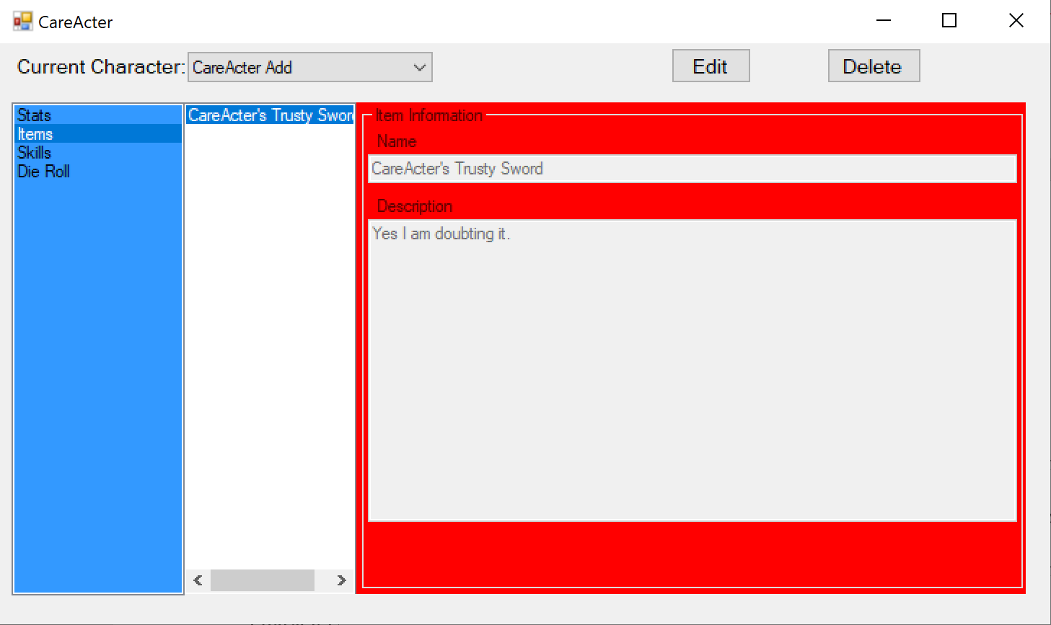

Click the “delete” button.

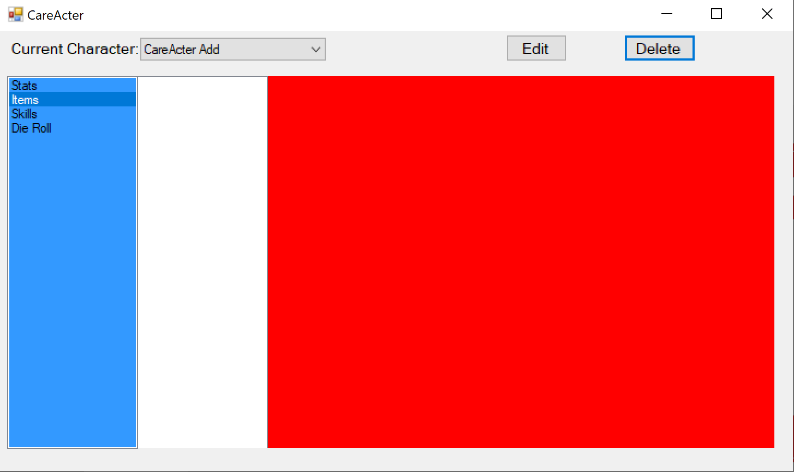

The item has been deleted.

Onto the character page:

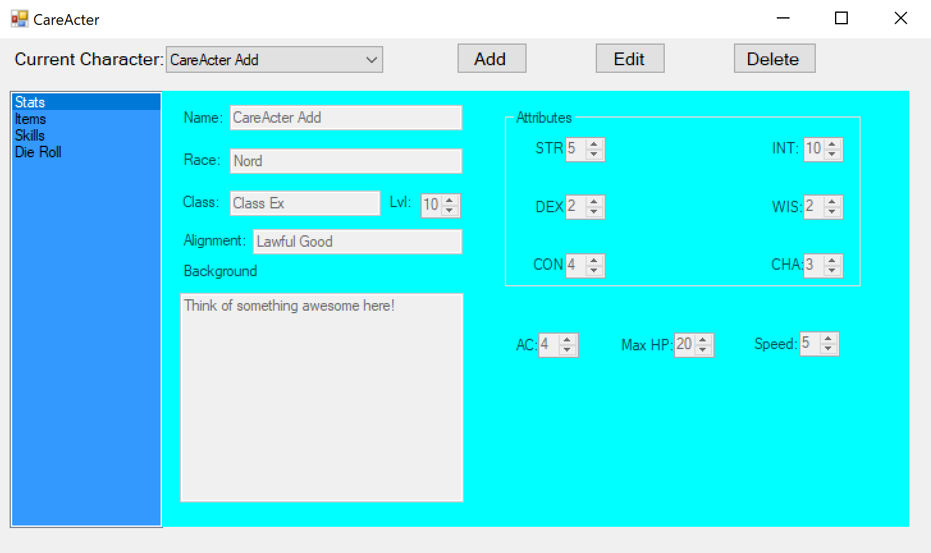

Click the “Delete” button.

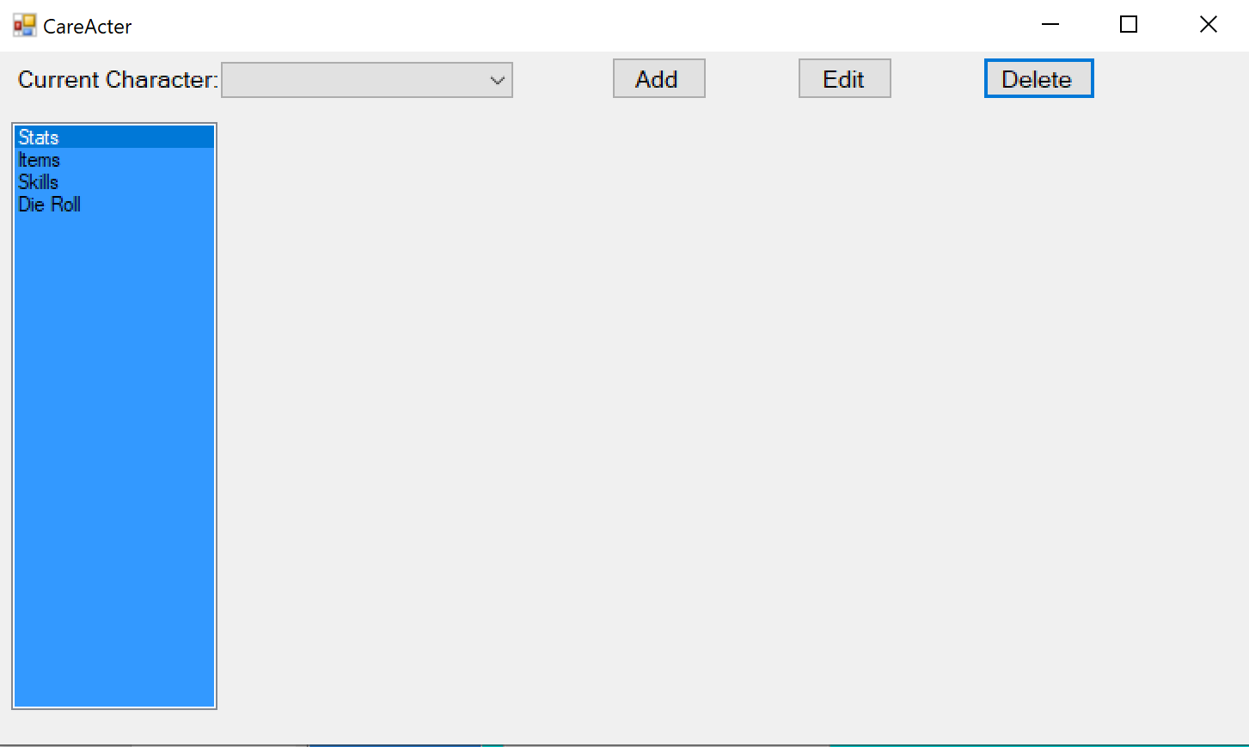

The character and all their items and skills have been deleted.

## Dice Roll Menu

CareActer also comes with a handy Dice Roll tab. Click on the Dice Roll tab.

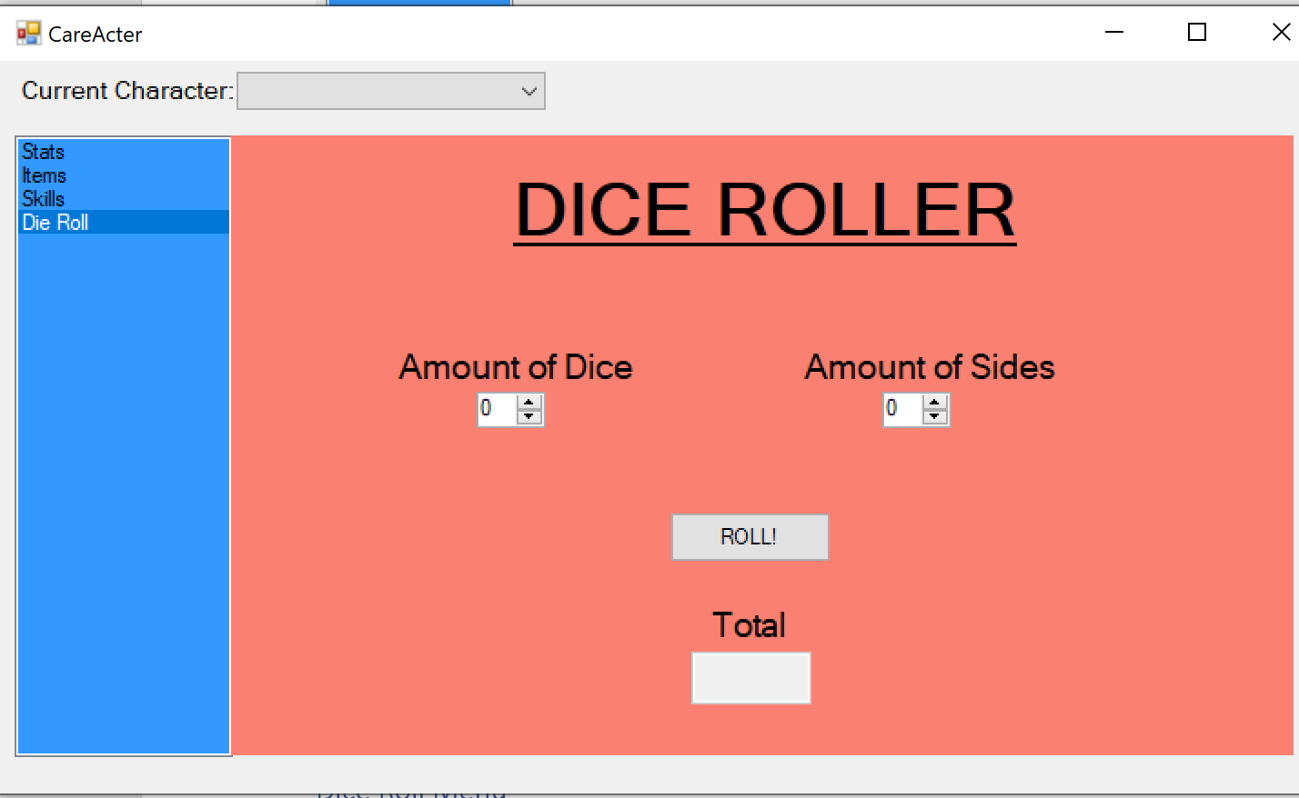

From here, select the amount of dice and the amount of sides each die has. When you are ready, click the “ROLL!” button.

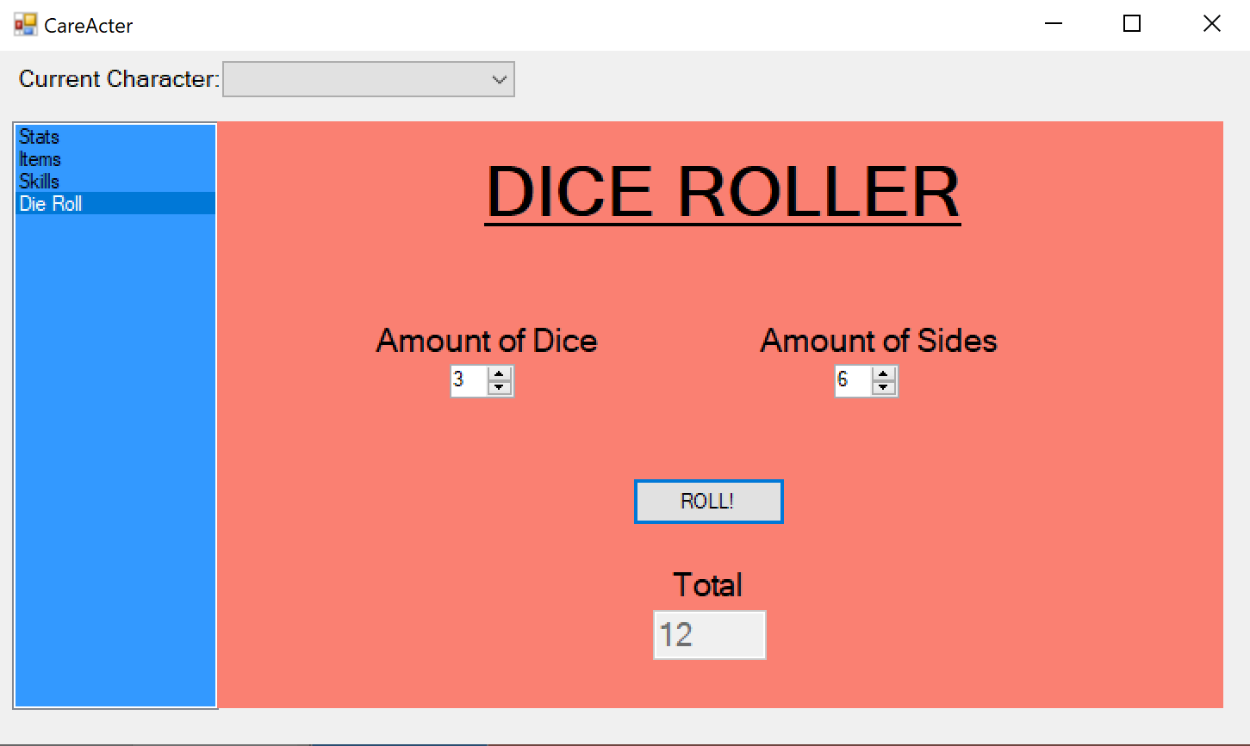

You now have the power to roll at your finger tips!