Thomas Morris

February 18th, 2020

CSC 583

Homework

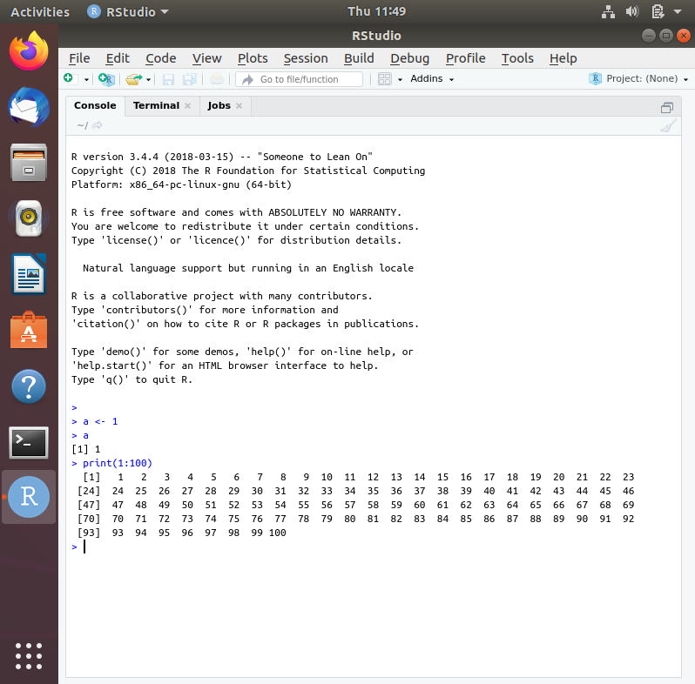

1. Both are numeric class

7)

