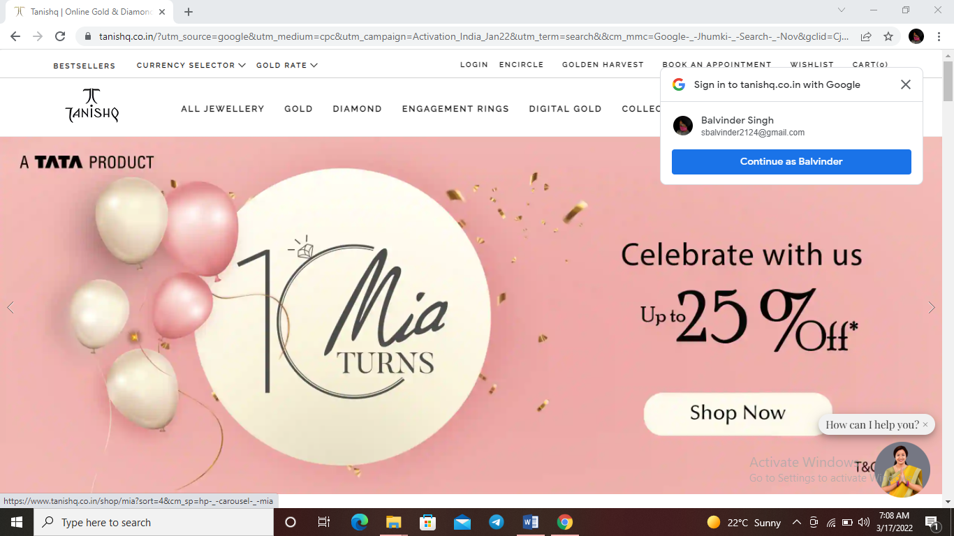

Project Name-***Tanishq***

*Balvinder Singh*

Edureka Presents

**Pages:**

Login / Sign up Page > Home page > Product Page > Buying options > Payment Gateway

Several pages links to homepage which takes us differentpages for explore more

Overview

 Explore the enchanting range of **Tanishq** gold collection. 100% Original. Free Shipping. Express Delivery. Contactless Delivery. Best Standard Safety. Types: Earrings, Pendants, Finger Rings.

Several-pages

1. Home
2. Jweller
3. Necklace
4. Pendant
5. rings
6. diamond rings
7. For several function
8. Signup
9. Login
10. Payment
11. Tracking
12. Contactus
13. Cancellation and refund

Language We use for now

HTML

CSS

For coding

Visual Studio

# For images

Imgbb

HOMEPAGE

Two Navigation Bar With Search Option

Carousel with shoping option

Trending div

Shop by gender div

For special moments jwellery

Header footer