## East West University

**Department of Computer Science and Engineering**

## A/2, Jahurul Islam Avenue, Jahurul Islam City, Aftabnagar, Dhaka

**Lab Manual:** 04

**Lab Topic:** String and Two-Dimensional Array Manipulations

**Course Code:** CSE110 (Object Oriented Programming)

**Course Instructor:** Tanni Mittra, Senior Lecturer, CSE

**Lab Objective**

1. **Apply** concepts of two dimensional arrays and String
2. **Write** and **execute** programs using these concepts in Java.

**Lab Problems**

**01:** Write a program that randomly fills in 0s and 1s into a 4-by-4 matrix, prints the matrix, and finds the first row and column with the most 1s. Here is a sample run of the program:

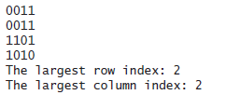

**02:** Write the following method that returns the location of the largest element in a two-dimensional array.

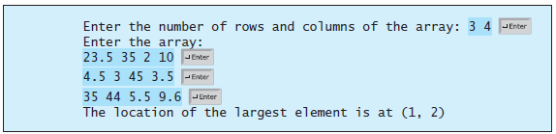

**03:** Write a program that grades multiple-choice test. Students' answers to the questions should be stored in a two dimensional array and answer to the question in a one dimensional array. Display Total number of correct and wrong answer per student. If the correct answer is greater than 7 then print Excellent for each student.

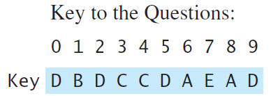

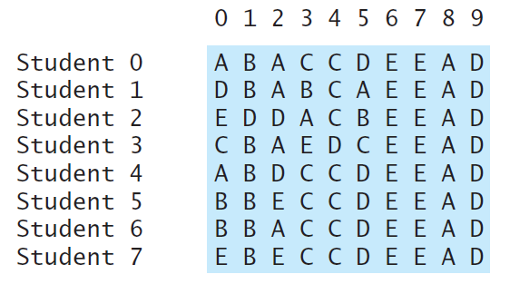

04: Write a java program to Sort N number of strings entered by keyboard in Lexicographical Order (Dictionary Order).

Enter 5 words: R programming

JavaScript

Java

C programming

C++ programming

In the lexicographical order:

C programming

C++ programming

Java

JavaScript

R programming

05: Write a program to sort a two-dimensional array according to the values in any given column

Input: If our 2D array is given as (Order 4X4)

39 27 11 42

10 93 91 90

54 78 56 89

24 64 20 65

Sorting it by values in column 3

Output: 39 27 11 42

24 64 20 65

54 78 56 89

10 93 91 90