

**Final Exam**

Version 1.1

**April 2019**

Date: Thursday, April 9, 2019

Authors: Jeff Palmieri, Kyriakos Mantzouridis, Abi Subedi, Lee Jordan

Last Updated: 4/22/19

**Table of Contents**

1 Abstract 3

1.1 Summary Overview 3

2 Design Steps 3

2.1 Planning 3

2.2 Requirement Analysis 3

2.3 Designing 4

2.4 Development 4

2.5 Testing 4

3 Application 7

3.1 Objects 7

3.2 Screens 7

3.3 Assets 9

4 Source Code Repository 10

4.1 Summary 10

# 1 Abstract

## Summary Overview

Provide an overview about your project task that you are going to work on here.

The group designed a webpage for the Pioneer Records on campus. We wanted to have a simple webpage that people could use to see what it is about, some of the content, how to join us, and an interview section

What it does? Notifications etc.;

# Design Steps

## Planning

What did you do to plan for the application? Did you use slack, met in person, what was the strategy around planning for your application?

We used slack and the time in class to help plan our strategy for the application, we also meet a couple of hours before class starts

How did you face challenges, and what did you do to overcome those challenges?

If we had an issue, we would use slack and try to solve whatever problem we had as a group.

## Requirement Analysis

Discuss what approach did you take in order to understand the matter at hand.

What did you do to understand the approach in order to take the appropriate steps to complete the analysis?

We sat down together as a group and we planned out how we should handle the webpage. From there we took things that were main features of any recording studios web page like an about, interview, join us, and content sections and applied it to our webpage

## Designing

How did you design your pages, did you use a mockup, if you did mockups on a sheet of paper, include it here? Talk about the design approach, use the scenario that I discussed in class on the board as an example.

Jeff had an idea that he wanted to use for the design of the webpage, and we all liked it, so we went with it. We talked about the things we liked and didn’t like in class and Jeff made any changes that needed to be made.

## Development

Discuss about what tasks were taken in development. Who did what, etc;

Lee did the Home Page

Jeff did the join us page

Kyriakos did the about page

Abi did the interview page

## Testing

Include pass/fail testing here.

**Test Scenario 1**:

1. Clicked on the form submission
2. Input email address and contact information
3. Input the reason for signing up.

**Result**:

1. Failed

**Reason**:

1. Could not input a wrong email address into the field. The email format was input wrong.

**Test Scenario 2:**

1. Clicked on the form submission
2. Input email address and contact information
3. Input the reason for signing up.

Result:

**Passed**

# Application

## Objects

Discuss what objects that you’re utilizing.

We use a tool bar that allows you to go from page to page, on the first page you can cycle through the images using the left and right buttons. On the about page we have a button that allows users to go to the point park pioneer records page and learn more about pioneer records.`We also have a contract form that the users can fill out and submit on the join us page.

## Screens

Provide the different screen names, and what the purpose of each screen is.

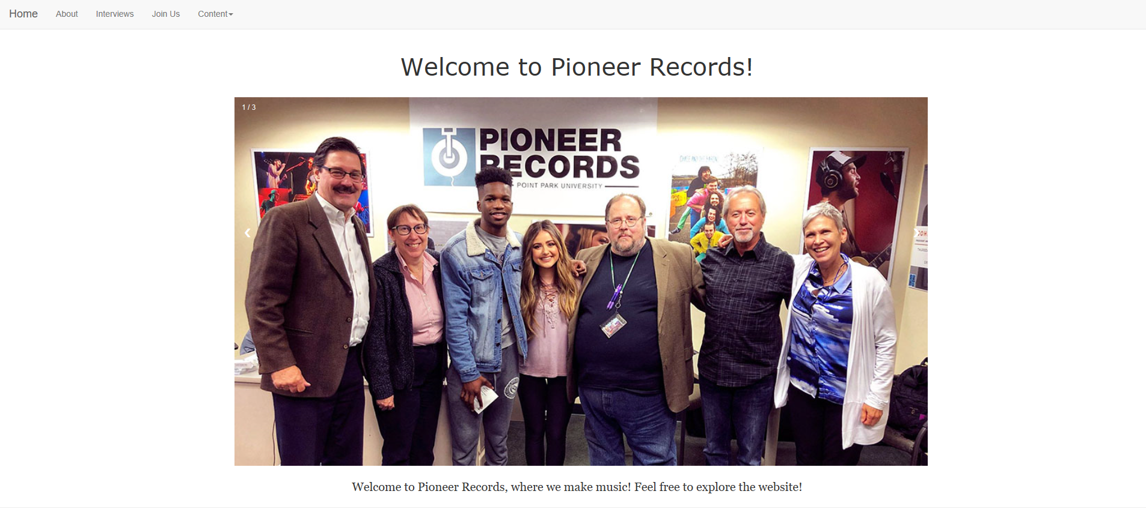

The above Is the welcome/ home screen

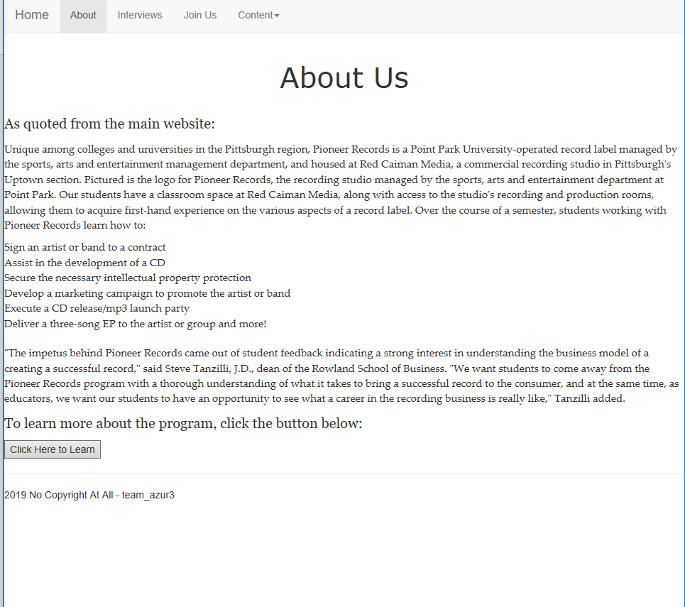

The above is the about us page with a link to the point park webpage.

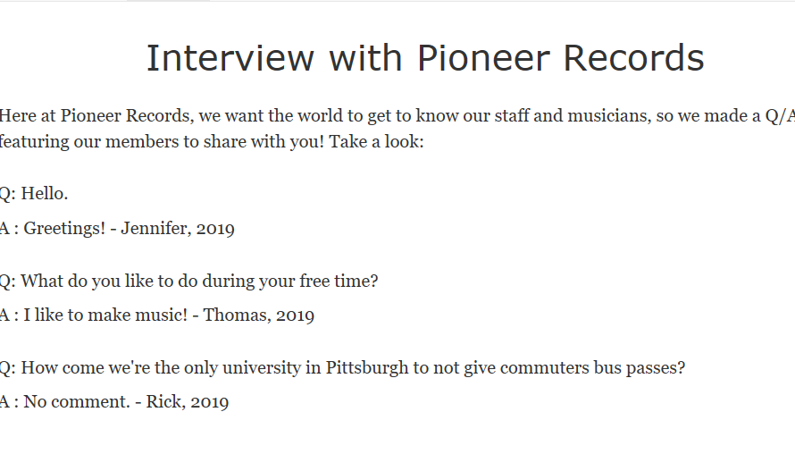the above is an interview page where viewers can see an interview with our staff

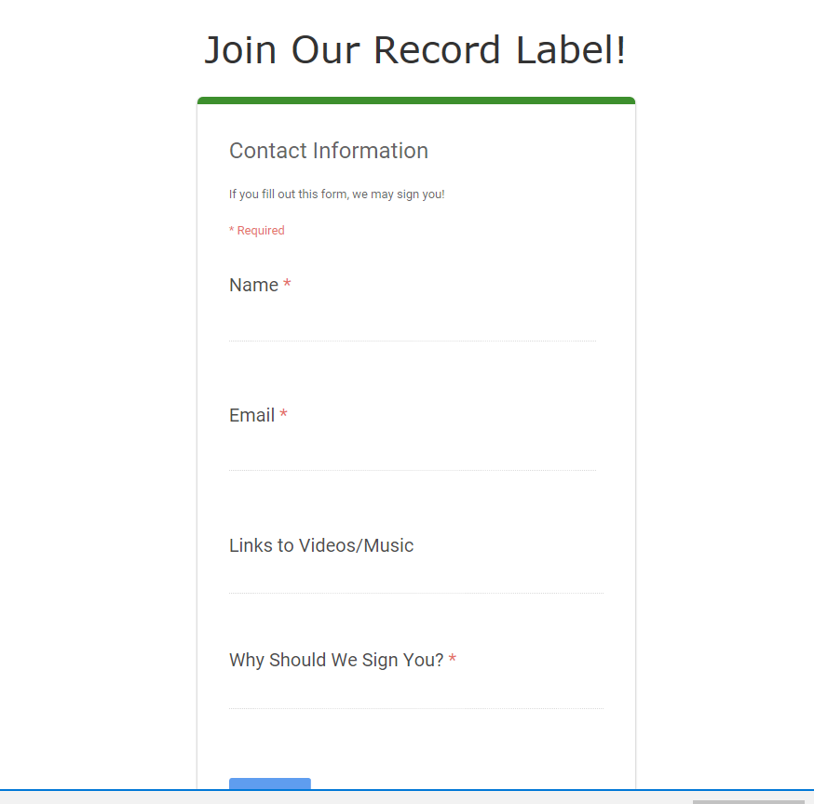

The above is the join us form where users can fill out an application to join the record label

## Assets

Discuss the assets that were used. HTML, JavaScript, CSS, Images etc;

# Source Code Repository

## Summary

<https://github.com/thetrooper159/GroupProjectAdv/tree/master/PRP>