DESIGN AND IMPLEMENTATION OF A FAKE NEWS DETECTION SYSTEM USING NATURAL LANGUAGE PROCESSING

BY

JOSEPH EZINWA EMMANUEL

REG NO. 20211274192

A PROJECT PRESENTED TO THE DEPARTMENT OF SOFTWARE ENGINEERING, FEDERAL UNIVERSITY OF TECHNOLOGY, OWERRI.

IN PARTIAL FULFILLMENT OF THE REQUIREMENTS FOR THE AWARD OF BACHELOR OF TECHNOLOGY (B. TECH) IN SOFTWARE ENGINEERING

OCTOBER 2026
CERTIFICATION

DEDICATION

ACKNOWLEDGEMENT

ABSTRACT
This study designed and implemented a system for fake-news detection and evidence retrieval using Natural Language Processing and transformer models. It addresses the challenge of analysing news articles at scale while recognising that a machine-learning prediction alone cannot establish whether an article is true.
The study prepared the ISOT Fake News Dataset through data cleaning, duplicate removal, label processing, and stratified splitting. It trained and evaluated a TF-IDF and Logistic Regression classifier and a fine-tuned DistilBERT model on the same held-out test set. DistilBERT achieved 99.95% accuracy, compared with 99.00% for the classical model.
The system also extracts checkable claims and retrieves relevant web sources through the Brave Search API, presenting evidence separately from the article-level prediction.
A FastAPI backend and responsive web interface bring these components together. The results demonstrate the feasibility of integrating text classification with evidence retrieval in a research prototype.
However, the evaluation relies primarily on the ISOT dataset and does not establish generalisation to current news, Nigerian news, or other domains. The system is therefore intended to support research and human review, not to serve as a definitive fact-checking authority.

TABLE OF CONTENTS

LIST OF TABLES

LIST OF FIGURES

CHAPTER ONE
INTRODUCTION
1.1 Background to the Study
For many people, the first account of an important event now arrives through a phone rather than a newspaper or scheduled broadcast. News websites, social networks, and messaging applications can carry a report to thousands of readers within minutes. This speed has made information easier to access, but it has also made false or misleading stories easier to circulate. By the time journalists or professional fact-checkers investigate a questionable report, it may already have been copied, discussed, and shared across several platforms.
This problem is especially relevant in Nigeria, where online reports shape conversations about politics, public health, security, business, and community life. A false story can move from a social-media post to a messaging group and then reappear on another platform without its original context. During elections, disease outbreaks, or security incidents, readers may face several conflicting accounts at once and may not have the evidence needed to judge them. Ahmed and Msughter (2022), in their study of COVID-19 information among social-media users in Kano State, linked exposure to fake news with consequences such as failure to follow safety measures. The concern, then, is not simply that false information exists. It is that it travels quickly and often looks convincing.
Although the expressions misinformation, disinformation, and fake news are often used interchangeably, they do not mean exactly the same thing. Misinformation is inaccurate information that may be shared without an intention to cause harm. Disinformation is deliberately created or circulated to deceive. Fake news usually refers to fabricated or seriously misleading content presented in the form of a genuine news report. For the purpose of this study, fake-news detection is framed as supervised text classification. The model reads the text of an article and estimates whether its language is more similar to articles labelled real or fake in the training data.
That definition sets an important boundary around what a text classifier can claim. On its own, it does not interview witnesses, consult official records, or check a report against current evidence. It learns patterns in vocabulary, style, topic, punctuation, and document structure. Some of those patterns may be useful, but none of them proves that a claim is true. For this reason, the proposed system adds an evidence-retrieval stage to the classifier. It identifies checkable claims in the article, searches for recent information from relevant and credible online sources, and compares the retrieved evidence with those claims. The system remains a decision-support tool, but its assessment is informed by both learned language patterns and evidence available at the time of analysis.
The two forms of analysis are kept visible rather than being treated as the same thing. The classification component produces the cautious labels Likely Real and Likely Fake with a confidence score. The evidence component reports whether the retrieved information supports, contradicts, is mixed about, or is insufficient to assess a claim. It also presents source links, publication dates, and the time of retrieval. This distinction reduces the risk that a strong linguistic prediction will be mistaken for factual proof or that weak search evidence will be presented as conclusive.
Natural Language Processing (NLP) makes it possible for a computer to represent and analyse written language. In this case, article text must first be converted into numerical features before a machine-learning model can work with it. Traditional approaches use features such as word frequency, n-grams, and term weights. Ahmed, Traore, and Saad (2017, 2018) showed that these features can help distinguish labelled fake articles from truthful ones. The approach is efficient and provides a useful baseline, although it captures observed word patterns more readily than the wider meaning of a sentence or document.
Term Frequency-Inverse Document Frequency (TF-IDF) is a widely used representation for classical text classification. It increases the importance of terms that occur frequently in a document but are less common across the entire document collection. A classifier such as Logistic Regression can then learn weights associated with terms or n-grams and produce a probability for each class. This combination is suitable as a baseline because it trains comparatively quickly, supports fast CPU inference, and makes it possible to inspect influential features.
Transformer models provide a more contextual approach to language representation. BERT introduced deep bidirectional pre-training that allows a model to interpret a word using the text that appears before and after it (Devlin et al., 2019). DistilBERT applies knowledge distillation to produce a smaller and faster version of BERT while retaining much of its language-understanding capability (Sanh et al., 2019). A fine-tuned DistilBERT classifier can therefore learn contextual patterns that a sparse TF-IDF representation may not capture. However, transformer training and inference generally require more computation, memory, and deployment resources than a classical model.
Rather than assume that the newer model will be better, this study compares both approaches under the same conditions. The classical branch combines TF-IDF with Logistic Regression, with a Linear Support Vector Machine as an optional benchmark. The second branch fine-tunes DistilBERT for the same binary task. Both models use the same reproducible data splits and evaluation procedure. Accuracy, precision, recall, F1-score, confusion matrices, error patterns, inference time, model size, and deployment needs are considered together. In this way, the final choice is based on evidence rather than model complexity alone.
The primary data source is the ISOT Fake News Dataset created by the Information Security and Object Technology Research Lab at the University of Victoria. It contains thousands of labelled truthful and fake news articles and is suited to an article-level workflow. The dataset is preferred to the LIAR benchmark for this study because LIAR consists mainly of short political statements, while the proposed system is designed to analyse fuller news-article text. The data pipeline loads the original Fake.csv and True.csv files, assigns labels, aligns fields, removes null and duplicate records, constructs the classification text, and generates reproducible stratified splits.
Careful preparation of the dataset is just as important as the choice of algorithm. If duplicate or nearly identical articles appear in both the training and test sets, the final score may look impressive even though the model has learned little that is useful. There is also a risk that the model will recognise a publisher or a recurring topic instead of learning patterns that transfer to other news sources. To make the experiment traceable, the study records its cleaning decisions, random seeds, dataset version, model settings, and outputs. False positives and false negatives are examined alongside the overall scores.
The implemented system combines the research pipeline with a usable full-stack application. A Next.js web application provides the user interface, while a FastAPI service validates requests and coordinates prediction and evidence retrieval. Shared Python modules handle data preparation, classical training, transformer fine-tuning, evaluation, artifact metadata, model loading, and production inference. When a user submits an article, the selected model first analyses its language. A separate verification workflow then extracts important factual claims, creates search queries, retrieves current material from selected online sources, ranks the evidence for relevance and source quality, and compares it with the claims. The response contains the model label and confidence, an evidence status, source citations, retrieval dates, model information, processing time, and a responsible-use disclaimer.
The architecture separates offline model development from online analysis. Training and evaluation occur outside the production request path, and only a validated artifact referenced by production metadata is loaded by the API. Current evidence, however, is retrieved when an article is analysed because it cannot be fixed at training time. Search results are filtered by relevance, date, accessibility, and source policy. The retrieved pages are treated as evidence candidates rather than automatically accepted as true. This separation allows the trained model to remain reproducible while the evidence layer can respond to recent events.
The work therefore goes beyond training a classifier in a notebook. It brings together data preparation, two modelling approaches, comparative evaluation, model management, a documented REST API, a responsive interface, testing, experiment records, and responsible-use guidance. At its centre are two related questions: how does a classical text classifier compare with a transformer on the same task, and how can the selected model be made available to users without presenting its output as unquestionable truth?
1.2 Statement of the Problem
Online stories can reach a large audience long before anyone has checked their claims, sources, or context. Some misleading reports are presented with the language and layout of professional journalism, making them difficult for an ordinary reader to recognise. Repetition can add an appearance of credibility: a story seen on several platforms may feel reliable even when each version comes from the same false source. Manual verification remains necessary, but it is much slower than sharing.
Although professional fact-checking remains essential, it is labour-intensive and cannot always provide an immediate first assessment for every reader. There is therefore a need to investigate automated tools that can analyse article text and identify patterns associated with labelled real and fake news. Such tools can support screening, research, media monitoring, and reader awareness, provided their limitations are communicated clearly.
There is also a practical question about which kind of model to use. A TF-IDF classifier is comparatively inexpensive to train and serve, but it may overlook context. A transformer can model context more effectively, yet it demands more memory, computation, and deployment effort. Evaluating only one of these approaches would leave that trade-off unanswered. They need to be compared on the same data and under the same evaluation conditions.
Even a high accuracy score can conceal serious weaknesses. If a credible article is wrongly labelled fake, the result may unfairly damage trust. If a fabricated article is labelled real, the output may give a reader false reassurance. Leakage, duplicated articles, source bias, class imbalance, and changes between the training data and real-world news can make the reported performance look better than it is. For that reason, this study considers class-level results, confusion matrices, typical errors, latency, and model size, not accuracy alone.
There is also an implementation gap between an experimental model and a responsible user-facing system. A notebook result does not provide input validation, stable model loading, current-source retrieval, evidence ranking, source citations, error handling, model versioning, responsive presentation, or disclaimers. Without these elements, users may misinterpret a score or assume that a linguistic classifier has checked the article against recent facts. A responsible system must also handle cases in which search results are unavailable, conflicting, outdated, or insufficient.
In response, this study designs and implements a full-stack automated fake-news detection system that prepares the ISOT dataset, trains a TF-IDF and Logistic Regression baseline, fine-tunes DistilBERT, and evaluates both approaches under a shared framework. The selected classifier is combined with claim extraction, current-source search, evidence ranking, and evidence-based verification. Predictions and supporting or contradicting sources are served through a web API and presented through a responsive interface using cautious labels and responsible-use information.
1.3 Objectives of the Study
The general objective of this study is to design and implement a full-stack system that uses NLP and machine-learning models to estimate whether a news article is likely real or likely fake from its textual content.
The specific objectives are to:
- develop a reproducible pipeline for loading, validating, cleaning, labelling, and splitting the ISOT Fake News Dataset;
- implement a classical fake-news classification baseline using TF-IDF and Logistic Regression, with an optional Linear SVM benchmark;
- fine-tune a DistilBERT transformer model on the same binary article-classification task;
- evaluate the candidate models using accuracy, precision, recall, F1-score, confusion matrices, class-wise results, inference latency, model size, and representative error analysis;
- select and export a validated production model with versioned metadata and metrics;
- implement a claim-extraction and search component that retrieves recent information from relevant and credible online sources;
- develop an evidence-analysis component that ranks retrieved material and identifies whether it supports, contradicts, or provides insufficient information for the extracted claims;
- develop a FastAPI service that returns the predicted class, confidence score, evidence status, cited sources, retrieval date, model identity, processing time, and disclaimer;
- develop a responsive Next.js interface through which users can submit article text and review both the model prediction and the retrieved evidence; and
- implement automated tests and documentation covering data processing, preprocessing, model utilities, search and retrieval behaviour, evidence handling, API responses, frontend states, system limitations, and responsible use.
1.4 Scope of the Study
This study covers the design and implementation of an English-language fake-news detection and evidence-retrieval system. The machine-learning scope includes ISOT dataset ingestion, schema validation, invalid-record and duplicate handling, text construction, label encoding, stratified train-validation-test splitting, classical preprocessing, TF-IDF feature extraction, Logistic Regression training, optional Linear SVM comparison, DistilBERT tokenisation and fine-tuning, shared evaluation, experiment reporting, model selection, and production artifact loading.
The evidence-retrieval scope includes extracting a limited set of checkable claims from an article, generating search queries, retrieving recent public web sources, recording URLs and retrieval times, filtering and ranking results, extracting relevant passages, and assigning an evidence status of supported, contradicted, mixed, or insufficient evidence. Preference is given to primary sources, official records, established news organisations, and professional fact-checking publications where appropriate. Search rank alone is not treated as proof of credibility.
The application scope includes a Next.js and TypeScript frontend, a FastAPI and Pydantic backend, request validation, environment-based configuration, model, search, evidence, and metrics endpoints, health checks, error handling, confidence presentation, cited evidence, and a responsible-use disclaimer. Automated testing covers central Python modules, API behaviour, retrieval failures, conflicting evidence, frontend components, and the main browser workflow.
The study uses the ISOT dataset as its primary classification benchmark and treats each input as article text. It does not build a general-purpose crawler, monitor private messages, or automatically collect user data. It does not perform image, audio, or video verification or analyse social-network propagation. Web retrieval is limited to publicly accessible textual sources returned for specific extracted claims. The system does not guarantee that every relevant source is indexed, accessible, current, independent, or correct, and it does not automatically remove, censor, or penalise content.
The system is not a substitute for professional fact-checking. Its classifier reflects patterns learned from historical labelled examples, while its retrieval component depends on the quality and availability of online sources. Newly emerging events may have little reliable evidence, and different credible sources may disagree. The classifier may also perform poorly on Nigerian local journalism, satire, scientific reporting, multilingual content, machine-generated articles, or other material outside the training distribution. The application therefore presents classification and evidence findings separately and allows an Insufficient Evidence outcome.
1.5 Significance of the Study
For readers, the proposed system provides more than a model score. It offers a preliminary linguistic assessment and shows recent evidence that may support or challenge important claims in the article. Source links, dates, and an insufficient-evidence option make uncertainty more visible and give readers a starting point for further verification.
For journalists, fact-checkers, moderators, and media-monitoring teams, the proposed system provides a prototype screening tool that may help prioritise content for human review and locate potentially relevant sources. It does not replace investigation, but it demonstrates how classification, search, and evidence comparison can contribute to a broader verification workflow.
For machine-learning researchers and students, the study offers a reproducible comparison between a strong classical baseline and a fine-tuned transformer. Using the same data split and evaluation utilities makes the performance-cost trade-off more defensible. The inclusion of confusion matrices, error analysis, latency, artifact size, and experiment metadata also encourages evaluation beyond a headline accuracy value.
For software engineering practice, the study demonstrates the path from an experimental NLP pipeline to a modular application. It connects Python model development, artifact versioning, FastAPI inference, Pydantic validation, Next.js presentation, automated testing, and environment-based configuration while maintaining a clear separation between training and serving.
For Nigerian academic and social contexts, the study contributes a practical discussion of automated misinformation detection while explicitly acknowledging domain limitations. It provides a foundation for future evaluation on locally sourced Nigerian news, multilingual material, source-aware features, claim-level evidence retrieval, and collaboration with professional fact-checkers.
Finally, the study contributes to responsible AI practice by avoiding absolute claims. It distinguishes statistical classification from factual verification, records known limitations, discourages automated censorship, and requires human judgement for consequential decisions.
1.6 Limitation of Study
The findings of this study are limited by the datasets used to develop and evaluate the classification models. The ISOT Fake News Dataset is the primary labelled dataset, and its articles represent a particular set of publishers, topics, periods, and editorial styles. The labels in the dataset are treated as the classification targets; they do not provide an independent measure of the factual accuracy of every sentence. The models may therefore learn associations between writing style or source markers and dataset labels instead of general features of misinformation. A source-style diagnostic conducted during development showed that the DistilBERT model's prediction on an accurate NASA example changed when a wire-service dateline was added. This result indicates sensitivity to style cues and reinforces that the reported ISOT scores should not be interpreted as proof of real-world accuracy.
The evaluation is primarily in-distribution. The study does not include a large, independently collected Nigerian news dataset or a full cross-dataset benchmark. A small hand-labelled challenge set is used for diagnostic error analysis, but it is not large or representative enough to establish general performance across publishers, regions, topics, or time periods. Consequently, the results may not transfer to local Nigerian reporting, newer events, different editorial conventions, or articles outside the training distribution. Changes in the vocabulary and style of news over time may further reduce performance.
The classification component analyses article text and estimates whether its patterns resemble examples labelled real or fake in the training data. It does not independently verify the truth of claims. Its confidence score is a model output and must not be read as the probability that an article is factually correct. The models can produce both false positives and false negatives, including confident errors. The system is therefore unsuitable as the sole basis for decisions that could affect a person's reputation, access to information, employment, or other important interests.
Evidence retrieval is also constrained. The Transformer workflow ranks retrieved material using lexical relevance and presents passages with overlap to a claim; it does not currently use a trained natural-language-inference component to determine whether each passage entails or contradicts that claim. Search depends on the configured provider, its index and limits, page accessibility, and the wording of the extracted claim. Relevant information may be missed, while a retrieved page may mention the same terms without addressing the claim. Source labels and ranking preferences do not guarantee that a source is accurate, independent, or authoritative. Retrieval results are consequently advisory and require direct human review.
The analysis is bounded by the number of claims and sources processed and by the amount of text accepted by the application. It focuses on English-language article text and publicly accessible web pages. It does not analyse images, video, audio, private messages, social-network propagation, author intent, or the provenance of a document. It is not a general web crawler and cannot guarantee coverage of every relevant source or event.
Finally, the implementation is a research prototype rather than a large-scale field deployment. Automated software tests assess important pipeline, API, and interface behaviours, but they do not replace a broad user study, a comprehensive fairness audit, or long-term monitoring in operational settings. The study demonstrates a technical workflow for classification and evidence retrieval; it does not establish that the system reduces the spread or impact of misinformation.
1.7 Definition of Terms
Accuracy: The proportion of all evaluated examples that a model classifies correctly.
Application Programming Interface (API): A defined interface through which the frontend sends article text to the backend and receives prediction results.
Artificial Intelligence (AI): The broad field concerned with computer systems that perform tasks commonly associated with human intelligence, including language analysis and pattern recognition.
Classification: The process of assigning an input to one of a defined set of categories. In this study, the categories are likely real and likely fake.
Claim Extraction: The identification of factual statements in an article that can reasonably be checked against external evidence.
Confidence Score: A model-derived numerical value representing the strength of a prediction. It is not proof or factual certainty.
Confusion Matrix: A table that summarises correct and incorrect predictions for each class, including false positives and false negatives.
DistilBERT: A compact transformer language model produced by distilling knowledge from BERT and suitable for fine-tuning on text-classification tasks.
Domain Shift: A change between the data on which a model was trained and the data it encounters after deployment.
Evidence Retrieval: The process of searching for and selecting source passages relevant to an extracted claim.
Evidence Status: The system's summary of whether retrieved evidence supports, contradicts, is mixed about, or is insufficient to assess a claim.
F1-Score: The harmonic mean of precision and recall, used to balance both measures in classification evaluation.
Fake News: For this study, article-style content labelled as fabricated or misleading in the research dataset. The term does not imply that the system can independently establish truth.
FastAPI: A Python web framework used in the implementation to expose the model's inference service and documented endpoints.
Fine-Tuning: The process of adapting a pretrained model to a specific labelled task by continuing its training on task-specific data.
Inference: The use of a trained model to generate a prediction for previously unseen input.
ISOT Fake News Dataset: A labelled collection of truthful and fake news articles released by the University of Victoria's ISOT Research Lab and used as the primary dataset in this study.
Logistic Regression: The supervised statistical classifier used in this study as the primary classical baseline.
Machine Learning: A field of computing in which algorithms learn patterns from data to make predictions or decisions.
Natural Language Processing (NLP): Computational methods for representing, analysing, and generating human language.
Next.js: The React-based web framework used to implement the proposed system's user interface.
Precision: The proportion of examples predicted as belonging to a class that actually belong to that class in the labelled evaluation data.
Recall: The proportion of labelled examples in a class that the model correctly identifies.
Retrieval-Augmented Verification: A process in which information retrieved from external sources is supplied to an NLP component to support the assessment of a claim.
Source Credibility: The degree to which a source is considered authoritative, transparent, relevant, and dependable for the claim being examined.
Temporal Relevance: The extent to which retrieved evidence is recent enough, or appropriately dated, for the event or claim under examination.
Stratified Split: A division of data that preserves approximately the same class proportions across training, validation, and test sets.
TF-IDF: Term Frequency-Inverse Document Frequency, a numerical weighting method that represents how important a term is to a document relative to a collection.
Transformer: A neural-network architecture based on attention mechanisms and widely used for contextual language modelling.

CHAPTER TWO
LITERATURE REVIEW
This chapter situates the study within research on automated fake-news detection and evidence-based claim verification. It first clarifies the meaning of fake news and the forms of information available to a detection system. The discussion then turns to supervised text classification, TF-IDF, Logistic Regression, transformer models, benchmark datasets, web evidence retrieval, evaluation, misinformation in Nigeria, and responsible deployment. Taken together, these areas show that a useful detection system depends on more than the choice of an algorithm. Its data must be prepared carefully, competing models must be evaluated on equal terms, current evidence must be retrieved from credible sources, and uncertainty must remain visible in the final result.
2.1 Conceptual Framework
The conceptual framework begins with the language of a news article and extends the analysis by considering external evidence. Online reports move quickly between news sites, search engines, social networks, and messaging applications. Although these channels broaden access to information, they can spread fabricated stories just as efficiently. Shu et al. (2017) therefore describe fake-news detection as a data-mining problem that may draw on both the content of a report and the social activity surrounding it. From an NLP perspective, Oshikawa, Qian, and Wang (2020) emphasise the difficulty of the task and distinguish it from related work on rumours, stance detection, and fact-checking.
The terms used to describe the problem are important. Misinformation can be false even when the person sharing it has no intention to mislead, whereas disinformation generally involves deliberate deception. Fake news commonly imitates the form of legitimate reporting while presenting fabricated or seriously misleading information. These categories often overlap, and a binary dataset label cannot fully represent intention, credibility, or factual accuracy. The classifier developed in this study therefore makes a narrower judgement: it estimates whether an article resembles the real or fake examples in its training data. It does not, by itself, establish the truth of every claim in the article.
Researchers have approached the task with different kinds of information. Content-based methods examine the language or structure of a report. Social-context methods consider who shared it, how it spread, and how other users responded. Knowledge-based methods compare claims with external evidence, while multimodal methods combine text with images, audio, or video. The present study begins with article text but does not rely on linguistic patterns alone. It also extracts checkable claims and searches public online sources for recent evidence that may support or contradict them.
Text is usually easy to obtain and can be processed consistently, which makes content classification practical. Still, language is only indirect evidence of truth. A model may learn the style of a particular publisher, the names linked to a recurring topic, or even the formatting of the dataset. It can therefore reach the correct label for the wrong reason. Evidence retrieval addresses part of this weakness by connecting claims to information outside the training data. It introduces its own risks, however: search engines may omit useful pages, rank unreliable material highly, return duplicated reporting, or provide evidence that is too old or too recent for the claim.
Evidence-based verification is normally organised as a sequence of tasks. A complex article is first reduced to a manageable set of checkable claims. Search queries are then produced for each claim, relevant documents and passages are retrieved, and the evidence is compared with the claim. Thorne et al. (2018) formalised this pattern in FEVER through document retrieval, evidence selection, and claim classification. More recent work has moved beyond fixed collections toward real-world web evidence. AVeriTeC, for example, evaluates systems on both the correctness of their verdict and the quality of the evidence they retrieve (Schlichtkrull et al., 2023, 2024).
Two families of text representation are examined. The classical branch converts each document into a sparse TF-IDF vector, giving more influence to terms that are frequent in one article but less common across the wider corpus. Unigrams capture individual words, while bigrams retain short local sequences. Logistic Regression then learns a weighted boundary between the two classes. This combination provides an efficient baseline whose feature weights are more accessible to inspection than those of a deep neural model.
The transformer branch uses DistilBERT. Unlike a bag-of-words representation, a transformer encodes tokens in context using self-attention. Its representation of a word can therefore vary according to surrounding language. DistilBERT is pretrained on large-scale text and then fine-tuned for the binary classification task. Knowledge distillation makes it smaller and faster than the original BERT model while preserving much of BERT's language capability (Sanh et al., 2019).
This comparison is not only about which model records the highest score. DistilBERT may capture context that the classical model misses, but Logistic Regression may train faster, respond more quickly, occupy less storage, and run comfortably on a CPU. A sensible deployment decision must weigh these practical costs against predictive performance and the kinds of errors each model makes.
Figure 2.1 brings these elements together in the conceptual framework of the study.
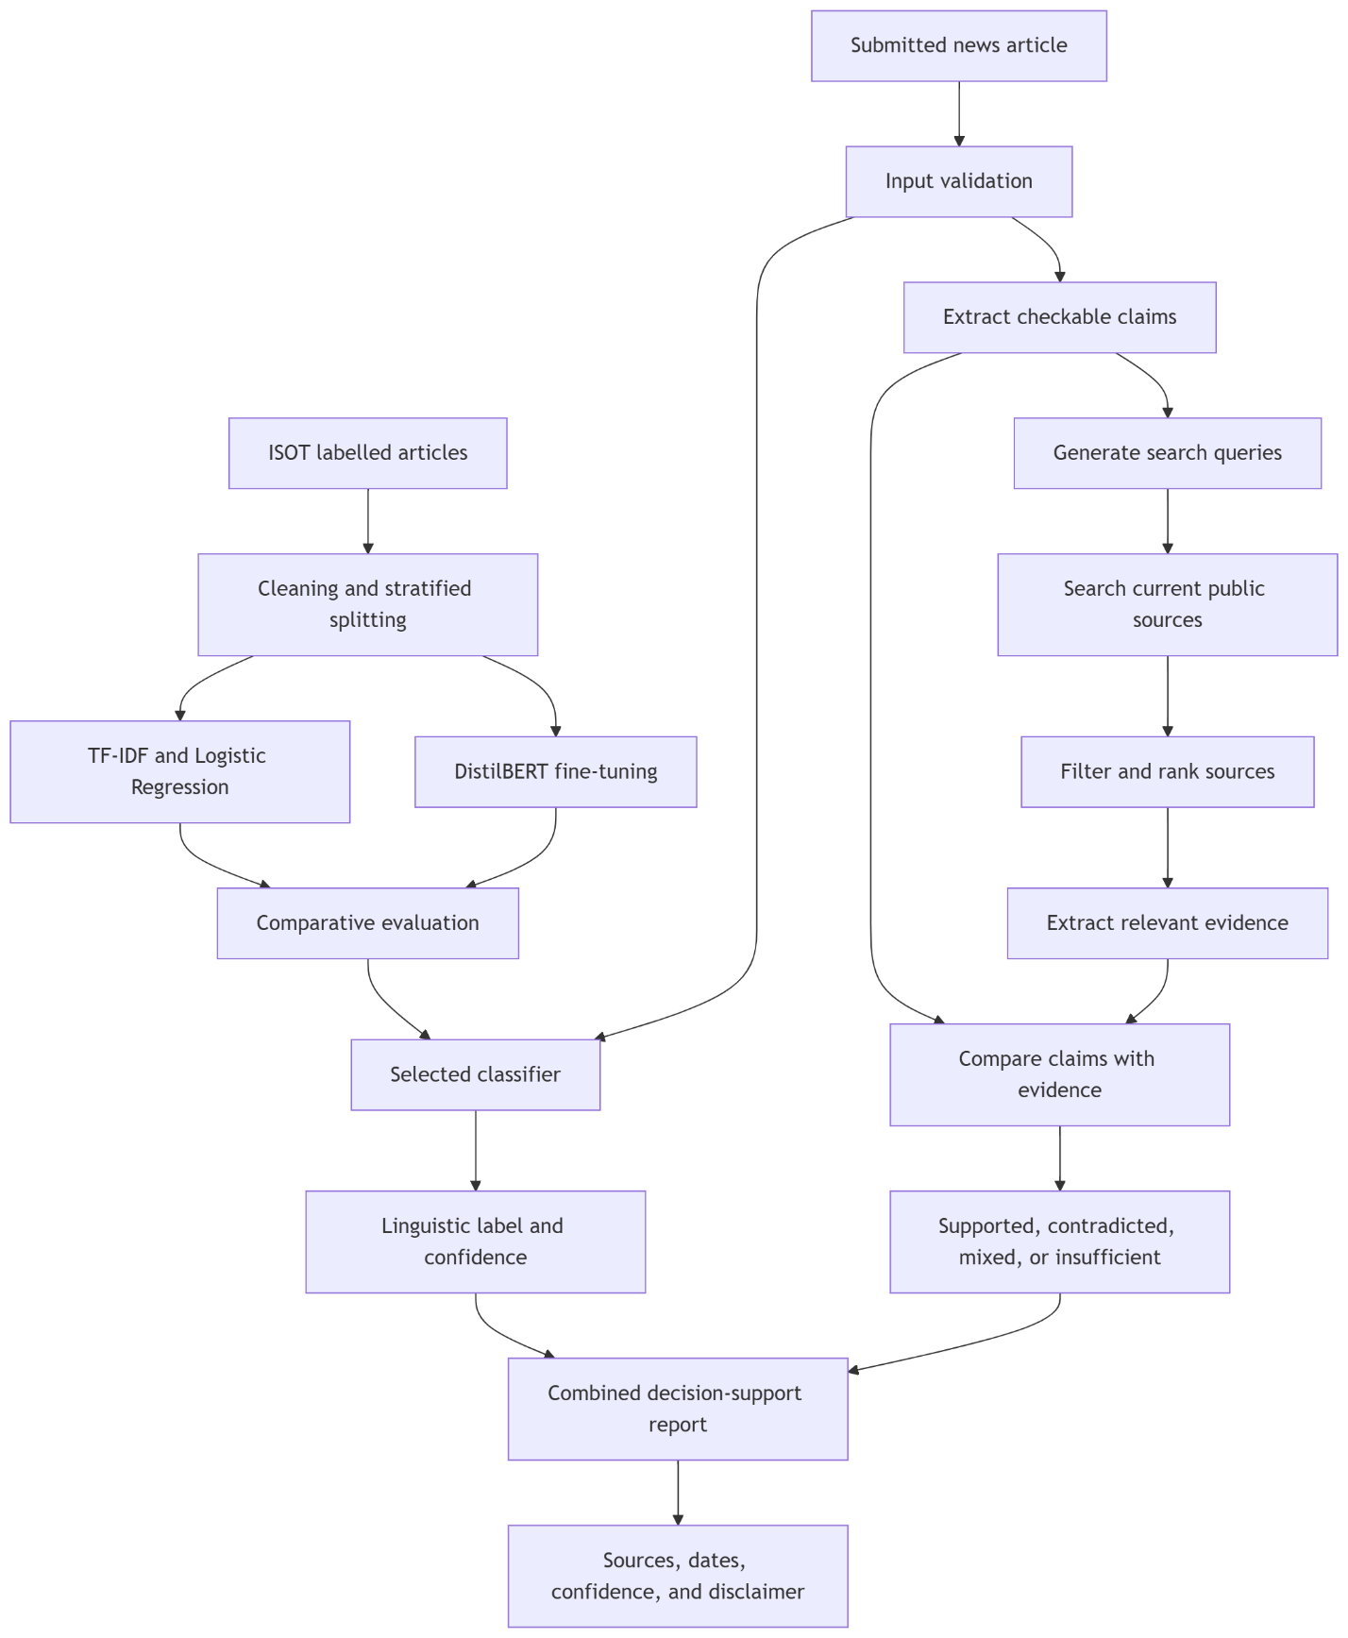
Figure 2.1: Conceptual Framework for Automated Fake-News Detection Using NLP
The upper part of the framework represents offline model development. The classical and transformer models are trained and compared on the same prepared data, with validation used for model configuration and a held-out test set used for the final evaluation. The selected classifier is then made available to the online system.
The lower part represents analysis at the time a user submits an article. One path produces a linguistic label and confidence score. The other extracts checkable claims, searches current public sources, ranks the results, and compares relevant passages with the claims. The final report keeps these findings distinguishable while presenting them together. It includes source links and dates and permits a result of insufficient evidence when the search does not provide a sound basis for a conclusion.
The framework also separates stable model training from time-sensitive retrieval. Training may require the complete dataset, repeated experiments, and GPU resources. Evidence retrieval takes place during analysis so that recently published information can be considered. Because current does not always mean credible, the retrieval stage must record dates, prefer authoritative and independent sources, identify duplicated reporting, and avoid treating search rank as evidence quality.
2.2 Theoretical Framework
Four ideas guide the study: supervised learning, statistical text representation, transfer learning, and responsible decision support. They explain where the models learn their patterns, why the classical and transformer approaches behave differently, how the comparison should be carried out, and why the final prediction still requires human judgement.
2.2.1 Supervised Machine Learning Theory
Supervised learning uses labelled examples to learn a mapping from inputs to outputs. In this study, each input is a news article and each output is a binary label. The training set is used to estimate model parameters, the validation set supports model and hyperparameter decisions, and the held-out test set estimates performance on unseen examples. Stratification helps preserve the class distribution across these subsets.
The resulting model learns statistical relationships between the articles and their dataset labels; it does not acquire a complete account of what is true in the world. Its performance is shaped by label quality, the representativeness of the articles, the absence of leakage, and the similarity between later inputs and the training data. Cautious result wording and explicit attention to domain shift follow directly from this limitation.
Generalisation is central to the study. A model that memorises training articles may achieve very low training error but perform poorly on unseen data. Duplicate removal, a held-out test set, regularisation, and error analysis are therefore part of the research design. The comparison between a simpler linear classifier and a more expressive transformer also reflects the bias-complexity trade-off: greater model capacity may capture useful context, but it may also increase computational cost and sensitivity to dataset artefacts.
2.2.2 Statistical Language Representation
Classical text classification commonly represents a document as a vector of term statistics. TF-IDF combines term frequency with inverse document frequency so that common, low-information words receive less influence than terms that better distinguish documents. N-grams extend the representation from individual words to short local sequences.
Ahmed et al. (2017) used n-gram analysis and machine-learning techniques for online fake-news detection, while Ahmed et al. (2018) further demonstrated text classification for fake news and opinion spam. These works support the use of lexical patterns as a practical baseline. Logistic Regression is particularly appropriate because it works well with high-dimensional sparse input, supports regularisation, and can estimate class probabilities. Its feature weights can also be inspected to determine which terms influence predictions, although those weights must not be interpreted as universal evidence of deception.
The weakness of this representation is that it sees language mainly through counts and short sequences. Two sentences can express the same idea with different words, and the same word can mean different things in different settings. Longer relationships within an article are also difficult to represent with short n-grams. The transformer branch is included to examine whether contextual representations handle these cases better.
2.2.3 Transfer Learning and Transformer Theory
Transformer models use attention mechanisms to represent relationships among tokens. BERT pretrains deep bidirectional language representations and can be adapted to downstream NLP tasks with a task-specific output layer (Devlin et al., 2019). Instead of learning language representation entirely from the fake-news dataset, fine-tuning begins with knowledge obtained during large-scale pretraining.
DistilBERT applies knowledge distillation during pretraining. Sanh et al. (2019) report a smaller model that retains much of BERT's language-understanding performance while reducing size and increasing speed. This makes DistilBERT a reasonable choice for the study because the proposed approach requires contextual modelling but must also consider deployment cost.
Fine-tuning adapts the pretrained encoder and classification head to the labelled articles. Tokenisation, truncation, padding, attention masks, optimisation settings, random seeds, and checkpoint selection all influence the experiment. Long articles present a particular challenge because transformer models accept a limited token sequence. Truncation may discard relevant information, while chunking increases complexity. The study must record the selected strategy and treat it as a limitation during evaluation.
2.2.4 Evaluation and Decision-Support Theory
Binary classification performance can be viewed through true positives, true negatives, false positives, and false negatives. Accuracy measures the overall proportion of correct predictions, but it can be insufficient where class distribution or error costs differ. Precision describes how often a predicted class is correct, recall describes how much of an actual class is found, and F1-score balances precision and recall. A confusion matrix makes the error distribution visible.
For the proposed system, false positives and false negatives have different practical meanings. Incorrectly labelling a credible article as likely fake may damage trust or reputation. Incorrectly labelling fabricated content as likely real may encourage unwarranted confidence. This asymmetry supports the use of per-class measures and representative error analysis rather than a single aggregate score.
The output is best understood as an aid to judgement. A confidence score shows how strongly the model favours one class under the patterns it has learned; it is not a measure of objective truth. Any decision with serious consequences still requires a person to examine the article and its evidence. This principle shapes the wording of the result, the disclaimer, and the decision not to use the prediction as an automatic basis for censorship.
2.2.5 Information Retrieval and Evidence-Based Verification Theory
Information retrieval concerns the selection and ranking of documents that are relevant to a user's information need. In automated fact-checking, the information need is derived from a claim. The system must formulate a useful query, retrieve candidate documents, find the passages that bear directly on the claim, and determine whether those passages support or contradict it. A failure at any early stage can affect the final verdict even when the verification model itself is capable.
FEVER established a widely used three-part pipeline consisting of document retrieval, sentence selection, and claim verification (Thorne et al., 2018). AVeriTeC extends this idea to naturally occurring claims and web evidence. Its evaluation requires both an appropriate verdict and evidence of sufficient quality, reflecting the principle that a conclusion should be traceable to its sources (Schlichtkrull et al., 2024).
Time introduces another dimension. A source published after a claim may be useful when analysing the claim today, but it would be inappropriate in an experiment that asks what evidence was available when the claim first appeared. Chen et al. (2024) address this issue by restricting retrieval to documents available before a claim was made when modelling emerging-claim verification. In the present system, the purpose is current assessment, so later evidence may be retrieved, but publication and retrieval dates must be displayed so that the user can understand the temporal relationship.
Source quality cannot be reduced to recency or search position. Primary documents, official statistics, court records, scientific publications, established news reporting, and professional fact-checks may serve different evidential roles. The system should prefer sources with clear authorship, dates, provenance, and direct relevance, seek more than one independent source where possible, and return insufficient or mixed evidence instead of forcing a binary conclusion.
2.3 Empirical Framework
Shu et al. (2017) organised fake-news detection around news content and social context, explaining that deceptive content may be difficult to identify from text alone and that user engagement can add useful signals. Their work provides a broad framework for understanding the task. The present study adopts only the content component, which makes the system easier to use independently of a social platform but limits the evidence available to the model.
Oshikawa et al. (2020) reviewed NLP formulations, datasets, and methods for fake-news detection and emphasised the task's practical value and difficulty. They also highlighted the need for fairer, more detailed, and more practical detection models. This supports the present study's attention to clearly defined labels, shared evaluation, error analysis, and responsible presentation.
Zhou and Zafarani (2020) surveyed fundamental theories and detection methods and described the multidisciplinary nature of fake-news research. Their review shows that detection can involve style, knowledge, propagation, and source information. The present system does not claim to cover all these dimensions; it investigates a defined text-classification approach within a deployable architecture.
Ahmed et al. (2017) investigated online fake-news detection using n-gram features and machine-learning algorithms. Their results demonstrated that lexical representations can identify useful differences between labelled fake and real articles. Ahmed et al. (2018) extended this direction through text classification for fake news and opinion spam. These studies are directly relevant because the ISOT dataset and the classical approach adopted in this study are associated with this line of work.
Classical approaches commonly combine bag-of-words or TF-IDF features with Naive Bayes, Logistic Regression, Support Vector Machines, Random Forests, or related classifiers. Their major strengths are training efficiency, relatively small artifacts, fast inference, and interpretable feature weights. Their weaknesses include limited context and dependence on observed vocabulary. This study selects Logistic Regression as the primary baseline and retains Linear SVM as an optional benchmark rather than evaluating many algorithms without a clear comparative purpose.
The quality and form of a dataset determine what a model can learn. Wang (2017) introduced LIAR, a benchmark of approximately 12,800 manually labelled short political statements collected from PolitiFact. LIAR supports claim-level and fine-grained truthfulness research, but its short statements differ from the article-level classification workflow adopted in this study.
The ISOT Fake News Dataset contains 21,417 real-news articles and 23,481 fake-news articles. The real articles were obtained from Reuters, while the fake articles came from sources identified as unreliable; much of the material concerns politics and world news from 2016 and 2017. Its True.csv and Fake.csv files include title, text, subject, and date fields. The dataset was introduced and evaluated in the text-classification work of Ahmed et al. (2017, 2018).
ISOT is suitable for article-level experiments and offers enough examples for both a classical model and transformer fine-tuning. However, its source composition creates an important risk. A random split may reward a model for learning Reuters style, topic distributions, or source-specific artefacts rather than broadly generalisable truthfulness cues. The age and geographic focus of the data also limit its relevance to current and Nigerian news. These characteristics require careful interpretation of any high held-out score.
The publication of BERT shifted many NLP tasks toward pretrained contextual encoders. Devlin et al. (2019) showed that one pretrained bidirectional representation could be fine-tuned for varied downstream tasks without extensive task-specific architecture. Fake-news researchers subsequently applied BERT-family models to text classification because contextual embeddings can represent relationships that sparse lexical features miss.
Kaliyar, Goswami, and Narang (2021) proposed FakeBERT, combining BERT-based representations with a neural classification architecture for fake-news detection. The work illustrates the use of pretrained contextual language models in this domain. Such approaches may improve predictive performance, but they also increase training cost, model size, latency, and the difficulty of explaining individual predictions.
DistilBERT offers a compromise between contextual modelling and efficiency. Sanh et al. (2019) designed it to be smaller and faster than BERT through knowledge distillation. This study uses DistilBERT rather than a larger transformer so that the comparison reflects a realistic model that could later be deployed under constrained resources.
Recent surveys show that fake-news detection research includes traditional machine learning, deep neural networks, transformers, social-context models, knowledge-based systems, and multimodal approaches (Alghamdi, Luo, & Lin, 2024). Comparisons across papers are difficult because studies often use different datasets, preprocessing rules, splits, metrics, and label definitions. A higher score reported in one paper may therefore not show that its model is better than a model evaluated elsewhere.
To make the comparison meaningful, the classical and transformer branches are trained on the same prepared dataset and assessed through a shared evaluation framework. Model selection considers F1-score, class-wise recall, confusion matrices, error examples, latency, artifact size, and deployment hardware. This chapter establishes the basis for that comparison, while the measured results are presented and discussed in Chapter Four.
The Nigerian context demonstrates why misinformation tools and media literacy matter, while also showing the need for locally representative data. Ahmed and Msughter (2022) studied COVID-19 fake news among social-media users in Kano State and found substantial awareness and exposure, with respondents associating misinformation with non-adherence to safety measures. Their work concerns user behaviour rather than automated classification, but it shows that misinformation can have consequences beyond online discussion.
The Kano study also illustrates a wider point: misinformation is not only a computational problem. Trust in institutions, media habits, and the conditions under which people receive information all affect what they believe and share. A classifier may assist a reader, but it cannot resolve those social questions on its own.
The primary dataset used in this study is not Nigerian. The system may therefore perform differently on Nigerian names, locations, political topics, journalistic conventions, code-switching, Pidgin English, or locally circulated reports. The present study provides an engineering and experimental foundation, while a locally curated and ethically labelled Nigerian news dataset remains an important direction for future work.
Thorne et al. (2018) introduced FEVER, a large benchmark in which claims are labelled as supported, refuted, or not enough information and are accompanied by evidence sentences. The work demonstrated that retrieving the correct evidence is itself a substantial part of the verification problem. However, FEVER uses a fixed Wikipedia collection and artificially constructed claims, so it does not fully reproduce open-web fact-checking.
Augenstein et al. (2019) introduced MultiFC using naturally occurring claims collected from 26 fact-checking organisations, together with textual sources and metadata. Their results showed that representing evidence improves veracity prediction. This supports the move from classifying an isolated claim toward analysing the relationship between a claim and supporting material.
AVeriTeC was designed for real-world claim verification with evidence from the web. The dataset contains 4,568 claims drawn from fact-checks by 50 organisations, with question-answer pairs, online evidence, justifications, and verdicts (Schlichtkrull et al., 2023). The subsequent shared task allowed evidence to be obtained through search engines or a supplied knowledge store and evaluated the verdict only when the evidence reached a quality threshold (Schlichtkrull et al., 2024). This is closely aligned with the proposed extension because it treats retrieval quality and verdict quality as connected requirements.
Chen et al. (2024) presented a realistic pipeline for complex claims that includes claim decomposition, raw web-document retrieval, fine-grained evidence retrieval, claim-focused summarisation, and veracity judgement. Their work shows why a full article should not be converted directly into one broad search query: complex content often needs to be divided into smaller claims before useful evidence can be found.
These studies also expose limitations. Relevant pages may be absent, inaccessible, duplicated, or ranked poorly. Sources may repeat one another without being independent, and a recent page may still be inaccurate. The proposed system therefore treats retrieved material as evidence candidates, records provenance and dates, and allows mixed or insufficient findings.
Many studies end with offline metrics, but a usable detection system requires additional engineering. The preprocessing used during training must match production inference. The API must reject empty, malformed, overly short, or oversized input. Model artifacts require metadata and versions. Search timeouts, unavailable pages, conflicting evidence, and unsupported claims require explicit handling. The interface must explain predictions without overstating them and must link evidence summaries back to their sources.
These concerns are reflected in the system architecture through validated request and response schemas, a production model loader, a search and evidence service, structured response fields, automated tests, and documentation. The result is designed to include the predicted label, confidence, evidence status, source title, URL, publication date where available, retrieval time, model identity, processing time, and a disclaimer. Together, these details improve traceability, although the presence of source links does not guarantee that the evidence has been interpreted correctly.
Responsible deployment also requires limits on use. Text-only classification should not automatically remove content, punish authors, determine legal liability, or replace professional fact-checking. Important claims must be evaluated against evidence. Privacy and security controls should minimise unnecessary retention of submitted text, restrict cross-origin access, validate request sizes, protect model files, and keep secrets outside source control.
2.4 Summary of Literature Review
The reviewed literature establishes fake-news detection as a significant but difficult NLP and data-mining task. Content-based models can analyse lexical, stylistic, and semantic features, while broader approaches may add social context, source information, external knowledge, or multiple media types. This study uses article text as its input and combines content classification with current web evidence. It does not analyse social propagation or non-textual media, and retrieved sources still require careful interpretation.
Classical research shows that n-gram and TF-IDF representations can support effective fake-news classification. Logistic Regression provides an efficient and interpretable baseline for sparse features. Transformer research shows that pretrained contextual language representations can be fine-tuned for classification, and DistilBERT offers a lighter alternative to BERT. The literature therefore supports comparing these approaches under the same experimental conditions.
Dataset studies show that benchmark choice matters. LIAR is oriented toward short political claims, whereas ISOT contains full articles and better matches the article-level input selected for classification. At the same time, ISOT's source, topic, time-period, and geographic characteristics can lead to bias and domain shift. Evidence-retrieval research adds another lesson: a correct verdict without relevant evidence is not sufficient. Evaluation must therefore cover classification metrics, evidence relevance, claim coverage, source diversity, retrieval failures, latency, and reproducible records.
Nigerian studies confirm the practical importance of misinformation but do not make a globally trained classifier locally valid. Current-source retrieval can provide locally relevant evidence that is absent from ISOT, but it does not remove the need for a Nigerian evaluation dataset. The reviewed deployment concerns further show that an experimental score must be accompanied by reliable preprocessing, model versioning, retrieval safeguards, source provenance, API validation, testing, security, and responsible-use communication.
The reviewed studies make substantial contributions to the understanding of fake news, benchmark datasets, classical classifiers, deep learning, transformers, and misinformation behaviour. Even so, an important gap remains between high-performing experimental models and systems that can examine current evidence, explain the basis of a result, and operate within realistic deployment constraints.
Several gaps emerge from the reviewed work. Some studies examine only one family of models, while others compare scores produced from different datasets and preprocessing choices. Those results do not reveal, under controlled conditions, what is gained or lost when a lightweight TF-IDF model is replaced by a contextual transformer. Text-only classification also cannot respond adequately to new claims that were not represented in historical training data. Evidence-based systems address this problem, but many are evaluated on fixed knowledge stores rather than current public sources. Accuracy is often given more attention than evidence relevance, source quality, class-specific errors, latency, model size, reproducibility, and deployment cost. In addition, many prototypes end as notebooks or scripts without addressing source provenance, retrieval failure, versioned model artifacts, input validation, a usable interface, automated testing, or responsible presentation. A final concern is local relevance: ISOT is useful for benchmarking, but it does not represent contemporary Nigerian journalism.
To address these gaps, the study compares TF-IDF with Logistic Regression against a fine-tuned DistilBERT model using one prepared ISOT pipeline. The selected classifier is combined with claim extraction and current web retrieval so that recent evidence can be considered alongside linguistic patterns. Retrieved pages are ranked for relevance and source quality, important passages are compared with the claims, and the report includes URLs, dates, and an explicit insufficient-evidence outcome. Classification and retrieval are evaluated separately as well as within the end-to-end workflow. Predictions are presented as Likely Real or Likely Fake, while the evidence component reports Supported, Contradicted, Mixed, or Insufficient Evidence. Locally representative Nigerian training and evaluation data, non-textual verification, multilingual support, and long-term production monitoring remain future work.

CHAPTER THREE
RESEARCH METHODOLOGY
3.1 Methodology Adopted
This study adopted a hybrid methodology that combines Agile development through the Scrum framework with the Machine Learning Development Life Cycle (MLDLC). The choice reflects the nature of the work. Building an automated fake-news detection system is both a software-engineering task and an experimental machine-learning task. The software must accept an article, validate it, call the appropriate services, and return a clear result. At the same time, the dataset must be cleaned, the models must be trained without leakage, and performance must be evaluated on unseen examples.
Scrum provides the short, reviewable development cycles needed to connect these parts gradually. MLDLC provides the technical discipline needed for data preparation, training, evaluation, deployment, and monitoring. The approaches were used together: Scrum managed when work was selected, reviewed, and improved, while MLDLC guided how the machine-learning work was carried out.
Requirements were derived from the objectives and literature discussed in Chapters One and Two, an examination of comparable verification workflows, and a questionnaire designed for prospective users. As questionnaire administration had not been completed at this stage of the study, the initial requirements were drawn from the literature and system objectives. They will be reviewed against the questionnaire findings when the response data become available.
3.2 Agile Methodology
Agile development organises work into small increments and encourages regular feedback instead of postponing integration until the end. This is useful for machine-learning systems because model behaviour, data problems, and deployment constraints often become visible only after an early version is tested. A highly accurate notebook experiment, for example, may still be unsuitable if its artifact cannot be loaded within the memory available to the deployed API.
The Agile approach supported gradual implementation of the dataset pipeline, classical baseline, transformer experiment, evaluation reports, FastAPI service, and current-source verification pipeline. Each increment was expected to be usable and testable before the next one began. Automated tests and documented configuration reduced the risk that an improvement in one part would silently break another.
The Agile Manifesto
The Agile Manifesto expresses four values: people and their interactions, working software, collaboration with stakeholders, and responsiveness to change. In this study, these values were interpreted in a practical academic context.
1. Individuals and interactions: Regular consultation creates room to examine progress, assumptions, findings, and limitations. Technical tools support this exchange but do not replace thoughtful discussion.
2. Working software: A tested dataset loader, trained classifier, or functioning API endpoint provides stronger evidence of progress than an unverified design description.
3. Stakeholder collaboration: Requirements and output wording should reflect how people encounter and assess online information. The questionnaire and periodic reviews provide opportunities to align the system with these needs.
4. Responding to change: Findings from data validation, model evaluation, error analysis, or deployment testing can change backlog priorities. The methodology permits those changes without abandoning the overall objectives.
Agile does not mean working without documentation or planning. In this study, research records, source citations, model metadata, locked dependencies, automated tests, and evaluation reports form part of a completed increment. This interpretation is important because reproducibility is a core requirement of academic machine-learning work.
3.2.1 Scrum Framework
Scrum is an iterative framework in which a product is developed through time-boxed sprints. It defines accountabilities, events, and artifacts that make progress and problems visible (Schwaber & Sutherland, 2020). In the context of this study, one person may carry out responsibilities that would normally be shared across a development team, while periodic reviews and prospective-user feedback provide the required external perspective.
The Product Owner responsibility involves maintaining the product goal and prioritising the backlog. The backlog contains research and engineering items such as cleaning the ISOT dataset, preventing duplicate leakage, training the TF-IDF and Logistic Regression baseline, fine-tuning DistilBERT, evaluating both models, exposing analysis through FastAPI, and retrieving evidence from current sources. The Scrum Master responsibility involves keeping the process visible and resolving obstacles such as limited storage, CPU-only training, dependency problems, and deployment constraints. The Developer responsibility covers implementation, testing, experimentation, documentation, and integration.
The Scrum events applied to the work are:
1. Sprint Planning: A small set of related backlog items and a clear sprint goal are selected.
2. Daily Scrum: Progress, next actions, and obstacles are inspected briefly. In an individual project this can be a concise daily development log.
3. Sprint Review: A working increment and its evidence, such as passing tests or an evaluation report, are examined with stakeholders.
4. Sprint Retrospective: The development process is reviewed and improvements are selected for the next sprint.
The main artifacts are the Product Backlog, which records prioritised work; the Sprint Backlog, which contains work selected for the current sprint; and the Increment, which is the integrated result satisfying the definition of done. For this project, that definition includes correct implementation, relevant automated tests, reproducible configuration, updated documentation, and an explicit record of known limitations.
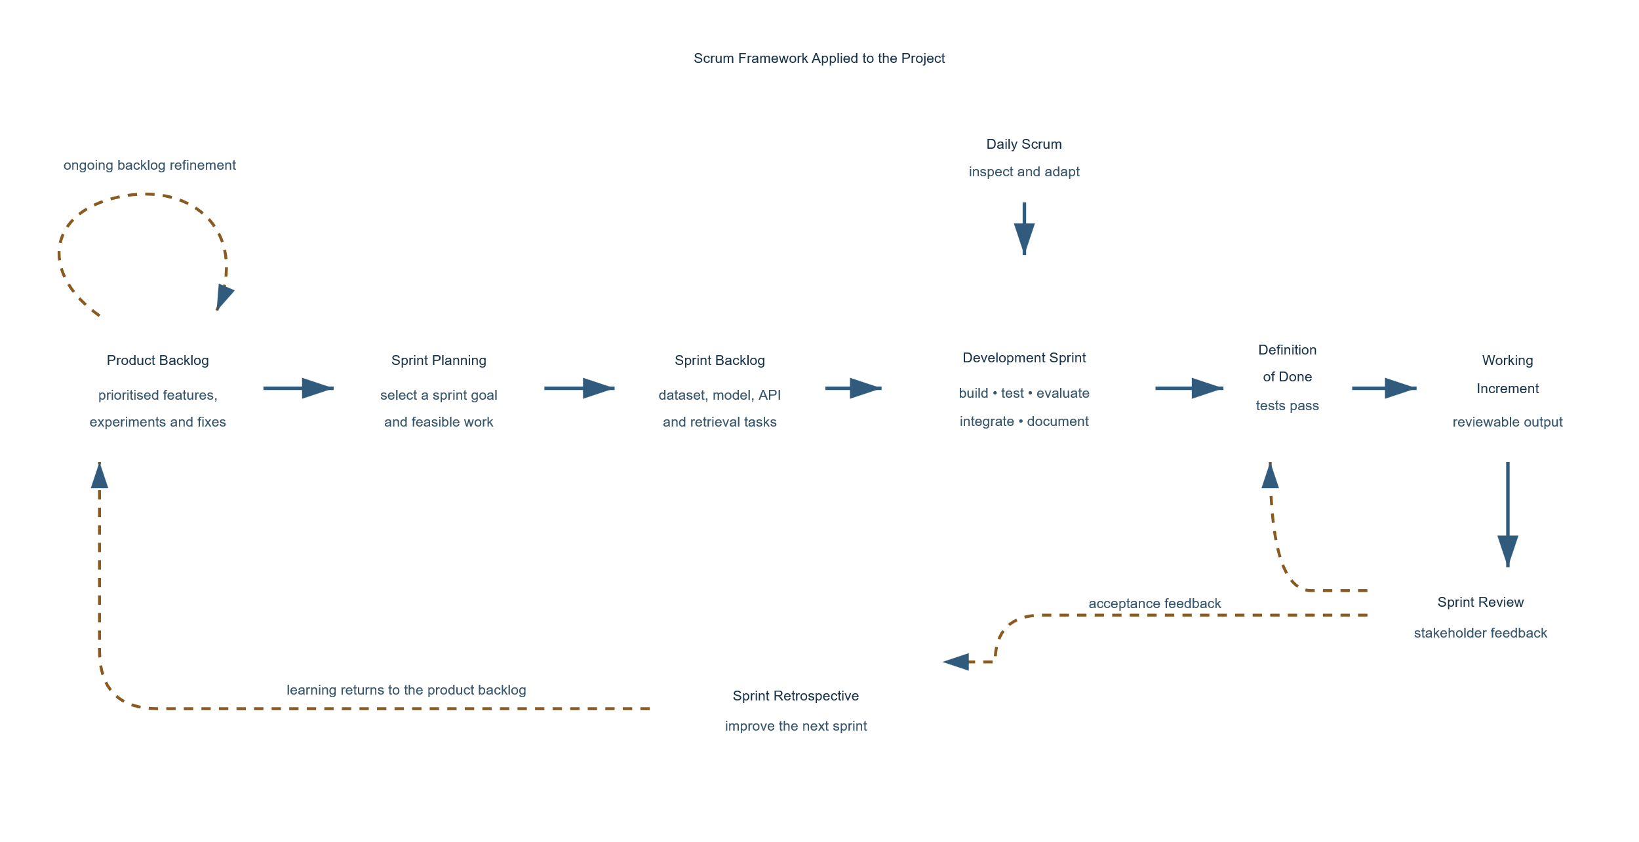
Figure 3.1: Scrum framework applied to the automated fake-news detection project
Figure 3.1 illustrates how Scrum was applied to the development process. Work moves from the product backlog through sprint planning and the sprint backlog into a development sprint. The Daily Scrum supports inspection and adjustment while the sprint is in progress. Before an increment is presented for review, it must satisfy the agreed definition of done. Observations from the Sprint Review and lessons from the Sprint Retrospective are then returned to the product backlog, allowing unfinished work and new insights to shape subsequent priorities.
Scrum offers early discovery of integration problems, frequent testing, visible priorities, and responsiveness to feedback. Its weaknesses are also relevant. A single-researcher project cannot reproduce every team interaction assumed by Scrum; frequent changes can cause scope growth; and short-term delivery can displace documentation unless documentation is included in the definition of done.
3.3 Machine Learning Development Life Cycle (MLDLC)
The MLDLC structures the activities required to move from raw data to a monitored machine-learning service. Machine-learning systems accumulate risks outside the model, including data dependencies, configuration errors, training-serving differences, and weak monitoring (Sculley et al., 2015). Amershi et al. (2019) similarly show that production machine learning requires coordinated practices across data, models, software, and operations. The lifecycle used in this study contains these connected stages:
1. Problem and success definition: The task is binary textual classification supported by a separate evidence-verification result. The classifier returns likely_fake or likely_real with confidence, while the evidence branch may return supported, contradicted, mixed, or insufficient.
2. Data acquisition: The study uses the ISOT Fake News Dataset, supplied as Fake.csv and True.csv (Ahmed et al., 2017). Title, text, subject, date, label, and source-file information are retained where possible.
3. Data preparation: Empty inputs are removed, whitespace is normalised, title and body are combined, exact duplicates are dropped, and texts with conflicting labels are excluded. The cleaned data are divided deterministically into training, validation, and held-out test sets. A temporal split is also available to examine time-related generalisation.
4. Model development: A TF-IDF and Logistic Regression pipeline provides the classical baseline. A fine-tuned DistilBERT sequence classifier provides the contextual deep-learning model. Shared labels and test records permit a meaningful comparison.
5. Evaluation: Accuracy, macro and weighted precision, recall, F1-score, confusion matrices, confidence distributions, expected calibration error, and Brier score are calculated. Per-row predictions support error analysis. High scores are interpreted cautiously because source and writing style may act as shortcuts.
6. Integration and deployment: The selected artifact is loaded behind FastAPI. Configuration comes from environment variables, and large artifacts may be downloaded from a versioned GitHub Release. The API is intended for Render and the later Next.js client for Vercel.
7. Monitoring and improvement: Health status, artifact availability, response time, retrieval failures, input drift, and limitations should be monitored. Problems return to the product backlog rather than being hidden by a single score.
The current-source branch follows its own pipeline within the lifecycle. Checkable claims are extracted, search queries are generated, candidate sources are fetched and filtered, relevant passages are ranked, and the passages are compared with each claim. This branch is evaluated separately because a classifier can be available while web evidence remains insufficient, and a retrieval failure must not be presented as proof that a claim is false.
The strengths of MLDLC are traceability, repeatability, attention to data quality, and continuous evaluation. Its limitations include the need for specialised knowledge, substantial computing and storage resources, dependence on dataset quality, and continuing maintenance after deployment. These are material because transformer training was performed locally on a CPU and current-source verification depends on changing external pages and search services.
3.4 Why Agile (Scrum) and MLDLC Were Chosen
Why Agile (Scrum)
Scrum was chosen because the system contains components that benefit from early integration. Dataset preparation affects training; training determines the artifact format; the artifact format influences API loading; and the API response shapes the user interface. Short sprints made these dependencies visible at manageable stages and allowed insights from stakeholder reviews, questionnaire findings, error analysis, and deployment tests to be incorporated into later work.
Why MLDLC
MLDLC was chosen because ordinary software completion criteria are not enough for a predictive system. A route can return a technically valid response even when its model was trained on duplicated data or tested on records seen during training. The lifecycle requires data validation, split separation, experiment metadata, held-out evaluation, artifact management, and monitoring. These controls make the study more reproducible and its conclusions more defensible.
Why the Combination
Neither approach fully covers the project by itself. Scrum manages priorities, review, and adaptation but does not prescribe how to prevent leakage or evaluate calibration. MLDLC provides the technical machine-learning sequence but not a lightweight rhythm for stakeholder feedback and software integration. Combining them offers both flexibility and experimental discipline: Scrum wraps work in reviewable sprints, while MLDLC defines technical quality gates within those sprints.
3.5 Steps in the Combined Methodology as Applied to This Project
1. Define the product and research goal: The system should analyse submitted news text, provide a cautious NLP classification, and retrieve traceable evidence from current sources.
2. Create and refine the product backlog: Requirements were translated into dataset, modelling, retrieval, API, testing, documentation, and deployment tasks.
3. Plan a focused sprint: Related tasks were selected under one goal, such as producing a leakage-resistant dataset or connecting a saved model to the API response.
4. Acquire and validate data: The ISOT files were loaded, labelled, cleaned, deduplicated, checked for conflicts, and validated before training.
5. Prepare reproducible splits: Stratified random splits and an optional temporal split were generated. Tests ensured that no cleaned article appeared across training and test sets.
6. Develop a baseline: TF-IDF and Logistic Regression were trained first to establish a fast, interpretable reference point.
7. Develop the contextual model: DistilBERT was fine-tuned using the same labels and evaluated on the same held-out test set.
8. Evaluate and review: Classification, calibration, confusion-matrix, confidence-distribution, and error-analysis outputs were generated and interpreted as evidence rather than merely as a success score.
9. Integrate the increment: FastAPI settings, schemas, routes, artifact loading, and current-source verification were connected and tested.
10. Demonstrate and obtain feedback: Working endpoints, reports, and diagrams were reviewed. New requirements and limitations returned to the backlog.
11. Prepare for deployment and monitoring: Environment-driven configuration, CORS, health checks, artifact download, bounded retrieval, and controlled failures were incorporated.
3.6 Benefit of the Combined Methodology over SSADM, OOADM, and Prototyping
1. Over SSADM: SSADM offers extensive documentation and a sequential structure, but it is less convenient when data findings or model behaviour require repeated experimentation. The hybrid approach retains documentation while allowing revision between sprints.
2. Over OOADM: Object-oriented analysis is useful for describing software responsibilities, but it does not by itself address data cleaning, leakage, calibration, artifacts, or drift. This methodology keeps modular design while adding an explicit ML lifecycle.
3. Over prototyping: Prototyping reveals interface needs early, but an attractive prototype may conceal an unevaluated model. Scrum retains incremental demonstrations, while MLDLC requires evidence that each predictive increment is valid and reproducible.
The combination is more suitable because it treats the interface, API, retrieval process, data, model, and research evidence as parts of one system without assuming that they must all mature at the same pace.
3.7 Methods and Practices
3.7.1 Sprint Planning
Sprint planning converted high-priority backlog items into a measurable goal. The first sprints established the repository structure and reproducible configuration. Subsequent sprints addressed the API, evidence retrieval, ISOT loading and splitting, classical-model training, transformer fine-tuning, evaluation, and documentation. The amount of work selected for each sprint reflected the available storage, CPU time, deployment limits, and research schedule.
3.7.2 Daily Stand-Up Meetings
Because development was undertaken as an individual study, the Daily Scrum took the form of a brief progress check rather than a team meeting. Each check recorded completed work, the next action, and any obstacle affecting progress. These obstacles included insufficient disk space during dataset export, the lengthy duration of CPU-based transformer training, and deployment limits on model storage. Keeping a record of them supported realistic planning and helped distinguish methodological concerns from limitations of the development environment.
3.7.3 Sprint Review
At the end of each sprint, the increment was examined using observable evidence. Dataset work was reviewed through validation output and separation tests, model work through saved artifacts and held-out metrics, and API work through health and analysis requests. Issues identified during these reviews were recorded in the backlog and considered in subsequent sprints. Questionnaire findings will provide an additional basis for refinement when the completed responses are analysed.
3.7.4 Sprint Retrospective
The retrospective examines how the work was performed. It asks what should continue, what caused avoidable delay, and what should change. Storage failures encouraged earlier disk-space checks and smaller intermediate outputs, while CPU training cost reinforced the value of completing a classical baseline first. These lessons improve the next sprint without changing reported results after the fact.
3.7.5 Product Backlog Management
The backlog contains features, experiments, defects, documentation, and risk-reduction work. Current items include stronger claim extraction, live-search provider configuration, source-diversity checks, transformer serving decisions, interface completion, deployment testing, and monitoring. An item is not complete merely because code exists; tests, documentation, configuration, and limitations are also required.
3.8 Tools and Technologies
3.8.1 Programming Language
Python 3.12 is the main language for dataset preparation, model development, evaluation, retrieval, verification, and the API. It was selected because the required data-science and NLP libraries share a mature Python ecosystem. TypeScript supports the web client and provides static checking for interface components and API response structures.
3.8.2 Libraries and Frameworks
Pandas and NumPy support data preparation and numerical operations. scikit-learn supplies TF-IDF, Logistic Regression, splitting utilities, and classification metrics. PyTorch supports transformer optimisation, while Hugging Face Transformers and Datasets provide DistilBERT, tokenisation, training, and artifact interfaces (Paszke et al., 2019; Wolf et al., 2020). Joblib persists the classical pipeline.
FastAPI implements the HTTP service, and Pydantic validates settings, requests, and responses. HTTPX retrieves search results and public pages with controlled timeouts. Pytest supports unit and integration testing. Matplotlib and Seaborn produce evaluation plots. Dependencies are declared in pyproject.toml, resolved in uv.lock, and installed through uv.
3.8.3 Database Management
The system does not require a database within the present scope. Training data and evaluation outputs are stored as CSV, JSON, and PNG files, while model artifacts are stored as Joblib files or Hugging Face directories. The API remains stateless and does not retain submitted articles, thereby reducing unnecessary data storage and its associated privacy risks. Database support would become necessary only if later requirements introduced user accounts, saved analyses, feedback records, or an audit history.
3.8.4 Frontend Technologies
The presentation layer is designed with Next.js, React, TypeScript, HTML, and CSS. Its API address is supplied through NEXT_PUBLIC_API_URL, allowing the Vercel-hosted client to communicate with the Render-hosted API without embedding a deployment address in the source code. The interface is intended to distinguish the linguistic prediction from the evidence assessment and to display source URLs, publication dates, confidence, and uncertainty clearly. Development at this stage concentrated on the machine-learning and API layers; full implementation of the user interface follows after these underlying services have been validated.
3.8.5 Development Environment
Development is performed on Windows using PowerShell, Visual Studio Code, Git, GitHub, uv, and JupyterLab where exploration is appropriate. Render is the intended API host and Vercel the intended web host. Environment variables configure CORS, model paths, artifact URLs and hashes, search credentials, recency windows, request limits, and timeouts; secrets and deployment-specific values are not embedded in source code.
CHAPTER FOUR
SYSTEM IMPLEMENTATION AND DESIGN
4.1 System Overview
The automated fake-news detection system was developed to help users examine news articles through two complementary forms of analysis. The first is an NLP classifier that estimates whether an article resembles the real or fake reports in its training data. The second is a current-source verification process that extracts checkable claims and searches for relevant online evidence. Keeping these processes distinct prevents a model prediction from being presented as direct proof of factual accuracy.
The classification component contains two model branches. A TF-IDF and Logistic Regression pipeline provides a lightweight classical baseline, while a fine-tuned DistilBERT classifier provides contextual language representation. Both models were developed from the same cleaned ISOT dataset and assessed on the same held-out test set. This common experimental foundation makes differences in their results easier to interpret.
The evidence component addresses a limitation of historical training data: a trained classifier cannot already know every new event or claim. During analysis, the system extracts a bounded set of claims, constructs search queries, retrieves candidate pages or snippets, filters and ranks the sources, extracts relevant passages, and assigns an evidence status of supported, contradicted, mixed, or insufficient. Source URLs, titles, publication dates where available, retrieval times, and relevance scores are retained in the response.
The application follows a client-server architecture. A FastAPI service provides health and analysis endpoints, loads the selected production model artifact, coordinates the evidence pipeline, and returns structured JSON. The Next.js, React, and TypeScript presentation layer provides a responsive article workspace, separate prediction and evidence views, loading and error states, a disclaimer, and mobile navigation. Deployment-specific values such as API addresses, CORS origins, model paths, artifact URLs, search credentials, recency limits, and timeouts are supplied through environment variables.
The system is intended as a decision-support tool rather than an automatic judge of truth. Its outputs use the cautious labels likely_fake and likely_real, preserve a separate evidence assessment, and include a disclaimer. This design acknowledges that high performance on a benchmark dataset does not remove the risks of source bias, domain shift, incomplete retrieval, or misleading confidence.
4.2 System Requirements
This section presents the resources required to develop, run, and deploy the system. The requirements are grouped into server-side, client-side, and software requirements because model inference and evidence retrieval take place on the API server, whereas users access the service through a browser-based client.
4.2.1 Server-Side Requirements
- Hosting environment: A Python-compatible service capable of running an ASGI application. Render is configured as the host for the FastAPI service.
- Python runtime: Python 3.11 to 3.13, with Python 3.12 used during development.
- Processor: A modern multi-core CPU is sufficient for the classical production model. Transformer inference benefits from greater CPU capacity or GPU acceleration.
- Memory: At least 1 GB is advisable for the classical API. Serving the PyTorch and DistilBERT stack directly requires substantially more memory; a 2 GB instance is a practical minimum for reliable transformer inference.
- Storage: Space is required for the application, locked dependencies, and the selected model artifact. The classical artifact is substantially smaller than the DistilBERT directory, whose weights alone are approximately 268 MB.
- Internet connectivity: Outbound network access is required when the evidence pipeline uses a live search provider and fetches public pages. It is also required when a versioned model artifact is downloaded during deployment.
- Environment configuration: The server must receive values for the runtime environment, model path, allowed CORS origins, and any configured search-provider credentials. Secrets must not be committed to the repository.
- Transport security: Production traffic should use HTTPS so submitted text, search credentials, and returned evidence are protected in transit.
4.2.2 Client-Side Requirements
- Device: A desktop computer, laptop, tablet, or smartphone capable of running a modern browser.
- Browser: A current version of Chrome, Firefox, Edge, Safari, or another standards-compliant browser with JavaScript enabled.
- Internet connection: A stable connection is required to submit the article and receive the combined analysis response.
- Text input: The user must provide article text containing between 100 and 20,000 non-whitespace characters by default. These limits are deployment-configurable.
- Display: The interface should have enough space to distinguish the model prediction, confidence, claim assessments, evidence passages, sources, dates, and disclaimer without merging them into one verdict.
No microphone, camera, biometric device, or browser extension is required because the system analyses text.
4.2.3 Software Requirements
- Programming languages: Python is used for the API, data pipeline, model training, evaluation, retrieval, and verification. TypeScript supports the web client.
- API framework: FastAPI provides routing, dependency injection, schema validation, OpenAPI documentation, and response serialisation. Uvicorn runs the ASGI application.
- Data libraries: Pandas and NumPy support dataset preparation and numerical operations. PyArrow supports efficient dataset interchange where required.
- Classical machine learning: scikit-learn provides TF-IDF vectorisation, Logistic Regression, splitting utilities, and evaluation metrics. Joblib stores and reloads the fitted pipeline.
- Transformer machine learning: PyTorch, Hugging Face Transformers, Datasets, and Accelerate support tokenisation, DistilBERT fine-tuning, batched inference, and artifact storage.
- Retrieval and verification: HTTPX handles search and page requests. Custom Python modules perform claim extraction, query construction, source filtering, ranking, evidence extraction, and verification.
- Visualisation: Matplotlib and Seaborn generate confusion matrices and confidence-distribution plots.
- Testing and quality checks: Pytest provides unit and integration testing, while Ruff supports static analysis and formatting checks.
- Dependency management: Project dependencies are declared in pyproject.toml, resolved in uv.lock, and installed through uv.
- Frontend technologies: Next.js, React, TypeScript, HTML, and CSS provide the responsive browser client and its article-analysis interface.
- Version control and deployment: Git and GitHub manage source history and versioned releases, including the transformer release artifact. Render hosts the API configuration and Vercel deploys the web client.
4.3 System Design
The system was designed as a collection of modules with clearly separated responsibilities. Offline modules prepare the dataset, train the models, save their artifacts, and produce evaluation reports. Online modules validate a submitted article, obtain a model prediction, search for current evidence, and return a combined response. This separation makes the model experiments reproducible while allowing the evidence available at analysis time to remain current.
The API route does not contain the complete retrieval or inference logic. Instead, it receives the inference service and verification pipeline through dependency injection. This arrangement permits deterministic tests to substitute temporary artifacts, in-memory search results, or controlled evidence pages without changing the production route. The following diagrams present the principal actors and runtime flow.
4.3.1 Use Case Diagram
The use case diagram identifies the people and external services that interact with the system. The news reader submits an article or claim and receives the resulting prediction and evidence assessment. A model developer prepares the dataset, trains and evaluates the models, and publishes a versioned artifact for deployment. The search provider supplies current result candidates used by the evidence pipeline.
Figure 4.1: Use case diagram for the automated fake-news detection system
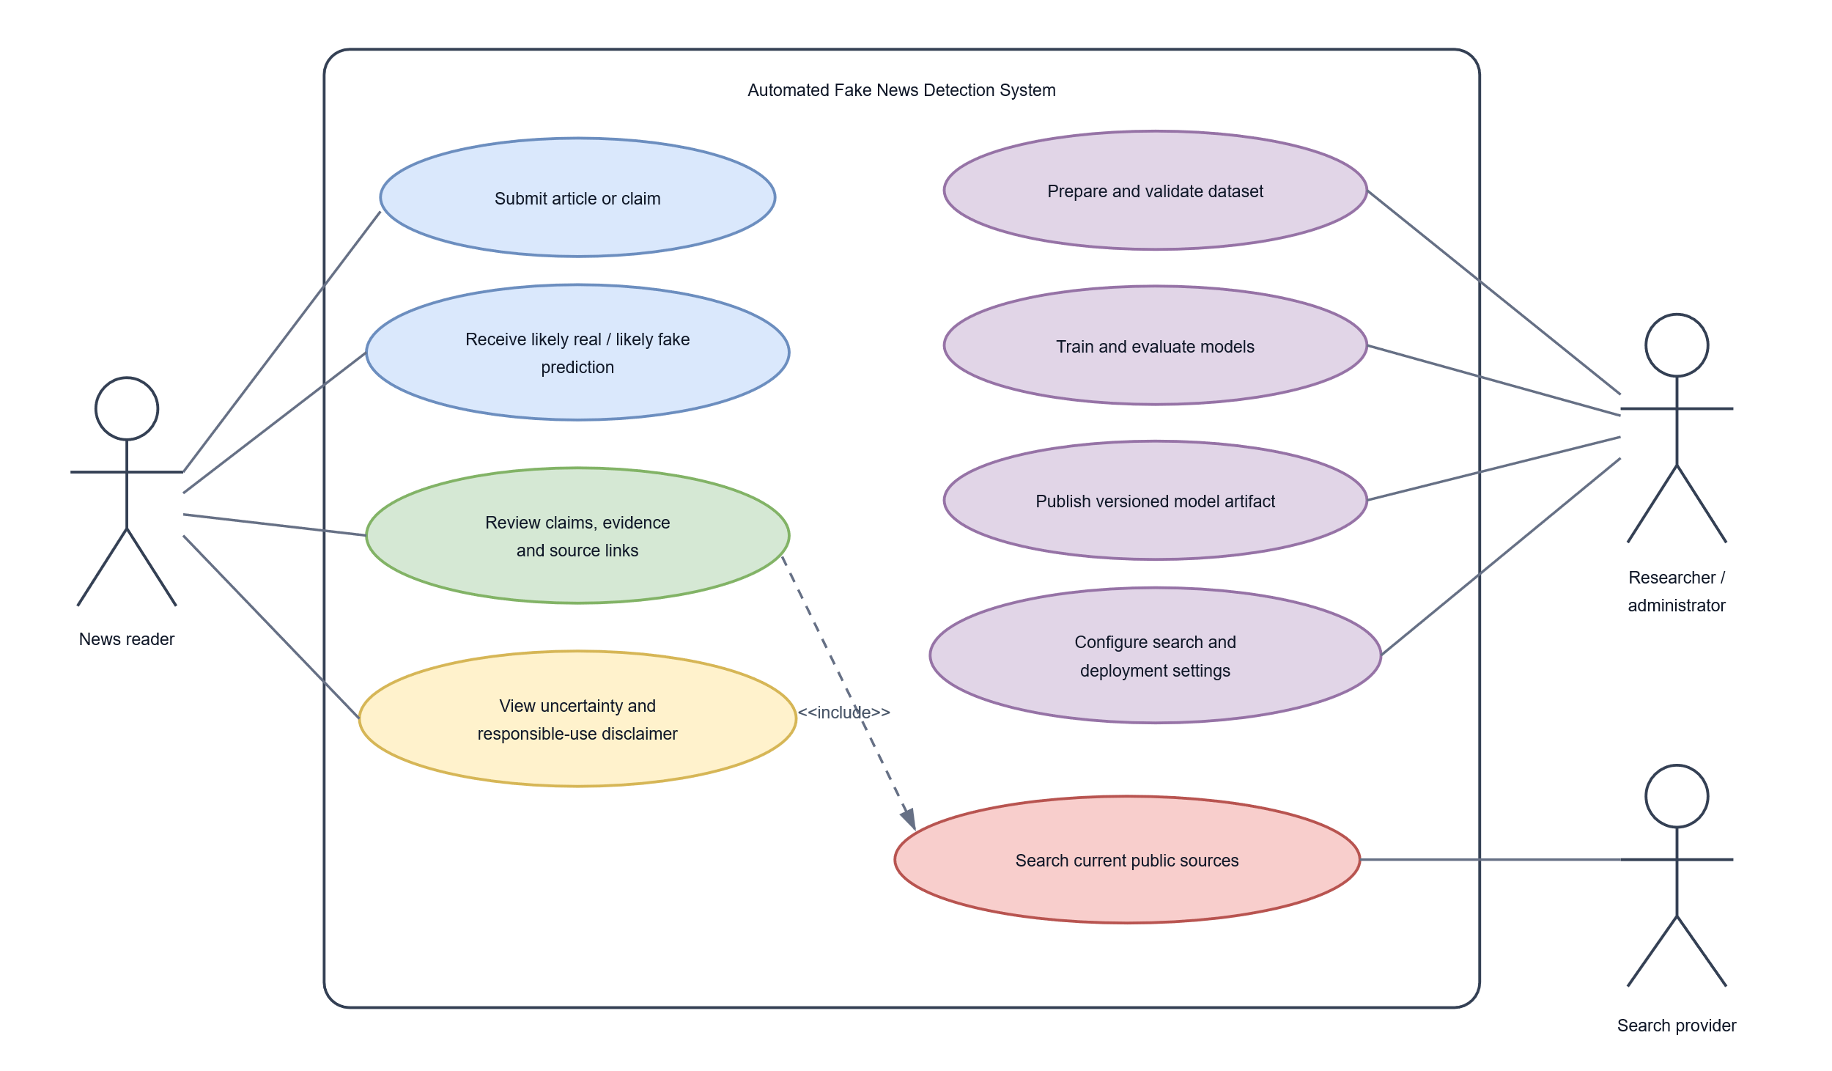
The diagram separates user-facing analysis from offline model development. This is necessary because users do not train the model when they submit an article, and the search provider does not determine the classifier's label. Its role is limited to providing candidate material that the evidence pipeline must still filter and assess.
4.3.2 Activity Diagram
The activity diagram describes the sequence followed after an article is submitted. Validation occurs before expensive processing. Valid text enters the evidence-verification and classification activities, after which the system combines the two outputs. Invalid input ends with a validation response, while unavailable or inadequate evidence leads to insufficient rather than a forced factual judgement.
Figure 4.2: Activity diagram for article analysis
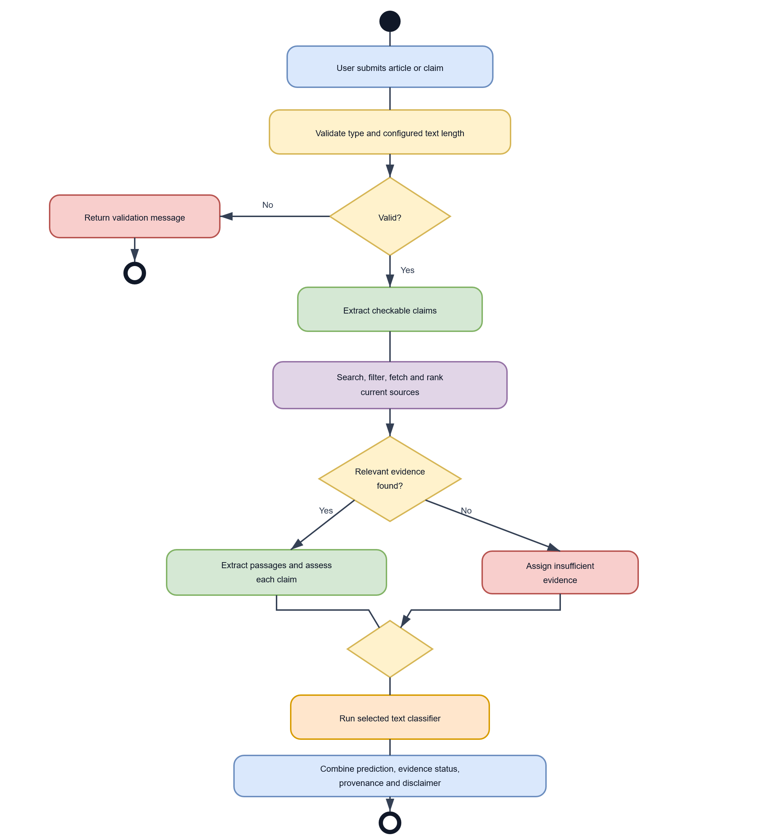
The two analytical branches answer different questions. Classification asks which training label the article most closely resembles. Verification asks what the retrieved sources indicate about the extracted claims. Their results are therefore kept in separate response objects even though they are returned by one API request.
4.3.3 Flowchart Diagram
The flowchart provides a simplified view of the runtime decisions made by the analysis endpoint. It includes the two controlled-failure conditions that are especially important in deployment: absence of a model artifact and absence of adequate evidence. Neither condition prevents the response from accurately describing what was and was not available.
Figure 4.3: Runtime flowchart for automated news analysis
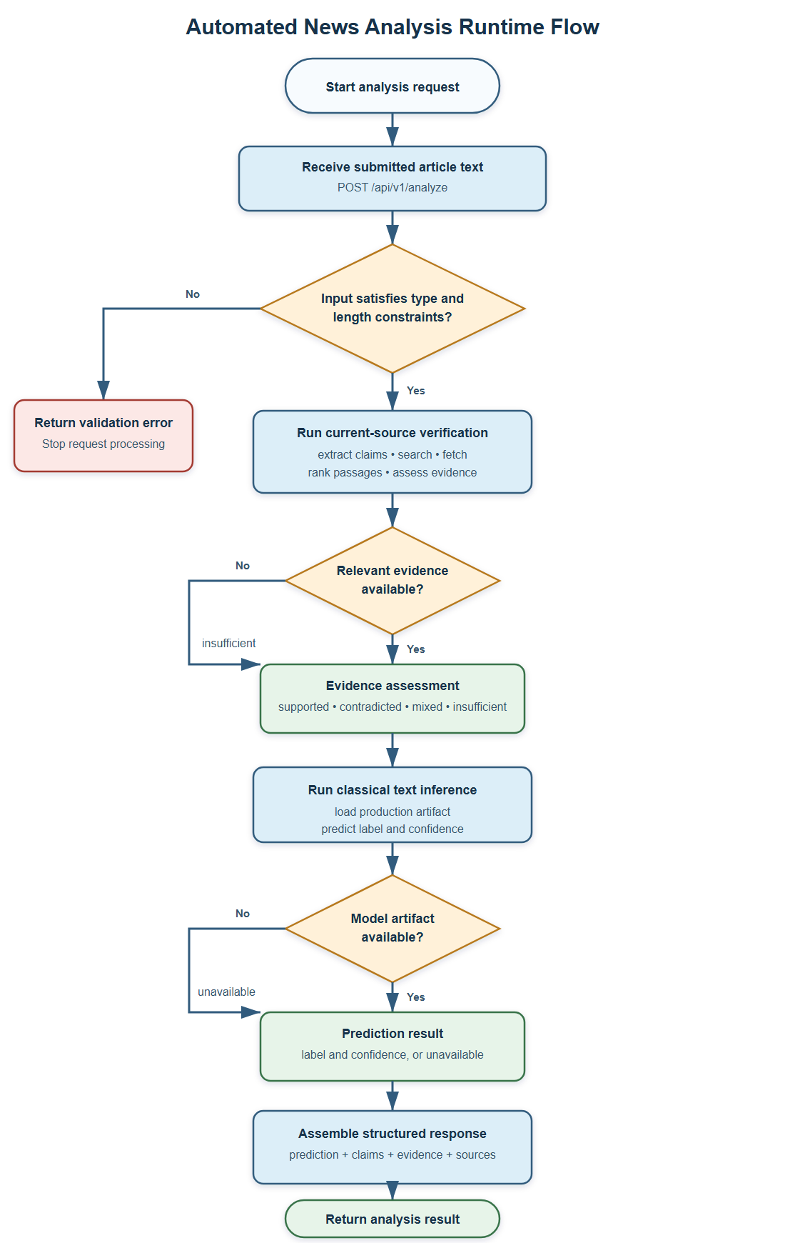
When the selected production artifact is available, the inference service returns the label, confidence, model identity, model version, processing time, and disclaimer. The selected predictor may be the classical TF-IDF/Logistic Regression pipeline or the fine-tuned DistilBERT classifier. If the selected artifact is unavailable, the prediction object reports that state without inventing a label. In the evidence branch, successful retrieval can lead to supported, contradicted, or mixed assessments; weak or missing evidence leads to insufficient evidence. The final response assembles both branches with the extracted claims and source provenance.
4.4 System Design Output/Result
The implemented outputs are exposed through the FastAPI service, reproducible evaluation reports, and the browser interface. The responsive web client accepts article text, displays the model estimate and confidence separately from the current-source evidence assessment, links evidence sources, and presents a cautionary disclaimer. Consequently, this section reports the observable API, machine-learning, and browser-client outputs.
(i) API Health and Article-Analysis Output
The GET /health endpoint confirms that the API process is available and returns the active environment and configured model name. The principal analysis operation is POST /api/v1/analyze. It accepts an object containing article text and returns two top-level objects: prediction and verification.
A shortened representation of the response structure is shown below. The values of claims, sources, dates, confidence, and evidence status vary with the submitted article, configured model artifact, search provider, and evidence available at request time.
{
"prediction": {
"available": true,
"label": "likely_fake",
"confidence": 0.86,
"model": "tfidf_logistic_regression",
"model_version": "classical-tfidf-logreg-0.1.0",
"processing_time_ms": 4.2,
"disclaimer": "This is a machine-learning prediction and should not be treated as independent factual verification."
},
"verification": {
"status": "insufficient",
"claims": [
{
"claim_id": "claim-1",
"claim": "Extracted checkable claim",
"status": "insufficient",
"evidence": [],
"rationale": "No sufficiently relevant evidence was retrieved."
}
]
}
}
The example demonstrates why prediction and verification are not collapsed into one label. An article may strongly resemble one class while current-source evidence is unavailable. The structured response preserves that uncertainty and enables the client to communicate it directly.
(ii) Classical Model Evaluation Output
The TF-IDF and Logistic Regression model was evaluated on 3,909 held-out records. Table 4.1 presents the main results.
Table 4.1: Classical-model performance on the random held-out test set
Measure | Result
Accuracy | 0.9900
Macro precision | 0.9901
Macro recall | 0.9898
Macro F1-score | 0.9899
Weighted F1-score | 0.9900
Expected calibration error | 0.0523
Brier score | 0.0130
Mean prediction confidence | 0.9378
The confusion matrix contained 1,768 correctly identified likely_fake articles and 2,102 correctly identified likely_real articles. Twenty-two likely_fake articles were predicted as likely_real, while seventeen likely_real articles were predicted as likely_fake, producing 39 errors in total.
Figure 4.4: Confusion matrix for TF-IDF and Logistic Regression
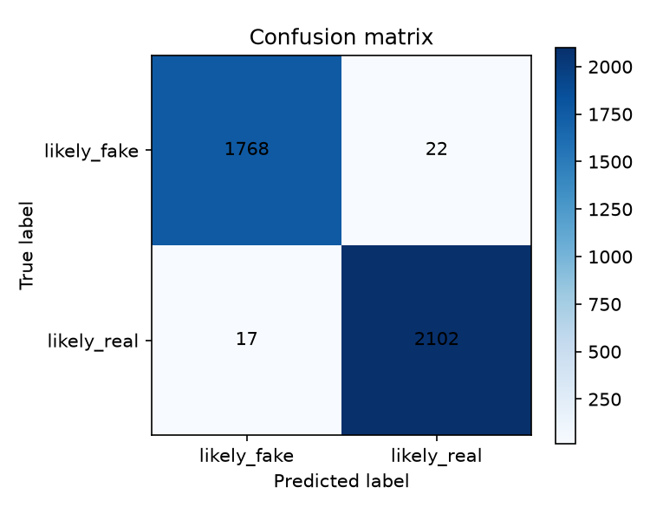
Figure 4.5: Prediction-confidence distribution for TF-IDF and Logistic Regression
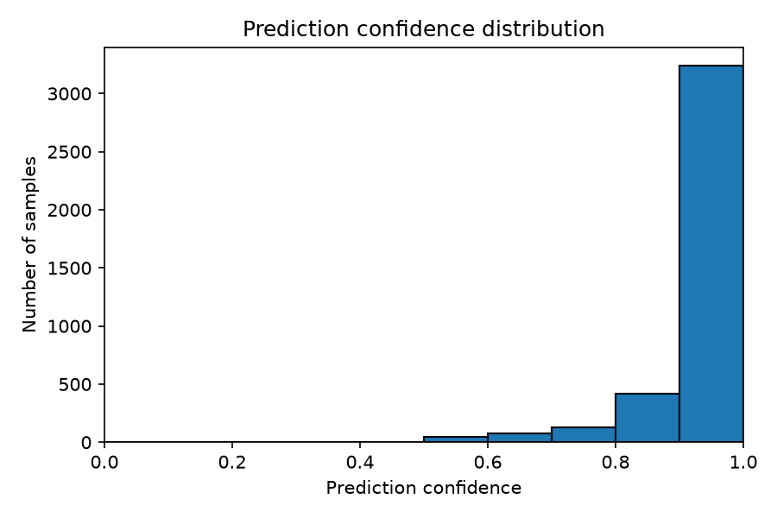
Most predictions fell above 0.90 confidence, but the lower-confidence bins contained a larger proportion of mistakes. The expected calibration error of 0.0523 shows that the probabilities were not perfectly aligned with observed correctness. The confidence score should therefore be interpreted as the model's degree of preference between its learned classes, not as a probability that an article is factually true.
The classical model was also evaluated with a temporal split containing 3,909 later records. It obtained 0.9936 accuracy and 0.9839 macro F1-score, with a confusion matrix of [[426, 10], [15, 3458]]. The large difference between the numbers of fake and real examples in this test set makes macro F1-score more informative than accuracy alone. Although the result was strong, it did not remove the broader risk that ISOT models learn source, topic, or period-specific patterns.
(iii) Transformer Model Evaluation Output
The fine-tuned DistilBERT model was evaluated on the same 3,909-record random test set. The completed training run used a maximum sequence length of 256, training batch size of 8, evaluation batch size of 16, learning rate of 2 × 10⁻⁵, weight decay of 0.01, random seed 42, and one training epoch. Training was performed on a CPU and required approximately 17.5 hours.
Table 4.2: DistilBERT performance on the random held-out test set
Measure | Result
Accuracy | 0.9995
Macro precision | 0.9994
Macro recall | 0.9995
Macro F1-score | 0.9995
Weighted F1-score | 0.9995
Expected calibration error | 0.0004
Brier score | 0.0005
Mean prediction confidence | 0.9999
The transformer correctly classified all 1,790 likely_fake test records. Of the 2,119 likely_real records, 2,117 were correct and two were predicted as likely_fake. Its confusion matrix was therefore [[1790, 0], [2, 2117]].
Figure 4.6: Confusion matrix for the fine-tuned DistilBERT model
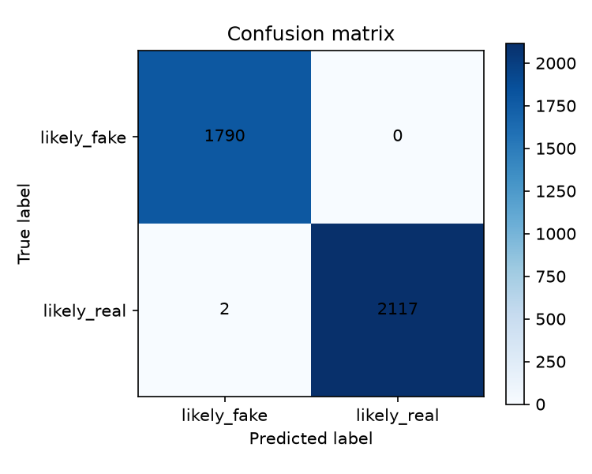
Figure 4.7: Prediction-confidence distribution for the fine-tuned DistilBERT model
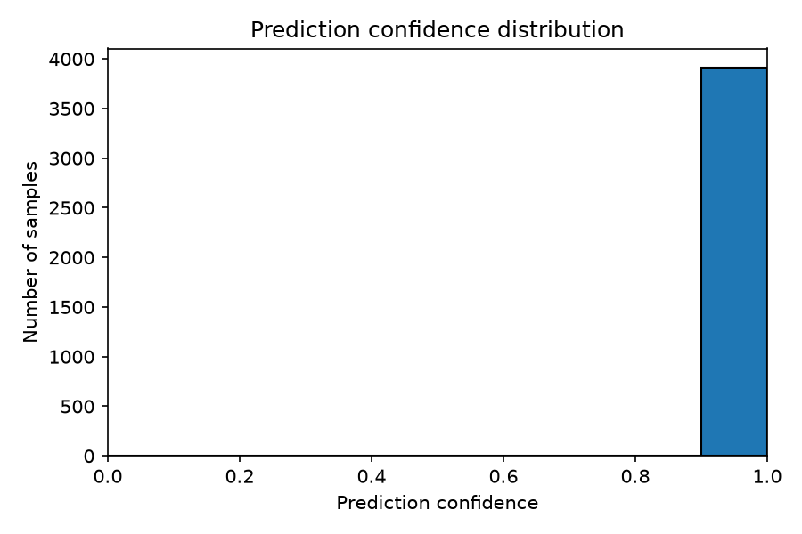
Every transformer prediction had confidence above 0.90, and the mean confidence was approximately 0.9999. The two errors were legitimate Reuters articles from True.csv, yet the model predicted the fake class with high confidence. This finding is important: excellent benchmark accuracy and apparent calibration on the same test distribution do not establish dependable factual verification on new publishers or current Nigerian news. For this reason, the transformer result supports further comparative study but does not replace the evidence-retrieval branch or human judgement.
4.5 System Implementation
Implementation was organised around the same separation used in the design. The ml package contains dataset, preprocessing, classical, transformer, evaluation, retrieval, verification, and inference modules. The apps/api package contains settings, request and response schemas, dependencies, routes, and application services. Tests exercise individual rules and connected API workflows with deterministic fixtures.
The implementation avoids embedding deployment-specific values in source code. Pydantic Settings reads local development values from an optional .env file and production values from the hosting environment. Python dependencies and development tools are version-resolved through uv.lock. Large model artifacts remain outside normal Git history and can be distributed as versioned GitHub Release assets with an optional SHA-256 integrity check.
4.5.1 System Architecture
The runtime architecture consists of a browser client, a FastAPI service, an inference service, a verification pipeline, a selected model artifact, and an external search provider. The browser sends article text to the API. FastAPI validates the request and obtains the inference and verification components through dependency injection. The inference service loads either the saved classical model or the fine-tuned DistilBERT artifact according to PRODUCTION_MODEL and returns a prediction. The verification pipeline extracts claims, searches for evidence through the configured Brave Search provider, fetches bounded public page content, ranks passages, and aggregates claim assessments. The route serialises both results into one response.
The production API supports model selection through PRODUCTION_MODEL. The Render deployment configuration selects the versioned DistilBERT release artifact, while the classical predictor remains available for lower-resource deployments. The transformer artifact is downloaded and verified with a SHA-256 checksum during deployment, allowing the deployed model to remain traceable to a versioned GitHub Release.
The API is stateless and does not store submitted articles. Cross-origin browser access is limited by CORS_ORIGINS. A health endpoint supports deployment monitoring, and missing artifacts or insufficient evidence are represented as controlled response states rather than server crashes or fabricated conclusions.
4.5.2 Text Preprocessing
Preprocessing differs between the two model branches. Both begin with a common stage that checks the input type, removes unnecessary whitespace, and ensures that usable text remains. During dataset construction, the article title and body are combined so the model can use information from both fields.
The classical pipeline applies TF-IDF vectorisation directly to the normalised text. Its configuration permits up to 50,000 features, includes unigrams and bigrams, uses sublinear term frequency, ignores terms appearing in more than 95 per cent of documents, and retains a minimum document frequency of one. Logistic Regression uses a maximum of 1,000 iterations and random state 42. The fitted vectoriser and classifier are saved together, ensuring that production input undergoes the same transformation used during training.
The transformer pipeline uses the distilbert-base-uncased tokenizer. Inputs are padded or truncated to a maximum of 256 tokens and accompanied by attention masks. Unlike the classical branch, it does not apply stemming or aggressive stop-word removal because the pretrained model relies on word order and context. The public labels are mapped consistently as likely_fake = 0 and likely_real = 1.
4.5.3 Model Training and Artifact Generation
The classical training module reads the prepared training CSV, validates that both labels are present, fits the TF-IDF and Logistic Regression pipeline, and saves a Joblib dictionary containing the estimator and model metadata. The prediction class reloads this artifact and verifies the required fields before serving inference. Each result contains the model name and version so that later outputs remain traceable to a particular artifact.
The transformer training module tokenises the training and validation records, loads DistilBERT with a two-class classification head, and fine-tunes the network through the Hugging Face Trainer interface. The pretrained classification layers are newly initialised, while the encoder begins from the downloaded DistilBERT weights. After training, the model, tokenizer, training arguments, and project metadata are saved in a Hugging Face-compatible directory.
Evaluation is kept separate from training. The classical and transformer evaluators load saved artifacts and make batched predictions on the held-out test set. Shared metric functions calculate classification, confusion-matrix, confidence-distribution, and calibration outputs. Keeping evaluation separate reduces the risk of adjusting the final model after observing its test errors.
4.5.4 Data Implementation
The raw ISOT files contain 23,481 fake and 21,417 real articles, giving 44,898 records before cleaning. The data pipeline assigns the canonical labels likely_fake and likely_real, preserves relevant metadata, normalises text, removes empty records, drops exact duplicates, and excludes texts that occur with conflicting labels.
The prepared dataset contains 39,100 records: 17,905 likely_fake and 21,195 likely_real. A deterministic stratified split with random seed 42 produced the distribution shown in Table 4.3.
Table 4.3: Prepared ISOT dataset split
Dataset partition | Number of records | Purpose
Training | 31,280 | Fitting model parameters
Validation | 3,911 | Monitoring and configuration decisions
Test | 3,909 | Final held-out evaluation
Total | 39,100 | Cleaned dataset
Automated checks verify required columns, permitted labels, non-empty text, duplicates, conflicting labels, reproducible splitting, and separation between train and test data. The temporal strategy sorts parseable dates, places later records in the test set, and reports malformed dates rather than silently treating them as valid. Six malformed date values were excluded from that temporal experiment.
Processed CSV files and raw datasets are kept outside normal source-control history because of their size. Evaluation reports are written as JSON, CSV, and PNG files, while models are stored as Joblib or Hugging Face artifacts. A database was unnecessary because the API does not manage user accounts or retain submitted content.
4.5.5 API and Web Interface Implementation
FastAPI creates the application, registers the routers, loads settings, and configures CORS from environment variables. Pydantic schemas enforce the request and response structures. GET /health exposes deployment-safe status information, while POST /api/v1/analyze coordinates the classifier and evidence pipeline. FastAPI's generated OpenAPI documentation also provides an interactive means of examining the endpoints during development.
The Next.js project provides the completed browser client, including a shared layout, responsive styling, sticky navigation, a mobile hamburger menu, an article form, client-side length checks, loading and network-error states, and a structured result presentation. NEXT_PUBLIC_API_URL identifies the deployed API without hard-coding localhost or Render addresses. The result view presents the model label and confidence separately from claim-level evidence statuses, passages, source links, dates where available, and the decision-support disclaimer.
The implemented result view keeps classification and verification visually separate. It displays the predicted class and confidence, followed by claim-level evidence statuses, relevant source links, and available dates. Loading, validation, network failure, missing-model, and insufficient-evidence states use distinct messages so users are not given a false sense of certainty.
4.5.6 Integration and Workflow
The integrated workflow begins when article text reaches the analysis endpoint. Pydantic validates the request before the route calls the verification pipeline and inference service. The verification pipeline extracts a bounded number of claims, constructs queries, obtains search results through the configured Brave Search client, applies source rules, retrieves bounded public page content, ranks documents, extracts relevant passages, and aggregates the claim-level findings. The inference service independently loads the selected classical or transformer artifact and predicts a label and confidence.
The route converts internal objects into a stable public schema and returns the two branches together. If one page fails, other evidence candidates can still be processed. If the search provider is not configured or no reliable evidence is found, the result becomes insufficient. If the model artifact is missing, prediction.available becomes false and an explanatory error is returned while the evidence branch remains usable.
Unit tests cover data loading, label mapping, duplicate removal, splitting, preprocessing, classical prediction, transformer tokenisation, evaluation metrics, claim extraction, query construction, Brave Search response handling, source filtering, evidence extraction, model download, configuration, and verification rules. Frontend tests cover the article form and responsive navigation. Integration tests follow requests through FastAPI, dependency injection, prediction, evidence assessment, and response serialisation. This layered testing makes it possible to identify whether a failure originates in an individual rule, a persisted artifact, an external-service adapter, the browser client, or the connected API workflow.

CHAPTER FIVE
SUMMARY, CONCLUSION AND RECOMMENDATIONS
5.1 Summary of Findings
This study designed and implemented a full-stack system for analysing news article text through two separate processes: machine-learning classification and current-source evidence review. The work addressed the preparation of the ISOT Fake News Dataset, comparison of a classical text classifier with a transformer, retrieval of evidence for extracted claims, and presentation of the results through a web application and API. The system is intended to support closer reading and human review; it does not determine truth conclusively.
The data preparation pipeline cleaned and validated the ISOT records, removed empty and duplicate texts, excluded records with conflicting labels, and produced a reproducible stratified dataset. The resulting dataset contained 39,100 articles: 17,905 labelled likely_fake and 21,195 labelled likely_real. The split comprised 31,280 training records, 3,911 validation records, and 3,909 held-out test records. A separate temporal evaluation was also conducted for the classical model.
The TF-IDF and Logistic Regression model achieved 0.9900 accuracy and 0.9899 macro F1-score on the random held-out test set. It made 39 errors among 3,909 records. On the separate temporal test set, it achieved 0.9936 accuracy and 0.9839 macro F1-score. The fine-tuned DistilBERT model achieved 0.9995 accuracy and 0.9995 macro F1-score on the same random test set, with two errors. These results show that DistilBERT performed better on this benchmark split. They do not establish that it will perform better on unrelated publishers, later events, or Nigerian news. The transformer also produced very high confidence on its two incorrect predictions, demonstrating why confidence must not be interpreted as proof of accuracy.
The implementation provides a FastAPI endpoint that validates article text and returns a prediction separately from the evidence assessment. The API can select the classical or transformer predictor through configuration. Its evidence pipeline extracts a bounded number of checkable claims, uses a Brave Search adapter to obtain public web results when configured, fetches and ranks source material, extracts relevant passages, and reports supported, contradicted, mixed, or insufficient evidence. The Next.js client allows users to submit text and view the prediction, confidence, evidence, source links, and responsible-use information. Tests cover key model, retrieval, API, and frontend behaviour. The application has also been configured for a Render API and Vercel web deployment; free hosting is suitable for demonstration but does not establish service capacity or production reliability.
5.2 Conclusions
The study demonstrates that classical and transformer models can be trained and evaluated on a shared article-classification dataset and integrated into a working web application. On the random ISOT test split, DistilBERT obtained higher classification scores than TF-IDF with Logistic Regression. The classical model nevertheless remains useful as a lower-resource baseline, and its separate temporal evaluation provides an additional, though still dataset-limited, view of generalisation.
The study also demonstrates how text classification can be presented alongside current-source evidence without treating the two outputs as equivalent. The classifier estimates similarity to patterns learned from historical labelled articles. The retrieval component gathers candidate evidence for selected claims and may return insufficient evidence when sources are unavailable or inadequate. This separation helps communicate uncertainty and gives users source material to examine.
The project objectives were addressed through data preparation, model development and comparison, evidence retrieval, API and interface implementation, and automated testing. However, the results support the conclusion that the implemented system is a research and decision-support prototype, not an automated fact-checker. Its outputs require independent review, particularly when the subject is consequential or the available evidence is limited. The high scores on ISOT should be interpreted within the limits of that dataset and should not be generalised to all publishers, topics, languages, or current events.
5.3 Recommendations
Based on the findings and limitations of the study, the following recommendations are made:
- Evaluate beyond ISOT. Test both classifiers on independent datasets and on recent articles from publishers not represented in training. Include Nigerian news sources and report class-wise precision, recall, F1-score, confusion matrices, and calibration so that performance is not represented by accuracy alone.
- Review data leakage and dataset shortcuts. Continue examining duplicate or near-duplicate articles, publisher overlap, topic cues, and time-period effects. Where possible, use publisher-held-out and time-based splits to determine whether the models learn transferable language patterns rather than dataset-specific signals.
- Calibrate and communicate confidence carefully. Reassess confidence on independent data and consider calibration methods if they improve reliability. Continue to describe confidence as the model's confidence in its learned label, not as the probability that a story is true.
- Improve and evaluate evidence verification. Compare extracted claims, retrieved sources, and evidence-status decisions with human-annotated examples. Measure claim coverage, relevance, source diversity, freshness, retrieval failures, and agreement with trained reviewers. Treat search rank as a retrieval signal rather than proof of source credibility.
- Expand locally representative research data. Develop a responsibly collected and labelled Nigerian news dataset with documented sources, dates, topics, annotation guidance, and adjudication. Protect annotators and publishers from unsupported accusations, and separate article-level labels from claim-level evidence judgements.
- Protect the live service and provider budget. Keep the Brave API key in Render's secret environment configuration. Before opening the service to broad public use, add and test request rate limits and a shared daily search budget; do not rely on process-local counters on a service that can restart or scale. Monitor provider usage and define the response shown when a search budget is exhausted.
- Plan hosting for the selected model. Measure memory use, cold-start time, inference latency, and failure rates on the actual host. The free Render tier can support a demonstration, but its resource and sleep limitations are not evidence of production capacity for PyTorch and DistilBERT. Select infrastructure that meets measured requirements before relying on the service for continuous public use.
- Strengthen operational monitoring and security. Monitor API availability, errors, latency, model loading, and retrieval failures. Keep dependencies updated, restrict CORS to the deployed web origin, protect model artifacts with checksum verification, and review public-source fetching safeguards as the service evolves.
- Complete user and stakeholder evaluation. Administer the proposed questionnaire and conduct usability sessions with readers, journalists, or fact-checkers. Use a documented protocol and report the number and characteristics of participants before drawing conclusions about user acceptance.
- Maintain responsible presentation. Preserve separate prediction and evidence results, provide direct source links and retrieval details when available, show insufficient evidence when appropriate, and avoid using the system output alone to censor, penalise, or make consequential decisions about people or publishers.
5.4 Contribution to Knowledge
This study contributes a reproducible comparison of TF-IDF with Logistic Regression and fine-tuned DistilBERT for binary article classification using a common prepared ISOT dataset and held-out test set. Reporting class-sensitive metrics, confusion matrices, calibration measures, error observations, and a temporal evaluation of the classical model extends the comparison beyond a single headline accuracy score. The results also document the limits of interpreting near-perfect benchmark performance as evidence of real-world factual reliability.
The study further contributes an integrated prototype that presents learned text classification and current-source claim review as distinct outputs in one workflow. The implementation connects data and model artifacts, configurable inference, claim extraction, Brave Search retrieval, evidence passage ranking, a FastAPI service, and a responsive Next.js interface. This implementation provides a concrete basis for further research into evidence-aware news analysis, while its explicit insufficient-evidence state and source presentation show how uncertainty can remain visible to users.
The contribution is therefore both empirical and practical: an experimental comparison under shared dataset conditions, and a tested software architecture that exposes a model estimate together with retrievable evidence. It does not establish a validated method for determining truth, nor does it establish that either model is locally valid for contemporary Nigerian journalism.
5.5 Future Work
Future work should first evaluate the implemented system with independent, recent, and locally representative Nigerian news data. The dataset should include clear annotation rules and quality review, and the evaluation should test generalisation across publishers, topics, and time periods. Both the classical model and DistilBERT should be assessed under comparable conditions, including deployment cost, latency, model size, class-specific errors, and confidence calibration.
The evidence workflow can be improved by using stronger claim extraction, query generation, source credibility and diversity policies, and natural-language inference methods for comparing evidence with claims. Human reviewers should annotate a representative sample so that retrieval relevance and evidence-status decisions can be measured rather than inferred from successful API responses. The system should also record when evidence could not be retrieved and distinguish this from evidence that contradicts a claim.
Further engineering work should add tested per-user or per-IP request limits and a persistent, shared search-usage budget, along with monitoring for service availability, model loading, retrieval quality, latency, and provider consumption. Hosting should be reassessed using measured transformer memory and cold-start requirements. Additional research could investigate multilingual and non-textual misinformation, such as image and video claims, but these capabilities require their own datasets, methods, and evaluations before inclusion in the system.
Finally, future studies should complete the planned questionnaire and carry out structured usability evaluation with intended users, including journalists and fact-checkers. Their feedback can guide improvements to the interface, evidence explanations, source context, and accessibility. Any extension should retain human review for consequential uses and should preserve the distinction between a model's text-pattern estimate and an evidence-based assessment.

REFERENCES
Ahmed, H., Traore, I., & Saad, S. (2017). Detection of online fake news using n-gram analysis and machine learning techniques. In I. Traore, I. Woungang, & A. Awad (Eds.), Intelligent, secure, and dependable systems in distributed and cloud environments (Lecture Notes in Computer Science, Vol. 10618, pp. 127–138). Springer. https://doi.org/10.1007/978-3-319-69155-8_9
Ahmed, H., Traore, I., & Saad, S. (2018). Detecting opinion spams and fake news using text classification. Security and Privacy, 1(1), e9. https://doi.org/10.1002/spy2.9
Ahmed, M. O., & Msughter, A. E. (2022). Assessment of the spread of fake news of COVID-19 amongst social media users in Kano State, Nigeria. Computers in Human Behavior Reports, 6, 100189. https://doi.org/10.1016/j.chbr.2022.100189
Alghamdi, J., Luo, S., & Lin, Y. (2024). A comprehensive survey on machine learning approaches for fake news detection. Multimedia Tools and Applications, 83, 51009–51067. https://doi.org/10.1007/s11042-023-17470-8
Amershi, S., Begel, A., Bird, C., DeLine, R., Gall, H., Kamar, E., Nagappan, N., Nushi, B., & Zimmermann, T. (2019). Software engineering for machine learning: A case study. In Proceedings of the 41st International Conference on Software Engineering: Software Engineering in Practice (pp. 291–300). IEEE/ACM. https://doi.org/10.1109/ICSE-SEIP.2019.00042
Augenstein, I., Lioma, C., Wang, D., Chaves Lima, L., Hansen, C., Hansen, C., & Simonsen, J. G. (2019). MultiFC: A real-world multi-domain dataset for evidence-based fact checking of claims. In Proceedings of the 2019 Conference on Empirical Methods in Natural Language Processing and the 9th International Joint Conference on Natural Language Processing (pp. 4685–4697). Association for Computational Linguistics. https://doi.org/10.18653/v1/D19-1475
Chen, J., Kim, G., Sriram, A., Durrett, G., & Choi, E. (2024). Complex claim verification with evidence retrieved in the wild. In Proceedings of the 2024 Conference of the North American Chapter of the Association for Computational Linguistics: Human Language Technologies (pp. 3569–3587). Association for Computational Linguistics. https://doi.org/10.18653/v1/2024.naacl-long.196
Devlin, J., Chang, M.-W., Lee, K., & Toutanova, K. (2019). BERT: Pre-training of deep bidirectional transformers for language understanding. In Proceedings of the 2019 Conference of the North American Chapter of the Association for Computational Linguistics: Human Language Technologies (pp. 4171–4186). Association for Computational Linguistics. https://doi.org/10.18653/v1/N19-1423
Kaliyar, R. K., Goswami, A., & Narang, P. (2021). FakeBERT: Fake news detection in social media with a BERT-based deep learning approach. Multimedia Tools and Applications, 80, 11765–11788. https://doi.org/10.1007/s11042-020-10183-2
Oshikawa, R., Qian, J., & Wang, W. Y. (2020). A survey on natural language processing for fake news detection. In Proceedings of the Twelfth Language Resources and Evaluation Conference (pp. 6086–6093). European Language Resources Association. https://aclanthology.org/2020.lrec-1.747/
Paszke, A., Gross, S., Massa, F., Lerer, A., Bradbury, J., Chanan, G., Killeen, T., Lin, Z., Gimelshein, N., Antiga, L., Desmaison, A., Köpf, A., Yang, E., DeVito, Z., Raison, M., Tejani, A., Chilamkurthy, S., Steiner, B., Fang, L., Bai, J., & Chintala, S. (2019). PyTorch: An imperative style, high-performance deep learning library. In Advances in Neural Information Processing Systems 32 (pp. 8024–8035).
Sanh, V., Debut, L., Chaumond, J., & Wolf, T. (2019). DistilBERT, a distilled version of BERT: Smaller, faster, cheaper and lighter. arXiv preprint arXiv:1910.01108. https://doi.org/10.48550/arXiv.1910.01108
Schlichtkrull, M., Guo, Z., & Vlachos, A. (2023). AVeriTeC: A dataset for real-world claim verification with evidence from the web. In Advances in Neural Information Processing Systems 36: Datasets and Benchmarks Track. https://papers.nips.cc/paper_files/paper/2023/hash/cd86a30526cd1aff61d6f89f107634e4-Abstract-Datasets_and_Benchmarks.html
Schlichtkrull, M., Chen, Y., Whitehouse, C., Deng, Z., Akhtar, M., Aly, R., Guo, Z., Christodoulopoulos, C., Cocarascu, O., Mittal, A., Thorne, J., & Vlachos, A. (2024). The Automated Verification of Textual Claims (AVeriTeC) shared task. In Proceedings of the Seventh Fact Extraction and VERification Workshop (pp. 1–26). Association for Computational Linguistics. https://doi.org/10.18653/v1/2024.fever-1.1
Schwaber, K., & Sutherland, J. (2020). The Scrum guide: The definitive guide to Scrum—The rules of the game. Scrum Guides.
Sculley, D., Holt, G., Golovin, D., Davydov, E., Phillips, T., Ebner, D., Chaudhary, V., Young, M., Crespo, J.-F., & Dennison, D. (2015). Hidden technical debt in machine learning systems. In Advances in Neural Information Processing Systems 28 (pp. 2503–2511).
Shu, K., Sliva, A., Wang, S., Tang, J., & Liu, H. (2017). Fake news detection on social media: A data mining perspective. ACM SIGKDD Explorations Newsletter, 19(1), 22–36. https://doi.org/10.1145/3137597.3137600
Thorne, J., Vlachos, A., Christodoulopoulos, C., & Mittal, A. (2018). FEVER: A large-scale dataset for fact extraction and verification. In Proceedings of the 2018 Conference of the North American Chapter of the Association for Computational Linguistics: Human Language Technologies (pp. 809–819). Association for Computational Linguistics. https://doi.org/10.18653/v1/N18-1074
Wang, W. Y. (2017). “Liar, liar pants on fire”: A new benchmark dataset for fake news detection. In Proceedings of the 55th Annual Meeting of the Association for Computational Linguistics (Volume 2: Short Papers) (pp. 422–426). Association for Computational Linguistics. https://doi.org/10.18653/v1/P17-2067
Wolf, T., Debut, L., Sanh, V., Chaumond, J., Delangue, C., Moi, A., Cistac, P., Rault, T., Louf, R., Funtowicz, M., Davison, J., Shleifer, S., von Platen, P., Ma, C., Jernite, Y., Plu, J., Xu, C., Le Scao, T., Gugger, S., Drame, M., Lhoest, Q., & Rush, A. M. (2020). Transformers: State-of-the-art natural language processing. In Proceedings of the 2020 Conference on Empirical Methods in Natural Language Processing: System Demonstrations (pp. 38–45). Association for Computational Linguistics. https://doi.org/10.18653/v1/2020.emnlp-demos.6
Zhou, X., & Zafarani, R. (2020). A survey of fake news: Fundamental theories, detection methods, and opportunities. ACM Computing Surveys, 53(5), Article 109. https://doi.org/10.1145/3395046

APPENDIX
This appendix contains supporting diagrams, detailed evaluation tables, example API structures, configuration references, and selected code listings for VeriScope. The materials expand on Chapters Three and Four. Example responses contain illustrative values and do not represent a specific live analysis. API keys and other secret values are intentionally omitted.
Appendix A: System and Methodology Diagrams
The following diagrams provide larger views of the system actors, analysis workflow, and development methodology.
Figure A.1: Use Case Diagram
Figure A.1: User, researcher, administrator, and search-provider interactions
Figure A.2: Activity Diagram for Article Analysis
Figure A.2: Validation, claim extraction, source retrieval, evidence assessment, selected-model inference, and response assembly.
Figure A.3: Iterative Development Methodology
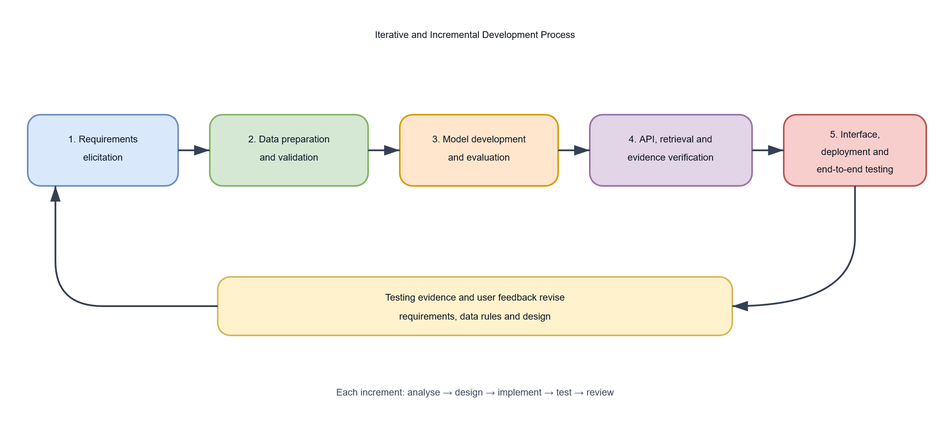
Figure A.3: Project progression from requirements through data preparation, model evaluation, API and evidence implementation, interface development, deployment, and testing.
Figure A.4: Scrum Process Applied
Figure A.4: Iterative planning, implementation, review, and backlog refinement.
Appendix B: Dataset and Model Evaluation Tables
Table B.1: Prepared ISOT Dataset Distribution
Partition or Class | likely_fake | likely_real | Total
Training | 14,324 | 16,956 | 31,280
Validation | 1,791 | 2,120 | 3,911
Test | 1,790 | 2,119 | 3,909
Prepared dataset | 17,905 | 21,195 | 39,100
The prepared dataset was produced from 44,898 initial ISOT records. Cleaning, duplicate removal, and removal of conflicting-label texts resulted in 39,100 records. The split was stratified and generated with random seed 42. The class counts in the random test set are visible in the confusion matrices below.
Table B.2: Random Held-Out Test Performance
Measure | TF-IDF + Logistic Regression | Fine-tuned DistilBERT
Test records | 3,909 | 3,909
Accuracy | 0.9900 | 0.9995
Macro precision | 0.9901 | 0.9994
Macro recall | 0.9898 | 0.9995
Macro F1-score | 0.9899 | 0.9995
Weighted F1-score | 0.9900 | 0.9995
Expected calibration error | 0.0523 | 0.0004
Brier score | 0.0130 | 0.0005
Mean confidence | 0.9378 | 0.9999
Misclassified records | 39 | 2
These are results from the same random held-out ISOT test split. They describe performance on that benchmark and do not establish equivalent performance on independent publishers, newly published articles, or Nigerian news. The transformer errors were made with high confidence, so confidence should not be interpreted as factual certainty.
Table B.3: Confusion Matrix for TF-IDF and Logistic Regression
Rows show actual labels; columns show predicted labels.
Actual Label | Predicted likely_fake | Predicted likely_real
likely_fake | 1,768 | 22
likely_real | 17 | 2,102
Table B.4: Confusion Matrix for Fine-tuned DistilBERT
Rows show actual labels; columns show predicted labels.
Actual Label | Predicted likely_fake | Predicted likely_real
likely_fake | 1,790 | 0
likely_real | 2 | 2,117
Table B.5: Temporal Test Result for the Classical Model
Measure | Result
Test records | 3,909
Accuracy | 0.9936
Macro F1-score | 0.9839
Expected calibration error | 0.0618
Brier score | 0.0116

Actual Label | Predicted likely_fake | Predicted likely_real
likely_fake | 426 | 10
likely_real | 15 | 3,458
This temporal result is available for the classical model. It should not be treated as a direct temporal comparison between the classical model and DistilBERT because a matching temporal transformer evaluation is not reported here.
Table B.6: Prediction Confidence Distribution
Confidence Interval | Classical Count | DistilBERT Count | Temporal Classical Count
0.0–0.1 | 0 | 0 | 0
0.1–0.2 | 0 | 0 | 0
0.2–0.3 | 0 | 0 | 0
0.3–0.4 | 0 | 0 | 0
0.4–0.5 | 0 | 0 | 0
0.5–0.6 | 46 | 0 | 34
0.6–0.7 | 79 | 0 | 54
0.7–0.8 | 129 | 0 | 147
0.8–0.9 | 417 | 0 | 552
0.9–1.0 | 3,238 | 3,909 | 3,122
Total | 3,909 | 3,909 | 3,909
Appendix C: API Reference and Example Structures
C.1 Analysis Request
The analysis endpoint accepts JSON containing article text. The default deployment limits are 100 to 20,000 non-whitespace characters; the API settings can change these values.
POST /api/v1/analyze
Content-Type: application/json
{
"text": "The full article text to analyse, containing enough context for claim extraction and model inference."
}
C.2 Illustrative Analysis Response
The API returns prediction and verification as separate objects. Values below illustrate the response structure only.
{
"prediction": {
"available": true,
"label": "likely_real",
"confidence": 0.87,
"model": "transformer_sequence_classifier",
"model_version": "transformer-distilbert-0.1.0",
"processing_time_ms": 125.4,
"error": null,
"disclaimer": "This is a machine-learning prediction and should not be treated as independent factual verification."
},
"verification": {
"status": "supported",
"claims": [
{
"claim_id": "claim-001",
"claim": "An illustrative factual statement from the submitted article.",
"status": "supported",
"rationale": "Relevant retrieved passages support this claim.",
"evidence": [
{
"url": "https://example.org/report",
"text": "Illustrative relevant source passage.",
"relevance_score": 0.82,
"title": "Example report",
"source_name": "Example Organisation",
"published_at": "2026-01-10T12:00:00+00:00",
"retrieved_at": "2026-01-11T09:30:00+00:00"
}
]
}
]
}
}
The prediction label is limited to likely_real or likely_fake. Evidence statuses are supported, contradicted, mixed, and insufficient. An unavailable model is represented with available: false and an error message; lack of evidence is represented as insufficient evidence and is not proof that a claim is false.
C.3 Health Check
GET /health
Illustrative response:
{
"status": "ok",
"environment": "production",
"model_name": "distilbert"
}
C.4 Validation Behaviour
Condition | HTTP Result | Behaviour
Valid article text within configured limits | 200 | Returns prediction and verification objects.
Text is shorter than the configured minimum | 422 | Returns a validation detail message.
Text exceeds the configured maximum | 422 | Returns a validation detail message.
Whitespace-only text | 422 | Rejected because it has no usable non-whitespace content.
Appendix D: Deployment Configuration Reference
The following table lists configuration names used by the deployed API and web client. Secret values belong in Render's protected environment settings or an equivalent secret manager. They must not be committed to Git or exposed through frontend variables.
Table D.1: API Environment Variables
Variable | Purpose | Example or Default
APP_ENV | Identifies the running environment. | production
PRODUCTION_MODEL | Selects the production predictor. | transformer or classical
CLASSICAL_MODEL_PATH | Location of the classical Joblib artifact. | models/classical/model.joblib
TRANSFORMER_MODEL_PATH | Location of the extracted transformer directory. | models/transformer/distilbert
TRANSFORMER_MODEL_ARTIFACT_URL | URL for the versioned transformer release archive. | GitHub Release asset URL
TRANSFORMER_MODEL_ARTIFACT_SHA256 | Verifies the downloaded archive. | 64-character SHA-256 digest
TRANSFORMER_MODEL_ARTIFACT_TOKEN | Optional token for a private release asset. | Leave unset for a public asset.
CORS_ORIGINS | Comma-separated browser origins allowed to call the API. | Deployed Vercel origin
SEARCH_PROVIDER | Selects the live search adapter. | brave
SEARCH_ENDPOINT | Brave Search web endpoint. | https://api.search.brave.com/res/v1/web/search
SEARCH_API_KEY | Authenticates API search requests. | Store as a Render secret.
SEARCH_MAX_RESULTS | Maximum search results requested per claim. | 5 for a conservative demo configuration
SEARCH_TIMEOUT_SECONDS | Timeout for provider and source-page requests. | 15
EVIDENCE_MAX_SOURCES | Maximum candidate pages fetched per claim. | 3 for a conservative demo configuration
EVIDENCE_MAX_CLAIMS | Maximum claims reviewed per article. | 1 for a conservative demo configuration
EVIDENCE_RECENCY_DAYS | Search freshness window. | 30
MIN_ARTICLE_LENGTH | Minimum non-whitespace article length. | 100
MAX_ARTICLE_LENGTH | Maximum article length. | 20000
PORT | Port assigned by Render. | Supplied automatically by Render.
The search and evidence limits above are configuration examples for a low-usage demonstration. They do not enforce a daily credit cap or per-user request limit. Those protections require explicit rate limiting and shared usage accounting.
Table D.2: Web Environment Variables
Variable | Purpose | Example or Default
NEXT_PUBLIC_API_URL | Public base URL used by the browser to contact the API. | https://veriscope-api.onrender.com
NEXT_PUBLIC_MIN_ARTICLE_LENGTH | Frontend minimum input length; should match the API. | 100
NEXT_PUBLIC_MAX_ARTICLE_LENGTH | Frontend maximum input length; should match the API. | 20000
Only public, non-secret values should use the NEXT_PUBLIC_ prefix. The Brave API key belongs on the API server and must never be supplied to Vercel as a public frontend variable.
Appendix E: Selected Implementation Listings
Listing E.1: Article Length Validation
The API checks the trimmed text length and returns the original input for consistent downstream preprocessing.
def validate_article_text(
text: str,
*,
min_length: int,
max_length: int,
) -> str:
article_length = len(text.strip())
if article_length < min_length:
raise ValueError(
f"Article text must contain at least {min_length} non-whitespace characters."
)
if article_length > max_length:
raise ValueError(
f"Article text must not exceed {max_length} characters."
)
return text
Listing E.2: Brave Search Request and Result Mapping
The adapter sends the API key in the request header and maps web results to provider-neutral result records.
params = {"q": query, "count": max_results}
if recency_days is not None:
params["freshness"] = _brave_freshness(recency_days)

response = httpx.get(
self.endpoint,
params=params,
headers={"Accept": "application/json", "X-Subscription-Token": self.api_key},
timeout=self.timeout_seconds,
)
response.raise_for_status()
values = response.json().get("web", {}).get("results", [])
The actual API key is read from server-side configuration and is not included in this listing.
Listing E.3: Analysis Workflow
receive article text
validate configured length limits
extract up to the configured number of checkable claims
for each claim:
query Brave Search when configured
deduplicate and filter candidate results
fetch public source pages within response-size limits
rank source passages and assess the claim
load the configured classical or transformer predictor
assemble prediction and verification as separate response objects
return structured response with source provenance and disclaimer
Appendix F: Test Suite Index
The repository's tests are grouped by responsibility. Unit tests cover data validation and splitting, preprocessing, classical and transformer inference, model artifact handling, settings, claim extraction, query construction, Brave response mapping, source filtering, document-fetch safeguards, evidence extraction, and verification rules. Integration tests cover API health, analysis responses, and the search-provider path. Frontend tests cover the analysis form and site navigation. These tests exercise code behaviour with fixtures; they do not constitute a live-provider accuracy study, user-acceptance study, or production-load test.

