Report
Problem definition
Basically,the game we designed is scrolling shooting game.This game is designed for everyone.In the game ,the background will move as the main character moves.They are moving vertically.You need to kill all the enemies.They will come out from different places of the screen.You can get something from kill the enemies.The game has several stages.In each stage there is a stronger enemy.After you destroy it,you will go to another stage.After you finish all the stages,you win.We will use Gamemaker to make this game.The game allows you to control with mouses,which is more casual.
Compared to traditional shooter games,we make some changes.
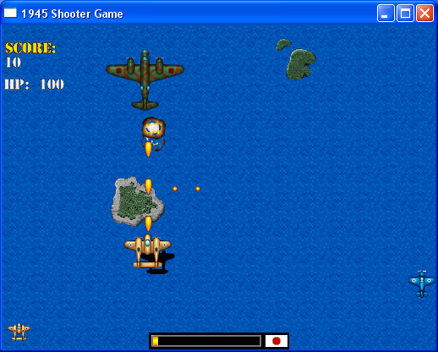
1945 is a traditional vertical shooter game.You controlled the plane to destroy the Japanese planes.
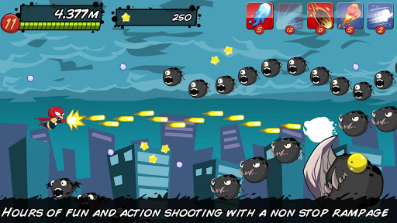
This game is a horizontal one.It has many interesting features,such as distance travelled and various items.
Feasibility
I think we can make the game.We’ll use gamemaker to make the game.We’ll use some software to deal with the graphics.The music will be added into the game to make it more interesting.

Information collection
We’ve received about 38 pieces of feedback.The questionnaire is:

- Have you ever played a shoot-em-up?
About question 1,1/3 of the answers are no.The rest of them are yes.So mainly of the respondents have at least tried a shooter game.

- If so, how many?
Nearly a half of the respondents have tried 3 types of shooter games,which means it is pretty possible for them to be a potential player of the game designed by us.The rest of them may try one or two types.

- Do you prefer shoot-em-ups that scroll horizontally, vertically, or not at all?
V:5
H:12
NP:12
This shows people may prefer games that scroll horizontally.And some people don’t have a preference
.
- Do you prefer short games or long games?
L:12
S:25
Most people like to play games casually.They wouldn’t like to spend hours on the games
.
- Would you prefer a game with a cartoony art style or a realistic art style?
C:17
R:20
More than a half of the respondents prefer a realistic style,which will influence our decision.The rest of them prefer a cartoony style.The number is quite close.

- Do you like game with role-playing elements?
Y:22
N:15
More people prefer role-playing elements,which will be a good suggestion for us.They will be a feature that makes the game more attractive and intersting.
- What place would you like the game to take place in?
We received various answers.In conclusion,respondents mainly prefer space and land.

Analysis of the questionnaire.
We’ll try to make a new kind of shooter games with different features , which will be attractive to the players.They will love the game because of those features.We decided to make a vertically scrolling game because it fits the screen better than horizontal ones. The background of the game is in space, which has the most preference.The graphics will be realistic instead of being cartoony.We will add role-playing elements into our game.The game is mainly aiming to casual players.It won’t take long to finish the game.

